Technical information
KDI 1903 M-MP Owner Manual (Rev.01)

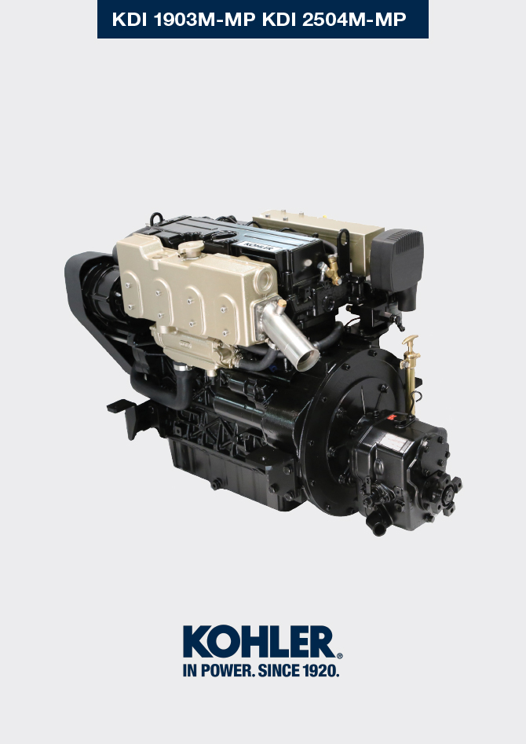

Registration of modifications to the document
Any modifications to this document must be registered by the drafting body, by completing the following table.

Released by | Code | Revision | Release Date | Revision date | Edited by | Endorsed
Technical Documentation | ED0053030860 | 05.1 | 02/2016 | 04/2023 | M. SILVESTRONE | C. TAGLIAVINI

Translated from the original manual in Italian language
Data reported in this issue can be modified at any time by KOHLER.

Sommario
1. TITOLO 1 2
1.1. Asdfsdfsdf 2
1.2. Asdfsdfsdfggg 2

Technical information

General description of the engine
- 4-stroke, in-line cylinders Diesel engine; -Liquid-cooling system;

- 4 valves per cylinder with hydraulic tappets;

- Direct Injection.

Engine specifications
Tab. 2.1
TECHNICAL DATA |  | UNIT  OF MEASURE | 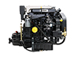
Engine type |  |  | KDI 1903 M-MP
Cylinders |  | n. | 3
Bore |  | mm | 88
Stroke |  | mm | 102
Displacement |  | cm ³ | 1861
MAX INCLINATION DURING OPERATION (even in combined) |  | α | 35° MAX ( transversal)
 |  | α | 15° MAX (longitudinal)
OIL CAPACITY (MAX level.) including oil filter | standard version | L | 8.9
DRY WEIGHT |  | Kg | 277

Engine dimensions (mm) - with TMC 260 reversing gear
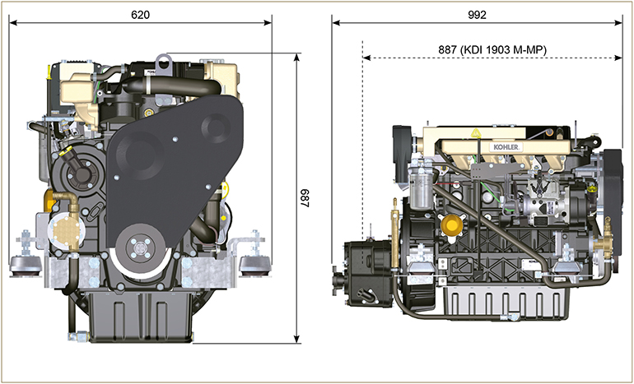
Fig. 2.1

Oil
2.4.1 Engine oil


Important

- The engine may be damaged if operated with improper oil level.
- Do not exceed the MAX level because a sudden increase in engine rpm could be caused by its combustion.
- Use only the recommended oil to ensure adequate protection, efficiency and service life of the engine.
- The use of lubricants other than recommended may shorten the engine life.
- Viscosity must be appropriate to the ambient temperature to which the engine is to be exposed ( Par. 2.4.1.1 ).


Danger

- Prolonged skin contact with the exhausted engine oil can cause cancer of the skin.
- If contact with oil cannot be avoided, thoroughly wash your hands with soap and water as soon as possible.
- For the exhausted oil disposal, refer to the Par. 6.9 .
2.4.1 SAE oil classification
- In the SAE classification, oils are identified according to viscosity without considering any other qualitative characteristic.
- The code is composed of two numbers, which indicate, and must correspond to, the ambient temperature in which the engine operates, the first number refers to the viscosity when cold, for use during winter (" W "), while the second number is for viscosity at high temperatures.

Tab. 2.2
RECCOMENDED OIL
VISCOSITY | SAE | 15w-40  (+15°c ÷ +45°c) | 10w-30  (-15°c ÷ +30°c) | 5w-30  (-30°c ÷ +30°c) | 5w-40  (-30°c ÷ +45°c)
WITH SPECIFICATIONS | API | CH4 | CJ4 | CH4 | CH4/ CJ4
WITH SPECIFICATIONS | ACEA | E4 - E5 - E7

CLASSIFICATION | DESCRIPTION AREA SPECIFICATION
E4 | High performance (Euro 1 - 2 - 3 Engines) heavy duty
E5 | High performance (Euro 1 - 2 Engines) heavy duty
E7 | High power over long distances (Euro 4 - 5 engines)

2.4.2 Reversing gear oil

NOTE : Refer to the technical documentation of the reversing gear supplied with the engine.

Fuel

Important

- Use of other types of fuel could damage the engine. Do not use dirty diesel fuel or mixtures of diesel fuel and water since this will cause serious engine faults.
- Any failures resulting from the use of fuels other than recommended will not be warranted.


Warning

- Clean fuel prevents the fuel injectors from clogging. Immediately clean up any spillage during refuelling.
- Never store diesel fuel in galvanized containers (i.e. coated with zinc). Diesel fuel and the galvanized coating react chemically to each other, producing flaking that quickly clogs filters or causes fuel pump and/or injector failure.
2.3
FUEL COMPATIBILITY
EN 590 (biodiesel content max. 7% (V/V))
ASTM D 975 Grade 1-D S15
ASTM D 975 Grade 2-D S15
NATO F-54, equivalent to diesel fuel in accordance with EN 590
EN 590 or ASTM D 975 Grade 1, 2 -D S15 Arctic Diesel
JIS K 2204 No. 1, No. 2
NOTE : In a warranty case the customer must prove by a certificate from the fuel supplier that an allowed fuel was used.
KDI Mechanical Injection Tier 3 – Stage IIIA certified Engines (w and w/o EGR)
- Those engines are designed for fuels in accordance with EN 590 and ASTM D975 for a cetane number of at least 45. Since those engines are not equipped with exhaust gas after-treatment, they can be operated with diesel fuels with sulfur content up to 500 mg/kg (ppm). Compliance with the emission requirements is guaranteed only with sulfur content up to 15 mg/kg (ppm).
Engines operated with fuels as per EN 590 and ASTM D975 with sulfur content < 15mg/kg have an oil changing interval of 500hrs. Fuels with a sulfur content > 500 mg/kg demand a shorter lubricating oil change interval. This is set at 250hrs. However, the engine oil must be changed when the Total Base Number TBN is reduced to 6.0 mgKOH/g test method ASTM D4739. With high fuel sulfur content fuel this may happen at 125hrs. Do not use low SAPS oils.

KDI Mechanical Injection Uncertified Engines (no EGR Engines)
- Those engines are designed for fuels in accordance with EN 590 and ASTM D975 for a cetane number of at least 45. Since those engines are not equipped with exhaust gas after-treatment, they can be operated with diesel fuels with sulfur content up to 2000 mg/kg (ppm).Engines operated with fuels as per EN 590 and ASTM D975 with sulfur content < 15mg/kg have an oil changing interval of 500hrs. Fuels with a sulfur content > 500 mg/kg demand a shorter lubricating oil change interval. This is set at 250hrs. However, the engine oil must be changed when the Total Base Number TBN is reduced to 6.0 mgKOH/g test method ASTM D4739

2.5.1 Fuel for low temperatures
- When operating the engine in ambient temperatures lower than 0 degrees C, use suitable low temperature fuel normally available from fuel distributors and corresponding to the specifications of Tab. 2.3 .
- These fuels reduce the formation of paraffin in diesel at low temperatures.
- When paraffin forms in the diesel, the fuel filter becomes blocked interrupting the flow of fuel.

2.5.2 Biodiesel fuel
- Fuels containing 10% methyl ester or B10, are suitable for use in this engine provided that they meet the specifications listed in the Tab. 2.3.
- DO NOT USE vegetable oil as a biofuel for this engine.
2.4
BIODIESEL COMPATIBILITY
Biodiesel according to EN 14214 (only permissible for mixture with diesel fuel at max. 10% (V/V))
US biodiesel according to ASTM D6751 – 09a (B100) (only permissible for mixtures with diesel fuel at 10% (V/V))

2.5.3 Synthetic fuels: GTL, CTL, BTL, HV
It is a well-known fact that engines which are operated for longer periods with conventional diesel fuel and then converted to synthetic fuels suffer shrinkage of polymer seals in the injection system and thus fuel leaks. The reason for this behavior is that the aromatic-free synthetic fuels can lead to a change in the selling behavior of polymer seals.
Therefore, conversion from diesel fuel to synthetic fuel may only be done after changing the critical seals. The problem of shrinkage does not occur when an engine was operated with synthetic fuel from the start.

2.5.4 Non-Road Fuels
Other non-road fuels may be used if they comply with all the limit values of EN 590 except for the fuel density, the cetane number and the sulfur content.
The following limits apply for these parameters:
2.5
FUEL PARAMETER | UNIT | LIMIT VALUE
Cetane number |  | Min. 49
Fuel density at 15°C | Kg/m ³ | 820 - 860
Sulfur content | mg/kg or ppm | max. 500

2.5.5 Jet Fuels
Only for KDI Mechanical Injection Uncertified Engines (no EGR Engines).
The following jet fuels can be used but only adopting an additional fuel filter with lubricity doser:
2.6
FUEL
F-34/F-35 (kerosene, NATO designation) | JP-8 (kerosene, US military designation)
F-44 (kerosene, NATO designation | JP-5 (kerosene, US military designation)
F-63 (kerosene, NATO designation, equivalent to F-34/F-35 with additives) | Jet A (kerosene for civil aviation)
F-65 (kerosene, NATO designation, 1:1 mixture of F-54 and F-34/F-35) | Jet A1 (kerosene for civil aviation)

2.5.6 Emission-Related Installation Instructions Failing to follow the instructions in the applications guidebook when installing a certified engine in a piece of nonroad equipment violates federal law (40 CFR 1068.105(b)), subject to fines or other penalties as described in the Clean Air Act.

OEM must apply a separate label with the following statement: “ULTRA LOW SULFUR FUEL ONLY” near the fuel inlet.

Ensure you are installing an engine appropriately certified for your application. Constant speed engines may only be installed on constant speed equipment for constant speed operation.

If you install the engine in a way that makes the engine's emission control information label hard to read during normal engine maintenance, you must place a duplicate label on the equipment, as described in 40 CFR 1068.105.

Coolant recommendation
A mixture of 50% demineralized water and 50% low silicate ethylene glycol based coolant liquid must be used. Use a Long Life or Extended Life Heavy Duty OAT coolant free of: silicates, phosphates, borates, nitrites and amines.

The following ethylene-glycol based engine coolant for all models within KDI engine family may be used:

- OAT (Organic Acid Technology) Low Silicate: ASTM D-3306 D-6210
- HOAT (Hybrid Organic Acid Technology) Low Silicate: ASTM D-3306 D-6210

The above coolants in concentrated formulation must be mixed with distilled, deionized, or demineralized water. A pre-mixed formulation (40-60% or 50-50%) can be used directly when available.


Important
- Do not mix ethylene glycol and propylene glycol based coolants. Do not mix OAT and HOAT based coolant. OAT performance life can be drastically reduced if contaminated with nitrite-containing coolants.
- Never use automotive-type coolants. These coolants do not contain the correct additives to protect heavy – duty diesel engines.

OAT coolants are maintenance free up to 6 years or 6000hrs of operation , provided that the cooling system is topped up using the same type of coolant. Do not mix different coolant types. Test the coolant condition annually with coolant test strips.
HOAT are not all maintenance free and it is recommended to have SCA (Supplemental Coolant Additives) added at the first maintenance interval.

Battery recommendations
Battery not supplied by Kohler

Tab. 2.5
RECOMMENDED BATTERIES
AMBIENT TEMPERATURE | BATTERY TYPE
> - 15°C | 12V 100 Ah - 800 CCA/SAE
-15°C ÷ -25°C | 12V 110 Ah - 950 CCA/SAE
< - 25°C | 12V 120 Ah - 1000 CCA/SAE

Control panel
Tab. 2.6 shows the control panel components.  Tab 2.6 | 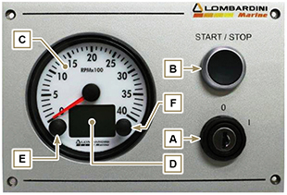  Fig 2.2
  POS. | DESCRIPTION
  A | Panel ignition switch with key switch
  B | Engine on/off push button
  C | Engine rpm indicator
  D | Engine data or errors display
  E | Engine data or errors push button
  F | Maintenance errors reset push button
Tab. 2.7 shows data that can be consulted on display D by pressing push button E .
Tab 2.7
POS. | DESCRIPTION
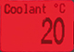 | Coolant temperature ( °C )
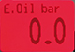 | Oil pressure ( bar )
 | Battery voltage ( V )
 | Total and partial hours of operation ( h )  - To reset partial hours, simultaneously press push buttons E and F for 3 seconds .
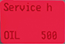 | Hours left for maintenance ( h )
 | Backlighting adjustment  - Press push button E for 3 seconds  - Press push button E to decrease brightness or F to increase it



