General information
KDI 1903TCR / KDI 1903TCRE5 Workshop manual (Rev. 17.8)



Registration of modifications to the document
Any modifications to this document must be registered by the drafting body, by completing the following table.

Released by | Code | Revision | Release Date | Revision date | Edited by | Endorsed
 | manoff

Translated from the original manual in Italian language
Data reported in this issue can be modified at any time by KOHLER.

Sommario
1. TITOLO 1 2
1.1. Asdfsdfsdf 2
1.2. Asdfsdfsdfggg 2

General information

Useful information
- This manual contains the instructions needed to carry out proper use and maintenance of the engine, therefore it must always be available, for future reference when required.
- Information, descriptions and pictures contained in this manual reflect the basic configuration of the engines ( Par. 1.4 and Par. 1.5 ).
- However, the development of engines is continuous. Therefore, the information in this manual is subject to change without notice.
- KOHLER reserves the right to make, at any time, changes on the engines for technical or commercial reasons.
- These changes do not require KOHLER to intervene on the production marketed up to that time and nor to consider this manual as inappropriate.
- The paragraphs, tables and figures are numbered by chapter and followed by the progressive paragraph, table and/or figure number.
Es: Par. 1.3 - chapter 1 paragraph 3 .
Tab. 2.4 - chapter 2 table 4 .
Fig. 4.5 - chapter 4 figure 5 .
NOTE: The paragraphs may contain sub-paragraphs.

- All technical terms, specific components and symbols ( Tab. 15.1 ) that are in the manual are listed and described inside the glossary, which can be consulted in ( Chap. 15 ).
- The references of the objects described in the text and in the figure are indicated by letters and numbers, which are always and only related to the paragraph you are reading unless there are specific references to other figures or paragraphs.
- Reference to values are indicated by letters or numbers.
- The mark ( ) after the title of a paragraph, indicates that the procedure is not required in order to disassemble the engine, however the procedures are featured in order to illustrate the disassembly of components.
- Any additional section that KOHLER will deem necessary to supply at a later stage must be kept with the manual and considered as an integral part of it.
- The information contained in this manual is the sole property of KOHLER , therefore no partial or total reproduction or replication is allowed without the express permission of KOHLER .

1.1.1 Useful Information - accident prevention - environmental impact

- Before proceeding repair - handling the motor , read the entire chapter 3, which contains important information about the procedures to be followed for safety and environment .

Manufacturer and engine identification
The engine identification name plate is situated in the lower part of the crankcase; it is visible from the intake or exhaust side.
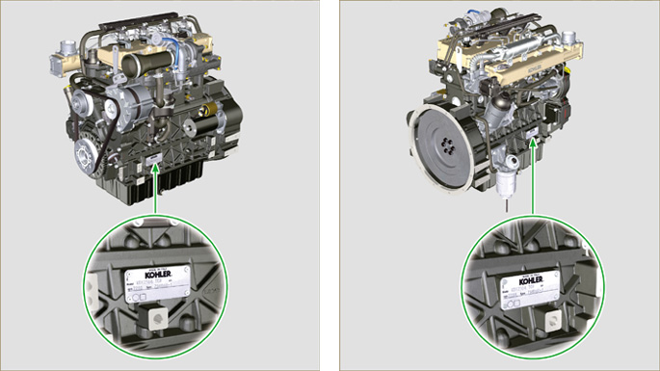
Fig 1.1 - Fig 1.2

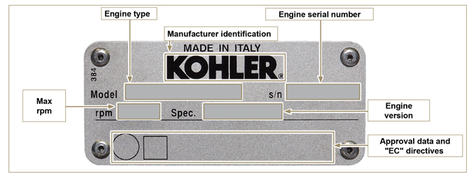
Fig 1.3

Homologation labels
Label for EPA rules (compilation example)

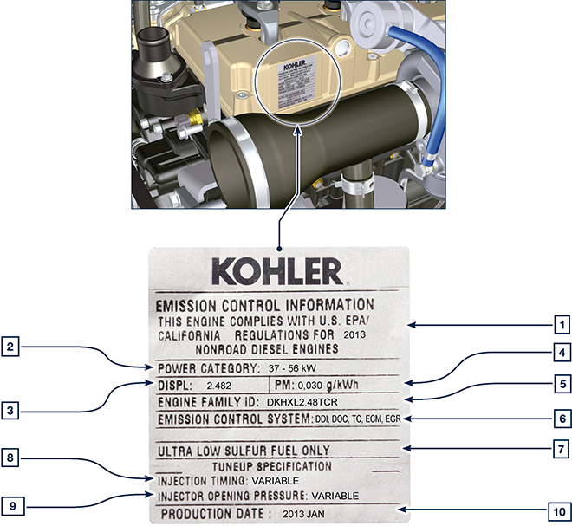

Tab 1.1
POS. | DESCRIPTION
1 | Model year in compliance with the rules
2 | Power category (kW)
3 | Engine displacement (L)
4 | Particulate emission limit (g/kWh)
5 | Engine family ID
6 | Emission Control System = ECS
7 | Fuel with low sulphur content
8 | Injection timing
9 | Electronic injector opening pressure (bar)
10 | Production date (example: 2013.JAN)

Label for China Standards (compilation example)

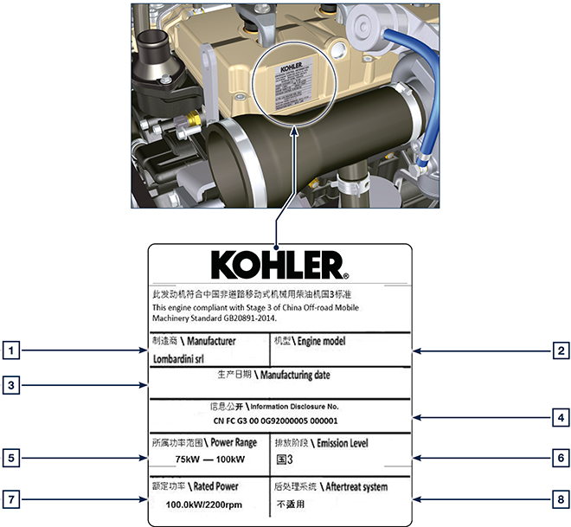
Tab 1.2
POS | DESCRIPTION
1 | Manufacturer
2 | Engine model
3 | Manufactoring date
4 | Certificate N°
5 | Power range (kW)
6 | Emission level
7 | Rated power
8 | Aftertreat system

Label for Korea Standards (compilation example)

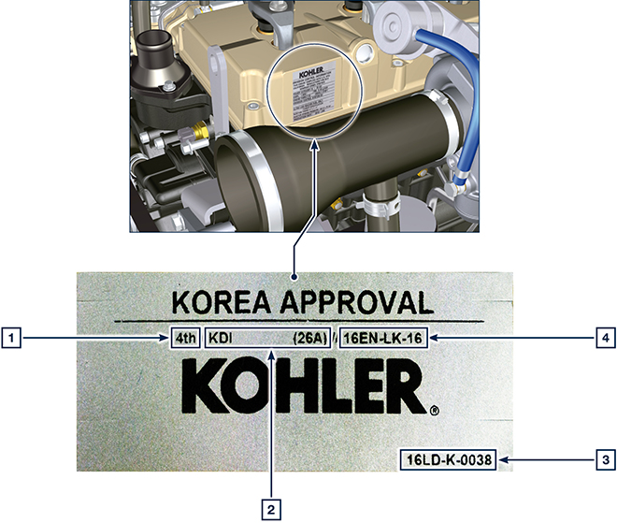
Tab 1.3
POS | DESCRIPTION
1 | Tier 4 Final
2 | Engine model
3 | Manufactoring date and manufacturer code
4 | N° Korea emission certificate

Identification of the main internal components of the engine and operating reference (BASE CONFIGURATION)
WIEW OF EXHAUST SIDE
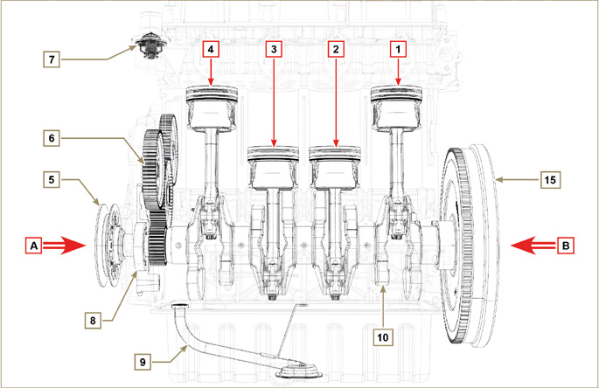
Fig 1.5

The following chapters contain operating references in order to clearly understand the engine. This paragraph illustrates these references that may be recognised by means of some main internal components.  Should you need to execute complex operations, always consult this paragraph | Tab 1.2
  REF. | DESCRIPTION
  A | View of timing system side (2 ^{nd} PTO)
  B | View of flywheel side (1 ^{nd} PTO)
  C | View of exhaust side
  D | View of intake side
  1 | Cylinder/Piston N. 1 (KDI 1903 - KDI 2504)
  2 | Cylinder/Piston N. 2 (KDI 1903 - KDI 2504)
  3 | Cylinder/Piston N. 3 (KDI 1903 - KDI 2504)
  4 | Cylinder/Piston N. 4 (KDI 2504)
  POS. | DESCRIPTION
  5 | Crankshaft pulley (2 ^{nd} PTO)
  6 | Gear timing system
  7 | Thermostatic valve
  8 | Oil pump
  9 | Oil suction hose
  10 | Crankshaft
  11 | Exhaust manifold
  12 | Intake manifold
  13 | Camshaft
  14 | Gears adaptor for 3 ^{th} /4 ^{th} PTO (optional)
  15 | Flywheel (1 ^{st} PTO)

WIEW OF FLYWHEEL SIDE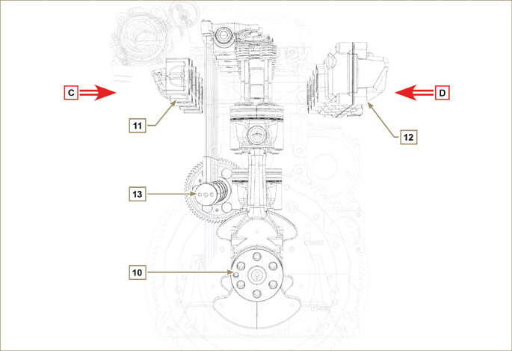
Fig 1.6

WIEW OF TIMING SYSTEM SIDE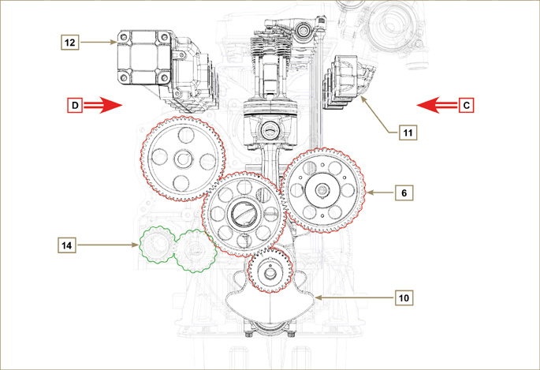
Fig 1.7

Identification of the external components of the engine (BASE CONFIGURATION)
VIEW OF TIMING SYSTEM SIDE - EXHAUST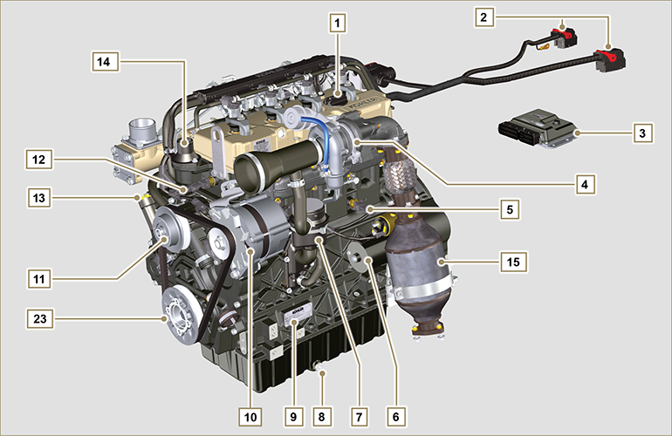
Fig 1.8

VIEW OF FLYWHEEL SIDE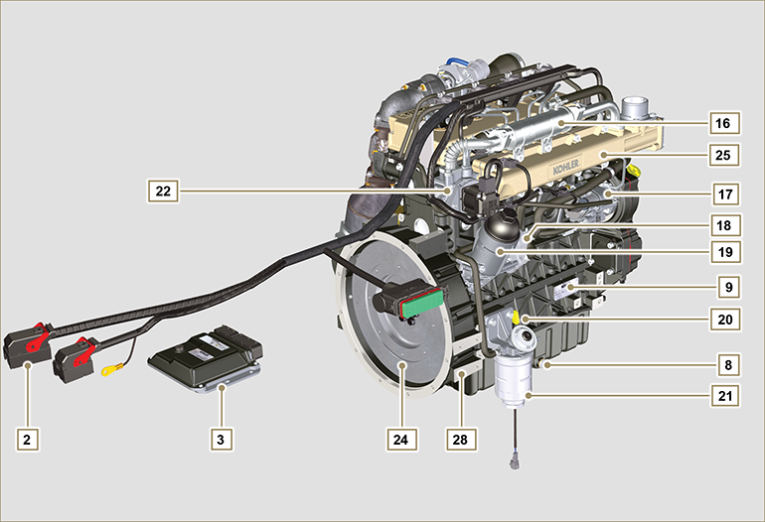
Fig 1.9

This paragraph illustrates all external components that are present in the base configuration of the engine.  For components present on engines that differ from those represented in these illustrations, refer to Chap. 11 . | NOTE: The illustrated components may differ from those illustrated; the illustration is only as an example.
Tab 1.3
  POS. | DESCRIPTION
  1 | Oil filler cap
  2 | Wiring
  3 | ECU
  4 | Turbocharger
  5 | Oil pressure switch
  6 | Starter motor
  7 | Oil steam separator
  8 | Oil drain plug
  9 | Engine identification name plate
  10 | Alternator
  11 | Coolant pump
  12 | Coolant temperature sensor
  13 | Oil filler cap side
  14 | Thermostatic valve
  15 | Catalyst
  16 | EGR Cooler
  17 | High-pressure fuel injection pump
  POS. | DESCRIPTION
  18 | Oil Cooler
  19 | Lub. oil filter
  20 | Oil dipstick
  21 | Fuel filter
  22 | EGR valve
  23 | Crankshaft pulley (2 ^{nd} PTO)
  24 | Flywheel (1 ^{st} PTO)
  25 | Intake manifold
  26 | Waste Gate valve control actuator
  27 | Exhaust manifold
  28 | Flange bell
  29 | Electronic injectors
  30 | Common Rail
  31 | Air intake hose

UPPER VIEW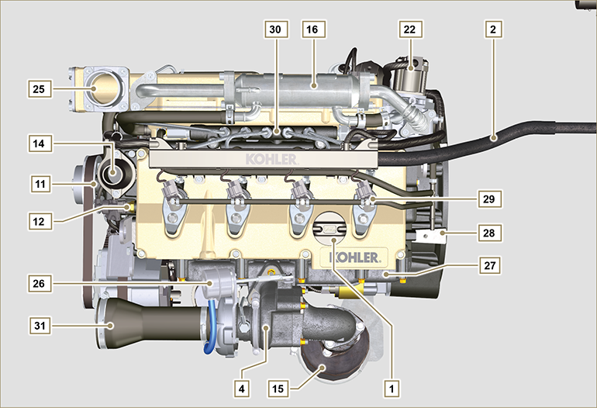
Fig 1.10

ATS (After Treatment System)
1.6.1 ATS with DOC filter  NOTE: The ATS system can be installed in a different way than shown.  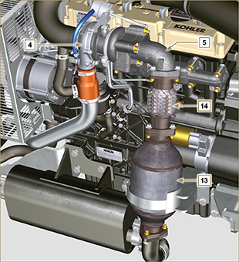  Fig 1.10 | Tab 1.4
  POS. | DESCRIZIONE
  4 | Turbocharger
  5 | Gas exhaust flange
  13 | DOC
  14 | Flexible exhaust tube
1.6.2 ATS with DOC+DPF filter  NOTE: the ATS system with DPF filter is only present for versions compliant with "Stage V" emission regulations.  The ATS system can be installed in a different way than shown. | Tab 1.5
  POS. | DESCRIZIONE
  1 | Turbocharger
  2 | Turbine exhaust pipe
  3 | DOC
  4 | DPF
  5 | ETB
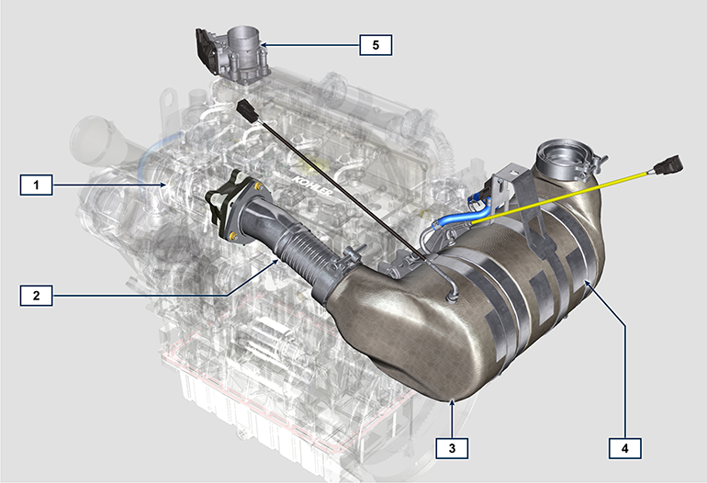
Fig 1.11



