Service procedures
KSD 1403 Workshop Manual Rev. 00

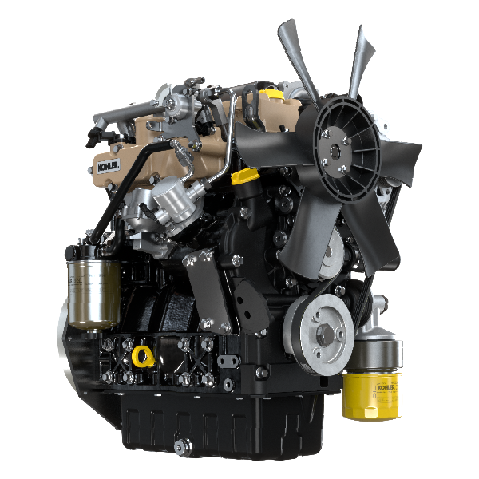

Registration of modifications to the document
Any modifications to this document must be registered by the drafting body, by completing the following table.

Released by | Code | Revision | Release Date | Revision date | Edited by | Endorsed
 | KSD1403-WS

Translated from the original manual in Italian language
Data reported in this issue can be modified at any time by KOHLER.

Sommario
1. TITOLO 1 2
1.1. Asdfsdfsdf 2
1.2. Asdfsdfsdfggg 2

Service procedures

Preliminary information


Important

- The operator should prepare all equipment and tools in order to enable him to carry out the operations correctly and safely.
- Before proceeding with operation, carefully read Chap. 3 .
- In order to operate safely and easily, we recommend positioning the engine on a rotating stand for engine overhauling.
- Seal all injection component unions as illustrated in Par. 2.8.8 during assembly.
- Protect all disassembled components and coupling surfaces subject to oxidation with lubricant.
- Where necessary, reference to special tools to use during disassembly operations is indicated (es. ST_05 ).
- Replace all gaskets or rubber components at each disassembly.

Cooling circuit
DRAINING
Radiator NA - TC model | 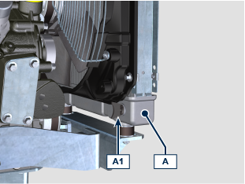
- Uncscrew the cap A1 of the radiator A to drain the remaining coolant.
Radiator TCA model | 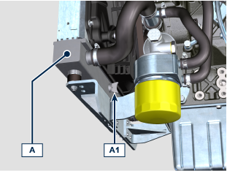
- Uncscrew the cap A1 of the radiator A to drain the remaining coolant.
DISASSEMBLING
Radiator NA - TC model | 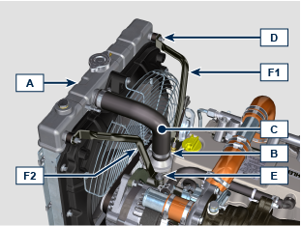
- Loosen the clamps B and remove the hose C .
- Unscrew the nuts D and the screw E to remove the rods F1 , F2 .
- Loosen the clamps B and remove the hose C .  - Unscrew the nuts D to remove the radiator A . | 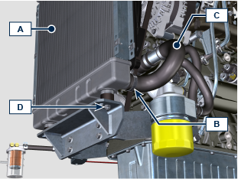
Radiator TCA model | 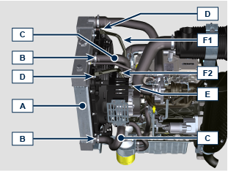
- Loosen the clamps B and remove the hose C .
- Unscrew the nuts D and the screw E to remove the rods F1 , F2 .
- Loosen the clamps G and remove the hose H .  - Loosen the clamps B1 and remove the hose L . | 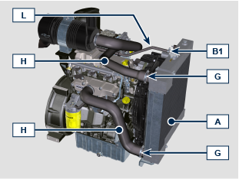
- Unscrew the nuts D to remove the radiator A . | 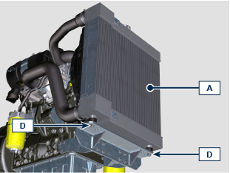
Oil Cooler hoses | 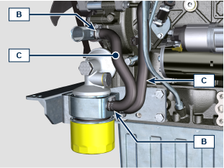
- Loosen the clamps B and remove the hoses C .

NOTE: the oil cooler has various configurations and can be installed also on the intake side.  - Unscrew the screws E1 and clamps B1 if present. | 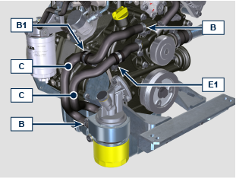
Fan and belt | 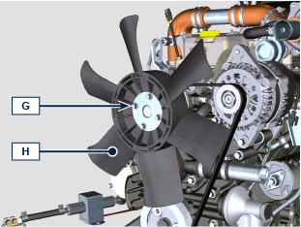
- Unscrew the screws G and remove the fan H .
- Remove the belt L using ST_57 tool. | 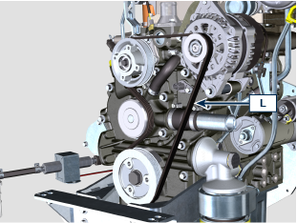  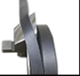  DISASSEMBLING
Coolant pump | 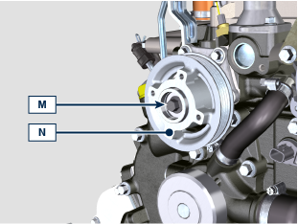
- Unscrew the screw M and remove the pulley N .
- Loosen the clamps B and remove the hose C . | 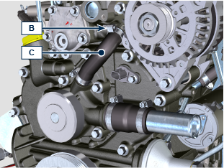
- Do not disassemble the flange R .  NOTE:  the flange R for pulley N can be intalled in various positions based from engine specification, each configuration has a specific belt and pulley.  It is not necessary to remove the flange R for pulley N to proceed with following operations below.  In case of flange disassembling, take note of its original position to avoid a wrong positioning at the assembling.  - Apply Loctite 242 on the thread of screws (tightening torque 10 Nm ).  - Unscrew the screws P and remove the coolant pump Q . | 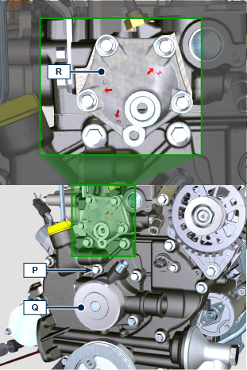
Thermostatic valve | 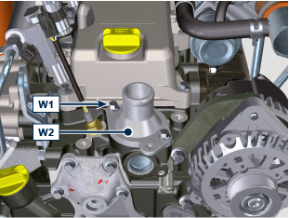
- Unscrew the screws W1 and remove the cover W2 .
- Remove the thermostatic valve W3 . | 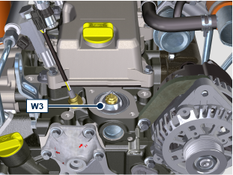
Thermostatic valve specifications

Opening start |  | Opening stop
0.1 mm | @ 80° C | 7 mm | @ 95° C

Radiator support | 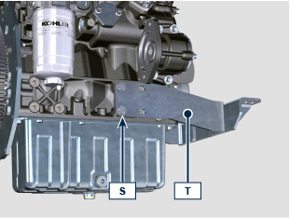
- Unscrew the screws S and remove the radiator support T .
ASSEMBLING
Radiator support | Option A (screws M10 - tightening torque at 45 Nm )  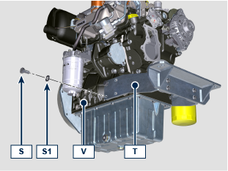  Option B (screws M8 - tightening torque at 25 Nm )  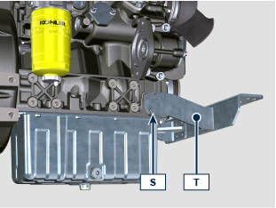
- Fix the radiator support T on the crankcase V using the screws S and washers S1 .
Thermostatic valve | 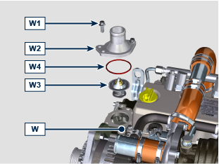
- Place the thermostatic valve W3 inside the seat of cylinder head W .
- Place the gasket W4 inside the seat of cover W2 .
- Apply Loctite 270 on the thread of screw W1 . §
- Fix the cover W2 with gasket W4 on the cylinder head W using the screws W1 (tightening torque 10 Nm ).

NOTE: make sure that the gasket W4 stays in its seat during cover W2 assembly process.
Coolant pump | 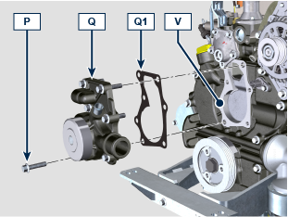
- Fix the coolant pump Q on the crankcase V with the gasket Q1 using the screws P (tightening torque 25 Nm ).
- Install components N1 , N2 inside pulley N .  - Apply Loctite 242 on the thread of screw M . §  - Fix the pulley N on flange R using the screw M (tightening torque 25 Nm ). | 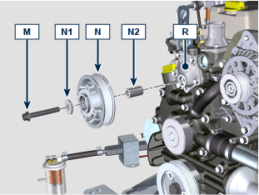
Fan and belt | 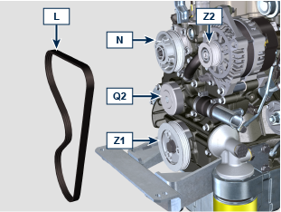  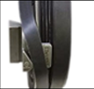  INSTALLING
- Install the new belt A on pulleys N , Q2 , Z1 , Z2 using the ST_57 tool.
- Apply Loctite 242 on the thread of screw G . §  - Fix the fan H with the plate H1 and the spacer H2 on pulley N (tightening torque 10 Nm ).  NOTE: the spacer H2 can be different based on engine specification. | 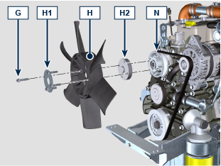
Oil Cooler hoses
- Fix the hoses C using the clamps B .
NOTE: the oil cooler has various configurations and can be installed also on the intake side.

- Fix the clamps B1 using screws E1 if present.
Radiator NA - TC model | 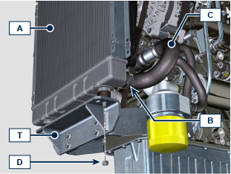
- Place the radiator A on support T .
- Fix the radiator A using nuts D (tightening torque 25 Nm ).
- Fix the hoses C using the clamps B .
- Place the rods F1 , F2 for the radiator fixing A .  - Fix the rods F1 , F2 using the nuts D with washers D1 and screws E (tightening torque 10 Nm ).  - Fix the hoses C using the clamps B . | 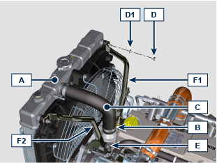
Radiator TCA model | 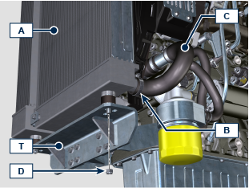
- Place the radiator A on support T .
- Fix the radiator A using nuts D (tightening torque 25 Nm ).
- Fix the hoses C using the clamps B .
- Place the rods F1 , F2 for the radiator fixing A .  - Fix the rods F1 , F2 using the nuts D with washers D1 and screws E (tightening torque 10 Nm ). | 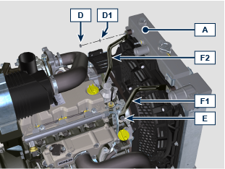
- Fix the hoses C using the clamps B .  - Fix the hoses H using the clamps G .  - Fix the hose L using the clamps B1 . | 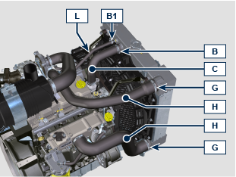

Air inlet line

Model NA | 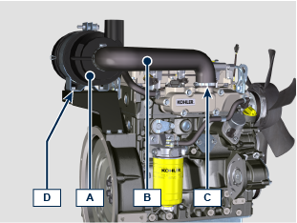
DISASSEMBLY

- Loosen the clamp C and remove the hose B .
- Unscrew the screws D and remove the air filter A .
ASSEMBLY  - Fix the hose B on the inlet manifold E using the clamp C .  - Fix the air filter A using the screws D on the support F ( tightening torque 25 Nm ). | 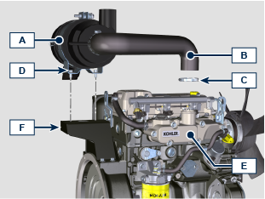
Model TC - TCA | 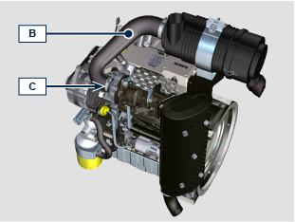  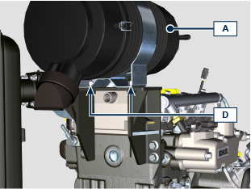
DISASSEMBLY

- Loosen the clamp C and remove the hose B .
- Unscrew the screws D and remove the air filter A
ASSEMBLY  - Fix the hose B on the turbocharger E using the clamp C .  - Fix the air filter A using the screws D on the support F (tightening torque 25 Nm ). | 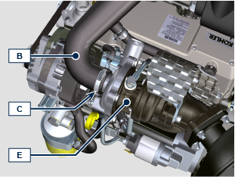  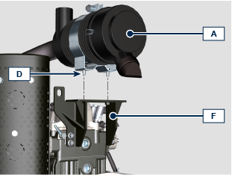

Exhaust line

NA Model | 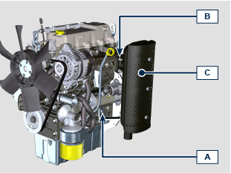
Muffler option A
DISASSEMBLING

- Unscrew the nuts B .
- Unscrew the screws A and remove the muffler C .
ASSEMBLING  - Fix the muffler C on the manifold D using the nuts B (tightening torque 25 Nm ).  - Fix the muffler C on the crankcase E using the screws A (tightening torque 25 Nm ). | 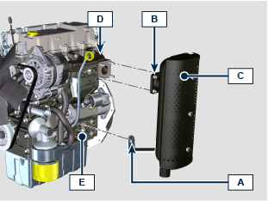
Muffler option B | 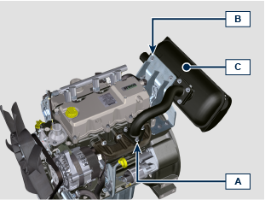
DISASSEMBLING

- Unscrew the nuts A .
- Unscrew the screws B and remove the muffler C .
ASSEMBLING  NOTE: replace gaskets G1 , G2 if removed | 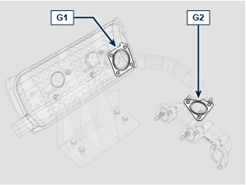
- Position the muffler C on the bracket E and the tube C1 on the manifold D .  - Fix the muffler C on the bracket E using the screws B (tightening torque 25 Nm ).  - Fix the tube C1 on the manifold D using the nuts A (tightening torque 25 Nm ). | 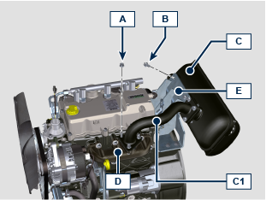
TC - TCA Model | 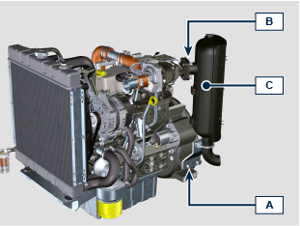
Muffler option A
DISASSEMBLING

- Unscrew the nuts B .
- Unscrew the screws A and remove the muffler C .
ASSEMBLING  - Fix the muffler C on the flange C1 using the nuts B (tightening torque 25 Nm ).  - Fix the bracket C2 on the bell F using the screws A and washer A1, A2 (tightening torque 50 Nm ). | 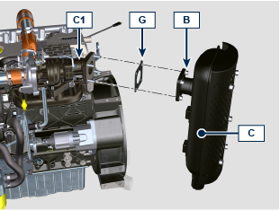  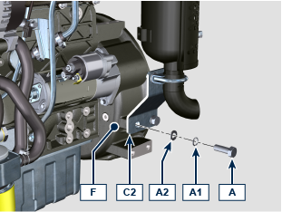
Turbocharger | 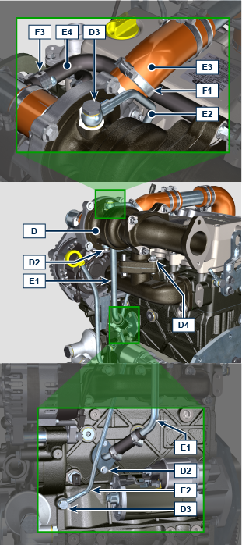
DISASSEMBLING

- Unscrew the screws D3 and remove the tube E2 .
- Unscrew the screws D2 and remove the tube E1 .
- Loosen the clamp F1 and disconnect the hose E3 .
- Loosen the clamp F3 and disconnect the hose E4 .
- Unscrew the nuts D4 and remove the turbocharger D .
ASSEMBLING  - Place the turbocharger D on the interfacing falnge of exhaust manifold H . | 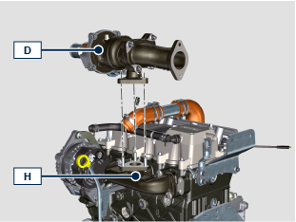
- Fix the turbocharger D on the exhaust manifold H using the nuts D4 (tightening torque 25 Nm ).  - Connect the hose E3 with the turbocharger D and fix it using the clamp F1 .  - Place the tube E2 on the turbocharger D and the crankcase G with screws D3 and copper washers D5 .  - Fix the tube E2 using the screws D3 (tightening torque 1 5 Nm ).  - Place the tube E1 on the crankcase G and under the turbocharger D with screws D2 and gskets E5 , E6 .  - Tighten the screws D2 (tightening torque 10 Nm ). | 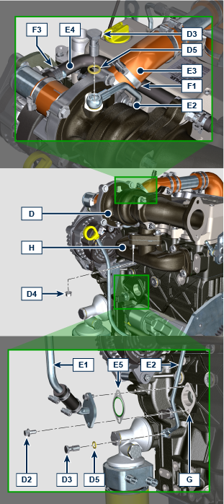  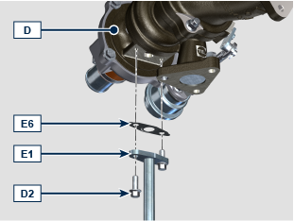
Only for TC model | 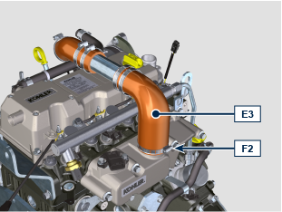
DISASSEMBLING

- Loosen the clamp F2 and remove the hose E3 . §

ASSEMBLING  - Connect the hose E3 with the inlet manifold L and fix it using the clamp F2 . | 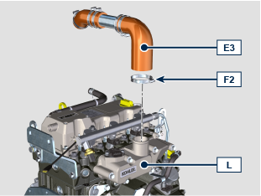

Fuel System

Fuel feed pump
Electric fuel feed pump § | 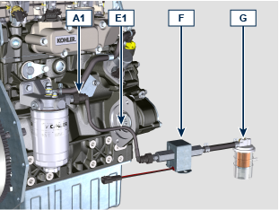
DISASSEMBLING

- Disconnect the junction A1 and remove the tube E1 with the pump F and the pre-filter G .
ASSEMBLING  - Connect the junction A1 on the filter D .  - Check the condition of tubes F and pre-filter G . | 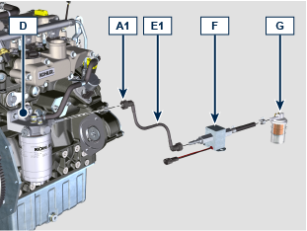
Mechanical fuel feed pump § | 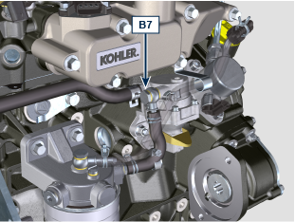  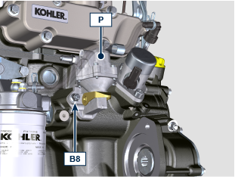
DISASSEMBLING

- Unscrew the screw B7 .
- Unscrew the nuts B8 and remove the pump P .
ASSEMBLING  - Place the pump P with gasket P1 on the crankcase Q .  - Fix the pump P on the crankcase Q using the nuts B8 (tightening torque 25 Nm ).  - Fix the tube E3 on the pump P using the screw B7 with copper washers B9 (tightening torque 15 Nm ). | 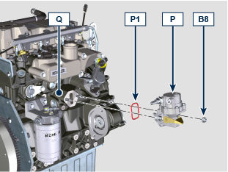  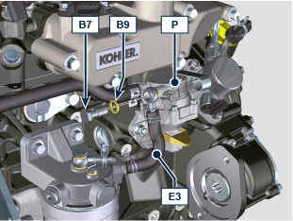
Fuel filter
DISASSEMBLING  - Disconnect the connector A1 from the injection pump A .  - Unscrew the screw B1 .  - Unscrew the screws B2 and remove the fuel filter D with the tube C . | 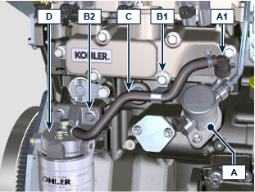
ASSEMBLING  - Fix the fuel filter D using the screws B2 (tightening torque 25 Nm ).  - Conect the connector A1 on the injection pump A .  - Fix the tube C using the screw B1 (tightening torque 25 Nm ). | 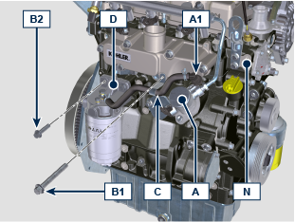
Rail §
DISASSEMBLING  - Unscrew the nuts A2 , A3 and remove the tube E2 from the rail H and injection pump A . | 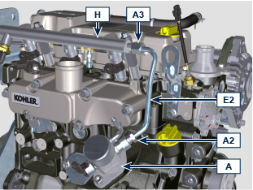
- Remove the lockers H2 .  - Unscrew the screws B2 and remove the spacers H1 and the rail H . | 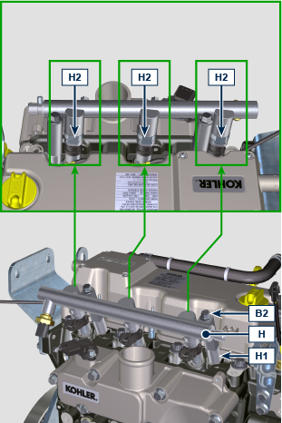
ASSEMBLING  - Apply oil EMI-385 on injector gaskets. §  - Place the rail H on the injectors L . | 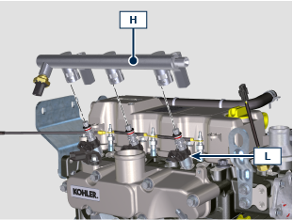
- Install the lockers H2 on the rail H . | 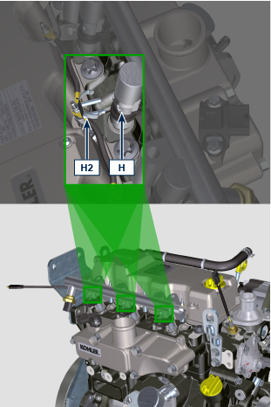
- Apply Loctite 242 on the thread of screws B2 .  - Place the spacers H1 under the rail H and fix the rail H using the screws B2 (tightening torque 25 Nm ). | 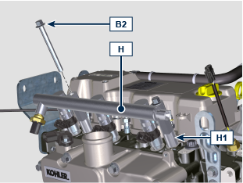
- Place the tube E2 on the injection pump A and Rail H , screw the nuts A2 , A3 .
- Tight the nut A2 (tightening torque 28 Nm ).
- Tight the nut A3 (tightening torque 28 Nm ).
Electronic injectors
DISASSEMBLING  - Install studs B3a on the head N .  - Place the the sockets L1 of the tool ST_48 on the injectors L .  - Fix the tool ST_48 on studs B3a using nuts B3b . | 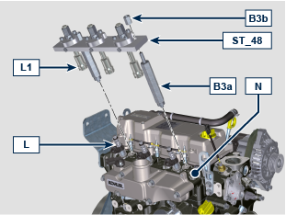
- Install the lockers L2 on the sockets L1 to lock the injectors L . | 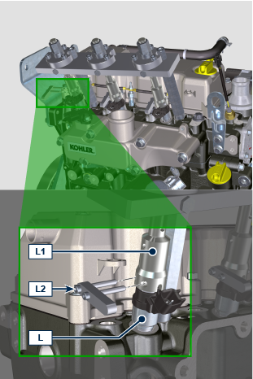
- Unscrew the nuts B4 to extract the injectors L from the cylinder head N . | 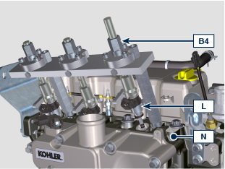
ASSEMBLING  - In case of injector reinstallation: before the reinstallation, replace all injector gaskets. §  - Apply oil EMI-385 on injector gaskets. §  - Place the injectors L inside the cylinder head N .  - Place the sockets L1 of the tool ST_48 on the injectors L .  - Place the washers B6 under the nuts B3 and fix the nuts B3 on the cylinder head N . | 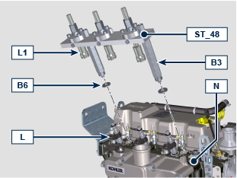
- Install the lockers L2 on the sockets L1 to lock the injectors L .  - Screw the nuts B4 to install the injectors L inside the cylinder head N . | 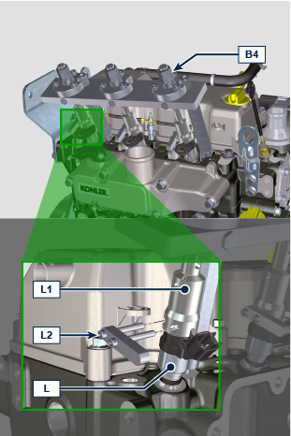
Injection pump
DISASSEMBLING  - Unscrew the screws B5 and remove the injection pump A . | 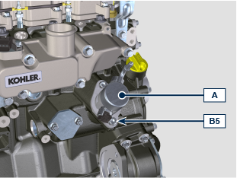
ASSEMBLING  - Install the roller tappet A4 inside the crankcase M if not allready present.  - Place the injection pump A on the crackcase M .  - Fix the pump A using the screws B5 respecting the tightening cycle below listed:  - cycle 1: 15 Nm  - cycle 2: 25 Nm | 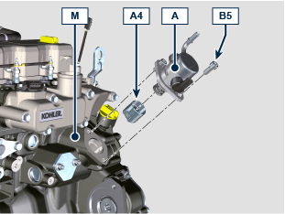

Sensors and Switches

T-MAP Sensor (only for model TC - TCA)
DISASSEMBLY  - Unscrew the screws A1 and remove the sensor A . | 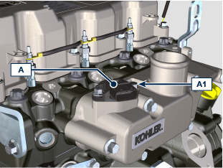
ASSEMBLY  - Place the sensor A on the intake manifold A3 .  - Fix the sendor A using the screws A1 (tightening torque 10 Nm ). | 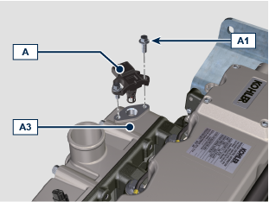
RPM Sensor
DISASSEMBLY  - Unscrew the screw B1 and remove the sensor B . | 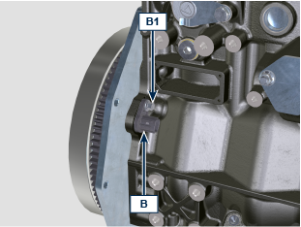
ASSEMBLY  - Place the sensor B on the crackcase B3 with the shim B2 .  - Fix the sensor A using the screw B 1 (tightening torque 10 Nm ). | 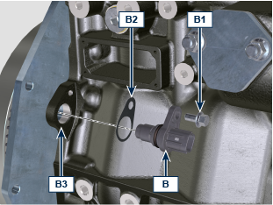
Phase Sensor
DISASSEMBLY  - Unscrew the screw C1 and remove the sensor C . | 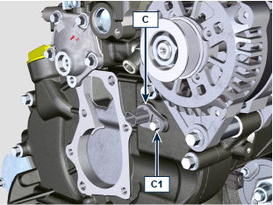
ASSEMBLY  - Place the sensor C on the carter C4 with the shim C2 .  - Apply Loctite 242 on the thread of screw C1 .  - Fix the sensor C using the screw C1 (tightening torque 10 Nm ). | 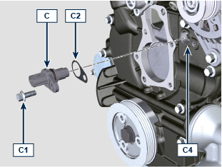
Coolant temperature Sensor
DISASSEMBLY  - Unscrew and remove the sensor D . | 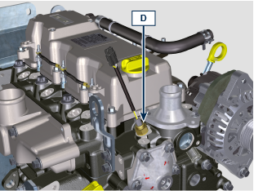
ASSEMBLY  - Fix the sensor D with the gasket D1 on the cylinder head D2 (tightening torque 12 Nm ). | 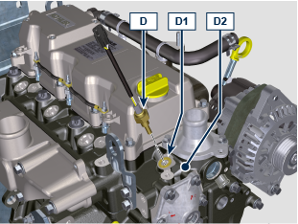
Oil Pressure Switch
DISASSEMBLY  - Unscrew and remove the switch E . | 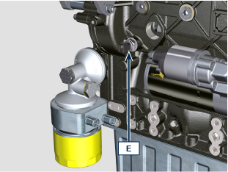
ASSEMBLY  - Fix the switch E on the crankcase E1 (tightening torque 25 Nm ). | 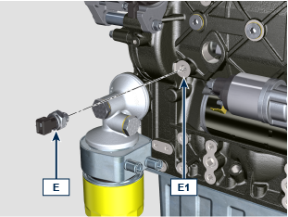

Electrical components

Starter Motor
DISASSEMBLY  - Unscrew the screws A and remove the motor B . | 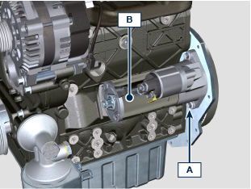
ASSEMBLY  - Fix the motor B to the flanging plate/bell C using the screws A (tightening torque 25 Nm ). | 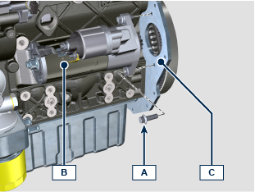
Voltage alternator
Alternator 45A | 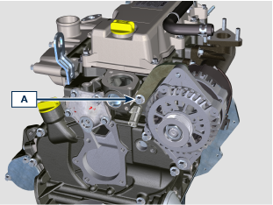
DISASSEMBLY

- Unscrew the screw A .
- Unscrew the nut B and remove the alternator C . | 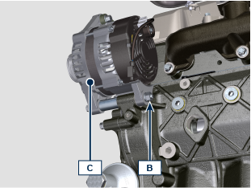
ASSEMBLY  - Place the alternator C on the crankcase D , install the screw B4 inside the fixing hole and install the spacer B3 .  - Screw the nut B with the washer B1 on the screw B4 . | 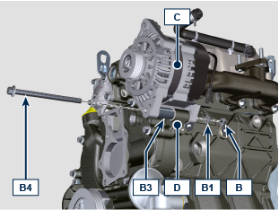
- Fix the bracket C1 on the cylinder head E using the screw A (tightening torque 25 Nm ).  - Fix the alternator C using the nut B and the screw B4 (tightening torque 25 Nm ). | 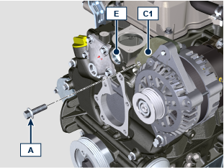
Alternator 80A - 100A | 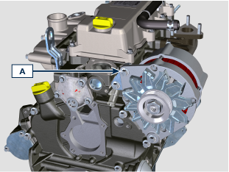
DISASSEMBLY

- Unscrew the screw A .
- Unscrew the nut B and remove the alternator C . | 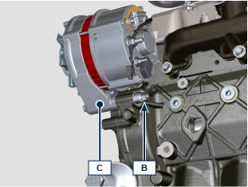
ASSEMBLY  - Place the alternator C on the crankcase D , install the screw B4 inside the fixing hole and install the spacer B3 .  - Screw the nut B with the washer B1 on the screw B4 . | 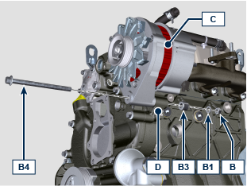
- Fix the alternator C using the screw A , the nut A1 with the washer A2 on the bracket C1 (tightening torque 25 Nm ).  - Fix the alternator C using the nut B and the screw B4 (tightening torque 25 Nm ). | 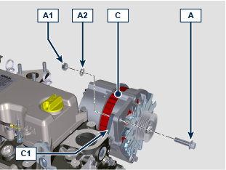
Glow plugs
DISASSEMBLY  - Unscrew the nuts A and remove the cables B1 , B2 . | 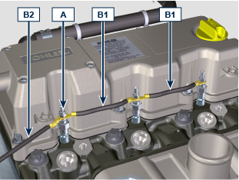
- Unscrew and remove the glow plugs C . | 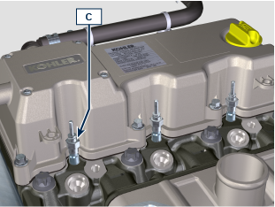
ASSEMBLY  - Install and fix the glow plugs C on cylinder head D (tightening torque 15 Nm ). | 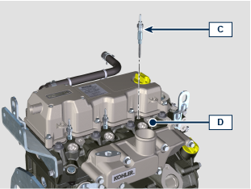
- Fix the cables B1 , B2 on the glow plugs C using the nuts A (tightening torque 2.5 Nm ).

Intake manifold

DISASSEMBLY  NOTE: for NA version, disconnect the oil return hose E .  - Loose the clamp D and disconnect the hose E from the manifold B . | 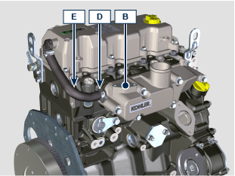
- Unscrew the screws A and remove the manifold B . | 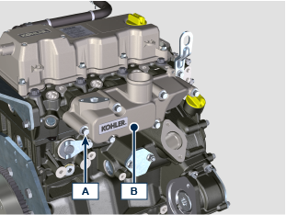
ASSEMBLY  - Place the manifold B on the cylinder head C using the tool ST_18 .  - Fix the manifold B and the gasket B1 on the cylinder head C using the screws A (tightening torque 25 Nm ). | 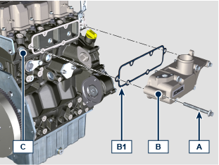

Exhaust manifold

DISASSEMBLY  - Unscrew the nuts A and remove the manifold B . | 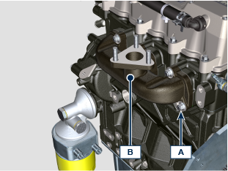
ASSEMBLY  - Place the gaskets B1 and the manifold B on the cylinder head C using the studs B2 .  - Fix the manifold B on the cylinder head C using the nuts A (tightening torque 25 Nm ). | 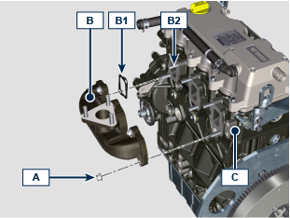

PTOs

1st PTO
Flywheel
DISASSEMBLY  - Install the tool ST_16 on pulley C .  - Install the component T3 on the crankcase D using the screws T2 entering the component T4 inside the groove of the component T3 .  - Fix the screws T5 to lock the pulley C to the tool ST_16 .  NOTE: in this way the crankshaft is locked. | 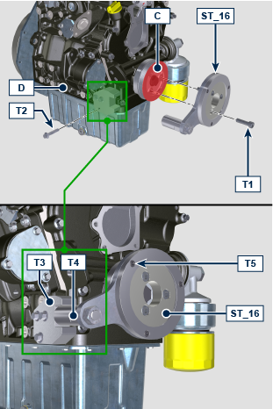
- Unscrew the screw A and remove the flywheel B . | 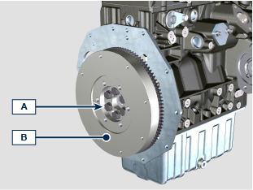
ASSEMBLY  - Place the flywheel B on the crankshaft C using the ST_46 .  - Fix the flywheel B on the crankshaft C using the screws A (tightening torque 140 Nm ). | 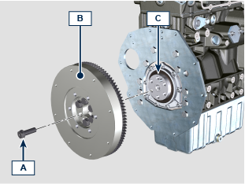
Flanging plate
DISASSEMBLY  - Unscrew the screws A and remove the plate B . | 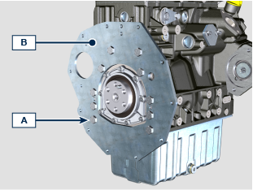
ASSEMBLY  - Place the plate B on the crankcase C .  NOTE: use the proper reference pins.  - Fix the plate B on the crankcase C using the screws A (tightening torque 45 Nm ). | 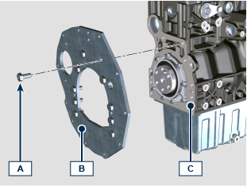
Flanging bell (TBD)
DISASSEMBLY  - Unscrew the screws A and remove the bell B . | 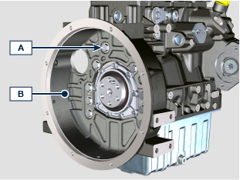
ASSEMBLY  - Place the bell B on the crankcase C .  NOTE: use the proper reference pins.  - Fix the bell B on the crankcase C using the screws A (tightening torque 45 Nm ). | 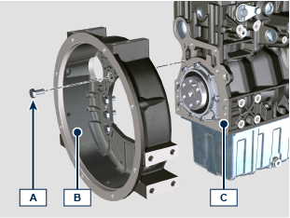
2nd PTO
DISASSEMBLY  - Unscrew the screw A and remove the pulley B with the tool ST_16 .  - Remove the component T3 from the crankcase D . | 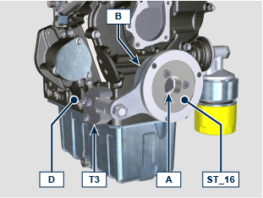
ASSEMBLY  - Install the pulley B on the crankshaft C using the screw A .  NOTE: do not fix the screw A .  - Install the tool ST_16 on pulley B .  - Install the component T3 on the crankcase D using the screws T2 entering the component T4 inside the groove of the component T3 .  - Fix the screws T5 to lock the pulley C to the tool ST_16 .  - Fix the screws A (tightening torque 360 Nm ). | 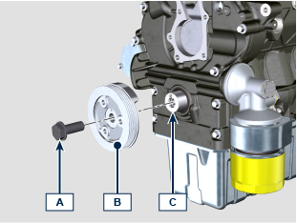  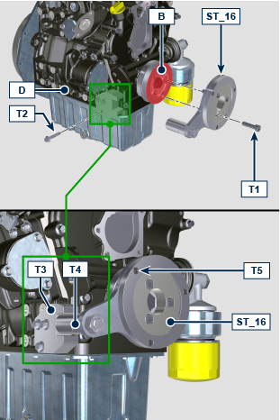
3rd PTO
DISASSEMBLY  - Unscrew the nuts A and remove the 3rd PTO B . | 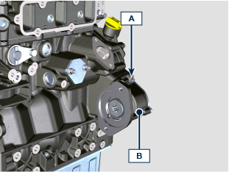
ASSEMBLY  - Place the 3rd PTO B on the crankcase C with the gasket B1 .  - Fix the 3rd PTO B using the nuts A (tightening torque 25 Nm ). | 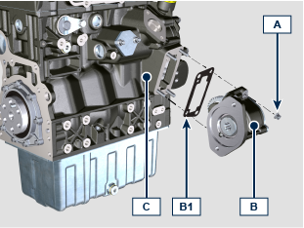

Cylinder head

DISASSEMBLY  - Unscrew the screws A1 and remove the cover A . | 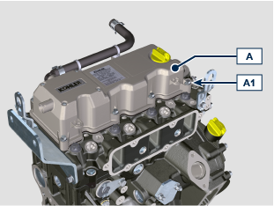
- Unscrew the screws B1 and remove the rocker arms B . | 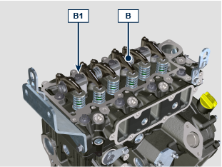
- Remove the rods C . | 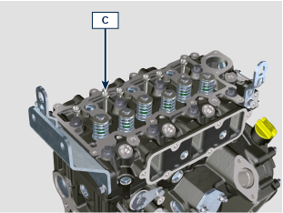
- Unscrew the screws D1 and remove the cylinder head D . | 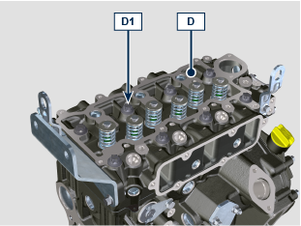
CHECKING AND OVERHAUL  - The MAX value of allowable irregularity of surface D3 is 0.1 mm .  - If the value is not observed, you are required to grind surface D3 .  - The MAX removal allowed is 0.2 mm .  NOTE:  Grinding task must be done with pre-chambers F assembled. | 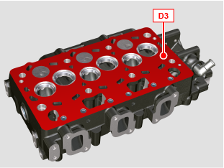  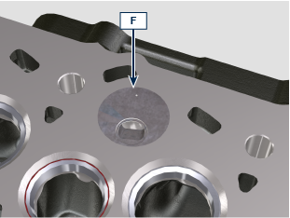
- Measure indentation X1 of each valve with regard to the cylinder head surface D3 , which is to be a MIN of 0.595 mm and MAX of 0.615 mm .  - The X1 MAX indentation allowed on worn components is 0 .815 mm .  - If the measured value does not correspond with the values indicated, replace the worn component.  NOTE:  The seats must be machined after their installation to reach value X1 , go to a rectification workshop for such operations.  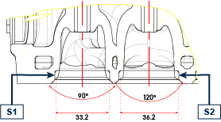  S1 > Exhaust seat  S2 > Intake seat | 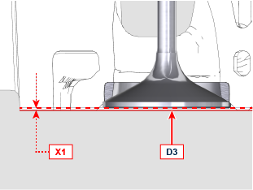
- Measure the diameters Y1 , Y2 of the rods and guides valve ( Tab. x.x ).  - If the diameters don't correspond to the values indicated, replace the valves or guides.  - The MAX increasing of clrearance for Y1 , Y2 worn components is 0.1 mm .  - Observe the dimension Y3 from surface D5 when assembling guides D4 ( Tab. x.x ) .  NOTE:  Carry out the measurements in different points to detect any ovalisation and/or concentrated wear.  Tab. x.x details the dimensional values of new components only.  The guides must be machined for value Y1 after their installation . Contact a machining workshop for such operations.  x.x  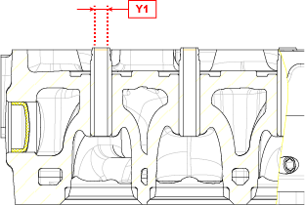 | 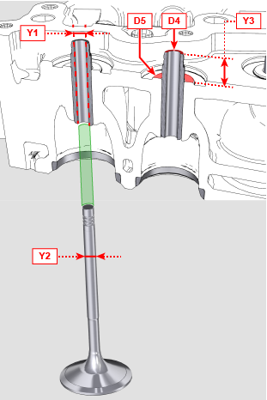
  Ref. | MIN | MAX
  Y1 | 6.03 | 6.042
  Y2 | 5.978 | 5.99
  Y3 | 12.5 | 13
ASSEMBLY  - Measure the piston protrusion P from head level E2 in 4 diametrically opposed points P1 .  - Repeat the operation for all pistons P and take note of the highest average value, determining value P1 ( Tab. x.x ).  X.X  - Based on the value detected, select the proper gasket D2 as shown in the Tab. x.x . | 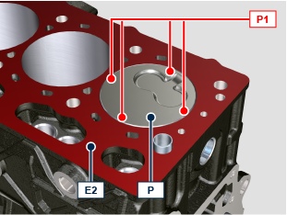  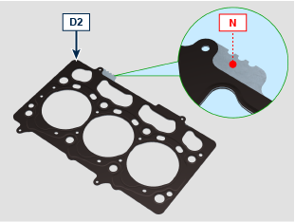
  P1 (mm) | THICKNESS REFERENCE (N)
  0.121 - 0.230 | 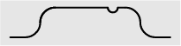
  0.231 - 0.330 | 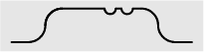
  0.331 - 0.436 | 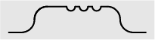
- Check the tappets E1 are correctly installed inside the crackcase E .  - Place the gasket D2 on the crankcase E using the reference pins E2 .  - Place the head D on the gasket D2 using the reference pins E2 .  NOTE:  Gasket D2 must be replaced at each time the head D is assembled. | 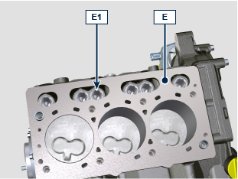  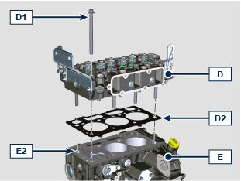
- Apply MOLY GREASE on the screw D1 (20 mm from the head bottom )  - Tighten the screws D1 respecting the tightening order as per illustration indication at each cycle below listed:  - cycle 1: 10 Nm  - cycle 2: 35 Nm  - cycle 3: 90°  - cycle 4: 90°  - cycle 5: 90°  - cycle 6: 90° | 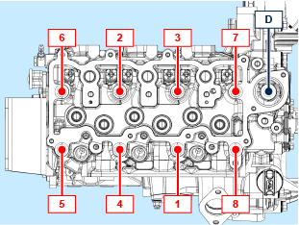
- Install the rods C inside the proper niches inside the cylinder head D . | 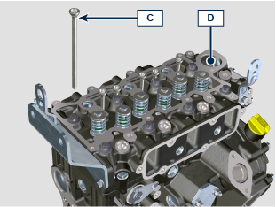
- Place the spacers B2 correctly on the valves B3 .  - Place the rocker arms B on the head D using the proper reference pins.  - Check all spacers B2 are correctly installed on the valves B3 .  - Apply Loctite 242 on the thread of screw B1 . §  - Fix the rocker arms B using the screws B1 (tightening torque 25 Nm ). | 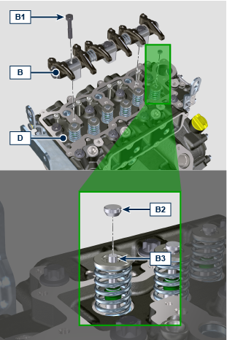
Check the gasket A2 is correctly installed insde its seat inside the cover A .  Place the cover A on the head D using the tool ST_17 .  + apply Loctite 242 on the thread of screws A1 .  Place the screws A1 inside the fixing holes. | 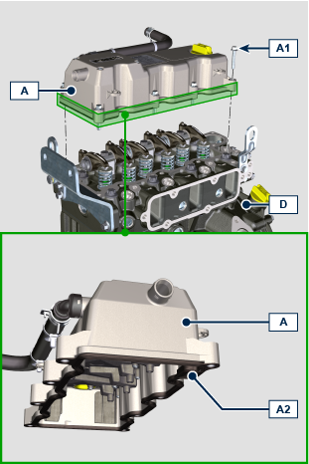
Tighten the screws A 1 respecting the tightening order as per illustration indication ( tightening torque 10 Nm ). | 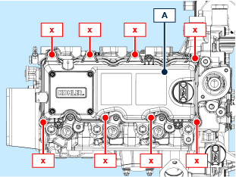

Oil circuit

Oil Cooler
DISASSEMBLY  - Unscrew and remove the filter A . | 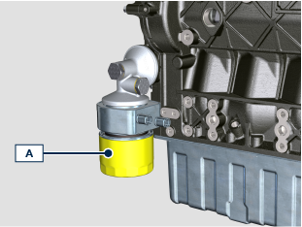
- Unscrew the joint C and remove the oil cooler D . | 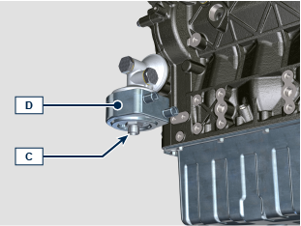
- Unscrew th screw E and remove the support F . | 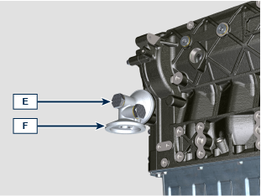
ASSEMBLY  - Install the gasket E1 in the proper seat on the screw E .  - Install the gasket F1 on the support F .  - Fix the support F on the crankcase G using the screw E with the gasket E2 (tightening torque 25 Nm ). | 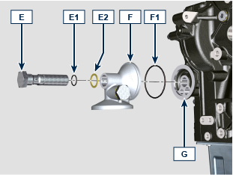
- Check the oil cooler gasket is correctly installed.  - Fix the oil cooler D on the support F using the joint C (tightening torque 30 Nm ). | 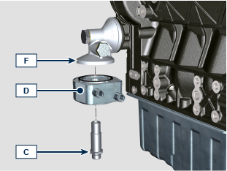
- Check the gasket D1 is correctly installed inside the proper seat of the oil filter D .  - Tifgten the filter D on the support F (tightening torque 20 Nm ). | 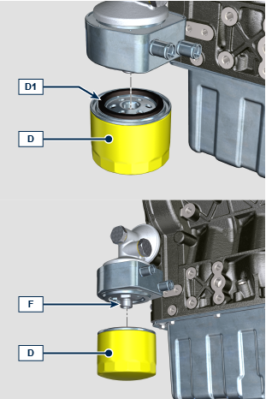
Oil Pressure valve
DISASSEMBLY  - Unscrew the plug A and remove the gasket A1 , the spring A2 , the piston A3 from the carter B . | 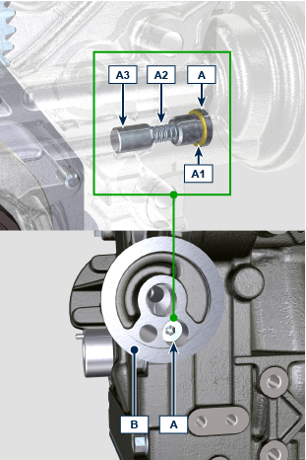
CHECKING AND OVERHAUL  - Measure the free length X of spring A2 , which must be 47.91 mm .  - If the measured value does not match, replace spring A2 . | 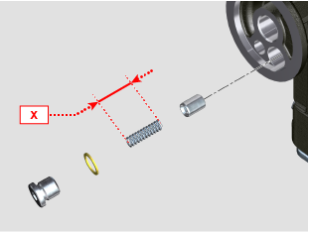
ASSEMBLY  - Install the piston A3 , the spring A2 inside the carter B .  - Tighten the plug A with the cooper washer A1 on the carter B (tightening torque 17.5 Nm ). | 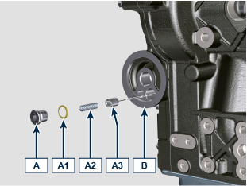
Oil sump
DISASSEMBLY  - Unscrew the screws A1 and remove the oil sump A .  NOTE: Use a metal sheet/spatula between the crankcase and oil sump to detach them. | 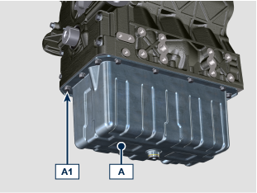
- Unscrew the screw B1 .  - Unscrew the screw B2 and remove the tube B .  - Unscrew the screws C1 and remove the plate C . | 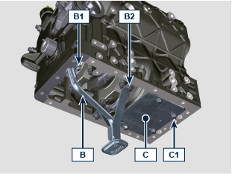
ASSEMBLY  - Install the gaskets B3 inside the proper seat of the tube B .  - Place the tube B installing it inside the oil inlet hole of the crankcase D .  - Apply Loctite 242 on the thread of screw B 1, B2 .  - Fix the tube B using the screws B2 (tightening torque 25 Nm ).  - Fix the tube B using the screws B1 (tightening torque 10 Nm ). | 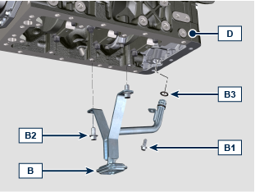
- Apply Loctite 242 on the thread of screw C1 .  - Fix the plate C using the screws C1 (tightening torque 25 Nm ). | 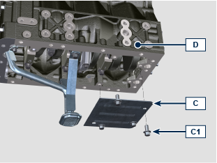
- Apply about 2.5 mm cord of sealant S ( Loctite 5699 ) on the oil sump A as per illustration.

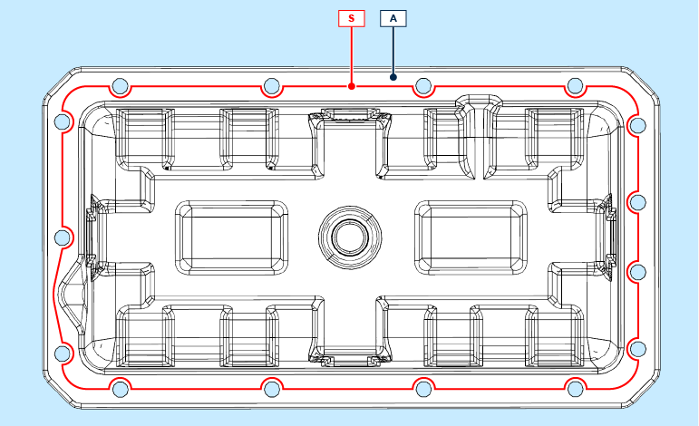
- Place the oil sump A on the crankcase sulbasamento D using the tool ST_18 .  - Apply Loctite 242 on the thread of screw A1 .  - Fix the oil sump A on the crankcase D using the screws A1 (tightening torque 25 Nm ). | 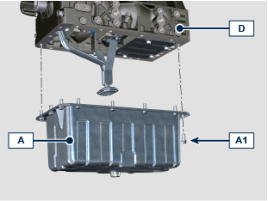
Timing gear cover (oil pump)
DISASSEMBLY  - Unscrew the screws A1 and remove the carter A . | 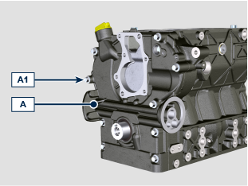
ASSEMBLY

- Apply about 2.5 mm cord of sealant S ( Loctite 5699 ) on the carter A as per illustration.

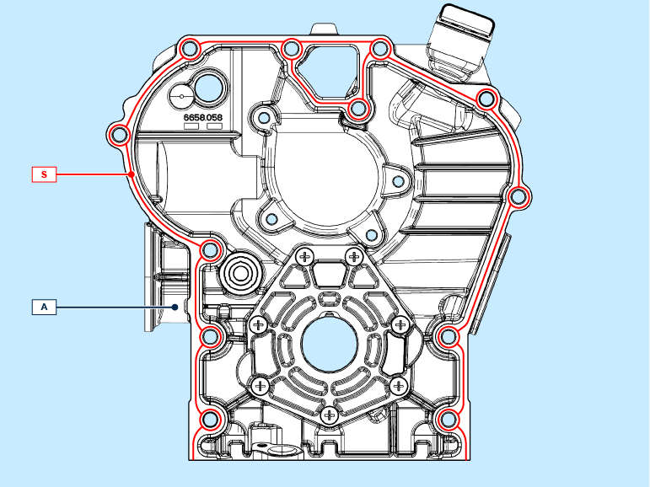
- Place the gasket A3 in the proper seat of the carter A .  - Install the gasket A2 on the carter A using the tool ST_58 .  - Place the carter A on the crankcase B using the tool ST_18 . | 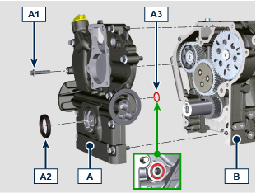
- Apply Loctite 242 on the thread of screw A1 .
- Fix the carter A on the crankcase B using the screws A1 respecting the fixing order as per illustration indication (tightening torque 25 Nm ).

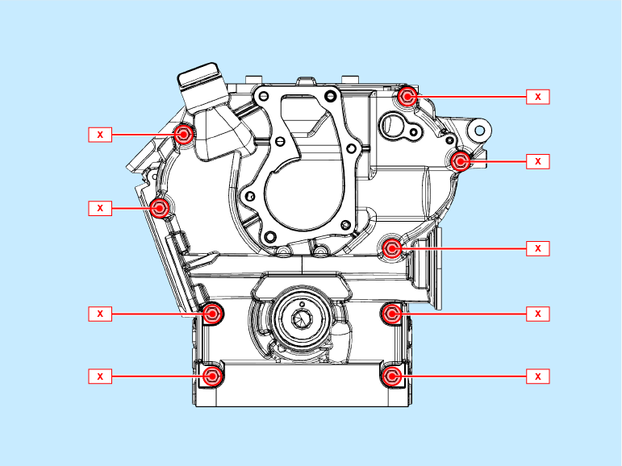

Crankcase

Timing gear (camshafts)
DISASSEMBLY  - Remove the tappets D1 from the crankcase D . | 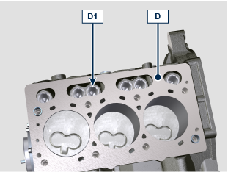
- Unscrews the screws A1 and remove the gear A . | 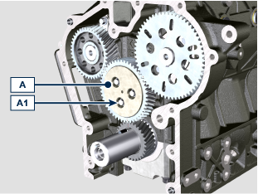
- Unscrews the screws B1 and remove the shaft B .  - Unscrews the screws C1 and remove the shaft C . | 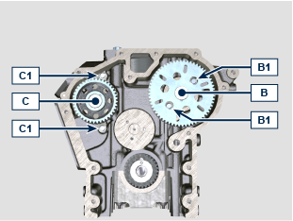
CHECKING AND OVERHAUL  - Measure the diameters of housings Z6 , Z7 .  - Measure the diameters of pins K6 , K7 .  - Calculate the clearance between the housings and pins, which is to observe the values in Tab. 5. 5 .  5. 5  NOTE:  The MAX value of wear allowed for housing Z6 , Z7 is 0.02 mm according to Ø MAX .  The MAX value of wear allowed for pins K6 , K7 is 0.005 mm according to Ø MIN . | 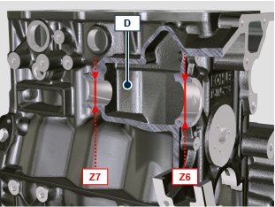  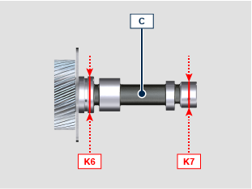
  Ref. | Ø MIN | Ø MAX | Ref. | Ø MIN | Ø MAX | CLEARANCE
  Z6 | 42 | 42.025 | K6 | 41.94 | 41.96 | 0.04 - 0.085
  Z7 | 30 | 30.021 | K7 | 29.94 | 29.96 | 0.04 - 0.081
- Measure the diameters of housings Z1 , Z2 , Z3 , , Z4 , Z5 .  - Measure the diameters of pins K1 , K2 , K3 , K4 , K5 .  - Calculate the clearance between the housings and pins, which is to observe the values in Tab. 5.6 .  5. 6  NOTE:  The MAX value of wear allowed for housing Z1 , Z2 , Z3 , , Z4 , Z5 is 0.02 mm according to Ø MAX .  The MAX value of wear allowed for pins K1 , K2 , K3 , K4 , K5 is 0.005 mm according to Ø MIN . | 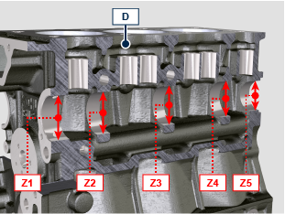  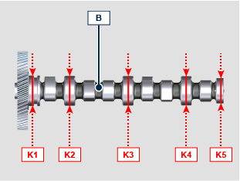
  Ref. | Ø MIN | Ø MAX | Ref. | Ø MIN | Ø MAX | CLEARANCE
  Z1 | 46 | 46.025 | K1 | 45.92 | 45.94 | 0.06 - 0.105
  Z2 | 45 | 45.025 | K2 | 44.92 | 44.94 | 0.06 - 0.105
  Z3 | 44.5 | 44.525 | K3 | 44.42 | 44.44 | 0.06 - 0.105
  Z4 | 44 | 44.025 | K4 | 43.92 | 43.94 | 0.06 - 0.105
  Z5 | 38 | 38.025 | K5 | 37.92 | 37.94 | 0.06 - 0.105
- Measure the diameters J2 , J3 of gear A2 and support A .  - Calculate the clearance between J2 , J3 which is to observe the values in Tab. X.X .  NOTE:  The MAX value of wear allowed is 0.xx mm .  - Measure the thickness J5 of washer A3 ( MIN X.XX mm ). | 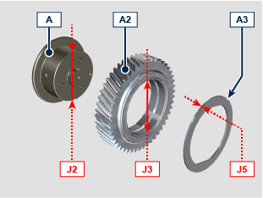
ASSEMBLY  - Install the shaft C inside the crankcase D .  - Apply Loctite 242 on the thread of screw C1 .  - Fix the shaft C using the screws C1 (tightening torque 10 Nm ). | 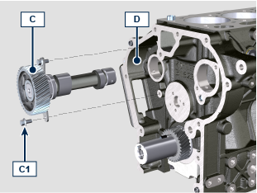
- Install the shaft B inside the crankcase D .  - Apply Loctite 242 on the thread of screw B1 .  - Fix the shaft B using the screws B1 (tightening torque 10 Nm ). | 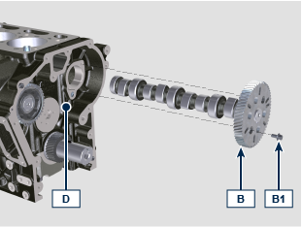
- Install the gear A2 on the support A .  - Install the washer A3 on the support A . | 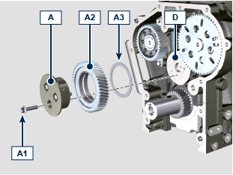
- Place the gear A2 on the crankcase D aligning the references as per illustration.
- Apply Loctite 243 on the thread of screw A1 . §
- Fix the support A on the crankcase D using the screws A1 (tightening torque see service letter 500001 ).

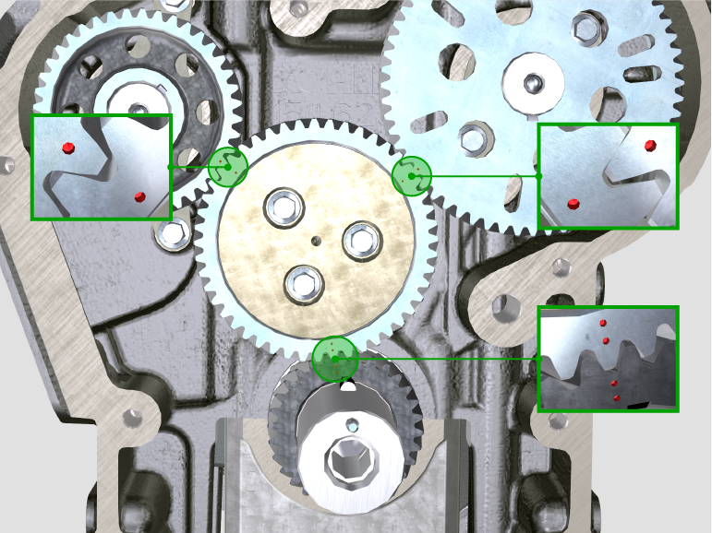
Crankshaft seal support - flywheel side
DISASSEMBLY  - Unscrew the screws A1 and remove the flange A . | 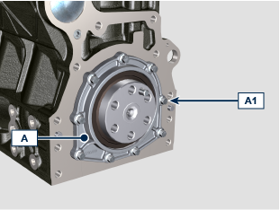
ASSEMBLY  - Install the gasket A2 inside the flange A using the tool ST_42 .  - Place the flange A on the crankcase B . | 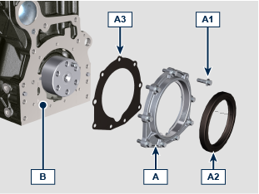
- Apply Loctite 242 on the thread of screw A1 .  - Fix the flange A using the screws A1 respecting the fixing order as per illustration (tightening torque 10 Nm ). | 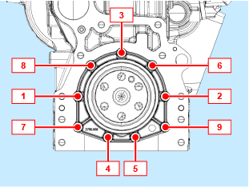
Conrod and piston
DISASSEMBLY  - Unscrew the screws B4 and remove the conrod caps B1a , B2a , B3a . | 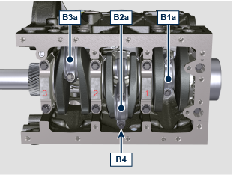
- Extract the conrod and piston P from the crankcase C . | 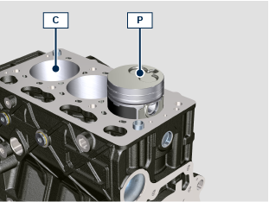
- Replace the bearings D on B1a , B2a , B3a, B1b , B2b , B3b .  NOTE: the bearing position D on B1a , B2a , B3a, B1b , B2b , B3b must be centered as per illustration.  - Install B1a , B2a , B3a su B1b , B2b , B3b using the screws B4 .  NOTE: do not tighten the screws B4 . | 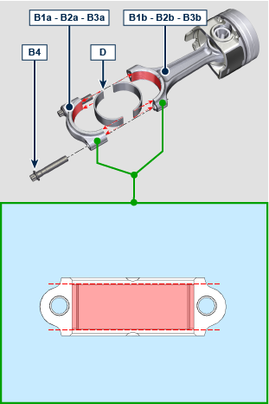
- Check the conrod and piston groups P , weight difference must not exceed 10 gr .  - Unscrew the screws B4 and remove B1a , B2a , B3a da B1b , B2b , B3b . | 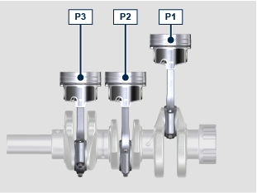
CHECKING AND OVERHAUL  - Measure the axial shift of crankshaft B .  - Axial shift must be a MIN 0.xx mm and MAX 0.xx mm .  - If the values measured do not correspond, replace thrust washers C4 . | 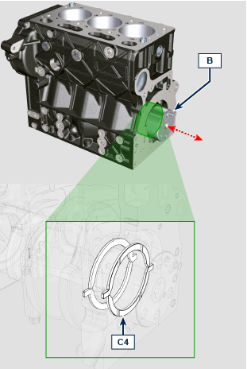
- Measure the dimension H1 , H2 .  - Calculate the clearance between H1 , H2 which is to observe the values in Tab. 5.8 .  5. 8  NOTE:  The MAX clearance increasing allowed is 0.01 mm .  - Measure the dimension H3 , H7 .  - Calculate the clearance between H3 , H7 which is to observe the values in Tab. 5.9 .  5. 9  NOTE:  The MAX clearance increasing allowed is 0.01 mm .  - Measure the dimension H4 , H5 .  5.10 | 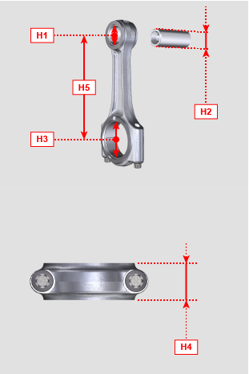  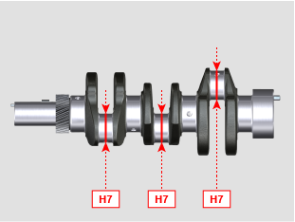
  Ref. | Ø MIN | Ø MAX | CLEARANCE
  H1 | 24.015 | 24.025 | 0.015 - 0.03
  H2 | 23.995 | 24 | 0.015 - 0.03
  Ref. | Ø MIN | Ø MAX | CLEARANCE
  H3 | 46.021 | 46.056 | 0.021 - 0.072
  H7 | 45.984 | 46 | 0.021 - 0.072
  Ref. | MIN | MAX
  H4 | 23.077 | 23.8
  H5 | 131.48 | 131.52
- Insert the gudgeon pin G into bearing G1 .  - Check the axis parallelism of the connecting rod big end and small end.  - Parallel deviation (value H6 ) measured at the tip of the gudgeonpin, must be a MIN 0,xx and MAX 0,xx mm .  - If the parallelism values do not comply with the specified ones, replace the connecting rod. | 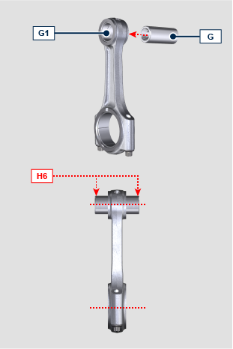
ASSEMBLY  - Rotate the crankshaft D moving the crankpin D1 at BDC . | 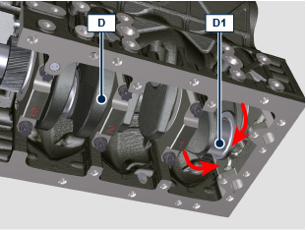
- The combustion chamber H of the piston must be oriented towards the inlet manifold. | 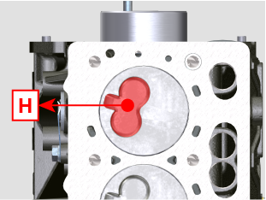
- Lubricate the piston mantle, segments, conrod bearings and cylinder surface C with engine oil 15W-40 .  - Install the conrod and piston groups P about 10 mm of the piston skirt. | 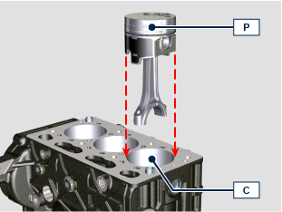
- Align the gudgeon pin axle with engine center axle.  - Rotate the piston P about 15° anticlockwise. | 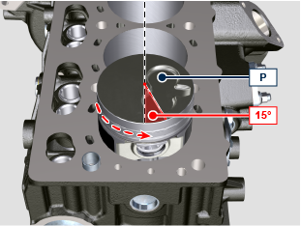
- This operation avoid the conrod impact against the oil sprayer E during the conrod and piston installation inside the cylinder C .  - Gently push the piston in the cylinder C paying attention to the sprayer E . | 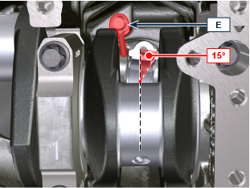
- Lubricate the crankpins with engine oil 15W-40 .  - Apply BRB100 MOLY GREASE under the screw head P1c .  - Place the conrod P1a on crankpin D1 .  - Install the cap P1b using the screws P1c .  NOTE: the caps P1b have the mating plan fractured, each cap can be mate with its origin conrod P1a , pay attention to the right mating.  - Tighten the screws P1c respecting the tightening cycle below listed:  - cycle 1: 5 Nm  - cycle 2: 20 Nm  - cycle 3: 33°  - cycle 4: 33° | 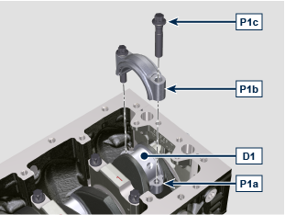
Piston
DISASSEMBLY  - Remove the lock ring R and extract the gudgeon pin G from the piston P . | 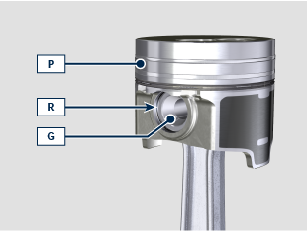
- Remove the rings S1 , S2 , S3 from the piston P . | 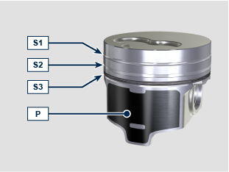
CHECKING AND OVERHAUL  - Measure the piston diameter on point X ( 15 mm from piston P base ) .  - If diemeter is lower than 80.922 mm , replace the short block or long block. | 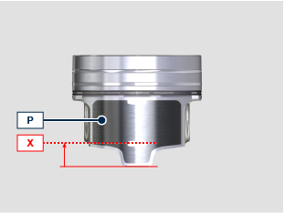
- Check the clearance between piston rings and their proper seats in piston P (dimension Y1, Y2, Y3 ).  - If dimensions Y1, Y2, Y3 detected does not match with values in Tab. 5.11 , replace short block o long block. | 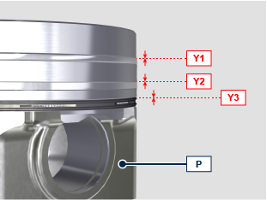
- Insert piston rings S1, S2, S3 inside the cylinder C .  - Check the rings gap distance (dimension RG ).  - If dimension RG detected does not match with values in Tab. 5.12 , replace the piston rings S1, S2, S3 .  5.12  NOTE:  Piston rings S1, S2, S3 cannot be replaced separately . | 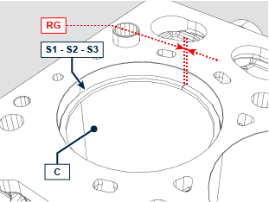
  Ref. | MIN | MAX | MAX WEAR
  S1 | 0.2 | 0.35 | 0.45
  S2 | 0.4 | 0.6 | 0.7
  S3 | 0.25 | 0.45 | 0.55
ASSEMBLY  - Install the rings S1 , S2 , S3 on the piston P .  NOTE:  position the piston rings gap at 120° from each other. | 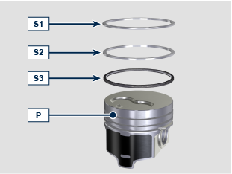  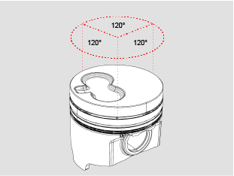
- Apply MOLYSLIP on gudgeon pin G .  - Mate the conrod P1a with the piston P and install the gudgeon pin G .  - Install the lock rings R to lock the gudgeon pin G . | 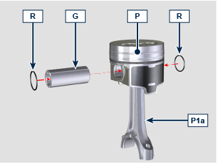
Crankshaft
DISASSEMBLY  - Take note of caps A1 , A2 , A3 marking their position on the crankcase.  - Unscrew the screws A and remove the caps A1 , A2 , A3 , A4 .  - Remove the crankshaft B . | 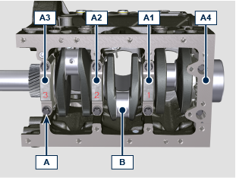
- Unscrew the screws C1 and remove the sprayers C2 . | 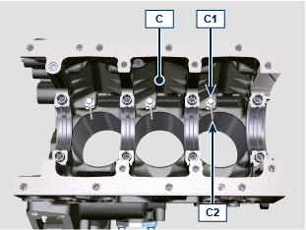
- Remove the bearings C3 , C4 . | 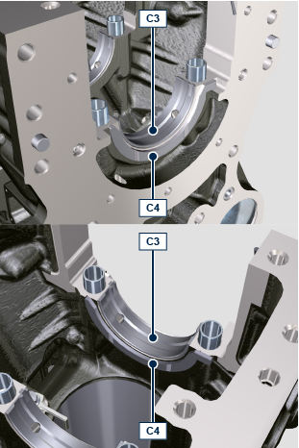
- Remove the bearings C5 , C4 from the caps A1 , A2 , A3 , A4 . | 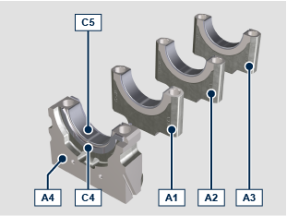
CHECKING AND OVERHAUL  - Measure the cylinder diameter on point H8 , H9 , H10 .  - According to Tab. 5.13 , if the wear is higher than 81.032 mm , replace the short block or long block.  NOTE:  Cylinder grinding is forbidden.  5.13 | 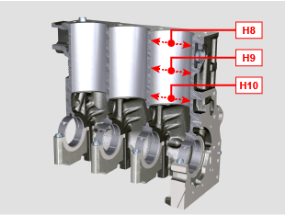
  Ø MIN | Ø MAX
  81.013 | 81.027
- Measure the diameters H11 , H12 .  - Calculate the clearance between H11 , H12 which is to observe the values in Tab. 5.14 .  NOTE:  The MAX value of wear allowed is 0.xx mm . | 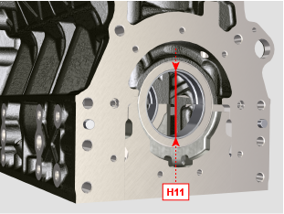  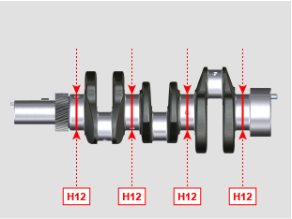
- The MAX value of allowable irregularity of surface T is 0.2 mm .  - If the value is not observed, replace the short block or long block. | 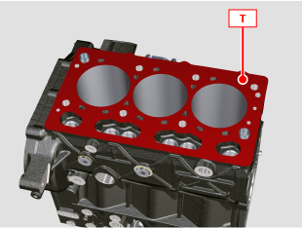
- Check the oil ducts are free of dust and debris. | 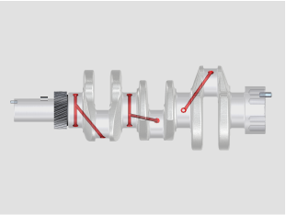  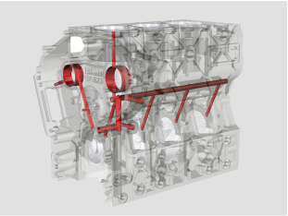
ASSEMBLY  - Fix the sprayers C2 on the crankcase C using the screws C1 (tightening torque 8 Nm ). | 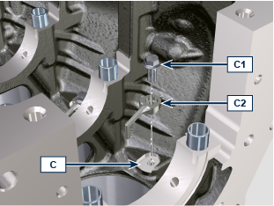
- Install the bearings C3 on crankcase C seats respecting the notches C3a and make sure the oil delivery holes C3b is matching with the crankcase ones. | 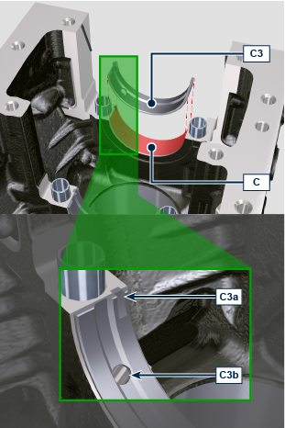
- Install the bearings C4 on the crankcase C seats. | 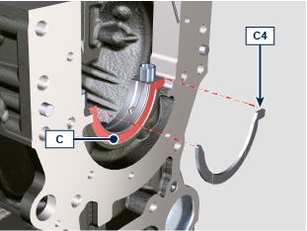  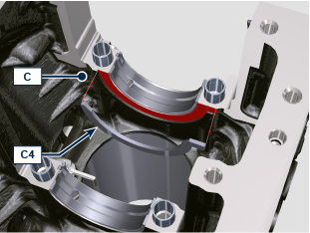
- Apply GX100 on half bearing surface C3 .  - Install the crankshaft B on the bearings C3 . | 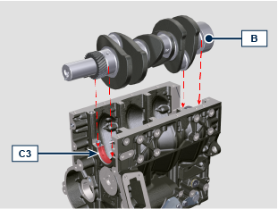
- Install the bearings C5 on caps A1 , A2 , A3 seats respecting the notches C5a .  - Apply GX100 on half bearing surface C5 | 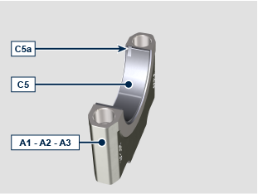
- Install the caps A1 , A2 , A3 on the crankcase C respecting their original position using the screws A .  - Apply MOLYSLIP under the screw head A  - Tighten the screws A respecting the tightening cycle below listed:  - cycle 1: 15 Nm  - cycle 2: 45°  - cycle 3: 45° | 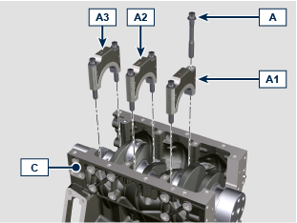
- Install the bearing C5 on cap A4 seat respecting the notch C5a . | 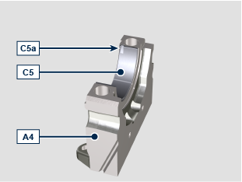
- Install the bearings C4 on the cap A4 seat. | 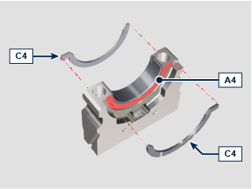
- Install the gaskets A4a inside the proper seat on cap A4 and keep in position using the tool ST_49 .  - Apply GX100 on half bearing surface C5 .  - Install the cap A4 inside the crankcase C paying attention to not cut the gasket A4a during installation.  - Apply MOLYSLIP under the screw head A  - Tighten the screws A respecting the tightening cycle below listed:  - cycle 1: 15 Nm  - cycle 2: 45°  - cycle 3: 45° | 