Information about use
KDI 2504 TM Owner Manual (Rev. 10)

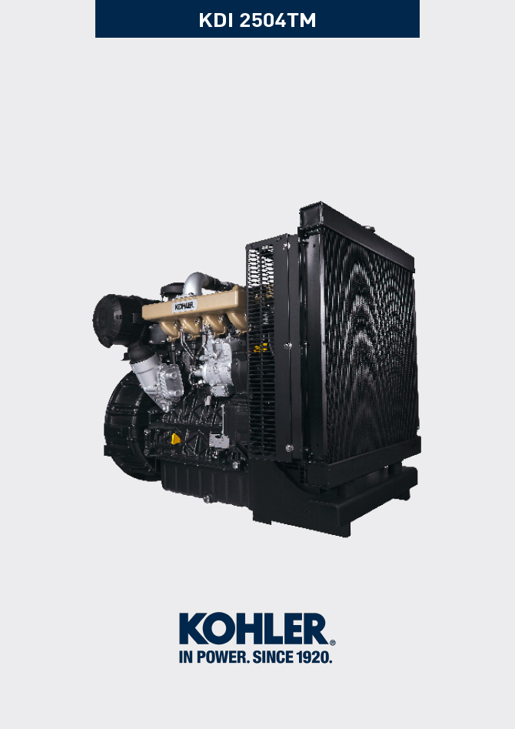

Registration of modifications to the document
Any modifications to this document must be registered by the drafting body, by completing the following table.

Released by | Code | Revision | Release Date | Revision date | Edited by | Endorsed
 | 2504TM

Translated from the original manual in Italian language
Data reported in this issue can be modified at any time by KOHLER.

Sommario
1. TITOLO 1 2
1.1. Asdfsdfsdf 2
1.2. Asdfsdfsdfggg 2

Information about use

Pre-start check
- Read carefully the following pages and carry out the operations described below in accordance with the instructions specified.


Important

- Non compliance with the operations described in the following pages involves the risk of damages to the engine and vehicle on which it is installed as well as personal and/or property damage.
- Increase the frequency of maintenance operations in heavy working conditions (engine starts but stops, very dusty and hot environments, etc..).

Running-in period
NOTE: For the first 50 hours of engine operation, it is advisable not to exceed 75% of the maximum power supplied.

Starting and turning off
4.3.1 Starting

- Check the level of the engine oil, fuel and coolant and fill if necessary ( Par. 4.5 e Par. 4.6 ).
- Put the ignition key in the ignition switch (if supplied).
- Tun the key to ON position.
- Turn the key beyond the ON position and release it when the engine starts (the key will return into ON position automatically).
Important

- At the first fuelling or if the tank was empty filling the fuel system ( Par. 6.3 from point 4 to point 6).
- Do not actuate the starter for more than 15 seconds at a time. If the engine does not start, wait for one minute before repeating attempt.
- If engine does not start after two attempts see Tab. 7.1 and Tab. 7.2 to found the cause.
Panel L can be assembled on the engine or machine. In Tab. 4.1 are described the main functions are illustrated.  Tab. 4.1 | 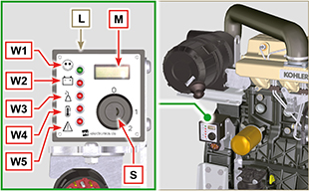
  POS. | DESCRIPTION
  M | Hour-meter indicator
  S | Control switch to start the engine
  W1 | Panel ignition indicator
  W2 | Warning Light - battery not charging
  W3 | Warning Light - engine oil not pressurised
  W4 | Warning Light - high coolant temperature
  W5 | Warning Light - alarm general indicator
4.3.2 After starting

Warning

- Make sure that all the warning lights on the control panel are off when the engine is running.
- Run at minimum speed for a few minutes according to table (except constant speed engine).

AMBIENT TEMPERATURE | TIME
≤-20°C | 2 minutes
from -20°C a -10°C | 1 minutes
from -10°C a -5°C | 30 seconds
from -5°C a 5°C | 20 seconds
≥ 5°C | 15 seconds

4.3.3 Turning off

- Do not turn off the engine when it is running at the maximum rotation speed (except constant speed engine).
- Before turning it off, keep it idle at minimum speed for about 1 minute.
- Turn the key to OFF position.

Refuelling

Important

- Before proceeding with operation, read Par. 3.2.2 .


Danger

- Fill the engine off.
- The only approved fuels are those listed in Tab. 2.3 .
- In those countries where fuel has a high sulphur content, its is advisable to lubricate the engine with a high alkaline oil or alternatively to replace the lubricating oil recommended by KOHLER more frequently.
- To avoid explosions or fire outbreaks, do not smoke or use open flames during the operations.
- Fuel vapours are highly toxic.Only carry out the operations outdoors or in a well ventilated place.
- Keep your face well away from the fuel fill to prevent harmful vapours from being inhaled.
- Dispose of fuel in the correct way and do not litter as it is highly polluting.
- When refuelling, it is advisable to use a funnel to prevent fuel from spilling out.The fuel should also be filtered to prevent dust or dirt from entering the tank.
Do not overfill the fuel tank. Leave room for the fuel to expand.
NOTE: At the first fuelling or if the tank was empty filling the fuel system (Par. 6.3 point 8).

Oil filling
Important
- For safety precautions see Par. 2.4 .
- Before proceeding with operation, read Par. 3.2.2 .
- Do not use the engine with the oil level below the minimum.

- Loosen the oil filler cap A or the oil filler cap C if the cap A is not accessible.  - Add the type of oil recommended ( Tab. 2.1 and Tab. 2.2 ). | 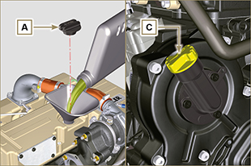  Fig 4.1
- Before checking oil engine needs to be level.  - Remove the oil dipstick B and check that the level is up to but does not exceed the MAX .  - If level is not at the MAX . level, add additional oil.  - Re-tighten the cap A or C . | 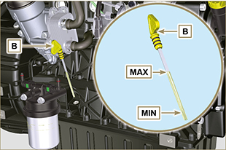  Fig 4.2
NOTE: Click on the right to play the procedure. | https://www.youtube.com/embed/A5WuDZuItu4?rel=0

Coolant filling
Important

- Before proceeding with operation, read Par. 3.2.2 .

Warning

- An anti-freeze protection liquid (ANTIFREEZE) - mixed with decalcified water - must be used.
- The freezing point of the refrigerant mixture depends on the amount concentration in water.
- As well as lowering the freezing point, the antifreeze also raises the boiling point.
- A 50% mixture is recommended to ensure a general level at protection prevents the formation of rust, galvanic currents and calcium deposits (Tab. 2.4) .
NOTE: Before proceeding with any operation on the engine, stop it and allow it to cool.  Warning  Presence of steam pressurized coolant danger of burns.  - Loosen the cap A and fill the radiator with coolant composed of:  50% ANTIFREEZE and 50% decalcified water.  - Top liquid up until the pipes inside the radiator are covered by about 5 mm. Do not overfill the radiator, but leave room for the coolant to expand.  - For engines equipped with expansion tank, pour in fluid until reaching the max level mark.  - Loosen the screw C , release any air and tighten the screw C (Tightening torque of 8 Nm - Fig. 4.5).  - Re-tighten the cap A .  - After a few hours of operator, stop the engine and allow the liquid to cool returns to a ambient temperature and check the coolant level again. | 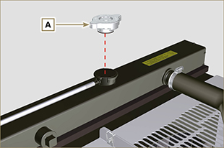  Fig. 4.3  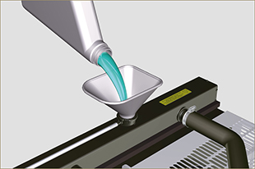  Fig. 4.4
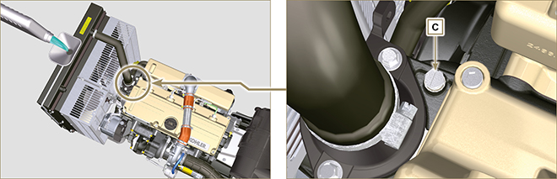
Fig. 4.5
NOTE: Click on the right to play the procedure. | https://www.youtube.com/embed/XuR1tlU2zmo?rel=0



