Tools information
KDI 3404 TCR-SCR Workshop Manual (Rev. 10.4)

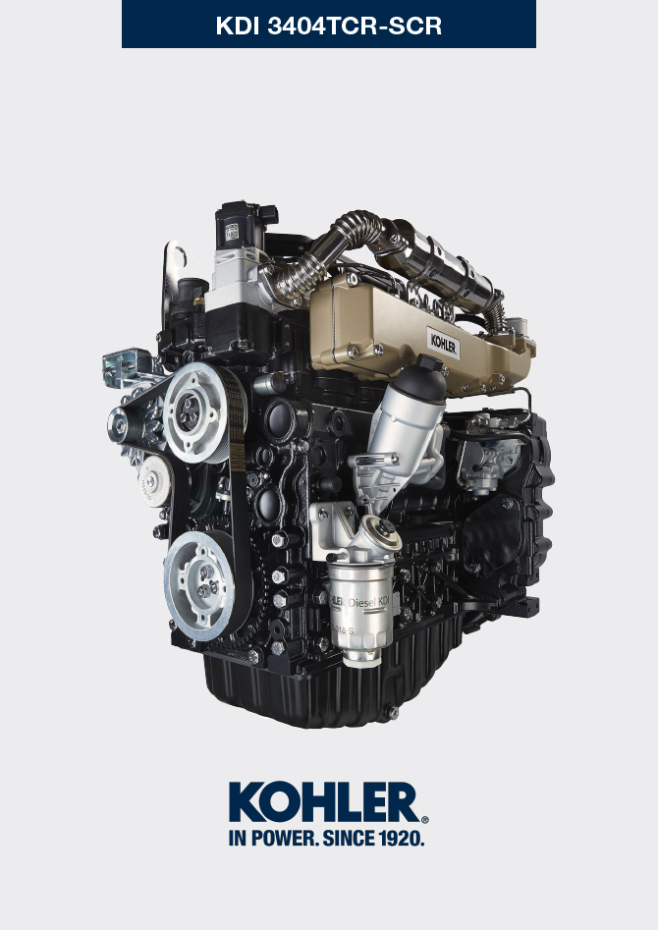

Registration of modifications to the document
Any modifications to this document must be registered by the drafting body, by completing the following table.

Released by | Code | Revision | Release Date | Revision date | Edited by | Endorsed
 | manoff

Translated from the original manual in Italian language
Data reported in this issue can be modified at any time by KOHLER.

Sommario
1. TITOLO 1 2
1.1. Asdfsdfsdf 2
1.2. Asdfsdfsdfggg 2

Tools information

Information regarding specific tools

In Tab 13.1 - 13.2 - 13.3 there is a list of all the specific tools that are required and approved to carry out operations of disassembly - assembly - regulations - settings - repairs on engine series KDI

, correctly and safely.

Warning

- KOHLER declines all responsibility for any damage to the engine, persons, or things caused by the use of different types of tools to those indicated in Tab 13.1 - 13.2 - 13.3 , where referred to them in the manual.

Tab. 13.1
SPECIAL TOOLS FOR DISASSEMBLY AND ASSEMBLY
"ST" | Picture/Draw | DESCRIPTION | PART NUMBER
ST_03 | 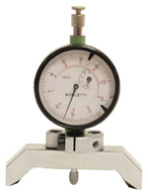 | Piston protrusion - electronic injectors cylinder head surface control tool | ED0014602980-S
ST_05 | 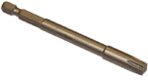 | Spanner for capscrews Six nicks SN 8 | ED0014603650-S
ST_06 | 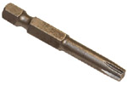 | Spanner for capscrews Six nicks SN 5 | ED0014603640-S
ST_07 | 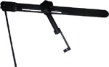 | Tool for disassembling / reassembling valves | ED0014603720-S
ST_08 | 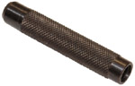 | Tool for gasket valve stem | ED0014603660-S
ST_11 | 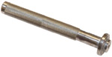 | Rocker arm cover gasket assembling tool (electronic injector seat) | ED0014603620-S
ST_12 | 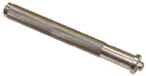 | Rocker arm cover gasket assembling tool (rocker arm capscrew gudgeon seat - electronic injector fastening capscrew brace seat) | ED0014603630-S
ST_13 | 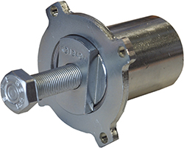 | High-pressure fuel injection pump puller gear | ED0014604050-S
ST_17 | 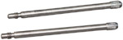 | Rocker arm cover mounting studs | ED0014603730-S
ST_18 | 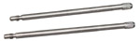 | Intake and oil sump manifold mounting studs | ED0014603740-S
ST_34 | 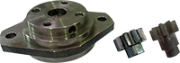 | Crankshaft blocking tool | ED0014604270-S
ST_43 | 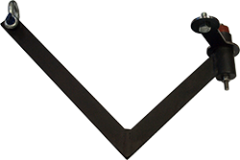 | Flywheel lifting tool | ED0014604030-S
ST_44 | 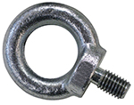 | Flange bell lifting tool | ED0014604010-S
ST_45 | 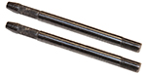 | Flange bell placing tool | ED0014604020-S
ST_46 |  | Flywheel placing tool | ED0014604040-S
ST_47 | 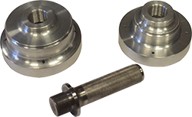 | Tool for sealing ring insertion flywheel side and pulley side | ED0014604340-S
Tab. 13.2
SPECIFIC EQUIPMENT TO PROTECT COMPONENTS OF THE INJECTION CIRCUIT
ST_40 | 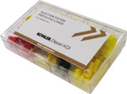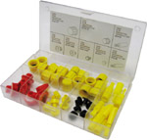 | Complete box with caps to close holes and unions for high-pressure injection circuit components. | ED0082051380-S
Tab. 13.3
SPECIAL TOOLS TO TEST THE ENGINE ON THE TEST BENCH - DIAGNOSTIC PROCEDURE
ST_01 | 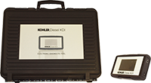 | Complete instrument Kit for diagnostics  "POLAR XL" | ED0014603690-S
ST_49 | 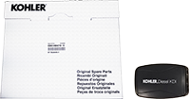 | Complete instrument Kit for diagnostics  "DIAGBOX" | ED0014604210-S
ST_50 | 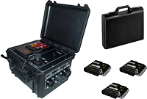 | Complete instrument Kit for engines bench test | ED0014604110-S



