KDI 2504TCR / KDI 2504TCRE5
Help File

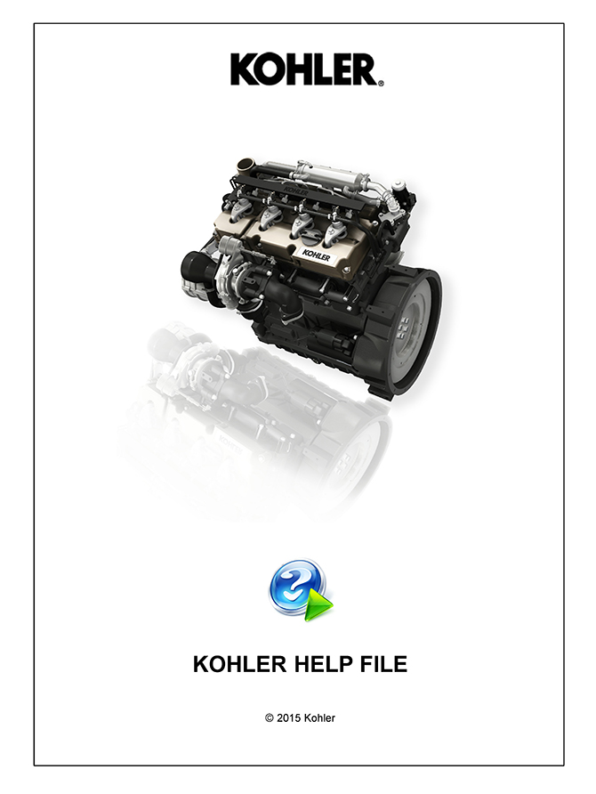
Sommario
1. TITOLO 1 2
1.1. Asdfsdfsdf 2
1.2. Asdfsdfsdfggg 2

KOHLER Help File KDI Engines

Fault Codes

Engine Device

Diagnostic - Troubleshooting

Machine Device

Kohler Diagnostic Tools

