KDI 3404TM
KDI 3404 TM Workshop Manual (Rev. 08.2)

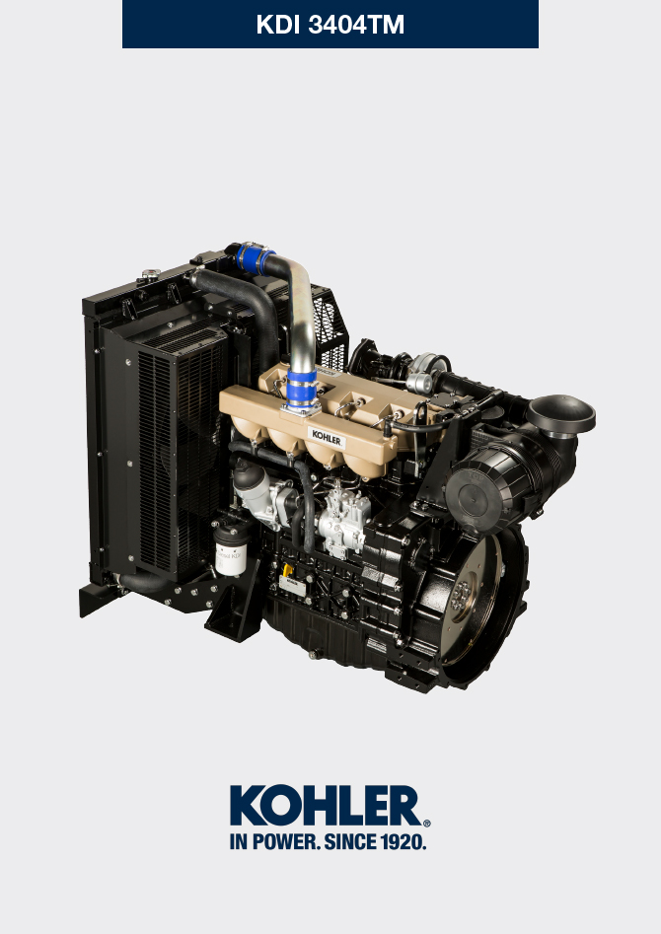
Sommario
1. TITOLO 1 2
1.1. Asdfsdfsdf 2
1.2. Asdfsdfsdfggg 2

General information

Useful information
- This manual contains the instructions needed to carry out proper use and maintenance of the engine, therefore it must always be available, for future reference when required.
- Information, descriptions and pictures contained in this manual reflect the basic configuration of the engines ( Par. 1.4 and Par. 1.5 ).
- However, the development of engines is continuous. Therefore, the information in this manual is subject to change without notice.
- KOHLER reserves the right to make, at any time, changes on the engines for technical or commercial reasons.
- These changes do not require KOHLER to intervene on the production marketed up to that time and nor to consider this manual as inappropriate.
- The paragraphs, tables and figures are numbered by chapter and followed by the progressive paragraph, table and/or figure number.
Es: Par. 1.3 - chapter 1 paragraph 3 .
Tab. 2.4 - chapter 2 table 4 .
Fig. 4.5 - chapter 4 figure 5 .
NOTE: The paragraphs may contain sub-paragraphs.

- All technical terms, specific components and symbols ( Tab. 15.1 ) that are in the manual are listed and described inside the glossary, which can be consulted in ( Chap. 15 ).
- The references of the objects described in the text and in the figure are indicated by letters and numbers, which are always and only related to the paragraph you are reading unless there are specific references to other figures or paragraphs.
- Reference to values are indicated by letters or numbers.
- Other important references are highlighted in red.
- The mark ( ) after the title of a paragraph, indicates that the procedure is not required in order to disassemble the engine, however the procedures are featured in order to illustrate the disassembly of components.
- Any additional section that KOHLER will deem necessary to supply at a later stage must be kept with the manual and considered as an integral part of it.
- The information contained in this manual is the sole property of KOHLER , therefore no partial or total reproduction or replication is allowed without the express permission of KOHLER .

1.1.1 Useful Information - accident prevention - environmental impact

- Before proceeding repair - handling the motor , read the entire Chap. 3 , which contains important information about the procedures to be followed for safety and environment .

Manufacturer and engine identification
The engine identification name plate is situated in the lower part of the crankcase; it is visible from the intake or exhaust side.
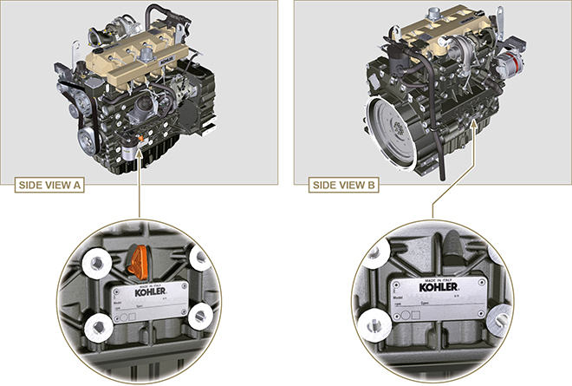
Fig 1.1 - Fig 1.2

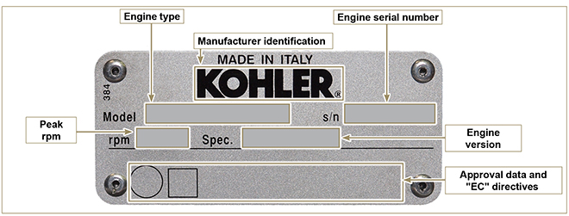
Fig 1.3

Homologation labels
1.7.1 Label for EPA rules (compilation example)

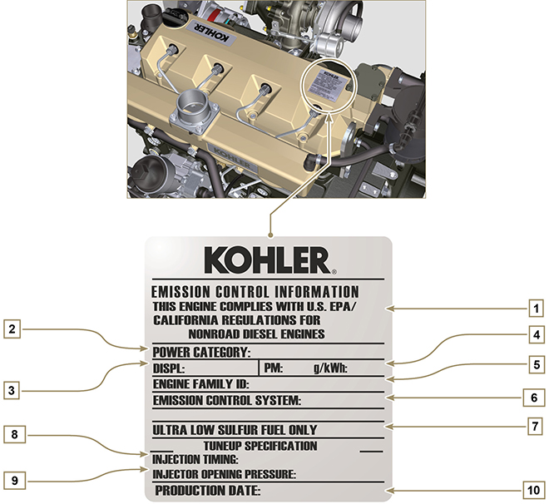
Tab. 1.1
POS. | DESCRIPTION
1 | Model year in compliance with the rules
2 | Power category (kW)
3 | Engine displacement (L)
4 | Particulate emission limit (g/kWh)
5 | Engine family ID
6 | Emission Control System = ECS
7 | Fuel with low sulphur content
8 | Injection timing
9 | Injector opening pressure (bar)
10 | Production date (example: 2013.JAN)

1.7.2 Label for China Standards (compilation example)

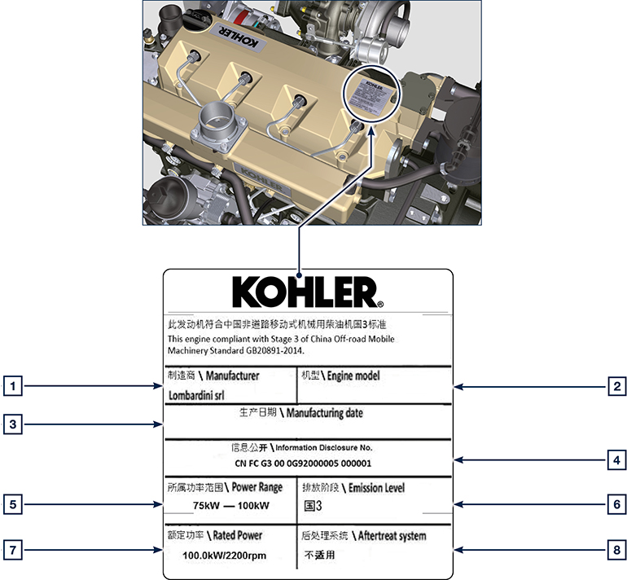
Tab 1.2
POS | DESCRIPTION
1 | Manufacturer
2 | Engine model
3 | Manufactoring date
4 | Certificate N°
5 | Power range (kW)
6 | Emission level
7 | Rated power
8 | Aftertreat system

1.7.3 Label for Korea Standards (compilation example)

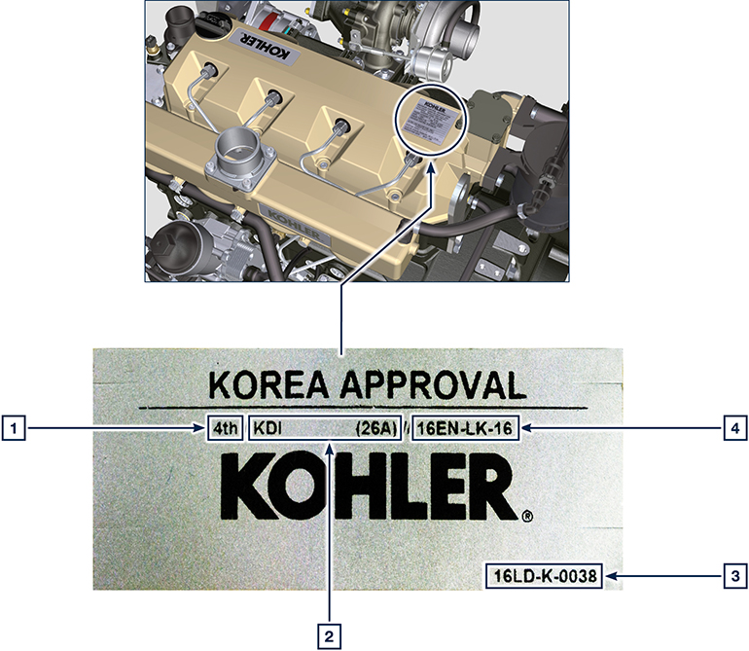
Tab 1.3
POS | DESCRIPTION
1 | Tier 4 Final
2 | Engine model
3 | Manufactoring date and manufacturer code
4 | N° Korea emission certificate

Identification of the main internal components of the engine and operating reference (BASE CONFIGURATION)
WIEW OF EXHAUST SIDE
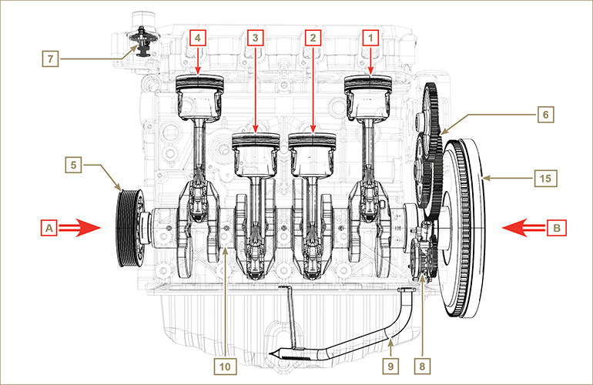
Fig 1.5

The following chapters contain operating references in order to clearly understand the engine. This paragraph illustrates these references that may be recognised by means of some main internal components.  Should you need to execute complex operations, always consult this paragraph | Tab 1.2  REF. DESCRIPTION  A View of timing system side (2 ^{nd} PTO)  B View of flywheel side (1 ^{nd} PTO)  C View of exhaust side  D View of intake side  1 Cylinder/Piston N. 1  2 Cylinder/Piston N. 2  3 Cylinder/Piston N. 3  4 Cylinder/Piston N. 4  POS. DESCRIPTION  5 Crankshaft pulley (2 ^{nd} PTO)  6 Gear timing system  7 Thermostatic valve  8 Oil pump  9 Oil suction hose  10 Crankshaft  11 Exhaust manifold  12 Intake manifold  13 Camshaft  15 Flywheel (1 ^{st} PTO)
WIEW OF FLYWHEEL SIDE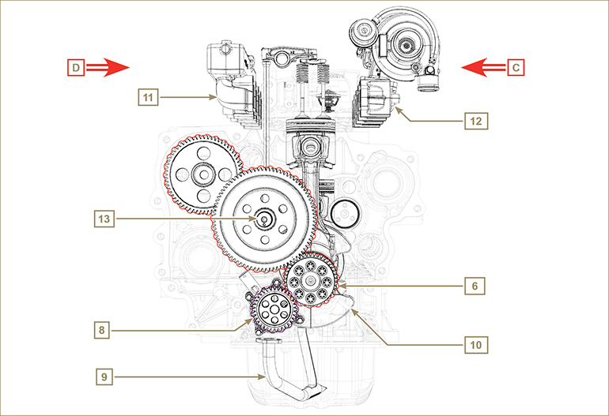
Fig 1.6

Identification of the external components of the engine (BASE CONFIGURATION)
WIEW OF PULLEY SIDE - INTAKE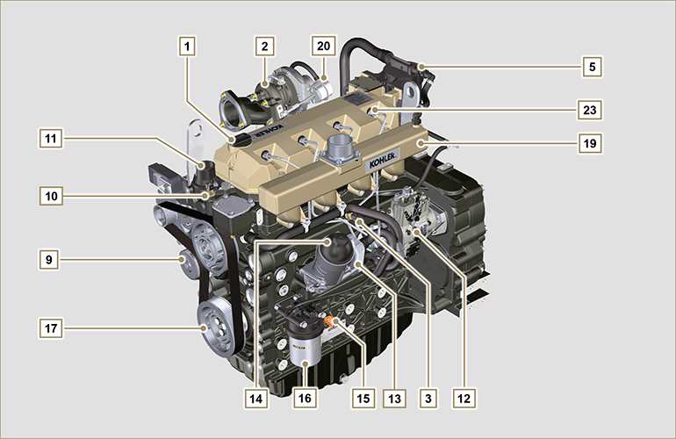
Fig 1.7

VIEW OF FLYWHEEL SIDE - EXHAUST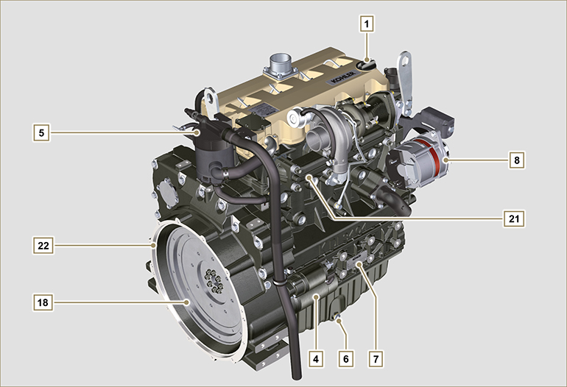
Fig 1.8

This paragraph illustrates all external components that are present in the base configuration of the engine.  For components present on engines that differ from those represented in these illustrations, refer to Chap. 11 . | NOTE: The illustrated components may differ from those illustrated; the illustration is only as an example.
Tab 1.3  POS. DESCRIPTION  1 Oil filler cap  2 Turbocharger  3 Oil pressure switch  4 Starter motor  5 Oil steam separator  6 Oil drain plug  7 Engine identification name plate  8 Alternator  9 Coolant pump  10 Coolant temperature sensor  11 Thermostatic valve  12 Fuel injection pump | POS. DESCRIPTION  13 Oil Cooler  14 Lub. oil filter  15 Oil dipstick  16 Fuel filter  17 Crankshaft pulley (2 ^{nd} PTO)  18 Flywheel (1 ^{st} PTO)  19 Intake manifold  20 Waste Gate valve control actuator  21 Exhaust manifold  22 Flange bell  23 Injectors

UPPER VIEW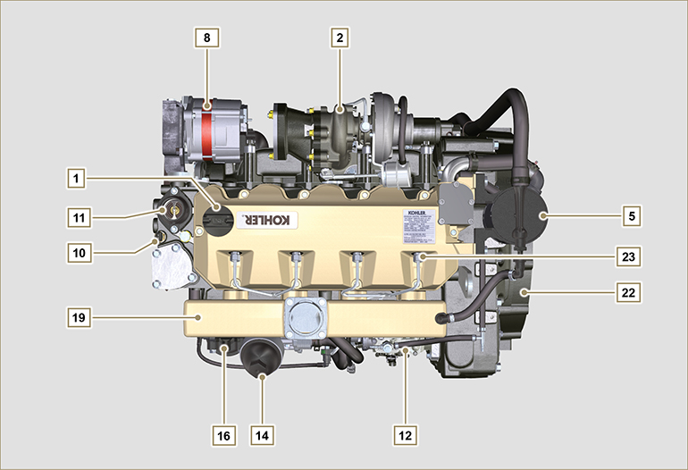
Fig 1.9

Technical information

Engine specifications
Tab. 2.1
MANUFACTURER SPECIFICATIONS AND OPERATION
GENERAL INFORMATION | UNIT OF MEASURE | KDI 3404 TM
Operating cycle |  | diesel - 4 stroke
Cylinders | N° | 4
Bore x stroke | mm | 96X116
Displacement | cm ³ | 3359
Compression ratio |  | 17:1
Intake |  | Supercharged with Turbocharger
Cooling |  | Liquid
Crankshaft rotation (view from flywheel side) |  | Counterclockwise
Combustion sequence |  | 1-3-4-2
Timing System
Valves per cylinder | N° | 4
Timing System |  | Rods and rocker arms - Camshaft in the crankcase
Tappets |  | Hydraulic
Injection |  | Direct
Engine dry weight | Kg | 394
MAX inclination 30' continuous operation | α | 40°
MAX inclination 1' continuous operation | α | 45°
POWER AND TORQUE
GENERAL INFORMATION | UNIT OF MEASURE | KDI 3404 TM
MAX operating speed | Rpm | 2400
MAX operating power (ISO TR 14396 - SAE J1995 - CE 97/68) | kW | 100
Maximum torque (at 1500 rpm) | Nm | 500
CONSUMPTIONS
GENERAL INFORMATION | UNIT OF MEASURE | KDI 3404 TM
Specific fuel consumption (best point) | g/kWh | 205
Oil consumption | %Fuel | < 0.1
FUEL SUPPLY SYSTEM
GENERAL INFORMATION | UNIT OF MEASURE | KDI 3404 TM
Type of fuel |  | Diesel UNI-EN590 - ASTM D975
High-pressure fuel injection pump |  | STANADYNE - DB
Fuel supply |  | Low pressure electric pump
Fuel filter
Filtering surface | cm ² | 2300
Degree of filtration | µm | 5
Maximum pressure at injection pump inlet | bar | < 0.5
LUBRICATION CIRCUIT
GENERAL INFORMATION | UNIT OF MEASURE | KDI 3404 TM
Lubrication
Recommended oil |  | See Par. 2.4
Circuit forced |  | Lobe pump
Oil sump capacity ( MAX ) | Lt. | 15,6
Oil pressure switch
Intervention pressure ( MIN ) | bar | 0.6±0.1
Oil filter

Maximum operating pressure | bar | 4.0
Degree of filtration | µm | 17±2
Filtering surface | cm ² | 1744
COOLING CIRCUIT
GENERAL INFORMATION | UNIT OF MEASURE | KDI 3404 TM
Coolant | % | See Par. 2.6
Coolant pump | Lt./min | 155
Thermostatic valve
Opening temperature | °C | +83 (0/-3)
Stroke at 95°C | mm | 7.50
Liquid recirculation | Lt./h | 9
ELECTRICAL SYSTEM - ELECTRIC FAN
GENERAL INFORMATION | UNIT OF MEASURE | KDI 3404 TM
Circuit rated voltage | V | 12
External alternator (rated current) | A | 90
Starter motor power | kW | 2
System electrical consumption, excluding:  heater, electric pump, electric fan, starter motor | W
Coolant temperature indicator light
Indicator light operating temperature | °C | +100/+110

Engine dimensions (mm)
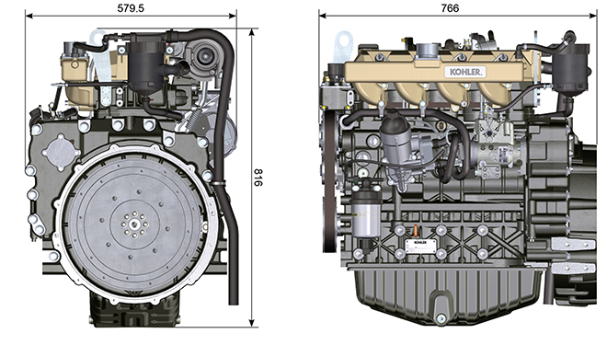

Performance
 |  |  | with AFTER COOLER |  |  |  | without AFTER COOLER
 |  |  | 70Hz @1800 rpm | 60Hz @1800 rpm | 50Hz @1800 rpm | 63Hz @1500 rpm | 63Hz @1500 rpm
 |  |  | POWER
Stand-by power (kW/HP) |  |  | 70 / 95.2 | 60 / 81.6 | 50 / 68 | 63 / 85.7 | 63 / 85.7
Prime power (kW/HP) |  |  | 63 / 85.7 | 54 / 73.4 | 45 / 61.2 | 56.7 / 77.1 | 56.7 / 77.1
 |  |  | FUEL CONSUMPTION (g/kWh)
Fuel consumption 100% load |  |  | 229.0 | 241.6 | 240.8 | 223,2 | 219
Fuel consumption 75% |  |  | 242.8 | 260.8 | 255.4 | 232.5 | 228
Fuel consumption 50% |  |  | 242.4 | 265.1 | 272 | 248.5 | 238
Fuel consumption 25% |  |  | 274.2 | 298.4 | 325.1 | 263.1 | 261
Fuel consumption 10% |  |  | 425.3 | 452.1 | 510.8 | 366.6 | 380

N = Automotive rating curve  M = Torque curve  C = Specific fuel consumption curve  NOTE: Refer to KOHLER for power curves, torque curves and specific consumptions at speeds other than those given above.  Key  - N ( ISO TR 14396 - SAE J1995 - CE 97/68 ) AUTOMOTIVE RATING CURVE : Intermittent duty at variable speed and load. Engine capacity at intermittent conditions with variable speed and load.  - M: = TORQUE RATING CURVE : Also called twisting moment, it is the push generated by the engine through transmission. The highest engine performance is obtained at the maximum torque.  - C = SPECIFIC CONSUMPTION CURVE : Engine fuel consumption in a given time at a certain revolution value. Expressed in g/kW (grams/kilowatt), it expresses fuel yield.  * The above curves express indicative values, in that the overall performance depends on the type of application and the ECU control uni.  - The ratings reported in the diagram regard the run-in engine, fitted with air and exhaust filters, at the atmospheric pressure of 1 Bar and at a room temperature of +20°C  - Maximum rating is guaranteed with a 5% tolerance.  Warning  - Non approval by KOHLER for any modification releases the company from liability for damage incurred on the engine. | 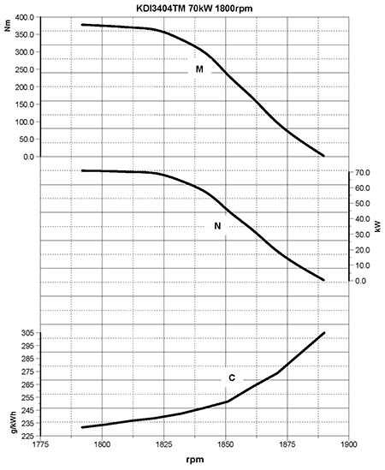
 | 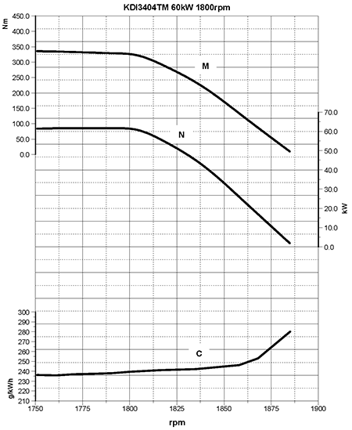
 | 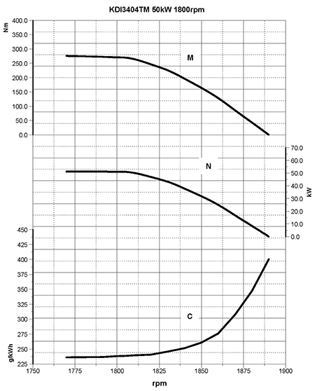
 | 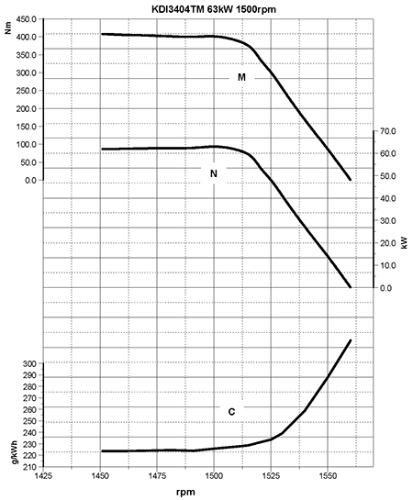
 | 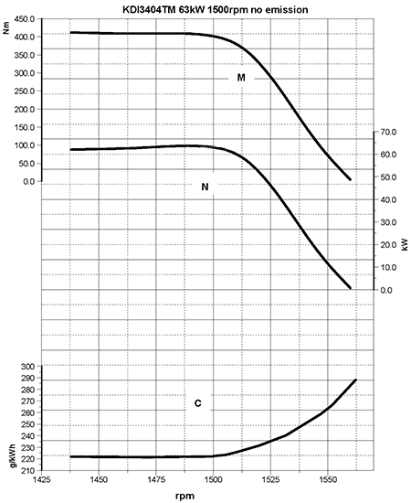

Oil

Important

- The engine may be damaged if operated with improper oil level.
- Do not exceed the MAX level because a sudden increase in engine rpm could be caused by its combustion.
- Use only the recommended oil to ensure adequate protection, efficiency and service life of the engine.
- The use of lubricants other than recommended may shorten the engine life.
- Viscosity must be appropriate to the ambient temperature to which the engine is to be exposed.

Danger

- Prolonged skin contact with the exhausted engine oil can cause cancer of the skin.
- If contact with oil cannot be avoided, thoroughly wash your hands with soap and water as soon as possible.
- For the exhausted oil disposal, refer to the Par. DISPOSAL and SCRAPPING .
2.4.1 SAE oil classification
- In the SAE classification, oils are identified according to viscosity without considering any other qualitative characteristic.
- The code is composed of two numbers, which indicate, and must correspond to, the ambient temperature in which the engine operates, the first number refers to the viscosity when cold, for use during winter (" W "), while the second number is for viscosity at high temperatures.

2.2
RECCOMENDED OIL
VISCOSITY | SAE | 10w-40 (-25°C ÷ +50°C)  5w-40 (-30°C ÷ +50°C)  0w-40 (-40°C ÷ +50°C)
WITH SPECIFICATIONS | API | CI-4 Plus CI-4  CH-4
 | ACEA | E7  E4

- Low S.A.P.S. oils, sulfate ashes <1% may not be used with fuels with a sulfur content >50ppm.
- Filtration of oils is critical to proper operation and lubrication; always change filters regularly as specified in this manual.

Fuel

Important

- Use of other types of fuel could damage the engine. Do not use dirty diesel fuel or mixtures of diesel fuel and water since this will cause serious engine faults.
- Any failures resulting from the use of fuels other than recommended will not be warranted.

Warning

- Clean fuel prevents the fuel injectors from clogging. Immediately clean up any spillage during refuelling.
- Never store diesel fuel in galvanized containers (i.e. coated with zinc). Diesel fuel and the galvanized coating react chemically to each other, producing flaking that quickly clogs filters or causes fuel pump and/or injector failure.
2.3
FUEL COMPATIBILITY
EN 590 (biodiesel content max. 7% (V/V))
ASTM D 975 Grade 1-D S15
ASTM D 975 Grade 2-D S15
NATO F-54, equivalent to diesel fuel in accordance with EN 590
EN 590 or ASTM D 975 Grade 1, 2 -D S15 Arctic Diesel
JIS K 2204 No. 1, No. 2
NOTE : In a warranty case the customer must prove by a certificate from the fuel supplier that an allowed fuel was used.
KDI Mechanical Injection Tier 3 , Tier 4 Final – Stage IIIA, Stage IIIB, Stage V certified Engines (w and w/o EGR)
- Those engines are designed for fuels in accordance with EN 590 and ASTM D975 for a cetane number of at least 45. Since those engines are not equipped with exhaust gas after-treatment, they can be operated with diesel fuels with sulfur content up to 500 mg/kg (ppm). Compliance with the emission requirements is guaranteed only with sulfur content up to 15 mg/kg (ppm).
Engines operated with fuels as per EN 590 and ASTM D975 with sulfur content < 15mg/kg have an oil changing interval of 500hrs. Fuels with a sulfur content > 500 mg/kg demand a shorter lubricating oil change interval. This is set at 250hrs. However, the engine oil must be changed when the Total Base Number TBN is reduced to 6.0 mgKOH/g test method ASTM D4739. With high fuel sulfur content fuel this may happen at 125hrs. Do not use low SAPS oils.

KDI Mechanical Injection Uncertified Engines (no EGR Engines)
- Those engines are designed for fuels in accordance with EN 590 and ASTM D975 for a cetane number of at least 45. Since those engines are not equipped with exhaust gas after-treatment, they can be operated with diesel fuels with sulfur content up to 2000 mg/kg (ppm).Engines operated with fuels as per EN 590 and ASTM D975 with sulfur content < 15mg/kg have an oil changing interval of 500hrs. Fuels with a sulfur content > 500 mg/kg demand a shorter lubricating oil change interval. This is set at 250hrs. However, the engine oil must be changed when the Total Base Number TBN is reduced to 6.0 mgKOH/g test method ASTM D4739
2.5.1 Fuel for low temperatures
- When operating the engine in ambient temperatures lower than 0 degrees C, use suitable low temperature fuel normally available from fuel distributors and corresponding to the specifications of Tab. 2.3 .
- These fuels reduce the formation of paraffin in diesel at low temperatures.
- When paraffin forms in the diesel, the fuel filter becomes blocked interrupting the flow of fuel.
2.5.2 Biodiesel fuel
- Fuels containing 10% methyl ester or B10, are suitable for use in this engine provided that they meet the specifications listed in the Tab. 2.3.
- DO NOT USE vegetable oil as a biofuel for this engine.
2.4
BIODIESEL COMPATIBILITY
Biodiesel according to EN 14214 (only permissible for mixture with diesel fuel at max. 10% (V/V))
US biodiesel according to ASTM D6751 – 09a (B100) (only permissible for mixtures with diesel fuel at 10% (V/V))

2.5.3 Synthetic fuels: GTL, CTL, BTL, HV
It is a well-known fact that engines which are operated for longer periods with conventional diesel fuel and then converted to synthetic fuels suffer shrinkage of polymer seals in the injection system and thus fuel leaks. The reason for this behavior is that the aromatic-free synthetic fuels can lead to a change in the sealing behavior of polymer seals.
Therefore, conversion from diesel fuel to synthetic fuel may only be done after changing the critical seals. The problem of shrinkage does not occur when an engine was operated with synthetic fuel from the start.

2.5.4 Non-Road Fuels
Other non-road fuels may be used if they comply with all the limit values of EN 590 except for the fuel density, the cetane number and the sulfur content.
The following limits apply for these parameters:
2.5
FUEL PARAMETER | UNIT | LIMIT VALUE
Cetane number |  | Min. 49
Fuel density at 15°C | Kg/m ³ | 820 - 860
Sulfur content | mg/kg or ppm | max. 500

2.5.5 Jet Fuels
Only for KDI Mechanical Injection Uncertified Engines (no EGR Engines).
The following jet fuels can be used but only adopting an additional fuel filter with lubricity doser:
2.6
FUEL
F-34/F-35 (kerosene, NATO designation) | JP-8 (kerosene, US military designation)
F-44 (kerosene, NATO designation | JP-5 (kerosene, US military designation)
F-63 (kerosene, NATO designation, equivalent to F-34/F-35 with additives) | Jet A (kerosene for civil aviation)
F-65 (kerosene, NATO designation, 1:1 mixture of F-54 and F-34/F-35) | Jet A1 (kerosene for civil aviation)

2.5.6 Emission-Related Installation Instructions Failing to follow the instructions in the applications guidebook when installing a certified engine in a piece of nonroad equipment violates federal law (40 CFR 1068.105(b)), subject to fines or other penalties as described in the Clean Air Act.

OEM must apply a separate label with the following statement: “ULTRA LOW SULFUR FUEL ONLY” near the fuel inlet.

Ensure you are installing an engine appropriately certified for your application. Constant speed engines may only be installed on constant speed equipment for constant speed operation.

If you install the engine in a way that makes the engine's emission control information label hard to read during normal engine maintenance, you must place a duplicate label on the equipment, as described in 40 CFR 1068.105.

Coolant recommendation
A mixture of 50% demineralized water and 50% low silicate ethylene glycol based coolant liquid must be used. Use a Long Life or Extended Life Heavy Duty OAT coolant free of: silicates, phosphates, borates, nitrites and amines.

The following ethylene-glycol based engine coolant for all models within KDI engine family may be used:

- OAT (Organic Acid Technology) Low Silicate: ASTM D-3306 D-6210
- HOAT (Hybrid Organic Acid Technology) Low Silicate: ASTM D-3306 D-6210

The above coolants in concentrated formulation must be mixed with distilled, deionized, or demineralized water. A pre-mixed formulation (40-60% or 50-50%) can be used directly when available.

Important
- Do not mix ethylene glycol and propylene glycol based coolants. Do not mix OAT and HOAT based coolant. OAT performance life can be drastically reduced if contaminated with nitrite-containing coolants.
- Never use automotive-type coolants. These coolants do not contain the correct additives to protect heavy – duty diesel engines.

OAT coolants are maintenance free up to 6 years or 6000hrs of operation , provided that the cooling system is topped up using the same type of coolant. Do not mix different coolant types. Test the coolant condition annually with coolant test strips.
HOAT are not all maintenance free and it is recommended to have SCA (Supplemental Coolant Additives) added at the first maintenance interval.

Battery recommendation
Battery not supplied by Kohler

Tab. 2.7
RECOMMENDED BATTERIES
AMBIENT TEMPERATURE | BATTERY TYPE
≥ - 15°C | 100 Ah - 800 CCA/SAE
< -15°C | 120 Ah - 1000 CCA/SAE

Periodic maintenance
The intervals of preventive maintenance in Tab. 2.8, Tab. 2.9, Tab. 2.10 and Tab. 2.11 refer to the engine operating under normal operating conditions with fuel and oil meeting the recommended specifications.

2.8
CLEANING AND CHECKING
OPERATION DESCRIPTION | PERIOD (HOURS)
 | 100 | 250 | 500 | 5000
Engine oil level ⁽⁸⁾
Coolant level ⁽⁸⁾ ⁽⁹⁾
Water presence in fuel filter
Cartridge dry-type air filter ⁽²⁾
Radiator heat-exchange surface and Intercooler ⁽²⁾ ⁽⁸⁾
Alternator belt ⁽⁸⁾
Rubber hose (intake air / coolant)
Fuel hose
Starter Motor
Alternator

2.9
REPLACEMENT
OPERATION DESCRIPTION |  | PERIOD (HOURS)
 |  | 500 | 2000 | 5000
Cartridge dry-type air filter ⁽²⁾
Intake manifold hose (air filter - intake manifold) ⁽⁷⁾
Coolant hoses ⁽⁷⁾
Fuel line hose ⁽⁷⁾
Alternator belt | Poly-V belt heavy environmental condition
 | Poly-V belt standard condition
Coolant | OAT
 | HOAT ⁽¹⁰⁾

2.10
ENGINE OIL AND OIL FILTER CARTRIDGE REPLACEMENT
ENGINE VERSION | PERIOD (HOURS)
 | 250 | 500
KDI Mechanical Injection Tier 3 – Stage IIIA ⁽¹⁾
KDI Mechanical Injection Uncertified Engines ⁽¹⁾ ⁽¹¹⁾

2.11
FUEL FILTER AND PREFILTER CARTRIDGE REPLACEMENT
ENGINE VERSION | PERIOD (HOURS)
 | 250 | 500
KDI Mechanical Injection Tier 3 – Stage IIIA ⁽¹⁾
KDI Mechanical Injection Uncertified Engines ⁽¹⁾

(1) - In case of low use: 12 months. (2) - The period of time that must elapse before checking the filter element depends on the environment in which the engine operates. The air filter must be cleaned and replaced more frequently under very dusty conditions.

(3) - In case of low use: 36 months.
(7) - The replacement interval is only an indication, it strongly depends from environmental condition and hose status detected during regular visual inspection.
(8) - The first check must be done after 10 hours.
(9) - Test the coolant condition annually with coolant test strips.
(10) - It is recommended to have SCA (Supplemental Coolant Additives) added at the first maintenance interval.
(11) - Read Cap. 2.5, "KDI Mechanical Injection Uncertified Engines (no EGR Engines)"

Fuel system
2.9.1 Supply system

Important

- The high pressure supply injection system is highly susceptible to damage if the fuel is contaminated.
- It is crucial that all components of the injection circuit are thoroughly cleaned before the components are removed.
- Thoroughly wash and clean the engine before maintenance.
- Contamination in the fuel supply injection system may cause a reduction in effectiveness / operation of engine fault indication.
- If the engine is cleaned with high pressure washer, then the nozzle must be kept at a minimum distance of 200mm from the surface, and not directed at electrical components and connectors.

The fuel supply system is under low pressure from the tank 1 to the high-pressure fuel injection pump 5 .  NOTE : The representation of fuel tank is purely indicative. Component not necessarily supplied by KOHLER .  Tab 2.10  POS. DESCRIPTION  1 Fuel tank  2 Fuel supply hose from the tank to the injection pump  3 Fuel filter  4 Electrical fuel feed pump  5 Injection pump  6 Injector high-pressure hose from the injection pump to the injectors  7 Injectors | 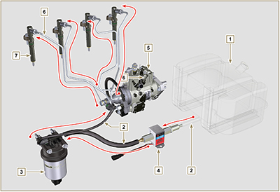  Fig 2.4
2.9.2 Fuel return circuit  The fuel return circuit is under low pressure.  NOTE : The representation of fuel tank is purely indicative. Component not necessarily supplied by KOHLER .  Tab 2.11  POS. DESCRIPTION  1 Injectors  2 Injectors fuel return pipe  3 Injection pump  4 Fuel tank  5 Fuel return pipe to the tank | 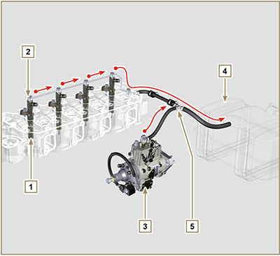  Fig 2.5

2.9.3 Injection pump  Pressure into the injection pump must be positive in all operating conditions.  The injection pump is operated by means of the pump control gear and sends high-pressure fuel to the injectors.  NOTE: In the event of leakage from the high pressure circuit do not intervene with the engine running, but turn it off and wait 5 - 10 minutes before checking the leak.  Tab 2.12  POS. COMPONENTS DESCRIPTION  1 Accelerator lever  2 Min Adjustment  3 Max Adjustment  4 Torque adjustment  5 High pressure delivery to injectors  6 Return to fuel tank  7 Inlet suction fuel  8 Cold starting device  9 Gasket  10 Shaft  11 Advance settings (locked)  12 Pump identification label  13 Air bleeding screw  14 Pump control shaft blocking device. | 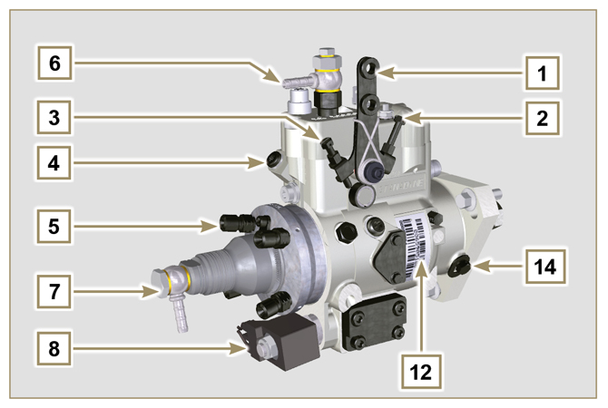  Fig 2.6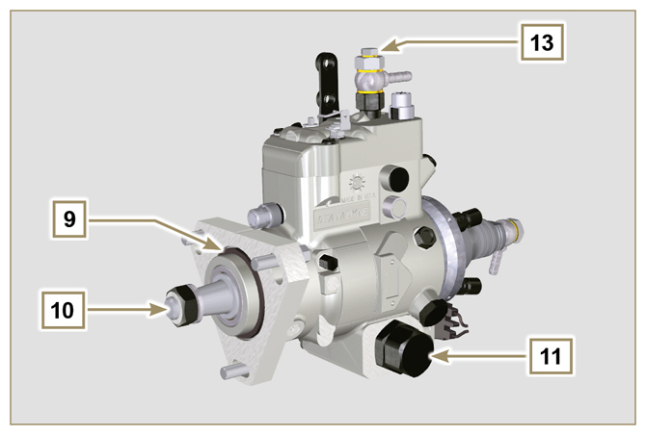  Fig 2.7

2.9.4 Injector  It is a device used to introduce fuel, in the form of one or more jets that are adequately pulverised and suitably oriented directly into the combustion chamber. They consist of a metallic body that internally provides a mobile element that acts on the needle: this, rising against the action of a calibrated spring,  allows the release of fuel under high pressure.  Important  - The injectors are calibrated individually.  - Fuel contamination causes serious damage to the injection system.  Tab 2.13  POS. COMPONENTS DESCRIPTION  1 Inlet fuel  2 Gasket  3 Gasket  4 Nozzle  5 Hole for fuel return to fuel tank | 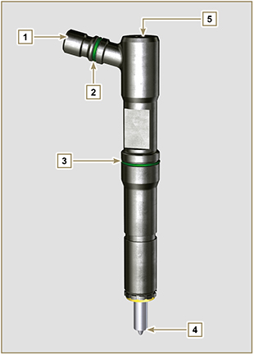  Fig 2.8

2.9.5 Fuel filter  The fuel filter is situated on the crankcase of the engine or it may be assembled on the frame of the vehicle.  Tab 2.14  POS. COMPONENTS DESCRIPTION  1 Fuel filter support cartridge  2 Air bleeding screw  3 Cartridge  4 Water draining device  5 Hole water drainage  Tab 2.15 Cartridge characteristics  DESCRIPTION VALUE  Filtering surface 2.300 cm ²  Degree of filtration 5 µm  Max operating pressure 2.0 Bar | 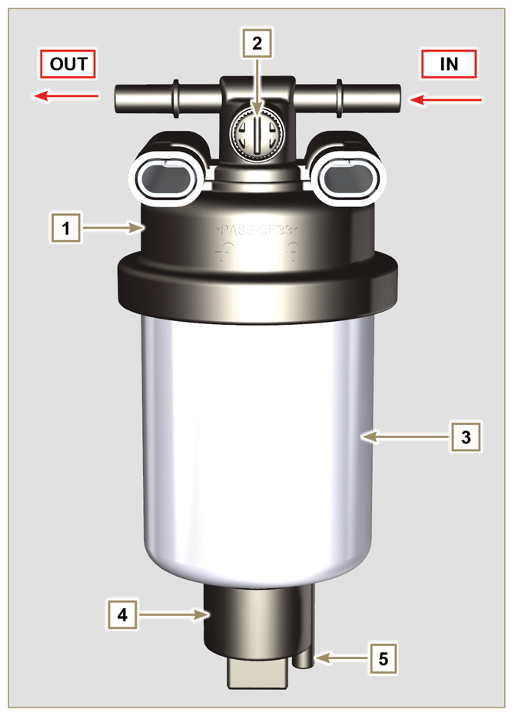  Fig 2.9

2.9.6 Electric fuel pump (optional)  When the electric fuel pump is installed in a diesel engine, one must:  - Remove any filters installed on the inlet of the electric fuel pump;  - Insert a pre-filter between the tank and the electric pump;  - The electric pump must be installed on the application at a height from the minimum tank level such as to generate a MAX . pressure drop equal to a column of 500 mm of fuel;  - Insert a shut-off valve to prevent dry operation due to the emptying of the intake manifold;  - The electric pump must guarantee a supply pressure at the inlet positive in all conditions.  Tab 2.16  POS. DESCRIPTION  1 Fuel tank  2 Arrival pipe from the tank  3 Prefilter  4 Flow pipe from pre-filter to electric pump  5 Electric pump  6 Flow pipe to the fuel filter  7 Fuel filter | 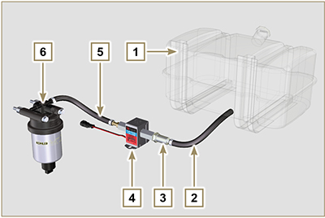  Fig 2.10
2.9.7 Guards for fuel injection circuit components  High-pressure injection circuit components are particularly sensitive to impurities.  To prevent impurities, even microscopic ones, from accessing the fuel input or output unions, you are required to close these accesses by means of specific caps as soon as the various tubes are disassembled and disconnected.  Disassembly of any component of the injection circuit must not occur in dusty environments.  Cap guards must remain closed in their housing (ST_40) until the moment they are to be used.  Pay special attention when using the caps and avoid any contamination of dust or dirt of any kind.  Even after using the caps illustrated in this paragraph, all components of the injection circuit must be placed with care in environments that are free of any type of impurity.  Fig. 2.11 and 2.12 illustrate the caps that must be used on components of the injection circuit.  Cap guards must be accurately washed after use and placed back in their housing (ST_40).  Important  - It is highly recommended to have this page visible during disassembly operations of the components of the fuel injection circuit. | 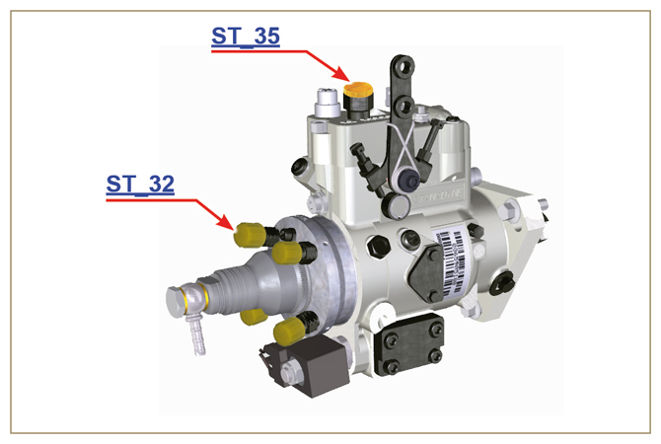  Fig 2.11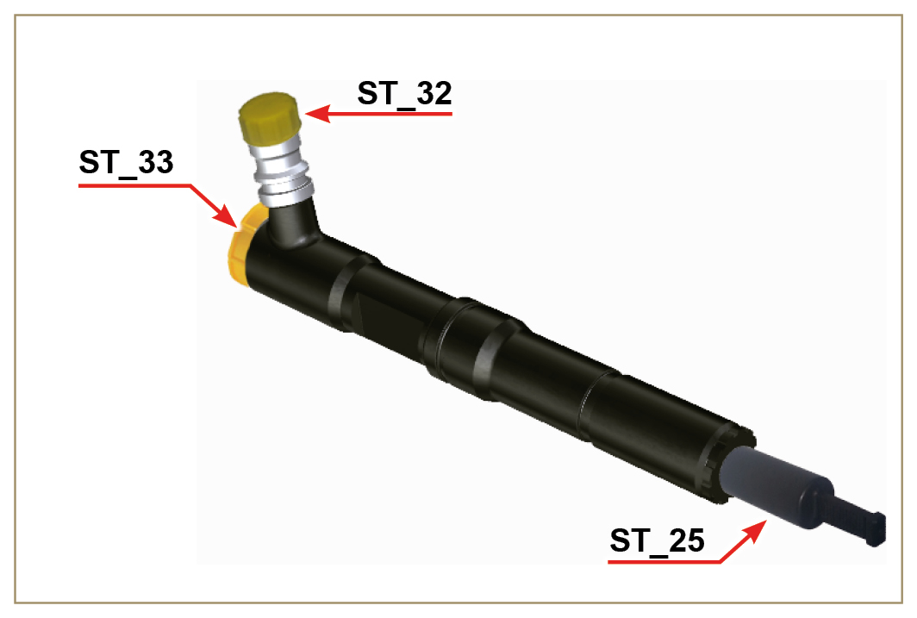  Fig 2.12

Lubrication circuit
2.10.1 Lubrication circuit diagram  The oil pump is driven by the crankshaft on the timing system side.  On the parts of the systems shown in green on In the parts in green, the oil is in intake, in the parts in red, the oil is under pressure and  in those in yellow the oil is returning towards the oil sump 2 (not under pressure).  Tab 2.17  COLOUR DESCRIPTION  Oil in intake  Oil under pressure  Oil returning to the oil sump  Tab 2.18  POS. DESCRIPTION  1 Oil pump rotors  2 Oil sump  3 Crankshaft  4 Camshaft  5 Turbocharger  6 Rocker arm pin  7 Hydraulic tappets  8 Rocker arm cover  9 Cylinder head  10 Upper crankcase  11 Lower crankcase  12 Oil filter  13 Oil Cooler  14 ⁽¹⁾ Idle gear Housing  15 ⁽¹⁾ Left balance shaft  16 ⁽¹⁾ Right balance shaft  ⁽¹⁾ - optional | 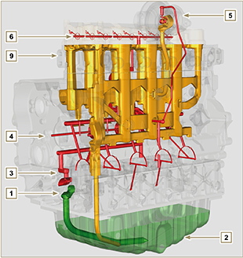  Fig 2.13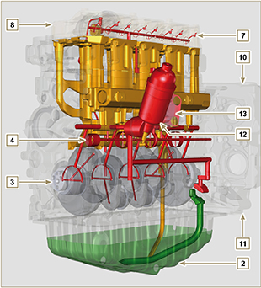  Fig 2.14
NOTE : Click by side to play the procedure. | https://www.youtube.com/embed/gb6hxNuHPKU?rel=0
2.10.2 Oil pump The oil pump rotors are trochoidal (with lobes) and are activated from the crankshaft by means of gears.  The pump body is situated on the crankcase.  It is imperative to assemble the rotors with reference A visible by the operator.  Tab 2.19  POS. DESCRIPTION  1 Internal rotor  2 External rotor  3 Oil pump crankcase  4 Oil pump control gear  5 Crankshaft gear | 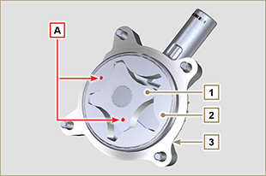  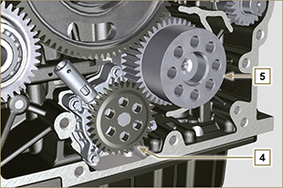  Fig 2.15

2.10.3 Oil filter and Oil Cooler

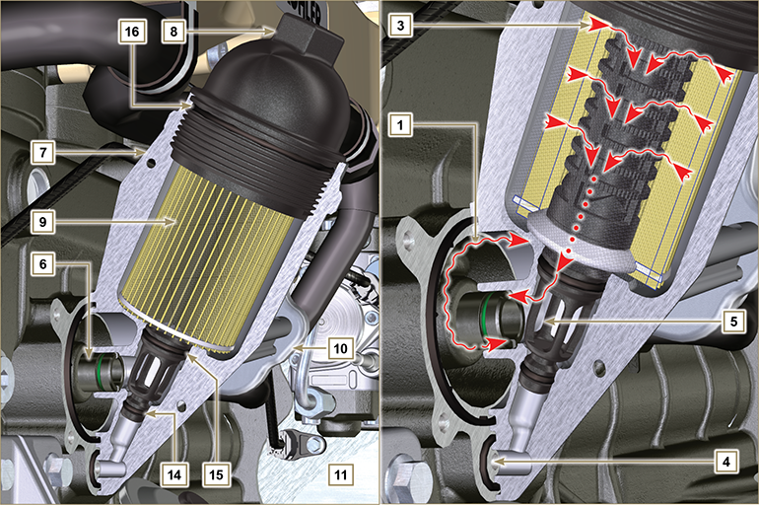
Fig 2.16

NOTE : unscrewing the cartridge holder cover makes the oil in support 7 flow towards the oil sump by means of the drain duct 4.
Tab 2.20  POS. DESCRIPTION  1 Oil arriving from the pump  2 Oil cooling  3 Oil filtering  4 Oil drain duct (oil sump return)  5 Oil returning into the circuit  6 Outgoing fitting from filter  7 Oil filter support  8 Cartridge holder cover  9 Oil filter cartridge  10 Oil Cooler  11 Crankcase  12 Oil directly from the cartridge  13 Coolant  14 Oil drain duct closure gasket  15 Oil filtering chamber closure gasket  16 Cartridge holder cover gasket  Tab 2. 21 Cartridge characteristics.  DESCRIPTION VALORE  Filtering surface 2.300 cm ²  Degree of filtration 2 µm  Max operating pressure 4.0 Bar  Max flow rate 190 litres/hour | 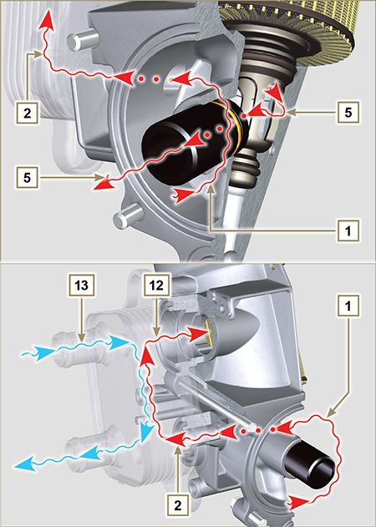  Fig 2.17

Cooling circuit
2.11.1 Cooling circuit diagram
Tab 2.22  POS. DESCRIPTION  1 Coolant pump  2 Coolant intake  3 Coolant, cylinder  4 Coolant, cylinder head  6 Coolant to radiator  7 Coolant into radiator  9 Coolant in the Oil Cooler  10 Coolant input into the Oil Cooler  11 Coolant output from the Oil Cooler  12 Vent line from radiator (to 15)  14 Return from compensation tank  15 Compensation tank  16 Thermostatic valve  17 Coolant drain cap from crankcase | Fig 2.18

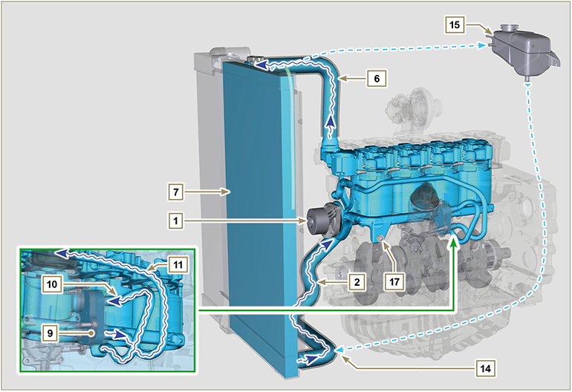
Fig 2.19

2.11.2 Coolant pump  Tab 2.23  POS. DESCRIPTION  1 Coolant pump control pulley  2 Coolant intake fitting | Fig 2.20
2.11.3 Thermostatic valve  Tab 2.24  POS. DESCRIPTION  1 Cylinder head  2 Coolant outlet cover  3 Thermostatic valve  4 Gaskets  5 Air bleeding hole  Starting opening temperature of +83 °C (0/-3 °C). | Fig 2.21
2.11.4 Radiator (optional)  Tab 2.25  POS. DESCRIPTION  1 Radiator  2 Coolant refill cap  3 Vent tube or excess coolant return  4 Coolant flow manifold  5 Coolant intake manifold  6 Fan  7 Protective grid  8 Air hose (from Intercooler to manifold -Fig. 2.23)  9 Intercooler air delivery hose (Fig. 2.23)  10 Compressed air delivery hose to the intake manifold (Fig. 2.22)  NOTE : Fig. 2.22 illustrates the radiator without Intercooler (the differences in POS. 10).  Fig. 2.23 illustrates the radiator with Intercooler (the differences in POS. 8 - 9).  Component not necessarily supplied by KOHLER . | Fig 2.22
Fig 2.23

Intake and exhaust circuit
2.12.1 Intake and exhaust circuit diagram with Intercooler

 | Air in intake |  |  |  | Gas in exhaust

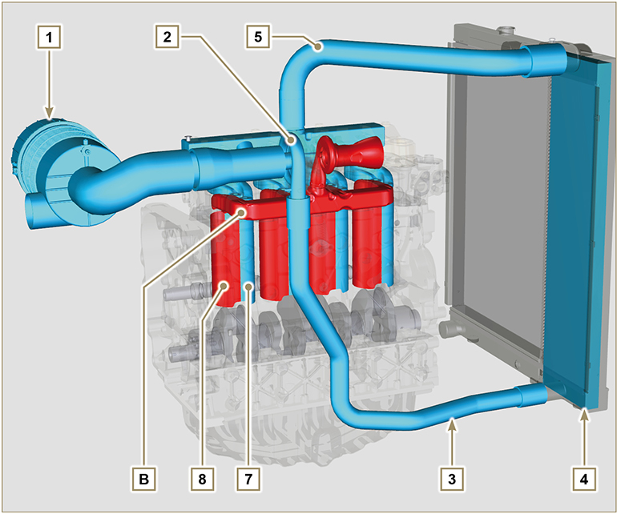
Fig 2.24

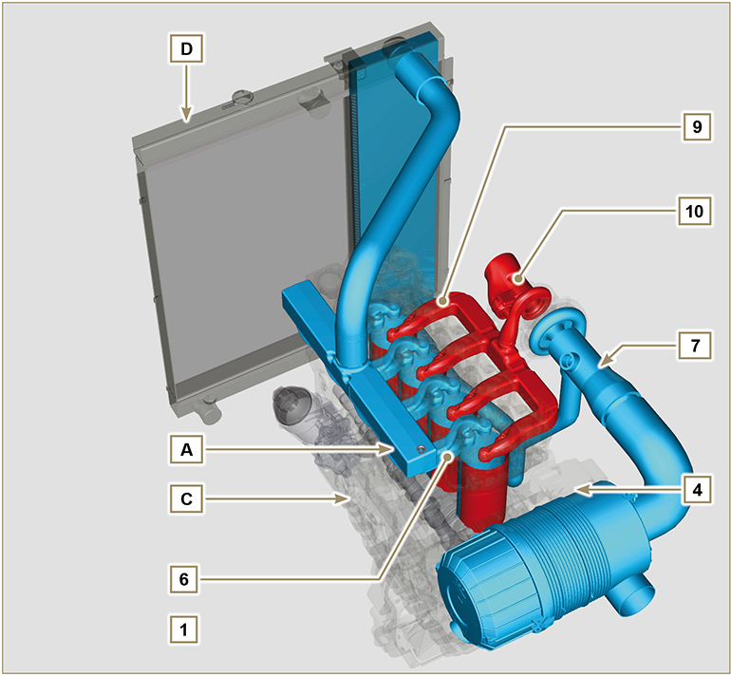
Fig 2.25

Important  - The air temperature inside the intake manifold must never exceed that of the environment by 10°C.  Clean air is sucked by means of an intake manifold and via ducts in the cylinder head, enters the cylinders. Compressed air inside the cylinders and mixed with the fuel transforms into Gas after combustion. Gas is expelled from the cylinders and sent to the exhaust manifold, which expels the gas towards the exhaust muffler. | Tab 2.26  POS. DESCRIPTION  1 Air in intake from air filter  2 Air in compression  3 Air in intake manifold flow  4 Air in head intake  5 Air in cylinder intake  6 Gas in cylinder outlet  7 Gas in head outlet  8 Gas in cylinder outlet  9 Gas in head outlet  10 Exhaust gas from the turbocharger  A Intake manifold  B Exhaust manifold  C Crankcase  D Radiator/intercooler
2.12.2 Diagram, intake and exhaust circuit without Intercooler  Tab. 2.27  POS. DESCRIPTION  1 Air in intake from air filter  2 Air in compression  3 Air in intake manifold flow  4 Air in head intake  5 Air in cylinder intake  6 Gas in cylinder outlet  7 Gas in head outlet  8 Exhaust gas from the turbocharger  A Intake manifold  B Exhaust manifold  C Crankcase | 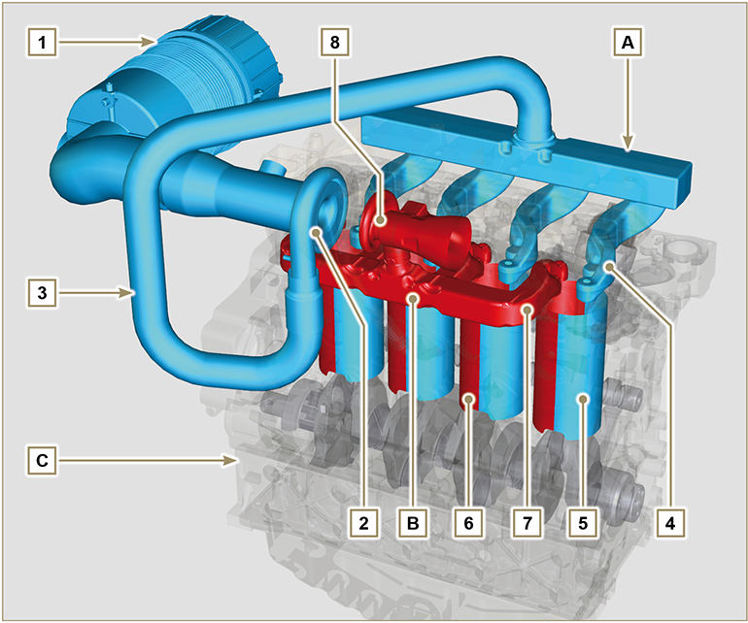  Fig. 2.26
2.12.3 Turbocharger  The turbocharger is controlled by means of exhaust gas that activates the turbine.  Important  - See Par 2.18 .  Tab 2.28  POS. DESCRIPTION  1 Air intake hose  2 Air compression volute  3 Turbo charger central body  4 Turbine housing with Waste Gate valve  5 Gas exhaust flange  6 Waste Gate control valve hose  7 Waste Gate valve control actuator  8 Waste Gate control valve linkage  9 Air compressed flow pipe to intercooler  10 Oil drain pipe  11 Turbo charger lubrication pipe | 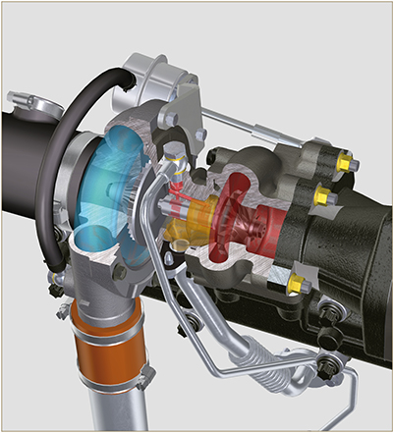  Fig 2.27
2.12.4 Air filter (optional)  NOTE : Component not necessarily supplied by KOHLER .  Important  - The air filter is a dry-type one, with a replaceable paper filter cartridge H (refer to Tab. 2.8 and Tab. 2.9 for procedure frequency on components).  - The filter intake must be positioned in a cool area.  - Should a hose be used, the length must not exceed 400 mm and is to be as straight as possible.  Tab 2.29  POS. DESCRIPTION  H Air filter cartridge  M Filter cover  N Filter support  Q Dust exhaust valve  R Filter cover hook | 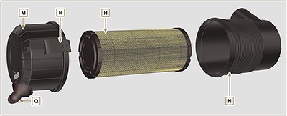  Fig 2.28
2.12.5 Internal EGR  The internal EGR is only on Stage IIIA or Tier 3 engines provided with " CE " approval ( Par. 1.2 ) or " EPA " name plate ( Par. 1.3 ). It is a system that enables breakdown of pollutants through recirculation of combusted gas by reintegrating it in the cylinder during the intake stage.  This process occurs through the use of cam J on the profile of exhaust cam K of camshaft F .  Cam J slightly opens the exhaust valves during opening of the intake valves. | 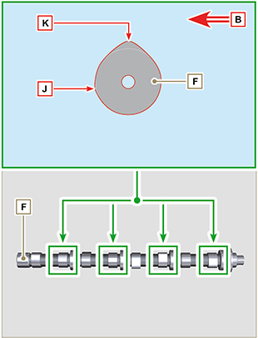  Fig 2.28 A

Electric system
2.13.1 Engine electrical wiring (opzional)  NOTE : Component not necessarily supplied by KOHLER .  Electrical wiring is supplied upon request, it interfaces with the panel by means of 19-way Deutsch connectors (female on engine panel - male on accessories panel).  The connectors are described in Tab. 2.30.  Fig 2.29 | Tab 2.30  REF. DESCRIPTION  1 Engine panel connector interface (Fig. 2.30)  2 Accessories panel connector interface (Fig. 2.31)  3 Electrical fuel pump connector  4 Cold Start Advance connector (on injection pump - Fig. 2.46 )  5 Fuse connector  6 Electro-Stop connector (on injection pump)  7 "L" alternator connector (Iskra)  8 "W" alternator connectors (Iskra)  9 Coolant temperature sensor connector  10 Coolant temperature sensor connector  11 Starter motor connector "+ 50"  12 Starter motor connector "+ 30"  13 Air cleaner clogging sensor connector  14 Earth connector

2.13.1.1 Connector panel on the engine/machine  The connector is a female 19-way Deutsch type. There is a list of all PIN connections in Tab. 2.31.  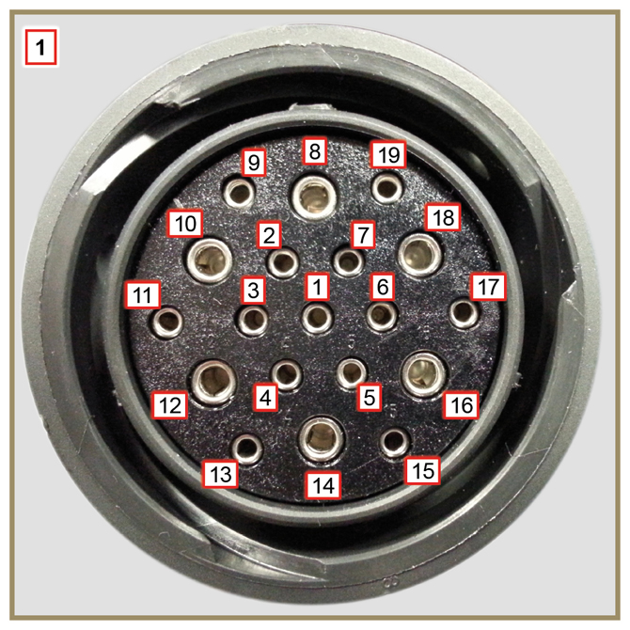  Fig 2.30 | Tab. 2.31  PIN. INLET SIGNALS TO THE PANEL  1 Oil pressure switch  2 Alternator indicator light  3 Coolant temperature warning light  4 Air cleaner clogging warning light  7 Air cleaner clogging warning light  9 Electro-Stop  13 Alternator (W)  14 Starter motor (+ 30)  15 Inlet indicator general alarm  PIN. OUTLET SIGNALS FROM THE PANEL  5 Earth  6 IG excitation alternator (+15 wrench)  8 Starter motor (+ 50)  10 Grid heater (Relay)  11 Electric pump  18 Injection pump (Cold Start Advance - Fig. 2.39 )

2.13.1.2 Accessories panel connector  The connector is a male 19-way Deutsch type. There is a list of all PIN connections in Tab. 2.32.  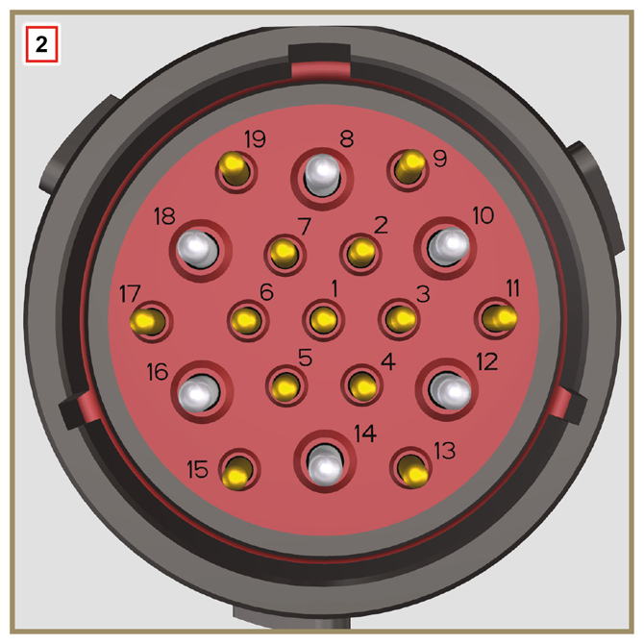  Fig 2.31 | Tab. 2.32  PIN. INLET SIGNALS TO THE PANEL  2 Fuel filter (water detection sensor)  4 Radiator (coolant level sensor)  7 Outlet indicator general alarm  9 External Stop  15 Inlet indicator general alarm  1 Fuel tank (fuel level sensor)  PIN. OUTLET SIGNALS FROM THE PANEL  5 Earth  6 Relay with 5A fuse (+ 15 wrench)  10 Grid heater (Relay)  13 Alternator (W)  17 Coolant temperature warning light

2.13.3.1 Wiring disconnection  Some sensor connectors and electronic control devices are sealed.  This tipe of connectors must be disconnected by means of pressure on tabs A or unblock the retainers B , as illustrated from Fig. 2.32 to Fig. 2.36. | 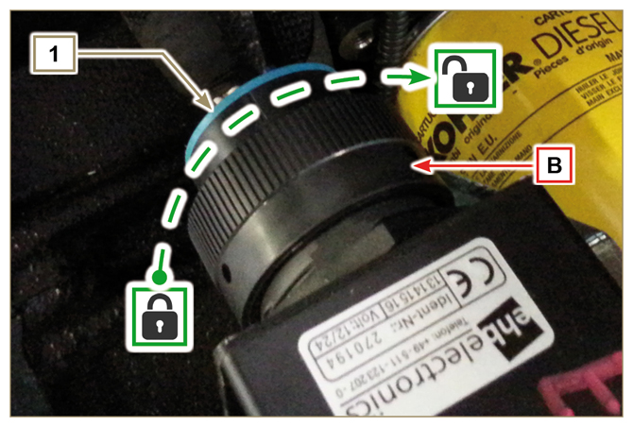  Fig 2.32
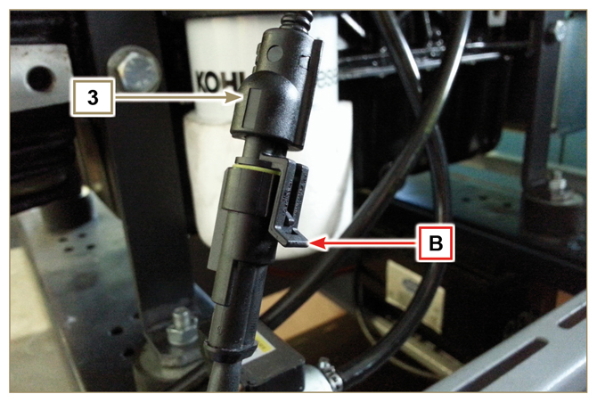  Fig 2.33 | 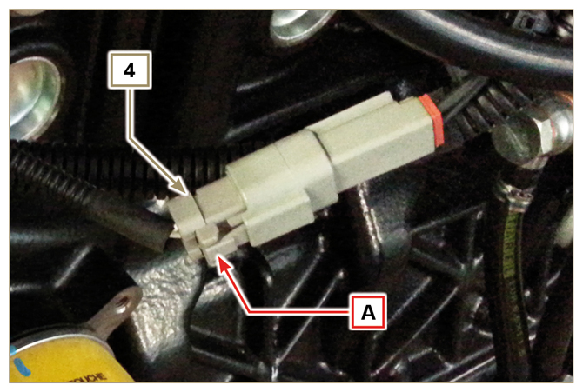  Fig 2.34
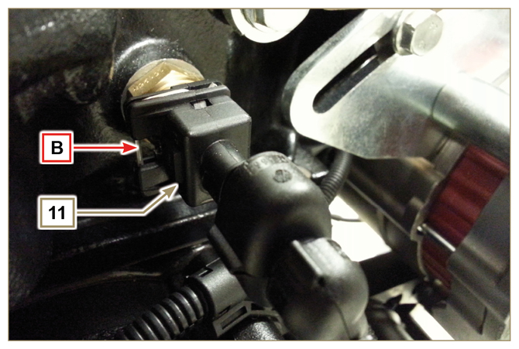  Fig 2.35 | 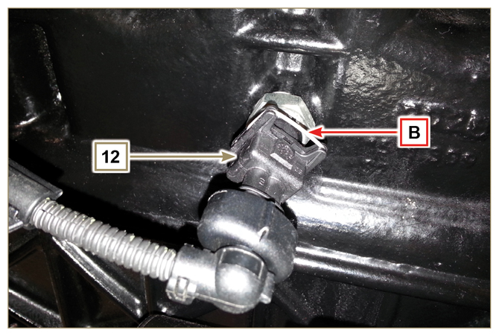  Fig 2.36

Sensors and switches
2.14.1 Fuel filter water detection sensor (optional)  The water presence sensor in the fuel filter serves to indicate the presence of water in the fuel.  The sensor closes the electrical circuit and the warnin lamp in the panel board switches on the dashboard of the car on which the motor is mounted.  Water, if present in the fuel, because of its greater specific weight separates and settles in the lower part of the filter  where there is a drain plug.  Gently loosen the water drain plug without removing it and spill out the water if present. Re-tighten the water drain plug H as soon as the fuel spills. | 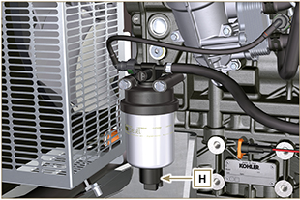  Fig 2.37
2.14.2 Oil pressure switch  Oil pressure switch N is assembled on the crankcase near to the injection pump.  It is a N/C sensor, calibrated at 0.6 bar ± 0.1 bar.  With oil low pressure the sensor closes the electrical circuit and the warning lamp in the panel board switches on. | 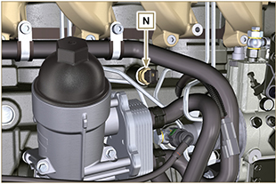  Fig 2.38

2.14.3 Coolant temperature sensor connector  The sensor has the dual function of a thermometer and thermal contact.  The coolant/thermal contact P temperature probe is applied to the cylinder head on the side of the thermostatic valve.  Sensor P1 or P2 (Fig. 2.39) can be assembled on the engine:  P1 Characteristics indicated in Tab. 2.33A (blue connector).  Thermal contact N/O with closing temperature at +110 °C ±3°C, re-opening +88 °C / +100 °C.  P2 Characteristics indicated in Tab. 2.33B (white connector).  Thermal contact N/O with closing temperature at +110 °C ±3°C, re-opening +88 °C / +100 °C.  NOTE : R indicates the pin where it is possible to measure electrical resistance.  Tab 2.33A  SENSOR P1 CHARACTERISTICS  Temperatura °C R min Ω R max Ω  -35 53.983 73.806  -30 39.229 52.941  -15 18.006 20.825  0 7.095 8.929  30 1.717 2.039  60 0.520 0.589  90 0.188 0.204  120 0.076 0.084  Tab 2.33B  SENSOR P2 CHARACTERISTICS  Temperatura °C R min Ω R max Ω  -36 11.835 15.724  -30 8.258 10.834  -16 3.721 4.753  0 1.611 2.003  30 414,1 493  60 132 151,7  90 50,27 56,11  120 21,6 24,29 | 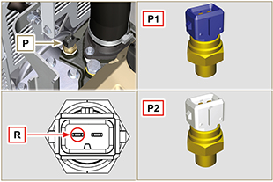  Fig 2.39
2.14.4 Air cleaner clogging switch  NOTE: Component not necessarily supplied by KOHLER .  The switch is assembled on the air cleaner. When the filter is clogged, it sends a signal to the panel.  Features:  - Operating temperature: -30 °C / +100°C  - Contact usually open.  - Contact closed by vacuum: -50 mbar. | 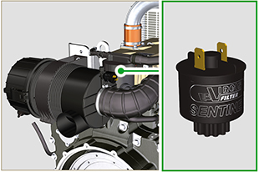  Fig 2.40

Electrical components
2.15.1 Alternator (A)  Externally controlled by the crankshaft by means of a belt.  - Ampere 90 A  - Volt 12V | 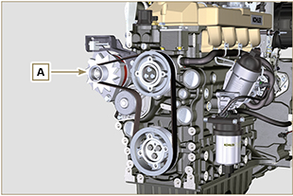  Fig 2.41
2.15.2 Starter Motor (C)  - Type Bosch 12 V  - Potenza 3.2 kW  - Anticlockwise rotation (seen from timing system side) | 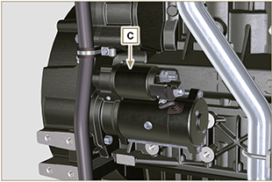  Fig. 2.42
2.15.3 Cold starting device (Heater)  The cold starting device consists of a resistance, managed by the pre-heater timer H , which is activated when the ambient temperature is ≤-16° C.  The intake air is heated through the resistance and facilitates starting the engine.  Characteristics:  - Type Hidria AET 12 V  - Power 550 W | 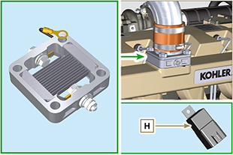  Fig 2.43

2.15.4 Electric fuel pump (optional)  NOTE: Component not necessarily supplied by KOHLER.  The electric pump A is located before the fuel filter.  Characteristics:  - Delivery: 60.56 L/h @ 0.41 bar  - Volt: 12 V | 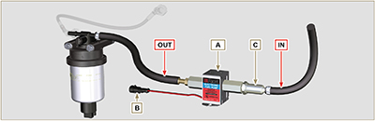  Fig 2.44  Tab. 2.38  POS. DESCRIPTION  B Electrical connection  C Prefilter pump  IN Ingoing fitting (IN) from tank  OUT Outgoing fitting (out) to fuel filter
2.15.5 Cold Start Advance (CSA)  The Cold Start Advance E device is part of injection pump D ; it provides for advance injection modification to enable advance of the engine at low temperatures.  2.15.6 Elettro-Stop  The electro-stop F device is part of injection pump D ; it turns off the engine by blocking the flow of fuel into pump D . | 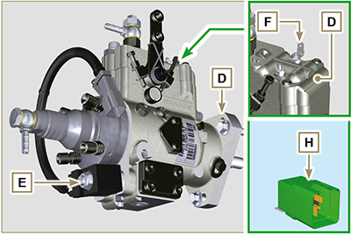  Fig 2.45

2.15.7 Starting Relay  The H device assists cold engine ignition controlling the "cold starting device" ( Heater ) and the "Cold Start Advance" ( CSA ). Tab. 2.39 indicates the activation times based on the ambient temperature.  Identify the code using the spare parts catalogue ( https://partners.lombardini.it/App/SparepartCatalogue_2.0/Default/Catalogue.aspx ).  Tab. 2.39a - code ED0021934440-S  °C Heater (Pre-Heating) Heater (Post- Heating ) CSA  > 20 ÷ -15 0" 0" 120"  -16 16" 10"  -21 21"  -26 26"  ≤ -32 32"  Tab. 2.39b - code ED0021936660-S  °C Heater ( Pre-Heating ) Heater ( Post- Heating ) CSA  > 20 ÷ -15 0" 0" 10"  -16 16" 10"  -21 21"  -26 26"  ≤ -32 32"  Tab. 2.39c - code ED0021939560-S  °C Heater ( Pre-Heating ) Heater ( Post- Heating ) CSA Fuel Delay (Fuel supply delay)  > 5 0" 0" 10" 3"  4 ÷ 0 3.1" ÷ 3.5"  -1 4"  -2 4.5"  -3 5"  -4 5.5"  -5 ÷ -9 6"  -10 ÷ -14 8"  -15 15" 10"  -16 16"  -21 21"  -26 26"  ≤ -32 32" | 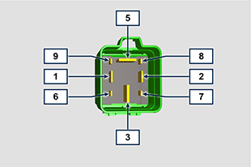  Fig 2.46  Tab. 2.40  POS. CONNECTED TO:  1 15 - ignition  2 Ground  3 30 - battery  5 Heater  6 CSA  7 Control panel indicator  8 ...  9 50 - ignition
2.15.8 Fusibile  Device G is assembled on cylinder head P (flywheel side); it protects the electrical circuit in the event of an overload or short circuit.  NOTE: Component not necessarily supplied by KOHLER. | 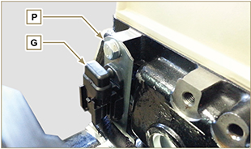  Fig 2.47

2.15.9 Control panel (optional)  Panel L can be assembled on the engine or machine.  In Tab. 2.41 , are described the main functions are illustrated.  NOTE: Component not necessarily supplied by KOHLER.  Tab. 2.41  POS. DESCRIPTION  M Hour-meter indicator  S Control switch to start the engine  W1 Panel ignition indicator  W2 Warning Light - battery not charging  W3 Warning Light - engine oil not pressurised  W4 Warning Light - high coolant temperature  W5 Warning Light - alarm general indicator | 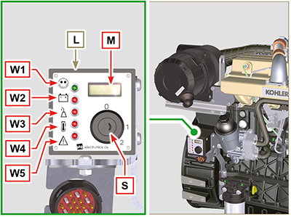  Fig 2.48

Timing system and tappets
The timing system is equipped with hydraulic tappets that automatically recover the operation of the rocker rods assembly.
No registration is therefore required.

2.16.1 Components identification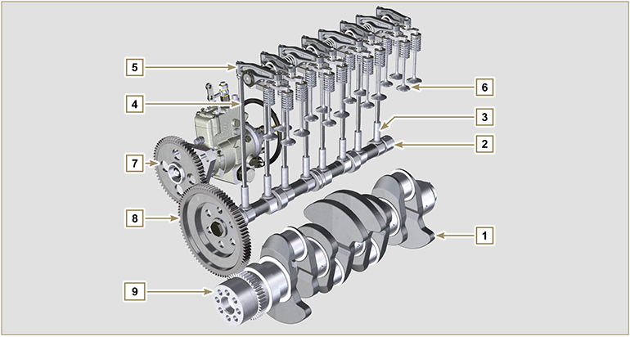
Fig 2.49
Tab 2.42  POS. DESCRIPTION  1 Crankshaft  2 Camshaft  3 Camshaft tappets  4 Rocker arm control rod  5 Rocker arms  6 Valves  7 High-pressure fuel injection gear pump control  8 Camshaft control gear  9 Crankshaft gear  10 Valve control bridge  11 Articulation control valves  12 Hydraulic tappets | 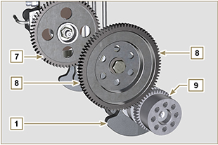  Fig 2.50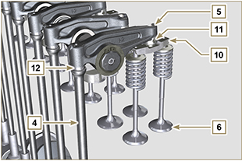  Fig 2.51
2.16.2 Timing system phasing angles  Important  - For information purposes, Tab. 2.43 reports the timing system diagram phasing angle values.  - It should be noted that the said values may be verified by rotating the crankshaft (Pos. 1 of Fig. 2.50) , by means of handling the rocker arm control rod (Pos. 4 of Fig. 2.51) .  NOTE: Detecting the value by means of handling the rocker arm/valves may not be correct due to the hydraulic tappets, which may compress and create clearances that alters the actual value.  Tab 2.43  ENGINE INTAKE EXHAUST  KDI 3404 TM opens 12° before TDC opens 22° before BDC  closes 36° after BDC closes 8° after TDC | 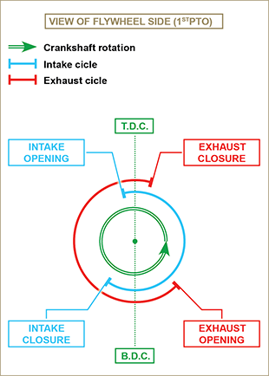  Fig 2.52
2.16.3 Rocker arm pin  Tab 2.44  POS. DESCRIPTION  1 Rocker arm pin  2 Rocker arm distancing spring  3 Rocker arm pin support  4 Exhaust rocker arm  5 Intake rocker arm | 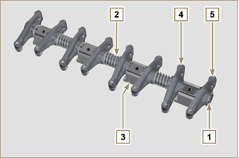  Fig 2.53
2.16.4 Rocker arms  Tab 2.45  POS. DESCRIPTION  1 Rocker arm body  2 Hydraulic tappet oil refill line  3 Valve tappet lubrication line  4 Valve tappet  5 Hydraulic tappet  6 Oil flow line | 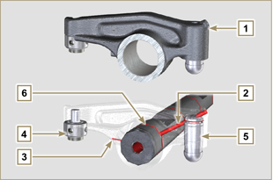  Fig 2.54
2.16.5 Hydraulic tappets  Tab 2.46  POS. DESCRIPTION  A Hydraulic tappets  B Hight pressure chamber  1 Hydraulic tappets oil refill pipe  2 Retaining ring  3 Piston  4 Unidirectional valve  5 Tappet body  6 Spring  2.16.5.1 Hydraulic tappet operation  The operating principle of the hydraulic tappet is based on the incompressibility of the liquids and on controlled leakage.  The oil under pressure enters the tappet chamber A , providing a constant supply of oil in the low-pressure chamber.  Through the non-return valve, 4 the oil can only access the high-pressure chamber B and exit via the clearance between the piston 3 and the tappet body 5 (controlled leakage).  The chamber B is filled when the rocker arm is on the base radius of the cam and the spring 6 keeps the piston 3 against the valve stem, thus eliminating any system play. Thanks to the spring extension, the tappet "extends", creating a small depression in the chamber B , making the non-return  valve 4 open, and allowing the oil in the chamber A to pass to chamber B , restoring the proper amount of oil required to eliminate any play in the valves. | 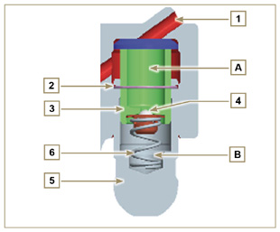  Fig 2.55

2.16.5.2 Difficult operating conditions
For proper operation on the hydraulic tappets it is essential that the low pressure chamber of the piston 3 is always full of oil.

In some conditions this may not occur (due to the fact that the oil leaks away when the engine is switched off, which can also partially drain the tappets). This situation will be the cause of clearances that will result in a characteristic noise similar toa ticking sound.
- When the engine is cold, the tappet filling time could be very long if the oil used is not suitable for the specific environmental conditions ( Tab. 2.2 )
- If the engine is very hot: at idle speed, oil pressure may be low, and small air bubbles could form in the circuit. Because of this, this compressing the tappet slightly and producing valve play which is responsible for the ticking sound. On account of this, the tappet compresses slightly giving rise to a valve clearance, thus generating a slight ticking sound, which however disappears rapidly ( MAX 10 seconds) once normal operating conditions have been restored.

Anyway the duration of ticking Anyway the duration of ticking sound must be MAX 30 seconds. If not, the problem is surely due to the poor quality of the oil, wear or impurities that, transported by the oil, can infiltrate between the ball valve and its seat inside the piston, compromising the operation of the tappet itself; In these cases, the only solution is to replace the oil or hydraulic tappets.

The prolonged persistence of the ticking sound or abnormal noise must be investigating in order to prevent any malfunctions; if necessary, replace the hydraulic tappets and engine oil.

Components handling
2.17.1 Injection pump  - Only handle by means of the points marked by Y .  - It is forbidden to handle using the points marked by N . | 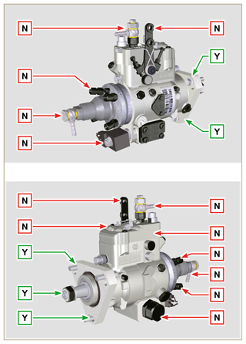  Fig 2.56
2.17.2 Injector  - Only handle by means of the points marked by Y .  - It is forbidden to handle using the points marked by N . | 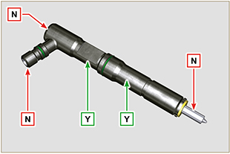  Fig 2.57
2.17.2 Turbochargerector  - Only handle by means of the points marked by Y .  - It is forbidden to handle using the points marked by N . | 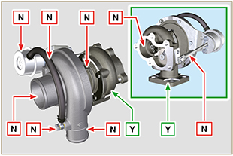  Fig 2.58

Turbocharger
2.18.1 What to do and what not to do  What to do:  - Before assembling the turbocharger, make sure that the protection caps are fitted on all openings of the turbo.  - Ensure pre-lubrication of the turbocharger.  - Periodically check that the joints are sealed against oil and air.  - Use lubricating oil according to the specifications described in Par. 2.4 .  - Check the engine oil level.  - Before switching it off after it has been used, make the engine run idle, or without a load, for approximately 1 minute.  - Ensure that controls and maintenance intervals of the engine are observed as specified in Tab. 2.8 and 2.9 .  - Make sure that the engine and equipment are used correctly so as not to compromise the life of the turbocharger. | What not to do:  - Do not store turbocharges in damp, wet places if they are not in their original packaging.  - Do not expose the turbocharger to dust and dirt if it is not in its original packaging.  - Do not lift of hold the turbocharger from the actuator rod if it is not in its original packaging.  - Do not apply additives to the lubricating oil and fuel, unless instructed to do so by Kohler.  - Do not increase engine speed, or apply loads, immediately after start-up.  - Do not intervene on the actuator settings A (Fig. 2.59) .  - Do not let the vehicle / engine run at idle speed for more than 20-30 minutes at a time.
2.18.2 Practical operating rules  Users can help to maximise the duration of their turbocharger by following the rules described below.  - Start-up Start the engine at idle speed, or without a load, for approximately one minute. Oil operating pressure is reached within a few seconds and enables the moving parts to warm up and be lubricated.  Immediately increasing the engine speed upon start-up means making the turbocharger run at high speed with suboptimal lubrication, which may compromise the life of the turbocharger.  - After maintenance or a new installation  Proceed with pre-lubrication by filling new oil into the oil supply duct B until filling it completely. Start the engine at idle speed, or without a load, for a few minutes in order to ensure that the oil and bearings system operate satisfactorily.  - Low temperature air or engine inactivity  If the engine has been inactive for some time, or the air temperature is very low, start the engine at idle speed or without a load for a few minutes.  - Engine shutdown  Before switching the engine off after intense activity, one must allow the turbocharger to cool down. One must therefore let the engine run at idle speed or without a load for at least 2 minutes, thus allowing the turbocharger to cool.  - Engine at idle speed  Avoid using the engine at idle speed or without a load for long periods (more than 20-30 minutes). When operating at idle speed or without a load, the turbocharger is at low pressure in the exhaust chamber C and air supply D ; this may cause oil leaks from seals E  to the extremity of the shaft. Even if this does not cause damage, it can cause blue smoke from the exhaust when the engine speed and load are increased. | 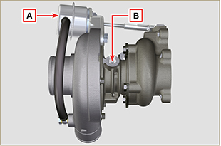  Fig 2.59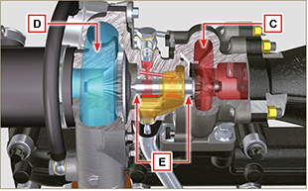  Fig 2.60
2.18.3 Before installing a new turbocharger  Important  - Do not lift the turbocharger with one hand from the box.  - Do not lift turbocharger from Comp hsg side.  - Lift the turbocharger with both hands from box.  - Make sure to use clean gloves.  - Handle the turbocharger as indicated in Par. 2.17.4. | 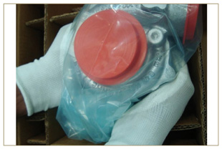  Fig 2.61
- Avoid lifting from the intake side G .  - Remove cap guard F and check that there is no excessive shaft axial and radial clearances. | 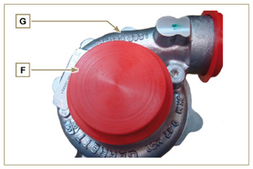  Fig 2.62
- Check for any signs of friction of the turbine on the turbocharger body.  - Check for any traces of oil leaks on the turbocharger body.  - After having check everything, reapply cap F on intake opening H of the turbocharger and do not remove it until assembly has been completed. | 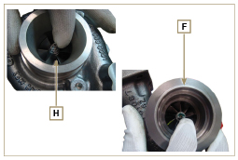  Fig 2.63
- Check the correct assembly of the capscrews and the presence of paint on them. | 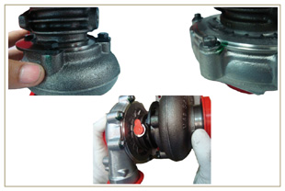  Fig 2.64
2.18.4 Installation instructions  - Remove the cap guards with care only when assembling.  Handle carefully avoiding erratic movements. | 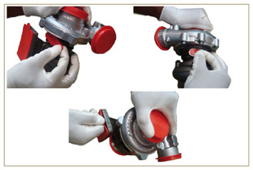  Fig 2.65
2.18.5 Replacement instructions

Always understand the cause of the breakage of the turbocharger before replacing it.

Correct the cause of the breakage before replacing it with a new turbocharger.

If in doubt, contact KOHLER service department.

Important

- Failure to comply with these instructions can cause damage to the turbocharger and void the warranty.
- Modifying the calibration of the turbocharger damages the turbocharger/engine.
- Always use the correct gaskets, and fit carefully to avoid blocking holes when mounting.
- Refer to the manual of the engine / vehicle, for: the correct type and quantity of oil, the correct tightening of components, instructions and installation.
- It is forbidden to use liquid gaskets or sealants, particularly for the oil inlet/outlet.
- Avoid dirt / debris while installing the turbocharger.
- Before mounting the turbocharger, check that the code of the component is correct for the type of engine, as mounting the wrong turbocharger can damage the turbo / engine and void the warranty.

Safety information

Before start-up
- Read the manual carefully and carry out the operations described below in compliance with the instructions specified.
- Periodic inspection and maintenance operations must be carried out as indicated in this manual and under the user's responsibility.

Important

- Only use original spare parts and accessories.
- The use of non-original parts, as well as voiding the warranty, affects the life and performance of the engine, and may be dangerous.
- Non compliance with the operations described in the following pages may result damage to the engine and vehicle on which it is installed, as well as to people and/or property.

Safety precautions
- The intended use of the engine is in conformity with the machine on which it is mounted.
- Any use of the machine other than that described cannot be considered as complying with its intended purpose as specified by KOHLER .
- KOHLER declines all responsibility for any change to the engine not described in this manual made by unauthorized KOHLER personnel.
- A proper use of the engine, a strict observance of the rules listed below and the rigorous application of all these precautions will avoid the risk of accidents or injuries.
- Those who carry out the use and maintenance on the engine must wear the safety equipment and the accident-prevention guards (Par 3.4.3) .
- KOHLER declines all direct and indirect liability for failure to comply with the standards of conduct contained in this manual.
- KOHLER cannot consider every reasonably unforeseeable misuse that may cause a potential danger.

General remarks
3.3.1 Note for OEM
- When installing the KDI engines, always bear in mind that any variation to the functional systems may result in serious failures to the engine.
- Any improvement must be verified at KOHLER testing laboratories before application of the engine.
- In case the approval to a modification is not granted, KOHLER shall not be deemed responsible for any consequential failures or damages to the engine.
- Those who carry out the use and maintenance on the engine must wear the safety equipment and the accident-prevention guards.
- KOHLER declines all direct and indirect liability for failure to comply with the standards of conduct contained in this manual.
- KOHLER cannot consider every reasonably unforeseeable misuse that may cause a potential danger.
3.3.2 Note for end user
- The following indications are dedicated to the user of the machine in order to reduce or eliminate risks concerning engine operation and the relative routine maintenance work.
- The user must read these instructions carefully. Failure to do this could lead to serious danger for his personal safety and health and that of any persons who may be in the vicinity of the machine.
- On starting, make sure that the engine is as horizontal as possible, unless the machine specifications differ.
- Make sure that the machine is stable to prevent the risk of overturning.
- The engine must not operate in places containing inflammable materials, in explosive atmospheres, where there is dust that can easily catch fire unless specific, adequate and clearly indicated precautions have been taken and have been certified for the machine.
- To prevent fire hazards, always keep the machine at least one meter from buildings or from other machinery.
- Children and animals must be kept at a due distance from operating machines in order to prevent hazards deriving from their operation.
- Thoroughly wash and clean all the external parts of the engine before performing any operation, in order to avoid the accidental introduction of impurities/foreign bodies. Use only water and/or appropriate products to clean the engine. If cleaning engine with a pressure washer or steam cleaner, it is important to maintain a minimum distance of at least 200mm between the surface to be washed and the nozzle. Avoid directing the nozzle on electrical components, cable connections and sealed rings (oil seals etc). Thoroughly wash and clean the area surrounding the engine following the instructions provided by machine manufacturer.
- Fuel and oil are inflammable. The tank must only be filled when the engine is off. Before starting, dry any spilt fuel.
- Make sure that no soundproofing panels and the ground or floor on which the machine is standing have not soaked up any fuel.
- Fuel vapour is highly toxic. Only refuel outdoors or in a well ventilated place
- Do not smoke or use open flames when refuelling.
- During operation, the surface of the engine can become dangerously hot. Avoid touching the exhaust system in particular.
- Before proceeding with any operation on the engine, stop it and allow it to cool.
- Always open the radiator plug or expansion chamber with the utmost caution, wearing protective garments and goggles.
- The coolant fluid is under pressure. Never carry out any inspections until the engine has cooled.
- If there is an electric fan, do not approach the engine when it is still hot as the fan could also start operating when the engine is at a standstill.
- The oil must be drained whilst the engine is hot. Particular care is required to prevent burns. Do not allow oil to come into contact with the skin because of the health hazards involved. It is recommended to use an oil intake pump.
- During operations that involve access to moving parts of the engine and/or removal of rotating guards, disconnect and insulate the negative wire (-) of the battery to prevent accidental short-circuits and to stop the starter motor from being energized.
- Check belt tension only when the engine is off.
- Fully tighten the tank cap each time after refuelling. Do not fill the tank right to the top but leave an adequate space for the fuel to expand.
- To start the engine follow the specific instructions provided in the engine and/or machine operating manual. Do not use auxiliary starting devices not originally installed on the machine (e.g. Startpilot).
- Before starting, remove any tools that were used to service the engine and/or machine. Make sure that all guards have been refitted.
- Do not mix fuel with elements such as oil or kerosene. Failure to comply with this prohibition will cause the non-operation of the catalyst and non-observance of the emissions declared by KOHLER .
- Pay attention to the temperature of the oil filter when the filter itself is replaced.
- Only check, top up and change the coolant fluid when the engine is off and reached the ambient temperature. Coolant fluid is polluting, it must therefore be disposed of in the correct way.
- Do not use air and water jets at high pressures on cables, connectors and injectors.

Important

- Only use the eyebolts A installed by KOHLER to move the engine (Fig. 3.1) .
- The angle between each lifting chain and the eyebolts shall not exceed 15° inwards.
- NOTE : the lifting chain must be vertical for engines equipped with the radiator with Intercooler.
- The correct tightening of the lifting screws is 80Nm.
- Do not interpose spacers or washers between the eyebolts and engine head.
- Provided that the above requirements are met, if the lifting eyebolts are subject to permanent deformation (inwards), all subsequent lifting operations must be performed in order to prevent them from bending in the opposite direction.
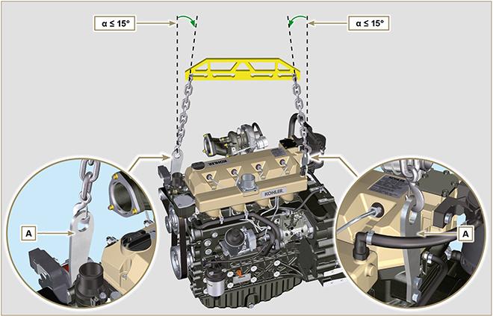
Fig 3.1

Safety signal description
- To ensure safe operation please read the following statements and understand their meaning.
- Also refer to your equipment manufacturer's manual for other important safety information.
- This manual contains safety precautions which are explained below.
- Please read them carefully.

3.4.1 Adhesive safety plates
The following is a list of the adhesive safety plates that may be found on the engine, which indicate potential points of danger to the operator.
Read the Operation and Maintenance handbook before performing any operation on the engine.
Hot Parts.
Danger of burns.
Presence of rotating parts.
Danger of jamming or cutting.
Presence of explosive fuel.
Danger of fire or explosion.
Presence of steam and pressurized coolant.
Danger of burns.
3.4.2 Warnings
Hereunder is a list of safety warnings that may be found in the manual, which advise you to pay attention when carrying out particular procedures that may be potentially dangerous to the operator or things.
Danger
This indicates situations of grave danger which, if ignored, may seriously threaten the health and safety of individuals.
Important
This indicates particularly important technical information that should not be ignored.
Warning
This indicates that failure to comply with it can cause minor damage or injury.
3.4.3 Safety guards Hereunder is a list of safety guards that must be worn prior to carrying out any type of operation and to avoid potential
harm to the operator.
Use suitable protective gloves before carrying out any type of operation.
Use protective goggles before carrying out any type of operation.
Use earmuffs before carrying out any type of operation.

Information and safety signals
ACCIDENTAL START  Accidental Starts can cause severe injury or death.  Before working on the engine or equipment, disconnect the battery negative (-) wire.  HOT PARTS  Hot Parts can cause severe burns.  Engine components can get extremely hot from operation. Do not touch engine while operating or just after stopping.  Never operate the engine with heat shields or guards removed.  ROTATING PARTS  Rotating Parts can cause severe injury.  Stay away while engine is in operation. Keep hands, feet, hair, and clothing away from all moving parts to prevent injury. Never operate the engine with covers, shrouds, or guards removed.  LETHAL EXHAUST GASES  Carbon Monoxide can cause severe nausea, fainting or death.  Avoid inhaling exhaust fumes and never run the engine in a closed building or confined area.  Carbon monoxide is toxic, odorless, colorless, and can cause death if inhaled.  ELECTRICAL SHOCK  Electrical Shock can cause injury.  Do not touch wires while engine is running. | HIGH PRESSURE FLUID RISK OF PUNCTURE  High Pressure Fluids can puncture skin and cause severe injury or death.  Work on the injection system must be carried out by suitably trained staff wearing protection equipment. Injuries caused by fluid penetration are highly toxic and dangerous.  If an injury occurs, seek immediate medical attention.  EXPLOSIVE FUEL  Explosive fuel can cause fires and severe burns.  Fuel is flammable and its vapours can ignite. Store fuel only in approved containers, in well ventilated,  unoccupied buildings. Do not fill the fuel tank while the engine is hot or running, since spilled fuel could ignite if it comes in contact with hot parts or sparks from ignition. Do not start the engine near spilled fuel. Never use fuel as a cleaning agent.  EXPLOSIVE GAS  Explosive Gas can cause fires and severe acid burns.  Charge battery only in a well ventilated area. Keep sparks, open flames, and other sources of ignition away from the battery at all times. Batteries produce explosive hydrogen gas while being charged.  Keep batteries out of the reach of children. Remove all jewelry when servicing batteries. Before  disconnecting the negative (-) ground cable, make sure all switches are OFF. If ON, a spark will occur at the ground cable terminal which could cause an explosion.  CALIFORNIA WARNING - DECLARATION 65  Engine exhaust from this product contains chemicals known to the State of California to cause cancer, birth defects, or other reproductive harm.

Safety and environmental impact
Every organisation has a duty to implement procedures to identify, assess and monitor the influence of its own activities (products, services, etc.) on the environment. Procedures for identifying the extent of the impact on the environment must consider the following factors: - Disposal of liquids.

- Waste management.

- Soil contamination.

- Atmospheric emissions.

- Use of raw materials and natural resources.

- Regulations and directives regarding environmental impact.
In order to minimise the impact on the environment, KOHLER provides some indications to be followed by all those handling the engine, for any reason, during its expected lifetime. - All components and fluids must be disposed of in accordance with the laws of the country in which disposal is taking place.

- Keep the injection system as well as engine management and exhaust pipes in efficient working order to limit environmental and noise pollution.

- When decommissioning the engine, select all components according to their chemical characteristics and dispose of them separately.

Location of safety labels on engine
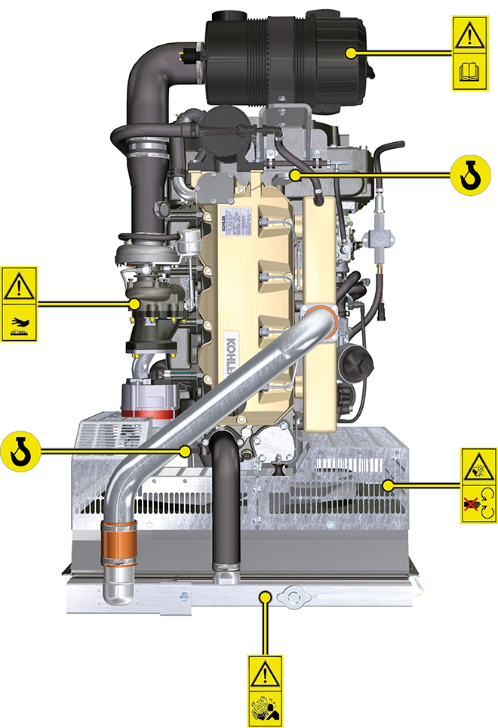

Storage information

Product preservation

Important

- If the engines are not to be used for 6 months, they must be protected by carrying out the operations described in Engine storage (up to 6 months) (Par. 4.2) .
- If the engine is still not in use after the first 6 months, it is necessary to carry out a further procedure to extend the protection period (more than 6 months) (Par. 4.3) .
- If the engine is not to be used for an extended period, the protective treatment procedure must be repeated within 24 months of the previous one.

Engine storage (up to 6 months)
Before storing the engine check that:
- The environments are not humid or exposed to bad weather. Cover the engine with a proper protective sheet against dampness and atmospheric contaminants.
- The place is not near electric panel.
- Avoid storing the engine in direct contact with the ground.

Engine storage (over 6 months)
Follow the steps described in Par. 4.2 .
- Pour protective oil in the carter up to the MAX level.
- Refuel with fuel additives for long storage.The following additives are recommended: DEFA Fluid Plus (Pakelo Lubricants),

Diesel Treatment (Green Star),

Top Diesel (Bardhal),

STP® Diesel Fuel Injector Treatment.
- With expansion tank:
make sure that the coolant is up to the maximum level.
- Without expansion tank: Top liquid up until the pipes inside the radiator are covered by about 5 mm.

Do not overfill the radiator, but leave room for the fuel to expand.
- Start the engine and run it at idle speed for around 2 minutes.
- Bring the engine to 75% of maximum rated speed for 5 to 10 minutes.
- Turn off the engine.
- Empty out completely the fuel tank.
- Spray SAE 10W-40 on the exhaust and intake manifolds.
- Seal the exhaust and intake ducts to prevent foreign bodies from entering.
- When cleaning the engine, if using a pressure washer or steam cleaning device, avoid directing the nozzle on electrical components, cable connections and sealed rings (oil seals etc).
If cleaning engine with a pressure washer or steam cleaner, it is important to maintain a minimum distance of at least 200mm between the surface to be washed and the nozzle - avoiding absolutely electrical components such as alternators, starter motors and engine control units (ECU).
- Treat non-painted parts with protective products.
- Loosen the alternator belt Par. 6.2.1 point 1 and 2 .
If the engine protection is performed according to the suggestions indicated no corrosion damage will be found.

Engine starting after storage
- Remove the protective sheet.
- Use a cloth soaked in degreasing product to remove the protective treatment from the external parts.
- Inject lubricating oil (no more than 2 cm ³ ) into the intake ducts.
- Adjust the alternator belt tension.
- Refill the tank with fresh fuel.

Warning

- Over time, lubricants and filters lose their properties, so itis important to consider whether they need replacing, also based on the criteria described in Tab. 2.9 .

- Make sure that the oil and the coolant are up to the maximum level.
- Start the engine and run it at idle speed for around 2 minutes.
- Bring the engine to 75% of maximum rated speed for 5 to 10 minutes.
- Stop the engine and while the oil still hot, perform the operation in Par. 5.2 .
- Replace the filters (air, oil, fuel) with original spare parts.
- Perform the operations described in Par. 10.1 .
- Perform the operations described in Par. 5.1 and Par. 10.2

Information regarding discharge of liquids

Coolant
Important  - Before proceeding with operation, read Par. 3.3.2 .  N OTE: Component not necessarily supplied by KOHLER . The representation of the radiator is purely indicative.  Warning  - Presence of steam pressurized coolant danger of burns.  - Undo the cap A carefully (circuit under pressure). | 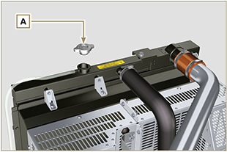  Fig 5.1
- Loosen clamp F and remove hose H to drain all liquid from the system contained in the engine crankcase ducts into an appropriate container and refer to Par. 3.6 . | 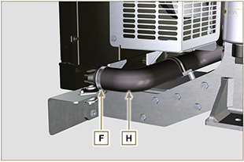  Fig 5.2
NOTE : Click by side to play the procedure. | https://www.youtube.com/embed/wRTc0YtKg3I?rel=0

Engine oil
Important  - Before proceeding with operation, read Par. 3.3.2 .  - This operation should be carried out with vacuum pump. The oil must be drained whilst the engine is hot, which requires particular care to prevent burns. Do not allow oil to come into contact with the skin because of the health hazards involved. It is recommended to use an oil intake pump via the oil dipstick hole B.  - Electric/pneumatic screwdrivers are forbidden.  - Undo the cartridge holder cover C by performing three complete turns and wait 1 minute.  NOTE : this operation will allow to oil contained in the support G to flow into the oil sump in the correct way.  - Unscrew cartridge holder cover C and check that the oil in the lub. oil filter bracket G has flowed towards the oil sump (refer to NOTE in Par. 2.10.3 ).  - Undo the oil filler cap A (Fig. 5.5) .  - Remove the oil dipstick B .  - Remove the oil drain plug D and the gasket E (the oil drain plug is on both sides of the oil sump).  - Drain oil in to an appropriate container.  (For used oil disposal refer to the Par. 3.6 ).  - Replace gasket E .  - Tighten the drain oil plug D (tightening torque at 50 Nm ).  - Perform the operations described in Par. 6.4.2 and the operation 5 Par. 6.4.3 . | 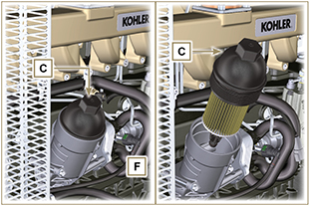  Fig 5.3  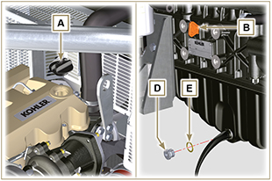  Fig 5.4
NOTE : Click by side to play the procedure. | https://www.youtube.com/embed/gQdAefV1CYs?rel=0

Information for replacing the functional units

Injector and injection pump replacement
Important  - Before proceeding with operation, carefully read Par. 3.3.2 .  - Replace the high pressure pipes after two disassemblies.  - Seal all injection component unions as illustrated in Par. 2.9.7 during disassembly.  - Always replace the gaskets after each disassembly.  - Handle the components as described in Par. 2.18 .  - Refer to Par. 1.3 for operating references when assembling and disassembling.  - When repaired, RSN-A injectors must be certified by a Stanadyne centre to check their correct operation - check the type of engine mounted injectors on the spare parts list ( RSN-A is specified in the description). | 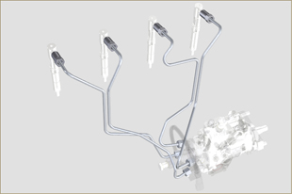  Fig 6.1
6.1.1 Injection fuel pipes disassembly (injection pump/injectors)  - Undo the screw s A .  - Undo the screws B .  - Remove quick fitting C .  - Undo the screws D and remove the manifold E . | 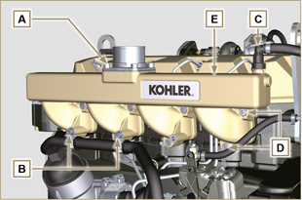  Fig 6.2
- Undo the screw H1 and remove the clamp H2 and remove rubber.  - Undo the nuts F .  - Undo the nuts G .  - Remove the tube H . | 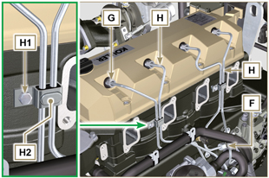  Fig 6.3
6.1.2 Rocker arms cover disassembly  - Undo the screw L .  - Undo the screw M.  - Undo the screws N and remove the rocker arm cap P . | 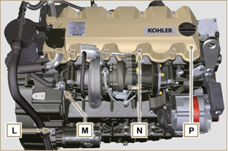  Fig 6.4
6.1.3 Fuel return pipes disassembly  - Undo the screws Q and remove hose R . | 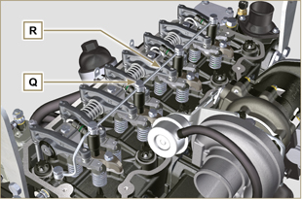  Fig 6.5
6.1.4 Injectors disassembly  - Undo the screw J and remove washer K and then bracket X .  - Remove the injector Z .  NOTE: Should you be unable to remove the electronic injector (acting only on point BC), use an open-ended spanner (Ø 11 mm), by applying small rotations to unblock the component.  - Seal all injection component unions as illustrated in Par. 2.9.7 .  - Ensure that gasket S has remained in the correct position ( Fig. 6.7 ). Otherwise, recover the gasket from inside the electronic injector V manifold. | 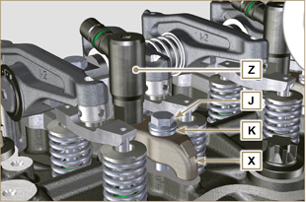  Fig 6.6  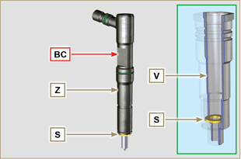  Fig 6.7
NOTE: Click on the right to play the procedure. | https://www.youtube.com/embed/mt-Dsw4A81A?rel=0
6.1.5 Injection pump disassembly  Importante  - Before proceeding with the disassembly, identify the pump code from its identifying name plate ( Pos. 12 - Tab. 2.12 ) and remove the cylinder injector 1 ( Par. 1.4 - 6.1.1 - 6.1.2 - 6.1.3 - 6.1.4 ).  - Alternatively, you can identify the pump from the online spare parts catalogue ( https://partners.lombardini.it/App/SparepartCatalogue/Default/Catalogue.aspx )  - Insert the tool ST_30 into the injector N°1 and fix it with the fixing brace X , capscrew J and washer K .  NOTE : Do not tighten the capscrew J . | 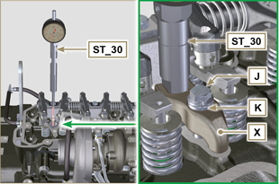  Fig 6.8
- Disassemble the starter motor.  - Mount the tool ST_34 in the seat of the starter motor Y and fit it with the two starter motor fixing screws.  - Rotate the crankshaft clockwise (Rif. A Par. 1.4 ) through the ST_34 tool bringing reference X upwards.  NOTE : When positioning reference X , make sure cylinder N° 1 is in compression phase (the valves on piston N° 1 must all be closed). | 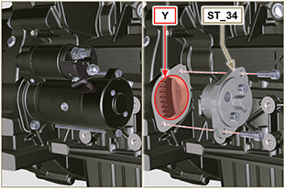  Fig 6.9

- With reference X pointed upwards, find the TDC through tool ST_30 , then bring the dial gauge indicator to 0. | 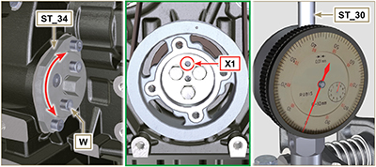  Fig 6.10
- By means of the identified pump code, refer to Tab. 6. 1 to know the advance degrees and the corresponding value to lower the piston.  - Having identified the value to lower the piston, rotate the crankshaft anti-clockwise by going beyond the value described in Tab. 6.1 , once again, rotate the crankshaft clockwise, stopping at the correct advance value by using tool ST_30 ( Rif. A Par. 1.4 ).  NOTE: The value indicated in Tab. 6.1 must be reached by rotating the shaft with the piston in compression phase. Use the ST_34 tool to totate the crankshaft. | Pump code Piston lowering (mm) Advance  ED0065905290-S 0,733 (0.562 - 0.927) 8° (± 1°)  ED0065905430-S 0,562 (0.413 - 0.733) 7° (± 1°)  ED0065905440-S 1,033 (0.828 - 1.261) 9,5° (± 1°)  ED0065905690-S 0,645 (0.485 - 0.828) 7.5° (± 1°)  Tab. 6.1
- Lock the ST_34 tool through J screws and ensure that the crankshaft does not rotate, which would alter the correct advance value. If this happens, repeat the instructions described in points 4 , 5 , 6 , 7 and 8 .  - Undo the screws A1 , remove the plate B1 . | 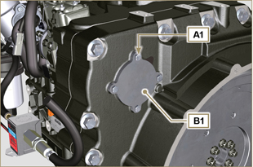  Fig 6.11
- Undo and remove the nut C1 fixing the injection pump control gear D1 .  Important  - After removing the nut C1 , ensure that the correct advance value has remained unchanged on ST_30 .  - Be careful that the nut C1 does not fall into the timing cover. | 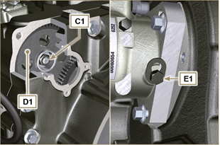  Fig 6.12
- Undo the capscrew E1 and shift the slotted plate F1 in the direction of arrow G1 .  - Tighten screw E1 to block the pump (tightening torque to 12 Nm ).  - Screw the tool ST_13 on the gear D1 . | 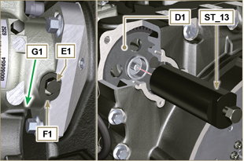  Fig 6.13
- Perform the operations of point 1 of Par. 5.2 .  - Remove quick fitting N1 .  - Undo the screws K1 and K2 and remove the Oil Cooler group L1 from the crankcase M1 .  - Loosen the screws J2 . | 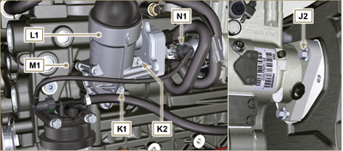  Fig 6.14
- Undo the screw P1 .  - Tighten the screw of tool ST_13 to disconnect the injection pump J1 from the high pressure pump control gear D1 .  - Svitare le viti J2 ed estrarre la pompa iniezione J1 .  - DO NOT remove the tool ST_13 . | 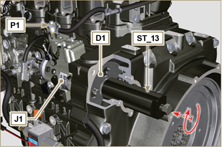  Fig 6.15
NOTE: Click on the right to play the procedure. | https://www.youtube.com/embed/lll9hIO0pXM?rel=0
6.1.6 Injection pump assembly  Important  - Before assembling the new pump J1 , make sure that plate F1 can move freely and that fastening capscrews E1 are not loose (the pump sold as a spare part is, upplied with the cylinder injection timing blocked N° 1 ).  - Ensure that the coupling surfaces on shaft Q1 and gear D1 are free from impurities and lubrication residues.  - Remove the guard cap only when the pipes are reconnected.  - Do not remove the tool ST_30 .  - Mount the injection pump J1 , inserting the shaft Q1 in the gear D1 .  Important  - Always change screws J2 with new ones or apply Loctite 2701 to the threads.  - Clamp the screws J2 on the crankcase M1 (tightening torque at 25 Nm ).  - Remove the tool ST_13 .  - Ensure that the correct advance value has remained unchanged, tighten nut C1 on shaft Q1 (as shown in Fig. 6.17, you are allowed to use a screwdriver to guide nut C1 onto shaft Q1 in order to prevent it from accidentally falling inside carter S1 - tightening torque at see service letter 710018 ). | 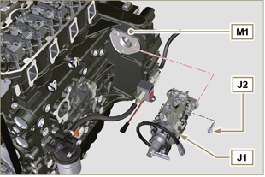  Fig 6.16  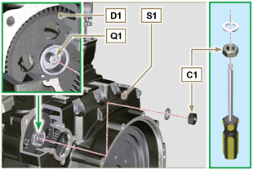  Fig 6.17
- Undo the capscrew E1 and shift the slotted plate F1 in the direction of arrow G2 .  - Tighten screw E1 (tightening torque to 5.5 Nm ). The injection pump is unlocked.  - Remove the tool ST_30 and ST_34 . | 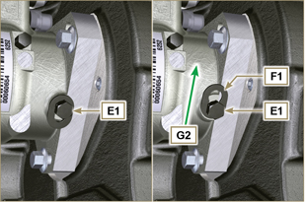  Fig 6.18
- Assemble Oil Cooler L1 onto crankcase M1 by means of capscrews K1 and K2 .  NOTE: Always replace the gasket R1 , R2 at each assembly. | 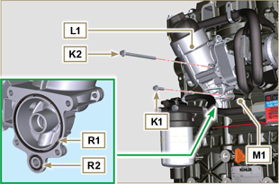  Fig 6.19
- Secure tube U1 by means of capscrew P1 , inserting gasket T1 .  - Fit quick coupling N1 onto pump J1 . | 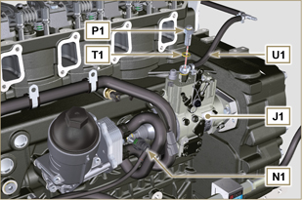  Fig 6.20
- Secure plate B1 by means of capscrews A1 , inserting gasket V1 onto carter S1 (tightening torque at 10 Nm ). | 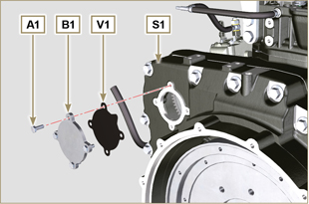  Fig 6.21
NOTE: Click on the right to play the procedure. | https://www.youtube.com/embed/xAUa9IQBmpU?rel=0
6.1.7 Injector assembly  Important  - To prevent damaging the injection system, the protection caps ( Par. 2.9.7 ) must be removed during assembly.  - Lubricate the gaskets U, T, S , and fit them on the injector Z . | 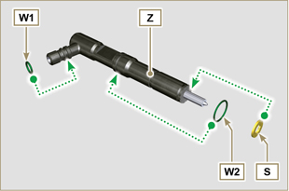  Fig 6.22
- Fit the injector Z in the sleeve V . | 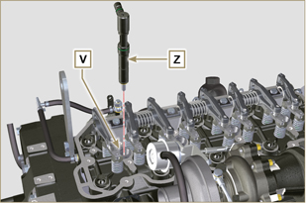  Fig 6.23
- Assemble the parts P, Q, R . and fit the parts so assembled on the injector Z . | 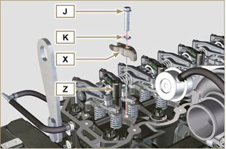  Fig 6.24
- Insert tool ST_52 on the injectors junctions Z (detail X2 ).  - Tighten the screw J (tightening torque to 20 Nm - Fig. 6.24 ). | 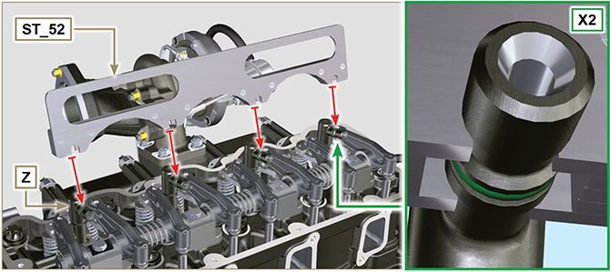  Fig 6.25
6.1.8 Assembly of the injector return pipes  - Position the tube N on the injectors Z and tighten screws M (tightening torque to 14 Nm ). | 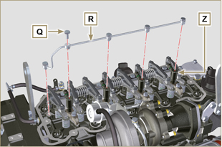  Fig 6.26
6.1.9 Assembly Rocker arm cover  Important  - The gasket Z1 between the rocker arm cover and the cylinder head must always be replaced every time it is disassembled.  - Position tool ST_17 onto the head in correspondence with the two fastening holes 9 and 10 .  - Position gasket Z1 and cap P on cylinder head A2 matching the holes of fastening capscrews N with the aid of the gudgeon guides ST_17 .  - Attach the rocker arm cover P on the head A2 with the screw N adhering to the tightening sequence shown in Fig. 6.28 (tightening torque to 10 Nm ).  - Secure the hose M2 with the screw L (tightening torque to 10 Nm ).  - Clamp the fitting M3 with the screw M (tightening torque to 25 Nm ) inserting the gasket B2 . | 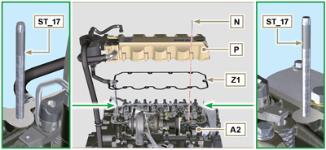  Fig 6.27  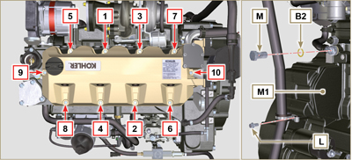  Fig 6.28
6.1.10 Installation of the fuel injector pipes (pump injector/injectors)  - Position pipes D on the injectors and on the injector pump.  Important  - Tighten the nuts F and G manually, without clamping them.  - Tighten the nuts F and G (tightening torque at 25 Nm ).  - Secure tubes H by means of clamps H2 , assembling:  - H3 rubber element;  - clamp H2 on element H3 ;  - secure clamp H2 by means of capscrew H4 and nut H5 (tightening torque at 10 Nm ).  - Secure manifold E onto cylinder head A2 by means of capscrews D , inserting gasket C2 .  - Secure suction line E2 onto manifold E by means of capscrews A , inserting gasket D2 .  - Fit quick coupling C onto manifold E .  - Fasten the pipe H6 on the manifold E with the screws B. | 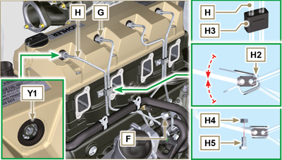  Fig 6.29
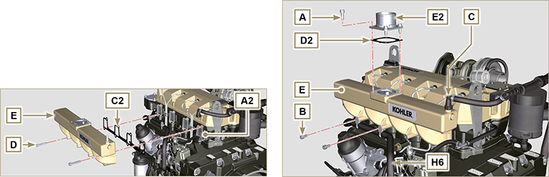
Fig. 6.30/6.31

Coolant pump replacement
6.2.1 Disassembly  NOTE: Perform the operations described in Par. 5.1 .  Important  - Before proceeding with operation, read Par. 3.3.2 .  - The coolant pump is not repairable.  - Loosen the screws A and B .  - Loosen capscrew C and disconnect voltage from belt D and remove belt D .  - Undo the screws E and remove the pulley F . | 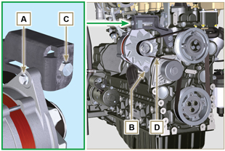  Fig 6.32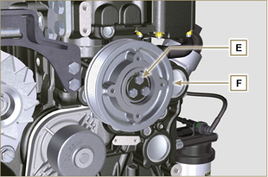  Fig 6.33
- Undo the screws G and remove the pump H with the relevant gasket. | 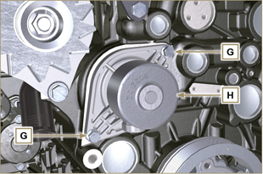  Fig 6.34
NOTE: Click by side to play the procedure. | https://www.youtube.com/embed/FdI56hBo_R0?rel=0
6.2.2 Assembly  Important  - Always replace the gaskets J , after each disassembly.  - Always replace the belt D after each assembly.  - To handling components refer to Par. 2.17  - Always replace the gaskets (where are provided) after each disassembly  - Fit the coolant pump G with the screws H interposing the new gasket J (tightening torque at 25 Nm ). | 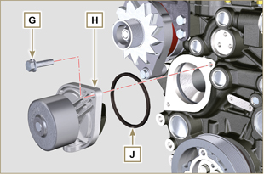  Fig 6.35
- By means of capscrews E , secure pulley F to crankcase K ( tightening torque at 25 Nm). | 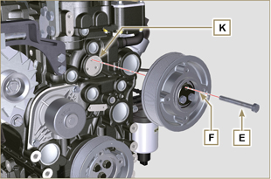  Fig 6.36
- Insert the belt D on the pulleys M .  - Tighten screw C and bring block L at 10 mm from bracket N (value C1 ).  - Fit the screw A (tightening torque at 25 Nm ).  - Fit the screw B (Fig. 6.32 - tightening torque at see service letter 710007 ).  - Start the engine and run it for some minutes, then turn off it, and let it cool down at ambient temperature. Check by the appropriate tool that at point P the tension value is between 135 and 178 Hz.  NOTE: If the poly-v belt tension results out of the above mentioned values, proceed with the replacement. | 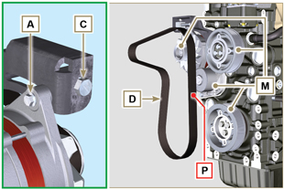  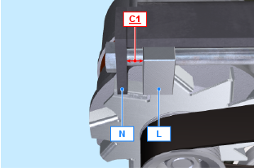  Fig 6.37
NOTE: Click by side to play the procedure. | https://www.youtube.com/embed/edCJrMN0G5M?rel=0

Oil vapour separator replacement
6.7.1 Disassembly  Important  - Before proceeding with operation, read Par. 3.3.2 .  - Remove quick fitting A .  - Release the clamps B and C .  - Remove hose D from breather body E . | 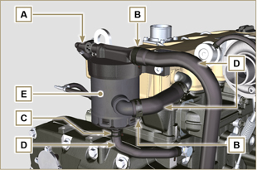  Fig 6.38
- Remove capscrews F and remove breather body E . | 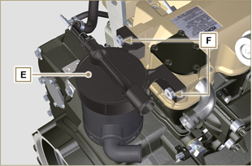  Fig 6.39
6.7.2 Assembly  - Secure breather body E by means of capscrews F (tightening torque at 22 Nm ).  - Fit hose D onto breather body E (Fig. 6.38) .  - Secure the clamps B and C (Fig. 6.38). | 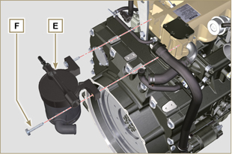  Fig 6.40

Oil cooler unit and oil filter replacement
6.4.1 Oil Cooler unit disassembly  Important  - Before proceeding with operation, read Par. 3.3.2 .  - Perform the operations described in Par 5.1 and Par 5.2 .  - Oil Cooler unit E is not repairable.  - Release the clamps A .  - Remove the manifolds B out of the Oil Cooler unit E . | 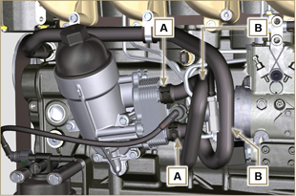  Fig 6.41
Warning  - Electric/pneumatic screwdrivers are forbidden.  - Use a suitable container to recover any residue oil.  - Unscrew cartridge holder cover H by performing three complete turns and wait 1 minute.  NOTE : this operation allows to oil contained in the support E to flow into the oil sump in the correct way.  - Unscrew cartridge holder cover H and check that the oil in the lub. oil filter support E has flowed towards the oil sump.  - Remove quick fitting N1 . | 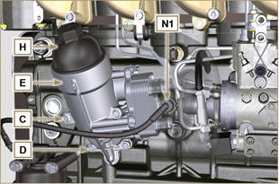  Fig 6.42
- Undo the screws C and D and remove the Oil Cooler unit E .  - Remove the gaskets F and G from the Oil Cooler unit E . | 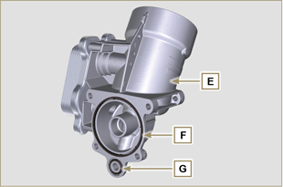  Fig 6.43
6.4.2 Oil filter cartridge replacement  - Remove gaskets L, M and N from element holder cover H .  - Remove cartridge P from element holder cover H . | 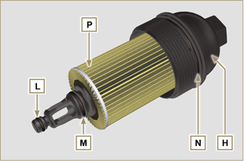  Fig 6.44
- Lubricate and insert gaskets L, M and N in the L1, M1 and N1 seats of element holder cover H .  - Insert element P into element holder cover H . | 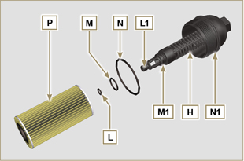  Fig 6.45
6.4.3 Oil Cooler unit assembly  Important  - In the event of assembly of union U on crankcase S , manual tightening torque with Loctite 2701 on the thread).  - Check that the surface Q on the support E and on the crankcase S are free from impurities.  - Lubricate and insert the gasket T on the fitting U .  - Lubricate and insert the gaskets on the support E :  F in seat F1 ;  G in seat G1 .  - Fit the support R with the screws C and D (tightening torque at 10 Nm ).  - Insert and tighten the cartridge support H on the filter support E (tightening torque at 25 Nm ).  - Fit the hoses B on the support E and secure the hoses B with the clamps A .  - Fit quick coupling N1 onto pump J1 . | 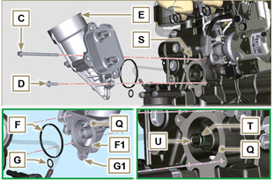  Fig 6.46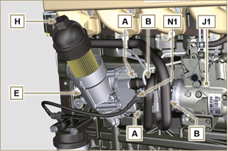  Fig 6.47

Fuel filter replacement
6.5.1 Disassembly  Important  - Before proceeding with operation, read Par. 3.3.2 .  Warning  - The fuel filter is not always mounted in the engine.  - When disassembling, use a suitable container to recover the fuel contained in the cartridge F .  - Remove quick fitting N1 .  - Release the clamps A and pull the pipes B out of the support H .  - Unscrew the cartridge F from the support H .  - Undo the screws C and remove the support H . | 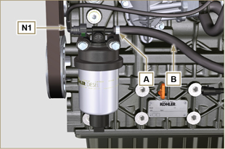  Fig 6.48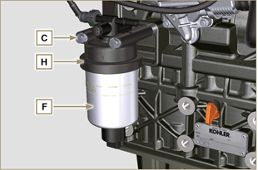  Fig 6.49
Warning  - Check that the fuel supply pump filter is present, and replace if necessary.  - Release the clamp D .  - Demount the hose E .  - Unscrew the filter G from the pump Q . | 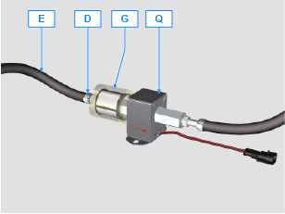
- Screw the new filter G onto the pump Q (tightening torque 20 Nm ).  - Connect the hose E to the filter G and fasten with the clamp D . | 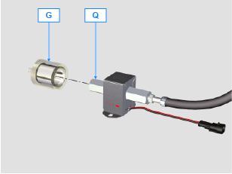
6.5.2 Assembly  - Secure fuel filter bracket H with capscrews C onto crankcase M , inserting spacer L between M and H and washer P between H and C (tightening torque at 25 Nm ).  - Fit the pipes B on the support H .  - Secure the pipes B with the clamps A . | 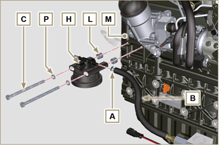  Fig 6.50
- Lubricate the gasket N with fuel.  - Tighten the cartridge F on the support H (tightening torque at 17 Nm ).  - Fit quick coupling N1 onto support H . | 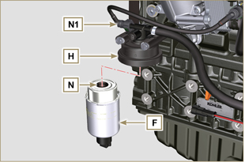  Fig 6.51

Information for disassembly

Recommendations for disassembly

Important

- The mark ( ) after the title of a paragraph, indicates that the procedure is not required in order to disassemble the engine, however the procedures are featured in order to illustrate the disassembly of components.
- The operator should prepare all equipment and tools in order to enable him to carry out the operations correctly and safely.
- Before disassembly, perform the operation described in Chap. 5 .
- Before proceeding with operation, carefully read Chap. 3 .
- In order to operate safely and easily, we recommend positioning the engine on a rotating stand for engine overhauling.
- Seal all injection component unions as illustrated in Par. 2.9.8 during assembly.
- Protect all disassembled components and coupling surfaces subject to oxidation with lubricant.
- Where necessary, reference to special tools to use during disassembly operations is indicated (es. ST_05 ), identified in Tab. 13.1 - 13.2 - 13.3 .

Turbocharger disassembly
- Unscrew the fittings A and remove the pipe B with the relative gaskets C . | 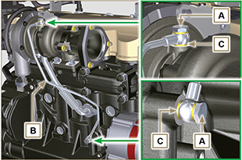  Fig 7.1
- Undo the screws D and remove pipe E and the relevant gaskets. | 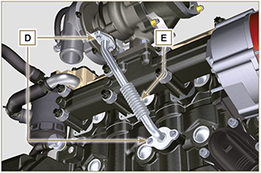  Fig 7.2
- Undo the nuts F and remove the turbocharger G . | 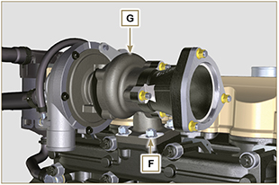  Fig 7.3

Coolant recirculation components disassembly
7.3.1 Oil Cooler manifold  - Release the clamps A .  - Undo the screw B and remove hoses C . | 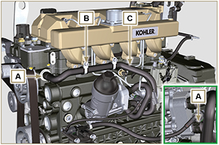  Fig 7.4
- Release the clamp D and remove hoses E . | 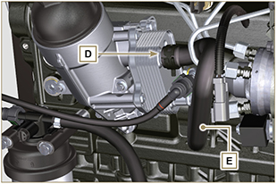  Fig 7.5
7.3.2 Coolant pump  Important  - The pump B is not repairable.  - Perform the operations described in Par. 6.2.1 .  - Undo capscrews F and remove flange G with the relative gasket. | 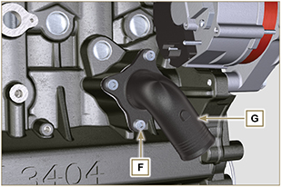  Fig 7.6
7.3.3 Thermostatic valve  - Undo the screws A and remove the thermostatic valve cover B .  - Remove the thermostatic valve C and its gasket.  Important  - Always replace the gasket D every time it is disassembled.  - Check that the air bleeding hole is not clogged or blocked ( Par. 2.11.3 ). | 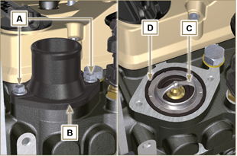  Fig 7.7

Electric components disassembly
7.4.1 Starter motor  Important  - The motor is not repairable.  - Perform the operations from point 2 to 3 of Par. 6.1.5 .  7.4.2 Alternator  - Undo the screws A1 and B1 and remove the alternator C1 . | 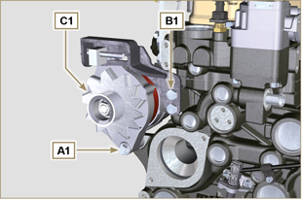  Fig 7.8
7.4.2 Sensors and switches  Important  - After disassembly, protect the sensors suitably against knocks, dampness and any high temperature sources.  - The sensors and switches cannot be repaired, therefore they must be replaced in the event of anomalies.  7.4.2.1 Oil pressure switch ( )  - Unscrew and remove the oil pressure switch AD . | 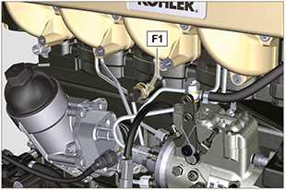  Fig 7.9
7.4.2.2 Coolant temperature sensor ( )  - Unscrew and remove the coolant temperature sensor AE . | 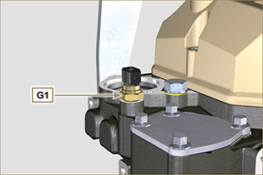  Fig 7.10

Exhaust manifold disassembly
- Remove nuts A , capscrews B and spacers C , manifold D and gaskets E .  - Close the openings and manifolds to prevent foreign bodies from entering. | 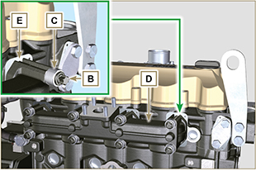  Fig 7.11

Fuel system disassembly
Important

- Seal all injection component unions as illustrated in Par. 2.9.8 during disassembly.

7.6.1 Injection fuel pipes

- Perform the operations of Par. 6.1.1 .
7.6.2 Rocker arms cover

- Perform the operations of Par. 6.1.1 .
7.6.3 Fuel return pipes  - Perform the operations of Par. 6.1.3 .  - Perform the operations of point 18 of Par. 6.1.5 .  - Loosen union A from cylinder head B and remove return line C . | 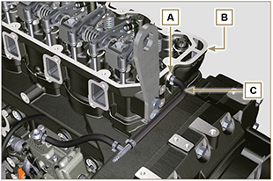  Fig. 7.12
7.6.4 Injectors

- Perform the operations of Par. 6.1.4 .

7.6.5 Injection pump

- Perform the operations of Par. 6.1.5 .
7.6.6 Fuel filter

- Perform the operations of Par. 6.5.1 .

Crankshaft pulley disassembly
- Undo the screws A and remove the pulley B . | 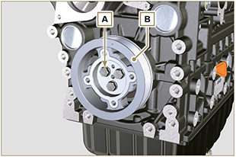  Fig 7.13

Flange unit disassembly
7.8.1 Flywheel  Danger  - The flywheel A is very heavy. Pay the utmost attention while removing it in order to prevent it dropping or falling, as this may have serious consequences for the operative.  - Undo the screws B and remove the flywheel A by means of tool ST_43 .  - Secure tool ST_41 onto gear C by means of capscrews B . | 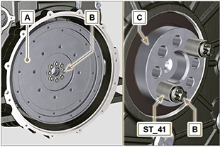  Fig 7.14
7.8.2 Flange housing  Danger  - The flange housing D is very heavy. Pay the utmost attention while removing it in order to prevent it dropping or falling, as this may have serious consequences for the operative  - Undo capscrews E by following the order indicated in the figure.  - Remove the engine housing D by means of tool ST_44 . | 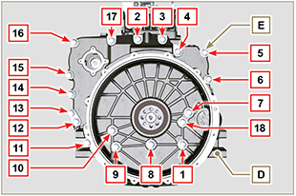  Fig 7.15

Lubrication circuit disassembly
7.9.1 Oil pump  Important  - The oil pump is not repairable.  - Undo the screws A and remove the pump unit B . | 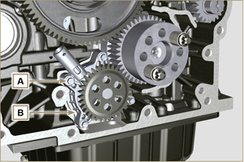  Fig 7.16
7.9.2 Oil pressure valve ( )  - Remove cotter pin C .  - Remove disk D , spring E , piston valve F using a magnet. | 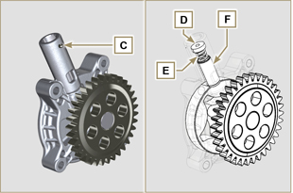  Fig 7.17

Cylinder head unit disassembly
7.10.1 Rocker arm pin  - Undo the screws D .  - Remove the rocker arm pin unit E . | 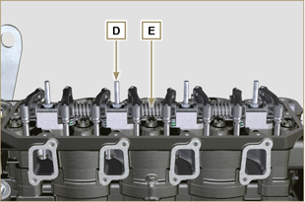  Fig 7.18
7.10.1.1 Rocker arm ( )  - Remove the retainer ring F .  - Remove the shoulder rings G .  - Remove the rocker arms H . | 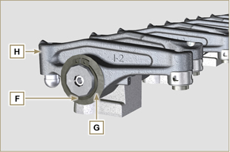  Fig 7.19
7.10.3 Valve rods and bridges  - Remove the valve control U-bolts M .  - Remove the rocker arm control rods N . | 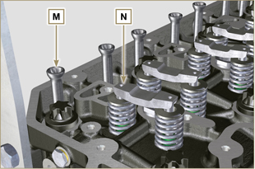  Fig 7.20
7.10.4 Cylinder head  Important  - The capscrews P must be replaced every time they are disassembled.  - Do NOT remove the capscrews completely, first loosen them by turning them a whole cycle following the order shown in the figure.  - Loosen fastening screws P , turning them by one turn following the order shown in the figure.  - Undo capscrews P by following the order indicated in the figure.  Important  - To lift cylinder head Q , only use both eyebolts AE provided by KOHLER (refer to Fig. 7.28 ).  - When removing the cylinder head Q and subsequent disassembly, control, and assembly operations, it is necessary to protect the contact surface W of cylinder head Q and crankcase J against impacts.  - Remove the cylinder head Q .  - Remove the head gasket R . | 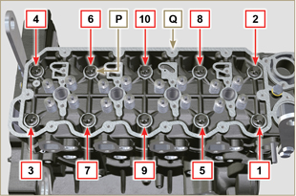  Fig 7.21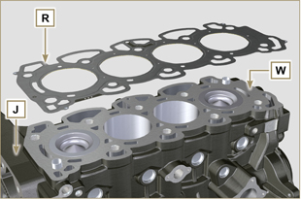  Fig 7.22
7.10.4.1 Valves ( )  - Mount the tool ST_07 on the head Q fixing it on one of the holes for fixing the rocker arm cover.  NOTE: Change the fixing hole according to the position of the valves to be removed.  - Position the tool ST_07 on the valve as shown in the figure. | 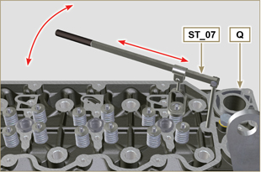  Fig 7.23
- Push the lever of the tool ST_07 downwards, in order to lower the valve plates S in the direction of the arrow T , remove cotters U using a magnet.  NOTE: Repeat all the operations for all the valves concerned. | 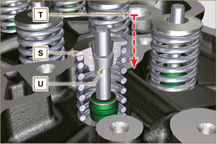  Fig 7.24
Important  - Before removing the valves, make some marks to record their original position, in order to avoid confusing them when reassembling (if they are not replaced).  - Remove the valves V . | 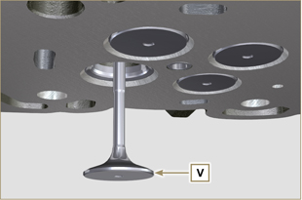  Fig 7.25
7.10.4.2 injector sleeves ( )  - Unscrew and remove the sleeves Z from the head Q .  - Remove the gaskets J, K . | 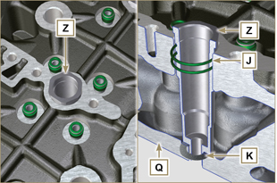  Fig 7.26
7.10.4.3 Valve stem gasket ( )  - Remove the gaskets W . | 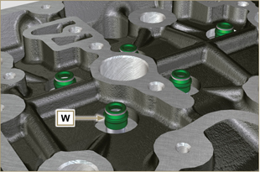  Fig 7.27
7.10.4.4 Lifting eyebolts ( )  - Undo the screws X and remove the eyebolts Y .  - Thoroughly wash the cylinder head Q . | 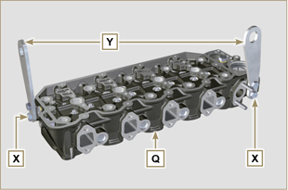  Fig 7.28

Oil sump unit disassembly
7.11.1 Oil sump  - Undo the screws A .  - Remove the oil sump B by inserting a plate between surface C of crankcase D and oil sump B .  - Remove the oil dipstick E . | 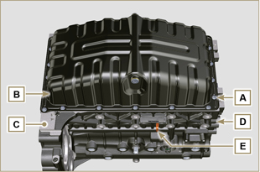  Fig 7.29
7.11.2 Oil suction pipe  - Undo the screws F and remove the oil pipe G . | 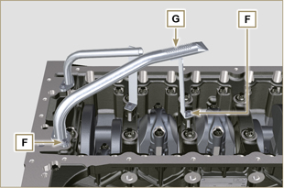  Fig 7.30
7.11.3 Oil drain pipe ( )  - Undo the screws H and remove the pipe L . | 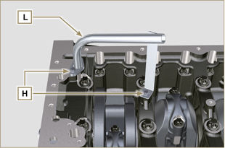  Fig 7.31

Engine block disassembly
7.12.1 Piston unit/connecting rod  Important  - Mark some numerical references (cylinder n°) on the connecting rods, connecting rod caps N , pistons and gudgeon pins to prevent unintentionally confusing the components not replaced during assembly. Failure to do this may result in engine malfunctions.  - References on connecting rod M and cap N must only be carried out on a side in correspondence with K1 and K2 , as illustrated in Fig. 7.35 .  - Screw the bolt M temporarily. | 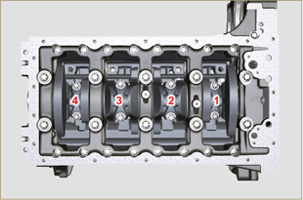  Fig 7.32
NOTE : coupling cap N on the connecting rod can be carried out with centring taper pins (Fig. 7.33) or broken ( Fig. 7.34 - without centring taper pins).  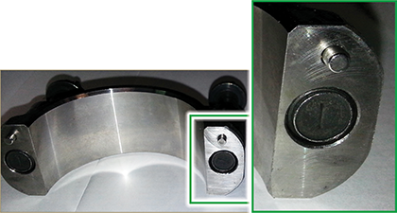  Fig. 7.33  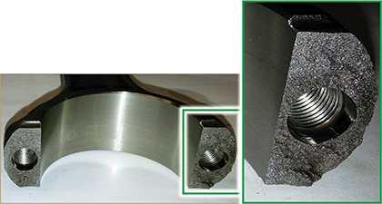  Fig. 7.34 | 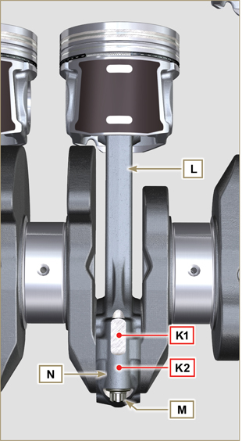  Fig 7.35
- Pull out the connecting rod - piston assembly from position 2 and 3 by manually applying pressure on the connecting rod big end M in the direction of arrow AK .  - Couple the connecting rod big end caps L with the relevant piston and connecting rod unit M .  - Rotate the crankshaft by 180°.  - Repeat points 2 to 5 to disassemble the connecting rod-piston assembly to position 1 and 4 . | 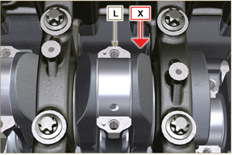  Fig 7.36
Warning  - The connecting rod half-bearings Z are made of special material. Therefore, they must be replaced every time they are removed to prevent seizures. | 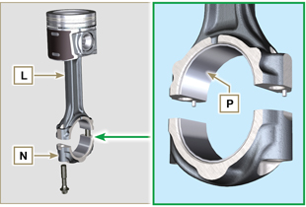  Fig 7.37
7.12.2 Timing system gear disassembly  - Unscrew screws A and remove the gear B .  - Remove the gear C .  - Unscrew screws D and remove the gear E . | 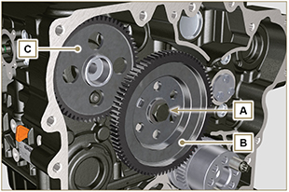  Fig 7.38  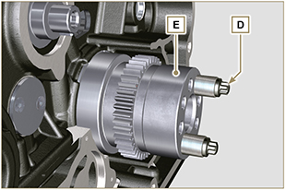  Fig 7.39
7.12.3 Lower semi-crankcase  Important  - The capscrews Q must be replaced every time they are disassembled.  - Do NOT remove the capscrews completely, first loosen them by turning them a whole cycle following the order shown in the figure.  - Loosen fastening screws Q , turning them by one turn following the order shown in the figure.  - Undo capscrews Q by following the order indicated in the figure. | 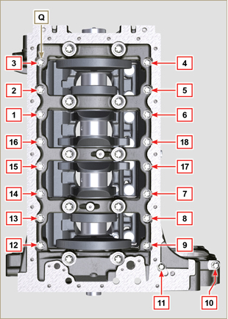  Fig 7.40
Important  - The capscrews R must be replaced every time they are disassembled.  - Do NOT remove the capscrews completely, first loosen them by turning them a whole cycle following the order shown in the figure.  - Loosen fastening screws R , turning them by one turn following the order shown in the figure.  - Undo capscrews R by following the order indicated in the figure.  - Remove the lower semi-crankcase D1 and store it in a suitable container for washing. | 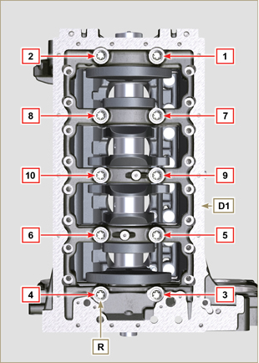  Fig 7.41
7.12.4 Crankshaft  Remove:  - Crankshaft S .  - The shoulder semi-rings T .  - gasket U from crankshaft S . | 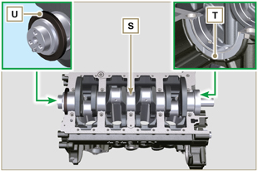  Fig 7.42
7.12.5 Piston ( )  - Remove the retainer ring V .  - Remove the pin Z to separate the piston J from the connecting rod L .  Important  - If they are not replaced, keep the components together (connecting rod - piston - gudgeon pin) by using references in order to prevent them from getting mixed up during assembly. | 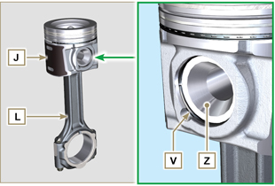  Fig 7.43
7.12.5.1 Rings ( )  - Remove the rings K . | 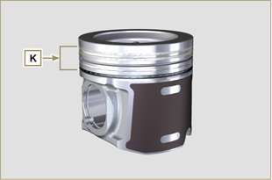  Fig 7.44
7.12.6 Oil spray nozzles ( )  - Undo the screws W and remove the spray nozzles X from the upper semi-crankcase D2 . | 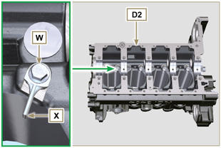  Fig 7.45
7.12.7 Camshaft  - Remove the lock ring C .  - Extract the camshaft F from the upper semi-crankcase D2 . | 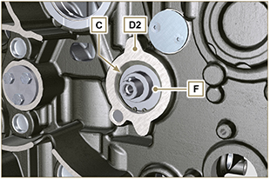  Fig 7.46
7.12.8 Camshaft tappets  - With a magnet, remove the tappets Y from the upper semi-crankcase D2 . | 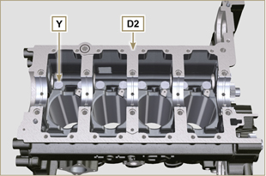  Fig 7.72
7.12.9 Crankshaft bushings  - Remove the crankshaft bushings A1 from the upper crankcase D2 .  Important  - The crankshaft half-bearings A1, B1 are made of special material. Therefore, they must be replaced every time they are removed to prevent seizures. | 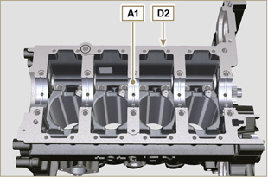  Fig 7.73
- Remove the crankshaft bushings B1 from the lower semicrankcase D2 . | 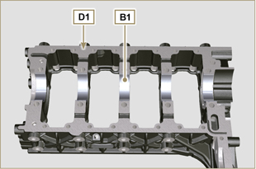  Fig 7.74

Information about overhauling

Recommendations for overhauls and tuning
- The information is laid out in sequence, according to operational requirements, and the intervention methods have been selected, tested and approved by the manufacturer's
technicians.
- This chapter describes procedures for checking, overhauling and tuning units and/or individual components.

NOT E : To easily locate specific topics, the reader should refer to the analytical index or chapter index.

- Before any intervention, the operator should lay out all equipment and tools in such a way as to enable him to carry out operations correctly and safely.
- The operator must comply with the specific measures described in order to avoid errors that might cause damage to the engine.
- Before carrying out any operation, clean the units and/or components thoroughly and eliminate any deposits.
- Do not wash the components with steam or hot water. Use suitable products only.
- Do not use flammable products (petrol, diesel, etc.) to degrease or wash components. Use suitable products only.
- Dry all washed surfaces and components thoroughly with a jet of air or special cloths before reassembling them.
- Apply a layer of lubricant over all surfaces of all disassembled components to protect them against oxidation.
- Check the integrity and state of wear of all disassembled components in order to ensure good working condition of the engine.
- When indicated, some components are to be replaced in pairs or together with other parts (e.g. crankshaft half-bearings/connecting rod, piston complete with rings and gudgeon pin, etc.).
- When indicated, some grinding operations are to be carried out in series (e.g. grinding of cylinders, crankpins, journals, etc.).

Crankcase
8.2.1 Oil line check

Important

- Replace and assemble the conical cap A3 in hole B , B1 (tightening torque at 30 Nm ), after having performed cleaning operations.
- Use a pipe cleaner in access points A , B , B1 , C , D to clean the oil ducts of crankcase G .
- Use compressed air to eliminate any residues.

- Remove capscrews A1 and remove plate A2 with its gasket.

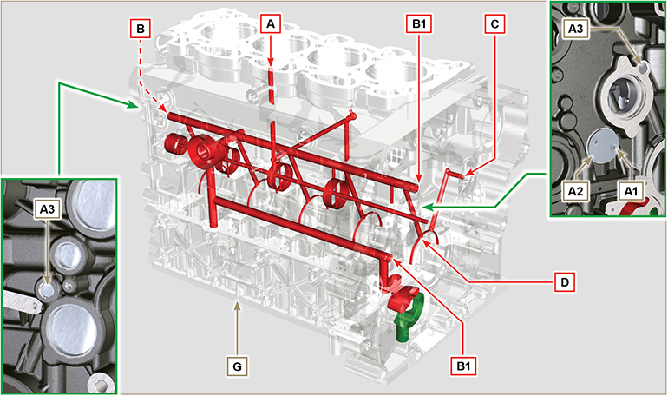
Fig 8.1

8.2.2 Cylinder check
Position crankcase G onto a workbench.
With a dial gauge, measure the diameter in correspondence to points J-M-N (Fig. 8.2) lengthwise and diagonally with regard to axis H of the crankshaft.
If ovalisation or wear detected in a single point in J-M-N is greater than +0.05 mm with regard to the value in Tab. 8.1 , you are required to perform grinding operations on all cylinders F.
Refer to Tab. 8.1 to establish the clearance value of cylinders subjected to grinding operations.
Important

- Grinding is prohibited before 10000 h of operation on all engines provided with an EPA name plate (refer to Par. 1.3 ).
- The grinding involved is of +0.20, +0.50 e + 1 mm .
- Cylinder grinding operations must observe KOHLER SPECIFICATIONS - cod. ED0035612500.
- Grinding must be strictly performed on all cylinders F .

Tab. 8.1 details the dimensional values of new components only.
Tab 8.1 Grinding values
PISTON | Ø CILINDER (± 0.007 mm) | Ø PISTON (± 0.007 mm) | CLEARANCE VALUE (mm)
STD | 96.010 | 96.950 | 0.046 - 0.074
+0.20 ⁽¹⁾ | 96.210 | 96.150
+0.50 | 96.510 | 96.450
+1.00 | 97.010 | 96.950

⁽¹⁾ The increase of +0.20 mm , may already be present on the engine.

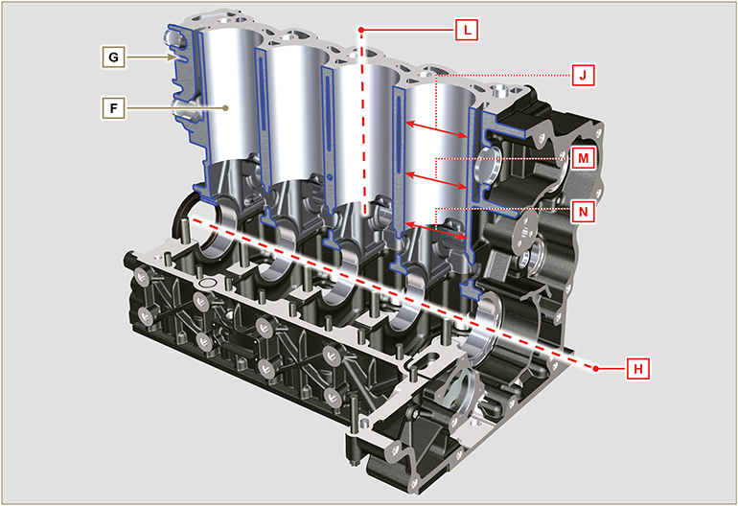
Fig 8.2

8.2.3 Camshaft housing check  Use an internal dial gauge to measure the diameters of housings X - W - K - Y - Z .  With a micrometer, measure the diameters of gudgeon pins X1 - W1 - K1 - Y1 - Z1 (Fig. 8.4) . According to the values measured, calculate the clearance between the housing and gudgeon, which is to observe the  values in Tab. 8.2 .  The MAX value of wear allowed is 0.120 mm  Important  - Tab. 8.2 details the dimensional values of new components only. | Tab 8.2 Housing and camshaft gudgeon dimensions.  REF. DIMENSIONS (mm) CLEARANCE VALUE (mm)  X 48.500 - 48.525 0.060 - 0.105  X1 48.420 - 48.440  W 47.500 - 47.525 0.060 - 0.105  W1 47.420 - 47.440  K 47.000 - 47.025 0.060 - 0.105  K1 46.920 - 46.940  Y 46.500 - 46.525 0.060 - 0.105  Y1 46.420 - 46.440  Z 35.000 - 36.025 0.060 - 0.105  Z1 34.920 - 35.940
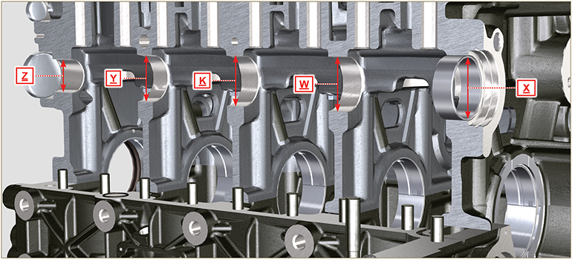
Fig 8.3

8.2.3.1 Block Surface Flatness  Use a dial gauge to check if the cylinder head surface A1 is level.  The MAX value of allowable irregularity of surface A1 is:  - 0.10 mm on the entire area;  - 0.03 mm on an area of 100x100 mm.  Grinding of surface A1 is not permitted | 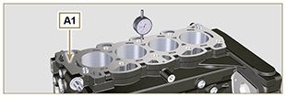  Fig 8.3a

8.2.4 Camshaft control  With a micrometer, measure the maximum dimensions of intake camshaft R and exhaust camshaft S (Tab. 8.3) .  The MAX value of wear allowed is 0.1 mm .  Important  - Tab. 8.3 details the dimensional values of new components only. | Tab 8. 3 Camshaft dimensions.  RIF. CODE (P) DIMENSIONS (mm)  R 40.495 - 40.433  S 39.175 - 39.113  S1 ED0010101820-S 35.666 - 35.616  S1 ED0010101730-S 35.564 - 35.514
8.2.5 Camshaft control with internal EGR

The internal EGR is available only for Stage IIIA or Tier 3 engines provided with " CE " approval ( Par. 1.2 ) or " EPA " name plate ( Par. 1.3 ).
With a micrometer, measure the dimensions of the S1 quota ( Tab. 8.3 ) on all of cams S (the S1 quota varies according to the code of camshaft P - refer to the spare parts catalogue to identify the code of camshaft P ).
Replace camshaft P if the S1 quota does not comply with the value on Tab. 8.3 .

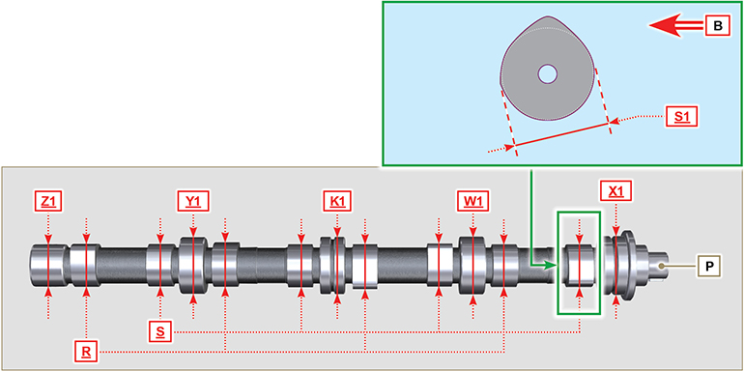
Fig. 8.4

Tappets and tappet housings
8.3.1 Tappets check  Use a surface plate and a dial gauge as shown in Fig. 8.5 .  Check the perpendicularity of the plate C , making the tappet D rotate in the direction of the arrow.  The MAX value of wear allowed is 0.02 mm .  With a gauge, check the length of value A and B (Tab. 8.4) . The MAX value of wear allowed is 0.08 mm . | 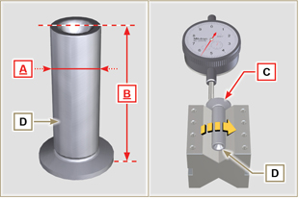  Fig 8.5
8.3.2 Tappet housing check  Use an internal dial gauge to measure the diameter of the tappet housings X .  Use value of A detected (Par. 8.3.1) to calculate the clearance value ( Tab. 8.4 ).  If the clearance values are not observed, replace the worn component.  Important  Tab. 8.4 T appets and t appet housing size.  REF. DIMENSIONS (mm) CLEARANCE VALUE (mm)  A 14.984 - 14.966 0.016 - 0.052  X 15.000 - 15.018  B 47.5 --- | 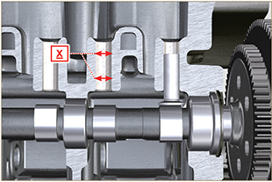  Fig 8.6

Crankshaft
8.4.1 Dimensional check and overhauling

Wash the crankshaft thoroughly using suitable detergent.
Insert the pipe cleaner into all lubrication ducts B and blow compressed air to free them completely from any dirt residues.
Check the state of wear and integrity of journals C and connecting rod D .
Perform the operations described in Par. 9.3.1 and Par. 9.3.5 - except points 2, 3, 5, 9 and 10 .
Tighten capscrews J ( Fig. 9.9 ) and K ( Fig. 9.10 ) observing the cycles, tightening, and subsequent rotation.
Cycle 1 - Screw J - Torx M14x1,5 - Torque 60 Nm. ( Fig. 9.9 );
Cycle 2 - Screw K - Torx M10x1.25 - Torque 30 Nm. ( Fig. 9.10 ).
Measure the crank pins A1 with a micrometer, and using a dial gauge measure the internal diameter of the connecting rod half-bearings A2 .
Measure the main journals B1 , with a micrometer, and using a dial gauge measure the internal diameter of the crankshaft half-bearings B2 .
If the values described in Tab. 8.5 do not correspond, proceed with grinding all gudgeon pins A1 and B1 .

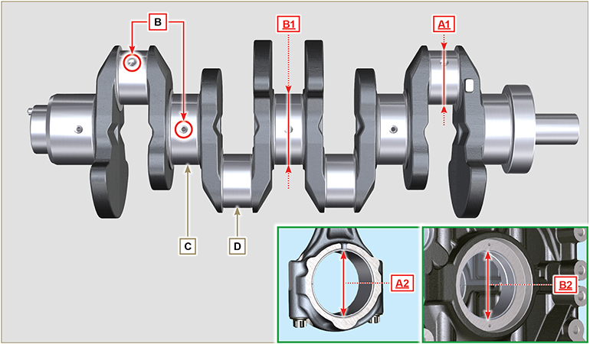
Fig 8.7

Important  - The crankshaft and connecting rod must be replaced every time they are assembled to prevent seizure, as they are made of special lead-free material.  - The MAX allowed value of wear for A1 and A2 is 0.120 mm.  - The MAX allowed value of wear for B1 and B2 is 0.120 mm.  - To grind the crankshaft, a decrease in diameter of the halfbearings and connecting rod is provided for at 0.25 mm and 0.50 mm, to grind gudgeon pins A1 and B1 , measure the values of diameters A2 and B2 by assembling the decreased half-bearings, define the diameter to grind of pins A1 and B1 ,  observing the clearance indicated in Tab. 8.5.  - La Tab. 8.5 riporta i valori dimensionali solo per i componenti nuovi. | Tab 8.5 Connecting rod and journal diameter  REF. DIMENSIONS (mm) CLEARANCE VALUE (mm)  A1 60.980 - 61.000 0.034 - 0.090  A2 61.034 - 61.069  B1 79.978 - 80.000 0.036 - 0.104  B2 80.036 - 80.082
8.4.2 Checking the axial clearance of the crankshaft  Perform the operations described in Par. 9.3.1 , Par. 9.3.4 and. Par. 9.3.5 - except points 2, 3, 5 , and 10 .  Tighten capscrew J ( Fig. 9.9 ) observing the cycles, tightening, and subsequent rotation.  Cycle 3 - Screw J - Torx M14x1,5 - Torque 45°. ( Fig. 9.9 )  Cycle 4 - Screw J - Torx M14x1,5 - Torque 45°. ( Fig. 9.9 ).  Using a dial gauge, measure the axial shift of crankshaft E .  Axial shift must be a MIN of 0.18 mm and MAX 0.38 mm..  If the values measured do not correspond, replace shoulder rings D . | 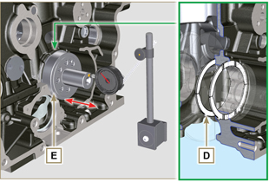  Fig 8.8

Connecting rod - piston assembly
8.5.1 Connecting rod dimensions check  Important  - Before assembling the connecting rod and pistons ( Par. 9.3.7 and 9.3.8 ), check that the difference in weight between the complete connecting rod and piston units do not exceed 15 gr to prevent weight imbalances during rotation of the crankshaft and consequent damage.  - Mark some references on the connecting rods, caps Q , pistons and gudgeon pins to prevent unintentionally confusing the components during assembly. Failure to do this may result in engine malfunctions.  - Connecting rod half-bearings S must be there with each assembly.  Check that the contact surfaces are perfectly clean and intact.  Assemble the connecting rod cap Q to the connecting rod with the half-bearings S and tighten capscrews P (tightening torque at 28 Nm ).  With a dial gauge, measure diameters B and D .  The MAX allowed value of wear for B and D is 0.06 mm.  Tab 8.6  REF. DIMENSIONS (mm) CLEARANCE VALUE (mm)  A 192.980 - 193.020  B 37.025 - 37.015 0.015 - 0.030  C 36.995 - 37.000  D 61.034 - 61.069  E 74.000 - 74.300  F 33.950 - 33.990  Important  - Tab. 8.6 details the dimensional values of new components only.  - Check that the connecting rod and crankshaft half-bearings are coupled properly.  - Refer to the warnings in Par. 8.4.1 for value D decreased.  - If the clearance value between B and C is not observed, you are required to replace bearing R (Fig. 8.10) .  Measure value A, C, D, E and F and confront them with those described in Tab.8.6 .  If the measured values do not follow those described in Tab.8.6 , replace connecting rod T . | 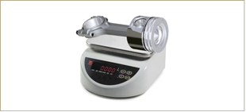  Fig 8.9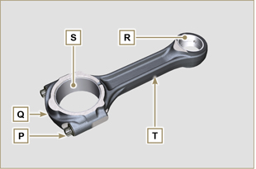  Fig 8.10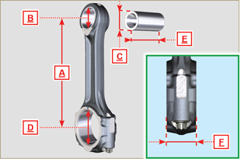  Fig 8.11
8.5.2 Checking the gudgeon pin-pin axes are parallel  Lubricate gudgeon pin A and bearing R (Fig. 8.10) .  Insert the gudgeon pin into bearing R . Use a dial gauge to check the axis parallelism of the connecting rod big end and small end.  Parallel deviation (value V ) measured at the tip of the gudgeonpin, must be a MIN of 0,015 and MAX of 0,030 mm.  If the parallelism values do not comply with the specified ones,replace the connecting rod with a new one.  8.5.3 Piston rings check  Insert ring U into the cylinder, measure value H (distance between the points of ring U ). Repeat for all the seal rings.  If the measured value H does not correspond to the values indicated in the table (Tab. 8.7) , replace the seal rings U .  Important  - Seal rings cannot be replaced separately.  NOTE: refer to Fig. 8.17 to locate the rings.  Tab. 8.7  RINGS H (mm)  U1 0.30 - 0.15  U2 0.50 - 0.70  U3 0.20 - 0.40 | 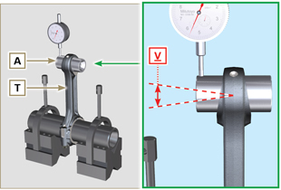  Fig 8.12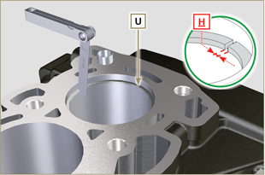  Fig 8.13
8.5.4 Piston dimension check  Clean the piston thoroughly.  Measure the diameter of the piston at 12 mm ( L ) from the base of the skirt in correspondence with the graphite lubrication windows M .  Refer to Tab. 8.8 to establish the clearance value of the pistons with a decreased diameter.  In correspondence with point W , there are: 3 digits for the STD piston;  3 digits followed by R for a piston with an increased diameter of 0.20 mm; +0.5 for a piston with an increased diameter of 0.50 mm;  +1 for a piston with an increased diameter of 1.00 mm;  If clearance between cylinder and piston is greater than 0,074 mm, the piston and seal rings must be replaced.  Important  - Tab. 8.8 details the dimensional values of new components only.  Tab. 8.8  PISTON Ø CYLINDERS (± 0.007 mm) Ø PISTON (± 0.007 mm) CLEARANCE VALUE (mm)  STD 96.010 95.950 0.046 + 0.074  +0.20 96.210 96.150  +0.50 96.510 96.450  +1.00 97.010 96.950 | 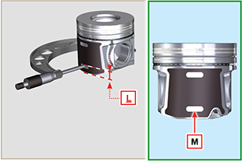  Fig 8.14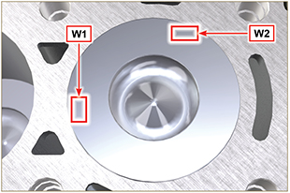  Fig 8.15
Important  - With a feeler gauge, measure the clearance of the seal ring in the respective seat (value L1, L2 e L3 ).  - If the clearance does not comply with the values shown in the Tab. 8.9 , replace the seal rings and the piston.  Tab 8.9  SEAL RINGS CLEARANCE VALUE (mm)  U1 (L1) 0.070 - 0.110  U2 (L2) 0.070 - 1.115  U3 (L3) 0.030 - 0.070 | 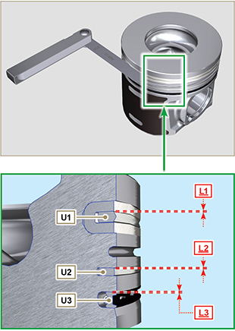  Fig 8.16 / 8.17

Cylinder head
8.6.1 Flatness check  Put the cylinder head on a surface plate and, with a dial gauge, check the flatness of surface C .  The MAX value of allowable irregularity of surface C is 0.10mm.  If the value is not observed, you are required to grind surface C .  The MAX removal allowed is 0.20 mm.  Important  - Grinding is to be performed with sleeves A of the electronic injectors assembled.  - Grinding is prohibited on all engines provided with an EPA name plate (refer to Par. 1.3 ). | 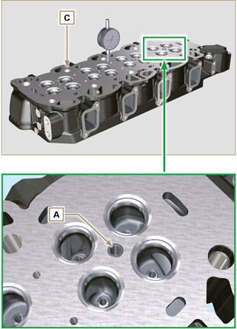  Fig 8.18 - Fig 8.19
8.6.2 Valve seats check  Measure indentation B of each valve with regard to the cylinder head surface C , which is to be a MIN of 0.50 mm and MAX of 0.53 mm.  The B MAX indentation allowed on worn components is 0.90 mm.  If the measured value does not correspond with the values indicated, replace the worn component.  Important  - The seats must be worked after driving to reach value B , go to a rectification workshop for such operations.  8.6.3 Valve springs  Use a gauge to measure the free length Z .  Using a dynamometer, subject the spring to two different forces and check that the length of the spring corresponds to the values indicated in Tab. 8.10 .  Tab 8.10  WEIGHT (kg) LENGHT (mm)  0 Z 42.50  20,4 Z1 33.00  42,8 Z2 23.80 | 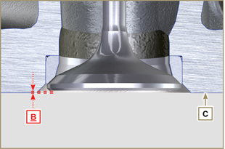  Fig 8.20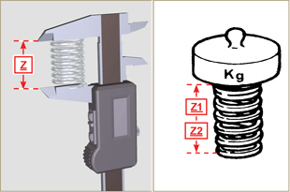  Fig 8.21
8.6.4 Valve guides check  Measure the diameters D and E of the rods and guides valve (Tab. 8.11) .  If the diameters don't correspond to the values indicated, replace the valves or guides.  The MAX allowed value of wear for D and E is 0.10 mm.  Observe values G from surface F when assembling guides H (Tab. 8.11) .  Important  - Carry out the measurements in different points to detect any ovalisation and/or concentrated wear.  - Tab. 8.11 details the dimensional values of new components only.  Tab 8.11 Valve stem - valve guide dimensions  REF. DIMENSIONS (mm) CLEARANCE VALUE (mm)  D 5.978 - 5.990 0.040 - 0.064  E 6.030 - 6.042  G 38.300 - 38.700 | 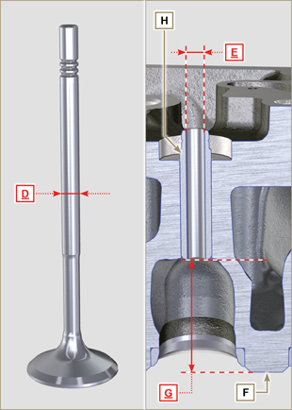  Fig 8.22
8.6.5 Valve guides replacement  The intake and exhaust guides are both made out of grey iron with pearlitic phosphoric matrix and they have the same dimensions.  The guides are press-fit assembled; assembly is possible by cooling the guides with the aid of liquid nitrogen.  Before assembling a new guide, measure value L and M ,calculate the press-fit value, which must observe the values in Tab. 8.12 .  Observe values G from surface F when assembling guides H (Tab. 8.11 - Fig. 8.22) .  Important  - The guides must be worked for value E (Tab. 8.11 - Fig.8.22) after driving. Contact a rectification workshop for such operations.  Tab 8.12 valve guides - housing dimensions  REF. DIMENSIONS (mm) PRESS-FIT VALUE (mm)  L 10.000 - 10.015 0.030 - 0.054  M 10.045 - 10.054 | 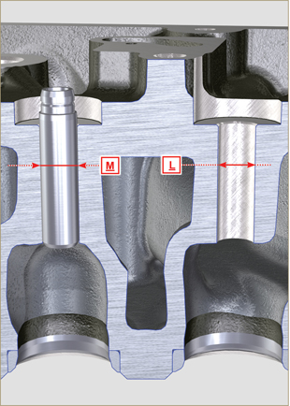  Fig 8.23
8.6.6 Rocker arm check  Measure values W1 in correspondence with holes M located on rocker arm gudgeon L (seen from B in Fig. 8.25 ).  Measure values W2 (Fig. 8.26).  Based on the values measured, calculate the clearance between W1 and W2 , which is to observe the values in Tab. 8.13.  Check that all oil pipes N and M are free from impurities or obstructions.  Tab 8.13  REF. DIMENSIONS (mm) CLEARANCE VALUE (mm)  W1 22.005 - 22.015 0.025 - 0.056  W2 22.040 - 22.061  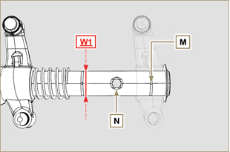  Fig. 8.25 | 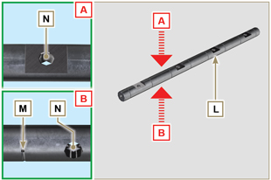  Fig 8.24  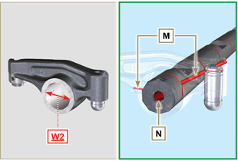  Fig 8.26

Oil pump check
8.7.1 Dimensional and visual check  Measure clearance value B between the rotor teeth, the value of allowable wear is MAX 0.28 mm.  Important  - Should the results from checks carried out not be in accordance with the conditions described, replace the oil pump A . | 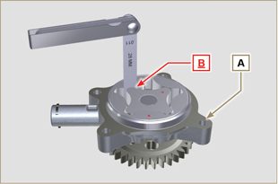  Fig 8.27
8.7.2 Oil pressure valve check  Measure the free length F of spring D , which must be 47.5 mm .  If the measured value does not correspond to the value indicated, replace spring D .  Tab 8.16  POS DESCRIPTION  B Oil stopper  C Gasket  D Spring  E Piston | 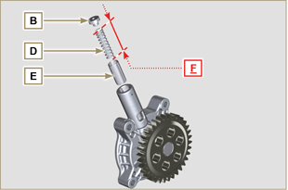  Fig 8.28

Assembly information

Information on engine configuration
- In this chapter, the engine is represented as "BASE CONFIGURATION" (refer to Par. 1.4 - 1.5 ).
- For the assembly of components not described in this chapter refer to Chap. 11 .
- The following are the components described in Chap. 11 .

11.1 Heater (reaplacement)
11.2 Air filter (cartridge replacement)
11.3 Cooling circuit (replacement)

Assembly recommendations
- The information is laid out in sequence, the intervention methods have been selected, tested and approved by the manufacturer's technicians.
- This chapter describes the installation procedures for the assemblies and/ or individual components which have already been checked, overhauled or possibly replaced with original spare parts.
- Where necessary, reference to special tools during assembly operations is indicated and identified in Tab 13.1 , hereinafter in Tab. 9.1 an example of a special tool ( ST_05 ).

Tab. 9.1
SPECIAL TOOLS
"ST" Code | Picture /draw | DESCRIPTION | PART NUMBER
ST_05 | 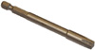 | Six nicks Key SN 8 | ED0014603650-S

Important

- Before proceeding with operations, read Par. 3.3.2 .
- To easily locate specific topics, the reader should refer to the analytical index or chapter index .
- The operator must check that:
  - the components, the assemblies, the coupling surfaces of the parts are washed, clean and thoroughly dried;
  - the coupling surfaces are undamaged;
  - the equipment and tools are ready so that all work can be carried out correctly and safely;
  - ensure that the working environment is safe.
- The operator must:
  - carry out the procedures smoothly and safely. It is thus recommended to install the engine on a special rotating stand used when servicing engines to ensure the safety of the operator and the other individuals involved;
  - tighten the assemblies and / or components in a criss-cross or alternating pattern, initially with a value lower than that preset, and then subsequently, with the tightening torque specified in the procedure;
  - replace all seal gaskets after each assembly for all components on which they are provided.

Engine block assembly
9.3.1 Crankshaft bushings  Important  - Execute the procedure in Par. 8.2.1 and 8.2.2 , before proceeding with assembly.  - The crankshaft half-bearings are made of special material. Therefore, they must be replaced every time they are assembled to prevent seizures.  - Fit the new half-bearings A1 onto the crankcase upper half B1 adhering to the reference notches C .  Importante  - After the half-bearings are fitted, check that the lubrication holes D correspond with the crankcase grooves B1 .  - The lower and upper half bearings CANNOT be singularly replaced, and both halves must be replaced together.  - Fit the new half-bearings A2 onto the lower crankcase B2 using the reference notches C .  - Lubricate the half-bearings A1 and A2 with oil. | 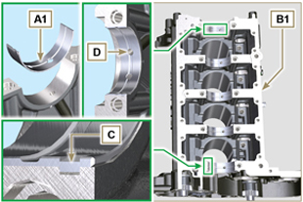  Fig 9.1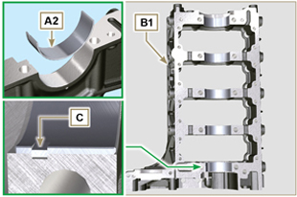  Fig 9.2
9.3.2 Tappets  - Lubricate the tappets E with oil.  - Insert the tappets E into the housings F of the upper crankcase B1 . | 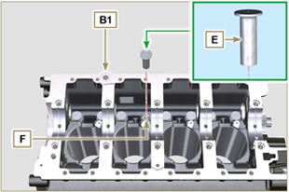  Fig 9.3
9.3.3 Oil spray nozzles  - Insert the sprayers G onto the upper crankcase B1 manually screwing the screw fittings H .  - Ensure that the spray nozzles G are inserted correctly in their seat, as shown in detail L and tighten the connecting screws H (tightening torque of 10 Nm ). | 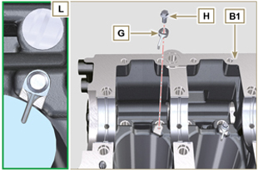  Fig 9.4
9.3.4 Crankshaft  Important  - Carry out the checks described in Par. 8.4.1 and Par. 8.4.2 .  - Check that the crankshaft half-bearings A1 are mounted correctly on the upper crankcase B1 .  - Lubricate the main journal and crankpin J , with oil.  - Insert the crankshaft M into its seat on the upper crankcase B1 .  - Insert the 2 shoulder half-rings N1 , between the crankshaft M and the upper crankcase B1 ( Q detail). | 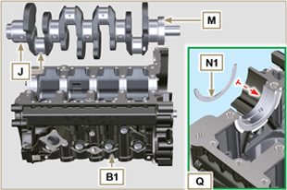  Fig 9.5
9.3.5 Lower semi-crankcase  - Check that the coupling surfaces P are free from dirt and grit.  - Spread a bead of Loctite 5660 of approx 1,5 mm thickness on the surface P of the upper crankshaft half B1 being careful not to block the oil feed grooves X and the return oil sump Y .  - Insert gasket S into the seat of crankcase B1 .  Note: alternatively apply Loctite 5699. | 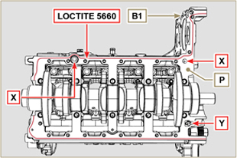  Fig 9.6

- Check that the crankshaft half-bearings A2 are mounted correctly on the lower crankcase B2 .
- Assemble the 2 shoulder half-rings N2 onto the lower crankcase B2 applying two drops of grease to keep them in their seat.
- Join the two crankshaft halves B1 and B2 observing the guide pins T .
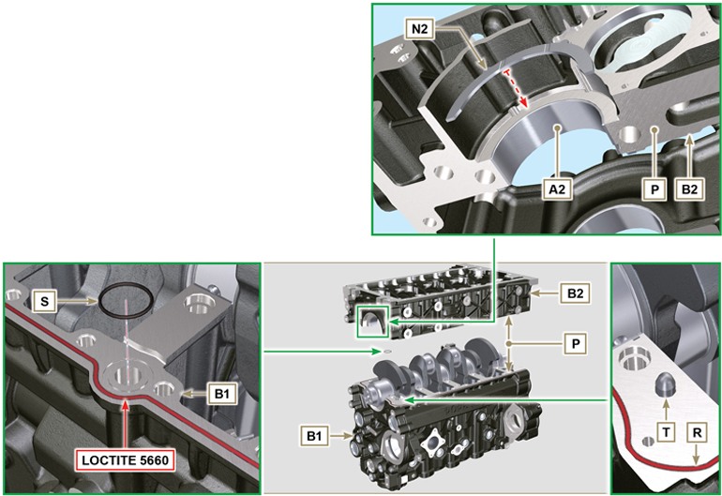
Fig 9.7 - F ig 9.8

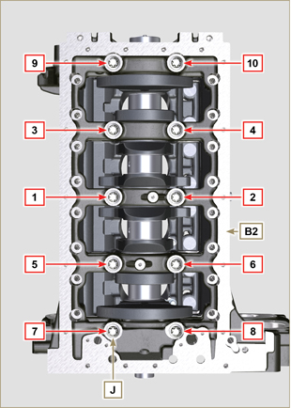  Fig 9.9 | 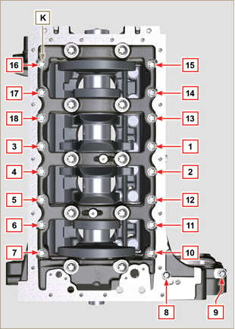  Fig 9.10
Tab 9.2  CYCLE SCREWS TORQUE  1 J - Torx M14x1,5 60 Nm  2 K - Torx M10x1.25 30 Nm  3 J - Torx M14x1,5 45°  4 J - Torx M14x1,5 45°  Important  - The fastening bolts J , K must be replaced every time they are assembled.  - Failure to adhere to the bolt fixing procedures may compromise the functionality of the engine, and also may cause damage to persons and property.  - Tighten capscrews J , K observing the cycles, tightening, and subsequent rotation as indicated in Tab. 9.2 .  - Apply " Molyslip AS COMPOUND 40 " on the threads and under the head of capscrews J and K and manually tighten them until their stop.  - Tightening the screws J , K strictly following the sequence indicated in the Fig. 9.9 or Fig. 9.10 and the tightening torque indicated in the Tab. 9.2 .  - Check that crankshaft M rotates smoothly.  - Insert gasket W into the seat of crankcase B ( ST_47 ) . | 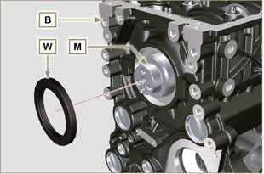  Fig 9.11
9.3.6 Camshaft  - Lubricate the pins S2 the cams S3 of the camshaft S1 all the housing Q1 with oil.  - Insert the camshaft S1 all the way into its housing Q1 .  - Fit the lock ring S4 on to the crankcase B to hold the position of the camshaft S1. | 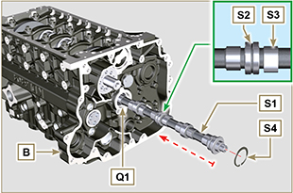  Fig 9.12
9.3.7 Timing system gear  - Check that the pin P1 is correctly fitted on the crankshaft M.  - Position the gear M1 on the crankshaft M respecting the reference with pin P1 .  - Fully tighten the screw N1 interposing tool ST_41 between N1 and M1 .  - Position the gear R1 on the camshaft S1 observing the marks T1 of the gear M1 .  Important  - Failure to comply with the marks T1 on the gears M1 and R1 causes engine malfunction and serious damage.  - Fastening capscrew R2 must be replaced every time it is assembled.  - Assemble gear R1 by means of capscrew R2 (tightening torque 100 Nm ).  - Check that crankshaft M rotates smoothly. | 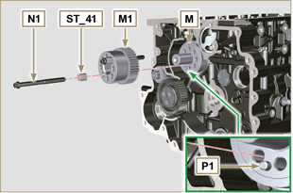  Fig 9.13  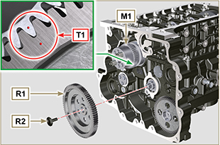  Fig 9.14
9.3.8 Piston rings  - Perform the operations described in Par. 8.5.3 .  - Put the scraper ring Z3 onto the piston Z .  - Put the 2° seal ring Z2 on the piston Z .  - Put the 1° seal ring Z1 onto the piston Z .  - Perform the operations described in Par. 8.5.4 .  - Position the segment openings with a 120° angle between them ( Y ).  NOTE: do not use the segment opening with the pin hole ( N )  - Lubricate the piston skirt and piston rings with oil. | 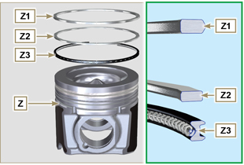  Fig 9.15  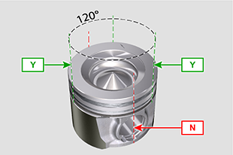  Fig 9.16
9.3.9 Piston  Importante  - The fastening bolts E1 must be replaced every time they are assembled.  - Before proceeding to the assembly of the piston and connecting rod, carry out the checks described in Par. 8.5.1 .  - Always replace the bearings D1 after each assembly.  - Mate components respecting references at Par. 7.12.5 .  - Loosen the screws E1 and remove the connecting rod cap F1 .  - Insert the connecting rod F2 into the piston Z and align the seats G1 .  - Insert the gudgeon pin H1 into the seat G1 for the assembly of the connecting rod and piston unit.  - Insert the lock rings L1 inside the seat G2 of the piston Z to lock the gudgeon pin H1 . | 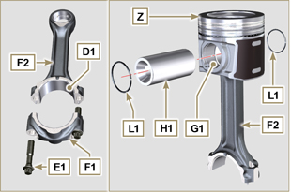  Fig 9.17  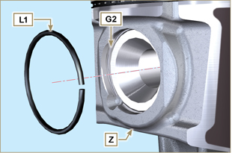  Fig 9.18

9.3.10 Piston and connecting rod assembly  Important  - Before assembling the piston and connecting rod assemblies, execute the controls described in Par. 8.5.5 .  - Rotate the crankshaft M by moving the crankpin J1 to a TDC position of the affected cylinder. | 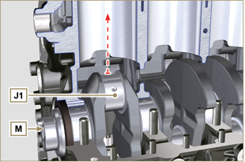  Fig 9.19
- Lubricate the piston skirt and rings Z .  - Check that the half-bearing U1 is mounted correctly and lubricate it thoroughly.  - Using the piston ring compression pliers, insert the piston inside the cylinder W1 by around 10mm (height T2 ).  Important  - Make sure you are at the stage described in Point 1 .  - Piston Z must be assembled with notch K1 on the side of the skirt facing oil spray nozzles G .  - Rotate the piston Z by 10° counter-clockwise with respect to its correct assembly position (Fig. 9.20 - height T3 ).  NOTE: Doing this prevents the impact between the connecting rod F2 and the sprayer G . | 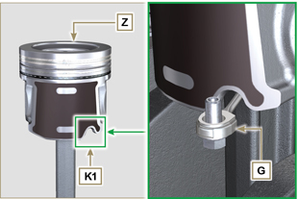  Fig 9.20  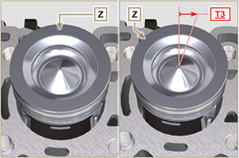  Fig 9.21  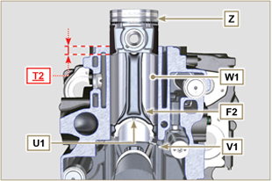  Fig 9.22  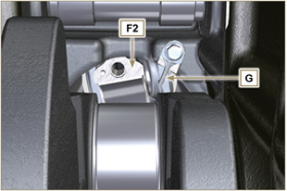  Fig 9.23
Important  - Leave the ring compressor assembled on the piston.  - Push piston Z downwards without introducing the segments in the cylinder, rotate piston Z by 10° in a clockwise direction (value T3 – correct assembly position). | 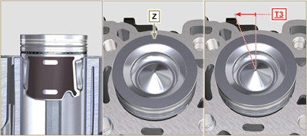  Fig 9.24

- Push the piston Z downwards by centering the crankpin J1 with the connecting rod F2 .  - Rotate the crankshaft M by moving the crankpin J1 to a BDC position of the affected cylinder.  - Push the piston Z downwards by centering the crankpin J1 with the connecting rod F2 .  - Turn the crankcase on support to assemble the con rod capp F1 .  - Check that the half-bearing U1 is mounted correctly on the connecting rod cap F1 .  Important  - Check that the break levels of connecting rod cap F1 coincide perfectly onto connecting rod F2 before screwing on and tightening capscrews E1 .  - Couple the connecting rod cap F1 to the connecting rod F2 using the marks made at disassembly ( Par. 7.12.2 and 7.12.5 ).  - Apply "Molyslip AS COMPOUND 40" on the threads and under the head of capscrew E1 and manually tighten them until their stop.  Important  - Failure to adhere to the assembly procedures may compromise the functionality of the engine, and also cause damage to persons and property.  - Tighten the screws E1 , alternately, strictly following the tightening torques indicated ( Tab. 9.3 ).  - Repeat the operations from 1 to 14 for each cylinder.  - Check that the connecting rods have axial play and the crankshaft M rotates smoothly.  NOTE: After the check carried out at point 16, position the shaft M with the first cylinder to TDC. | 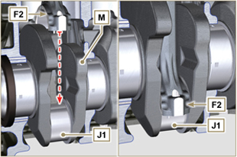  Fig 9.25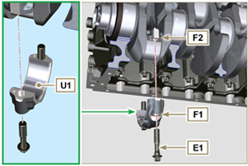  Fig 9.26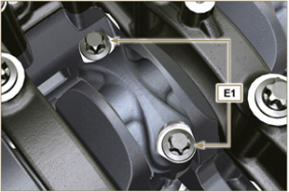  Fig 9.27
Tab 9.3
CYCLE | SCREWS | TORQUE
1 | E1 | 28 Nm
2 | E1 | 30°
3 | E1 | 30°

NOTE : Click by side to play the procedure. | https://www.youtube.com/embed/lo6hvF5R6qA?rel=0

Oil sump unit assembly
9.4.1 Oil drain pipe  Important  - It is mandatory to replace the gasket D after each assembly.  - Always replace capscrews B with new ones or alternatively apply Loctite 2701 .  - Secure the hose A on the crankcase C with the screws B inserting the gasket D (tightening torque 10 Nm ). | 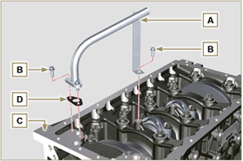  Fig 9.28
9.4.2 Oil suction pipe  Important  - It is mandatory to replace the gasket F after each assembly.  - Always replace capscrews B with new ones or alternatively apply Loctite 2701 .  - Secure the hose E on the crankcase C with the screws B (tightening torque 10 Nm ) fitting the gasket F . | 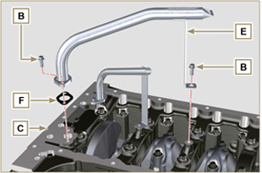  Fig 9.29
9.4.3 Oil Sump  - Ensure that the contact surfaces G of the oil sump H and the crankcase C are completely clean.  - Apply a bead of approx. 2.5 mm of sealant ( Loctite 5660 ) on the surface G of the crankcase C .  Note: alternatively apply Loctite 5699. | 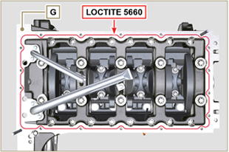  Fig 9.30
- Position the oil sump H on the crankcase C in line with the fastening holes (use the aid of tool ST_18 ). | 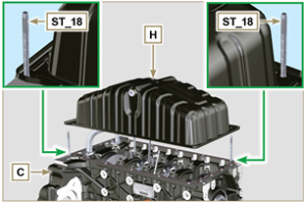  Fig 9.31
Important  - Tighten the screws L , strictly following the sequence and tightening torque indicated.  - Secure oil sump H by means of capscrews L .  - After tightening of the screw n° 10 , loosen screw n°1 and re-tighten it to the torque value specified in step 4 . | 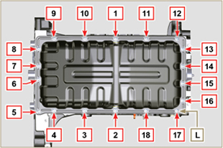  Fig 9.32

Cylinder head unit assembly
9.5.1 Valve stem gasket  Important  - Carry out the checks described in Par. 8.6.4 before proceeding with the following operations.  - Always replace gasket A with every assembly.  - Lubricate the oil seals A on the inside.  - Fit the oil seals A on the valve guides B using the tool ST_08 . | 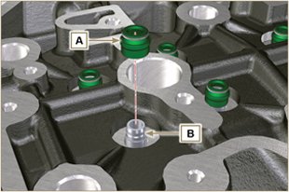  Fig 9.33
9.5.2 Injector sleeves ( )  - Insert the seals C in the seats of the sleeve D .  - Insert the seal E with the convex side facing upward at the base of the sleeve D .  - Lubricate the gaskets C .  - Insert and carefully screw the sleeve D into the seat of the head F .  NOTE: The sleeve D must not protrude above the surface of the head G .  - Clamp the sleeve D (tightening torque at 30 Nm ). | 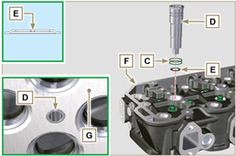  Fig 9.34
9.5.3 Injectors projection  - Perform the operations of Par. 6.1.7.  - Check using ST_03 tool (Fig. 9.35) , the projection of the injector, which must range between 1.68 ÷ 2.42 mm.  NOTE : if the value detected does not correspond, replace gasket Q with a different thickness. | 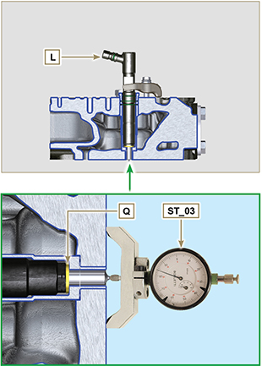  Fig 9.35 - Fig. 9.36
9.5.4 Valves  - Pre-lubricate and insert the valves X into the head F taking care to fit them in the original positions as per the reference marks made in Par. 7.12.4.1 .  - Position the spring Y on the seat of the head F .  - Position the disk S on the spring Y centering the valve X .  - Mount the tool ST_07 on the head F fixing it on one of the holes for securing the rocker arm cover.  NOTE: Change the fixing hole according to the position of the valves to be fitted.  - Position the tool ST_07 on the valve as shown in the Fig. 9.37 .  - Push the lever of the tool ST_07 downwards, in order to lower the valve disks S in the direction of the arrow AK , and insert the valve cotters AJ inside the disk S .  - Check that the valve cotters AJ are properly mounted on the valve seats X and release the tool ST_07 .  NOTE: repeat all the steps for the relevant valves and remove the tool ST_07 . | 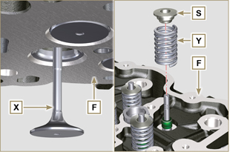  Fig 9.37
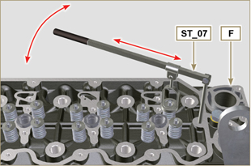
Fig 9.38
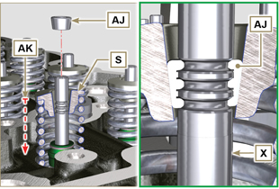
Fig 9.39
9.5.5 Cylinder head  - Fix the eyebolts AW with the screws AX onto the head F (tightening torque of 80 Nm ).  - Position the piston P at the TDC.  - Position the tool ST_03 on the crankcase surface of the head and measure the piston protrusion P from head level K in 4 diametrically opposed points R. Repeat the operation for all pistons P and take note of the highest average value, determining valu e S (Tab. 9.4) .  Tab. 9.42  S (mm) Hole number  0.030 - 0.126 1  0.127 - 0.250 2  0.251 - 0.375 3  - Based on the value detected at point 3 , select the relevant gasket T as shown in the Tab. 9.4 (Fig. 9.41 detail U ).  - Check that the crankcase surface K and the gasket T are completely free of dirt and grit.  Important  - The head gasket must be replaced for each assembly.  - Position the gasket T on the surface K with reference to the centering bushings J . | 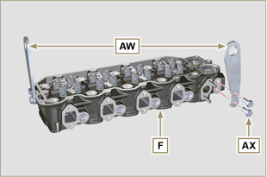  Fig 9.40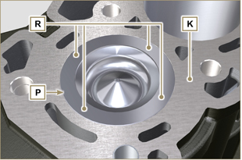  Fig 9.41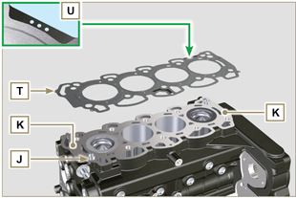  Fig 9.42
- Check that the surface head W is free from impurities.  - Position the head F on the crankcase Z with reference to the centering bushings J .  Important  - The fastening bolts V must be replaced every time they are assembled.  Modified component, see service letter 710009.  - Failure to adhere to the bolt fixing procedures may compromise the functionality of the engine, and also may cause damage to persons and property.  - Tighten capscrews V observing the cycles, tightening, and subsequent rotation as indicated in Tab. 9.5 .  - Secure the head F by tightening the screws V strictly following the sequence indicated in the Fig. 9.43 and the tightening torque and pauses between cycles indicated in the Tab. 9.5 . | 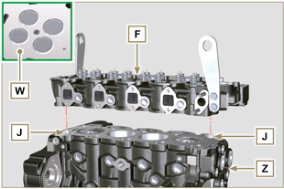  Fig 9.43
Tab. 9.5  CYCLE TORQUE PAUSE  1 75 Nm 3min  2 90° 3min  3 90° 3min  4 90° --- | 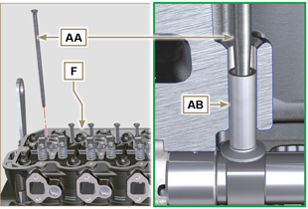  Fig 9.44
9.5.6 Rods and valve bridges  - Insert the rocker control rods AA into the niches of the head F .  Important  - Properly centre the rods AA into the spherical housing of the camshaft tappets AB .  - Mount the valve bridge AC on to the pairs of discharge and suction valves. | 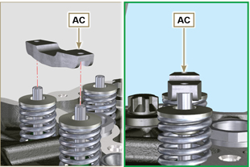  Fig 9.45
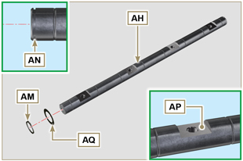
Fig 9.46
9.5.7 Rocker arms  Important  - The discharge rocker arm AT is shorter than the suction arm AR .  - Fit the lock ring AM into the seat AN of the rocker arm pin AH .  - Position the pin AH with the screw support surface AP facing upwards and insert the 2 shoulder rings AQ .  - Insert in sequence the suction rocker arm AR , the holder AS and the discharge rocker arm AT in the pin AH .  - Insert the spring AU in the pin AH .  - Repeat points 3, 4 for all the rocker arms.  NOTE: Support AV , which contains taper pin BV , must be assembled in correspondence with cylinder n° 3 .  - Insert 2 shoulder rings AQ and the lock ring AN to lock all the components inserted in the pin AH .  NOTE : The spring AU ensures that the supports AS and AV are kept in place. | 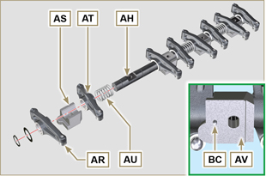  Fig 9.47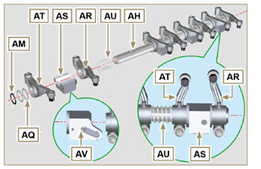  Fig 9.48
9.5.8 Rocker arm pin assembly  Important  - Position the rocker arm pin assembly BB on a level to align all the support surfaces.  - Check that the pistons are positioned half way between the TDC and BDC. As seen from A ⇒ ( Par. 1.4 ) turn the crankshaft anticlockwise by 90°, complying with TDC of the 1st cylinder , positioning taper pin BP of the crankshaft as shown in Fig. 9.48 .  - Position rocker arm shaft unit BB on cylinder head F , complying with the taper pin BC reference with hole BF of cylinder head F .  - Check the correct positioning of all the rocker arms and the u-bolt control valves (detail BD ).  House the tappet in the seat of the rocker arms control rod.  - Secure the rocker arm pin BB tightening the screws BE (tightening torque to 40 Nm ). Adhere to the screw tightening sequence BE as shown in Fig. 9.50 . | 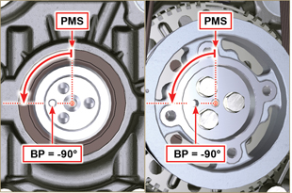  Fig 9.49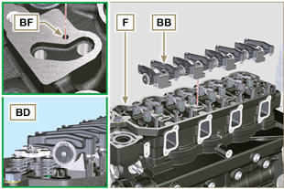  Fig 9.50
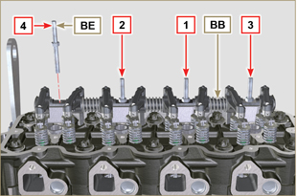
Fig 9.51

Assembly lubrication circuit
9. 6 .1 Oil pressure relief valve  - Lubricate the piston N and fully insert it in the seat P .  - Insert the spring Q in the piston N .  - Insert disk R onto spring Q .  - Insert cotter pin S in the provided seat of oil pump T to lock components N, Q and R . | 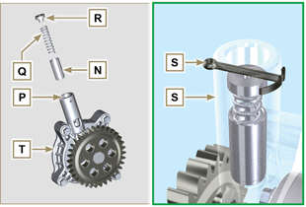  Fig 9.52
9.6 .2 Oil pump  NOTE: Carry out the checks described in Par. 8.7 before proceeding with the following operations.  - Check that all contact surfaces between T, V are free of impurities – scratches - dents.  - When assembling, do not use any type of gasket between T and V .  - Thoroughly lubricate the seat of the rotors on oil pump T .  - Make sure the external rotor is assembled correctly with Ref. U visible, as shown in the picture (or refer to Par. 2.10.2 ).  - Fasten the oil pump cover T on the crankcase V with the screws X (tightening torque 10 Nm ). | 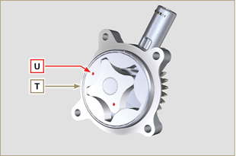  Fig 9.53
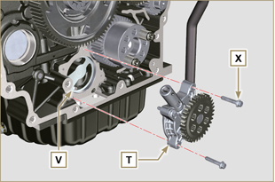
Fig 9.54

Flange unit assembly
9.7.1 Bell housing  Danger  - Bell A is very heavy; pay special attention during assembly operations to avoid dropping and causing serious risks to the operator.  - Apply a bead of approx. 2.5 mm of sealant ( Loctite 5188 ) on the surface B of the bell A .  - Assemble bell A onto crankcase D , complying with reference taper pins E ( ST_45 ) . | 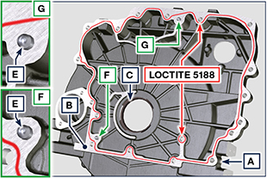  Fig 9.55

Important  - Failure to adhere to the assembly procedures may compromise the functionality of the engine, and also cause damage to persons and property.  - Always replace and lubricate the gasket C with oil, every time they are assembled (the gasket C is to be mounted after the operation at point 4 ST_47 ).  - Apply the screws F by hand without tightening them.  - Tighten the screws F following the tightening sequence indicated (tightening torque 75 Nm ). | 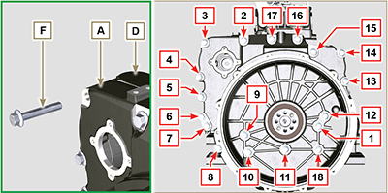  Fig 9.56

9.7.2 Flywheel  Danger  - Flywheel F is very heavy; pay special attention during assembly operations to avoid dropping and causing serious risks to the operator.  - Loosen capscrews G and remove tool ST_41 .  - Position flywheel H onto crankshaft L by means of tool ST_43 - ST_46 .  - Apply " Molyslip AS COMPOUND 40 " on the threads and under the head of capscrews G and manually tighten them until their stop.  - Secure flywheel H with capscrews G (tightening torque 60 Nm ).  - Once again, tighten capscrews G (2 cycles with tightening torque 130 Nm ). | 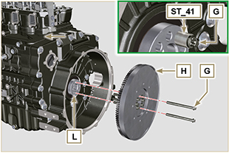  Fig 9.57

Fuel system assembly
Important

- Remove the protective caps from all the components of the fuel circuit just before assembly just before assembly ( Par. 2.9.8 ).
9.8.1 High-pressure injection pump

- Follow operations 1, 2, 3, 4, 5, 6, 7 and 8 of Par. 6.1.5 .
- Follow operations 1, 2, 3, 4, 5, 6, 7 and 10 of Par. 6.1.6 .
9.8.2 Injectors

Important

- To prevent damaging the injection system, the protection caps ( Par. 2.9.7 ) must be removed during assembly.

- Follow operations of Par. 6.1.7 .
9.8.3 Fuel return pipes  - Tighten union A onto cylinder head B , inserting the relative gasket.  - Perform the operations of point 8 of Par. 6.1.6 . | 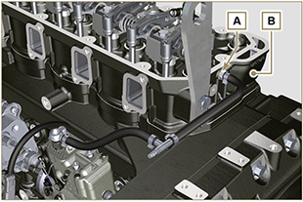
9.8.4 Rocker arms cover

- Perform the operations of Par. 6.1.9 .
9.8.5 Injection fuel pipes

- Perform the operations of Par. 6.1.10 .
9.8.6 Fuel filter

- Perform the operations of Par. 6.5.2 .

Crankshaft pulley assembly
- Check that the pin A is mounted properly on the crankshaft B .  - Position the pulley C on the crankshaft B using the pin mark A .  - Apply " Molyslip AS COMPOUND 40 " grease onto the thread and under the head of capscrew D .  - Fix the pulley C with the screw D (tightening torque of 100 Nm ) and remove special tool ST_34 . | 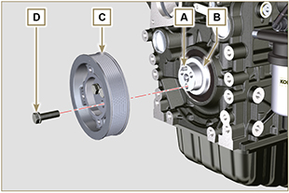  Fig 9.61

Coolant circuit assembly
9.14.1 Thermostatic valve  Important  - Always replace the gasket A after each assembly.  - Check the condition of the seal gasket A and fit it on the thermostatic valve B .  - Position the thermostatic valve B in the seat on the head C (detail D ).  - Secure the cover E with the screws F on the head C (tightening torque of 10 Nm ). | 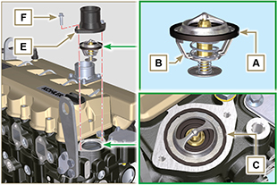  Fig 9.62
9.10.2 Coolant pump  Important  - Always replace the gasket L every time it is assembled.  - Secure the flange G with the screws H interposing the gasket L onto the crankcase M (tightening torque of 25 Nm ).  - Perform the operations 1 and 2 of Par. 6.2.2. | 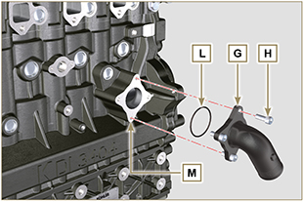  Fig 9.63
9.10.3 Oil Cooler hoses  - Secure hose N on Oil Cooler P and on crankcase M by means of clamps Q .  - Position and secure hose R by means of clamp S on Oil Cooler P and on crankcase M .  - Secure clamps T on manifold U by means of capscrews V in points X (tightening torque 10 Nm - ST_06 ). | 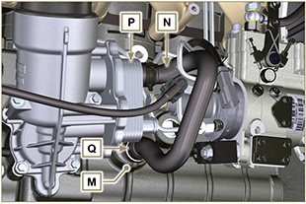  Fig 9.64
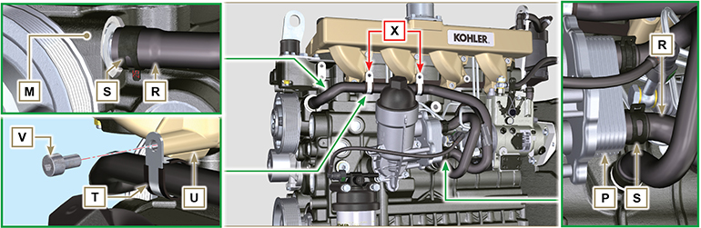
Fig 9.65

Exhaust manifold assembly
Important  - Replace the metal gaskets A every time they are assembled.  - Check that the contact surfaces D are free from impurities.  - Position manifold E onto cylinder head G by manually tightening capscrews F , inserting:  - gaskets A between cylinder head G and manifold E ;  - spacers H between capscrews F and manifold E .  - Secure manifold E onto cylinder head G by means of capscrews F (tightening torque 25 Nm ). | 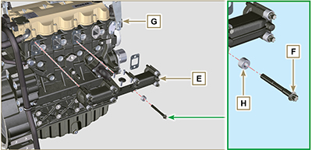  Fig 9.66

Turbocharger assembly
Importante  - Before proceeding, perform the operation described in Par. 2.18 .  - Ensure that tube C is not clogged.  - Always replace the gaskets A, B, Q at each assembly.  - Remove the plastic or foam caps from the turbo compressor before assembling.  - Check that the contact surfaces D are free from impurities deformations or cracks, otherwise replace the damaged component.  - Position the turbo-compressor E on the bolts F on the manifold G .  - Fasten the turbo-compressor E with the nuts H (tightening torque of 25 Nm ).  - Fasten the pipe L with the screws M to the turbo-compressor E .  - Fasten the pipe G with the screws N on the crankcase P .  Importante  - Always replace the gasket Q after each assembly.  - Before assembly of the tube R , perform the operation described in Par. 2.18.2 - Point 2 .  - Ensure that tube R is not clogged.  - Fasten the pipe R with the fittings S on the turbo-compressor E and on the crankcase P (tightening torque of 15 Nm ).  Insert the gaskets Q between:  - S and R; - E and R;  - P and R. | 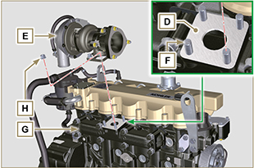  Fig 9.67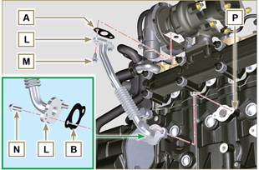  Fig 9.68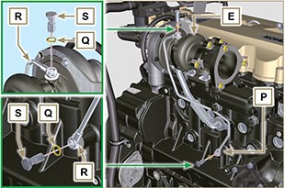  Fig 9.69

Electric component assembly
9.13.1 Sensors and switches

9.13.1.1 Coolant temperature sensor  - Secure the sensor A onto the head B (tightening torque of 20 Nm ). | 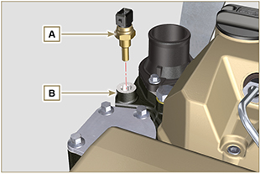  Fig 9.70
9.13.1.2 Oil Pressure Switch  - Clamp the oil pressure switch C on the crankcase D (tightening torque at 35 Nm ). | 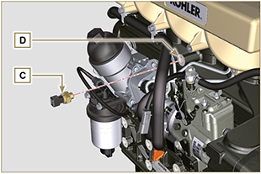  Fig 9.71
9.13.2 Alternator  - Insert the washer E onto the screw F .  - Insert the screw F onto the alternator G .  - Secure the bracket H and the alternator G using the screws L, F onto the crankcase M .  - Follow operations 3, 4, 5, 6 and 7 of Par. 6.2.2. | 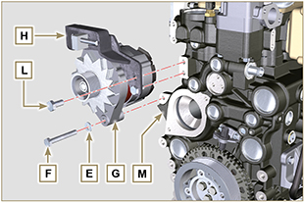  Fig 9.72
9.13.3 Starter Motor  - Secure motor N by means of capscrews P (tightening torque at 45 Nm ). | 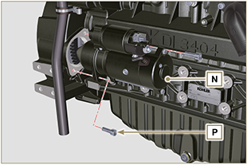  Fig 9.73

Tightening torques and the use of sealants
Tab. 9.4 - *Alternatively to the capscrew replacements, with "Dri-loc"
BASE CONFIGURATION

SHORT BLOCK
Component | Thread (mm) | Torque (Nm) | Sealer
Oil sprays fastening capscrew | M6x1 | 10
Lower crankcase fastening capscrew | M14x1.25 | 3 Torque cycles
1st Cycle |  | 60
2nd Cycle |  | +45°
3rd Cycle |  | +45°
Lower crankcase fastening capscrew | M10x1.25 | 30
Connecting rod screw | M11x1 | 3 Torque cycles
1st Cycle |  | 28
2nd Cycle |  | +30
3rd Cycle |  | +30
Coolant drain hole closing cap | M16x1.5 | 50
Main oil delivery line closing plate | M6x1 | 15
Intermediate idle gear cap fastening screw | M8x1 | 25
Camshaft gear fastening screw | M10x1 | 100 | DRI LOC 2040
OIL SUMP ASSEMBLY
Component | Thread (mm) | Torque (Nm) | Sealer
Oil suction hose fastening capscrew | M6x1 | 10 | Loctite 2701*
Oil return pipe fastening screw | M6x1 | 10 | Loctite 2701*
Oil sump fastening capscrew | M8x1.25 | 25
Oil drain cap | M18x1.5 | 30
FLANGE ASSEMBLY (1st PTO)
Component | Thread (mm) | Torque (Nm) | Sealer
Flange bell fastening capscrew | M12x1,75 | 75
Flywheel fastening capscrew | M12x1,25 | 3 Torque cycles
1st Cycle |  | 60
2nd Cycle |  | 130
3rd Cycle |  | 130
ENGINE CYLINDER HEAD ASSEMBLY
Component | Thread (mm) | Torque (Nm) | Sealer
Air bleeding cap (Rev. 00) | M6x1 | 6
Air bleeding cap (Rev. 01) | M14x1,5 | 50
Lifting brace fastening capscrew | M8x1.25 | 80
Injector manifold | M12x1 | 30
Cylinder head fastening capscrew | M12x1.25 | 4 Torque cycles
1 ^{st} Cycle |  | 75
2 ^{nd} Cycle |  | +90°
3 ^{rd} Cycle |  | +90°
4 ^{th} Cycle |  | +90°
Rocker arm gudgeon fastening capscrew | M8x1,25 | 40
Rocker arm cover fastening capscrew | M6x1 | 10
INJECTION SYSTEM
Component | Thread (mm) | Torque (Nm) | Sealer
Fuel filter fastening capscrew | M8x1.25 | 25
Injector brace fastening capscrew | M8x1.25 | 20
Injector side injection tube nuts | M12x1.5 | 25
Injection pump side injection tubes nuts | M12x1.5 | 25
Injection pump fastening capscrew | M8x1.25 | 25 | Loctite 2701*
Gear fastening nut on fuel injection pump | M14x1.5 | 140
Screw for cover over injection pump shaft nut (on bell housing) | M6x1 | 10
INTAKE MANIFOLD
Component | Thread (mm) | Torque (Nm) | Sealer
Manifold fastening screw | M8x1.25 | 25
Intake flange fastening capscrew | M8x1.25 | 25
EXHAUST MANIFOLD
Component | Thread (mm) | Torque (Nm) | Sealer
Exhaust manifold fastening screw | M10x1.5 | 50
LUBRICATION CIRCUIT
Component | Thread (mm) | Torque (Nm) | Sealer
Oil vapour separator support plate fastening capscrew | TG8 | 22
Oil steam separator return tube drilled fastening screw (on crankcase) | M6x1.5
Oil filter fastening union | M20x1.5 | 15 | Loctite 2701*
Oil cooler fastening capscrew | M6x1 | 10
Cartridge-holder cover | ... | 25
Oil pump fastening screw | M6x1 | 10
CRANKSHAFT PULLEY ASSEMBLY (2nd PTO)
Component | Thread (mm) | Torque (Nm) | Sealer
Crankshaft pulley fastening capscrew | M12x1.75 | 100 | Molyslip
COOLANT CIRCUIT

Component | Thread (mm) | Torque (Nm) | Sealer
Coolant tube clamp fastening capscrew (Oil Cooler return) | TG8 | 22
Thermostatic valve cover fastening capscrew | M6x1 | 10
Coolant pump fastening capscrew | M8x1.25 | 25
Blower fastening capscrew | M8x1.25 | 25
TURBO COMPRESSOR
Component | Thread (mm) | Torque (Nm) | Sealer
Oil return tube fastening capscrew | M6x1 | 10
Oil supply tube fastening capscrew | M10x1 | 15
Turbine fastening stud (on manifold) | M10x1.5 | 30
Exhaust fastening stud (on turbine) | M8x1.25 | 25
Exhaust flange fastening stud (on turbine) | M10x1.5 | 30
Exhaust flange fastening nut (on turbine) | M8x1.25 | 25
ELECTRICAL COMPONENTS
Component | Thread (mm) | Torque (Nm) | Sealer
Coolant temperature sensor | M12x1.5 | 20 max.
Oil pressure switch | M12x1.5 | 35
Alternator fastening capscrew | M10x1.5 | 45
Alternator fastening capscrew | M8x1.25 | 25
Starter motor fastening capscrew | M10x1.5 | 45
Supply cable fastening nut (starter motor) | M10x1.5 | 15
* Alternatively to the capscrew replacements, with "Dri-loc"

OPTIONAL COMPONENTS (Chap. 11)
HEATER
Component | Thread (mm) | Torque (Nm) | Sealer
Flange intake with heater fastening capscrew | M8x1.25 | 25
COOLING CIRCUIT
Component | Thread (mm) | Torque (Nm) | Sealer
Blower fastening capscrew | M6x1 | 10
Radiator support fastening capscrew | M12x1.75
Shroud radiator fastening capscrew | M6x1 | 10
Radiator lower brace fastening capscrew | M10x1.5
Radiator on anti-vibrating | M8x1.25 | 25
Vibration-damping nut fixing (on radiator support) | M8x1.25 | 25
Anti-vibrating and brace fastening capscrew (upper) | M8x1.25 | 25
Upper brace fastening capscrew (on engine cylinder head) | M8x1.25 | 25
Side bulkheads fastening capscrew | M6x1 | 10
* Alternatively to the capscrew replacements, with "Dri-loc"

Fluids filling information

Engine oil
Warning

- Before proceeding with operation, carefully read Par. 3.3.2 .

- Loosen the oil filler cap A .  - Add the type and amount of oil recommended ( Tab. 2.2 ).  - Remove the oil dipstick B and check that the level is up to but does not exceed the MAX .  Important  - Do not use the engine with the level of oil below MIN or above MAX  - If the oil level is not at MAX , insert more oil until the MAX level is reached as indicated on the dipstick.  - Re-tighten the cap A . | 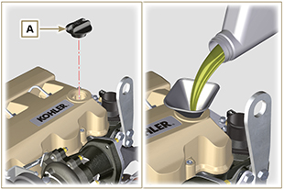  Fig 10.1
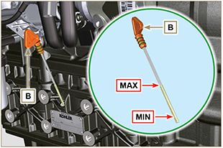
Fig 10.2
NOTE : Click by side to play the procedure. | https://www.youtube.com/embed/AKB8FW8k5rY?rel=0

Coolant
Important

- Before proceeding with operation, read Par. 3.3.2 .
- Fit tube A onto radiator B and secure it with clamp C . | 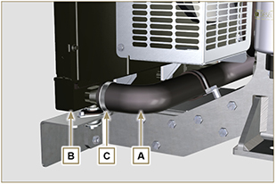  Fig 10.3
- Refill the radiator with coolant (refer to Par. 2.6 for the liquid specifications).  - Top liquid up until the pipes inside the radiator are covered by about 5 mm.  - For engines equipped with separate expansion tank, pour in fluid until reaching the max level mark.  - Loosen the screw F on the head H , release any air and tighten the screw F (Tightening torque of: 8 Nm for screw M6 (Rev. 00); 30 Nm for screw M12 (Rev. 01) ).  - Start the engine without the radiator cap D or the expansion tank cap. | 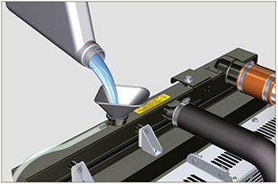  Fig 10.4
- Keep it running at idle speed until the cooling liquid level goes down and becomes steady (the waiting times varies according to the ambient temperature).  - Stop the engine and allow it to cool.  - If there is an expansion tank ( C ) top liquid up to the mark MAX .  - Without expansion tank top liquid up until the pipes inside the radiator are covered by 5 mm. Do not overfill the radiator, but leave room for the coolant to expand.  - Tighten the radiator cap D or the expansion tank cap.  Warning  - Before starting make sure that the radiator cap and expansion tank cap, if present, are installed correctly to avoid spillage of liquid or vapour at high temperatures.  - After a few hours of operation stop the engine and allow it to cool.  Check and top up the coolant liquid. | 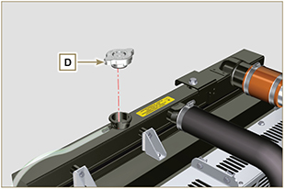  Fig 10.5  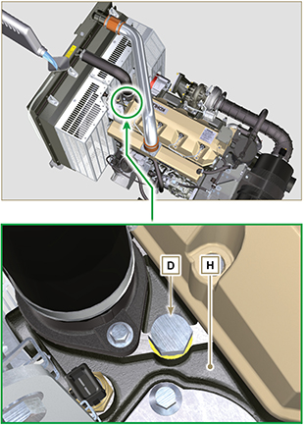  Fig 10.6
NOTE: Click on the right to play the procedure. | https://www.youtube.com/embed/AHBKX3Q90p4?rel=0

Information about optional components

Heater (replacement)
Important

- Before proceeding with operation, read Par. 3.3.2 .
11.1.1 Disassembly  - Undo the screws A .  - Remove the flange C .  - Remove the heater E and the relevant gaskets F . | 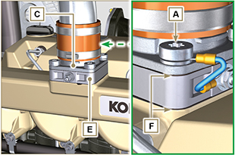  Fig 11.1
11.1.2 Assembly  Important  - Always replace gaskets F , with each assembly.  - In sequence, fit the manifold G with the gasket F , the new heater E , the second gasket F , the flange C , the washers H , the screws A and the cable B .  - Secure the flange C with the screws A (tightening torque at 22 Nm ). | 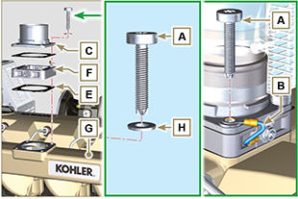  Fig 11.2

Air filter (cartridge replacement)
Important

- Before proceeding with operation, read Par. 3.3.2 .
- Release the two hooks A and remove the cover B from the body C .  - Remove the cartridges D . | 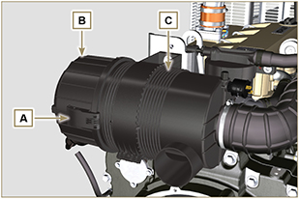  Fig 11.3
- Insert the new cartridge D and both of them inside the filter body C .  - Secure the cover B via the hooks A . | 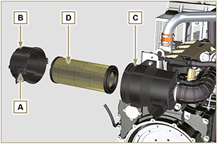  Fig. 11.4

Cooling circuit (replacement)
Important

- Before proceeding with operation, read Par. 3.3.2 .
11.3.1 Radiator disassembly  - Release the clamp A1, A2 .  - Disconnect hose B from radiator C . | 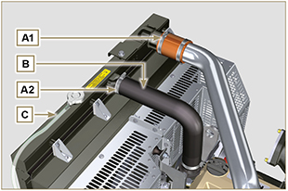  Fig. 11.5
- Release the clamp A3, A4 .  - Disconnect hose D from radiator C . | 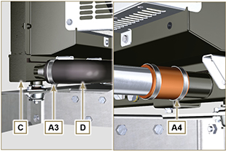  Fig. 11.6
- Loosen all capscrews E1 , E2 and E3 .  - Release nut F .  - Remove floodgates G1 and G2 .  - Loosen capscrews K .  - Disconnect radiator C from hoses H1 and H2 , being careful not to deform tubes J1 and J2 .  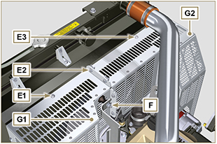  Fig. 11.7 | 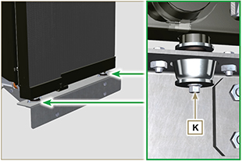  Fig. 11.8
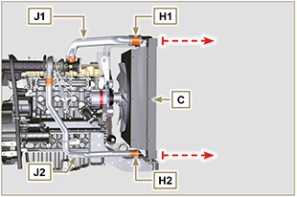
Fig. 11.9
11.3.2 Fan disassembly  - Undo the screws P and remove the fan R . | 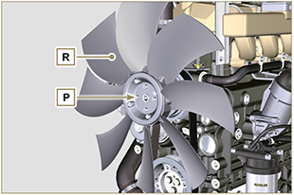  Fig. 11.10
11.3.3 Fan assembly  - Assemble the fan R on the pulley U .  - Fasten the fan R by using the screws P (tightening torque at 10 Nm ). | 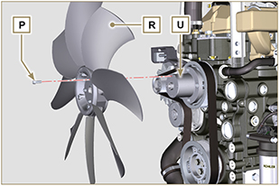  Fig. 11.11

11.3.4 Radiator assembly  - Fit radiator C onto hose H2 , being careful not to deform tube J2 .  - Centre radiator C onto vibration-dampening devices V .  - Secure radiator C onto vibration-dampening devices V by means of capscrews K (tightening torque at 25 Nm ). | 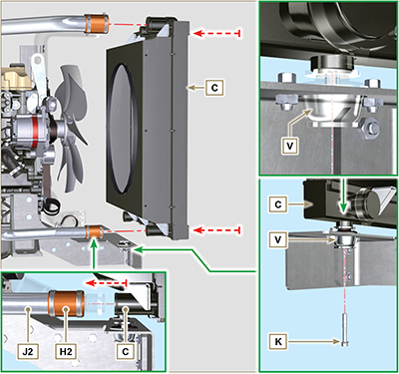  Fig. 11.12
- Position floodgate G1 onto radiator C .  - Secure all capscrews E1 .  - Place floodgate G2 onto radiator C .  - Secure all capscrews E3 and E2 . | 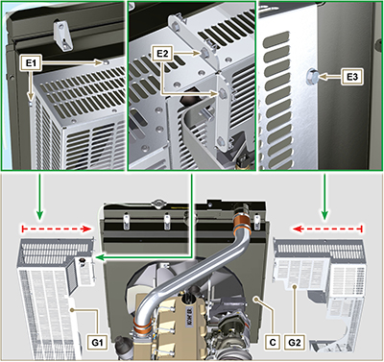  Fig. 11.13

- Fit hose H1 onto radiator C , being careful not to deform tube J1 .  NOTE : Make sure vibration-dampening device V2 is correctly installed in its place on brace S . | 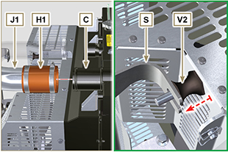  Fig. 11.14
- Secure vibration-dampening device V2 onto brace S by means of nut F , inserting washer F1 (tightening torque at 25 Nm).  - Secure hoses B and D by means of clamps A2 and A3 ( Fig. 11.5 - 11.6 ).  - Secure hoses H1 and H2 by means of clamps A1 and A4 ( Fig. 11.5 - 11.6 ). | 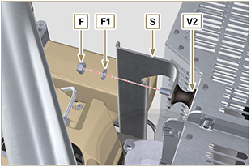  Fig. 11.15

Information on adjustments

'Waste Gate' opening valve regulation

Important

- Before proceeding with operation, read Par. 3.3.2 .
- Regulation must not be carried out with the engine running.
- During the procedure in point 5 , pay special attention not to bend rod H .

- Disconnect the hose A from the turbocharger, and connect a pressure gauge B (scale from 0 to 5 bar).
- Connect the gauge B to the network of compressed air, interposing a pressure reducer C .
- Position dial gauge D in such a way that feeler F rests onthe Waste Gate rod control valve extremity H (point E ).
- By using gradually the reduction gear C send the air to the Waste Gate actuator control L in order to move rod H forward by 1 mm (value M to check on dial gauge D). Pressure read on gauge B must be: 2500 mbar.
- If pressure is less or more than the indicated value, proceed as follows: - Undo lock nut G from rod H.

- Remove the retainer cotter pin (point E ) and disconnect rod H from the Waste Gate control lever.
- Tighten (to increase) / or loosen (to decrease) pressure of the ring nut of rod H until reaching the corrected calibration.
- Redo lock nut G .
- Reconnect rod H and assemble the cotter pin point E .

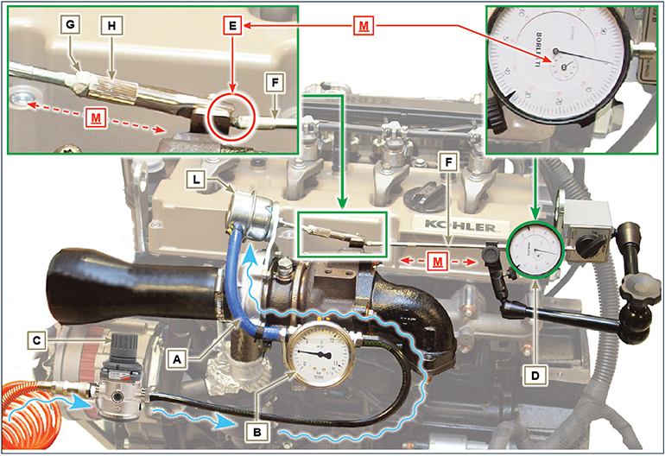
Fig 12.1

Air filter check
Important

- Before proceeding with operation, read Par. 3.3.2 .

- Hose A must be completely clean and not damaged.  - Air filter cartridge B and its housing C must be completely clean and free from impurities. | 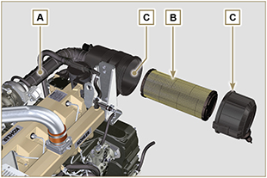  Fig 12.2

Oil steam separator check
Important

- Before proceeding with operation, read Par. 3.3.2 .
- Loosen clamp B and remove hose C from hose A .  - Remove rapid fitting D from separator A .  - Start the engine at idle speed or without a load and check if air comes out from unions A1 and A2 .  NOTE: If what is described in Point 3 does not occur, proceed with cleaning or replacing oil separator A and accurately clean all connecting  hoses, and repeat the operation from Point 3. | 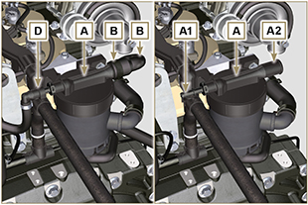  Fig 12.3

Rubber hoses and manifolds check
Important

- Before proceeding with operation, read Par. 3.3.2 .
The check is carried out by applying slight deflection or bending along the tube/hose and next to the hose clamps.  Components must be replaced if they have clear signs of cracks, tears, cuts, leaks, or do not retain a certain degree of elasticity.  - Check the condition of all hoses and rubber tubes highlighted in red in Fig. 12.4 - 12.5 .  - Check whether there are any leakages of air, refrigerant, oil or fuel next to their connections.  NOTE : Refer to the technical documentation of the machine for components that are not shown in the figure. | 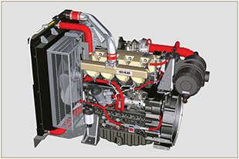  Fig 12.4
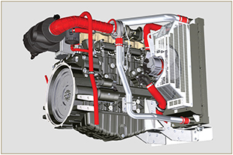
Fig 12.5

Oil leak check
Important

- Before proceeding with operation, read Par. 3.3.2 .
Check that there are no leakages next to area A .  - Start the engine at idle speed or without a load and check whether there are any leakages next to area A.  - It is anyhow necessary to also check the seals of all main components and their surface contact, such as:  - crankcase and gasket (side 1 ª PTO) - oil sump and exhaust caps  - cylinder head and its assembled components  - rocker arm cover  - Timing system carter and gasket (side 2 ª PTO) - oil dipstick housing or rod support tube.  NOTE: Perform the checks described in Points 1 and 2 periodically and during maintenance procedures.  It is also necessary to check for leakages on the components that are not listed.  If necessary, disassemble the components that have a leakage and investigate the possible cause.  The components must be replaced otherwise they do notguarantee their sealing. | 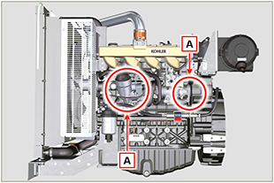  Fig 12.6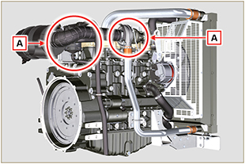  Fig 12.7

Oil pressure check
Important

- Before proceeding with operation, read Par. 3.3.2 .
- Replace the oil dipstick A with a thermocouple B (Fig. 12.8).  - Unscrew and remove the oil pressure switch C and screw on a 10 bar pressure gauge in its seat (Fig. 12.10) .  - Start the engine at idle speed and without a load, check the oil pressure value according to the oil temperature (Fig. 12.9 ).  NOTE : The graph in Fig. 12.9 illustrates the pressure line with speed of 1000 Rpm.  - If the pressure values are below the values indicated in Fig. 12.9 , check to identify the cause of the problem.  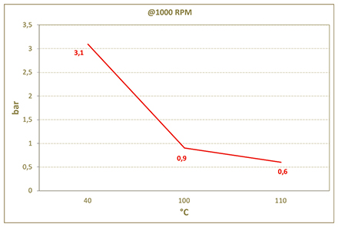  Fig. 12.9 | 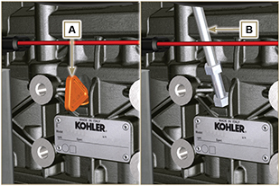  Fig. 12.8  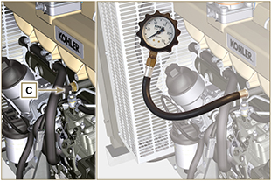  Fig. 12.10

Tools information

Information regarding specific tools

In Tab 13.1 - 13.2 there is a list of all the specific tools that are required and approved to carry out operations of disassembly - assembly - regulations - settings - repairs on engine series KDI

, correctly and safely.
Warning

- KOHLER declines all responsibility for any damage to the engine, persons, or things caused by the use of different types of tools to those indicated in Tab 13.1 - 13.2 , where referred to them in the manual.

Tab. 13.1
SPECIAL TOOLS FOR DISASSEMBLY AND ASSEMBLY
"ST" | Picture/Draw | DESCRIPTION | PART NUMBER
ST_03 | 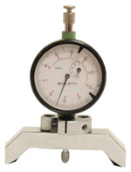 | Piston protrusion - injectors cylinder head surface control tool | ED0014602980-S
ST_05 | 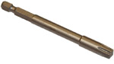 | Spanner for capscrews Six nicks SN 8 | ED0014603650-S
ST_06 | 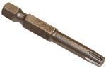 | Spanner for capscrews Six nicks SN 5 | ED0014603640-S
ST_07 | 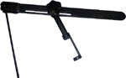 | Tool for disassembling / reassembling valves | ED0014603720-S
ST_08 | 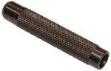 | Tool for gasket valve stem | ED0014603660-S
ST_13 | 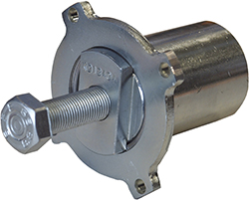 | High-pressure fuel injection pump puller gear | ED0014604050-S
ST_17 | 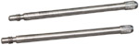 | Rocker arm cover mounting studs | ED0014603730-S
ST_18 | 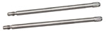 | Intake and oil sump manifold mounting studs | ED0014603740-S
ST_30 | 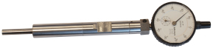 | Piston n°1 tool positioning prior to injection pump assembly. | ED0014603940-S
ST_34 | 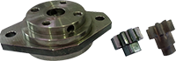 | Crankshaft blocking tool | ED0014604270-S
ST_36 | 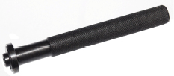 | Assembling tool for a gasket on a rocker arm cover (injector seat) | ED0014603830-S
ST_41 |  | Spacers for crankshaft gears locking | ED0014604070-S
ST_43 | 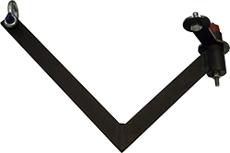 | Flywheel lifting tool | ED0014604030-S
ST_44 | 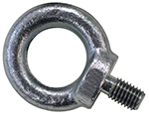 | Flange bell lifting tool | ED0014604010-S
ST_45 | 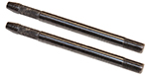 | Flange bell placing tool | ED0014604020-S
ST_46 |  | Flywheel placing tool | ED0014604040-S
ST_47 | 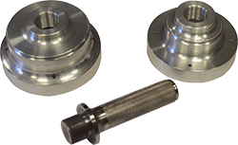 | Tool for sealing ring insertion flywheel side and pulley side | ED0014604340-S
ST_52 | 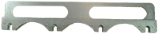 | Injectors placing tool | ED0014604320-S
Tab. 13.2
SPECIFIC EQUIPMENT TO PROTECT COMPONENTS OF THE INJECTION CIRCUIT
ST_40 | 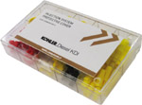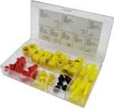 | Complete box with caps to close holes and unions for high-pressure injection circuit components. | ED0082051380-S

Information about failures

Possible causes and trouble shooting
IMMEDIATELY STOP THE ENGINE WHEN:
- Engine rpm increases and decreases suddenly without being able to control them;
- A sudden and unusual noise is heard;
- The colour of the exhaust fumes suddenly darkens or turns white;
- The oil pressure warning light or a Warning Lamp turns on during operation;
- The coolant temperature warning light turns on during operation.

Tab. 14.1 contains the possible causes of some failures, which may occur during operation.

Always perform these simple checks before removing or replacing any part.
Warning

- Search for a topic and the operations to carry out from the analytical index or chapter index found at the beginning of the manual.
- Do not carry out any checks or operations on the engine when it is running.

Tab. 14.1

Glossary

Glossary
A

Air gap: | Distance to respect between a fixed component and one in movement.
Alternator: | A component that transforms mechanical energy into AC electrical energy.
Authorised service station: | KOHLER authorised workshop.
Authorised workshop: | KOHLER authorised service centre.

B

Base configuration: | Engine having components represented in Par. 1.3 - 1.4 . .
BDC: | Bottom Dead Centre; a moment in which the piston is at the start of its stroke.
Bore | Internal diameter of the cylinder in combustion engines.

C

Cold Start Advance: | The device provides for advance injection modification to enable advance of the engine at low temperatures.
Combustion: | Chemical reaction of a mixture composed of fuel and fuel (air) inside a combustion chamber.
Crankshaft: | A component that transforms straight operation into rotary operation, and vice-versa.

E

EC: | "European Community".

F

Fig.: | Figure.
Functional units: | Component, or group of main components, able to carry out specific functions on the engine.

G

Galvanised: | Material that has undergone surface protection treatment.
Grinding (valves and seats): | Cleaning operation of the valves and seats carried out with an abrasive paste (refer to an authorised service station for this type of operation).

H

Heater: | A device that heats the intake air by means of an electrical resistor.
Heavy conditions: | Type of extreme condition referred to the work environment in which the engine is used (very dusty - dirty area, or in a contaminated environment due to various types of gas).

I

Idle speed operation: | Operation of a running engine with the vehicle stopped and on idle speed.

K

KDI: | "Kohler Direct Injection"

M

Maintenance - periodic | A group of maintenance actions that have the sole objective to control and replace elements on their expiry, without modifying or improving the functions carried out by the system, neither increasing the value nor improving performance.
MAX: | Maximum.
Methyl ester: | It is a mixture of products by means of a chemical conversion of oils and animal and/or vegetable fat, which is used to produce Biofuel.
Min.: | Minutes.
MIN: | Minimum.
Model: | Model, engine identification plate, which indicates the engine's model.

N

N/C: | Normally Closed, referred to switches (oil-pressure switch).
N/O: | Normally Opened, referred to switches (Coolant temperature sensor)

O

Oil Cooler: | Small radiator used to cool the oil.

P

Par.: | Paragraph.
Paraffin.: | Fatty and solid substance that may form inside the diesel.
Pipe cleaner: | An instrument having a metal cylindrical body with bristles that jut outwards. It is similar to a brush and is used to clean areas that are not easily accessible manually (e.g. oil ducts inside an engine).
Power operation: | Operation of the engine at high speeds.
PTO: | Power Take Off - a point provided to take advantage of alternative operation transmission.

R

Ref.: | Reference.
Rpm: | Rounds per minute.

S

s/n: | Serial number (engine identification name plate) indicating the engine identification series/chassis number.
Spec.: | Specification, (engine identification name plate) indicating the engine version.
STD: | (Standard), base configuration of a component, or a group of components.

T

Tab.: | Table.
TDC: | Top Dead Centre; a moment in which the piston is at the end of its stroke.
Thermostatic valve: | A valve that adjusts the flow of coolant liquid; it is able to operate by means of temperature variation.
Torque: | Force applied to an object that rotates on an idler shaft.
Trochoid: | Rounded toothed profile (also known as "lobes").
Turbocharger: | Device that compresses air intake by sending it to the intake manifold by means of a turbine.

U

Used oil: | Oil altered by operation or time, which is no longer compliant for correct lubrication of the components.

W

Warning Lamp: | A warning light (usually red) that indicates a serious anomaly during engine operation.

SYMBOLS AND UNITS OF MEASUREMENT
SYMBOL | UNIT OF MEASUREMENT | DESCRIPTION | EXAMPLE
α | degree | Rotation/inclination angle | 1°
cm ² | square centimetre | Area | 1 cm ²
Ø | millimetre | Circumference | Ø 1 mm
Nm | newton-metre | Torque | 1 Nm
mm | millimetre | Length | 1 mm
µm | 1/1000 of a millimetre (micron) |  | 1 µm
H | hour | Time | 1 h
g/kW | grammes per kilowatt per hour | Specific consumption | 1 g/kWh
kg/h | kilogramme per hour | Max. flow rate | 1 kg/h
Lt./min. | litres per minute | Flow rate | 1 Lt./min.
Lt./h | litres per hour |  | 1 Lt./h
ppm | parts per million | Percentage | 1 ppm
N | newton | Force | 1 N
A | Ampere | Intensity of electrical current | 1 A
gr. | gramme | Weight | 1 gr.
kg | kilogramme |  | 1 kg
W | Watt | Power | 1 W.
kW | kiloWatt |  | 1 kW
pa | pascal | Pressure | 1 pa
KPa | Kilopascal |  | 1 KPa
bar | barometric pressure |  | 1 bar
mbar (1/1000 bar) | barometric pressure |  | 1 mbar
R | Resistance | Resistance to electrical current (referred to a component) | 1 Ω
Ω | ohm | Resistance of electrical current | 1 Ω
Rpm | revs per minute | Rotation of an axis | 1 Rpm
Ra | average roughness expressed in microns | Roughness | 1 Ra
°C | degree centigrade | Temperature | 1°C
V | Volt | Electrical voltage | 1 V
 | millimetre | Hex-head capscrew | 1 mm
cm ³ | cubic centimetre | Volume | 1 cm ³
Lt. | litre |  | 1 Lt.

