Information for disassembly
KDI 1903 M-MP Workshop manual (Rev.02.3)

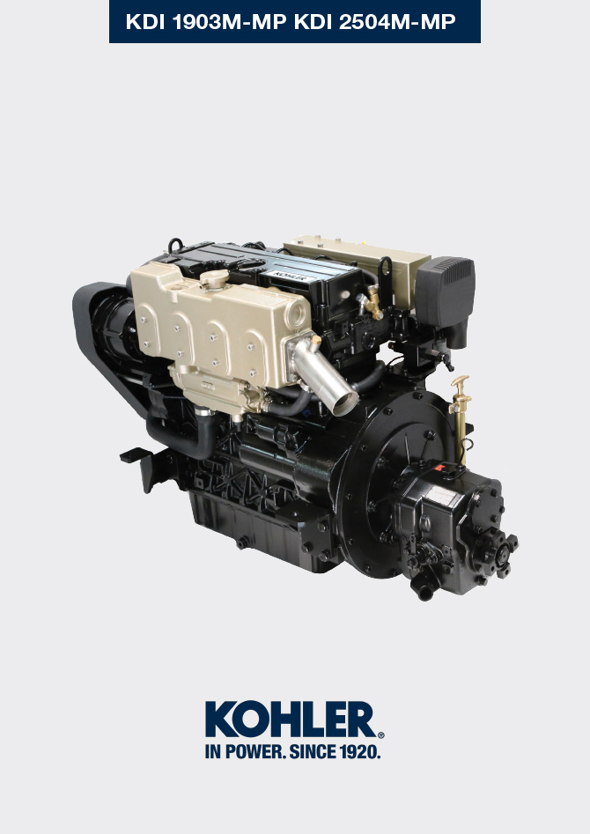

Registration of modifications to the document
Any modifications to this document must be registered by the drafting body, by completing the following table.

Released by | Code | Revision | Release Date | Revision date | Edited by | Endorsed
 | manoff

Translated from the original manual in Italian language
Data reported in this issue can be modified at any time by KOHLER.

Sommario
1. TITOLO 1 2
1.1. Asdfsdfsdf 2
1.2. Asdfsdfsdfggg 2

Information for disassembly

Recommendations for disassembly


Important

- To easily find the specific topics of interest consult the index .
- The mark ( ) after the title of a paragraph, indicates that the procedure is not required in order to disassemble the engine, however the procedures are featured in order to illustrate the disassembly of components.
- The operator should prepare all equipment and tools in order to enable him to carry out the operations correctly and safely.
- Before disassembly, perform the operation described in Chap. 5 .
- Before proceeding with operation, carefully read Chap. 3 .
- In order to operate safely and easily, we recommend positioning the engine on a rotating stand for engine overhauling.
- eal all injection component unions as illustrated in Par. 2.9.7 during assembly.
- Protect all disassembled components and coupling surfaces subject to oxidation with lubricant.
- Where necessary, reference to special tools to use during disassembly operations is indicated (es. ST_05 ), identified in Chap.12 .

Disassembly of the exhaust line
- Loosen clamps A and disconnect hoses B .  - Disconnect hose C .  - Loosen capscrews D and remove the cooled exhaust manifold E . | 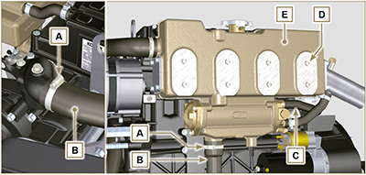  Fig. 7.1

Disassemble the intake line
- Loosen clamp A and disconnect tube B .  - Loosen capscrews C and remove accelerator support D .  - Loosen hollow studs E and remove oil dipstick F .  - Loosen capscrews G and remove manifold H together with gasket J . | 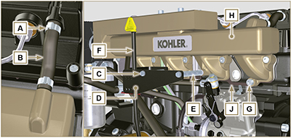  Fig. 7.2

Electric components disassembly
7.4.1 Electric wiring

- Disconnect and remove the engine wiring.
NOTE : refer to Par. 2.13.1.3 to disconnect all connectors.
7.4.2 Starter motor  Important  - The motor is not repairable.  - Perform the operations described in Par 6.1.5 points 1-2. | 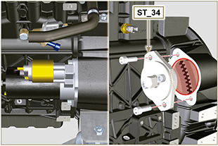  Fig 7.3
7.4.3 Belt and alternator  - Perform the operations described in Par. 6.4.1 - 6.5.1 .  - Undo the screws A and B and remove the alternator C.  - Loosen hollow stud D .  Important  - The belts must always be replaced every time they are disassembled, even if they have not reached the scheduled hours for replacement | 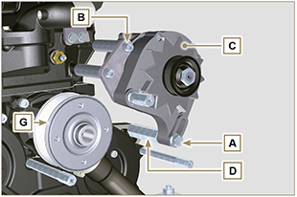  Fig 7.4
7.4.4 Sensors and switches

Important

- After disassembly, protect the sensors suitably against knocks, dampness and any high temperature sources.
- The sensors and switches cannot be repaired, therefore they must be replaced in the event of anomalies.
7.4.4.1 Oil pressure switch and sensor ( )  - Loosen capscrew E and remove oil sensor F and oil pressure switch G . | 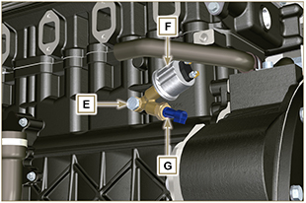  Fig 7.5
7.4.4.2 Coolant temperature sensor ( )  - Unscrew and remove the sensor H . | 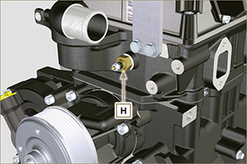  Fig 7.6
7.4.4.3 Coolant temperature switch  - Loosen and remove switch J . | 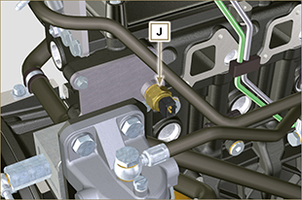  Fig. 7.7
7.4.5 Electric fuel pump ( )  - Loosen capscrew K .  - Loosen nuts M and remove pump L . | 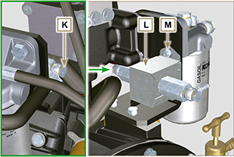  Fig 7.8

Coolant recirculation components disassembly
7.5.1 Coolant recirculation components disassembly

Important

- The pump B is not reparaible

- Perform the operations described in Par. 6.6.1 .

7.5.2 Thermostatic valve  - Undo the screws A and remove the thermostatic valve cover B .  - Remove the thermostatic valve C and its gasket D .  Important  - Always replace the gasket D every time it is disassembled.  - Check that the air bleeding hole is not clogged or blocked ( Par. 2.11.3 ). | 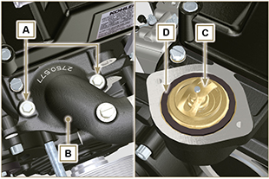  Fig 7.9
7.5.3 External water pump  - Loosen capscrews E and remove clamps F .  - Loosen capscrews G and remove pump H . | 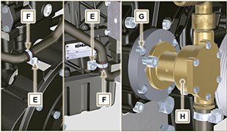  Fig 7.10

Crankshaft pulley disassembly
- Perform the operations described in Par. 6.7.1.

Lubrication circuit disassembly
7.7.1 Oil overpressure valve

- Perform the operations described in Par. 6.9.1 .

7.7.2 Timing system semi-crankcase oil filling flange ( )  - Undo the screws A and remove the oil filling flange B ( ST_06 ) .  - Remove the gasket C . | 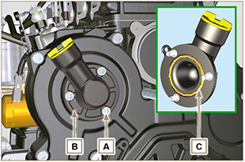  Fig 7.11
7.7.3 Timing system

- Perform the operations described in Par. 6.8.3 .

7.7.4 Oil pump

Important

- The oil pump is not repairable.

- Perform the operations described in Par. 6.8.4 .

7.7.5 Oil filter

- Perform the operations described in Par. 6.10.1 .

7.7.6. Oil extraction pump  - Loosen capscrew D and remove tube E .  - Loosen union F .  - Loosen capscrew G and remove pump H . | 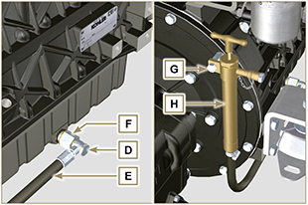  Fig 7.12

Fuel system disassembly
Important
• Seal all injection component unions as illustrated in Par. 2.9.7 .
• The fuel injection circuit undergoes high pressure, use safety protections as described in Par 3.4.3 .

7.8.1 Fuel pipes  - Undo the screws A .  - Undo the screws B,C,D and remove pipes E . | 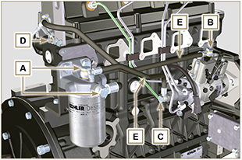  Fig 7.13
7.8.2 Fuel filter ( )  - Undo the screws F and remove filter G . | 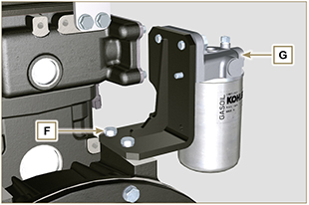  Fig 7.14
7.8.3 Fuel injection pipes

- Perform the operations described in Par 6.1.1 .
7.8.4 Rocker arm cover
- Perform the operations described in Par 6.1.2 point 2.

7.8.5 Fuel return pipes

- Perform the operations described in Par 6.1.3 .
7.8.6 Injectors

- Perform the operations described in Par 6.1.4 .
7.8.7 Injection pump

Important

- Before disassembling, carefully read Par. 2.17.1 .
- The injectoion pump cannot be repaired.
- Perform the operations described in Par 6.1.5 .

Timing system gear disassembly
- Unscrew screws C and remove camshaft gear D .  - Remove lock ring A and the shoulder ring B .  - Remove the intermediate gear L . | 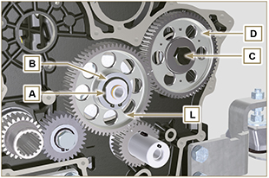  Fig 7.15
- Undo screws E and remove plate F .  - Remove centring ring G .  - Remove the retainer ring H and the shoulder ring J . | 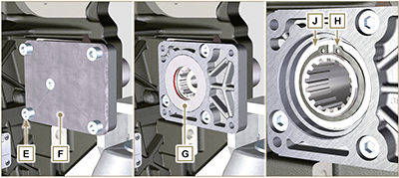  Fig 7.16
- Remove gear K .  - Undo screw M and remove gear N  - Undo the screws F and remove the intermediate gear support G. | 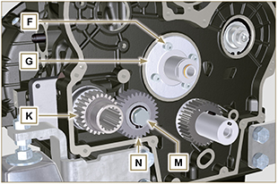  Fig. 7.17

Disassembling the reversing gear
- Loosen capscrews A and remove inverter B . | 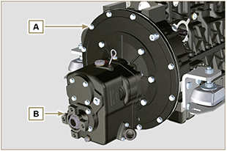  Fig. 7.18

Disassembling the flexible coupling
 Important  - Leave the special flywheel locking tool ST_34 assembled.  - Loosen capscrews A and remove coupling B . | 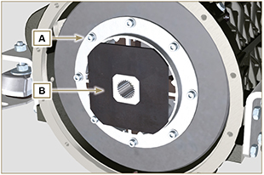  Fig. 7.19

Flange unit disassembly
7.12.1 Flywheel  Important  - Leave the special tool ST_34 for blocking the flywheel.  - Only undo the screw C located upwards.  - Insert the tool ST_09 in the seat of the screw C tightening it all the way.  - Undo the remaining screws D .    Danger  - The flywheel E is very heavy, pay utmost attention while removing it in order to prevent it from falling, with serious consequences for the operator.  - Remove the flywheel E.  - Remove the tool ST_09 .  - Remove the tool ST_34 shown in Fig. 7.3 . | 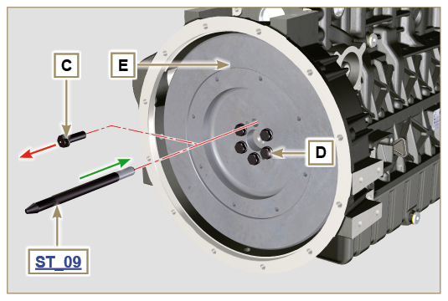  Fig 7.20
7.12.2 Flange housing  - Undo the screws F and remove the engine housing G .  Danger  - The housing G is very heavy, pay utmost attention while removing in order to prevent it from falling, with serious consequences for the operator. | 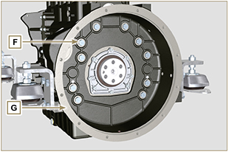  Fig 7.21

Cylinder head unit disassembly
7.13.1 Rocker arm pin  - Undo the screws A .  - Remove the rocker arm pin unit B . | 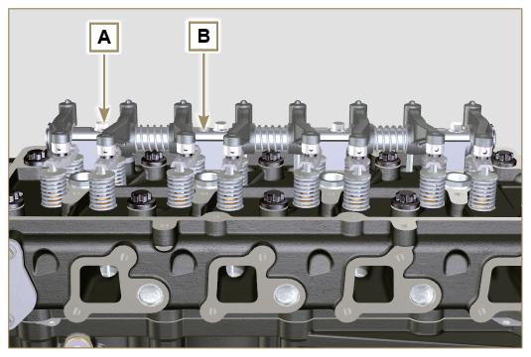  Fig 7.22
7.13.1.1 Rocker arm ( )  - Remove the retainer snap ring C .  - Remove the shoulder rings D .  - Remove the rocker arms E and springs. | 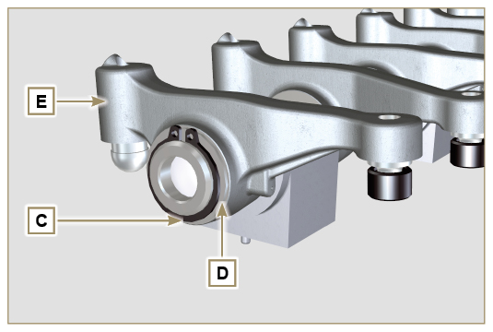  Fig 7.23
7.13.2 Rods and u-bolts  - Remove the valve control U-bolts H .  - Remove the rocker arm control rods L . | 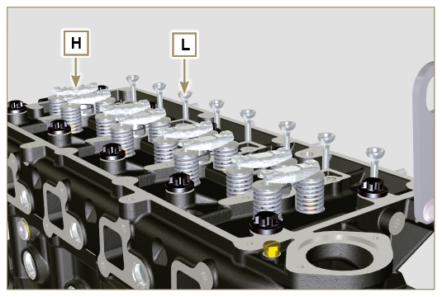  Fig 7.24
7.13.3 Cylinder head  Important  - Wait for the engine to reach ambient temperature before to remove the head in order to prevent deforming.  - The cylinder head fastening bolts M must be replaced every time they are disassembled.  - Undo the bolts M .  - Remove the cylinder head N .  Important  • Only use the eyebolts AE installed by Lombardini Marine to move the cylinder head Q.  3. Remove the head gasket P . | 3 Cylinders  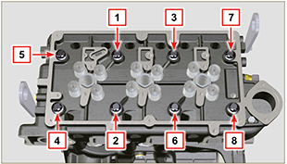  Fig. 7.25  4 Cylinders  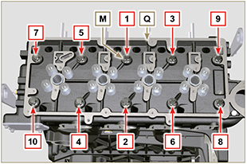  Fig 7.26  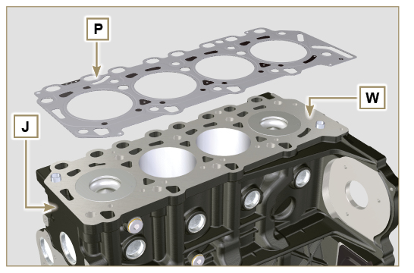  Fig 7.27
7.13.3.1 Valves ( )  - Mount the tool ST_07 on the head Q fixing it on one of the holes for fixing the rocker arm cover.  NOTE: change the fixing hole according to the position of the valves to be removed.  - Position the tool striker ST_07 on the valve concerned as shown in the figure. | 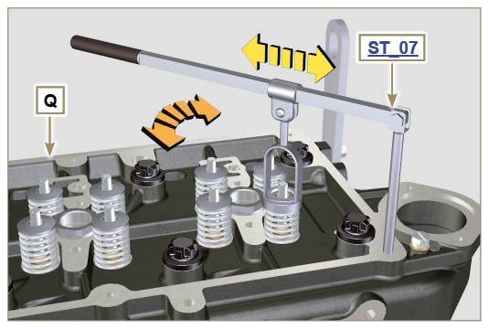  Fig 7.28
- Push the lever of the tool ST_07 downwards, in order to lower the valve plates S in the direction of the arrow T , using a magnet, remove the cotters U .  NOTE : repeat all the operations for all the valves concerned. | 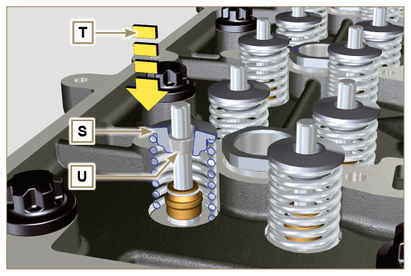  Fig 7.29
Important  - Before removing the valves, make some marks in their original position, in order to prevent confusing them when they are re-assembled, if they are not replaced.  - Remove the valves V . | 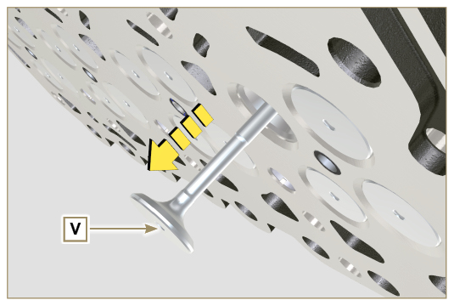  Fig 7.30
7.13.3.2 Injector sleeve ( )  - Unscrew and remove the sleeves Z from the head Q .  - Remove the gaskets AA and AB . | 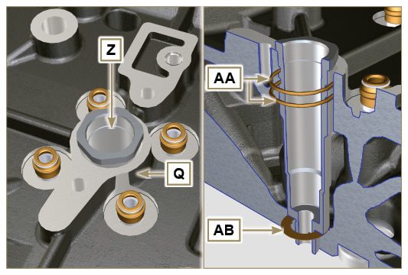  Fig 7.31
7.13.3.3 Valve steam gasket ( )  - Remove the oil seals AC . | 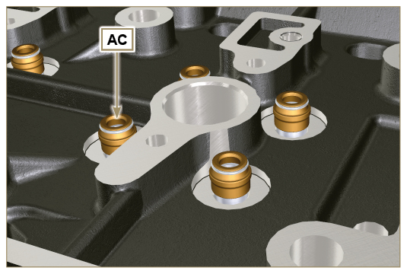  Fig 7.32
7.13.3.4 Lifting eyebolts ( )  - Undo the screws AD and remove the eyebolts AE .  - Make the thorough washing the cylinder head Q . | 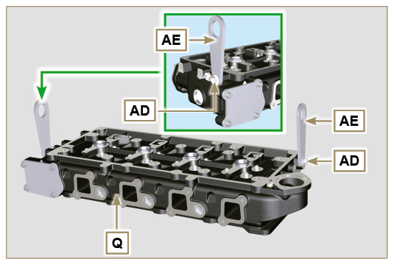  Fig 7.33

Oil sump unit disassembly
7.14.1 Oil sump  - Undo the screws A .  - Remove the oil sump B by inserting a plate in the areas indicated by the arrow AA. | 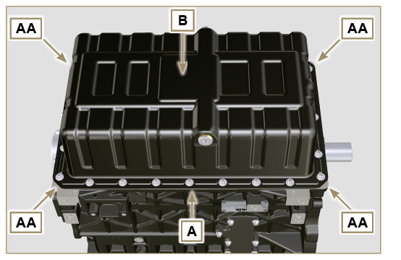  Fig 7.34
7.14.2 Oil intake pipe  - Undo the screws C and remove the oil pipe D . | 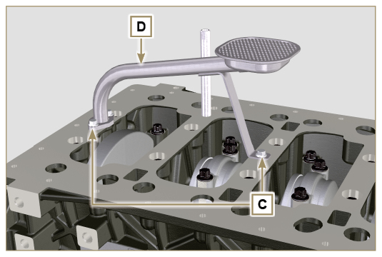  Fig 7.35
7.14.3 Oil vapour pipes ( )  - Unscrew and removethe pipes E . | 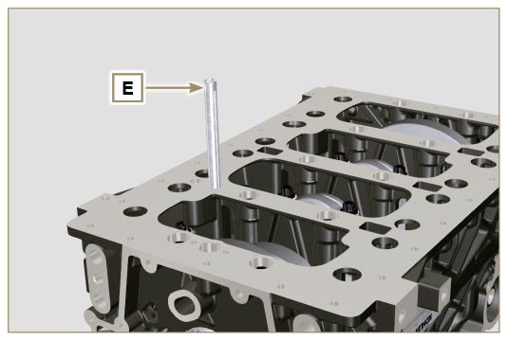  Fig 7.36

Engine block disassembly
7.15.1 Crankshaft gasket flange  - Undo the screws A .  - Remove the flange B and the gasket C . | 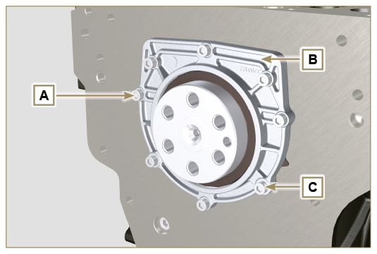  Fig 7.37
7.15.2 Piston unit/connecting rod  Important  - Mark some numerical references (cylinder n°) on the connecting rods, connecting rod caps F1 , pistons and gudgeon pins to prevent unintentionally confusing the components not replaced during assembly. Failure to do this may result in engine malfunctions.  - References on connecting rod M and cap F1 must only be carried out on a side in correspondence with K1 and K2 , as illustrated in Fig. 7.39 .  - Screw the bolt AM temporarily.  - Unsrew bolts E1 and remove the connecting rod caps F1 . | 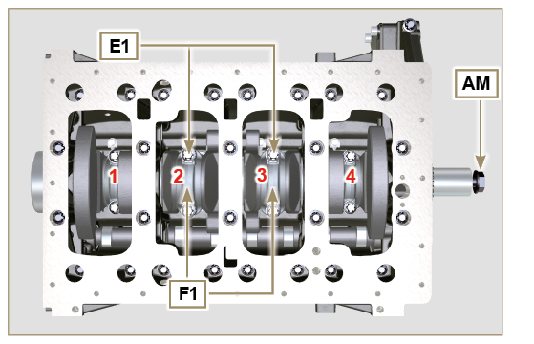  Fig 7.38
NOTE : coupling cap F1 on the connecting rod can be carried out with centring taper pins (Fig. 7.40) or broken ( Fig. 7.41 - without centring taper pins).    Fig. 7.40    Fig. 7.41 | 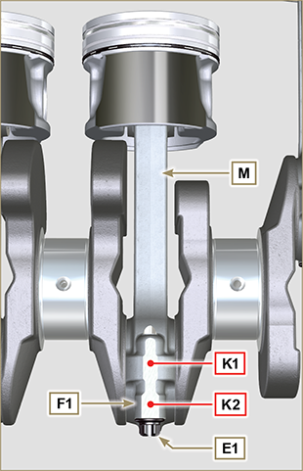  Fig 7.39
- Pull out the connecting rod - piston assembly from position 2 and 3 by manually applying pressure on the connecting rod big end L in the direction of arrow AK .  - Couple the connecting rod big end caps L with the relevant piston and connecting rod unit M .  - Turn capscrew AM and rotate the crankshaft by 180°.  - Repeat points 2 to 5 to disassemble the connecting rod-piston assembly to position 1 and 4 . | 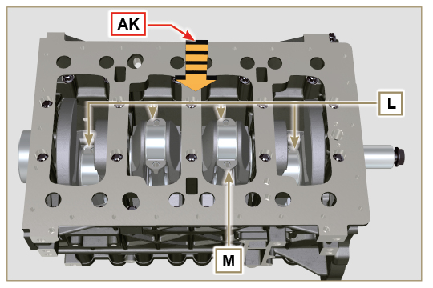  Fig 7.42
  Warning  - The connecting rod half-bearings Z are made of special material. Therefore, they must be replaced every time they are removed to prevent seizures. | 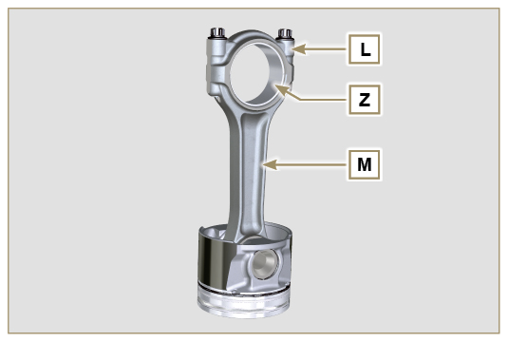  Fig 7.43
7.15.3 Lower semi-crankcase  3 CYLINDERS  - Undo capscrews E and F by following the order indicated in the figure.  - Remove the lower semi-crankcase D and store it in a suitable container for washing. | 3 Cylinders  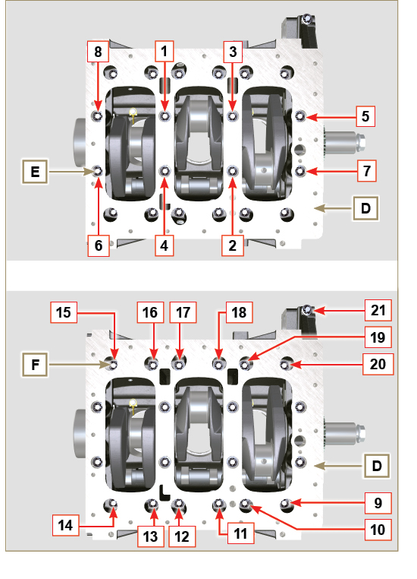  Fig 7.44
4 CYLINDERS  - Undo capscrews E and F by following the order indicated in the figure.  - Remove the lower semi-crankcase D and store it in a suitable container for washing. | 4 Cylinders  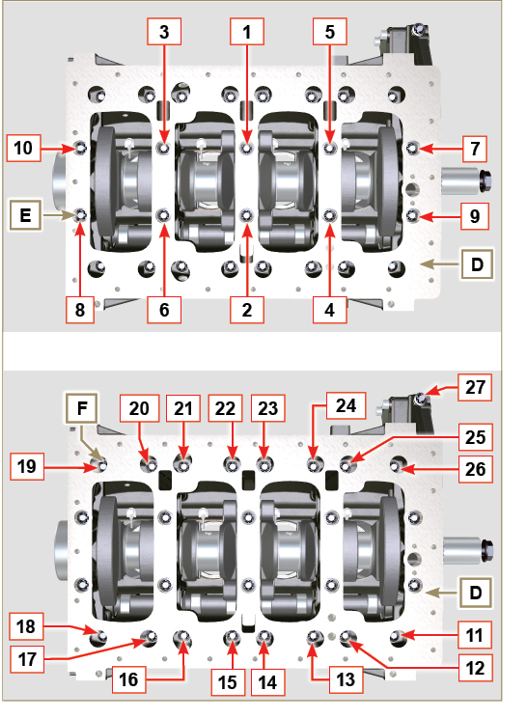  Fig 7.45
7.15.4 Crankshaft  Remove:  - Crankshaft G .  - The four shoulder semi-rings H . | 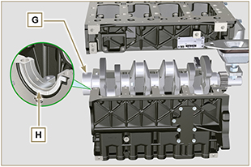  Fig 7.46
7.15.5 Piston ( )  - Remove the retainer ring N .  - Remove the pin P to separate the piston Q from the connecting rod R .  Important  - If they are not replaced, keep the components together (connecting rod - piston - gudgeon pin) by using references in order to prevent them from getting mixed up during assembly. | 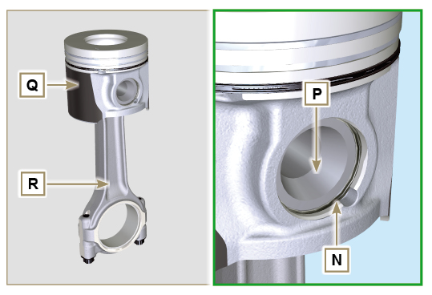  Fig 7.47
7.15.5.1 Rings ( )  - Remove the seal rings S . | 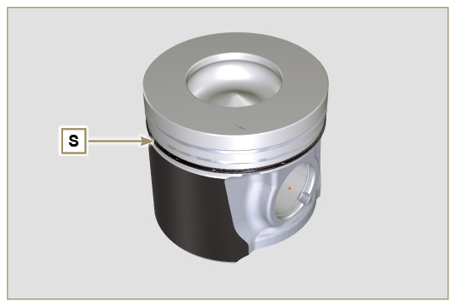  Fig 7.48
7.15.6 Breather room closing cover ( )  - Undo the screws AE and remove the cover AF . | 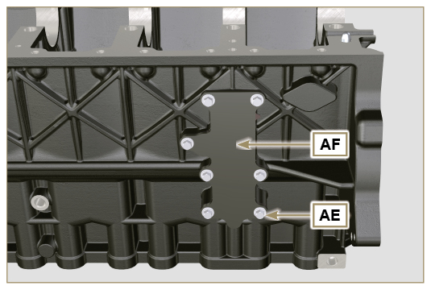  Fig 7.49
7.15.7 Camshaft  - Remove the retainer ring V .  - Extract the camshaft W from the upper crankcase AB . | 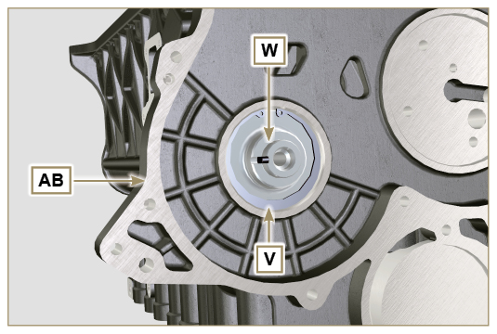  Fig 7.50
7.15.8 Camshaft tappets  - With a magnet, remove the tappets AA from the upper semi-crankcase AB . | 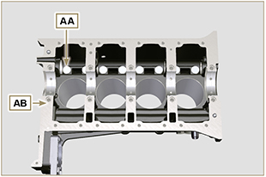  Fig 7.51
7.15.9 Crankshaft bushings  - Remove the crankshaft bushings AC from the upper semi-crankcase AB .  Important  - The crankshaft half-bearings AC are made of special material. Therefore, they must be replaced every time they are removed to prevent seizures. | 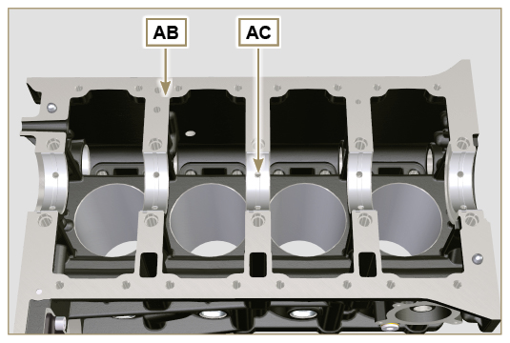  Fig 7.52
- Remove the crankshaft bushings AF from the lower crankcase D . | 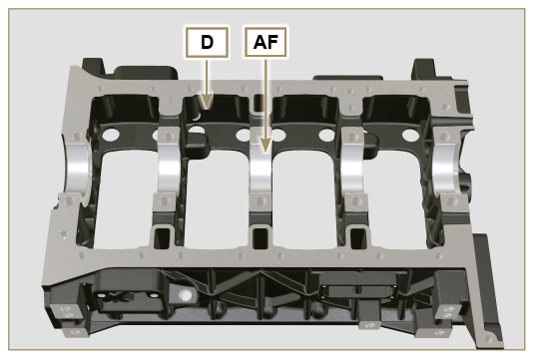  Fig 7.53
7.15.10 Flange 3 ^{rd} PTO ( )  - Undo the screws AG .  - Remove the cover AH and the gasket AL . | 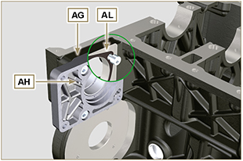  Fig 7.54



