Technical information
Owner Manual KDW 502 | 702 | 1003 | 1404 - K-HEM 1003 (Rev. 01)

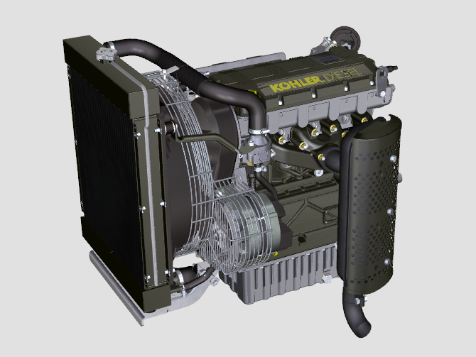

Registration of modifications to the document
Any modifications to this document must be registered by the drafting body, by completing the following table.

Released by | Code | Revision | Release Date | Revision date | Edited by | Endorsed
 | KDW 502-702-1003-1404 - K-HEM 1003

Translated from the original manual in Italian language
Data reported in this issue can be modified at any time by KOHLER.

Sommario
1. TITOLO 1 2
1.1. Asdfsdfsdf 2
1.2. Asdfsdfsdfggg 2

Technical information

General description of the engine
- 4-stroke, in-line cylinders Diesel engine; - Liquid-cooling system;

- 2 valves per cylinder;

- Indirect injection.

Engine specifications
Tab. 2.1
TECHNICAL DATA |  | UNIT OF MEASURE | 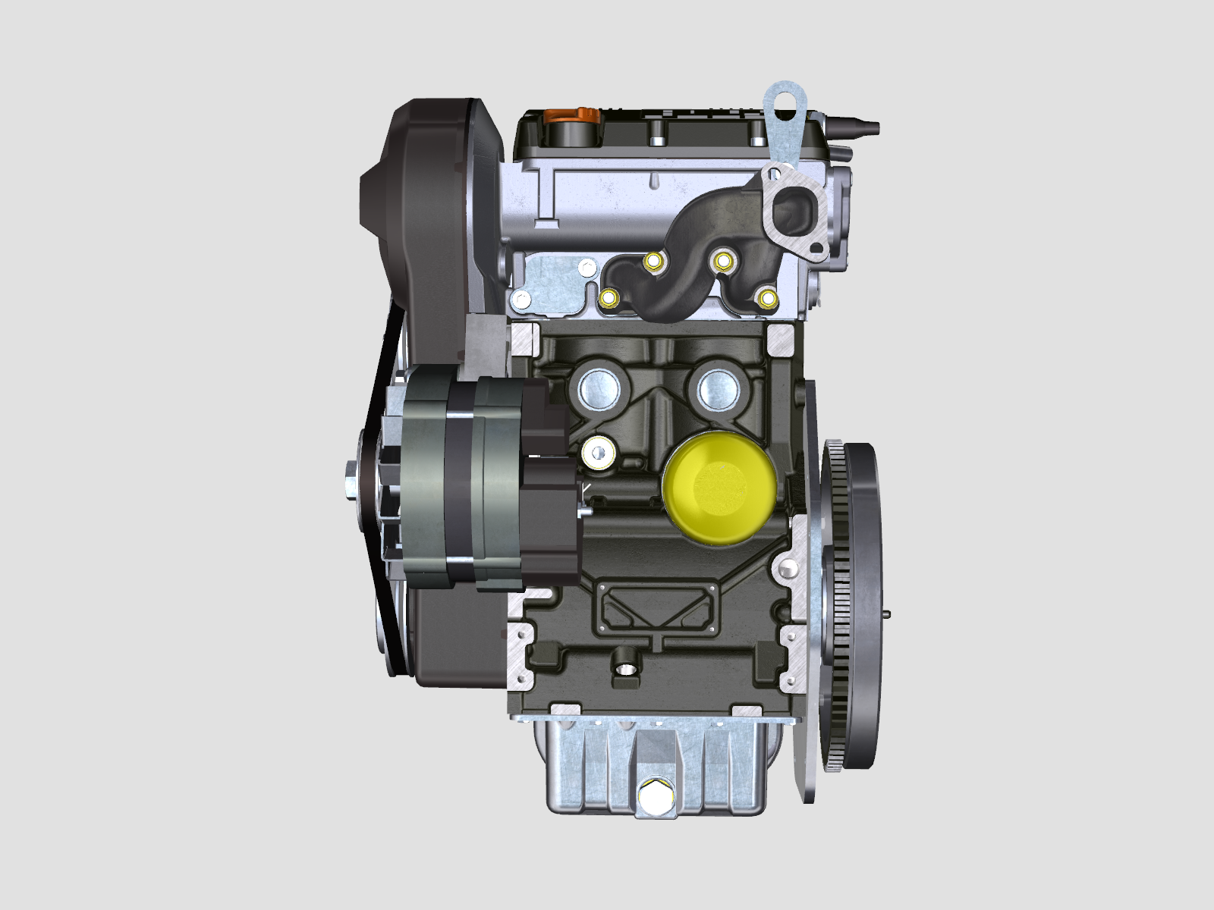 |  | 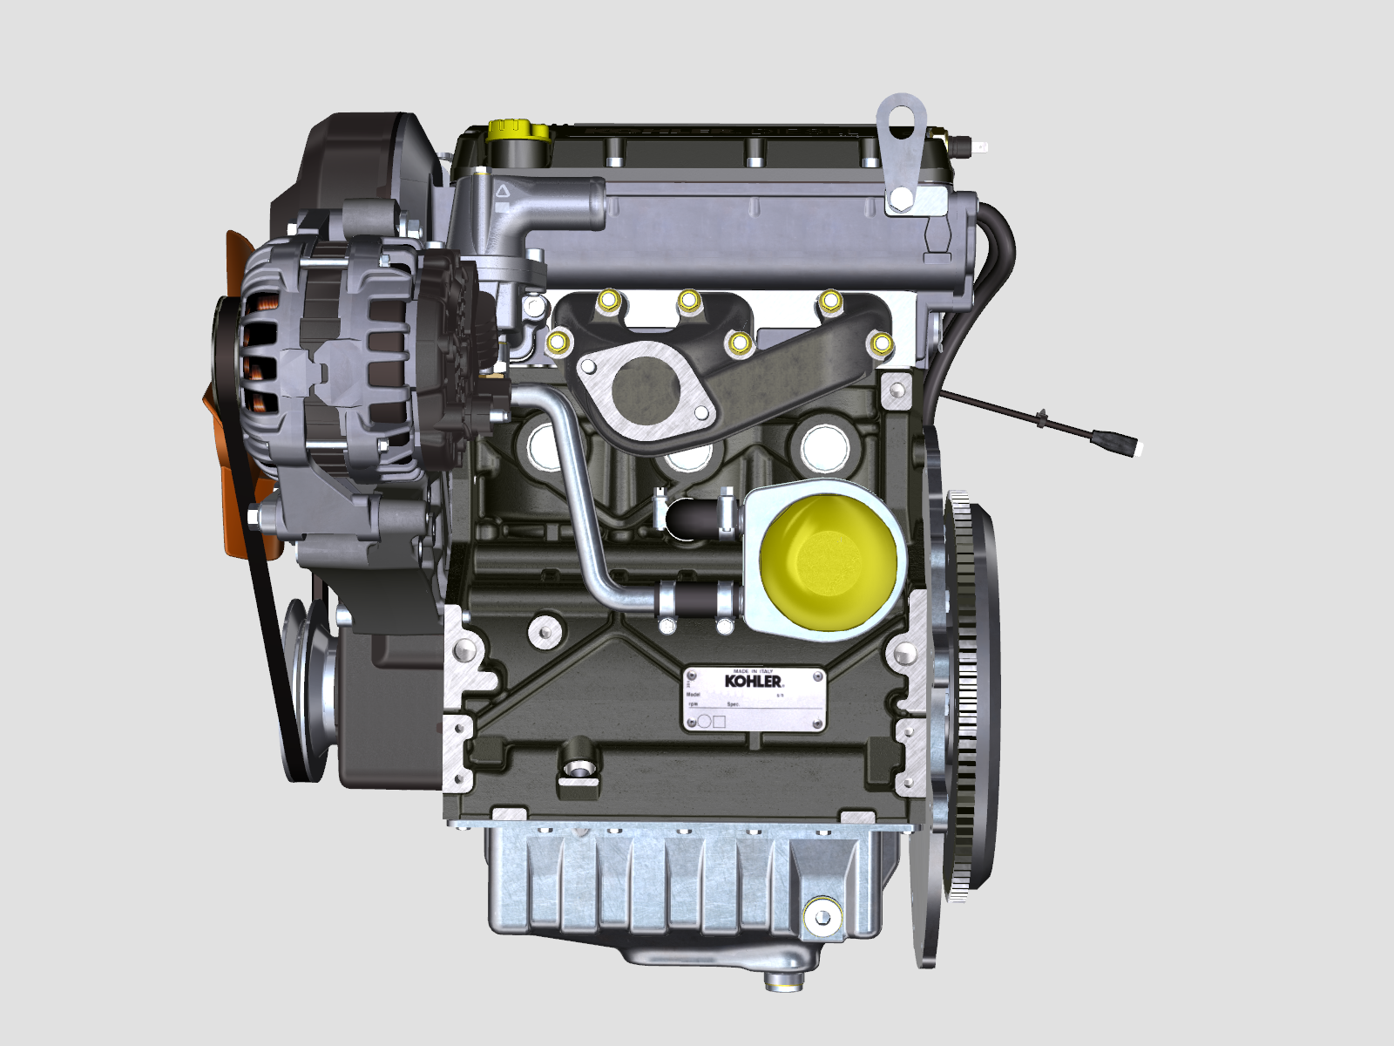 | 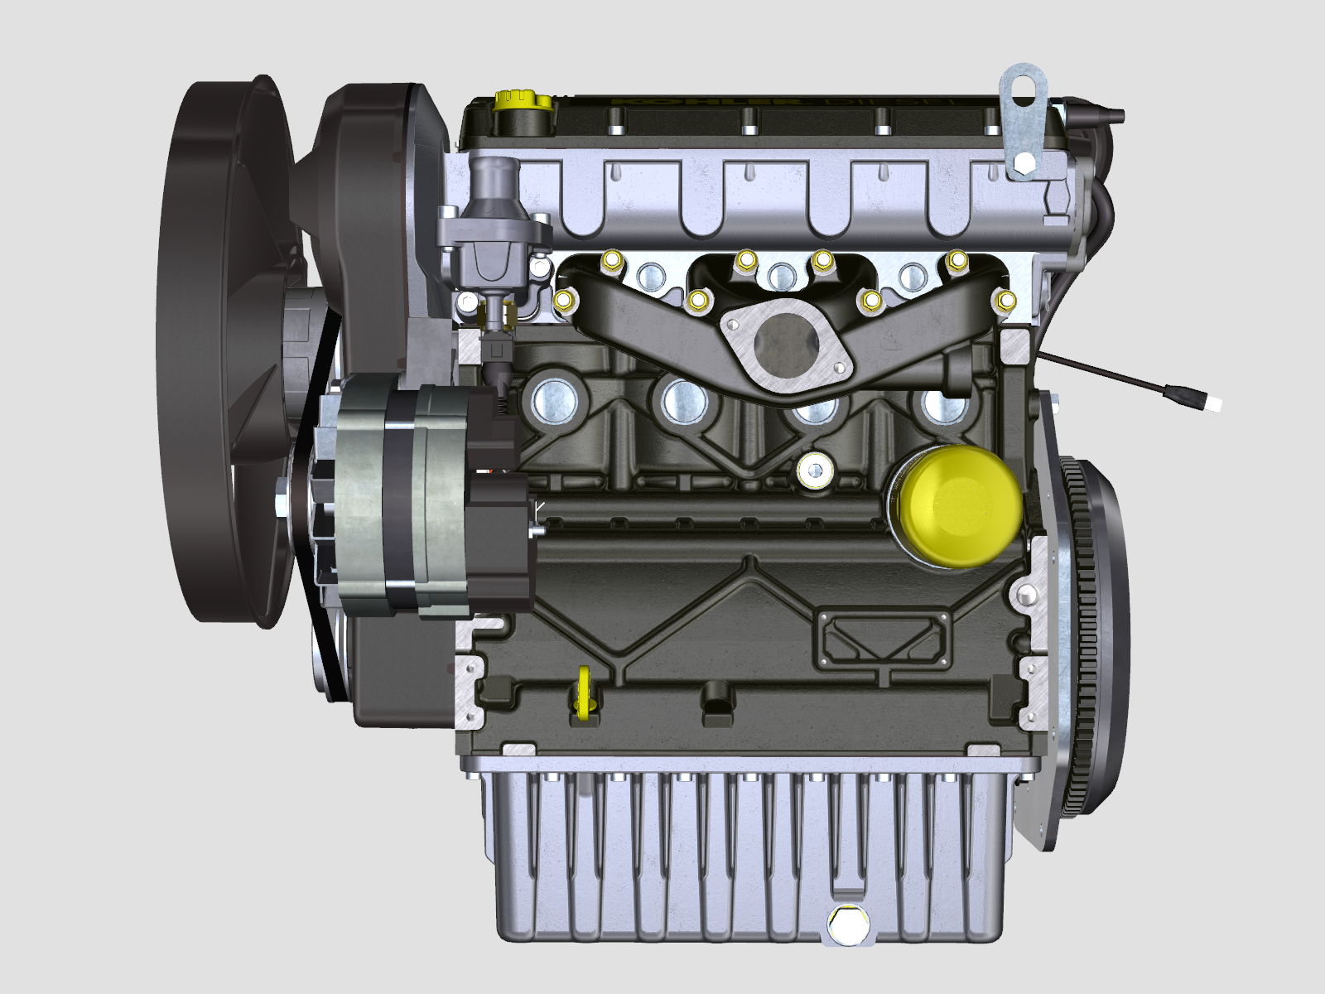
Engine type |  |  | KDW 502 | KDW 702 | KDW 1003 | KDW 1404
Cylinders |  | n. | 2 | 2 | 3 | 4
Bore |  | mm | 72 | 75 | 75 | 75
Stroke |  | mm | 62 | 77.6 | 77.6 | 77.6
Displacement |  | cm ³ | 505 | 686 | 1028 | 1372
MAX INCLINATION DURING OPERATION (even in combined) |  | α | 25° max. 30 min.
 |  | α | 35° max.1 min.
OIL CAPACITY (MAX level.) - filter included | standard oil sump | lt. | 1.5 | 1.6 | 2.4 | 3.2
OIL CAPACITY (MAX level.) - filter included | enhanced oil sump | lt. | 2.5 | 2.5 | 3.8 | 5.2
OIL CAPACITY (MAX level.) - without filter | standard oil sump | lt. | 1.4 | 1.5 | 2.3 | 3.0
OIL CAPACITY (MAX level.) - without filter | enhanced oil sump | lt. | 2.4 | 2.4 | 3.7 | 5.1
DRY WEIGHT |  | Kg | 60 | 66 | 87 | 98

Engine dimensions (mm)
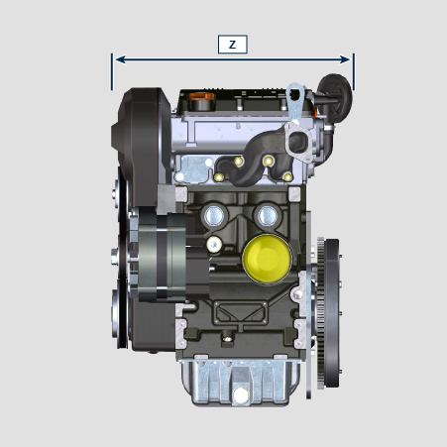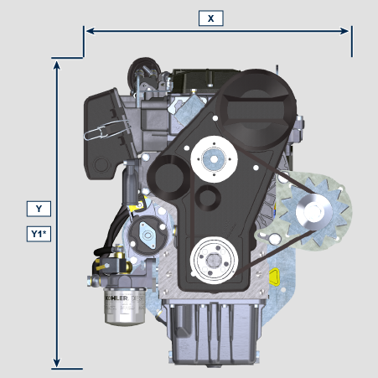
 | KDW 502 | KDW 702 | KDW 1003 | KDW 1404
X | 387 | 412 | 412 | 412
Y | 490 | 516 | 516 | 516
Z | 426 | 421 | 513 | 596
Y1* | 562.35 =(Y+72.35) | 588.35 = (Y+72.35) | 588.35 = (Y+72.35) | 588.35 = (Y+72.35)

Y1* = Deep oil sump

NOTE : Dimensions vary according to engine configuration.

Oil


Important

- The engine may be damaged if operated with improper oil level.
- Do not exceed the MAX level because a sudden increase in engine rpm could be caused by its combustion.
- Use only the recommended oil to ensure adequate protection, efficiency and service life of the engine.
- The use of lubricants other than recommended may shorten the engine life.
- Viscosity must be appropriate to the ambient temperature to which the engine is to be exposed.


Danger

- Prolonged skin contact with the exhausted engine oil can cause cancer of the skin.
- If contact with oil cannot be avoided, thoroughly wash your hands with soap and water as soon as possible.
- For the exhausted oil disposal, refer to the Par. DISPOSAL and SCRAPPING .
2.4.1 SAE oil classification
- In the SAE classification, oils are identified according to viscosity without considering any other qualitative characteristic.
- The code is composed of two numbers, which indicate, and must correspond to, the ambient temperature in which the engine operates, the first number refers to the viscosity when cold, for use during winter (" W "), while the second number is for viscosity at high temperatures.
Use oil viscosity based on the experienced air temperature range during the period between oil changes as indicated
in the table below.
Kohler / Rehlko X-treme 10W-40 formula pro; X-treme 10W-40; X-treme 5W-40 oil are preferred:

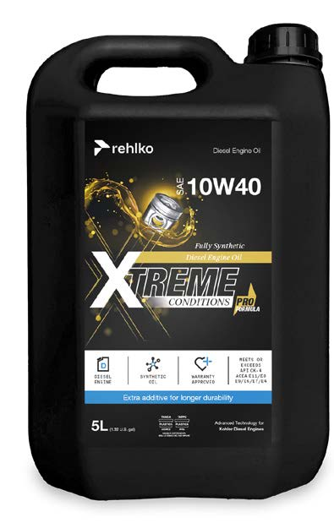 | 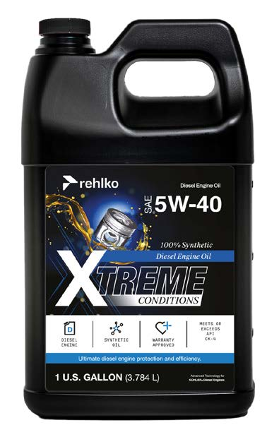 | 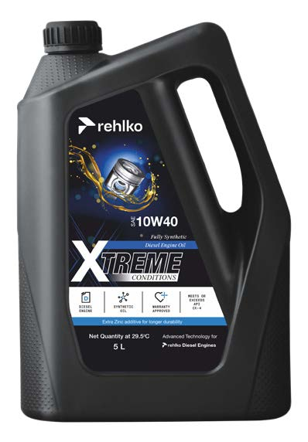

Oils meeting the following specifications are also recommended.

2.2
RECCOMENDED OIL
WITH SPECIFICATIONS | API | SJ/CF 4
WITH SPECIFICATIONS | ACEA | A3-96  B3-96
WITH SPECIFICATIONS | MIL | L-46152 D/E
VISCOSITY | SAE | 5w-40 (-30°C ÷ +40°C)

- Filtration of oils is critical to proper operation and lubrication; always change filters regularly as specified in this manual.

Fuel
  Important  - Use of other types of fuel could damage the engine. Do not use dirty diesel fuel or mixtures of diesel fuel and water since this will cause serious engine faults. |   Warning  - Clean fuel prevents the fuel injectors from clogging. Immediately clean up any spillage during refuelling.  - Never store diesel fuel in galvanized containers (i.e. coated with zinc). Diesel fuel and the galvanized coating react chemically to each other, producing flaking that quickly clogs filters or causes fuel pump and/or injector failure.  - Any failure resulting from the use of fuel other than Tab. 2.3, 2.4 will not be covered by warranty.
Cetane number of 40 minimum. Cetane number greater than 47 is preferred, especially for temperatures below –20 °C (–4 °F) or elevations above 1675 m (5500 ft.).

2.3
Certification --> | Stage 5 | Stage 3A | Tier III  IV | no certification (*1) | Remarks  *1: the regions known as poor lubricity diesel fuel quality or if the engine is operated with Jet fuels, the primary filter must be with lubricity dosing capability. Contact Kohler for information about the approved filter for this purpose .
Fuel Type --> | (EN 590 - DIN 51628) |  |  | (EN 590 - DIN 51628) | Do NOT USE vegetable oils as a biofuel not compliant with EN590 prescription.
Fuel Type --> | HVO 100% (EN 15940) |  |  |  | Power and torque might be 1% to 5% lower due to low fuel density compared to standard diesel fuel.
Fuel Type --> | Military NATO Fuel F-54 (S = 10 ppm)
Fuel Type --> | JIS K 2204 No.1, No.2
Fuel Type --> |  |  | Grade 1-D S15 |  | For ambient temperatures below 0°C (32°F) with no arctic fuel available (Grade 1-D S15, Grade 2-D S15, ASTM D 975) use the following additives to prevent possible engine damage with low engine load in cold weather:  - Power Service Diesel Fuel Supplement+Cetane Boost  Different additives are not allowed.  The use of approved additives has no impact on the engine maintenance schedule.  Do NOT USE vegetable oils as a biofuel not compliant with ASTM D975 Grade1 and Grade2 prescription.
Fuel Type --> |  |  | Grade 2-D S15
Fuel Type --> |  | Sulphur Fuel S < 500 ppm
Fuel Type --> |  |  |  | High Sulphur Fuel S < 2000 ppm
 |  |  |  | F-34/F-35 (kerosene, NATO designation) | Operations with Jet Fuels  Because of lower density and greater leak fuel volume due to lower viscosity, depending on the engine speed and torque, a power loss up to 10% is possible.  There are some problematical fuel proprieties amongst the listed jet fuels (viscosity, lubricating capacities and low boiling point). A slight increase in wear in the injection system is to be expected which can lead to a statistically shorter life of these components. Sulphur content must be below 2000ppm.
 |  |  |  | F-44 (kerosene, NATO designation)
 |  |  |  | F-63 (kerosene, NATO designation, equivalent to F-34/F-35 with additives)
 |  |  |  | JP-8 (kerosene, US military designation)
 |  |  |  | JP-5 (kerosene, US military designation)
 |  |  |  | Jet A (kerosene for civil aviation)
 |  |  |  | Jet A1 (kerosene for civil aviation)

2.5.1 Fuel Additives
To aid in maintaining performance of the engines injection system, Rehlko has developed a family of fuel additives product for North America market.
The Extra Performance Fuel Additive Arctic Formula a fuel conditioner in winter, the Extra Performance Fuel Additive a fuel injector deposit removal and prevention. See your local Rehlko dealer for availability.

2.4
Extra Performance Fuel Additive  (North America only) | 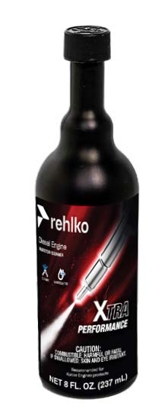
Use Rehlko Injector Cleaner Diesel Fuel Additive before filling the tank once a year or every 500hrs with summer or winter grade fuel. Formulated to clean deposits from injectors and provide lubrication to high pressure pump and injectors to reduce wear, increasing fuel quality. Compatible with all exhaust emission system, including diesel particulate filters (DPFs). Follow all recommended instruction on product label.
Extra Performance Fuel Additive Arctic Formula  (North America only) | 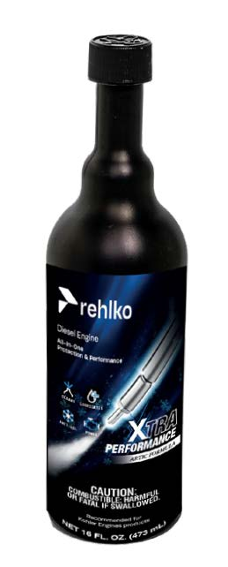
Use Rehlko Extra Performance Fuel Additive Arctic Formula, which contains anti-gel chemistry to treat non-winter grad fuel (No. 2-D in North America) during the cold-weather season. This extends the operability to about 10°C (18°F) below the could point. For operability at even lower temperatures, use winter grade fuel. Treat the fuel when the outside temperature drops below 0°C (32°F). For best results, use untreated fuel and follow all recommended instruction on product label.
Cloud point is the temperature at which wax begins to from in the fuel causing filters to plug.
Fuel additives with biocide/algaecide functions are allowed in case of storage of fuel in the tank for long periods (one year or more). | For suggested brands and types contact Rehlko staff
NOTE: These additives must be diluted in the fuel following the product prescribed percentages when filling the tank. | For suggested brands and types contact Rehlko staff

Coolant recommendation
Kohler / Rehlko XtendedTM prediluted coolant 50% ethylene glycol OAT is preferred.

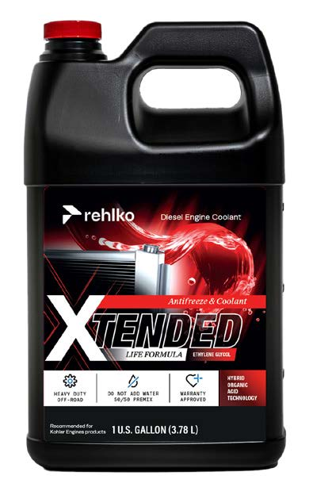

Coolant meeting the following specifications are also recommended.

A mixture of 50% demineralized water and 50% low silicate ethylene glycol based coolant liquid must be used. Use a Long Life or Extended Life Heavy Duty OAT coolant free of: silicates, phosphates, borates, nitrites and amines.

The following ethylene-glycol based engine coolant for all models within KDW engine family may be used:

- OAT (Organic Acid Technology) Low Silicate: ASTM D-3306 D-6210
- HOAT (Hybrid Organic Acid Technology) Low Silicate: ASTM D-3306 D-6210

The above coolants in concentrated formulation must be mixed with distilled, deionized, or demineralized water. A pre-mixed formulation (40-60% or 50-50%) can be used directly when available.

Important
- Do not mix ethylene glycol and propylene glycol based coolants. Do not mix OAT and HOAT based coolant. OAT performance life can be drastically reduced if contaminated with nitrite-containing coolants.
- Never use automotive-type coolants. These coolants do not contain the correct additives to protect heavy – duty diesel engines.

OAT coolants are maintenance free up to 6 years or 6000hrs of operation , provided that the cooling system is topped up using the same type of coolant. Do not mix different coolant types. Test the coolant condition annually with coolant test strips.
HOAT are not all maintenance free and it is recommended to have SCA (Supplemental Coolant Additives) added at the first maintenance interval.

Battery recommendation
Battery not supplied by Kohler

2.5
RECOMMENDED BATTERIES
 | IN STANDARD START CONDITIONS | IN HEAVY-DUTY START CONDITIONS
KDW 502 | 12w-44 Ah / 210 A/DIN  12w-44 Ah / 410 A/EN  12w-44 Ah / 400 A/SAE | 12w-55 Ah / 255 A/DIN  12w-55 Ah / 500 A/EN  12w-55 Ah / 485 A/SAE
KDW 702 | 12w-66 Ah / 330 A/DIN  12w-66 Ah / 650 A/EN  12w-66 Ah / 630 A/SAE | 12w-88 Ah / 350 A/DIN  12w-88 Ah / 690 A/EN  12w-88 Ah / 665 A/SAE
KDW 1003-1404 | 12w-70 Ah / 350 A/DIN  12w-70 Ah / 690 A/EN  12w-70 Ah / 665 A/SAE | 12w-92 Ah / 420 A/DIN  12w-92 Ah / 825 A/EN  12w-92 Ah / 800 A/SAE

for K-HEM model:
to replace the batteries for the hybrid unit, contact the machine manufacturer.



