Information about failures
Owner Manual KDW 502 | 702 | 1003 | 1404 - K-HEM 1003 (Rev. 01)

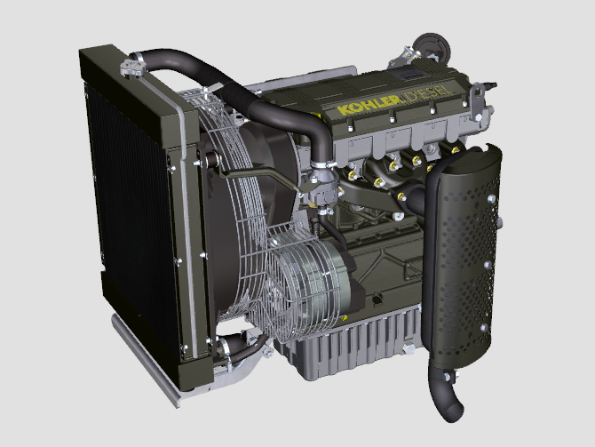

Registration of modifications to the document
Any modifications to this document must be registered by the drafting body, by completing the following table.

Released by | Code | Revision | Release Date | Revision date | Edited by | Endorsed
 | KDW 502-702-1003-1404 - K-HEM 1003

Translated from the original manual in Italian language
Data reported in this issue can be modified at any time by KOHLER.

Sommario
1. TITOLO 1 2
1.1. Asdfsdfsdf 2
1.2. Asdfsdfsdfggg 2

Information about failures

Useful information about failures
- This chapter contains information about the problems that may appear during engine operation with its causes and trouble shooting Tab. 5.2 .
- In some cases, you shall turn off the engine immediately to avoid further damage Tab. 5.1 .
5.1
THE ENGINE MUST BE IMMEDIATELY TURNED OFF WHEN:
1 | The engine rpms suddenly increase and decrease
2 | A sudden and/or unusual noise is heard
3 | The colour of the exhaust fumes suddenly darkens
4 | The oil pressure indicator light turns on while running

5.2
TROUBLES | POSSIBLE CAUSE | SOLUTION
The engine does not start | Sulphated battery terminals corroded | Clean the battery terminals
The engine does not start | Battery voltage too low | Recharge the battery or replace it
The engine does not start | Low fuel level | Refuel
The engine does not start | Frozen fuel | Contact KOHLER authorised workshops
The engine does not start | Clogged fuel filter | Replace with a new filter
The engine does not start | Air suction in fuel system | Contact KOHLER authorised workshops
The engine does not start | Clogged air filter | Replace with a new filter
The engine does not start | Clogged pipes | Contact KOHLER authorised workshops
The engine does not start | Open fuse | Replace with a new fuse; if the problem persists, contact KOHLER authorised workshops
The engine does not start | Intake or exhaust system clogged | Contact KOHLER authorised workshops
Engine starts but stops | Inefficient electrical connections | Clean the electrical contacts; if the problem persists, contact KOHLER authorised workshops
Engine starts but stops | Sulphated battery terminals | Clean the battery terminals
Engine starts but stops | Clogged fuel filter | Replace with a new filter and clean the tank
Engine starts but stops | Clogged fuel pipes | Contact KOHLER authorised workshops
RPM instability at idle speed | Clogged fuel pipes | Contact KOHLER authorised workshops
Low idle speed | Clogged fuel pipes | Contact KOHLER authorised workshops
Low idle speed | Poor quality fuel | Clean the tank and refuel with quality fuel
Blue smoke | High oil sump level | Replace the engine oil; if the problem persists, contact KOHLER authorised workshops
Blue smoke | Clogged air filter | Replace with a new filter
Excessive fuel consumption | Clogged air filter | Replace with a new filter
Excessive fuel consumption | High oil sump level | Replace the engine oil; if the problem persists, contact KOHLER authorised workshops
Engine lost its initial performance | Clogged air filter | Replace with a new filter
Engine lost its initial performance | Clogged fuel pipes | Contact KOHLER authorised workshops
Engine lost its initial performance | Cheap fuel | Clean the tank and refuel with quality fuel
Engine lost its initial performance | High oil sump level | Replace the engine oil; if the problem persists, contact KOHLER authorised workshops
Slow acceleration | Clogged fuel filter | Replace the fuel filter
Engine jerking | Clogged fuel pipes | Contact KOHLER authorised workshops
Engine overheats | Insufficient coolant level | Fill up to the level
Engine overheats | High oil sump level | Replace the engine oil; if the problem persists, contact KOHLER authorised workshops
Engine overheats | Clogged radiator | Clean the radiator; if the problem persists, contact KOHLER authorised workshops
In the event that the solutions proposed in Tab. 5.2 do not eliminate the trouble, contact a KOHLER authorized workshop.



