Tools information
KDI 3404 TM Workshop Manual (Rev. 08.4)

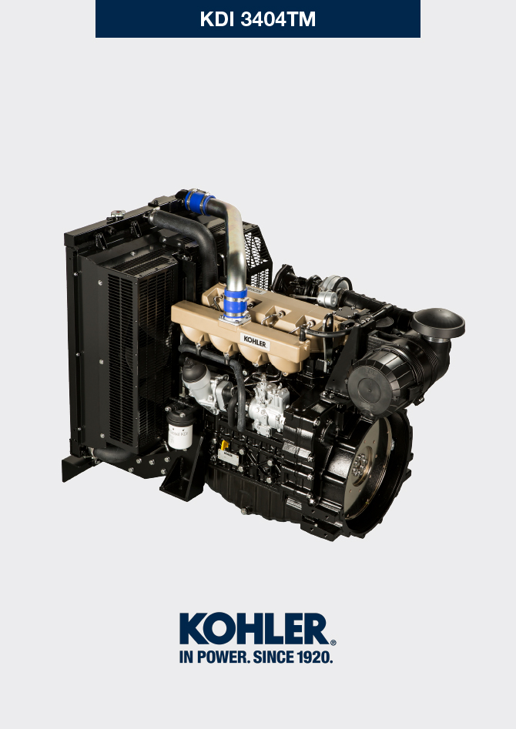

Registration of modifications to the document
Any modifications to this document must be registered by the drafting body, by completing the following table.

Released by | Code | Revision | Release Date | Revision date | Edited by | Endorsed
 | manoff

Translated from the original manual in Italian language
Data reported in this issue can be modified at any time by KOHLER.

Sommario
1. TITOLO 1 2
1.1. Asdfsdfsdf 2
1.2. Asdfsdfsdfggg 2

Tools information

Information regarding specific tools

In Tab 13.1 - 13.2 there is a list of all the specific tools that are required and approved to carry out operations of disassembly - assembly - regulations - settings - repairs on engine series KDI

, correctly and safely.

Warning

- KOHLER declines all responsibility for any damage to the engine, persons, or things caused by the use of different types of tools to those indicated in Tab 13.1 - 13.2 , where referred to them in the manual.

Tab. 13.1
SPECIAL TOOLS FOR DISASSEMBLY AND ASSEMBLY
"ST" | Picture/Draw | DESCRIPTION | PART NUMBER
ST_03 | 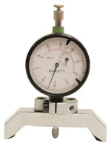 | Piston protrusion - injectors cylinder head surface control tool | ED0014602980-S
ST_05 | 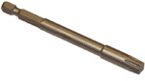 | Spanner for capscrews Six nicks SN 8 | ED0014603650-S
ST_06 | 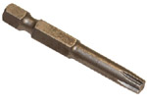 | Spanner for capscrews Six nicks SN 5 | ED0014603640-S
ST_07 | 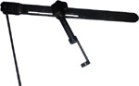 | Tool for disassembling / reassembling valves | ED0014603720-S
ST_08 | 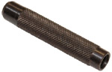 | Tool for gasket valve stem | ED0014603660-S
ST_13 | 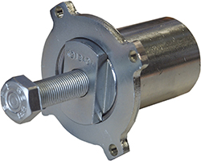 | High-pressure fuel injection pump puller gear | ED0014604050-S
ST_17 | 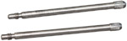 | Rocker arm cover mounting studs | ED0014603730-S
ST_18 | 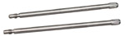 | Intake and oil sump manifold mounting studs | ED0014603740-S
ST_30 | 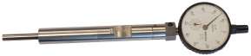 | Piston n°1 tool positioning prior to injection pump assembly. | ED0014603940-S
ST_34 | 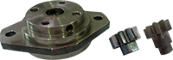 | Crankshaft blocking tool | ED0014604270-S
ST_36 | 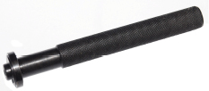 | Assembling tool for a gasket on a rocker arm cover (injector seat) | ED0014603830-S
ST_41 | 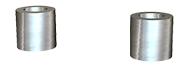 | Spacers for crankshaft gears locking | ED0014604070-S
ST_43 | 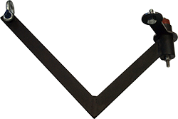 | Flywheel lifting tool | ED0014604030-S
ST_44 | 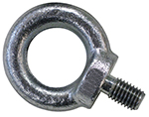 | Flange bell lifting tool | ED0014604010-S
ST_45 | 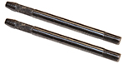 | Flange bell placing tool | ED0014604020-S
ST_46 |  | Flywheel placing tool | ED0014604040-S
ST_47 | 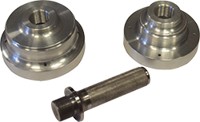 | Tool for sealing ring insertion flywheel side and pulley side | ED0014604340-S
ST_52 | 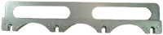 | Injectors placing tool | ED0014604320-S
Tab. 13.2
SPECIFIC EQUIPMENT TO PROTECT COMPONENTS OF THE INJECTION CIRCUIT
ST_40 | 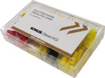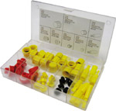 | Complete box with caps to close holes and unions for high-pressure injection circuit components. | ED0082051380-S



