Information about use
KDI 3404 TCR-SCR Owner Manual (REV. 03.4)

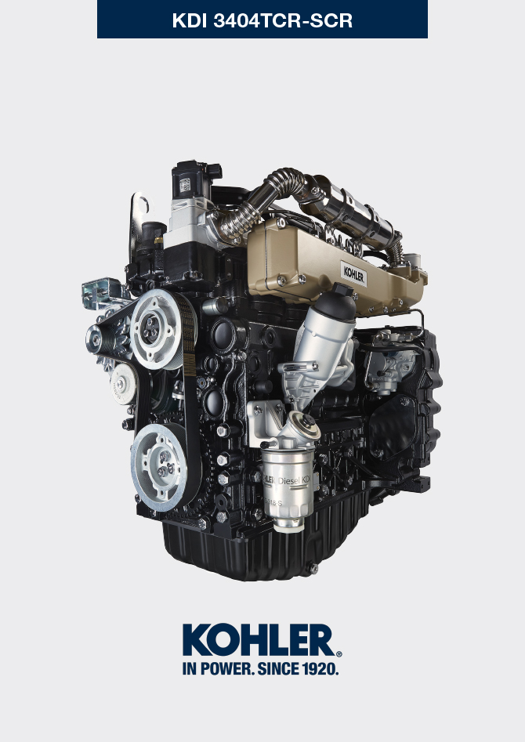
Sommario
1. TITOLO 1 2
1.1. Asdfsdfsdf 2
1.2. Asdfsdfsdfggg 2

Information about use

Pre-start check
Important
- Read carefully the following pages and carry out the operations described below in accordance with the instructions specified.
- Non compliance with the operations described in the following pages involves the risk of damages to the engine and vehicle on which it is installed as well as personal and/or property damage.
- Increase the frequency of maintenance operations in heavy working conditions (engine starts but stops, very dusty and hot environments, etc...).
- Check that the minimum required AdBlue®/DEF quantity is present inside the AdBlue®/DEF tank. Refer also to the car documentation to check the AdBlue®/DEF level required for engine correct operation.

Running-in period
NOTE: For the first 50 hours of engine operation, it is advisable not to exceed 75% of the maximum power supplied.

Starting and turning off
4.3.1 Starting
- Check the level of the engine oil, fuel and coolant and fill if necessary ( Par. 4.5 e Par. 4.6 ).
- Put the ignition key in the ignition switch (if supplied).
- Tun the key to ON position.
- Turn the key beyond the ON position and release it when the engine starts (the key will return into ON position automatically).
Important
- Do not actuate the starter for more than 15 seconds at a time. If the engine does not start, wait for one minute before repeating attempt.
- If engine does not start after two attempts see Tab. 7.1 and Tab. 7.2 to found the cause.
4.3.2 After starting
Warning
- Make sure that all the warning lights on the control panel are off when the engine is running.
- Run at minimum speed for a few minutes according to table (except constant speed engine).

NOTE: To avoid damaging the engine do not use it mostly at idle for a long time ( MAX 30min. ).

AMBIENT TEMPERATURE | TIME
≤ -20°C | 2 minutes
from -20°C a -10°C | 1 minutes
from -10°C a -5°C | 30 seconds
from -5°C a 5°C | 20 seconds
≥ 5°C | 15 seconds

4.3.3 Turning off
- Do not turn off the engine when it is running at the maximum rotation speed (except constant speed engine).
- Before turning it off, keep it idle at minimum speed for about 1 minute.
- Turn the key to OFF position.

Refuelling
Important
- Before proceeding with operation, read Par. 3.2.2 .

Danger
- Fill the engine off.
- The only approved fuels are those listed in Tab. 2.3 .
- In those countries where fuel has a high sulphur content, its is advisable to lubricate the engine with a high alkaline oil or alternatively to replace the lubricating oil recommended by KOHLER more frequently.
- To avoid explosions or fire outbreaks, do not smoke or use open flames during the operations.
- Fuel vapours are highly toxic. Only carry out the operations outdoors or in a well ventilated place.
- Keep your face well away from the fuel fill to prevent harmful vapours from being inhaled.
- Dispose of fuel in the correct way and do not litter as it is highly polluting.
- When refuelling, it is advisable to use a funnel to prevent fuel from spilling out.The fuel should also be filtered to prevent dust or dirt from entering the tank.
- Do not overfill the fuel tank. Leave room for the fuel to expand.
NOTE: At the first fuelling or if the tank was empty filling the fuel system (Par. 6.3 point 8) .

Oil filling
Important
- For safety precautions see Par. 2.4 .
- Before proceeding with operation, read Par. 3.2.2 .

- Loosen the oil filler cap A.  - Add the type oil recommended ( Tab. 2.2 ). | 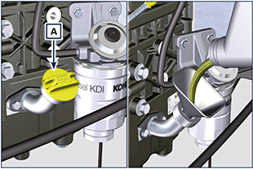  4.1
- Before checking oil engine needs to be level.  - Remove the oil dipstick B and check that the level is up to but does not exceed the MAX.  - If level is not at the MAX. level, add additional oil.  - Re-tighten the cap A.  Important  - Do not use the engine with the oil level below the minimum. | 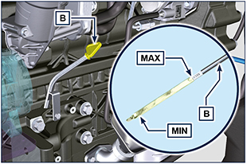  4.2
NOTE : Click on the right to play the procedure. | https://www.youtube.com/embed/HWCzK41Br1U?rel=0

Coolant filling
Important  - Before proceeding with operation, read Par. 3.2.2 .  NOTE: Refer to the technical documentation of the vehicle. | Warning  - An anti-freeze protection liquid (ANTIFREEZE) - mixed with decalcified water - must be used.  - The freezing point of the refrigerant mixture depends on the amount concentration in water.  - As well as lowering the freezing point, the antifreeze also raises the boiling point.  - A 50% mixture is recommended to ensure a general level at protection prevents the formation of rust, galvanic currents and calcium deposits ( Par. 2.7 ).

AdBlue®/DEF filling
NOTE: Refer to the technical documentation of the vehicle.

