Information about failures
KDI 1903 M-MP Owner Manual (Rev.01)

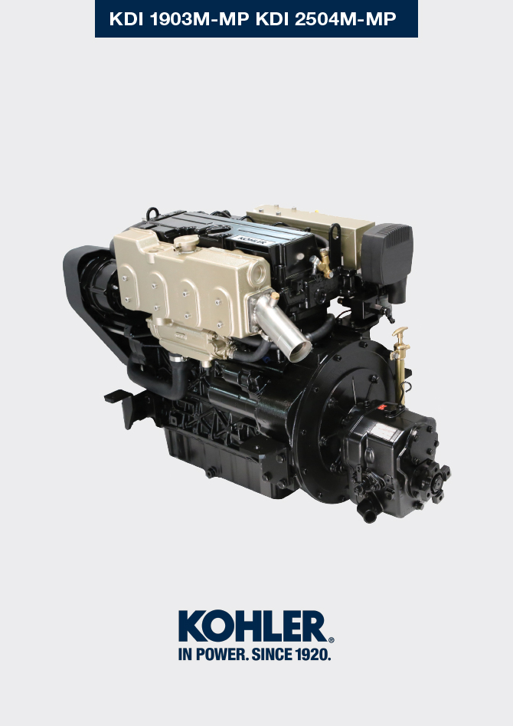

Registration of modifications to the document
Any modifications to this document must be registered by the drafting body, by completing the following table.

Released by | Code | Revision | Release Date | Revision date | Edited by | Endorsed
Technical Documentation | ED0053030860 | 05.1 | 02/2016 | 04/2023 | M. SILVESTRONE | C. TAGLIAVINI

Translated from the original manual in Italian language
Data reported in this issue can be modified at any time by KOHLER.

Sommario
1. TITOLO 1 2
1.1. Asdfsdfsdf 2
1.2. Asdfsdfsdfggg 2

Information about failures

Useful information about failures
- This chapter contains information about the problems that may appear during engine operation with its causes and trouble shooting Tab. 7.2 .
- In some cases, you shall turn off the engine immediately to avoid further damage Tab. 7.1 .
Tab 7.1
THE ENGINE MUST BE IMMEDIATELY TURNED OFF WHEN:
1 | The engine rpms suddenly increase and decrease
2 | A sudden and/or unusual noise is heard
3 | The colour of the exhaust fumes suddenly darkens
4 | The oil pressure indicator light turns on while running

Tab 7.2
TROUBLES | POSSIBLE CAUSE | SOLUTION | PAR.
The engine does not start | Sulphated battery terminals corroded | Clean the battery terminals | --
The engine does not start | Battery voltage too low | Recharge the battery or replace it | --
The engine does not start | Low fuel level | Refuel | 4.4
The engine does not start | Frozen fuel | Contact Lombardini Marine authorised workshops | --
The engine does not start | Clogged fuel filter | Replace with a new filter | 6.3
The engine does not start | Air suction in fuel system | Contact Lombardini Marine authorised workshops | --
The engine does not start | Clogged air filter | Replace with a new filter | --
The engine does not start | Clogged pipes | Contact Lombardini Marine authorised workshops | --
The engine does not start | Open fuse | Replace with a new fuse; if the problem persists, contact Lombardini Marine authorised workshops | --
The engine does not start | Intake or exhaust system clogged | Contact Lombardini Marine authorised workshops | --
Engine starts but stops | Inefficient electrical connections | Clean the electrical contacts; if the problem persists, contact Lombardini Marine authorised workshops | --
Engine starts but stops | Sulphated battery terminals | Clean the battery terminals | --
Engine starts but stops | Clogged fuel filter | Replace with a new filter and clean the tank | 6.3
Engine starts but stops | Clogged fuel pipes | Contact Lombardini Marine authorised workshops | --
RPM instability at idle speed | Clogged fuel pipes | Contact Lombardini Marine authorised workshops | --
Low idle speed | Clogged fuel pipes | Contact Lombardini Marine authorised workshops | --
Low idle speed | Poor quality fuel | Clean the tank and refuel with quality fuel | 2.5
Blue smoke | High oil sump level | Replace the engine oil; if the problem persists, contact Lombardini Marine authorised workshops | 6.1
Blue smoke | Clogged air filter | Replace with a new filter | 6.8
Excessive fuel consumption | Clogged air filter | Replace with a new filter | 6.8
Excessive fuel consumption | High oil sump level | Replace the engine oil; if the problem persists, contact Lombardini Marine authorised workshops | 6.1
Engine lost its initial performance | Clogged air filter | Replace with a new filter | 6.8
Engine lost its initial performance | Clogged fuel pipes | Contact Lombardini Marine authorised workshops | --
Engine lost its initial performance | Cheap fuel | Clean the tank and refuel with quality fuel | --
Engine lost its initial performance | High oil sump level | Replace the engine oil; if the problem persists, contact Lombardini Marine authorised workshops | 6.1
Slow acceleration | Clogged fuel filter | Replace the fuel filter | 6.3
Engine jerking | Clogged fuel pipes | Contact Lombardini Marine authorised workshops
Engine overheats | Insufficient coolant level | Fill up to the level | 5.6
Engine overheats | High oil sump level | Replace the engine oil; if the problem persists, contact Lombardini Marine authorised workshops | 6.1
Engine overheats | Clogged radiator | Clean the radiator; if the problem persists, contact Lombardini Marine authorised workshops | 5.7
In the event that the solutions proposed in Tab. 7.2 do not eliminate the trouble, contact a Lombardini Marine authorized workshop.

Error signals on the control panel
Tab. 7.3 shows the errors that can be generated on the control panel.  Tab. 7.3  Besides visual signals, acoustic errors are also transmitted from the panel. Any errors disappear automatically once the anomaly has been solved.  (*1) - A maintenance service does not automatically carry out a reset; it must be reset manually, as follows:  - Press the E push button until the maintenance service page (Service h) is displayed on the screen D .  - Simultaneously press push buttons E and F for 10 secs . for screen D to reset the hours until the next maintenance. | 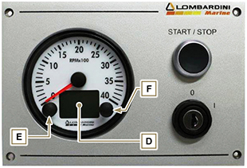  Fig 7.1
  POS. | DESCRIPTION
   | Engine oil pressure low
   | High coolant temperature
   | Disabled alternator  (with engine rpm < 850 rpm)
  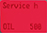 | Maintenance service (*1)
  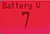 | Insufficient battery voltage  (flashing display with battery < 9 V)



