Information about maintenance
KDI 1903 M-MP Owner Manual (Rev.01)

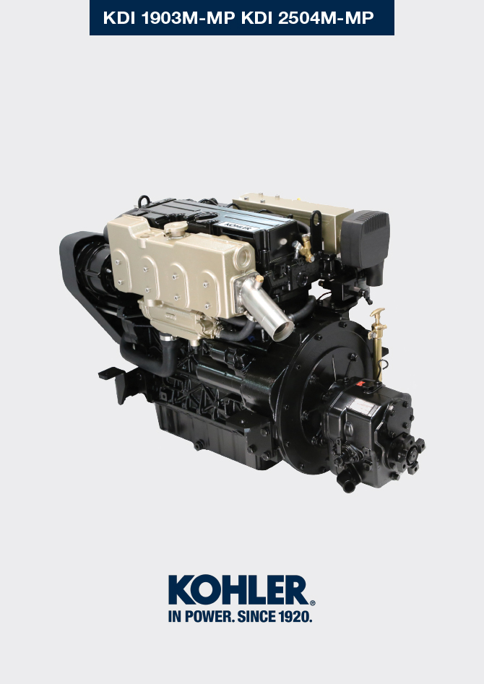

Registration of modifications to the document
Any modifications to this document must be registered by the drafting body, by completing the following table.

Released by | Code | Revision | Release Date | Revision date | Edited by | Endorsed
Technical Documentation | ED0053030860 | 05.1 | 02/2016 | 04/2023 | M. SILVESTRONE | C. TAGLIAVINI

Translated from the original manual in Italian language
Data reported in this issue can be modified at any time by KOHLER.

Sommario
1. TITOLO 1 2
1.1. Asdfsdfsdf 2
1.2. Asdfsdfsdfggg 2

Information about maintenance

Useful information about maintenance
- This chapter shows all operations described in the Tab. 5.1 and Tab. 5.2 . if you have the skills appropriate may be directly carried out by the user.
- Periodic inspection and maintenance operations must be carried out as indicated in this manual and are the responsability of the user.
- Failure to comply with these service and maintenance intervals increases the risk of technical damage to the engine. Any non compliance makes the warranty become null and void.
- In order to prevent personal and property damage read carefully the instructions listed below before proceeding with any operation of the engine.


Warning

- Inspections must be made when the engine is off and cold.
- Place engine on level sur face to ensure accurate measurement of oil level.
- Before starting, to avoid spillages of oil make sure that: - the oil dipstick is inserted correctly;

- also check that:

oil drain plug and

oil filler cap are tightened firmly.


Important

- Before proceeding with operation, read Par. 3.2.2 .


Danger

- For safety precautions see Chap. 3 .

Periodic maintenance
The intervals of preventive maintenance in Tab. 5.1 e Tab. 5.2 refer to the engine operating under normal operating conditions with fuel and oil meeting the recommended specifications.
Tab. 5.1
CLEANING AND CHECKING
OPERATION DESCRIPTION | PERIOD (HOURS) |  |  |  | PAR.
OPERATION DESCRIPTION | 10 | 250 | 500 | 5000 | PAR.
Engine oil level |  |  |  |  | 5.3
Coolant level |  |  |  |  | 5.5
Radiator heat-exchange surface ⁽²⁾ |  |  |  |  | 5.6
Rubber hose |  |  |  |  | 5.4
Fuel hose |  |  |  |  | 5.4
Starter Motor ⁽⁵⁾ |  |  |  |  | --
Tab 5.2
REPLACEMENT
OPERATION DESCRIPTION |  | PERIOD (HOURS) |  |  |  | PAR.
 |  | 10 | 250 | 500 | 5000 | PAR.
Engine oil ⁽¹⁾ |  |  |  |  |  | 6.1
Oil filter cartridge ⁽¹⁾ |  |  |  |  |  | 6.2
Fuel filter cartridge ⁽¹⁾ |  |  |  |  |  | 6.3
Water pump belt ⁽³⁾⁽⁵⁾ |  |  |  |  |  | 6.7
Alternator belt ⁽³⁾ ⁽⁵⁾ |  |  |  |  |  | 6.6
Coolant ⁽⁴⁾⁽⁵⁾ |  |  |  |  |  | 6.5
Coolant hoses ⁽⁵⁾⁽⁷⁾ |  |  |  |  |  | --
Fuel hoses ⁽⁵⁾⁽⁷⁾ |  |  |  |  |  | --
Dry air cleaner cartridge ⁽²⁾ |  |  |  |  |  | 6.8
Water pump impeller |  |  |  |  |  | 6.4

(1) - In case of low use: 12 months. (2) - The period of time that must elapse before checking the filter element depends on the environment in which the engine operates.

The air filter must be cleaned and replaced more frequently under very dusty conditions.

(3) - In case of low use: 36 months.

(4) - In case of low use: 24 months.

(5) - The replacement must be carried out by authorized Lombardini Marine workshops.
(7) - The replacement interval is only an indication, it strongly depends from environmental condition and hose status detected during regular visual inspection.
(8) - Not supplied by Lombardini Marine .

Oil level check (standard dipstick)
Important  - Before proceeding with operation, read Par. 3.2.2 .  - Do not exceed the MAX level on the dipstick.  - Do not use the engine with the oil level below the MIN .  - Place engine on horizontal surface to ensure accurate measurement of checking.  - Loosen the oil filler cap A . Remove the oil dipstick B and check that the level is up to MAX.  - Pour in recommended oil until reaching the MAX level mark.  - Reinstall the oil dipstick B completely.  - Re-tighten the cap A and/or C . | 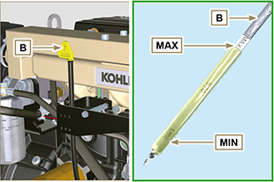  Fig 5.1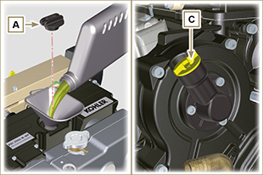  Fig 5.2

Rubber hoses check
Danger  - For safety precautions see Chap. 3 .  The check is carried out by exerting a slight deflection or bending along the pipe and near the hose clamps. Components must be replaced if they have clear signs of cracks, tears, cuts, leaks and do not retain a certain degree of elasticity.  Important  - Before proceeding with operation, read Par. 3.2.2 .  - If hoses are damaged contact an authorized Lombardini Marine workshop.  Check that the:  - Fuel system hoses A are intact.  - Hoses for the cooling circuit B1 , B2, B3 and B4 .  - Vent system pipes C . | 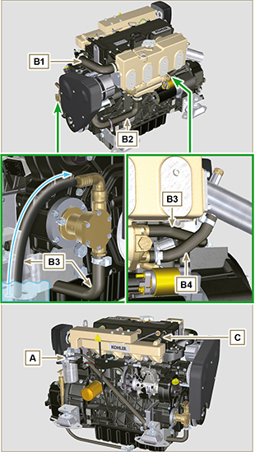  Fig 5.3

Check coolant level
NOTE : Before proceeding with any operation on the engine, stop it and allow it to cool.  Important  - Before proceeding with operation, read Par. 3.2.2 .  - Place engine on horizontal surface to ensure accurate measurement of checking.  Danger  - For safety precautions see Chap. 3 .  Warning  - Presence of steam pressurized coolant danger of burns.  - Start the engine without the radiator cap A .  - Undo capscrew C and refill the cooled exhaust manifold B until coolant leaks out of capscrew C .  NOTE: The MAX filling level for exhaust manifold B is in correspondence of capscrew C , complete the coolant refilling procedure as soon as the coolant starts leaking out of capscrew C .  - Reinstall the cap A and capscrew C .  NOTE : For coolant filling see Par. 4.7 .  Warning  - Before starting make sure that the radiator cap and cap, if present, are installed correctly to avoid spillage of liquid or vapour at high temperatures. | 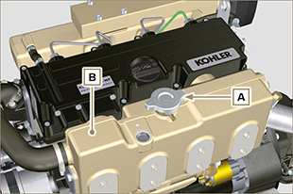  Fig 5.4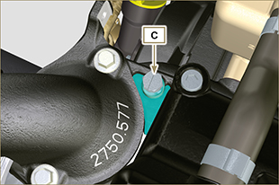  Fig 5.5

Zinc anode and radiator check
Important  - Before proceeding with operation, read Par. 3.2.2 .  Danger  - For safety precautions see Chap. 3 .  Warning  - Protect the starter motor adequately against contact with liquids before starting operations.  - Slightly undo union A to drain the coolant into an appropriate container and refer to Par. 3.5 .  - Undo capscrew B .  - Replace component B if value C is below 15 mm .  - Undo capscrew D1 , D2 and remove cap E1 , E2 .  - Remove radiator F from cooled manifold G .  - Perform the cleaning operations, immerse components F, E1, E2 in a solution of distilled water with 10% hydrochloric acid.  - Make sure that radiator F is free from deposits and dirt of any kind.  - Make sure that all the holes in surfaces F1, F2 are free from deposits and dirt of any kind. | 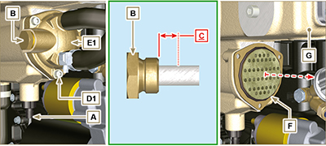  Fig. 5.6
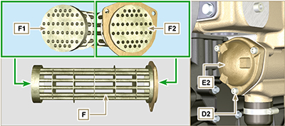
Fig. 5.7

NOTE : if the inside of the pipes on surfaces F1 and F2 ( Fig. 5.7 ) are clogged with deposits even after having been cleaned as per step 6, the pipes must be cleaned using specific mechanical tools.  Important  - Replace all the gaskets.  - Fasten cap E2 onto manifold G using capscrews D2 inserting flange E3 and also inserting:  - gasket H1 between E2 and E3  - gasket H2 between E3 and G .  (tightening torque: MIN 5 Nm , MAX 7.5 Nm )  - Insert gasket H3 in radiator F .  - Insert radiator F all the way into manifold G .  - Insert gasket H4 in radiator F .  - Fasten cap E1 onto manifold G using capscrews D1 (tightening torque: MIN 5 Nm , MAX 7.5 Nm )  - Clamp capscrew B on cap E1 inserting gasket H5 (tightening torque 30 Nm ).  - Screw union A onto manifold G .  - Perform the operations described in Par. 6.4 . | 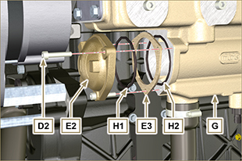  Fig. 5.8  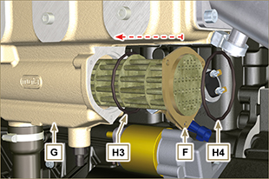  Fig. 5.9
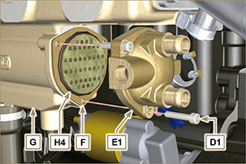  Fig. 5.10 | 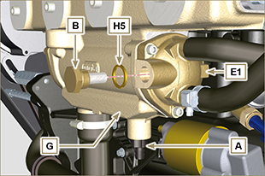  Fig. 5.11

Product preservation

Important

- If the engines are not to be used for 6 months, they must be protected by carrying out the operations described in Engine storage (up to 6 months) ( Par. 5.8 ) .
- If the engine is still not in use after the first 6 months, it is necessary to carry out a further operation to extend the protection period (more than 6 months) ( Par. 5.9 ).
- If the engine is not to be used for an extended period, the protective treatment procedure must be repeated within 24 months of the previous one.

Engine storage (up to 6 months)
Before storing the engine check that:
- The environments are not humid or exposed to bad weather. Cover the engine with a proper protective sheet against dampness and atmospheric contaminants.
- The place is not near electric panel.
- Avoid storing the engine in direct contact with the ground.

Engine storage (over 6 months)
Follow the steps described in Par. 5.8 .

- Engine oil replacement ( Par. 6.1 ).
- Refuel with fuel additives for long storage.
- With expansion tank:
make sure that the coolant is up to the maximum level.
- Without expansion tank:
Follow the steps described in Par. 4.7 .
- Start the engine and keep it idle at minimum speed for 2 minutes.
- Bring the engine to 3/4 of the maximum speed for 5÷10 minutes.
- Turn off the engine.
- Completely empty the fuel tank.
- Spray SAE 10W-40 on the exhaust and intake manifolds.
- Seal the exhaust and intake ducts to prevent foreign bodies from entering.
- When cleaning the engine, if using a pressure washer or steam cleaning device, avoid directing the nozzle on electrical components, cable connections and sealed rings (oil seals etc).
If cleaning engine with a pressure washer or steam cleaner, it is important to maintain a minimum distance of at least 200mm between the surface to be washed and the nozzle - avoiding absolutely electrical components such as alternators, starter motors and engine control units (ECU).
- Treat non-painted parts with protective products.
If the engine protection is performed according to the suggestions indicated no corrosion damage should occur.

Engine starting after storage
- Remove the protective sheet.
- Use a cloth soaked in degreasing product to remove the protective treatment from the external parts.
- Inject lubricating oil (no more than 2 cm ³ ) into the intake ducts.
- Refill the tank with fresh fuel.
- Make sure that the oil and the coolant are up to the maximum level.
- Start the engine and keep it idle at minimum speed for a two about minutes.
- Bring the engine to 75% of maximum rated speed for 5 to 10 minutes.
- Stop the engine while the oil is still hot ( Par. 6.1 ) , discharge the protective oil in a suitable container.

Warning

  - Over time, lubricants and filters lose their properties, so it is important consider whether they need replacing, also based on the criteria described in Tab. 5.2 .

- Replace the filters (air, oil, fuel) with original spare parts.
- Pour new oil ( Par. 4.5 ) up to the maximum level.
- Empty the cooling circuit completely and pour in the new coolant up to the maximum level ( Par. 6.5 ) .



