Informations sur les outils
KDI 1903 M Workshop manual (Rev. 09.6)



Registration of modifications to the document
Any modifications to this document must be registered by the drafting body, by completing the following table.

Released by | Code | Revision | Release Date | Revision date | Edited by | Endorsed
Technical Documentation | ED005302-960 | 9.6 | 04/2013 | 03/2023 | M. SILVESTRONE | V. MANINI

Translated from the original manual in Italian language
Data reported in this issue can be modified at any time by KOHLER.

Sommario
1. TITOLO 1 2
1.1. Asdfsdfsdf 2
1.2. Asdfsdfsdfggg 2

Tools information

Information regarding specific tools

In Tab 13.1 - 13.2 there is a list of all the specific tools that are required and approved to carry out operations of disassembly - assembly - regulations - settings - repairs on engine series KDI

, correctly and safely.

Warning

- KOHLER declines all responsibility for any damage to the engine, persons, or things caused by the use of different types of tools to those indicated in Tab 13.1 - 13.2 , where referred to them in the manual.

Tab. 13.1
SPECIAL TOOLS FOR DISASSEMBLY AND ASSEMBLY
"ST" | Picture/Draw | DESCRIPTION | PART NUMBER
ST_03 | 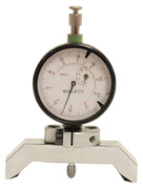 | Piston protrusion - injectors cylinder head surface control tool | ED0014602980-S
ST_04 | 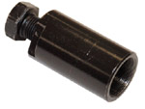 | High-pressure fuel injection pump puller gear | ED0014603680-S
ST_05 | 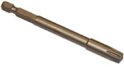 | Spanner for capscrews Six nicks SN 8 | ED0014603650-S
ST_06 | 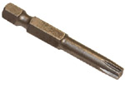 | Spanner for capscrews Six nicks SN 5 | ED0014603640-S
ST_07 | 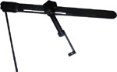 | Tool for disassembling / reassembling valves | ED0014603720-S
ST_08 | 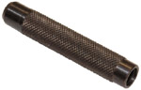 | Tool for gasket valve stem | ED0014603660-S
ST_09 | 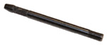 | Tool for flywheel assembling / disassembling | ED0014603610-S
ST_10 | 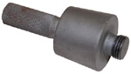 | Crankshaft gasket assembling tool | ED0014603670-S
ST_14 | 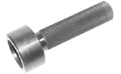 | Buffer insertion of a crankshaft gasket onto a timing system carter | ED0014603750-S
ST_15 | 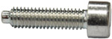 | Locking screw balance shafts | ED0097301980-S
ST_17 | 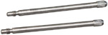 | Rocker arm cover mounting studs | ED0014603730-S
ST_18 | 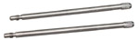 | Intake and oil sump manifold mounting studs | ED0014603740-S
ST_30 | 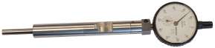 | Piston n°1 tool positioning prior to injection pump assembly. | ED0014603940-S
ST_34 | 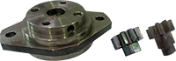 | Crankshaft blocking tool | ED0014604270-S
ST_36 | 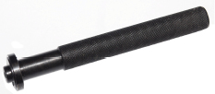 | Assembling tool for a gasket on a rocker arm cover (injector seat) | ED0014603830-S
ST_51 | 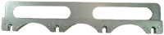 | Injectors placing tool | ED0014604310-S
Tab. 13.2
SPECIFIC EQUIPMENT TO PROTECT COMPONENTS OF THE INJECTION CIRCUIT
ST_40 | 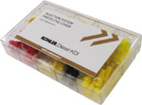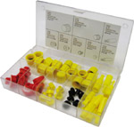 | Complete box with caps to close holes and unions for high-pressure injection circuit components. | ED0082051380-S



