Information about failures
KDI 3404 TCR / KDI 3404 TCR HT Owner Manual (REV. 11.6)

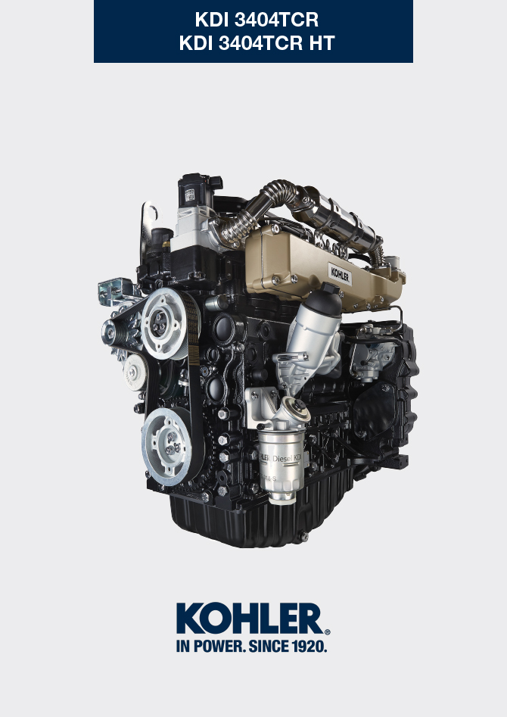

Registration of modifications to the document
Any modifications to this document must be registered by the drafting body, by completing the following table.

Released by | Code | Revision | Release Date | Revision date | Edited by | Endorsed
 | 3404tcr

Translated from the original manual in Italian language
Data reported in this issue can be modified at any time by KOHLER.

Sommario
1. TITOLO 1 2
1.1. Asdfsdfsdf 2
1.2. Asdfsdfsdfggg 2

Information about failures

Useful information about failures
- This chapter contains information about the problems that may appear during engine operation with its causes and trouble shooting Tab. 7.2 .
- In some cases, you shall turn off the engine immediately to avoid further damage Tab. 7.1 .
Tab 7.1
THE ENGINE MUST BE IMMEDIATELY TURNED OFF WHEN
1 | Warning RED light turn on
2 | The oil pressure indicator light turns on while running
3 | The engine rpms suddenly increase and decrease
4 | A sudden and/or unusual noise is heard
5 | Colour the exhaust fumes suddenly darkens

Tab 7.2
TROUBLES | POSSIBLE CAUSE | SOLUTION | PAR.
Warning YELLOW light turn on | Engine ECU has detect a malfunctions | Contact KOHLER authorised workshops | --
The engine does not start | Sulphated battery terminals corroded | Clean the battery terminals | --
The engine does not start | Battery voltage too low | Recharge the battery or replace it | --
The engine does not start | Low fuel level | Refuel | 4.4
The engine does not start | Frozen fuel | Contact KOHLER authorised workshops | --
The engine does not start | Clogged fuel filter | Replace with a new filter | 6.3
The engine does not start | Air suction in fuel system | Contact KOHLER authorised workshops | --
The engine does not start | Clogged air filter | Replace with a new filter | 6.4
The engine does not start | Clogged pipes | Contact KOHLER authorised workshops | --
The engine does not start | Intake or exhaust system clogged | Replace with a new fuse; if the problem persists,  Contact KOHLER authorised workshops | --
The engine does not start | Intake or exhaust system clogged | Contact KOHLER authorised workshops | --
Engine starts but stops | Inefficient electrical connections | Clean the electrical contacts; if the problem persists,  Contact KOHLER authorised workshops | --
Engine starts but stops | Sulphated battery terminals | Clean the battery terminals | --
Engine starts but stops | Clogged fuel filter | Replace with a new filter and clean the tank | --
Engine starts but stops | Clogged fuel pipes | Contact KOHLER authorised workshops | --
RPM instability at idle speed | Clogged fuel pipes | Contact KOHLER authorised workshops | --
Numero dei giri al minimo basso | Clogged fuel pipes | Contact KOHLER authorised workshops | --
Numero dei giri al minimo basso | Poor quality fuel | Clean the tank and refuel with quality fuel | 2.5
Blue smoke | High oil sump level | Replace the engine oil; if the problem persists,  Contact KOHLER authorised workshops | --
Blue smoke | Clogged air filter | Replace with a new filter | 6.4
Excessive fuel consumption | Clogged air filter | Replace with a new filter | 6.4
Excessive fuel consumption | High oil sump level | Replace the engine oil; if the problem persists,  Contact KOHLER authorised workshops | --
Engine lost its initial performance | Clogged air filter | Replace with a new filter | 6.4
Engine lost its initial performance | Clogged fuel pipes | Contact KOHLER authorised workshops | --
Engine lost its initial performance | Cheap fuel | Clean the tank and refuel with quality fuel
Engine lost its initial performance | High oil sump level | Replace the engine oil; if the problem persists,  Contact KOHLER authorised workshops | --
Slow acceleration | Clogged fuel filter | Replace the fuel filter | 6.3
Engine jerking | Clogged fuel pipes | Contact KOHLER authorised workshops
Engine overheats | Insufficient coolant level | Fill up to the level | 4.6
Engine overheats | High oil sump level | Replace the engine oil; if the problem persists,  Contact KOHLER authorised workshops | --
Engine overheats | Clogged radiator | Clean the radiator; if the problem persists, contact KOHLER authorised workshops | --
In the event that the solutions proposed in Tab. 7.2 do not eliminate the trouble, contact a KOHLER authorized workshop



