PC Arrangement for Diagbox software
Diagnostic tool manual

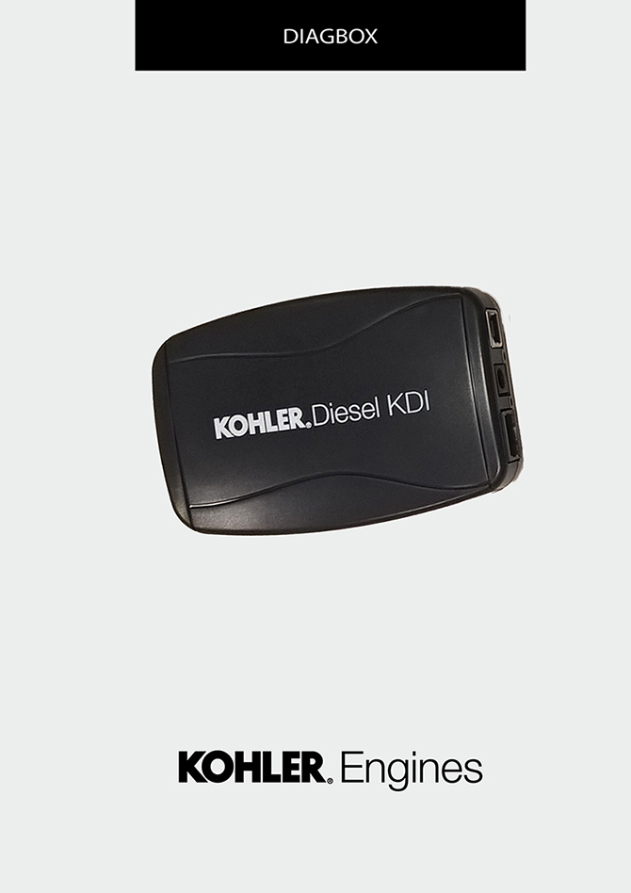
Sommario
1. TITOLO 1 2
1.1. Asdfsdfsdf 2
1.2. Asdfsdfsdfggg 2

PC Arrangement for Diagbox software

PC Arrangement for Diagbox software
Warning
Start the engine; connect the test equipment ONLY after starting the engine.
NOTE : if the test equipment is connected before starting the engine, hunting may occur.
To cure the issue, disconnect test equipment cable from the engine, allow a few seconds and then reconnect the equipment.
To download the "Setup DiagBox.exe" oftware, perform the following operations:
Go to website "http://iservice.lombardini.it" and click on "KDI KOHLER DIESEL".

Read carefully "PRIVACY" box and click on "I ACCEPT"

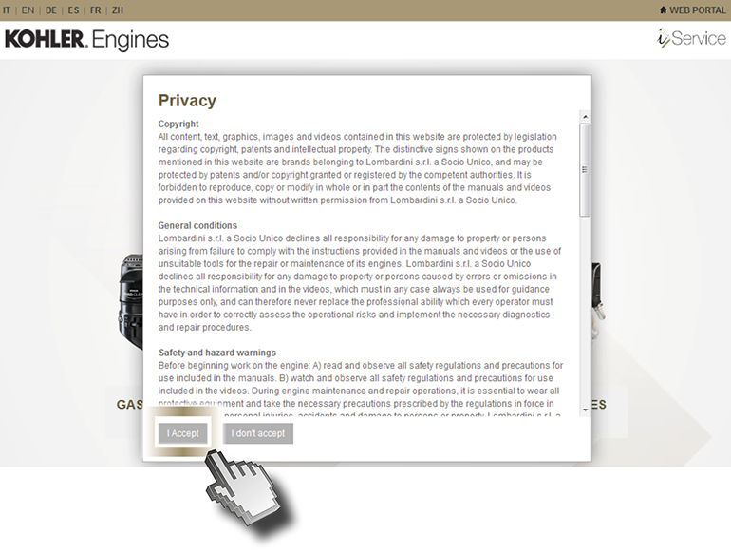
Enter the "Username and Password", flag "I AM NOT A ROBOT" and clicking "Log-in"

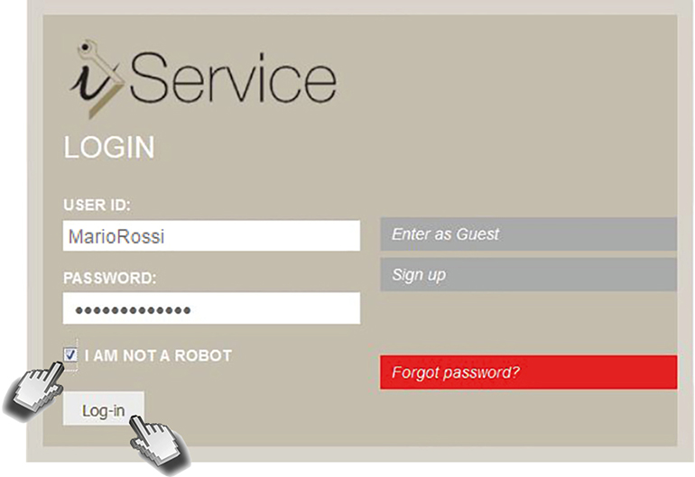

If you have no "USER ID" and "PASSWORD", register by clicking on "SIGN IN".

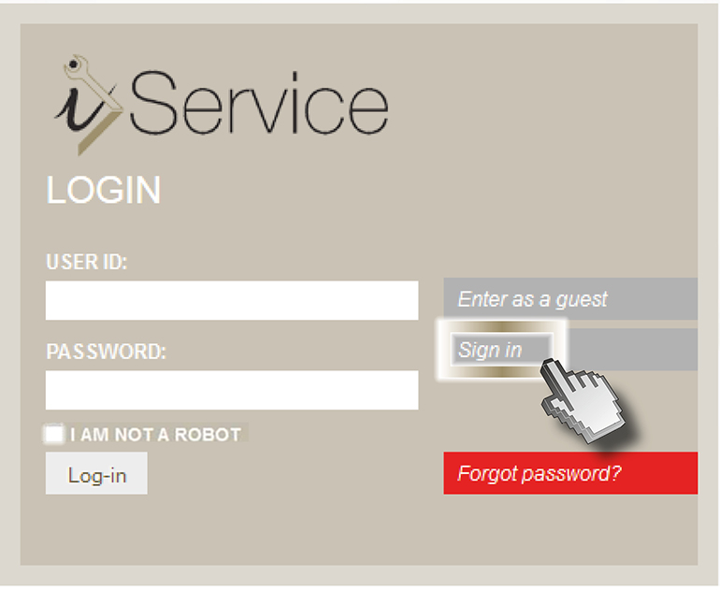
Fill out the required fields and “DIAGNOSTIC TOOL CODE (ONLY IF YOU HAVE THE TOOL)" box. | 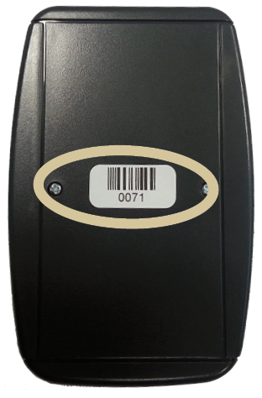
Wait for the email to confirm your registration.
Click on "DIAGNOSIS AND FLASHING"

Click on "DIAGNOSTIC TOOL"

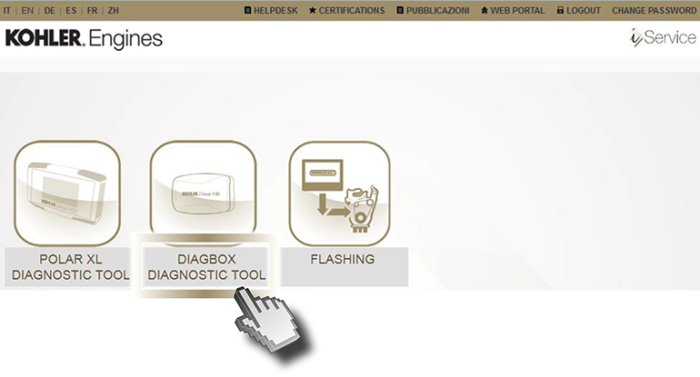

Download from i-Service Setup DiagBox.exe and click on "Salva file".

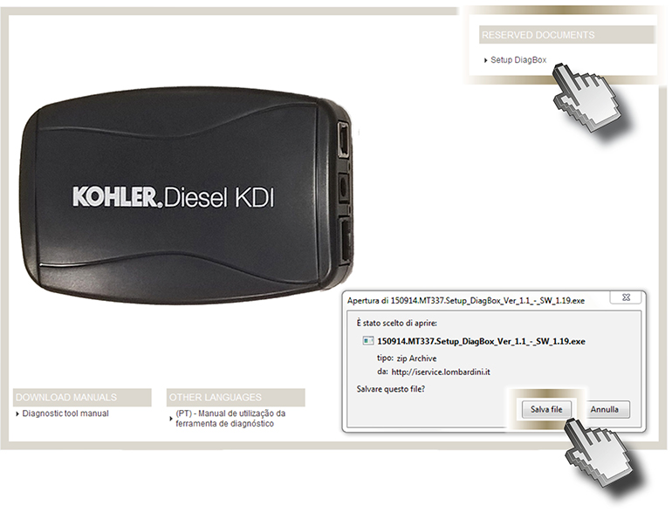
Click on "Esegui".

Warning
If you upgrade your software, you can:
- uninstall the earlier version and install the most recent version using the wizard, or
- launch the new software installation wizard directly (click on "Modify" when prompted)
Warning
In the event that the PC is equipped with anti-virus protection, proceed as follows

Click on "Azioni".

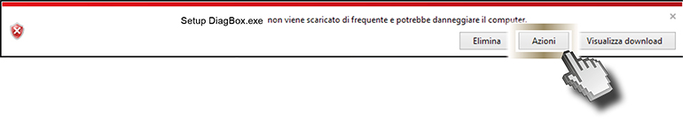

Click on "Run anyway".

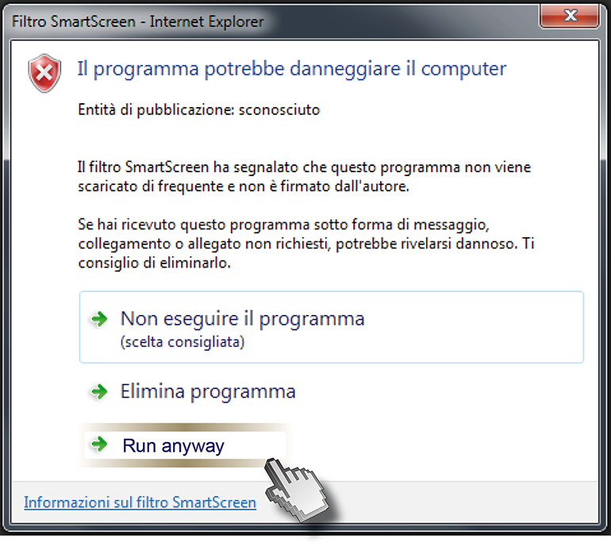

Click on "Allow this file".

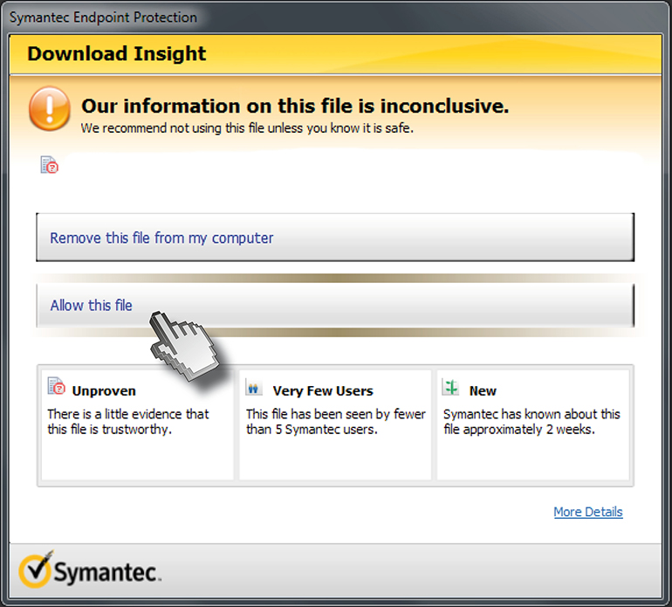

Select the desired language (1) and press "OK" (2).

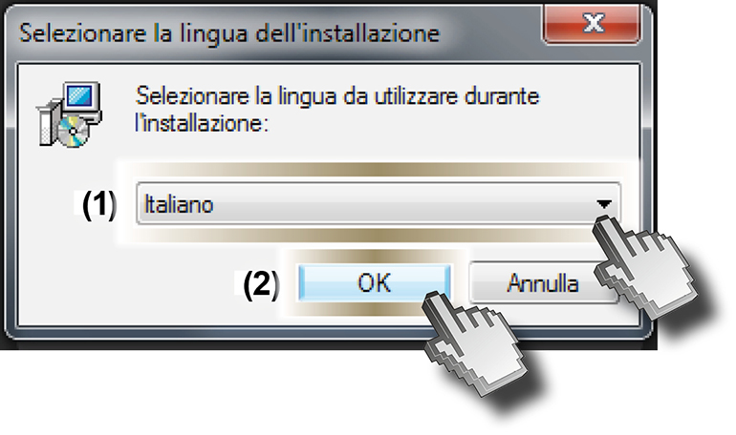
Click on "Next".

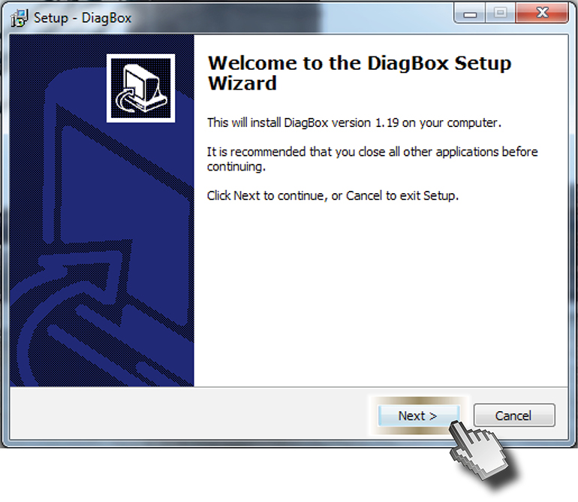
Click on "Next".

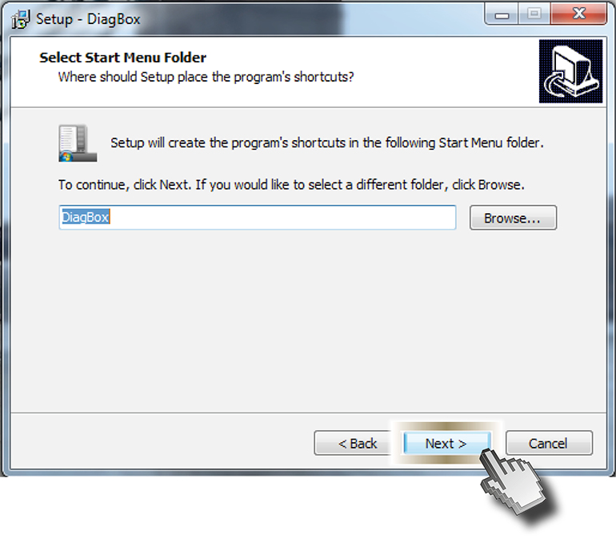
Tick "Create a desktop icon" (1) and then click on "Next" (2).

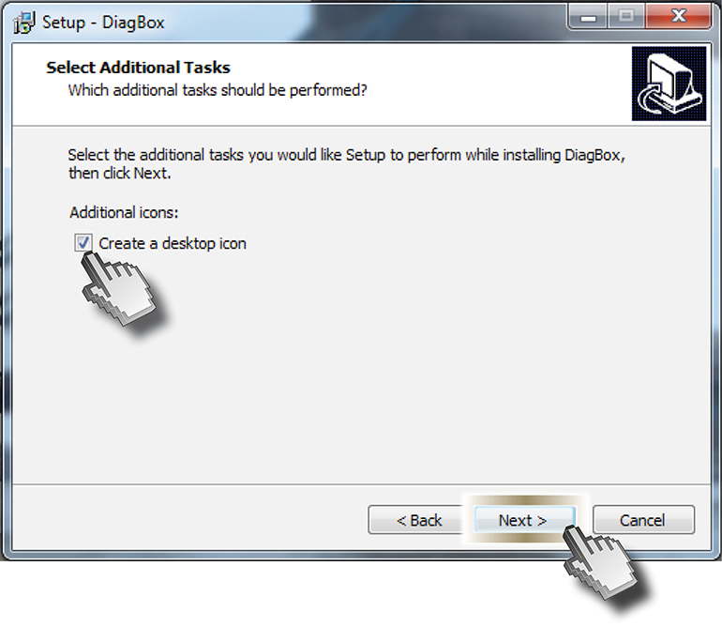
Click on "Install".

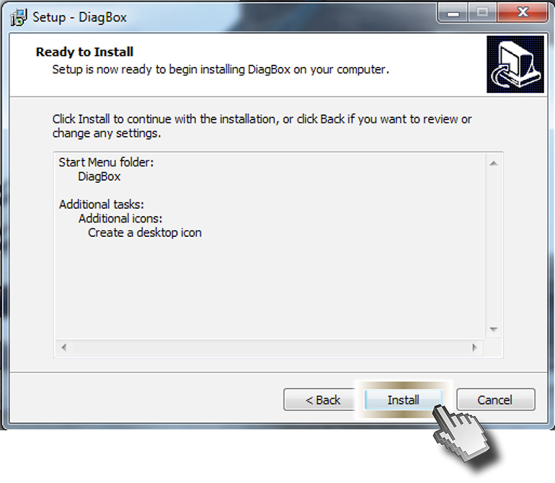
Please wait while setup installs DiagBox on your computer.

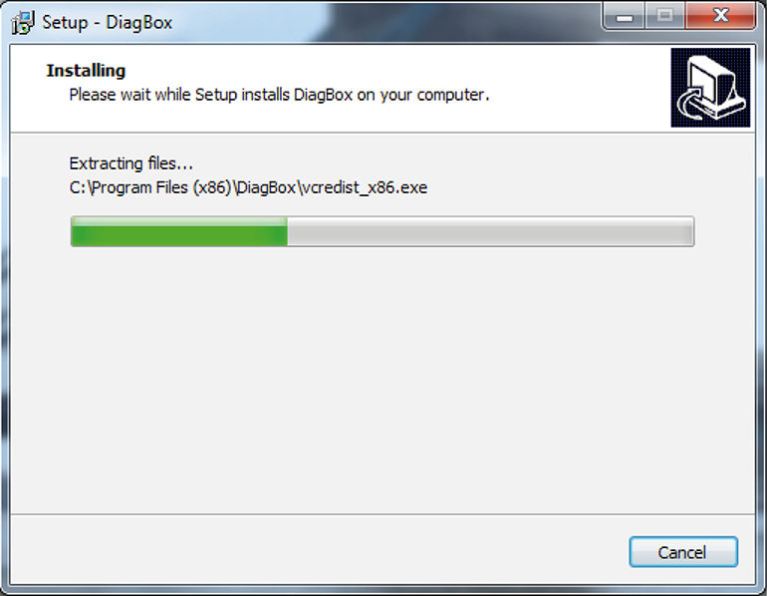

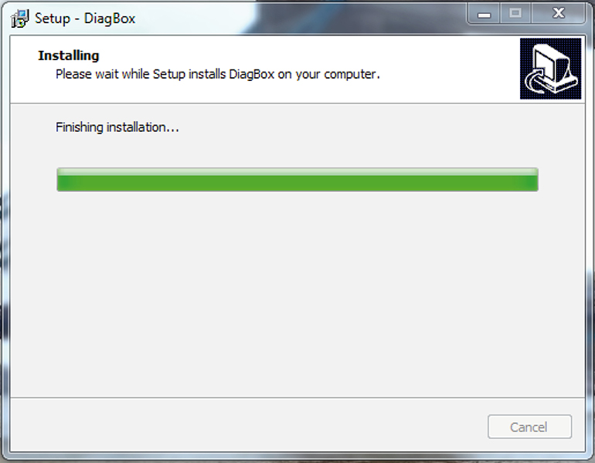

Click on "Next"

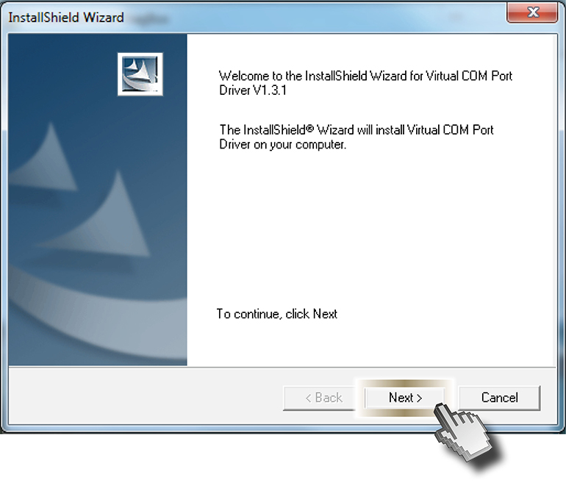
Click on "Next"

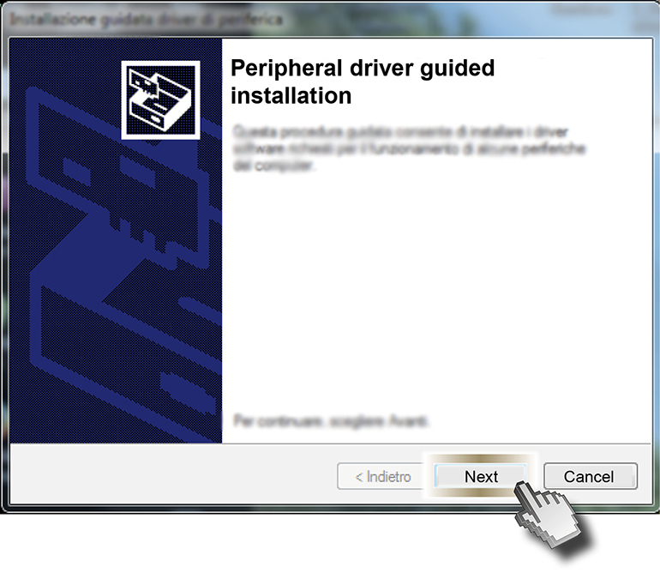
Click on "I have read the licence conditions" and press "Install"

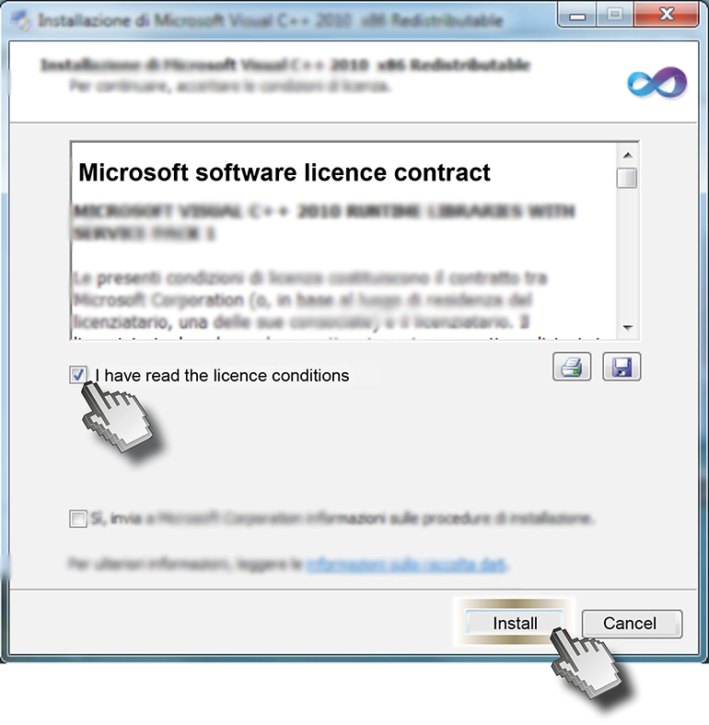
Please wait while setup installs on your computer.

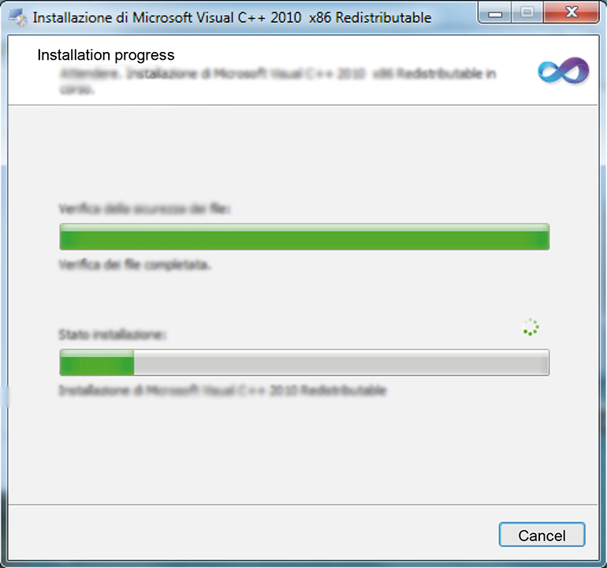

Click on "Finish".

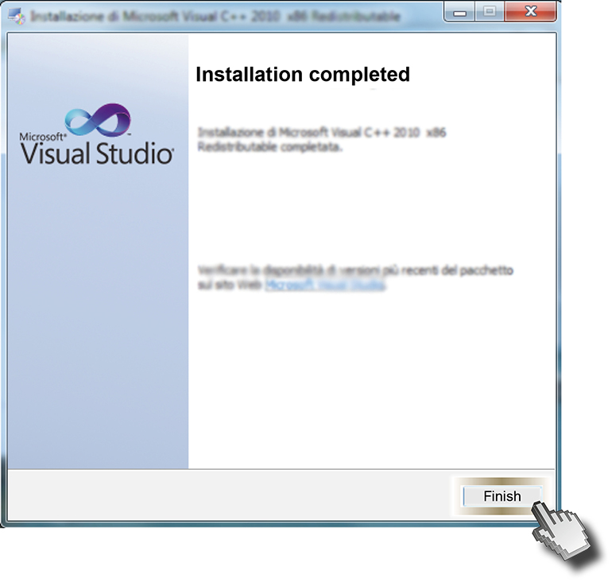
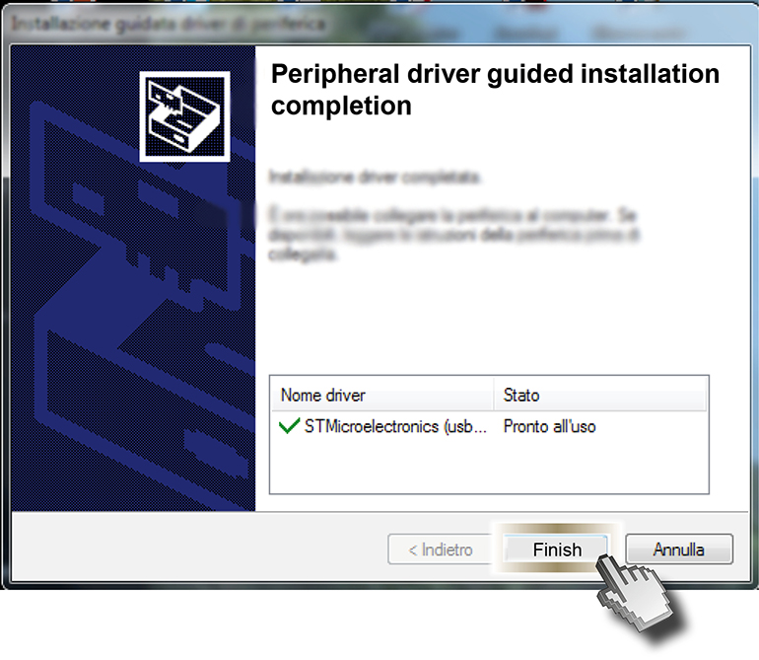
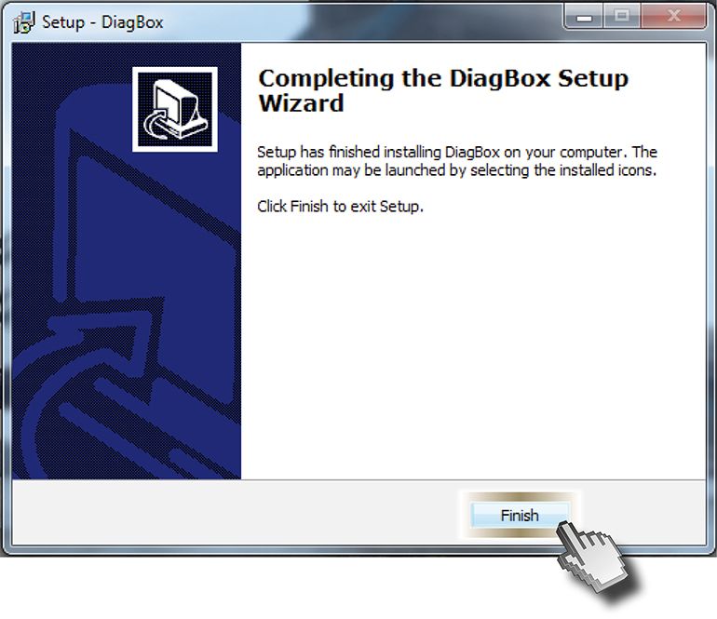

Warning
The USB DRIVER will be installed automatically when Diagbox is connected to the PC for the first time

