Information about replacements
KDI 1903 M Owner Manual (Rev_14.1)

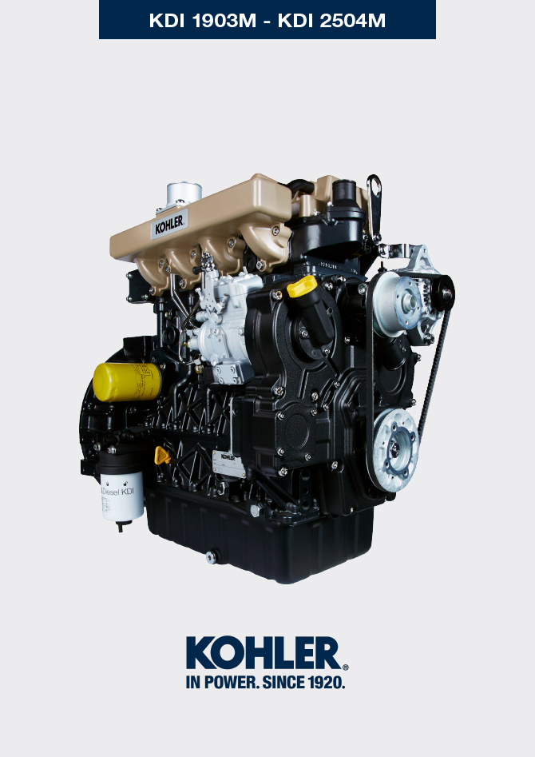
Sommario
1. TITOLO 1 2
1.1. Asdfsdfsdf 2
1.2. Asdfsdfsdfggg 2

Information about replacements

Engine oil replacement
Danger  - Disconnect the negative wire (-) from the battery to avroid accidental engine stating.  Important  - Before proceeding with operation, read Par. 3.2.2  - Place engine on level sur face to ensure accurate measurement of oil level.  NOTE : Perform this operation with warm engine, to get a better fluidity of the oil and get a full discharge of oil and impurities contained in it.  - Loosen the oil filler cap A (Fig. 6.1) .  - Remove the oil dipstick B .  - Remove the oil drain plug D and the gasket E (the oil drain plug is on both sides of the oil sump).  - Drain oil in an appropriate container.  (For the exhausted oil disposal, refer to Par. 6.6 DISPOSAL and SCRAPPING ).  - Replace gasket E .  - Tighten the drain oil plug D (tightening torque at 50 Nm ).  - Perform the operation described in Par. 6.2.  - Add the type and amount of oil recommended ( Tab. 2.1 and Tab. 2.2 ).  - If the plug A is not accessible, use the oil filler cap C .  Important  - Do not exceed the MAX level on the dipstick.  - Fit and remove the oil dipstick B to check the level.  Pour in fluid until reaching the MAX level mark.  - Upon completion, reinstall the oil dipstick B completely.  - Tighten the cap A or C . | 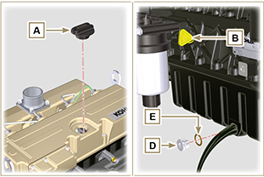  Fig. 6.1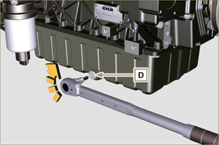  Fig. 6.2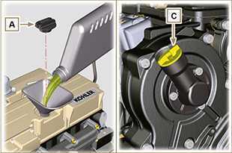  Fig. 6.3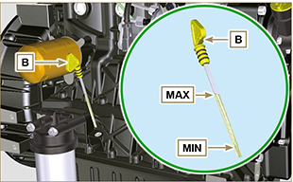  Fig. 6.4
NOTE: Click on the icon to play the procedure. | https://www.youtube.com/embed/EpASqRzBxe0?rel=0

Oil filter cartridge replacement
Important  - Before proceeding with operation, read Par. 3.2.2  Warning  - In case of low use replace it 12 months.  - For disposal of oil filter cartridge refer to Par. 6.6 DISPOSAL and SCRAPPING .  - Unscrew the oil filter A with appropriate wrench. | 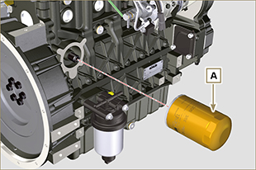  Fig 6.5
2. Assembly and tighten the new oil filter cartridge A tightening it with torque wrench B (torque to 15 Nm ). | 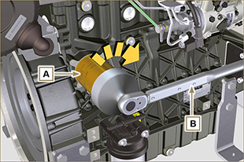  Fig 6.6
NOTE : Click on the icon to play the procedure. | https://www.youtube.com/embed/v9pGAnWFd08?rel=0

Remote oil filter cartridge replacement (optional)
Important  - Before proceeding with operation, read Par. 3.2.2 .  - Unscrew and remove the cartridge A using the appropriate wrench.  - Lubricate the gasket and screw on the new cartridge A using the appropriate wrench. | 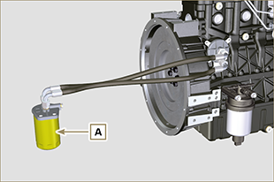  Fig 6.7

Fuel filter cartridge replacement
Important  - Before proceeding with operation, read Par. 3.2.2  Warning  - In case of low use replace il 12 months.  - For disposal of oil filter cartridge and fuel filter refer to Par. 6.6 DISPOSAL and SCRAPPING  - Procure a suitable container to collect the fuel.  - Rotate the filter A to take it to the unlocked position and remove it.  - Lubricate the gasket C .  Assemble the filter A on the support B and rotate it until reaches the lock position.  Important  - Do not fill the new cartridge A with fuel.  - Turn the key on the control panel to the ON position.  The electric pump D sends fuel to the filter and then the injection pump E .  - Loosen the air bleeding screw F on fuel filter bracket B .  The air inside the circuit and the filter will begin to escape from the screw G .  - Tighten the bleeding screw F (tightening torque of 1.5 Nm ) when the fuel begins to flow. | 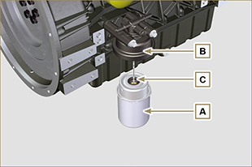  Fig 6.8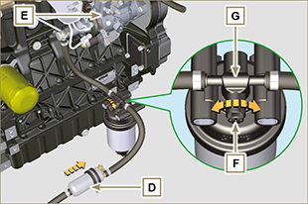  Fig 6.9
NOTE: Click on the icon to play the procedure. | https://www.youtube.com/embed/meko2s8_-U0?rel=0

Air filter cartridge replacement
Important  - Before proceeding with operation, read Par. 3.2.2.  NOTE : Component not necessarily supplied by KOHLER.  - Release the two fastenings F of the cover A .  - Remove the cartridge B .  - Reinstall:  - the new cartridges B .  - the cover A checking the right tightness of fastenings F . | 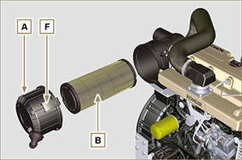  Fig. 6.10

Disposal and scrapping
- In case of scrapping, the engine shall be disposed of in appropriate locations, in conformity with the law in force.
- Before scrapping, it is necessary to separate the rubber or plastic parts from the rest of the components.
- The parts only composed of plastic material, aluminium and steel can be recycled if collected by the appropriate centers.
- Waste oil must properly be recycled and disposed of in the correct way to safeguard the environment. According to the laws in force, it is classified as hazardous waste, therefore it must be collected by the appropriate centers.

