Information regarding discharge of liquids
KDI 3404 TCR-SCR Workshop Manual (Rev. 10.3)

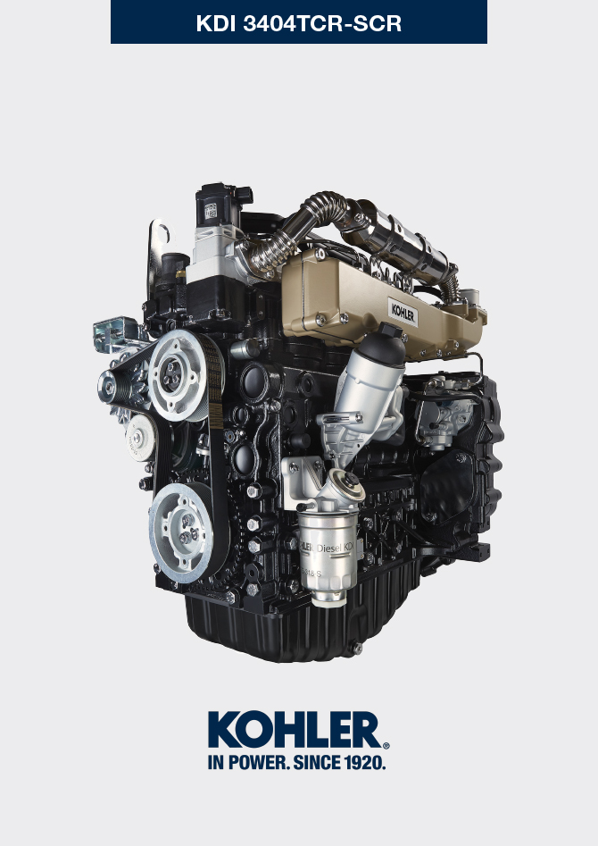
Sommario
1. TITOLO 1 2
1.1. Asdfsdfsdf 2
1.2. Asdfsdfsdfggg 2

Information regarding discharge of liquids

Coolant
NOTE : Component not supplied by KOHLER .

Refer to the technical documentation of the vehicle.

Engine oil
Important  - Before proceeding with operation, read Par. 3.3.2 .  - This operation should be carried out with vacuum pump. The oil must be drained whilst the engine is hot, which requires particular care to prevent burns. Do not allow oil to come into contact with the skin because of the health hazards involved. It is recommended to use an oil intake pump via the oil dipstick hole B.  - Electric/pneumatic screwdrivers are forbidden.  - Undo the cartridge holder cover C by performing three complete turns and wait 1 minute.  NOTE : this operation will allow to oil contained in the support G to flow into the oil sump in the correct way.  - Unscrew cartridge holder cover C and check that the oil in the lub. oil filter bracket G has flowed towards the oil sump (refer to NOTE in Par. 2.10.3 ).  - Undo the oil filler cap A (Fig. 5.5) .  - Remove the oil dipstick B .  - Remove the oil drain plug D and the gasket E (the oil drain plug is on both sides of the oil sump).  - Drain oil in to an appropriate container.  (For used oil disposal refer to the Par. 3.6 ).  - Replace gasket E .  - Tighten the drain oil plug D (tightening torque at 50 Nm ).  - Perform the operations described in Par. 6.8.2 and the operation 5 Par. 6.8.3 . | 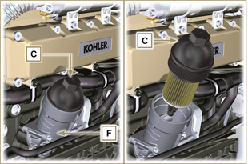  Fig 5.1  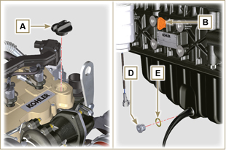  Fig 5.2
NOTE : Click by side to play the procedure. | https://www.youtube.com/embed/3J7y9uoALfI?showinfo=0&rel=0

