Information about optional components
KDI 3404 TM Workshop Manual (Rev. 08.2)

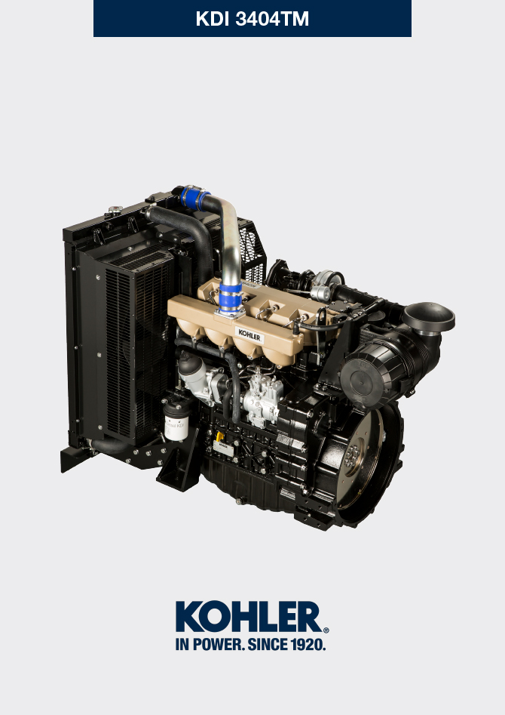
Sommario
1. TITOLO 1 2
1.1. Asdfsdfsdf 2
1.2. Asdfsdfsdfggg 2

Information about optional components

Heater (replacement)
Important

- Before proceeding with operation, read Par. 3.3.2 .
11.1.1 Disassembly  - Undo the screws A .  - Remove the flange C .  - Remove the heater E and the relevant gaskets F . | 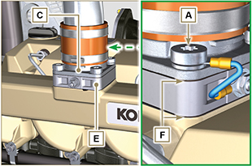  Fig 11.1
11.1.2 Assembly  Important  - Always replace gaskets F , with each assembly.  - In sequence, fit the manifold G with the gasket F , the new heater E , the second gasket F , the flange C , the washers H , the screws A and the cable B .  - Secure the flange C with the screws A (tightening torque at 22 Nm ). | 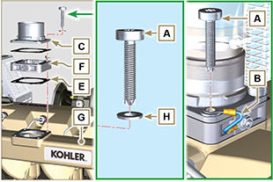  Fig 11.2

Air filter (cartridge replacement)
Important

- Before proceeding with operation, read Par. 3.3.2 .
- Release the two hooks A and remove the cover B from the body C .  - Remove the cartridges D . | 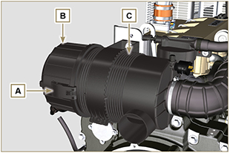  Fig 11.3
- Insert the new cartridge D and both of them inside the filter body C .  - Secure the cover B via the hooks A . | 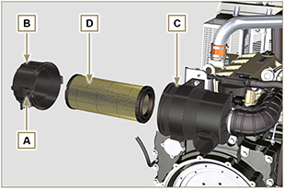  Fig. 11.4

Cooling circuit (replacement)
Important

- Before proceeding with operation, read Par. 3.3.2 .
11.3.1 Radiator disassembly  - Release the clamp A1, A2 .  - Disconnect hose B from radiator C . | 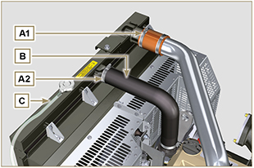  Fig. 11.5
- Release the clamp A3, A4 .  - Disconnect hose D from radiator C . | 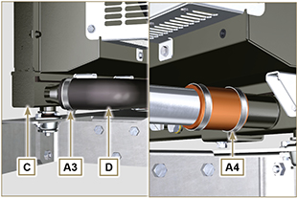  Fig. 11.6
- Loosen all capscrews E1 , E2 and E3 .  - Release nut F .  - Remove floodgates G1 and G2 .  - Loosen capscrews K .  - Disconnect radiator C from hoses H1 and H2 , being careful not to deform tubes J1 and J2 .  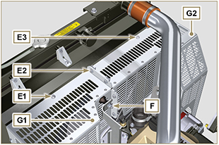  Fig. 11.7 | 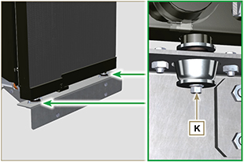  Fig. 11.8
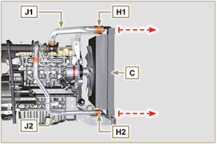
Fig. 11.9
11.3.2 Fan disassembly  - Undo the screws P and remove the fan R . | 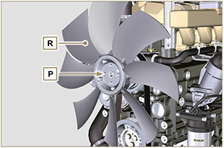  Fig. 11.10
11.3.3 Fan assembly  - Assemble the fan R on the pulley U .  - Fasten the fan R by using the screws P (tightening torque at 10 Nm ). | 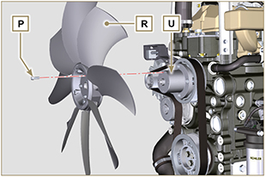  Fig. 11.11

11.3.4 Radiator assembly  - Fit radiator C onto hose H2 , being careful not to deform tube J2 .  - Centre radiator C onto vibration-dampening devices V .  - Secure radiator C onto vibration-dampening devices V by means of capscrews K (tightening torque at 25 Nm ). | 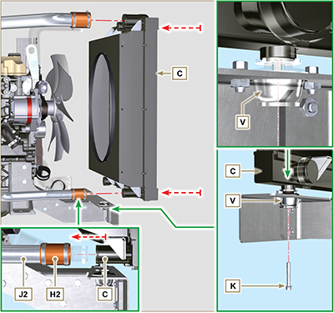  Fig. 11.12
- Position floodgate G1 onto radiator C .  - Secure all capscrews E1 .  - Place floodgate G2 onto radiator C .  - Secure all capscrews E3 and E2 . | 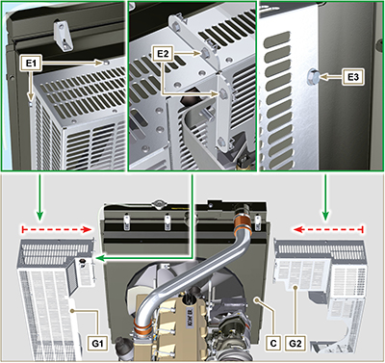  Fig. 11.13

- Fit hose H1 onto radiator C , being careful not to deform tube J1 .  NOTE : Make sure vibration-dampening device V2 is correctly installed in its place on brace S . | 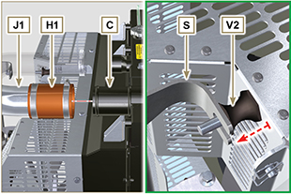  Fig. 11.14
- Secure vibration-dampening device V2 onto brace S by means of nut F , inserting washer F1 (tightening torque at 25 Nm).  - Secure hoses B and D by means of clamps A2 and A3 ( Fig. 11.5 - 11.6 ).  - Secure hoses H1 and H2 by means of clamps A1 and A4 ( Fig. 11.5 - 11.6 ). | 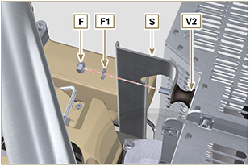  Fig. 11.15

