Information for replacing the functional units
KDI 1903TCR / KDI 1903TCRE5 Workshop manual (Rev. 17.6)


Sommario
1. TITOLO 1 2
1.1. Asdfsdfsdf 2
1.2. Asdfsdfsdfggg 2

Information for replacing the functional units

Electronic injector replacement
Important  - Before proceeding with operation, read Par. 3.3.2 .  - In the event of the electronic injectors being disassembled (not necessarily replaced) their position with respect to individual cylinders must not be changed when re-assembled. Refer to the reference between each injector and respective cylinder number.  - Seal all injection component unions as illustrated in Par. 2.9.8 during disassembly.  - Handle the components as described in Par. 2.17 .  - Replace all seal gaskets after each assembly for all components on which they are provided.  - The high pressure pipes must be replaced every time they are disassembled.  - Before disassembling the electronic injectors, make sure the new high pressure pipes are available.  - If a new (or different) electronic injector is fitted on the engine, the new calibration data must be entered in the ECU through a specific instrument ( ST_01 ) .  - Electronic injectors are not repairable.  - This procedure may be performed on one or more electronic injectors.  NOTE: In the event of a leak upon replacement (oil - coolant - fuel - air), do not intervene with the engine running, but stop it and wait for 5/10 minutes before checking and solving the problem. | 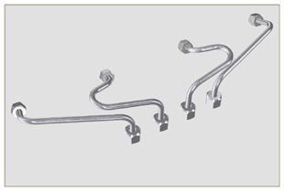  Fig 6.1
6.1.1 Fuel return pipes disassembly (Common Rail/electronic injectors)  - Disconnect the connector C . | 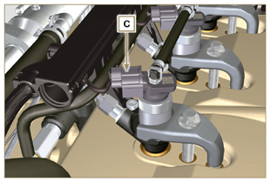  Fig 6.2
- Remove clips E from the electronic injector F .  - Disconnect the junction G from the electronic injector F .  Warning  - After removing the fittings, the clips E must automatically return to their initial position; otherwise they must be replaced.  - Seal all injection component unions as illustrated in Par. 2.9.8 . | 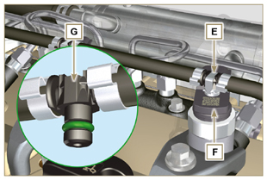  Fig 6.3
6.1.2 High pressure fuel pipes disassembly (Common Rail/electronic injectors)  Danger  - The fuel injection circuit is under high pressure, use safety protections as described in Par 3.4.3 .  - Ensure that the Common Rail is not under pressure by slowly and carefully unscrewing one of the nuts H .  - Undo the nut H on the Common Rail L and then the nut M on the electronic injector F and remove the pipe N .  Important  - In the event that the electronic injectors are disassembled (not necessarily replaced), mark them with the relevant cylinder number from which they originate so as not to confuse them during re-assembly.  - Seal all injection component unions as illustrated in Par. 2.9.8 . | 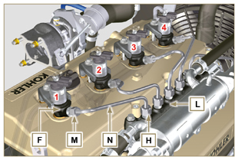  Fig 6.4
6.1.3 Electronic injectors disassembly  - Undo and remove the screw P with the washer R e and then the bracket Q .  Important  - Be careful not to damage the gaskets X .  - Replace rings X , if damaged.  2. Pull out the electronic injector F .  NOTE: Should you be unable to remove the electronic injector (acting only on point BC ), use an open-ended spanner (Ø 34 mm), by applying small rotations to unblock the component.  3. Seal all injection component unions as illustrated in Par. 2.9.8 .  4. Ensure that gasket S has remained in the correct position (Fig. 6.6) . Otherwise, recover the gasket from inside the electronic injector T manifold. | 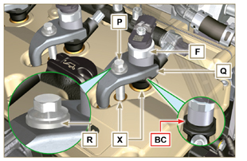  Fig 6.5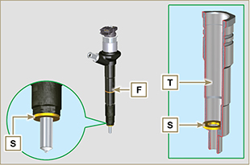  Fig 6.6
NOTE: Click by side to play the procedure. | https://www.youtube.com/embed/QQZtx2i75AY?rel=0
6.1.4 Electronic injector assembly  Important  - Always replace and lubricate the gaskets AA and S of the electronic injectors F with fuel, every time they are replaced.  - Reposition the electronic injectors (not replaced) by following the references made for disassembly, as indicated in Par. 6.1.2.  - If the engine is painted or protected with clear paint, clean the paint off the diesel injector F near to the part in contact with the gasket AB .  - Insert the gasket S on the electronic injectors F (Fig. 6.7) .  - Insert electronic injector F into manifold T , being extra careful not to damage gasket AB and direct it as indicated in Fig. 6.7 . | 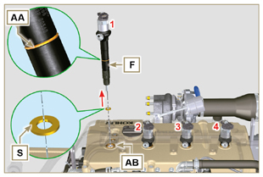  Fig 6.7
6.1.5 High pressure fuel pipes assembly  Important  - Always replace the pipes N after each assembly.  - If the engine is painted or protected with clear paint, replace the fastening screws P to ensure the gaskets are sealed properly.  - Position tube N in the Common Rail seat of the electronic injector; correct the position of the electronic injector by means of the entrance of the electronic injector unions F and Common Rail L .  - Apply the nuts H and M by hand without tightening them.  - Position the fastening brace of electronic injectors Q on capscrew surface AD , insert capscrews P in brace Q inserting washer R . | 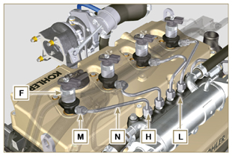  Fig 6.8
Important  - Ensure that brace S is perfectly positioned onto the electronic injector.  4. Tighten the fixing screws P of the electronic injector bracket (tightening torque at 20 Nm ).  5. Tighten the nut M (tightening torque at 25 Nm ).  6. Tighten the nut H (tightening torque at 30 Nm ). | 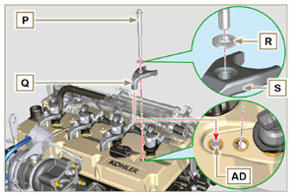  Fig 6.9
6.1.6 Fuel return pipes assembly  - Check the condition of the gaskets AE . | 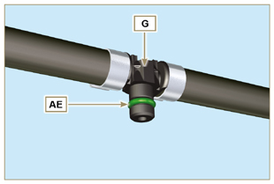  Fig 6.10
- Insert unions AF onto electronic injectors F and block them with clips E .  - Mount the connectors C on the electronic injectors F .  Warning  - Slightly move the wiring support to check that the electrical wire of connector C is not strained in correspondence with the outlet hole AF . | 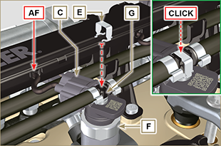  Fig 6.11
NOTE: Click by side to play the procedure. | https://www.youtube.com/embed/ArOgFV739EU?rel=0

High-pressure fuel injection pump replacement
Danger  - The fuel injection circuit undergoes high pressure, use safety protections as described in Par 3.4.3 .  - Ensure that the Common Rail is not under pressure by slowly and carefully unscrewing nut A .  Important  - Before proceeding with operation, read Par. 3.3.2 .  - Always replace the high pressure pipes after each disassembly.  - Before disassembling the injection pump, make sure the new high-pressure pipe is available.  - The injection pump is not repairable.  - Should the fuel feeding pump need to be replaced, after assembly, it is necessary to perform the Pump Learning procedure by means of instrument ST_01 .  - Seal all injection component unions as illustrated in Par. 2.9.8.  - To handling components refer to Par. 2.17.  - Always replace the gaskets (where are provided) after each disassembly. | 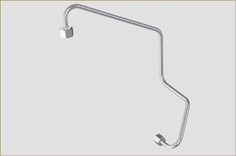  Fig 6.12
6.2.1 High-pressure fuel line disassembly (from the injection pump to the Common Rail).  - Undo the nut A . | 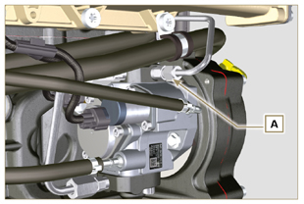  Fig 6.13
- Undo nut D from Common Rail E . | 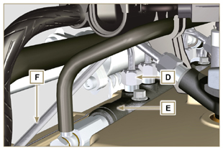  Fig 6.14
- Undo the nut B on the intake manifold C and remove the pipe F . | 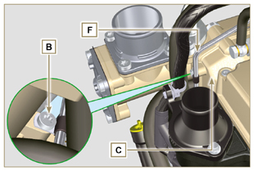  Fig 6.15
6.2.2 Timing system carter oil filling flange disassembly  - Remove starter motor ( Par. 7.3.2 ) and assemble special tool ST_34 ( Par. 7.7 point 2 ) .  - Undo the screws G ( ST_06 ) ,remove the clamp E and the flange H . | 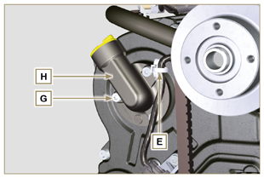  Fig 6.16
6.2.3 High-pressure fuel injection pump disassembly  - Undo and remove nut L fixing the fuel feeding pump control  gear M .  Important  - Be careful that the nut L does not fall into the timing cover.  - Tighten tool ST_04 on the gear M . | 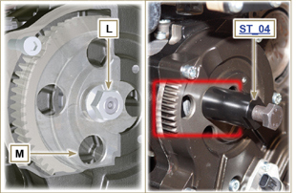  Fig 6.17
Important  - Do NOT use the cylinder connection pipe W as a handle, to prevent damage or fuel leaks.  - Before disassembling, carefully read Par. 2.17 .  - Seal all injection component unions as illustrated in Par. 2.9.8.  - Release the clamps N on the return pipe P and on the fuel inlet pipe Q .  - Disconnect tubes P and Q from fuel feeding pump R .  - Disconnect connectors S and T .  - Loosen the screws U .  - Redo the capscrew of tool ST_04 to disconnect injection  pump R from gear M .  - Undo capscrews U and extract injection pump R with the relevant gasket V .  - Undo and remove the tool ST_04 . | 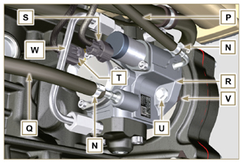  Fig 6.18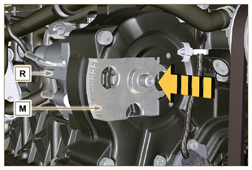  Fig 6.19
NOTE: Click by side to play the procedure. | https://www.youtube.com/embed/UaZgKyWrP48?rel=0
6.2.4 High-pressure fuel injection pump assembly  Important  - Before assembling, carefully read Par. 2.17  - Always replace the gasket V after each assembly. The gasket V can only be fitted in one direction.  - Remove the tool ST_04 from the pump control gear ( Ref. M of Par. 6.2.3 ) if applicable.  - Do NOT use the cylinder connection pipe W as a handle, to prevent damage or fuel leaks.  - Remove the protection caps only when reconnecting the hoses. | 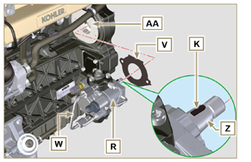  Fig 6.20
- Check that the contact surfaces AA are free from impurities.  - Insert the reference key K in the seat of the shaft Z .  - Assemble the new gasket V on injection pump R . Insert injection pump R in its housing on crankcase AA making key K coincide with key seat AH of gear M . | 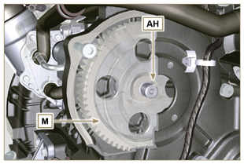  Fig 6.21
- Fully tighten the nut L on the shaft Z of the injection pump.  Important  - Apply nut L by hand, but do not tighten. | 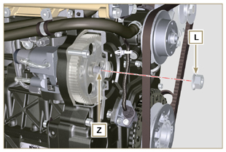  Fig 6.22
Important  - It is mandatory to replace the screws U or apply a few drops of Loctite 270 .  - Clamp the screws U on the crankcase AB (tightening torque at 25 Nm ).  - Clamp the nut L (Fig. 6.22) (tightening torque at 65 Nm ). | 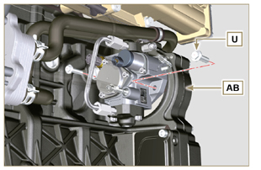  Fig 6.23
- Fit the connector T on the sensor J .  - Fit the connector S on the sensor Y .  - Remove the protection caps.  - Fit the pipe Q on the fitting AA .  - Fit the pipe P on the fitting AB .  - Hook the clamps N on the hoses Q and P . | 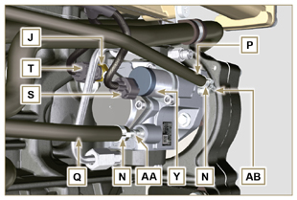  Fig 6.24
6.2.5 High-pressure line assembly (injection pump /  Common Rail)  - Remove the protection cap.  - Position the pipe F .  Important  - Manually tighten the nut A . | 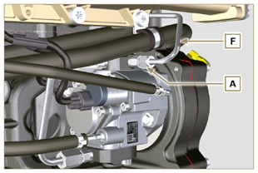  Fig 6.25
- Manually tighten the nut D .  - Fix clamp AC by means of capscrew B on intake manifold C (tightening torque 10 Nm - ST_06 ).  - Clamp nut D (tightening torque at 30 Nm ) and A (tightening  torque at 25 Nm ) in sequence. | 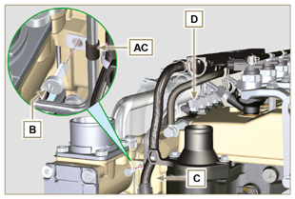  Fig 6.26
6.2.6 Timing system carter oil filling flange assembly  NOTE: Always replace the gasket AE after each assembly.  - Position the gasket AE in the set on the flange H .  - Fix the flange H on the crankcase AF with the screws AG (tightening torque at 10 Nm - ST_06 ).  - Fit the clamp E on the flange H .  - Disassemble the special tool ST_34 and assemble the starter motor (tightening torque 45 Nm ). | 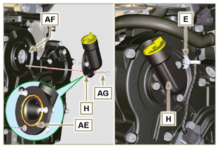  Fig 6.27
NOTE: Click by side to play the procedure. | https://www.youtube.com/embed/o3h6Say9sc4?rel=0

Unit EGR Cooler replacement
6.3.1 Disassembly  Important  - Before proceeding with operation, read Par. 3.3.2 .  - To handling components refer to Par. 2.17.  - Always replace the gaskets (where are provided) after each disassembly.  NOTE: Perform the operations described in Par. 5.1 .  - Undo the screws B of pipe C . | 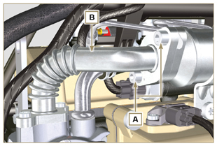  Fig 6.28
- Undo screws D and E .  - Remove pipe F and the relevant metal gaskets.  - Release the clamps G and remove the sleeve M . | 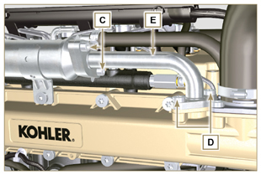  Fig 6.29
- Undo the screws H and remove the EGR Cooler L from the sleeve N ( ST_05 ).  - Should the passage ducts of the gas exhaust be clogged by soot or carbon, replace EGR Cooler L . | 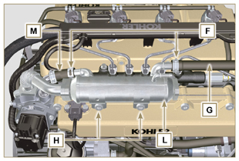  Fig 6.30
NOTE: Click by side to play the procedure. | https://www.youtube.com/embed/xGWUnc-V1YY?rel=0
6.3.2 Assembly  - Insert the fitting U in the manifold M of the EGR valve unit.  - Fit the EGR Cooler L with the screws H on the intake manifold S (tightening torque at 22 Nm - ST_05 )  - Insert the hose G on the fitting V .  - Secure the clamps F . | 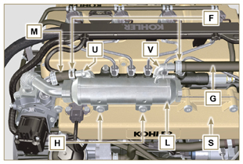  Fig 6.31
- Insert the gasket N between the hose B and the EGR Cooler L and fix the screws A (tightening torque at 25 Nm ) | 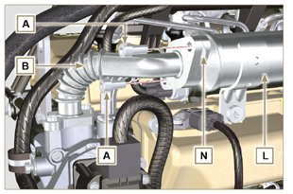  Fig 6.32
- Insert the hose E in its housing on the manifold S inserting the gasket R .  - Insert the gasket T between the hose E and the EGR Cooler L and fit the screws C (tightening torque at 25 Nm ).  - Fit the screws D (tightening torque at 22 Nm - ST_05 ).  NOTE: Perform the operations described in Par. 10.2 . | 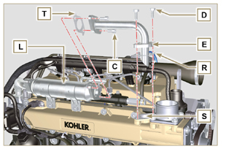  Fig 6.33
NOTE: Click by side to play the procedure. | https://www.youtube.com/embed/XSTfzyJa-9Q?rel=0

EGR valve replacement
6.4.1 Disassembly  Important  - Before proceeding with operation, read Par. 3.3.2 .  NOTE: Perform the operations described in Par. 5.1 .  - Disconnect the connector A from the valve C .  - Undo the screws B and remove the EGR valve C with the relevant gasket. | 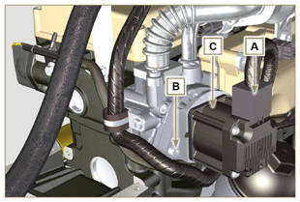  Fig 6.34
NOTE: Click by side to play the procedure. | https://www.youtube.com/embed/lZlk78GFzsg?rel=0
6.4.2 Assembly  Important  - Always replace gasket D after each assembly.  - The EGR valve is not a serviceable item, and if faulty / worn out, should be replaced with a new one.  - Movimentare i componenti come descritto nel Par. 2.17 .  - Mount the new gasket D on the valve C .  - Fit the valve C on the flange E with screws B (tightening torque at 10 Nm ). | 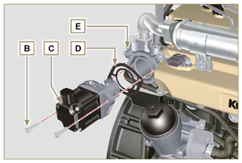  Fig 6.35
- Fit the connector A on the valve C .  NOTE: Perform the operations described in Par. 10.2 | 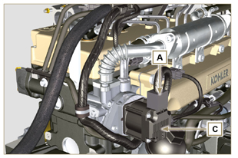  Fig 6.36
NOTE: Click by side to play the procedure. | https://www.youtube.com/embed/KGHm0dnsQdc?rel=0

Coolant pump replacement
6.5.1 Disassembly  NOTE: Perform the operations described in Par. 5.1 .  Important  - Before proceeding with operation, read Par. 3.3.2 .  - If the engine is fitted with the Poly-V belt, perform the operations described in Par. 11.3 .  - Loosen the screws A and B .  - Push the alternator C in the direction of the arrow D and remove the belt E .  - Release clamp F and disconnect tube G from the coolant pump N .  NOTE : If union R , is disassembled, replace it or alternatively apply Loctite 2701 on the thread when assembling on pump G (tightening torque of 20 Nm ). | 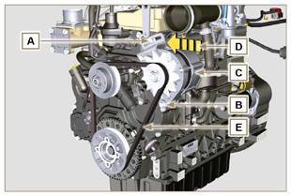  Fig 6.37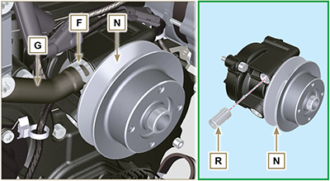  Fig 6.38
- Release the clamp M from the coolant pump N .  - Undo the screws H and remove the pump N with the relevant gasket L . | 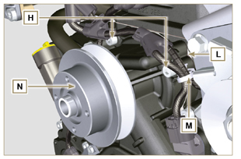  Fig 6.39
NOTE: Click by side to play the procedure. | https://www.youtube.com/embed/_QESHZf50PU?rel=0
6.5.2 Assembly  Important  - Always replace the gaskets L , after each disassembly.  - Always replace the belt E after each assembly.  - If the engine is fitted with the Poly-V belt, perform the operations described in Par. 11.3 .  - To handling components refer to Par. 2.17.  - Always replace the gaskets (where are provided) after each disassembly  - Fit the coolant pump N with the screws H interposing the new gasket L (tightening torque at 25 Nm ). | 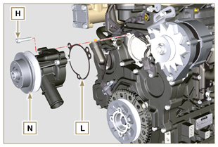  Fig 6.40
- Reinsert the pipe G and hook the clamp F ( Fig. 6.38 ).  - Rehook the clamp M on the pump N (Fig. 6.39) .  - Push the alternator C in the direction of the arrow D .  - Insert the belt E on the pulleys P . | 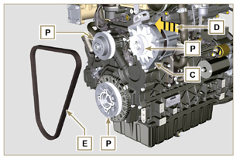  Fig 6.41
- Pull the alternator C in the direction of the arrow Q .  - While tensioning the alternator C , first clamp screw A (tightening torque at 25 Nm ) and then screw B (tightening torque at 69 Nm [thread M10] - 40 Nm [thread M8] ).  - Check the tension of the belt E with the instrument ( DENSO BTG-2 ), positioning it in point P (the tension must be between 350 and 450 Nm ).  - If the tension values do not correspond, tighten screws A and B , then repeat operations 6, 7 and 8 . | 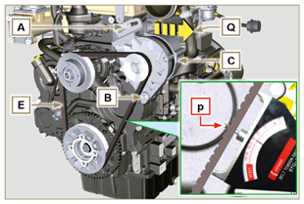  Fig 6.42
NOTE: Click by side to play the procedure. | https://www.youtube.com/embed/GbvNS15R9SQ?rel=0

Target wheel replacement
6.6.1 Disassembly  Important  - Before proceeding with operation, read Par. 3.3.2 .  - Position the crankshaft with the 1st cylinder in TDC, reference A upwards.  - Remove the alternator belt following steps 1 and 2 ( Par. 6.5.1 ) . | 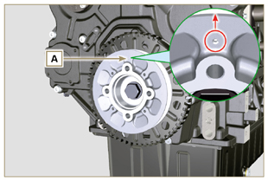  Fig 6.43
- Disassemble the starting motor.  - Mount the tool ST_34 in the seat of the starter motor C and fit it with the two starter motor fixing screws. | 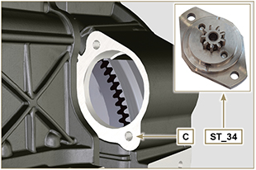  Fig 6.44
- Disconnect the connector L .  - Undo the screw M and remove the revolution sensor N and its respective spacer. | 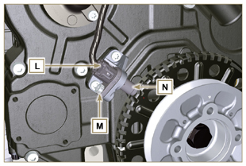  Fig 6.45
- Undo the screw P (clockwise) and remove the pulley/targetwheel unit Q . | 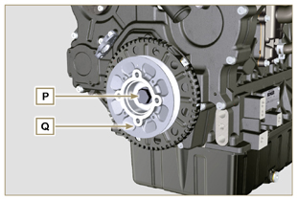  Fig 6.46
- Undo the screws R and remove the target wheel S with the relevant sound-absorption disk T . | 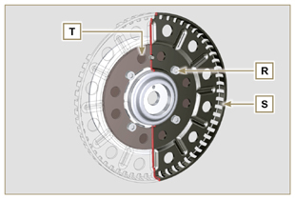  Fig 6.47
6.6.2 Assembly  - Check that the pin U is mounted properly on the pulley V .  - Insert the disk T on the pulley V respecting the reference of the pin U .  - Position the target wheel S on the pulley V respecting the reference of the pin U .  - Fit the target wheel S with the screws W (tightening torque 10 Nm ).  - Perform the operations described in Par. 6.7.7 and then the operations between point 2 and 9 of Par. 6.5.2 . | 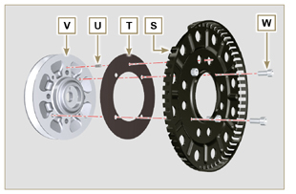  Fig 6.48

Oil pump replacement

Important

- Before proceeding with operations, read Par. 3.3.2 .
- The oil pump is not repairable.

6.7.1 Refrigerant pump disassembly  - Perform the operations described in Par 6.5.1 .  6.7.2 Crankshaft and target wheel pulley disassembly  - Perform the operations described in Par 6.6.1 .  - Disconnect the connector AE from the sensor S . | 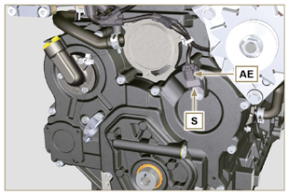  Fig 6.49
6.7.3 Timing system crankcase disassembly  Important  - Perform the operations described in Par. 5.2 .  - Make sure that the reference pin A is facing upwards.  - Undo the screw H ( ST_06 ) and remove the sensor S .  - Undo the screws B and remove the timing system crankcase C . | 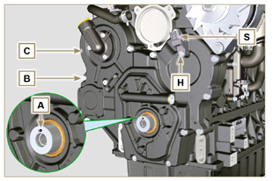  Fig 6.50
6.7.4 Oil pump disassembly  - Undo the screws D ( ST_06 ) and remove the group pump E from the timing system crankcase C .  - Remove the rotors F and G from the oil pump crankcase E . | 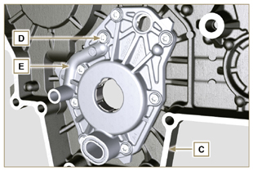  Fig 6.51  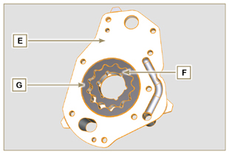  Fig 6.52
6.7.5 Oil pump assembly  NOTE: Carry out the checks described in Par. 8.7 prior to assembly.  - Check that all surfaces in contact between F, G, H, E and C are free from impurities - scratches - dents.  - When assembling, do not use any type of gasket between E and C .  - Thoroughly lubricate the seat of the rotors H on the oil pump crankcase E and the two rotors F and G .  - Within housing H insert the 2 rotors (in sequence) G and F , observing the references BP as described in figure (or refer to Par. 2.10.2 ).  - Check that the 2 pins L are inserted properly in the timing system crankcase C .  - Position the oil pump carter E using the reference pins L .  - Clamp the oil pump carter E with the screws D (tightening torque 10 Nm - ( ST_06 ) ). | 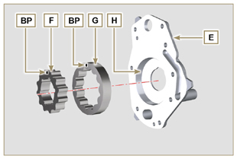  Fig 6.53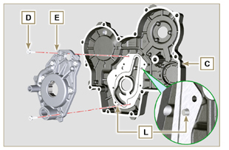  Fig 6.54
6.7.6 Timing system crankcase assembly  Important  - Always replace the oil seal J after each assembly.  - Always replace the gasket P after each assembly.  - Lubricate the lip of the oil seal J .  - Apply a coating of Loctite 5188 around 1mm thick on the surfaces K of the crankcase C .  - Make sure that the key M (Fig. 6.56) is inserted properly on the crankshaft and that it is facing upwards.  - Check that the 2 pins N are inserted properly in the timing system crankcase C . | 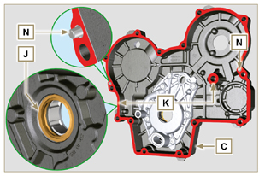  Fig 6.55
- Lubricate and insert the gasket P in the seat of the oil pump Q .  - Tighten the tool ST_10 on the crankshaft.  - Position the crankcase C on the base, using the reference pins N , inserting the oil pump Q on the crankshaft. | 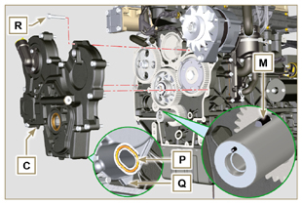  Fig 6.56
- Fit the timing system crankcase C with the screws R observing the indicated clamping sequence (tightening torque at 25 Nm ). | 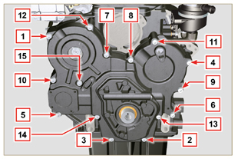  Fig 6.57
- Assemble sensor S by means of capscrew T on carter C inserting gasket U (tightening torque at 10 Nm ST_06 ). | 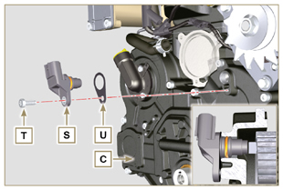  Fig 6.58
6.7.7 Crankshaft and target wheel pulley assembly  - Leave the tool ST_34 mounted ( Fig. 6.44 ) .  - Check that the pin A is mounted properly on the crankshaft Z .  - Position the pulley unit W on the crankshaft Z respecting the reference with the pin A .  - Apply Molyslip grease on the screw thread Y .  - Clamp the pulley unit W with the screw Y (tightening torque at 360 Nm ).  - Remove the special tool ST_34 ( Fig. 6.44 ) . | 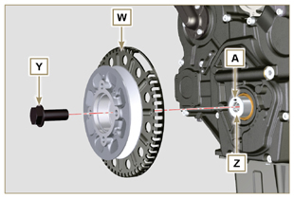  Fig 6.59
- Mount the bracket Z with the screws AA (tightening torque at 10 Nm ).  - Perform the operations described in Par. 9.12 .  - Insert the shim AB on the sensor AC .  - Clamp the sensor AC on the bracket Z with the screw AD (tightening torque at 10 Nm ).  6.7.8 Coolant pump assembly  - Perform the operations described in Par 6.5.2 . | 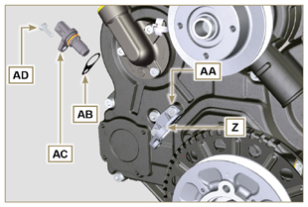  Fig 6.60

Oil pressure valve replacement
6.8.1 Disassembly  Important  - Before proceeding with operation, read Par. 3.3.2 .  - Undo cap A .  - Remove spring B , check its condition and replace it if broken.  - Remove the valve piston C using a magnet. | 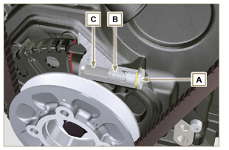  Fig 6.61
6.8.2 Assembly  - Lubricate the piston C and fully insert it in the seat E .  - Insert the spring B in the piston.  NOTE: Always replace the gasket F after each assembly.  - Mount the gasket F on cap A .  - Clamp the cap A on the crankcase D (tightening torque at 50 Nm ). | 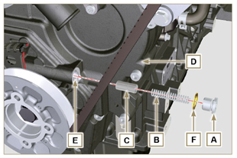  Fig 6.62

Oil vapour separator replacement
6.9.1 Disassembly  Important  - Before proceeding with operation, read Par. 3.3.2 .  - Release the clamp AA and remove the pipe D .  - Release the clamps F .  - Remove the clamp P cutting it in the point indicated and remove the separator body C removing it from the hose AG and G . | 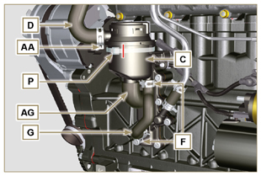  Fig 6.63
- Release the clamp F .  - Remove the pipes G and AG .  - Remove the clamp J .  - Undo the screws B .  - Release the clamp S from the sleeve K .  - Pull the flange H out of the manifold K and remove the relevant gasket, being careful not to bend the pipe E . | 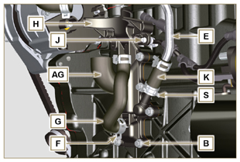  Fig 6.64
6.9.2 Assembly  Warning  - Always carefully inspect the condition of the tubes, and replace them if there is any doubt regarding their integrity.  - Always replace the gasket M after each assembly.  - Check that the contact surface L is free from impurities.  - Position flange H inserting hose K onto the flange union H , being careful not to bend tube E .  - Insert the gasket M between the flange H and the crankcase N .  - Secure the flange H using the screws B on the crankcase N (tightening torque at 10 Nm ).  - Secure the clamp S on the manifold K .  - Fit the pipes G and AG on the flange H .  - Fit the breather body C on the pipes G and D and fit the pipe G with the clamps F and the pipe D with the clamp AA .  - Fit the breather body C on the support flange H with the new clamp P . | 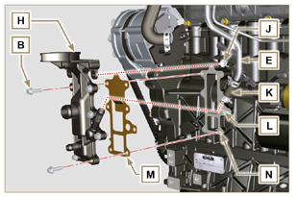  Fig 6.65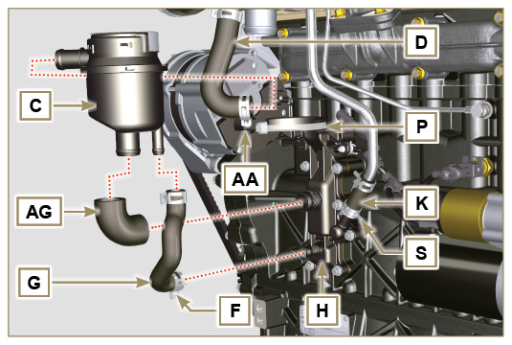  Fig 6.66

Oil cooler unit and oil filter replacement
6.10.1 Oil Cooler unit disassembly  Important  - Before proceeding with operation, read Par. 3.3.2 .  - Perform the operations described in Par 5.1 and Par 5.2 .  - Oil Cooler unit E is not repairable.  - Release the clamps A .  - Remove the pipes B out of the Oil Cooler unit E . | 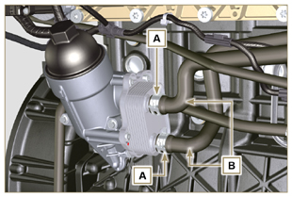  Fig 6.67
Warning  - Electric/pneumatic screwdrivers are forbidden.  - Use a suitable container to recover any residue oil.  - Unscrew cartridge holder cover H by performing three complete turns and wait 1 minute.  NOTE : this operation allows to oil contained in the support E to flow into the oil sump in the correct way.  - Unscrew cartridge holder cover H and check that the oil in the lub. oil filter support E has flowed towards the oil sump.  - Undo the screws C and D and remove the Oil Cooler unit E . | 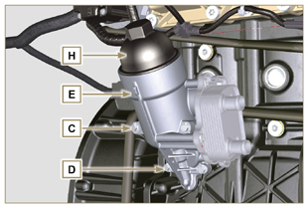  Fig 6.68
- Remove the gaskets F and G from the Oil Cooler unit E . | 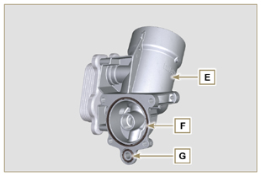  Fig 6.69
6.10.2 Oil filter cartridge replacement  - Remove gaskets L, M and N from element holder cover H .  - Remove cartridge P from element holder cover H . | 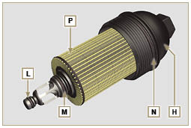  Fig 6.70
- Lubricate and insert gaskets L, M and N in the L1, M1 and N1 seats of element holder cover H .  - Insert element P into element holder cover H . | 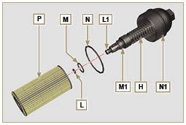  Fig 6.71
6.10.3 Oil Cooler unit assembly  Important  - In the event of assembly of union U on crankcase S , manual tightening torque with Loctite 2701 on the thread).  - Check that the surface Q on the support E and on the crankcase S are free from impurities.  - Lubricate and insert the gasket T on the fitting U .  - Lubricate and insert the gaskets on the support E :  F in seat F1 ;  G in seat G1 .  - Fit the support R with the screws C and D (tightening torque at 10 Nm ).  - Insert and tighten the cartridge support H on the filter support E (tightening torque at 25 Nm ).  - Fit the pipes B on the support E and secure the pipes B with the clamps A . | 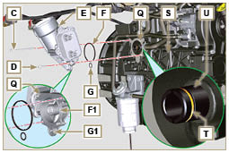  Fig 6.72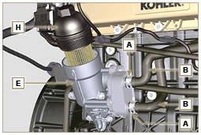  Fig 6.73

Fuel filter replacement
6.11.1 Disassembly  Important  - Before proceeding with operation, read Par. 3.3.2 .  Warning  - The fuel filter is not always mounted in the engine.  - When disassembling the sensor E , use a suitable container to recover the fuel contained in the cartridge F .  - Release the clamps A and pull the pipes B out of the support H .  - Unscrew the sensor E from the cartridge F .  - Unscrew the cartridge F from the support H .  - Undo the screws C and remove the support H . | 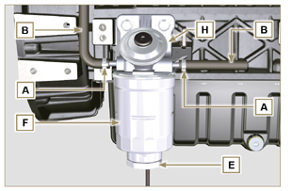  Fig 6.74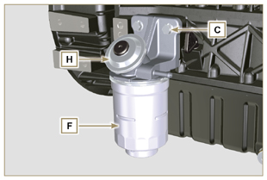  Fig 6.75
Warning  - Check that the fuel supply pump filter is present, and replace if necessary.  - Release the clamp D .  - Demount the hose E .  - Unscrew the filter G from the pump Q . | 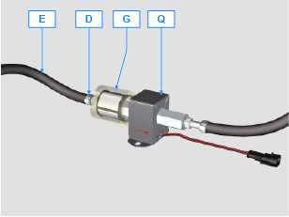
- Screw the new filter G onto the pump Q (tightening torque 20 Nm ).  - Connect the hose E to the filter G and fasten with the clamp D . | 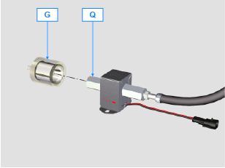
6.11.2 Assembly  - Clamp the fuel filter support H with the screws C on the crankcase M (tightening torque at 25 Nm ).  - Fit the pipes B on the support H .  - Secure the pipes B with the clamps A . | 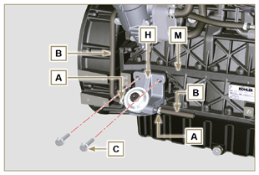  Fig 6.76
- Lubricate the gasket N with fuel.  - Tighten the cartridge F on the support H (tightening torque at 17 Nm ).  - Assemble gasket J onto sensor E and lubricate with fuel.  - Tighten the sensor E on the cartridge F (tightening torque at 5 Nm ). | 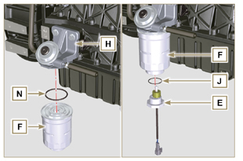  Fig 6.77

Replacement of SCV valve
Important  - Before starting any replacement operations, make sure the work area is free from dust (part X of valve B is extremely sensitive to micro-dust).  - Pay the utmost attention to cleaning in order to prevent any type of contamination during replacement operations  - - Before proceeding with the replacement, clean the outer part of pump A thoroughly - Avoid any type of contact with part X of the valve during replacement.  - Lubricate part X of valve B with oil spray.  - Before starting any replacement operations, make sure that the key on the vehicle’s panel is OFF .  - Assemble the new valve in the same position as the previous one. | 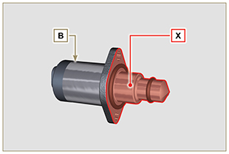  Fig. 6.78
6.12.1 Disassembly  1 - Disconnect connector C from valve B .  2 - Loosen screws D .  3 - Remove valve B from pump A . | 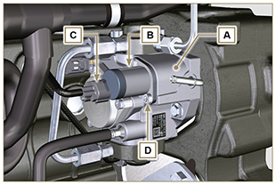  Fig. 6.79
6.12.2 Assembly  1 - Insert studs E supplied with valve B in the fastening holes of pump A and insert gasket F in the seat of pump A .  2 - Assemble valve B on pump A using studs E as positioning guides.  3 - Remove studs E and secure valve B with screws D (tightening torque of 6 Nm).  4 - Fasten valve B by means of screws D (tightening torque of 10 Nm). | 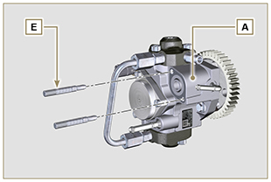  Fig. 6.80
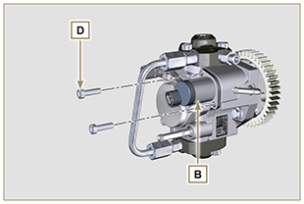  Fig. 6.81 | 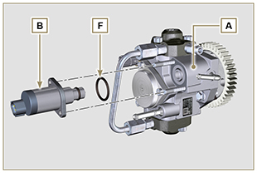  Fig. 6.82

