Information on adjustments
KDI 2504 TM Workshop manual (Rev. 07.6)

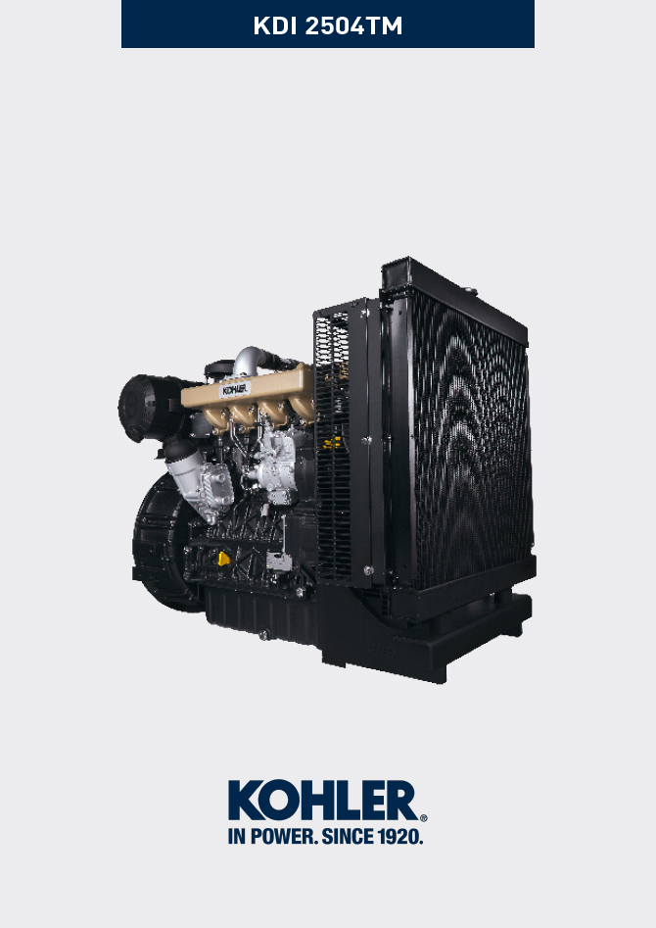

Registration of modifications to the document
Any modifications to this document must be registered by the drafting body, by completing the following table.

Released by | Code | Revision | Release Date | Revision date | Edited by | Endorsed
null | manoff

Translated from the original manual in Italian language
Data reported in this issue can be modified at any time by KOHLER.

Sommario
1. TITOLO 1 2
1.1. Asdfsdfsdf 2
1.2. Asdfsdfsdfggg 2

Information on adjustments

Air filter check

Important

- Before proceeding with operation, read Par. 3.3.2 .

- Hose A must be completely clean and not damaged.  - Air filter cartridge B and its housing C must be completely clean and free from impurities. | 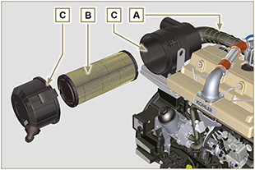  Fig 12.1

Rubber hose and manifold control
Important

- Before proceeding with operation, read Par. 3.3.2 .

The check is carried out by applying slight deflection or bending along the tube/hose and next to the hose clamps.  Components must be replaced if they have clear signs of cracks, tears, cuts, leaks, or do not retain a certain degree of elasticity.  - Check the condition of all rubber hoses A .  - Check whether there are any leakages of air, water, oil or fuel next to their connections. | 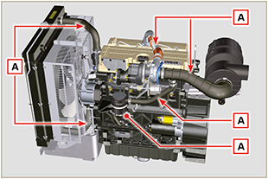  Fig 12.2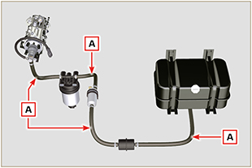  Fig 12.3

Oil leak check
Important

- Before proceeding with operation, read Par. 3.3.2 .

Check that there are no leakages next to area A .  - Start the engine at idle speed or without a load and check whether there are any leakages next to area A.  - It is anyhow necessary to also check the seals of all main components and their surface contact, such as:  - crankcase and oil seal (side 1 ª PTO) - oil sump and exhaust caps  - cylinder head and its assembled components  - rocker arm cover  - Timing system carter and oil seal (side 2 ª PTO) - oil dipstick housing or rod support tube.  NOTE: Perform the checks described in Points 1 and 2 periodically and during maintenance procedures.  It is also necessary to check for leakages on the components that are not listed.  If necessary, disassemble the components that have a leakage and investigate the possible cause.  The components must be replaced otherwise they do notguarantee their sealing. | 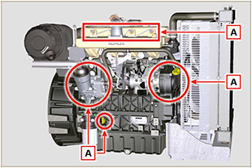  Fig 12.4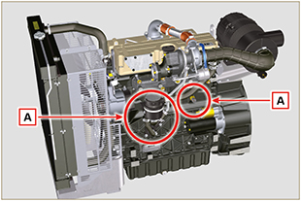  Fig 12.5

Oil pressure check
- Insert a thermocouple instead of the oil dipstick A .  - Unscrew and remove the oil pressure switch B and screw on a 10 bar pressure gauge in its seat (Fig. 12.8) .  - Start the engine at idle speed and without a load, check the oil pressure value according to the oil temperature (Fig. 12.7 ).  NOTE : The graph in Fig. 12.7 illustrates the pressure line with speed of 1000 Rpm.  - If the pressure values are below the values indicated in Fig. 12.7 , check to identify the cause of the problem.  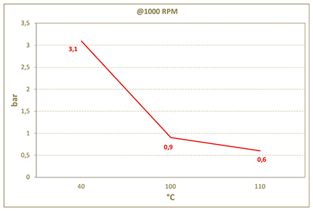  Fig. 12.7 | 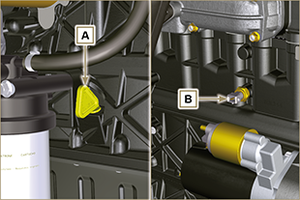  Fig. 12.6  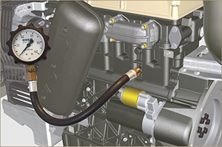  Fig. 12.8



