General Information
KDI 2504TCR / KDI 2504TCRE5 Owner Manual (Rev_20)



Registration of modifications to the document
Any modifications to this document must be registered by the drafting body, by completing the following table.

Released by | Code | Revision | Release Date | Revision date | Edited by | Endorsed
 | 2504tcr

Translated from the original manual in Italian language
Data reported in this issue can be modified at any time by KOHLER.

Sommario
1. TITOLO 1 2
1.1. Asdfsdfsdf 2
1.2. Asdfsdfsdfggg 2

General Information

Manual's Purpose
- This manual contains the instructions needed to carry out proper use and maintenance of the engine, therefore it must always be available, for future reference when required.
- This manual is an integral part of the engine, in the event of transfer or sale, it must be attached to it.
- Safety pictograms can be found on the engine and it is the operator's responsibility to keep them in a perfectly visible place and replace them when they are no longer legible.
- Information, description and pictures in this manual reflect the state of the art at the time of the marketing of engine.
- However, development on the engines is continuous. Therefore, the information within this manual is subject to change without notice and without obligation.
- KOHLER reserves the right to make, at any time, changes in the engines for technical or commercial reasons.
- These changes do not require KOHLER to intervene on the marketed production up to that time and not to consider this manual as inappropriate.
- Any additional section that KOHLER will deem necessary to supply some time after the main text shall be kept together with the manual and considered as an integral part of it.
- The information contained within this manual is the sole property of KOHLER . As such, no reproduction or replication in whole or part is allowed without the express written permission of KOHLER .

Glossary and Definitions
The paragraphs, tables and figure are divided into chapter with their progressive numbers.
Es: Par. 2.3 - chapter 2 paragraph 3.
Tab. 3.4 - chapter 3 table 4.
Fig. 5.5 - chapter 5 figure 5.

The references of the objects described in the text and in figure and number are indicated by letters, which are always and only related to the paragraph you are reading unless there are specific references to other figures or paragraphs.
NOTE: All data, measurements and relevant symbols are shown in the glossary section.

Emission-Related Installation Instructions
Failing to follow the instructions in the applications guidebook when installing a certified engine in a piece of nonroad equipment violates federal law (40 CFR 1068.105(b)), subject to fines or other penalties as described in the Clean Air Act. OEM must apply a separate label with the following statement: “ULTRA LOW SULFUR FUEL ONLY” near the fuel inlet.

Ensure you are installing an engine appropriately certified for your application. Constant speed engines may only be installed on constant speed equipment for constant speed operation.

If you install the engine in a way that makes the engine's emission control information label hard to read during normal engine maintenance, you must place a duplicate label on the equipment, as described in 40 CFR 1068.105.

Service request
- The complete and updated list of authorized Kohler Co. service centers can be found on websites:
www.kohlerengines.com & dealers.kohlerpower.it .
- If you have any questions regarding your warranty rights and responsibilities or the location of the nearest Kohler Co. authorized service location, you should contact Kohler Co. at 1-800-544-2444 or access our website at www.kohlerengines.com (USA and North American).

Engine component identification
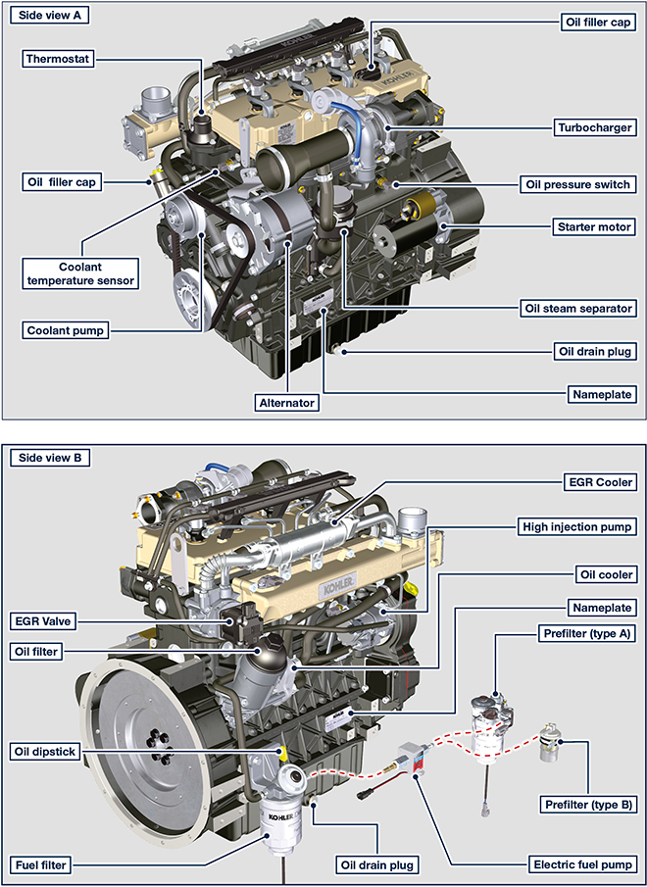

ATS (After Treatment System)

A: Turbocharger
B: Turbine exhaust pipe
NOTE: The ATS system is only present for versions that conform to "Stage V" emission regulations. The ATS system can be mounted differently than the figure. | - The ATS system reduces emissions because the DPF eliminates the particulates generated by the combustion of the diesel. The system starts automatic regeneration cycles of the DPF based on the level of clogging. The smell of the gases emitted by the exhaust line is different from that of traditional gases of diesel engines. Also, during the regeneration phases, the exhaust gases could be temporarily white.  - The minimum engine speed increases during the forced regeneration phases.  - See Par. 4.7 for the regeneration strategies of the DPF.

Manufacturer and motor identification data
The nameplate motor identification is find side A or side B .
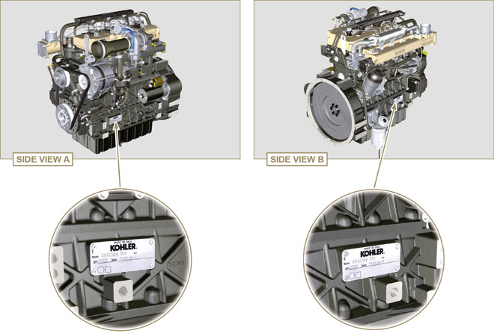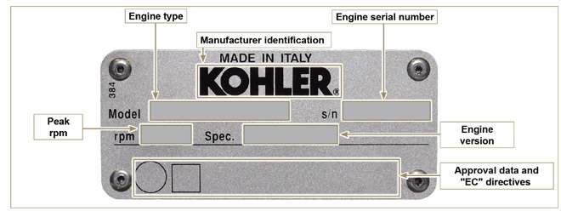

Homologation labels
Label for EPA rules (compilation example)



Tab 1.1
POS. | DESCRIPTION
1 | Model year in compliance with the rules
2 | Power category (kW)
3 | Engine displacement (L)
4 | Particulate emission limit (g/kWh)
5 | Engine family ID
6 | Emission Control System = ECS
7 | Fuel with low sulphur content
8 | Injection timing
9 | Electronic injector opening pressure (bar)
10 | Production date (example: 2013.JAN)

Label for China Standards (compilation example)


Tab 1.2
POS | DESCRIPTION
1 | Manufacturer
2 | Engine model
3 | Manufactoring date
4 | Certificate N°
5 | Power range (kW)
6 | Emission level
7 | Rated power
8 | Aftertreat system

Label for Korea Standards (compilation example)


Tab 1.3
POS | DESCRIPTION
1 | Tier 4 Final
2 | Engine model
3 | Manufactoring date and manufacturer code
4 | N° Korea emission certificate



