Information om utbyten
KDI 2504 M-MP Owner Manual (Rev.01)

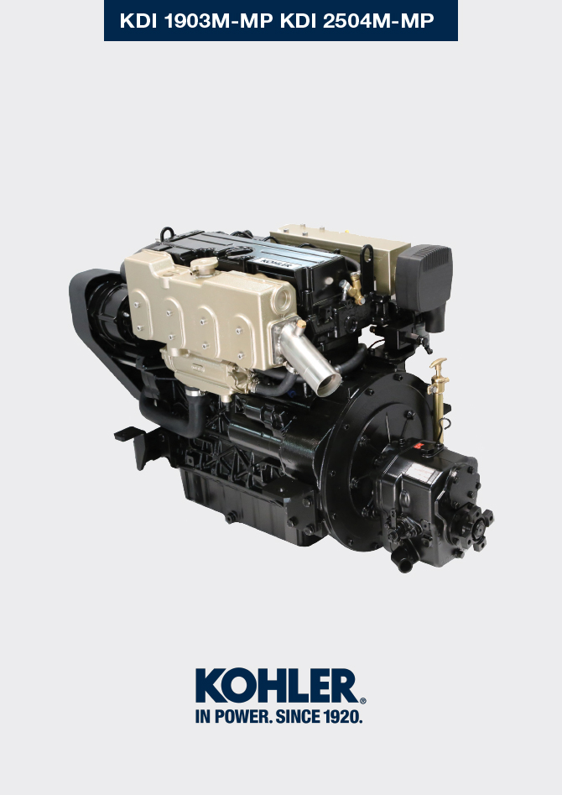

Registration of modifications to the document
Any modifications to this document must be registered by the drafting body, by completing the following table.

Released by | Code | Revision | Release Date | Revision date | Edited by | Endorsed
Technical Documentation | ED0053030860 | 05.1 | 02/2016 | 04/2023 | M. SILVESTRONE | C. TAGLIAVINI

Translated from the original manual in Italian language
Data reported in this issue can be modified at any time by KOHLER.

Sommario
1. TITOLO 1 2
1.1. Asdfsdfsdf 2
1.2. Asdfsdfsdfggg 2

Information about replacements

Engine oil replacement
  Danger  - Disconnect the negative wire (-) from the battery to avroid accidental engine stating.    Important  - Before proceeding with operation, read Par. 3.2.2  - Place engine on level sur face to ensure accurate measurement of oil level.  NOTE : Perform this operation with warm engine, to get a better fluidity of the oil and get a full discharge of oil and impurities contained in it.  - Loosen the oil filler cap A .  - Remove the oil dipstick B ( Fig. 6.3 ).  - Remove oil drain plug D from pump E .  - Start pump E and drain the oil in the engine.  - Drain oil in an appropriate container (For the exhausted oil disposal, refer to Par. 6.9 ).  - Tighten the drain oil plug D (tightening torque at 10 Nm ).  - Perform the operation described in Par. 6.2 .  - Add the type oil recommended ( Tab. 2.1 and Tab. 2.2 ).  - If the plug A is not accessible, use the oil filler cap C .  - Fit and remove the oil dipstick B to check the level. Pour in fluid until reaching the MAX level mark.  - Upon completion, reinstall the oil dipstick B completely.  - Tighten the cap A or C .  Important  - Do not exceed the MAX level on the dipstick.  - Do not use the engine with the oil level below the MIN . | 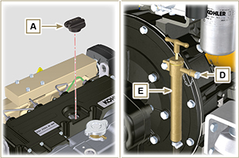  Fig. 6.1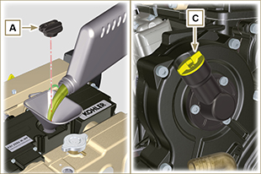  Fig. 6.2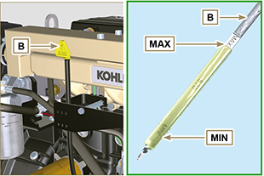  Fig. 6.3

Oil filter cartridge replacement
Important  - Before proceeding with operation, read Par. 3.2.2    Warning  - In case of low use replace it 12 months.  - For disposal of oil filter cartridge refer to Par. 6.9 .  - Unscrew the oil filter A with appropriate wrench.  - Assembly and tighten the new oil filter cartridge A tightening it with torque wrench B (torque to 15 Nm ). | 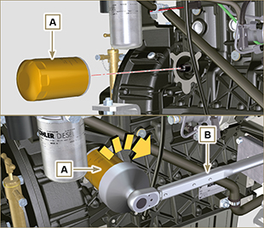  Fig 6.4

Fuel filter cartridge replacement
Important  - Before proceeding with operation, read Par. 3.2.2  Warning  - In case of low use replace it 12 months.  - For disposal of oil filter cartridge and fuel filter refer to Par. 6.9.  - Procure a suitable container to collect the fuel.  - Loosen and remove cartridge A .  - Lubricate the gasket C .  Tighten the new cartridge A onto support B (tighten manually).  Important  - Do not fill the new cartridge A with fuel.  - Turn the key on the control panel to the ON position.  The electric pump D sends fuel to the filter B and then the injection pump.  - Loosen the air bleeding screw F on fuel filter bracket B .  The air inside the circuit and the filter will begin to escape from the screw F .  - Tighten the bleeding screw F (tightening torque of 1.5 Nm ) when the fuel begins to flow. | 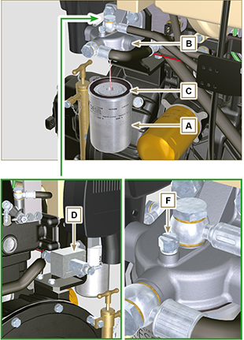  Fig 6.5

Water pump impeller replacement
Danger  - Disconnect the negative wire (-) from the battery to avroid accidental engine stating.  Important  - Before proceeding with operation, read Par. 3.2.2  - Replace gasket G.  - Loosen capscrews A and remove cover B .  - Remove impeller C from pump body D .  - Grease the new impeller C .  - Insert the new impeller C onto shaft E .  - Fasten cover B with capscrews A and washers F and insert gasket G between cover B and pump body D . | 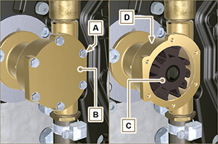  Fig. 6.6
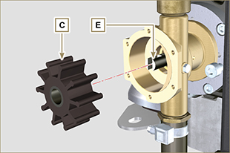  Fig. 6.7 | 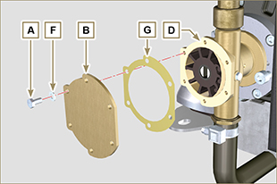  Fig. 6.8

Coolant replacement
Danger  - Disconnect the negative wire (-) from the battery to avroid accidental engine stating.  Important  - Before proceeding with operation, read Par. 3.2.2.  - Undo cap A to drain all liquid from the system contained in the engine crankcase ducts into an appropriate container ( Par. 3.5 ).  Important  - Perform the operations described in Par. 5.6 before proceeding.  - Replace gasket C .  - Screw cap A onto crankcase B , inserting gasket C (tightening torque 50 Nm ).  - Perform the operations described in Par. 4.7 . | 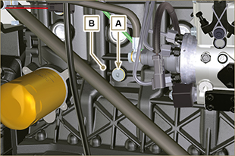  Fig. 6.9  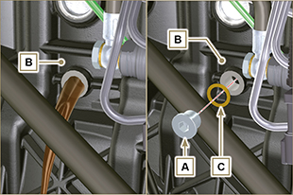  Fig. 6.10

Alternator belt replacement
Danger  - Disconnect the negative wire (-) from the battery to avroid accidental engine stating.  Important  - Before proceeding with operation, read Par. 3.2.2.  - Loosen capscrews A and remove guard B .  - Loosen hollow stud C and capscrew D .  - Remove the belt F .  - Perform the operations from point 2 to 6 of Par. 6.7 . | 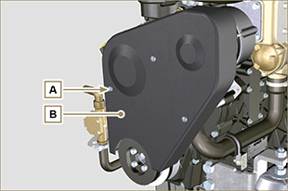  Fig. 6.11  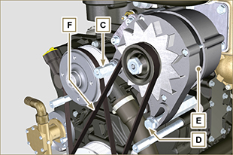  Fig. 6.12

- Insert the new belt F on pulleys G .  - Move alternator E in the direction of arrow H , tighten capscrew D followed by hollow stud C (tightening torque at 40 Nm ).  - Check the tension of belt F with a Clavis-type of instrument, positioning it in point P (the value must be 392 N ). | 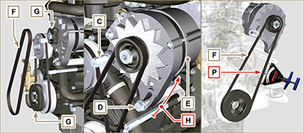  Fig. 6.13

- Secure guard B with capscrews A (tightening torque at 5 Nm ). | 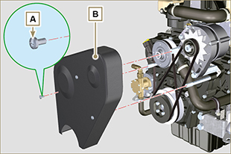  Fig. 6.14

Coolant pump belt replacement
Danger  - Disconnect the negative wire (-) from the battery to avroid accidental engine stating.  Important  - Before proceeding with operation, read Par. 3.2.2.  - Perform the operations from point 1 to 3 of Par. 6.6 .  - Remove belt A . | 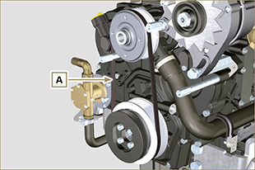  Fig. 6.15

- Insert the new belt A onto pulley G1 and start fitting pulley G2 in point B , making sure to channel the internal ribs of the belt into the ducts of pulley G2 , as shown in detail B1 .  - Start turning pulley G1 clockwise manually, keeping belt A in position, as shown in detail B1 .  - Continue turning pulley G1 until belt A is completely channelled on pulley G2 .  - Perform operations from point 4 to 7 of Par. 6.6 . | 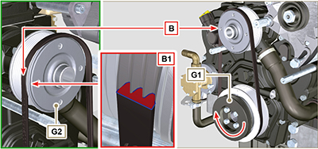  Fig. 6.16

Air cleaner replacement
Danger  - Disconnect the negative wire (-) from the battery to avroid accidental engine stating.  Important  - Before proceeding with operation, read Par. 3.2.2.  - Loosen clamp A and remove filter B from manifold A .  - Fasten the new air cleaner B onto manifold C using clamp A . | 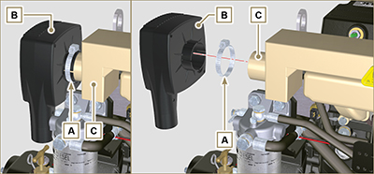  Fig. 6.17

Disposal and scrapping
- In case of scrapping, the engine shall be disposed of in appropriate locations, in conformity with the law in force.
- Before scrapping, it is necessary to separate the rubber or plastic parts from the rest of the components.
- The parts only composed of plastic material, aluminium and steel can be recycled if collected by the appropriate centers.
- Waste oil must properly be recycled and disposed of in the correct way to safeguard the environment. According to the laws in force, it is classified as hazardous waste, therefore it must be collected by the appropriate centers.



