Information about maintenance
KDI 1903TCR - TCRE5 - TC Owner manual (Rev. 21)

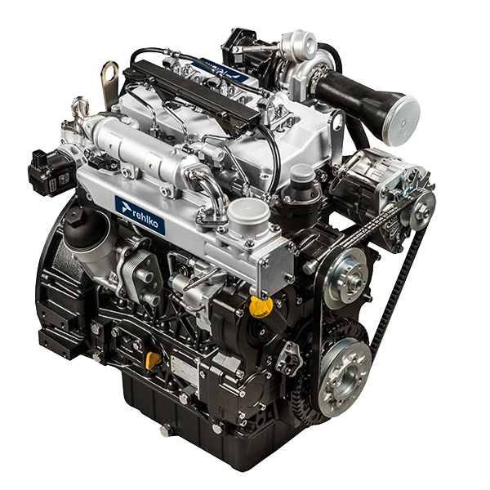

Registration of modifications to the document
Any modifications to this document must be registered by the drafting body, by completing the following table.

Released by | Code | Revision | Release Date | Revision date | Edited by | Endorsed
 | ED005302-949 | 21 | 01/2013 | 02/2026 | M.SILVESTRONE | SERVICE DEPT

Translated from the original manual in Italian language
Data reported in this issue can be modified at any time by KOHLER.

Sommario
1. TITOLO 1 2
1.1. Asdfsdfsdf 2
1.2. Asdfsdfsdfggg 2

Information about maintenance

Useful information about maintenance
- This chapter shows all operations described in the Tab. 5.1 and Tab. 5.2 . if you have the skills appropriate may be directly carried out by the user.
- Periodic inspection and maintenance operations must be carried out as indicated in this manual and are the responsability of the user.
- Failure to comply with these service and maintenance intervals increases the risk of technical damage to the engine. Any non compliance makes the warranty become null and void.
- In order to prevent personal and property damage read carefully the instructions listed below before proceeding with any operation of the engine.


Warning

- Inspections must be made when the engine is off and cold.
- Place engine on level sur face to ensure accurate measurement of oil level.
- Before starting, to avoid spillages of oil make sure that: - the oil dipstick is inserted correctly;

- also check that:

oil drain plug and

oil filler cap are tightened firmly.


Important

- Before proceeding with operation, read Par. 3.2.2 .


Danger

- For safety precautions see Chap. 3 .

Periodic maintenance
The intervals of preventive maintenance in Tab. 5.1, Tab. 5.2, Tab. 5.3 and Tab. 5.4 refer to the engine operating under normal operating conditions with fuel and oil meeting the recommended specifications.

5.1
CLEANING AND CHECKING
OPERATION DESCRIPTION | PERIOD (HOURS)
OPERATION DESCRIPTION | 100 | 250 | 500 | 5000
Engine oil level ⁽⁴⁾ ⁽⁸⁾
Coolant level ⁽⁸⁾ ⁽⁹⁾
Cartridge dry-type air filter ⁽²⁾
Radiator heat-exchange surface and Intercooler ⁽²⁾ ⁽⁸⁾
Standard alternator belt ⁽⁸⁾
Poly-V alternator belt ⁽⁸⁾
Rubber components
Starter Motor ⁽⁶⁾
Alternator ⁽⁶⁾
5.2
REPLACEMENT
OPERATION DESCRIPTION |  | PERIOD (HOURS)
 |  | 500 | 2000 | 5000
Cartridge dry-type air filter ⁽²⁾
Intake manifold hose (air filter - intake manifold) ⁽⁶⁾ ⁽⁷⁾
Coolant hoses ⁽⁶⁾ ⁽⁷⁾
Fuel line hose ⁽⁶⁾ ⁽⁷⁾
Delta-P > DPF pipes ⁽⁶⁾
Alternator belt | Standard alternator belt (trapezoidal) ⁽³⁾ ⁽⁶⁾
Alternator belt | Poly-V belt heavy environmental condition ⁽⁶⁾
Alternator belt | Poly-V belt standard condition ⁽⁶⁾
Coolant | OAT ⁽⁶⁾
Coolant | HOAT ⁽⁶⁾⁽¹⁰⁾
ATS ⁽⁶⁾ |  | ECU request (message or warning light activation) refer to the machine documentation

5.3
ENGINE OIL AND OIL FILTER CARTRIDGE REPLACEMENT
ENGINE VERSION | PERIOD (HOURS) - 6.1 - 6.2 - 6.3
ENGINE VERSION | 250 | 500
KDI TCR Tier 4 final – Stage IIIB – Stage IV- Stage V ⁽¹⁾
KDI TCR/D Tier 3 – Stage IIIA ⁽¹⁾ ⁽¹¹⁾
KDI TCR/D uncertified ⁽¹⁾

5.4
FUEL FILTER AND PREFILTER CARTRIDGE REPLACEMENT
ENGINE VERSION | PERIOD (HOURS) - 6.4
ENGINE VERSION | 250 | 500
KDI TCR Tier 4 final – Stage IIIB – Stage IV- Stage V ⁽¹⁾
KDI TCR/D Tier 3 – Stage IIIA ⁽¹⁾
KDI TCR/D uncertified ⁽¹⁾
(1) - In case of low use: 12 months.

(2) - The period of time that must elapse before checking the filter element depends on the environment in which the engine operates. The air filter must be cleaned and replaced more frequently under very dusty conditions.

(3) - In case of low use: 36 months.
(4) - The inspection must be carried out every 50 hours or every week in engines with an ATS system ( see Par. 1.6 ).
(6) - Contact authorized REHLKO workshops.
(7) - The replacement interval is only an indication, it strongly depends from environmental condition and hose status detected during regular visual inspection.
(8) - The first check must be done after 10 hours.
(9) - Test the coolant condition annually with coolant test strips.
(10) - It is recommended to have SCA (Supplemental Coolant Additives) added at the first maintenance interval.
(11) - Read Cap. 2.5, "KDI De- Contented Electronic Injection Tier 3 – Stage IIIA emission equivalent certified Engines (EGR engines)" and "KDI De- Contented Electronic Injection Uncertified Engines (no EGR engines)".

Oil level check
Important  - Before proceeding with operation, read Par. 3.2.2 .  - Do not use the engine with the oil level below the minimum.  - Change the oil and oil filter if the level exceeds the MAX.  - Do not use the engine with the level of oil over MAX.  - Loosen the oil filler cap A .  Remove the oil dipstick B and check that the level is up to MAX .  - Pour in recommended oil until reaching the MAX level mark.  - Reinstall the oil dipstick B completely..  - Re-tighten the cap A and/or C (Fig. 5.2) . | 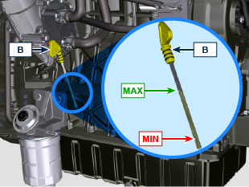  Fig. 5.1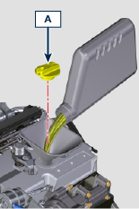  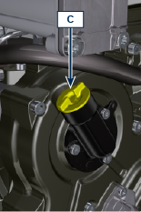  Fig. 5.2

Oil dipstick on cylinder head

Important

- Before proceeding with operation, read Par. 3.2.2 .
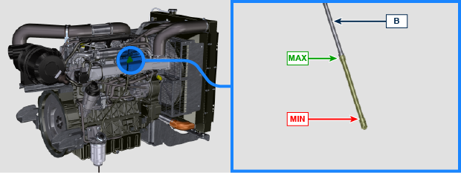
Fig 5.3 - Fig. 5.4

Air filter check
Important  - Before proceeding with operation, read Par. 3.2.2 .  - When the cartridge G is dirty, do not clean it but replace cartridges B and G.  NOTE: Components not necessarily supplied by REHLKO .  - Release the two clasps F of the cover A .  - Remove the cartridges B and G .  - Clean the inside components A and D with a damp cloth.  - Check the condition of cartridge B , replace it in case of suspecting of high level of clogging even if the hours of Tab. 5.2 are not reached.  - Reinstall:  - cartridges G and B.  - the cover A checking the right tightness of clasps F . | 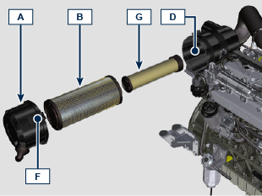  Fig 5.5

Check of the radiator heat - exchanger surface
Danger  - For safety precautions see Chap. 3 .  NOTE: Component not necessarily supplied by REHLKO .  Important  - Before proceeding with operation, read Par. 3.2.2 .  - Wear safety goggles when using compressed air.  - The radiator heat-exchange surface must be cleaned on both.  - Check the radiator heat-exchange surface D .  - Clean the surface with a brush soaked in special detergent if it is clogged. | 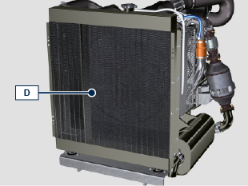  Fig 5.6

Rubber hoses check
Danger

- For safety precautions see Chap. 3 .

The check is carried out by exerting a slight deflection or bending along the pipe and near the hose clamps. Components must be replaced if they have clear signs of cracks, tears, cuts, leaks and do not retain a certain degree of elasticity.

Important

- Before proceeding with operation, read Par. 3.2.2 .
- If hoses are damaged contact an authorized REHLKO workshop.
- Check the integrity of:
- Fuel system pipes .
- Cooling circuit hoses .
- Oil circuit pipes
- Air system hoses.
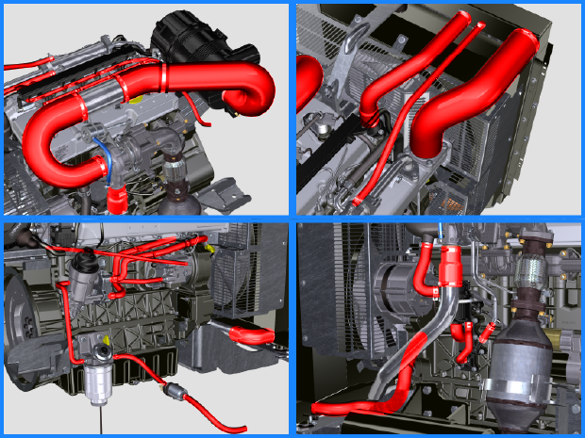
Optional for remote oil filter:
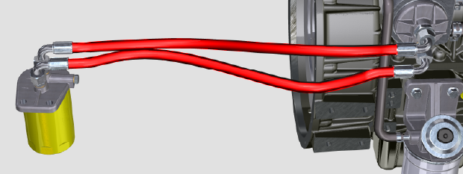

Check coolant level
Important  - Before proceeding with operation, read Par. 3.2.2 .  Danger  - For safety precautions see Chap. 3 .  NOTE : Before proceeding with any operation on the engine, stop it and allow it to cool.  Warning  - Presence of steam pressurized coolant danger of burn.  NOTE : Component not necessarily supplied by REHLKO .  - Start the engine without the radiator cap A .  - Top liquid up until the pipes inside the radiator are covered by about 5 mm.  - Top up if necessary.  - Do not overfill the radiator, but leave room for the coolant to expand.  - Reinstall radiator cap A  - For engines equipped with expansion tank (B) , check that the fluid is until reaching the max level mark  NOTE : For coolant filling see Par. 4.6 .  Warning  - Before starting make sure that the radiator cap and cap, if present, are installed correctly to avoid spillage of liquid or vapour at high temperatures. | 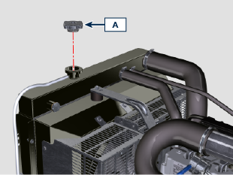  Fig 5.9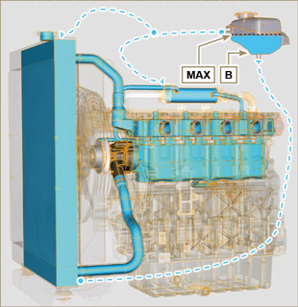  Fig 5.10

Check and setting alternator standard belt tension
Warning  - For safety precautions see Chap. 3 .  5.9.1 Check  - Check the belt A condition, if worn out or deteriorated, replace it.  - Check by the appropriate tool that at point p the tension value is between 80 and 85 Hz .  Using the tool F (DENSO BTG-2 or a similar one) shown in the picture, it is possible to check the corresponding value in Newtons, which should be between 350 and 450 N.  Should the correct tool not be available, the belt tension can be checked by applying a force in the direction of arrow G of approx' 10kg on the point p. When correctly tensioned the belt must show a movement of less than 10 mm. If not adjust it.  5.9.2 Adjustment  - Loosen the fastening bolts B e C .  - Pull the alternator D outwards to tension the belt A .  - Tension the belt A , screw the bolts B , C .  - Tighten bolts B (tightening torque of 25 Nm ) and C (tightening torque at 69 Nm [thread M10] - 40 Nm [thread M8] ) in sequence with a torque wrench E .  - Check by the appropriate tool that at point p the tension value is between 80 and 85 Hz .  Using the tool F (DENSO BTG-2 or a similar one) shown in the picture, it is possible to check the corresponding value in Newtons, which should be between 350 and N.450.  Should the correct tool not be available, the belt tension can be checked by applying a force in the direction of arrow G of approx' 10kg on the point p. When correctly tensioned the belt must show a movement of less than 10mm.  Let the engine run for some minutes, then let it cool down at ambient temperature and repeat the operations 2, 3, 4 and 5 in case the belt tension results out of the above mentioned values.  NOTE: Contact REHLKO authorised workshops for replacement. | 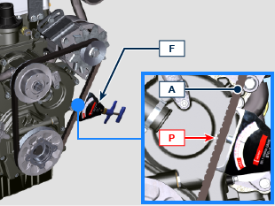  Fig 5.11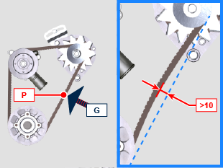  Fig 5.12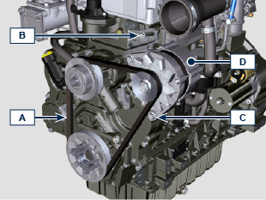  Fig 5.13

Check Poly-V alternator belt
Important  - Before proceeding with operation, read Par. 3.2.2 .  Danger  - For safety precautions see Chap. 3 .  NOTE : The poly-v belt is not adjustable.  - Check the belt A condition, if worn out or deteriorated, replace it.  NOTE : Make sure that the ribs of the belt A are inserted correctly into the grooves of the pulleys B (as shown in Fig. 5.14 and Fig. 5.15 ).  - Start the engine and run it for some minutes ( 15min ), then turn off it, and let it cool down at ambient temperature.  Check by the appropriate tool that at point P .  NOTE: For belt ED0024405540-S the value is between 109 and 170 Hz .  NOTE: For belt ED0024405560-S the value is between 126 and 180 Hz .  NOTE : If the poly-v belt tension results out of the above mentioned values contact REHLKO authorised workshops for replacement. | 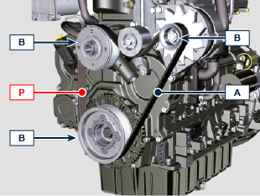  Fig 5.14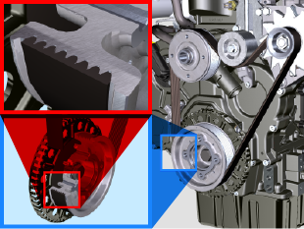  Fig 5.15

Filter cartridge and fuel pre-filter check
Important  - Before proceeding with operation, read Par. 3.2.2 .  Warning  - For safety precautions see Chap. 3 .  When turn on lights on control water filter cartridge fuel:  - Gently loosen the wing screw A without removing it.  - Drain the water if present.  - Re-tighten the wing screw A as soon as the fuel begins to flow. | 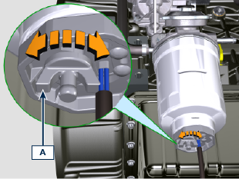  Fig 5.16

Product preservation

Important

- If the engines are not to be used for 6 months, they must be protected by carrying out the operations described in Engine storage (up to 6 months) ( Par. 5.13 ) .
- If the engine is still not in use after the first 6 months, it is necessary to carry out a further operation to extend the protection period (more than 6 months) ( Par. 5.14 ) .
- If the engine is not to be used for an extended period, the protective treatment procedure must be repeated within 24 months of the previous one.

Engine storage up to 6 months
Before storing the engine check that:
- The environments are not humid or exposed to bad weather. Cover the engine with a proper protective sheet against dampness and atmospheric contaminants.
- The place is not near electric panel.
- Avoid storing the engine in direct contact with the ground.

Engine storage over 6 months
Follow the steps described in Par. 5.13 .
- Engine oil replacement ( Par. 6.1 ) .
- Refuel with fuel additives for long storage.
- With expansion tank:
make sure that the coolant is up to the maximum level.
- Without expansion tank: Top liquid up until the pipes inside the radiator are covered by about 5 mm.

Do not overfill the radiator, but leave room for the fuel to expand.
- Start the engine and keep it idle at minimum speed for 2 minutes.
- Bring the engine to 3/4 of the maximum speed for 5÷10 minutes.
- Turn off the engine.
- Completely empty the fuel tank.
- Spray SAE 10W-40 on the exhaust and intake manifolds.
- Seal the exhaust and intake ducts to prevent foreign bodies from entering.
- When cleaning the engine, if using a pressure washer or steam cleaning device, avoid directing the nozzle on electrical components, cable connections and sealed rings (oil seals etc).
If cleaning engine with a pressure washer or steam cleaner, it is important to maintain a minimum distance of at least 200mm between the surface to be washed and the nozzle - avoiding absolutely electrical components such as alternators, starter motors and engine control units (ECU).
- Treat non-painted parts with protective products.

If the engine protection is performed according to the suggestions indicated no corrosion damage should occur.

Engine starting after storage
- Remove the protective sheet.
- Use a cloth soaked in degreasing product to remove the protective treatment from the external parts.
- Inject lubricating oil (no more than 2 cm ³ ) into the intake ducts.
- Refill the tank with fresh fuel.
- Make sure that the oil and the coolant are up to the maximum level.
- Start the engine and keep it idle at minimum speed for a two about minutes.
- Bring the engine to 75% of maximum rated speed for 5 to 10 minutes.
- Stop the engine while the oil is still hot ( Par. 6.1 ) , discharge the protective oil in a suitable container.

Warning

  - Over time, lubricants and filters lose their properties, so it is important consider whether they need replacing, also based on the criteria described in Par. 5.2 .

- Replace the filters (air, oil, fuel) with original spare parts.
- Pour new oil ( Par. 4.5 ) up to the maximum level .
- Empty the cooling circuit completely and pour in the new coolant up to the maximum level ( Par. 4.6 ) .

Unused machine
If the machine is not used for a certain amount of time, follow the operations below:

5.16.1 Operations for the engine
POINT | OPERATION
1 | Unused machine up to 2 months | - The place must be dry and fresh throughout the period in which the machine is not used.  - Consult the machine’s manual to disconnect the battery (before disconnecting the battery, wait for minimum 5 mins after turning off the engine).  - Make sure the engine is not exposed to direct sunlight.  - Make sure the engine is not near any heat sources.
1 | Starting | - Before starting the engine, check Par. 5.2 for maintenance operations.  - Consult the machine’s manual to connect the battery and start the engine.
2 | Unused machine from 2 to 9 months | - Perform the operations related to unused machine described in point 1.  - Perform the operations described in Par. 5.6.  - Start the engine at least every 4 months as per operations described in point 1: Avoid sudden accelerations for the first few minutes.  Bring the engine to the working temperature by pressing the accelerator 3/4 from MAX.  Leave the engine running at minimum speed for a few minutes and turning off the engine.
2 | Starting | - Before starting the engine, check Par. 5.2 for maintenance operations.  - Consult the machine’s manual to connect the battery and start the engine.  - Avoid sudden accelerations for the first few minutes.
3 | Unused machine over 9 months | - Perform the operations related to unused machine described in point 1 and 2.
3 | Starting | - Before starting the engine, check Par. 5.2 for maintenance operations.  - Check the quality of coolant from the relative testing strips.  - Consult the machine’s manual to connect the battery and start the engine.  - Avoid sudden accelerations for the first few minutes.



