Technical information
KDI 3404 TCR-SCR Workshop Manual (Rev. 10.4)

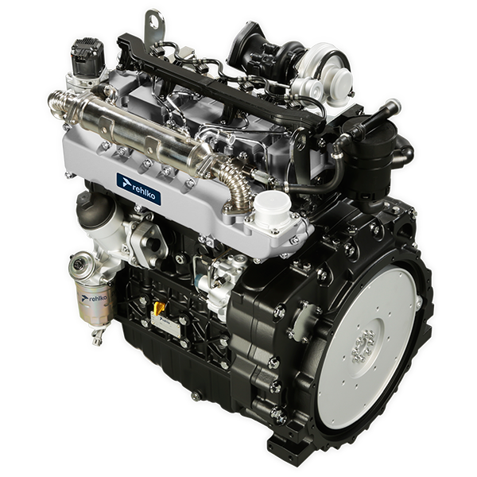

Registration of modifications to the document
Any modifications to this document must be registered by the drafting body, by completing the following table.

Released by | Code | Revision | Release Date | Revision date | Edited by | Endorsed
 | manoff

Translated from the original manual in Italian language
Data reported in this issue can be modified at any time by KOHLER.

Sommario
1. TITOLO 1 2
1.1. Asdfsdfsdf 2
1.2. Asdfsdfsdfggg 2

Technical information

Engine specifications
Tab. 2.1
MANUFACTURER SPECIFICATIONS AND OPERATION
GENERAL INFORMATION | UNIT OF MEASURE | KDI 3404 TCR / KDI 3404 TCR-SCR
Operating cycle |  | diesel - 4 stroke
Cylinders | N° | 4
Bore x stroke | mm | 88x102
Displacement | cm ³ | 3359
Compression ratio |  | 17:1
Intake |  | Supercharged with Turbocharger
Cooling |  | Liquid
Crankshaft rotation (view from flywheel side) |  | Counterclockwise
Combustion sequence |  | 1-3-4-2
Timing System
Valves per cylinder | N° | 4
Timing System |  | Rods and rocker arms - Camshaft in the crankcase
Tappets |  | Hydraulic
Injection |  | Direct - Common Rail
Engine dry weight | Kg | 394
MAX inclination 30' continuous operation | (min./α) | 40°
MAX inclination 1' continuous operation | (min./α) | 45°
POWER AND TORQUE
GENERAL INFORMATION | UNIT OF MEASURE | KDI 3404 TCR / KDI 3404 TCR-SCR
MAX operating speed | Rpm | 2400
MAX operating power (ISO TR 14396 - SAE J1995 - CE 97/68) | kW | 100
Maximum torque (at 1500 rpm) | Nm | 500
Admissible axial load on crankshaft | Kg
CONSUMPTIONS
GENERAL INFORMATION | UNIT OF MEASURE | KDI 3404 TCR / KDI 3404 TCR-SCR
Specific fuel consumption (best point) | g/kWh | 210
Oil consumption | %Fuel | < 0.1
FUEL SUPPLY SYSTEM
GENERAL INFORMATION | UNIT OF MEASURE | KDI 3404 TCR / KDI 3404 TCR-SCR
Type of fuel |  | Diesel UNI-EN590 - ASTM D975
High-pressure fuel injection pump |  | DENSO HP3
Fuel supply |  | Low pressure electric pump (if necessary)
Fuel filter
Filtering surface | cm ² | 2300
Degree of filtration | µm | 5
Maximum pressure at injection pump inlet | bar | 0,2
LUBRICATION CIRCUIT
GENERAL INFORMATION | UNIT OF MEASURE | KDI 3404 TCR / KDI 3404 TCR-SCR
Lubrication
Recommended oil |  | See Par. 2.4
Circuit forced |  | Lobe pump
Oil sump capacity ( MAX ) | Lt. | 15,6
Oil pressure switch
Intervention pressure ( MIN ) | bar | 0.6±0.1
Oil filter

Maximum operating pressure | bar | 4.0
Degree of filtration | µm | 17±2
Filtering surface | cm ² | 1744
COOLING CIRCUIT
GENERAL INFORMATION | UNIT OF MEASURE | KDI 3404 TCR / KDI 3404 TCR-SCR
Coolant | % | See Par. 2.6
Coolant pump | Lt./min | 155
Thermostatic valve
Opening temperature | °C | +83 (0/-3)
Stroke at 95°C | mm | 7.50
Liquid recirculation | Lt./h
ELECTRICAL SYSTEM - ELECTRIC FAN
GENERAL INFORMATION | UNIT OF MEASURE | KDI 3404 TCR / KDI 3404 TCR-SCR
Circuit rated voltage | V | 12
External alternator (rated current) | A | 90
Starter motor power | kW | 2
System electrical consumption, excluding:  heater, electric pump, electric fan, starter motor | W
Coolant temperature indicator light
Indicator light operating temperature | °C | +100/+110

Engine dimensions (mm)
NOTE : Dimensions vary according to engine configuration.

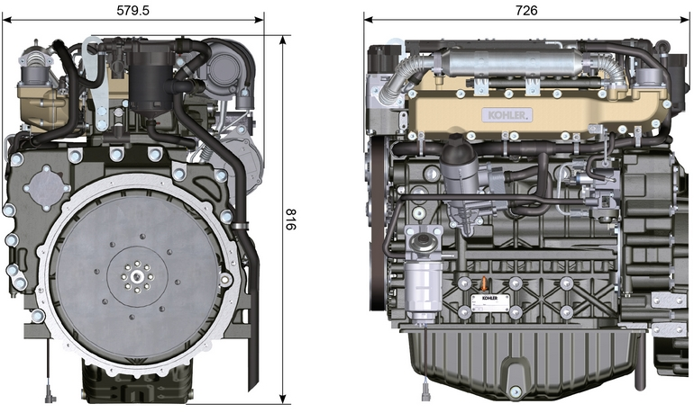
Fig. 2.1 - Fig. 2.2

Performance
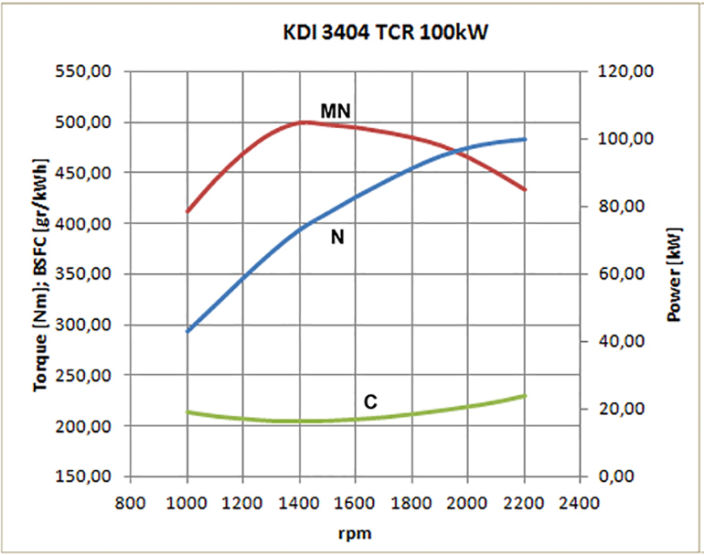

Fig. 2.3
N = Automotive rating curve
MN = Torque curve
C = Specific fuel consumption curve

NOTE: Refer to KOHLER for power curves, torque curves and specific consumptions at speeds other than those given above.

Key

- N ( ISO TR 14396 - SAE J1995 - CE 97/68 ) AUTOMOTIVE RATING CURVE : Intermittent duty at variable speed and load. Engine capacity at intermittent conditions with variable speed and load.

- MN: = TORQUE RATING CURVE : Also called twisting moment, it is the push generated by the engine through transmission. The highest engine performance is obtained at the maximum torque.

- C = SPECIFIC CONSUMPTION CURVE : Engine fuel consumption in a given time at a certain revolution value. Expressed in g/kW (grams/kilowatt), it expresses fuel yield.

* The above curves express indicative values, in that the overall performance depends on the type of application and the ECU control uni.

- The ratings reported in the diagram regard the run-in engine, fitted with air and exhaust filters, at the atmospheric pressure of 1 Bar and at a room temperature of +20°C
- Maximum rating is guaranteed with a 5% tolerance.


Warning

- Non approval by KOHLER for any modification releases the company from liability for damage incurred on the engine.

Oil


Important

- The engine may be damaged if operated with improper oil level.
- Do not exceed the MAX level because a sudden increase in engine rpm could be caused by its combustion.
- Use only the recommended oil to ensure adequate protection, efficiency and service life of the engine.
- The use of lubricants other than recommended may shorten the engine life.
- Viscosity must be appropriate to the ambient temperature to which the engine is to be exposed.


Danger

- Prolonged skin contact with the exhausted engine oil can cause cancer of the skin.
- If contact with oil cannot be avoided, thoroughly wash your hands with soap and water as soon as possible.
- For the exhausted oil disposal, refer to the Par. DISPOSAL and SCRAPPING .
2.4.1 SAE oil classification
- In the SAE classification, oils are identified according to viscosity without considering any other qualitative characteristic.
- The code is composed of two numbers, which indicate, and must correspond to, the ambient temperature in which the engine operates, the first number refers to the viscosity when cold, for use during winter (" W "), while the second number is for viscosity at high temperatures.

Use oil viscosity based on the experienced air temperature range during the period between oil changes as indicated
in the table below.
Kohler / Rehlko X-treme 10W-40 formula pro; X-treme 10W-40; X-treme 5W-40 oil are preferred:

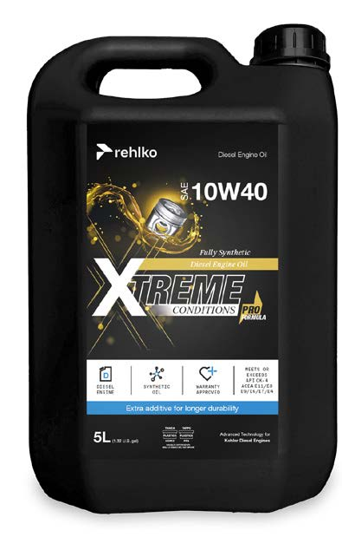 | 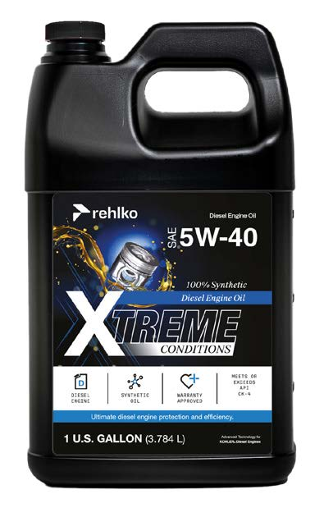 | 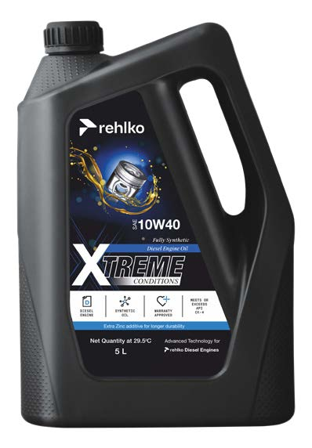

Oils meeting the following specifications are also recommended.

2.2
RECCOMENDED OIL
 |  | TCR STAGE-V (*1) (*2) | TCR TIER IV FINAL (*1) | TCR/D TIER III o NON CERTIFICATO (*3)
WITH SPECIFICATIONS | API | CJ-4 Low S.A.P.S  CK-4 Low S.A.P.S | CJ-4 Low S.A.P.S  CK-4 Low S.A.P.S | CI-4 Plus  CI-4  CH-4
WITH SPECIFICATIONS | ACEA | E6 Low S.A.P.S. | E6 Low S.A.P.S. | E7  E4
VISCOSITY | SAE | 0w-40 (-40°C ÷ +50°C)  5w-40 (-30°C ÷ +50°C)  10w-40 (-25°C ÷ +50°C) | 0w-40 (-40°C ÷ +50°C)  5w-40 (-30°C ÷ +50°C)  10w-40 (-25°C ÷ +50°C) | 0w-40 (-40°C ÷ +50°C)  5w-40 (-30°C ÷ +50°C)  10w-40 (-25°C ÷ +50°C)

- Low S.A.P.S. technology (oil with low Sulfated Ash, Phosphorus, Sulfur content) keeps catalyst in good working conditions. The presence of sulfated ash, phosphorus and sulfur causes with time the catalyst clogging and its consequent inefficiency.
- For Mid S.A.P.S oil sequence the sulfated ash level is the same as API CJ-4 ≤ 1.0% but as per ACEA standardization those oils are referenced as mid SAPS.
- Filtration of oils is critical to proper operation and lubrication; always change filters regularly as specified in this manual.

(*1) NOTE : Do NOT use fuel with sulphur content above 15ppm.

(*2) - On all engines compliant with Stage-V emission regulation (engines with DPF device), the oil to use must comply with the specification API CJ-4 Low S.A.P.S or ACEA E6 Low S.A.P.S.

(*3) - NOTE : Do NOT use fuel with sulphur content above 500ppm.

(*3) - NOTE : Low S.A.P.S. oils, sulfate ashes <1% may not be used with fuels with a sulfur content >50ppm.

Fuel
  Important  - Use of other types of fuel could damage the engine. Do not use dirty diesel fuel or mixtures of diesel fuel and water since this will cause serious engine faults. |   Warning  - Clean fuel prevents the fuel injectors from clogging. Immediately clean up any spillage during refuelling.  - Never store diesel fuel in galvanized containers (i.e. coated with zinc). Diesel fuel and the galvanized coating react chemically to each other, producing flaking that quickly clogs filters or causes fuel pump and/or injector failure.  - Any failure resulting from the use of fuel other than Tab. 2.3, 2.4 will not be covered by warranty.
Cetane number of 40 minimum. Cetane number greater than 47 is preferred, especially for temperatures below –20 °C (–4 °F) or elevations above 1675 m (5500 ft.).

Highly Regulated Engines (EU, USA, CANADA, JAPAN, CHINA, INDIA)
- EU EN 590
- North America ASTM D975 No. 2-D S15; No. 1-D S15
- Japan JIS K 2204 No. 1; No. 2
- India BS-V ULSD; BS-VI ULSD
- China GB 19147-2016 ULSD; GB 17691—2018 ULSD
- HVO EN 15940 or ASTM D975
- Military NATO fuel F-54 S < 10ppm

Less or Not Regulated Engines (Rest of the World and Military applications)
- Equivalent to all above specification
- Equivalent to all above specification but with Suplhur < 500ppm
- Equivalent to all above specification but with Suplhur < 2000ppm
- F-34/F-35 (kerosene NATO designation) (1)
- F-44 (kerosene, NATO designation) (1)
- F-63 (kerosene, NATO designation, equivalent to F-34/F-35 with additives (1)
- JP-8 (kerosene, US military designation) (1)
- JP-5 (kerosene, US military designation) (1)
- Jet A / A1 (kerosene for civil aviation) (1)

(1) - Operations with Jet Fuels: The jet fuels can be used but only adopting an additional fuel filter with lubricity doser. Because of lower density and greater leak fuel volume due to lower viscosity, depending on the engine speed and torque, a power loss up to 10% is possible. There are some problematical fuel proprieties amongst the listed jet fuels (viscosity, lubricating capacities and low boiling point). A slight increase in wear in the injection system is to be expected which can lead to a statistically shorter life of these components. Sulphur content must be below 2000ppm.

2.5.1 Fuel Additives
To aid in maintaining performance of the engines injection system, Rehlko has developed a family of fuel additives product for North America market.

The Extra Performance Fuel Additive Arctic Formula a fuel conditioner in winter, the Extra Performance Fuel Additive a fuel injector deposit removal and prevention. See your local Rehlko dealer for availability.

2.3
Rehlko Extra Performance Fuel Additive  (North America only) | 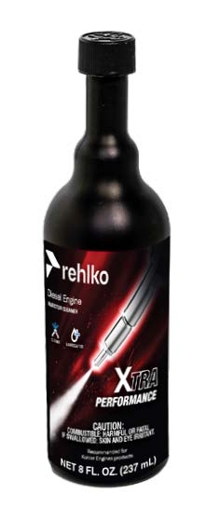
Use Rehlko Injector Cleaner Diesel Fuel Additive before filling the tank once a year or every 500hrs with summer or winter grade fuel. Formulated to clean deposits from injectors and provide lubrication to high pressure pump and injectors to reduce wear, increasing fuel quality. Compatible with all exhaust emission system, including diesel particulate filters (DPFs). Follow all recommended instruction on product label.
Rehlko Extra Performance Fuel Additive Arctic Formula  (North America only) | 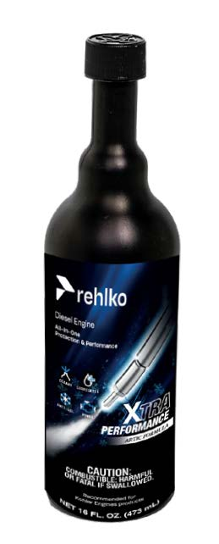
Use Rehlko Extra Performance Fuel Additive Arctic Formula, which contains anti-gel chemistry to treat non-winter grad fuel (No. 2-D in North America) during the cold-weather season. This extends the operability to about 10°C (18°F) below the could point. For operability at even lower temperatures, use winter grade fuel. Treat the fuel when the outside temperature drops below 0°C (32°F). For best results, use untreated fuel and follow all recommended instruction on product label.
Cloud point is the temperature at which wax begins to from in the fuel causing filters to plug.
Fuel additives with biocide/algaecide functions are allowed in case of storage of fuel in the tank for long periods (one year or more). | For suggested brands and types contact Rehlko staff
NOTE: These additives must be diluted in the fuel following the product prescribed percentages when filling the tank. | For suggested brands and types contact Rehlko staff

Coolant recommendation
Rehlko XtendedTM prediluted coolant 50% ethylene glycol OAT is preferred.

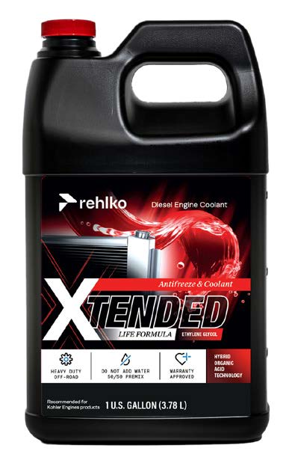

Coolant meeting the following specifications are also recommended.

A mixture of 50% demineralized water and 50% low silicate ethylene glycol based coolant liquid must be used. Use a Long Life or Extended Life Heavy Duty OAT coolant free of: silicates, phosphates, borates, nitrites and amines.

The following ethylene-glycol based engine coolant for all models within KSD engine family may be used:

- OAT (Organic Acid Technology) Low Silicate: ASTM D-3306 D-6210
- HOAT (Hybrid Organic Acid Technology) Low Silicate: ASTM D-3306 D-6210

The above coolants in concentrated formulation must be mixed with distilled, deionized, or demineralized water. A pre-mixed formulation (40-60% or 50-50%) can be used directly when available.

Important
- Do not mix ethylene glycol and propylene glycol based coolants. Do not mix OAT and HOAT based coolant. OAT performance life can be drastically reduced if contaminated with nitrite-containing coolants.
- Never use automotive-type coolants. These coolants do not contain the correct additives to protect heavy – duty diesel engines.

OAT coolants are maintenance free up to 5 years or 4000hrs of operation , provided that the cooling system is topped up using the same type of coolant. Do not mix different coolant types. Test the coolant condition annually with coolant test strips.
HOAT are not all maintenance free and it is recommended to have SCA (Supplemental Coolant Additives) added at the first maintenance interval.

Battery recommendation
Battery not supplied by Kohler

2.6
RECOMMENDED BATTERIES
AMBIENT TEMPERATURE | STARTER MOTOR | OIL | BATTERY TYPE | MACHINE CONDITION
≥ - 25°C | 3.2kW + HEATER | 10W-40  5W-40 | 880CCA SAE (=1000 A (EN)) | light hydraulic parasitic loads or mechanical clutch and gearbox
≥ - 25°C | 4.2kW + HEATER | 10W-40  5W-40 | 1000CCA SAE =(1250 A (EN)) | heavy hydraulic parasitic loads

Periodic maintenance
The intervals of preventive maintenance in Tab. 2.7, Tab. 2.8, Tab. 2.9 and Tab. 2.10 refer to the engine operating under normal operating conditions with fuel and oil meeting the recommended specifications.

2.7
CLEANING AND CHECKING
OPERATION DESCRIPTION | PERIOD (HOURS)
OPERATION DESCRIPTION | 100 | 250 | 500 | 5000
Engine oil level ⁽⁸⁾
Coolant level ⁽⁸⁾⁽⁹⁾
Cartridge dry-type air filter ⁽²⁾
Radiator heat-exchange surface and Intercooler ⁽²⁾
Rubber components
Starter Motor

Alternator

2.8
REPLACEMENT
OPERATION DESCRIPTION |  | PERIOD (HOURS)
 |  | 500 | 2000 | 5000
Cartridge dry-type air filter ⁽²⁾
Intake manifold hose (air filter - intake manifold) ⁽⁷⁾
Coolant hoses ⁽⁷⁾
Fuel line hose ⁽⁷⁾
Delta-P > DPF pipes
DEF filter cartridge (1)
Alternator belt | Poly-V belt heavy environmental condition
Alternator belt | Poly-V belt standard condition
Coolant | OAT
Coolant | HOAT ⁽¹⁰⁾

2.9
ENGINE OIL AND OIL FILTER CARTRIDGE REPLACEMENT
ENGINE VERSION | PERIOD (HOURS)
ENGINE VERSION | 250 | 500
KDI TCR Tier 4 final – Stage IIIB – Stage IV- Stage V ⁽¹⁾
KDI TCR/D Tier 3 – Stage IIIA ⁽¹⁾ ⁽¹¹⁾

2.10
FUEL FILTER AND PREFILTER CARTRIDGE REPLACEMENT
ENGINE VERSION | PERIOD (HOURS)
ENGINE VERSION | 250 | 500
KDI TCR Tier 4 final – Stage IIIB – Stage IV- Stage V ⁽¹⁾
KDI TCR/D Tier 3 – Stage IIIA ⁽¹⁾
(1) - In case of low use: 12 months.

(2) - The period of time that must elapse before checking the filter element depends on the environment in which the engine operates. The air filter must be cleaned and replaced more frequently under very dusty conditions.
(7) - The replacement interval is only an indication, it strongly depends from environmental condition and hose status detected during regular visual inspection.
(8) - The first check must be done after 10 hours.
(9) - Test the coolant condition annually with coolant test strips.
(10) - It is recommended to have SCA (Supplemental Coolant Additives) added at the first maintenance interval.
(11) -Read Cap. 2.5 "KDI Electronic Injection Tier 3 – Stage IIIA emission equivalent certified Engines (EGR engines)".

Fuel system
2.9.1 Injection circuit (pressure 2000 bar) (Fig 2.4)
The materials of the fuel system components (pipes, tank, filters, etc.) and any surface treatments must be free from chemical elements that, transported in the fuel, compromise the operation of the injectors over time (hole clogging).

The most critical chemical element is Zinc (Zn), therefore it is forbidden to use galvanised components.

Other damaging elements are indicated in the table below.
Tab 2.11
POLLUTANTS | LIMIT VALUES OF PRESENCE IN FUEL | LIMIT VALUE
Zn (Zinc) | - Zinc (Zn) is eluted from the rubber (NBR) in the fuel line. Thus, the growing carboxylate (Zn) was adhered on the parts in the injection system for reacting carboxylic acid in the fuel.  - In case that the changed injection quantity, nozzle coking occurs the fuel contents Zn≥1ppm.  - Zinc (Zn) is ≤ 0.3ppm is the limited value to avoid occur coking. | Zn ≤ 0.3ppm
Pb (Lead) | - Lead (Pb)is eluted from Pd coading in the fuel tank. Thus, the growing carboxylate (Pd) was adhered on the injection system for reacting carboxylic acid in the fuel.  - In case that the changed injection quantity and nozzle coking occurs the fuel contents Pd.  - As interim, the identical level is the limited value with Zn. | Pd ≤ 0.3ppm
Na (Sodium) | - The growing carboxylate (Na) was adhered on the parts in the injection system for reacting carboxylic acid in the fuel with fuel contents Na ≥ 0.5ppm. Thus, sliding malfunction was occurred.  - In case that the changed injection quantity and nozzle coking occurs the fuel contents Na.  - Especially concerns of occurring defects, NaOH is residue for using production process of bio fuel.  - ≤ 0.3ppm is the limited value to avoid occur nozzle coking and carboxylate. Combine K with Na equivalent alkali metal that are less than 0.3ppm. | Na + K ≤ 0.3ppm
K (Potassium) |  | Na + K ≤ 0.3ppm
Ca (Calcium) | - In case that carboxylate (Ca) was adhered the injection system inside.  - Under study on the results in the moment.  - Maximum value is 0.3ppm when using fuel that is B100 fuel with regulation EN14214 of contents 7%. | Ca + Mg ≤ 0.3ppm
Mg (Magnesium) |  | Ca + Mg ≤ 0.3ppm
Cu (Copper) | - Copper (Cu) on the fuel that can be acted wear and catalyst for making decline.  - In case that the changed injector quantity and nozzle coking occurs in the fuel contents Cu.  - As interim, the identical level is the limited value with Zn. | Cu ≤ 0.3ppm
Ba (Barium) | - In case that changed injection quantity and nozzle coking occurs in the fuel contents Barium (Ba).  - As interim, the identical level is the limited value with Zn. | Ba ≤ 0.3ppm
P (Phosphorus) | - Phosphorus (P) in the fuel can poison catalyst.  - No failure case is in the injection system in the moment.  - Maximum value is 0.3ppm when using a B100 fuel with regulation EN 14214 of contents 7%. | P ≤ 0.3ppm
Na - K - Ca - Mg - P | These metals are regulated in EN14214

Important

- The high pressure supply injection system is highly susceptible to damage if the fuel is contaminated.
- It is crucial that all components of the injection circuit are thoroughly cleaned before the components are removed.
- Thoroughly wash and clean the engine before maintenance.
- Contamination in the injection system may cause a reduction in in performance or engine faults.
- If the engine is cleaned with high pressure washer, then the nozzle must be kept at a minimum distance of 200mm from the surface, and not directed at electrical components and connectors.

The fuel supply system is under low pressure from fuel tank 1 to the high-pressure fuel injection pump 5 .  NOTE : The representation of fuel tank is purely indicative. Component not necessarily supplied by KOHLER .  Tab 2.12 | 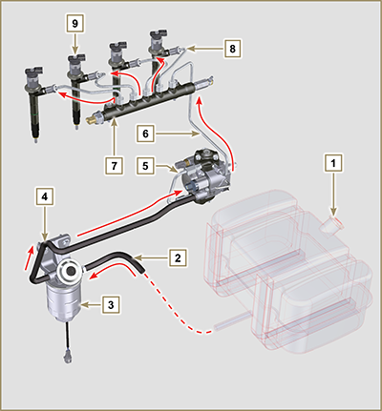  Fig 2.4
  POS. | DESCRIPTION
  1 | Fuel tank
  2 | Fuel pipe under low pressure from the tank to the fuel filter
  3 | Fuel filter
  4 | Low-pressure fuel tube from the fuel filter to the high-pressure injection pump
  5 | High-pressure fuel injection pump
  6 | High-pressure fuel tube from the high-pressure fuel injection pump to the Common Rail
  7 | Common Rail
  8 | Fuel pipes under high pressure from the Common Rail to the electronic injectors
  9 | Electronic injectors
2.9.2 Fuel return circuit  The fuel return circuit is under low pressure.  NOTE : The representation of fuel tank is purely indicative. Component not necessarily supplied by KOHLER .  Tab 2.13 | 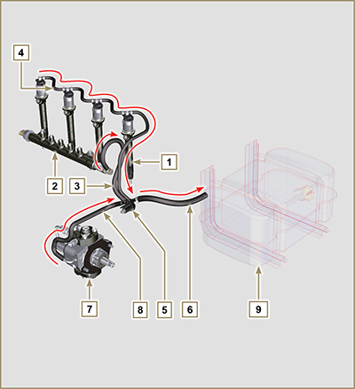  Fig 2.5
  POS. | DESCRIPTION
  1 | Electronic injectors
  2 | Common Rail
  3 | Low-pressure fuel return tube from the Common Rail to the fuel return distributor
  4 | Low-pressure fuel return tube from the electronic injectors to the fuel return distributor
  5 | Low-pressure fuel return distributor
  6 | Low-pressure fuel return tube from the return distributor to the fuel tank
  7 | High-pressure fuel injection pump
  8 | Low-pressure fuel return tube from the injection pump to the fuel return distributor
  9 | Fuel tank

2.9.3 High-pressure injection pump (2000 bar)  Important  - DO NOT use the cylinder connecting pipe (item 5) to carry the pump during movement as this may cause damage resulting in fuel leakag; to handle the injection pump, refer Par. 2.17.1.  - The injection pump CANNOT be repaired.  - DO NOT perform any maintenance on temperature sensor 7 as it is integral part of of the injection pump  - DO NOT attempt to remove the temperature sensor 7 from the pump. Should the sensor 7 be defective, replace the injection pump.  - It is possible to replace the fuel intake adjustment valve (SCR) 6.  - DO NOT attempt to remove the fuel intake regulating valve 6 from the injection pump. Should the valve be defective, replace the injection pump.  NOTE: In the event of leakage from the high pressure circuit do not intervene when the engine is running, but turn it off and wait 5 - 10 minutes before checking the leakage.  The inlet pressure to the high pressure pump must be between -250 mbar (suction pump without electric supply) and 200 mbar (with electric pump power) to the high pressure rail.  The high pressure pump is operated via the pump control gear and sends high pressure fuel to the common rail.  NOTE: The supply tube (on union 8) and fuel return (on union 9), have different diameters.  Tab 2.14 | 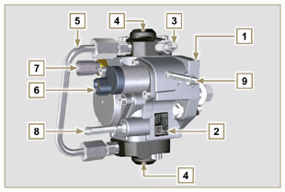  Fig 2.6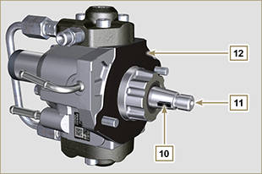  Fig 2.7
  POS. | COMPONENTS DESCRIPTION
  1 | High-pressure fuel injection pump
  2 | Name plate with QR code
  3 | Fitting for high pressure outlet to Common Rail
  4 | Plunger housing
  5 | Connection pipe plunger housing
  6 | Fuel intake regulating valve
  7 | Fuel temperature sensor
  8 | Fuel inlet fitting
  9 | Fuel return fitting
  10 | Shaft key positioning on the pump control gear
  11 | Pump control shaft
  12 | Gasket

2.9.4 Electronic injector  The electronic injector is equipped with an integral solenoid valve which, when excited electronically, manages a valve controlled from  inside the electronic injector to commence fuel injection.  The ECU output signal is digital.  Important  - The electronic injector is NOT repairable.  - The electronic injectors are calibrated individually.  - They are NOT interchangeable with the other cylinders of the same - or other - engines.  - It is assembled on the engine; the new calibration code (QR code) must be inserted in the ECU by means of a diagnostics instrument (ST_01).  - Do NOT fit new or different electronic injectors without the instruments required to enter the injector calibration code.  - Fuel containing impurities causes serious damage to the electronic injectors. | 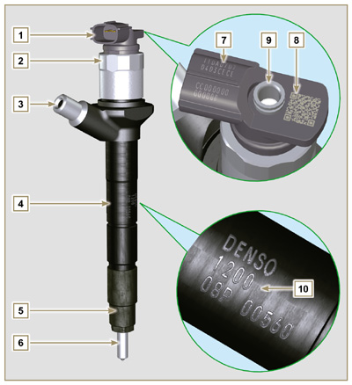  Fig 2.8  Tab 2.15
  POS. | COMPONENTS DESCRIPTION
  1 | Connector for solenoid control
  2 | Solenoid and valve closure ring
  3 | High pressure pipe inlet fitting
  4 | Electronic injectors body
  5 | Nozzle closure ring nut
  6 | Nozzle
  7 | QR code (Visual reading)
  8 | QR code (Electronic reading)
  9 | Return pipe fitting
  10 | Electronic injector identification code
2.9.5 Common Rail
Fuel is injected under pressure into the Common Rail ( Pos.3 ), from the high-pressure fuel injection pump.
- The internal volume of the Common Rail is optimised to obtain the best compromise in order to minimise pressure peaks due to the cyclical flow of the injection pump;
- Opening the electronic injectors;
- The high speed response of the system to the requests of the ECU control unit.
The pressure sensor 5 measures the pressure of the fuel in the Common Rail.
Safety valve 2 , only opens if internal pressure of the Common Rail exceeds the maximum value of 2400 bar.
Pressure inside the Common Rail is regulated by the highpressure fuel injection pump by means of the fuel intake regulation valve ( Pos. 6 Fig. 2.6 ).

The fuel ejected from the safety valve is introduced in the circuit of rejection returning to the tank.

Important

- Common Rail is NOT reparaible.
- It is NOT possible to perform any maintenance on the fuel pressure sensor 5 , as it is an integral part of the Common Rail unit.
- Do NOT remove the pressure sensor or the fuel pressure limit valve from the Common Rail.
- If the pressure sensor or the pressure limit valve are not working, replace the entire Common Rail unit.
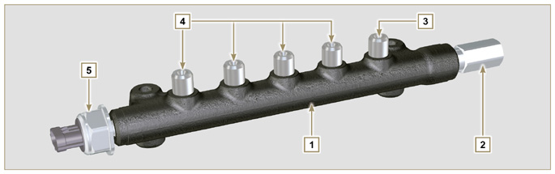
Fig 2.9

Tab 2.16
POS. | DESCRIPTION
1 | Common Rail
2 | Pressure limit valve (return due to overpressure)
3 | Tube inlet union from high-pressure fuel injection pump
4 | Outlet fittings for supply pipes to electronic injectors
5 | Fuel pressure sensor

2.9.6 Fuel filtering
2.9.6.1 Fuel filter  The fuel filter is situated on the crankcase of the engine or it may be assembled on the frame of the vehicle.  Tab 2.17  Tab 2.18 Cartridge characteristics | 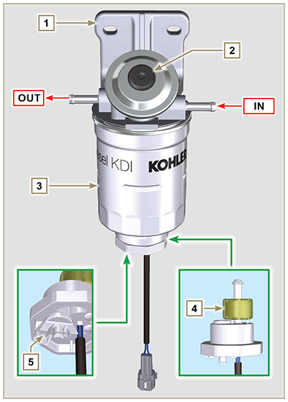  Fig 2.10
  POS. | COMPONENTS DESCRIPTION
  1 | Fuel filter support
  2 | Fuel system filling button
  3 | Cartridge
  4 | Water in fuel sensor
  5 | Wing nut, filter drainage
  DESCRIPTION | VALUE
  Filtering surface | 2.300 cm ²
  Degree of filtration | 5 µm
  Max operating pressure | 2.0 Bar
  Max flow rate | 190 litres/hour
2.9.6.2 Fuel pre-filter (optional)  The fuel pre-filter is situated on the engine or may be assembled on the frame of the vehicle, and is always coupled with the electric pump.  2.18b  2.18c Cartridge characteristics | 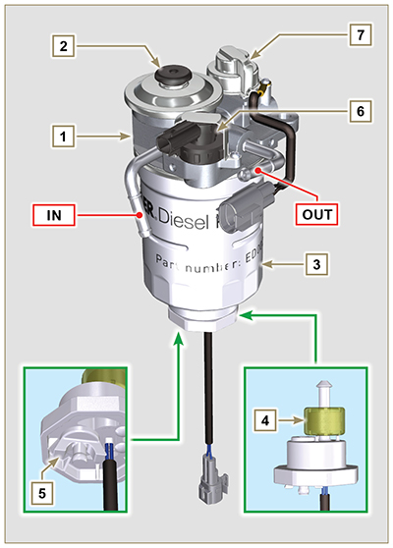  2.10b
  POS. | COMPONENTS DESCRIPTION
  1 | Fuel filter support
  2 | Fuel system filling button
  3 | Cartridge
  4 | Water in fuel sensor
  5 | Wing nut, filter drainage
  6 | Fuel clogging sensor
  7 | Heater
  DESCRIPTION | VALUE
  Filtering surface | 1.800 cm ²
  Degree of filtration | 5 µm
  Max operating pressure | 2.0 Bar
  Max flow rate | 126 litres/hour

2.9.7 Electric fuel pump (optional)  When the electric fuel pump is installed in a diesel engine, one must:  - Install a pre-filter between the tank and electric pump, if one has not already been assembled on the electric pump;  - The electric pump may be assembled on application at a maximum height of 500 mm from the position of the fuel tank.  - Insert a shut-off valve to prevent dry operation due to the emptying of the intake manifold;  - The supply pressure given from the electric pump must not exceed the pressure of 0.2 bar to the input of highpressure injection pump.  Tab 2.19 | 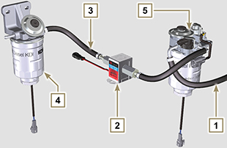  Fig 2.11
  POS. | DESCRIPTION
  1 | Arrival pipe from the tank
  2 | Electric pump
  3 | Flow pipe to the fuel filter
  4 | Fuel filter
  5 | Fuel pre-filter
2.9.8 Guards for fuel injection circuit components  High-pressure injection circuit components are particularly sensitive to impurities.  To prevent impurities, even microscopic ones, from accessing the fuel input or output unions, you are required to close these accesses by means of specific caps as soon as the various tubes are disassembled and disconnected.  Disassembly of any component of the injection circuit must not occur in dusty environments.  Cap protections must remain closed in their housing (ST_40) until the moment they are to be used.  Pay special attention when using the caps and avoid any contamination of dust or dirt of any kind.  Even after using the caps illustrated in this paragraph, all components of the injection circuit must be placed with care in environments that are free of any type of impurity.  Fig. 2.13, 2.14 and 2.15 illustrate the caps that must be used on components of the injection circuit.  Cap protections must be accurately washed after use and placed back in their housing (ST_40).  Important  - It is highly recommended to have this page visible during disassembly operations of the components of the fuel injection circuit. | 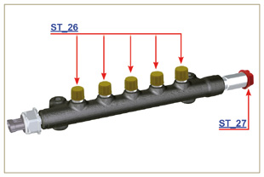  Fig 2.13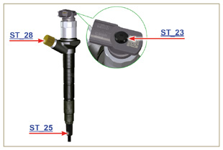  Fig 2.14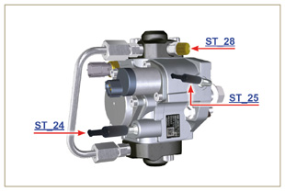  Fig 2.15

Lubrication circuit
2.10.1 Lubrication circuit diagram  The oil pump is driven by the crankshaft on the timing system side.  On the parts of the systems shown in green on In the parts in green, the oil is in intake, in the parts in red, the oil is under pressure and  in those in yellow the oil is returning towards the oil sump 2 (not under pressure).  Tab 2.20  Tab 2.21  ⁽¹⁾ - optional | 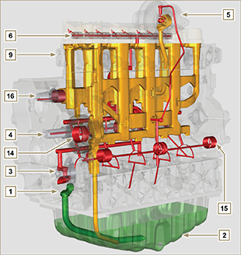  Fig 2.16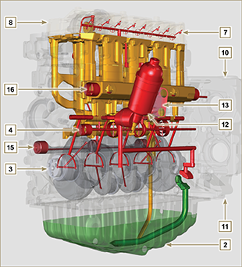  Fig 2.17
  COLOUR | DESCRIPTION
   | Oil in intake
   | Oil under pressure
   | Oil returning to the oil sump
  POS. | DESCRIPTION
  1 | Oil pump rotors
  2 | Oil sump
  3 | Crankshaft
  4 | Camshaft
  5 | Turbocharger
  6 | Rocker arm pin
  7 | Hydraulic tappets
  8 | Rocker arm cover
  9 | Cylinder head
  10 | Upper crankcase
  11 | Lower crankcase
  12 | Oil filter
  13 | Oil Cooler
  14 ⁽¹⁾ | Idle gear Housing
  15 ⁽¹⁾ | Left balance shaft
  16 ⁽¹⁾ | Right balance shaft
NOTE : Click by side to play the procedure. | https://www.youtube.com/embed/rtTjmWlZ1cc?rel=0&showinfo=0
2.10.2 Oil pump The oil pump rotors are trochoidal (with lobes) and are activated from the crankshaft by means of gears.  The pump body is situated on the crankcase.  It is imperative to assemble the rotors with reference A visible by the operator.  Tab 2.22 | 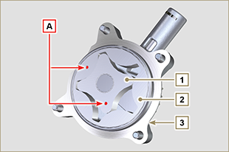  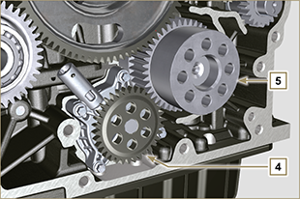  Fig 2.18
  POS. | DESCRIPTION
  1 | Internal rotor
  2 | External rotor
  3 | Oil pump crankcase
  4 | Oil pump control gear
  5 | Crankshaft gear

2.10.3 Oil filter and Oil Cooler

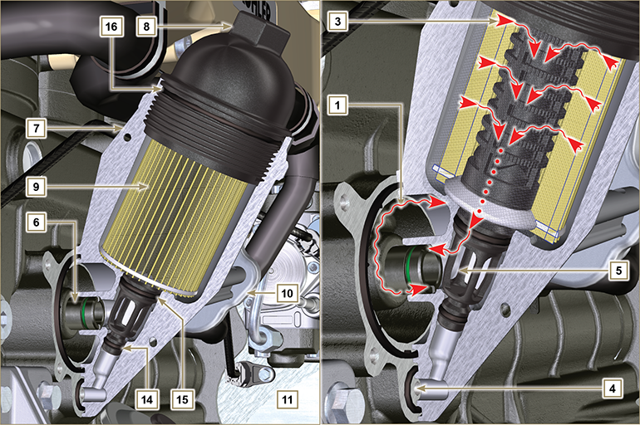
Fig 2.1 9

NOTE : unscrewing the cartridge holder cover makes the oil in support 7 flow towards the oil sump by means of the drain duct 4.
Tab 2.23  Tab 2.24 Cartridge characteristics. | 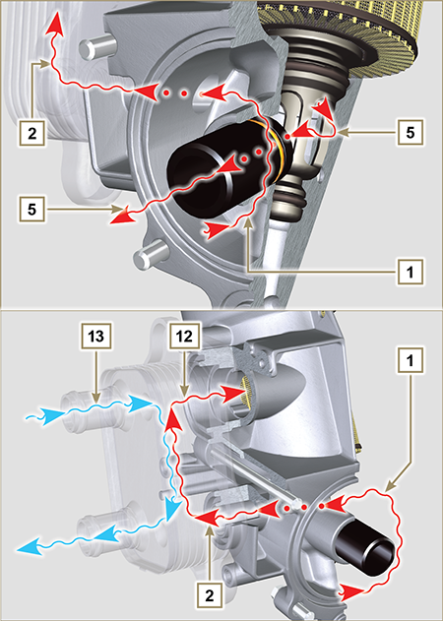  Fig 2.20
  POS. | DESCRIPTION
  1 | Oil arriving from the pump
  2 | Oil cooling
  3 | Oil filtering
  4 | Oil drain duct (oil sump return)
  5 | Oil returning into the circuit
  6 | Outgoing fitting from filter
  7 | Oil filter support
  8 | Cartridge holder cover
  9 | Oil filter cartridge
  10 | Oil Cooler
  11 | Crankcase
  12 | Oil directly from the cartridge
  13 | Coolant
  14 | Oil drain duct closure gasket
  15 | Oil filtering chamber closure gasket
  16 | Cartridge holder cover gasket
  DESCRIPTION | VALORE
  Filtering surface | 2.300 cm ²
  Degree of filtration | 2 µm
  Max operating pressure | 4.0 Bar
  Max flow rate | 190 litres/hour

Cooling circuit
2.11.1 Cooling circuit diagram  Tab 2.25 | 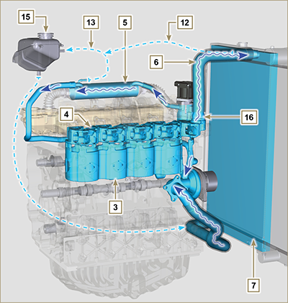  Fig 2.21
  POS. | DESCRIPTION
  1 | Coolant pump
  2 | Coolant intake
  3 | Coolant, cylinder
  4 | Coolant, cylinder head
  5 | EGR gas coolant
  6 | Coolant to radiator
  7 | Coolant into radiator
  8 | EGR valve coolant
  9 | Coolant in the Oil Cooler
  10 | Coolant input into the Oil Cooler
  11 | Coolant output from the Oil Cooler
  12 | Vent line from radiator (to 15)
  13 | Vent line to expansion vase (to 15)
  14 | Return from compensation tank
  15 | Compensation tank
  16 | Thermostatic valve
  17 | Coolant drain cap from crankcase
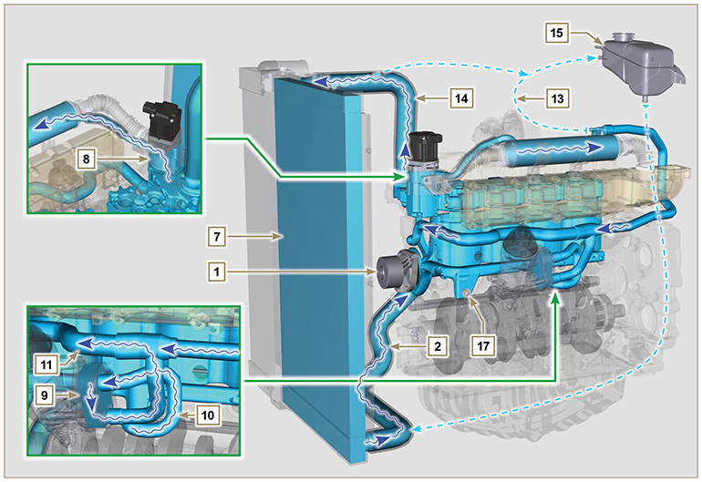
Fig 2.22

2.11.2 Coolant circuit diagram of the SCR system (SCR versions only)  Tab 2.25b  NOTE: Certain components are for illustrative purposes only, can be subject to change and may not be supplied by KOHLER. | 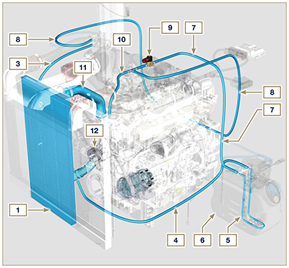  2.22b
  POS. | DESCRIPTION
  1 | Coolant into radiator
  2 | Coolant intake
  3 | Coolant intake
  4 | Coolant intake
  5 | Coolant into AdBlue ® tank
  6 | AdBlue ® tank
  7 | Coolant to AdBlue tank
  8 | Coolant to AdBlue injector
  9 | Electronic valve for coolant delivery to AdBlue tank
  10 | Coolant to SCR system
  11 | Coolant to radiator
  12 | Coolant pump
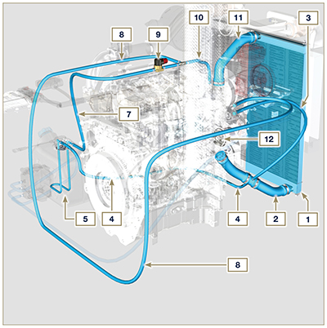
2.22c
2.11.3 Water pump  Tab 2.26 | 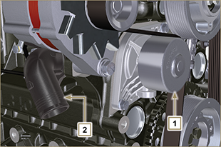  Fig 2.23
  POS. | DESCRIPTION
  1 | Coolant pump control pulley
  2 | Coolant intake fitting
2.11.4 Thermostatic valve  Tab 2.27  Starting opening temperature of +83 °C (0/-3 °C). | 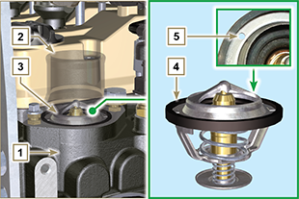  Fig 2.24
  POS. | DESCRIPTION
  1 | Cylinder head
  2 | Coolant outlet cover
  3 | Thermostatic valve
  4 | Gaskets
  5 | Air bleeding hole
2.11.5 EGR gas circuit cooling (EGR Cooler)  Device that cools exhaust gas  Tab 2.28  Tab 2.29 | 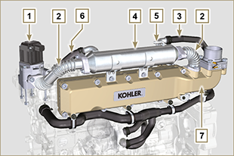  Fig 2.25  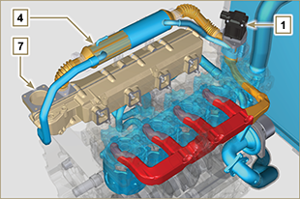  Fig 2.25a
  POS. | DESCRIPTION
  1 | EGR valve
  2 | EGR gas passage tubes
  3 | Coolant outlet hose
  4 | EGR Cooler
  5 | Coolant draining union
  6 | Coolant delivery hose
  7 | Intake manifold
  COLOR | DESCRIPTION
  RED | Exhaust gas
  ORANGE | Coolant drain cap from crankcase
  BLUE | Coolant

Intake and exhaust circuit
2.12.1 Turbocharger  The turbocharger is controlled by means of exhaust gas that activates the turbine.  Important  - See Par 2.18 .  Tab 2.30 | 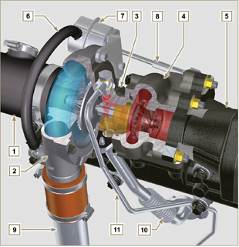  Fig 2.26
  POS. | DESCRIPTION
  1 | Air intake hose
  2 | Air compression volute
  3 | Turbo charger central body
  4 | Turbine housing with Waste Gate valve
  5 | Gas exhaust flange
  6 | Waste Gate control valve hose
  7 | Waste Gate valve control actuator
  8 | Waste Gate control valve linkage
  9 | Air compressed flow hose to intercooler
  10 | Oil drain pipe
  11 | Turbo charger lubrication pipe
2.12.2 Intake and exhaust circuit diagram with EGR

 | Air in intake |  | Gas in recycle |  | Gas in exhaust

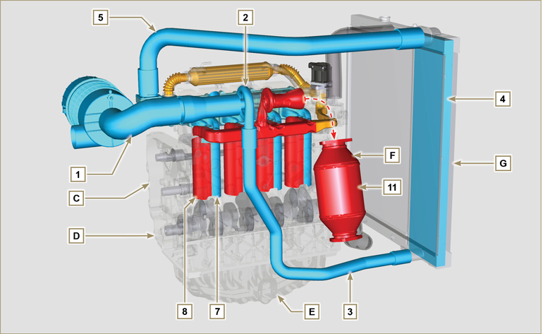
Fig 2.27a

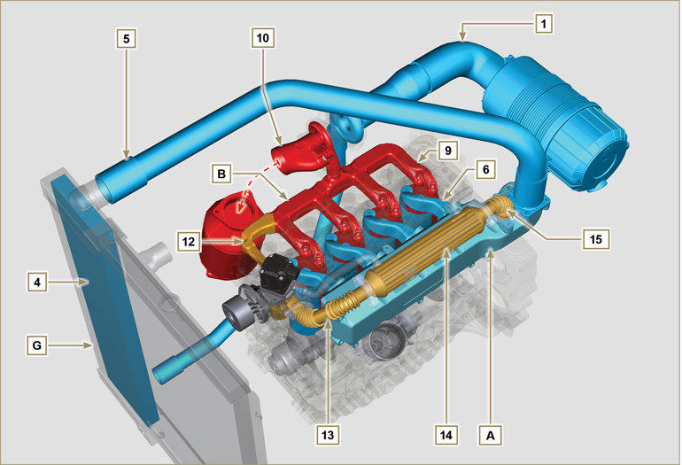
Fig 2.27b

Important

- The air temperature inside the intake manifold must never exceed that of the environment by 10°C.
Filtered air is sucked by the turbocharger, which compresses and sends it to the intercooler (as a consequence of compression, the air increases the temperature - the Intercooler cools it - this process enables better performance during combustion inside the cylinders). From the Intercooler, it is sent to the

intake manifold and, via ducts in the cylinder head, enters the cylinders. Compressed air inside the cylinders and mixed with the fuel transforms into Gas after combustion. The gas is expelled from the cylinders and sent to the exhaust manifold. The exhaust manifold sends the Gases to 2 ducts:

- 1st duct : to the turbocharger body (the expelled Gases activate the turbine), the Gases then proceed towards the catalyst, which break down the pollutants contained in them before being definitely expelled.
- 2nd duct : to the EGR circuit, which takes care of recovering a part of the Gases that return to intake
(this process burns less oxygen when power is not requested, thus breaking down pollutants further).
The EGR circuit is managed by ECU, which controls the EGR valve that provides for the recovery of Gases when the engine does not require power.
The EGR circuit is furnished with a heat exchanger (EGR Cooler), which cools the recovered Gases (this process enables better performance during combustion inside the cylinders).

Tab 2.31a
POS. | DESCRIPTION
1 | Air in intake from air filter
2 | Air in compression
3 | Air in intercooler flow
4 | Air cooling
5 | Air in intake manifold flow
6 | Air in head intake
7 | Air in cylinder intake
8 | Gas in cylinder outlet
9 | Gas in head outlet
10 | Gas in outlet towards catalyst
11 | Gas in oxidation
12 | Gas in recycle towards EGR valve
13 | Gas in EGR valve outlet
14 | Gas cooling (in EGR Cooler)
15 | Exhaust gas recirculation into intake manifold
A | Intake manifold
B | Exhaust manifold
C | Upper crankcase
D | Lower crankcase
E | Oil sump
F | DOC
G | Radiator/intercooler

2.12.3 ATS Device (optional)  2.12.3.1 DOC  The catalyst is a device to filter exhaust gas by means of its oxidation.  Internally, it is composed of hundreds of small ducts that enable the passage of exhaust gas.  It contains precious metals (platinum, palladium, iridium).  NOTE: The image is indicative only. The installation of the DOC must be approved by KOHLER, for each application.  In order to prevent breakage on the connection flange, the catalyst is normally connected via a hose.  Important  - In order to prevent breakage on the connection flange, the DOC must be connected via a flexible exhaust tube ( POS. 14 - Tab. 2.31b ).  Tab 2.31b | 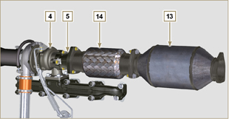  Fig 2.28a
  POS. | DESCRIPTION
  4 | Turbocharger
  5 | Gas exhaust flange
  13 | DOC
  14 | Flexible exhaust tube
2.12.3.1.1 DOC exhaust gas path and transformation

NOTE: The following data are indicative and may vary based on the engine use conditions.

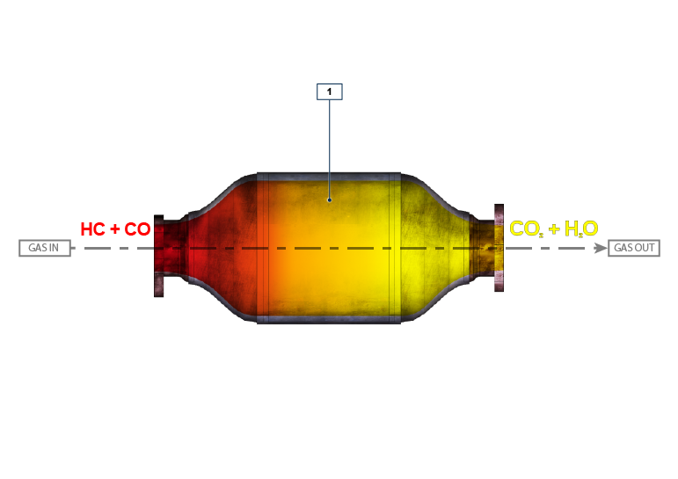
Fig 2.28b

Tab 2. 31c
POS. | DESCRIPTION
1 | DOC Element
HC | Unburnt hydrocarbons
CO | Carbon monoxide
CO ₂ | Carbon dioxide
H ₂ O | Water

2.12.3.2 SCR Device

2.12.3.2.1 DOC+SCR exhaust gas path and transformation

NOTE: The following data are indicative and may vary based on the engine use conditions.

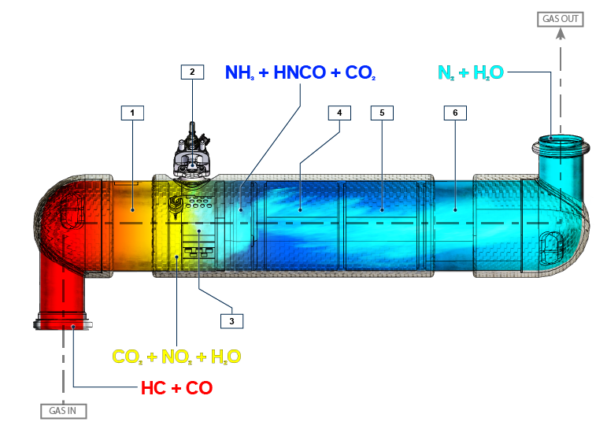
Fig 2.29a

Tab 2. 31d
POS. | DESCRIPTION
1 | DOC
2 | AdBlue® injector (NH ₃ )
3 | Mixer
4 | SCR element 1
5 | SCR element 2
6 | SCR element 3 + ASC (Ammonia Slip Catalyst)
HC | Unburnt hydrocarbons
CO | Carbon monoxide
NO ₂ | Nitrogen dioxide
H ₂ O | Water
NH ₃ | Ammonia
HNCO | Isocyanic acid
CO ₂ | Carbon dioxide
N ₂ | Nitrogen

2.12.3.2.2 Inducement strategy of SCR system

The inducement is the operation aimed at reducing the engine performance due to a malfunction or tampering with the SCR system detected by the DCU.

The inducement degree is decided by the ECU according to the error detected by the DCU.

The inducement can have the following 2 levels:
- Level 1: 25% reduction of the MAX available torque.
- Level 2: 50% reduction of the MAX available torque and 40% reduction of MAX rpm available.
Before activating the inducement (level 1 or level 2) the ECU activates a warning or a warning light on the car panel (refer to the car documentation for the warning type).

The information on the car panel or the activation of the inducement can occur for the following reasons:

- Low AdBlue ® level
- Poor AdBlue ® quality
- Interruption of AdBlue ® supply
- EGR valve malfunctioning
- Tampering with the monitoring systems of the SCR system.
The inducement strategy is applied according to:

- detected problem
- hours passed.
NOTE: Hours are reset after 40h if the DCU does not detect any fault, otherwise the hours are added to those already counted. For low AdBlue ® level, activation depends on the percentage of liquid inside the AdBlue ® tank, and the fault hours are not counted.

The strategy for the different faults is listed below:

Low AdBlue ® level
- information activation on car panel: <10% of MAX level
- Level 1 inducement: <2.5% of MAX level
- Level 2 inducement: 0% of MAX level
Poor AdBlue ® quality
- information activation on car panel: upon fault detection
- Level 1 inducement: after 10h from fault detection
- Level 2 inducement: after 20h from fault detection
Interruption of AdBlue ® supply
- information activation on car panel: upon fault detection
- Level 1 inducement: after 10h from fault detection
- Level 2 inducement: after 20h from fault detection
EGR valve malfunctioning
- information activation on car panel: upon fault detection
- Level 1 inducement: after 36h from fault detection
- Level 2 inducement: after 100h from fault detection
Tampering with the monitoring systems of the SCR system
- information activation on car panel: upon fault detection
- Level 1 inducement: after 36h from fault detection
- Level 2 inducement: after 100h from fault detection
2.12.3.2.3 Intake and exhaust circuit diagram of the SCR system (SCR versions only)

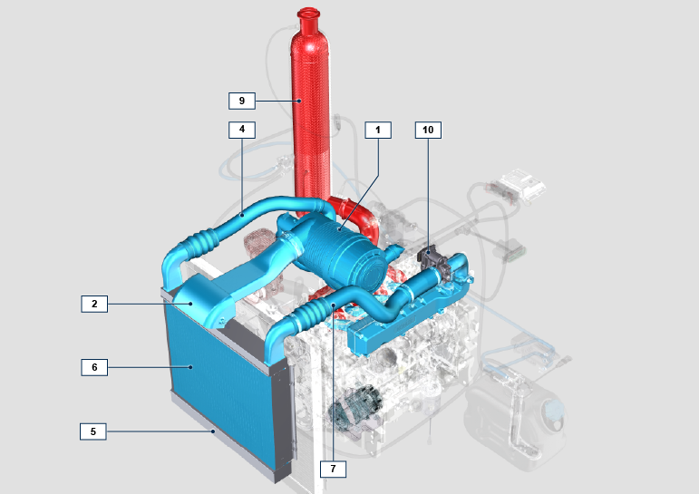
2.29b

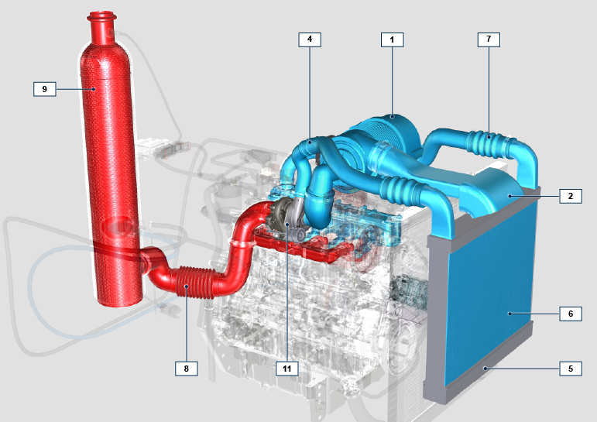
2.29c

Tab 2. 31e
POS. | DESCRIPTION
1 | Air filter
2 | Air in intake from air filter
3 | Turbocharger
4 | Air in intercooler flow
5 | Intercooler
6 | Air cooling
7 | Air in intake manifold flow
8 | Gas in outlet towards SCR
9 | SCR
10 | ETB
11 | Turbocharger

NOTE: Certain components are for illustrative purposes only, can be subject to change and may not be supplied by KOHLER.
2.12.4 Air filter (optional)  NOTE: Component not necessarily supplied by KOHLER .  Important  - The air filter is a dry type of filter with a paper filtering element; element s H and L are replaceable (refer to Tab. 2.8 and Tab.2.9 for procedure frequency on components).  - Filter suction must be positioned in a cool place.  - Should a hose be used, the length must not exceed 400 mm and is to be as straight as possible.  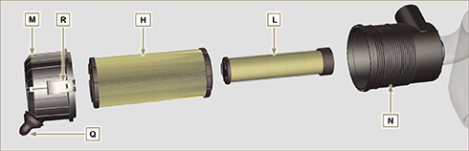  Fig 2.31 | Tab 2.32
  POS. | DESCRIPTION
  H | Air filter cartridge
  L | Air filter safety cartridge
  M | Filter cover
  N | Filter support
  Q | Dust exhaust valve
  R | Filter cover hook

Electric system
2.13.1ECU (and DCU for SCR versions only) input and output signals diagram

SENSORS/SWITCH (INPUT) |  | DEVICES (OUTPUT)
Power relay | ECU | Electronic injector 1
Engine revolutions sensor | ECU | Electronic injector 2
Engine phase sensor | ECU | Electronic injector 3
Coolant temperature sensor | ECU | Electronic injector 4
Common Rail pressure sensor | ECU | EGR valve control
Oil pressure switch | ECU | Fuel intake adjustment valve (SCV)
EGR valve position | ECU | Revolution indicator
Fuel temperature sensor | ECU | Heater relay
T-MAP sensor | ECU | Diagnosis indicator lights
ACACT sensor | ECU | ETB control
Main accelerator pedal  (double track) | ECU | Electric fan control (1-2 speeds or variable speed)
Secondary accelerator pedal (optional) | ECU | CAN 1 (ISO15765 diagnostics)
Hydraulic oil pressure sensor (optional) | ECU | CAN 2 (Vehicle SAE J1939)
Fuel level sensor (optional) | ECU
Air filter clogging sensor (optional) | ECU
Water in fuel sensor | ECU
ETB position | ECU
MAF Sensor | ECU

SENSORS/SWITCH (INPUT) |  | DEVICES (OUTPUT)
NO _{x} upstream Sensor | DCU | Coolant delivery valve to AdBlue ® tank for AdBlue ® heating
NO _{x} downstream Sensor | DCU | AdBlue ® line heaters
AdBlue ® level sensor | DCU | AdBlue ® Pump
AdBlue ® quality sensor | DCU | AdBlue ® Injector
AdBlue ® temperature sensor | DCU
SCR inlet exhaust gas temperature sensor | DCU
Ambient temperature sensor | DCU

2.13.2 Control unit (ECU)  The ECU is a central processor, which monitors and controls engine operation.  The electronic control unit is responsible for engine management.  It is fitted on the frame of the vehicle, or in the cab (refer to the technical documentation of the vehicle).  Important  - The ECU must only be used with the configuration defined  by KOHLER , for each individual engine. | 2.13.2.1 Installation rules  - Protection degree: 1P 6K/9K.  - Operating temperature: -40°C - +100°C.  - Storage temperature: -40°C - +100°C.  - Do NOT install the ECU on the engine. It should be mounted on the frame of the vehicle / plant in a position where it will be well cooled, mechanically protected, and free from vibration and ingress of moisture.  - It is crucial that the ECU is earthed. Electrical connection may be as follows: by means of four fixing points D of the ECU to the vehicle brace, thus ensuring good connection (avoid painted or insulated parts).  - Alternatively, connect using a cable (with 4mm ² section and a maximum length of 300 mm) from one of the ECU fixing points D to a plate of mass, taking care to ensure perfect electrical contact.  - The position of the ECU in an application must be done carefully to protect barometric capsule C from liquids (during engine washing or engine/vehicle maintenance).  - The connection area (ECU connectors A-B ) must not be the lowest point of all the wiring to prevent any water infiltrations in the wiring itself.
Fig 2.32 - Fig. 2.33
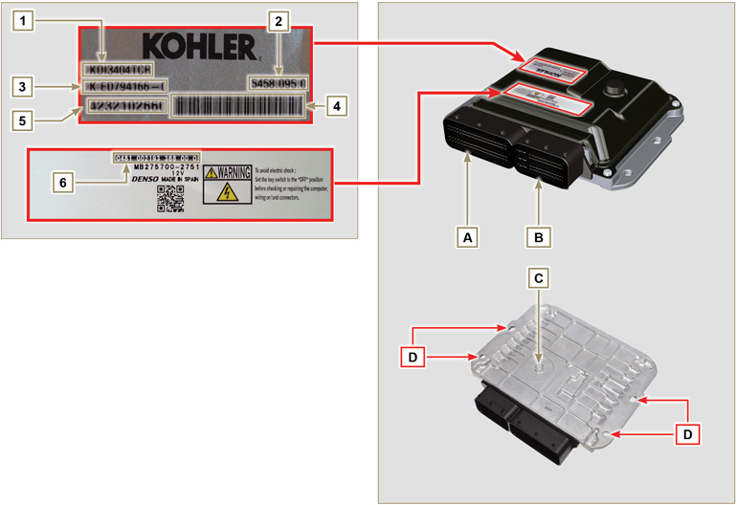

Tab. 2.33
ECU AND ENGINE IDENTIFICATION PLATES
POS. | DESCRIPTION
1 | Engine model
2 | Validation code
3 | Engine specifications
4 | Bar Code of the engine chassis number
5 | Engine chassis number
6 | ECU identification code
A | Connector A (ECU A)
B | Connector B (ECU B)
C | Barometric capsule
D | Fastening points

- Do NOT mount or replace the control unit with that of another engine.
- Although externally each ECU seems to be identical, internally they are specifically configured only for use on the engine that they are supplied with.
- To install a new control unit, is required to recharge on it's the original configuration relating to that specific engine .
- The control units are not interchangeable nor modifiable.
- Each control unit is accompanied by its adhesive identification plate.

2.13.3 DCU control unit (SCR versions only)

The processor monitors and controls operation of the SCR (Selective Catalytic Reduction) system.
The DCU control unit is fitted on the frame of the vehicle, or in the cab (refer to the technical documentation of the vehicle).

The DCU controls and manages the values that are received from various sensors and devices of the SCR system and intervenes in the event of a fault with the inducement strategies described in Par. 2.13.3.1 .
Fig 2.34 - Fig. 2.35
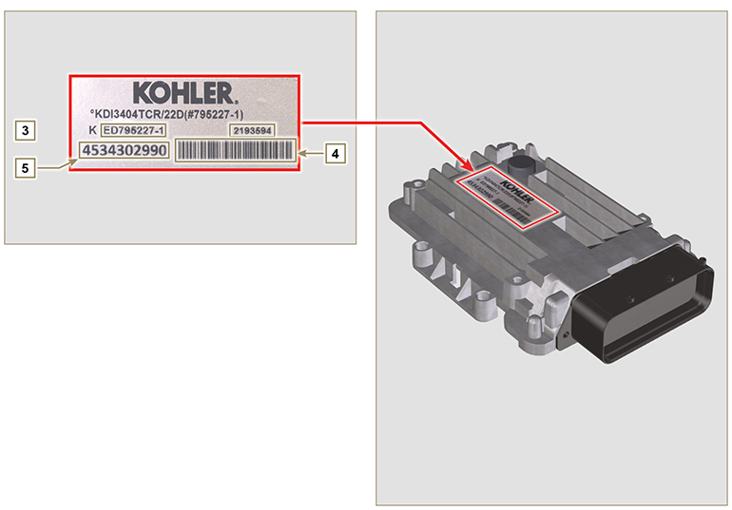

DCU IDENTIFICATION PLATES
POS. | DESCRIPTION
1 | Engine model
2 | DCU identification code
3 | Engine specifications
4 | Bar code of the engine chassis number
5 | Engine chassis number

Important

- The ECU must only be used with the configuration defined by KOHLER, for each individual engine .
- Do NOT mount or replace the control unit with that of another engine .
- The control units are not interchangeable nor modifiable.
- Each control unit is accompanied by its adhesive identification plate.

2.13.4 Engine electrical wiring

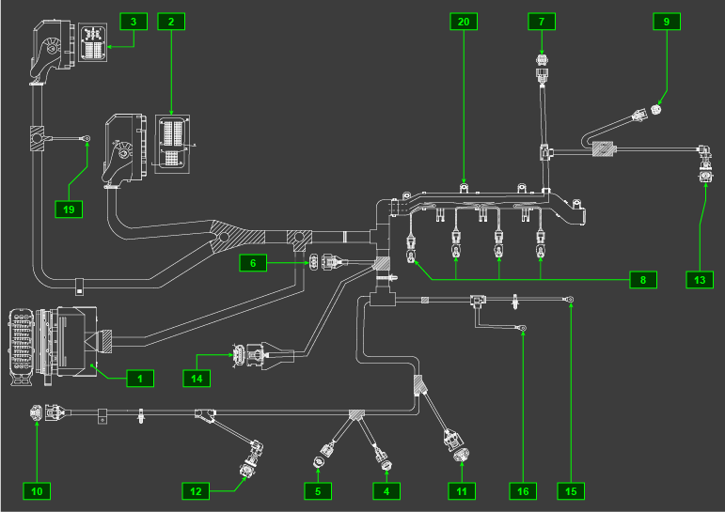
Fig 2.34

Tab. 2.34 | 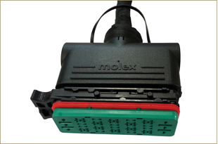  Fig 2.34a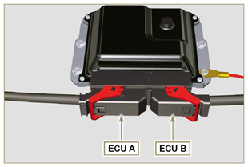  Fig 2.34b
  RIF. | DESCRIPTION
  1 | Vehicle interface connector (Fig. 2.34a))
  2 | ECU Connector A (Fig. 2.34b)
  3 | ECU Connector B (Fig. 2.34b)
  4 | Fuel pressure regulating valve connector
  5 | Fuel temperature sensor connector
  6 | T-MAP sensor connector
  7 | Common Rail pressure sensor connector
  8 | Injectors connectors
  9 | EGR valve connector
  10 | Engine speed sensor connector
  11 | Engine phase sensor connector
  12 | Oil pressure switch connector
  13 | Coolant temperature sensor connector
  14 | Throttle Body Connector
  15 | D+ Connector Alternator
  16 | Starter motor connector
  19 | Ground
  20 | Wiring support
NOTE: Click by side to play the procedure. | https://www.youtube.com/embed/6-0TbYG2EkY?showinfo=0&rel=0
2.13.4.1 Wiring disconnection  All sensor connectors and electronic control devices are sealed.  The connectors must be disconnected by means of pressure on tabs A or unblock the retainers B , as illustrated from Fig. 2.34c to Fig. 2.34q. | 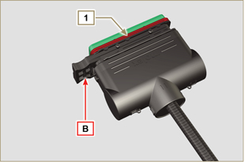  Fig 2.34c
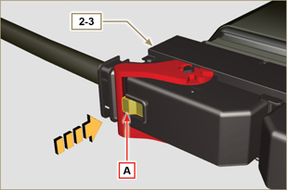  Fig 2.34d | 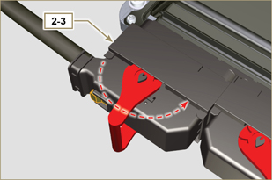  Fig 2.34e
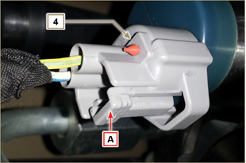  Fig 2.34f | 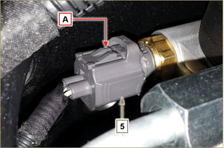  Fig 2.34g
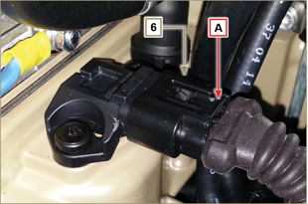  Fig 2.34h | 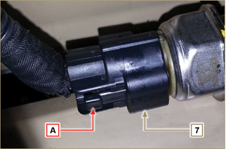  Fig 2.34i
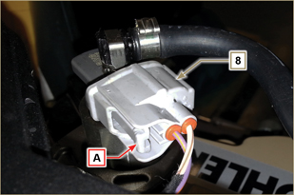  Fig 2.34l | 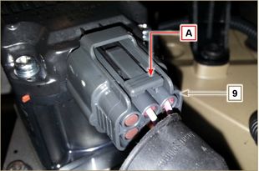  Fig 2.34m
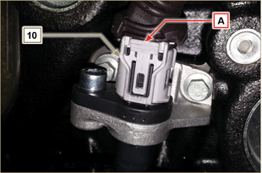  Fig 2.34n | 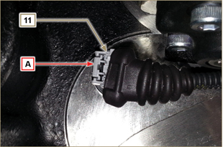  Fig 2.34o
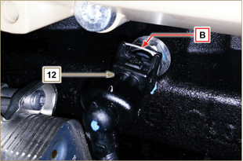  Fig 2.34p | 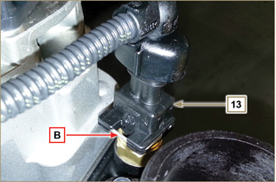  Fig 2.34q
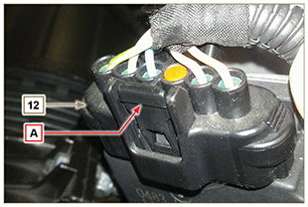
Fig 2.34r

2.13.5Electrical wiring of the SCR system (SCR versions only)

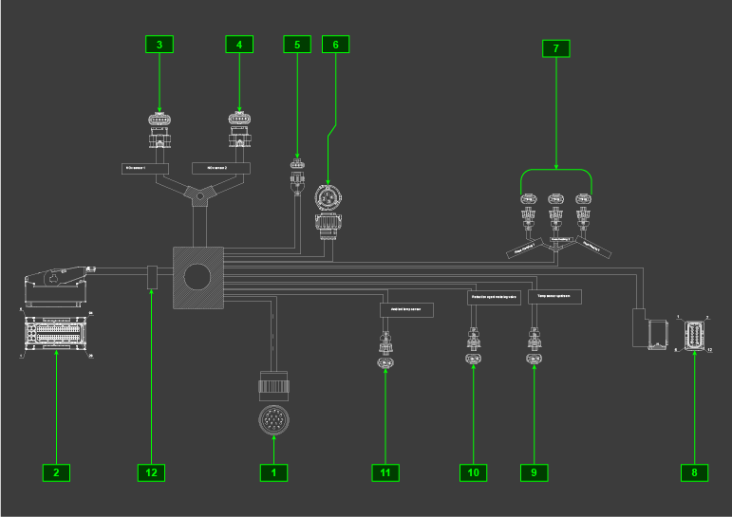
Fig. 2.35

Tab 2.36
REF. | DESCRIZIONE
1 | Vehicle interface connector( Fig.2.36a )
2 | DCU Connector
3 | NOx upstream sensor connector (SCR inlet)
4 | NOx downstream sensor connector (SCR outlet)
5 | AdBlue tank connector
6 | Valve connector for AdBlue heating
7 | AdBlue pipe heaters connectors
8 | AdBlue pump connector
9 | SCR inlet temperature sensor connector
10 | AdBlue injector connector
11 | Ambient temperature sensor connector
12 | Wiring identification label

2.13.5.1SCR electrical wiring disconnection (SCR versions only)  All sensor connectors and electronic control devices are sealed.  The connectors must be disconnected by means of pressure on tabs A or unblock the retainers B, as illustrated from Fig. 2.36a a 2.36k | 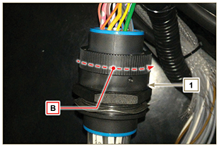  Fig. 2.36a  NOTE: MAF sensor - connected to the machine’s wiring.
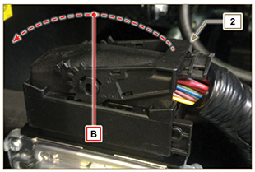  Fig. 2.36b | 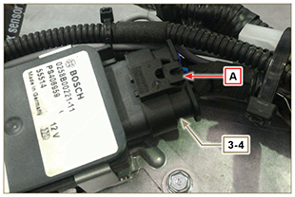  Fig. 2.36c
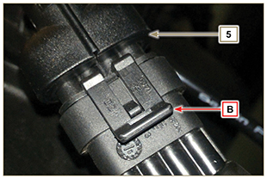  Fig. 2.36d | 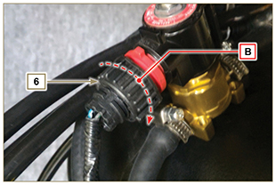  Fig. 2.36e
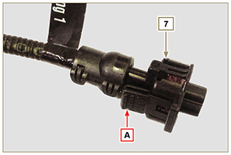  Fig. 2.36f | 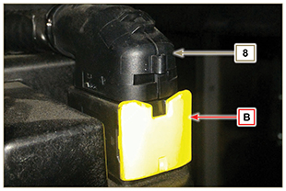  Fig 2.36g
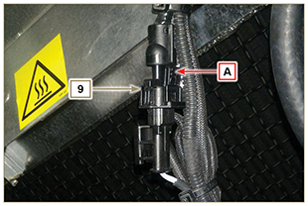  Fig. 2.36h | 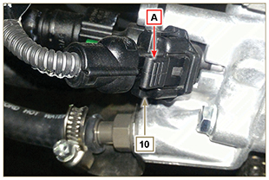  Fig. 2.36i
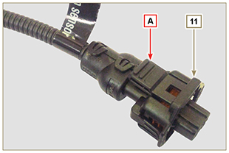  Fig. 2.36j | 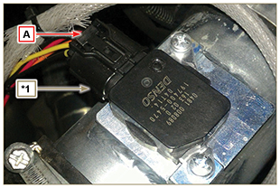  Fig. 2.36k

Sensors and switches
2.14.1 Revolution sensor on target wheel  Speed sensor A is situated on the crankcase.  The sensor detects the signal from the target wheel B (60 - 2teeth) situated on the crankshaft pulley. It sends it to the ECU as an analogical signal.  The sensor sends and analogue signal to the ECU.  The sensor produces a 5V square wave signal having a Hall effect while the crankshaft in rotation detects its position and speed.  The data sent by this sensor enables the ECU to pilot fuel anticipation injection for each piston.  For gap adjusting see Par. 9.13.1.5 . | 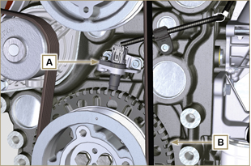  Fig 2.35
2.14.2 Camshaft sensor  Camshaft sensor C is situated on the timing system carter.  The purpose of the camshaft sensor C is to identify the position of the Camshaft control gear D with respect to the engine shaft and consequently the position of the pistons with respect to the T.D.C. The sensor produces a 5V square wave signal having a Hall effect while the camshaft in rotation detects the phases of the 4 strokes of the 1st cylinder. As a consequence, ECU by means of internal calculations, also recognises the phases of the other cylinders.  The data sent by this sensor enables the ECU to pilot fuel anticipation injection for each piston. | 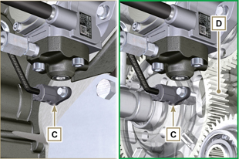  Fig 2.36
2.14.3 T-MAP sensor  The T-MAP F sensor is situated on the intake manifold. It detects the input pressure in the intake manifold by means of electrical voltage variation and the air temperature by means of an electrical resistor.  The sensor sends signals to the ECU, which determines the values and modifies the injection strokes.  Tab. 2.35 reports the electrical resistor values according to the intake air temperature.  NOTE : R indicates the pin where it is possible to measure electrical resistance.  Tab 2.35 | 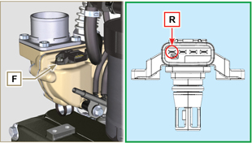  Fig 2.37
  °C (°F) | R ( Ω )
  -30 (-22) | 23475 - 25945
  0 (32) | 5370 - 5935
  25 (77) | 1900 - 2100
  50 (122) | 772 - 854
  100 (212) | 177 - 195
  120 (248) | 107 - 119
2.14.4 Common Rail pressure sensor  Fuel pressure sensor G assembled on the Common Rail, detects the fuel pressure inside it by means of electrical voltage variation.  Depending on the signal sent, ECU manages the fuel intake valve on the injection pump and, if necessary, modifies the injection strokes.  Important  - Refer to Par. 2.9.5 | 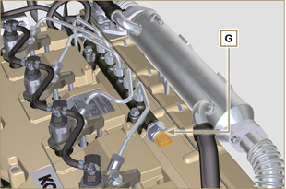  Fig 2.38
2.14.5 Fuel filter water detection sensor  The water presence sensor H is situated in the fuel filter, which is there to indicate the presence of water in the fuel.  Water, if present in the fuel, because of its greater specific weight separates and settles in the lower part of the filter where there is a specific sensor that, by means of the ECU activates an alarm signal on the dashboard.  The butterfly valve nut M situated in the lower part of the body sensor enables the elimination of any water present in the fuel and prevent malfunctions on components of the injection circuit. | 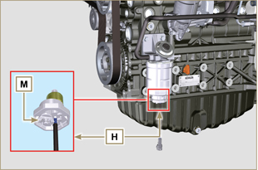  Fig 2.39
2.14.6 Fuel temperature sensor on the fuel injection pump  The fuel temperature sensor L is situated on the high-pressure fuel injection pump.  The fuel temperature sensor L , measures the temperature of the fuel entering the pump at high pressure. The signal sent to the ECU is analogue.  The resistance detected by the ECU is proportional to the fuel temperature.  Important  - Refer to Par. 2.9.3  Tab. 2.36 reports the electrical resistor values according to the fuel’s temperature.  Tab.2.36 | 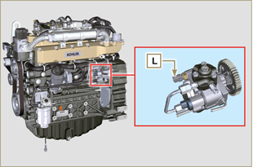  Fig 2.40
  ºC (ºF) | R (KΩ)
  120 (248) | 2,811
  110 (230) | 2,842
  100 (212) | 2,884
  90 (194) | 2,940
  80 (176) | 3,018
  70 (158) | 3,128
  60 (140) | 3,284
  50 (122) | 3,511
  40 (104) | 3,850
  30 (84) | 4,360
  20 (66) | 5,150
  10 (50) | 6,400
  0 (32) | 8,440
  -10 (14) | 11,860
  -20 (-4) | 17,700
  -30 (-22) | 28,102
2.14.7 Oil pressure switch  Oil pressure switch N is assembled on the crankcase near to the injection pump.  It is a N/C sensor, calibrated at 0.6 bar ± 0.1 bar.  With oil low pressure the sensor closes the electrical circuit and the warning lamp in the panel board switches on. | 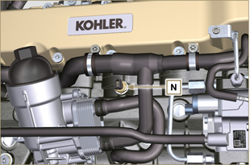 Fig 2.41
2.14.8 Coolant temperature sensor  The P coolant temperature sensor of the coolant circuit is applied to the cylinder head on the side of the thermostatic valve.  It is used by the ECU in order to obtain information regarding the coolant temperature (from PIN R).  NOTE : R refers to the pin where it is possible to measure the electrical resistor.  Tab 2.37 | 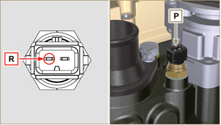 Fig 2.42  NOTE: R indicates the pin where it is possible to measure electrical resistance.
  CHARACTERISTICS
  Temperature °C | R min Ω | R max Ω
  -35 | 53983 | 73806
  -30 | 39229 | 52941
  -15 | 18006 | 20825
  0 | 7095 | 8929
  +30 | 1717 | 2039
  +60 | 520 | 589
  +90 | 188 | 204
  +120 | 76 | 84
2.14.9MAF (Mass Air Flow) sensor  The Q MAF sensor is situated on the intake manifold between the air cleaner and intake collector.  It measures the temperature and mass air intake.  Signals are sent to the ECU and DCU in order to check and regulate the intake air from the intake valve and dosage of AdBlue® in the SCR.  NOTE: Use PIN 1 to measure the voltage according to the mass air intake (Tab. 2.38). Use PIN 5 to measure the resistor according to the temperature (Tab. 2.38).  Tab 2.38  Tab 2.39  Tab 2.40 | 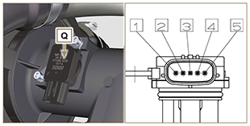  Fig 2.43
  PIN | SIGNAL
  1 | outlet V
  2 | mass for signal V
  3 | feeding
  4 | mass for temperature sensor
  5 | temperature sensor
  FLOW kg/h | V
  4.32 | 1
  9 | 1.222
  144 | 2.764
  324 | 3.496
  468 | 3.913
  612 | 4.250
  ºC | Ω
  -20 | 16000
  0 | 6000
  20 | 2450
  40 | 1200
2.14.10 AdBlue tank sensors  The sensors inside the AdBlue® tank are:  - AdBlue level sensor  - AdBlue® quality and AdBlue temperature sensor  These sensors send signals to the DCU, which controls the values and intervenes in the event of a fault.  NOTE: The device complete with sensors is only supplied as a spare part together with the tank. The AdBlue® tank may not be supplied by KOHLER. | 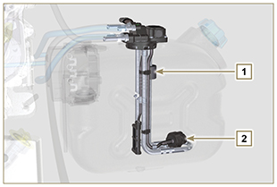  Fig 2.44
2.14.11 Ambient temperature sensor  The R ambient temperature sensor helps the DCU regarding the operating strategies of the SCR system, it provides the actual air temperature and must not be affected by other sources of heat. It is not usually situated in the engine’s compartment.  Tab 2.41 | 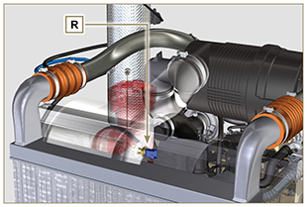  Fig 2.45
  ºC | MIN (Ω) | MAX (Ω)
  -40 | 38457 | 52630
  -10 | 8208 | 10656
  20 | 2233 | 2780
  80 | 297 | 349
  120 | 105 | 122
2.14.12 Nox sensors  NOx sensors (upstream U and downstream T) are identical. The DCU recognises the position of the sensor upstream from connection to a supplementary earth pin (PIN 5) via the wiring connected to the Z SCU.  The component is supplied as a spare part completed with the Z SCU.  Tab 2.42 | 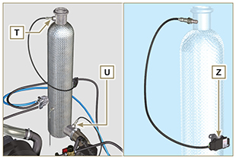  Fig 2.46  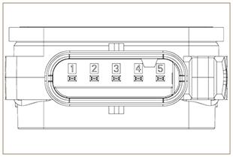  Fig 2.47
  PIN | SIGNAL
  1 | alimentazione
  2 | massa
  3 | CAN LOW
  4 | CAN HI
  5 | CAN-ID
2.14.13 SCR-T  The S sensor is situated on the SCR and measures the exhaust gas temperature before entering the SCR and sends a signal to the DCU.  NOTE: PIN 1 and 2 are used to measure the resistor according to the temperature (Tab. 2.43).  Tab 2.43 | 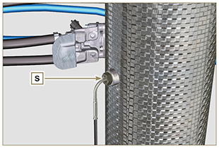  Fig 2.48
  ºC | Ω
  0 | 201
  25 | 220
  400 | 492
  900 | 803
2.14.18 Air cleaner clogging switch  NOTE: Component not necessarily supplied by KOHLER.  The switch is assembled on the air cleaner. When the filter is clogged, it sends a signal to the panel.  Features :  - Operating temperature: - 30 °C / +100°C  - Contact usually open.  - Contact closed by vacuum: -50 mbar. | 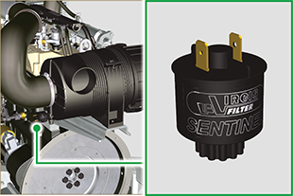  Fig. 2.48d

Electrical components
2.15.1 Alternator (A)  Externally controlled by the crankshaft by means of a belt.  - Ampere 90 A  - Volt 12V | 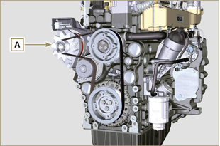  Fig 2.44
2.15.2 Starter Motor (C)  - Type Bosch 12 V  - Potenza 3.2 kW  - Anticlockwise rotation (seen from timing system side) | 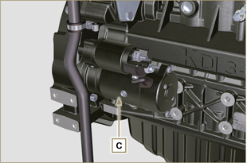 Fig. 2.45
2.15.3 EGR Valve (D)  A device that provides for exhaust gas recovery that is controlled by ECU, which, according to acceleration parameters, RPM and power requested, varies the opening and closing of the valve.  The device has an integrated ECU, which, on each start-up of the control panel, executes an operation self-check.  In the event of a malfunction, it sends a signal to ECU, which, in turn, signals the anomaly on the control panel.  Characteristics:  - Type Dell'Orto EGV A16  - Operating/storage temperature: -30°C / +130°C. | 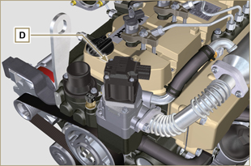 Fig 2.46
2.15.4 Cold starting device (Heater)  The cold starting device consists of a resistance, managed by the ECU, which is activated when the ambient temperature is ≤ -16°C.  The intake air is heated through the resistance and facilitates starting.  Characteristics:  - Type Hidria AET 12 V  - Power 550 W | 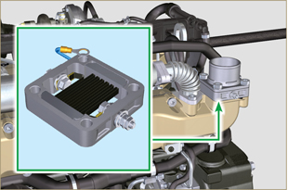 Fig 2.47
2.15.5 Fuel intake regulating valve (SCV)  Valve E is situated on the high-pressure fuel injection pump.  It is managed by ECU, which regulates fuel intake by means of fuel pressure values inside the Common Rail, choking the input entrance of fuel in the injection pump. The digital signal varies the opening of the valve in proportion to the quantity of fuel required for the Common Rail.  Important  - Refer to Par 2.9.3 | 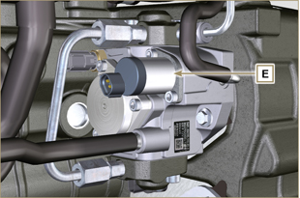 Fig 2.48
2.15.7 Fuel heater  Heater F is situated on the fuel pre-filter. It is activated when required, after checking the fuel, by the clogging sensor G (usually below 10° C).  Note: Both device G and F are connected to the MCU. In the event of faults, refer to the machine’s documentation.  Features:  Volt 12 V  Power140-180 W | 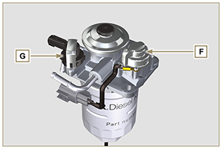  Fig. 2.49
2.15.8 AdBlue® heating valve (SCR versions only)  The valve is situated on the coolant line.  The DCU opens the valve in order to circulate the coolant heated by the engine inside the AdBlue® tank in the event of AdBlue freezing.  Features:  - Volt 12 V  - Power12.5 W  - MAX pressure3.0 bar  - ValveNormally closed | 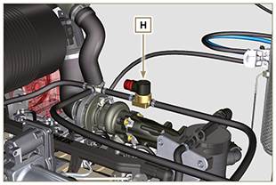  Fig. 2.49b
2.15.9 AdBlue® Pump (SCR versions only)  The AdBlue® pump L sends AdBlue® to the injector only if Adblue® is in its liquid state.  After turning off the engine, the pump empties the AdBlue® circuit in order to prevent freezing inside the pump and/or pipes (AdBlue® sent to the tank via union L3).  L1 - AdBlue® intake (from Tank)  L2 - AdBlue outlet (towards the AdBlue injector)  L3 - return (Towards the AdBlue tank)  L4 - AdBlue filter  Features:  - Volt 12 V  - MAX storage2 years (in original package) | 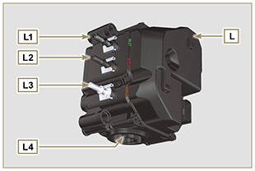  Fig. 2.49c
2.15.10 AdBlue® injector (SCR versions only)  The AdBlue® injector M is enabled by the DCU according to the values received from various sensors of the SCR system.  The injector is cooled by the coolant via the connector unions M3  M1 - SCR wiring connector  M2 - AdBlue inlet  M3 - coolant inlet and outlet  M4 - metal gasket (it must be replaced every time it is disassembled).  - MAX storage2 years (in original package)  - storage temperature 0 | 40 °C | 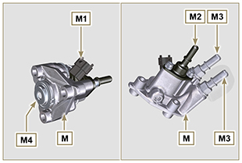  Fig. 2.49d
2.15.11 ETB (SCR versions only)  The ETB N is situated on the air intake line, is controlled by the ECU, which interfaces with the DCU and regulates the amount of intake air and is involved in the SCR system regeneration strategies. | 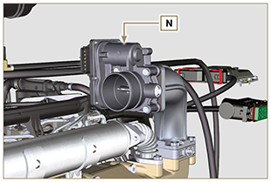  Fig. 2.49e
2.15.12 AdBlue® line heater (SCR versions only)  The P AdBlue® line pipes are covered with a resistor that heats the pipes in case of low temperature.  The resistor is activated by the DCU.  Features:  - Volt 12 V  - activation temperature< 5 °C  - operating temperature-40 °C | 120 °C | 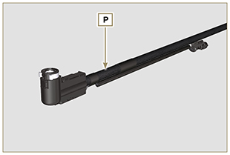  Fig. 2.49f
2.15.13 Electric fuel pump (optional)  NOTE: Component not necessarily supplied by KOHLER.  The electric pump is located before the fuel filter. One of the following pumps can be assembled A1 - A2 - A3 - A4.  Tab. 2.37 (a-d) indicates pump features.  Tab. 2.37  Tab. 2.37a  Tab. 2.37b  Tab. 2.37c  Tab. 2.37d | 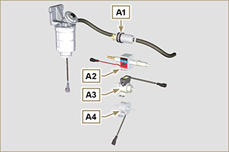  Fig 2.50  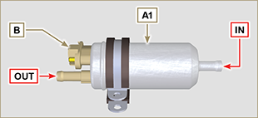  Fig 2.50a  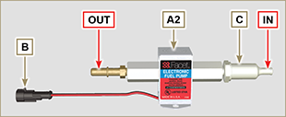  Fig 2.50b  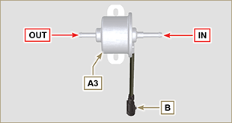  Fig 2.50c  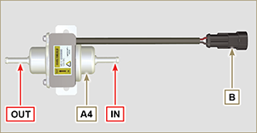  Fig 2.50d
  POS. | Description
  B | Electrical connection
  C | Prefilter pump
  IN | Ingoing fitting (IN) from tank
  OUT | Outgoing fitting (out) to fuel filter
  A1 | Value
  Voltage | 12 V - 24 V
  Delivery | 100 L/h @ 0.44 - 0.56 bar
  A2 | Value
  Voltage | 12 V
  Delivery | 60.56 L/h @ 0.41 bar
  A3 | Value
  Voltage | 12 V
  Delivery | 24 L/h @ 0.1 bar
  A4 | Value
  Voltage | 12 V
  Delivery | 30 L/h @ 0.4 bar

Timing system and tappets
The timing system is equipped with hydraulic tappets that automatically recover the operation of the rocker rods assembly.
No registration is therefore required.

2.16.1 Components identification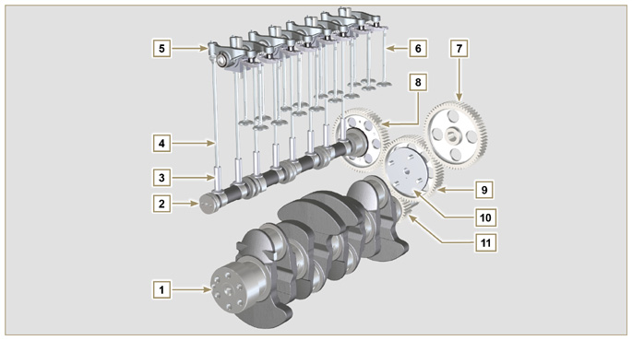
Fig 2.51
Tab 2.38 | 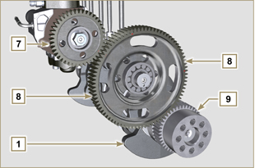 Fig 2.52 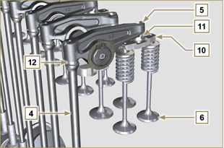  Fig 2.53
  POS. | DESCRIPTION
  1 | Crankshaft
  2 | Camshaft
  3 | Camshaft tappets
  4 | Rocker arm control rod
  5 | Rocker arms
  6 | Valves
  7 | High-pressure fuel injection gear pump control
  8 | Camshaft control gear
  9 | Crankshaft gear
  10 | Valve control bridge
  11 | Articulation control valves
  12 | Hydraulic tappets
2.16.2 Rocker arm pin  Tab 2.40 | 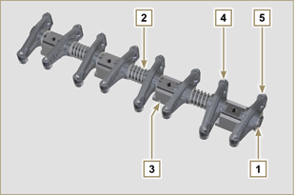 Fig 2.55
  POS. | DESCRIPTION
  1 | Rocker arm pin
  2 | Rocker arm distancing spring
  3 | Rocker arm pin support
  4 | Exhaust rocker arm
  5 | Intake rocker arm
2.16.3 Rocker arms  Tab 2.41 | 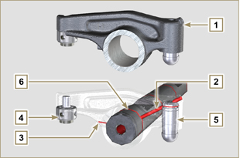 Fig 2.56
  POS. | DESCRIPTION
  1 | Rocker arm body
  2 | Hydraulic tappet oil refill line
  3 | Valve tappet lubrication line
  4 | Valve tappet
  5 | Hydraulic tappet
  6 | Oil flow line
2.16.4 Hydraulic tappets  Tab 2.42  2.16.4.1 Hydraulic tappet operation  The operating principle of the hydraulic tappet is based on the incompressibility of the liquids and on controlled leakage.  The oil under pressure enters the tappet chamber A , providing a constant supply of oil in the low-pressure chamber.  Through the non-return valve, 4 the oil can only access the high-pressure chamber B and exit via the clearance between the piston 3 and the tappet body 5 (controlled leakage).  The chamber B is filled when the rocker arm is on the base radius of the cam and the spring 6 keeps the piston 3 against the valve stem, thus eliminating any system play. Thanks to the spring extension, the tappet "extends", creating a small depression in the chamber B , making the non-return  valve 4 open, and allowing the oil in the chamber A to pass to chamber B , restoring the proper amount of oil required to eliminate any play in the valves. | 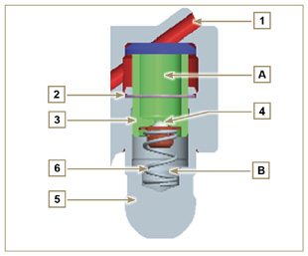  Fig 2.57
  POS. | DESCRIPTION
  A | Hydraulic tappets
  B | Hight pressure chamber
  1 | Hydraulic tappets oil refill pipe
  2 | Retaining ring
  3 | Piston
  4 | Unidirectional valve
  5 | Tappet body
  6 | Spring

2.16.4.2 Difficult operating conditions
For proper operation on the hydraulic tappets it is essential that the low pressure chamber of the piston 3 is always full of oil.

In some conditions this may not occur (due to the fact that the oil leaks away when the engine is switched off, which can also partially drain the tappets). This situation will be the cause of clearances that will result in a characteristic noise similar toa ticking sound.
- When the engine is cold, the tappet filling time could be very long if the oil used is not suitable for the specific environmental conditions ( Tab. 2.2 )
- If the engine is very hot: at idle speed, oil pressure may be low, and small air bubbles could form in the circuit. Because of this, this compressing the tappet slightly and producing valve play which is responsible for the ticking sound. On account of this, the tappet compresses slightly giving rise to a valve clearance, thus generating a slight ticking sound, which however disappears rapidly ( MAX 10 seconds) once normal operating conditions have been restored.

Anyway the duration of ticking Anyway the duration of ticking sound must be MAX 30 seconds. If not, the problem is surely due to the poor quality of the oil, wear or impurities that, transported by the oil, can infiltrate between the ball valve and its seat inside the piston, compromising the operation of the tappet itself; In these cases, the only solution is to replace the oil or hydraulic tappets.

The prolonged persistence of the ticking sound or abnormal noise must be investigating in order to prevent any malfunctions; if necessary, replace the hydraulic tappets and engine oil.

Components handling
2.17.1 High-pressure fuel injection pump  - Only handle by means of the points marked by Y .  - It is forbidden to handle using the points marked by N . | 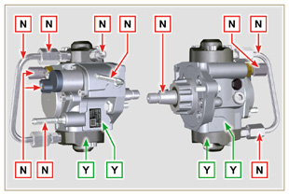  Fig 2.58
2.17.2 Electronic injector  - Only handle by means of the points marked by Y .  -It is forbidden to handle using the points marked by N . | 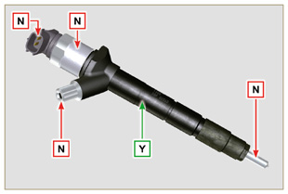  Fig 2.59
2.17.3 Common Rail  - Only handle by means of the points marked by Y .  - It is forbidden to handle using the points marked by N . | 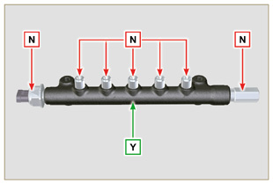  Fig 2.60
2.17.4 Turbocharger  - Only handle by means of the points marked by Y .  - It is forbidden to handle using the points marked by N .  Important  - Refer to Par. 2.18 . | 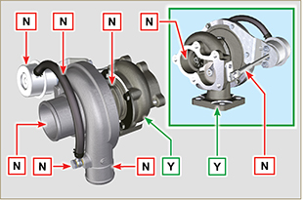  Fig 2.61
2.17.5 NOx Sensor  - Only handle by means of the points marked by Y .  - It is forbidden to handle using the points marked by N . | 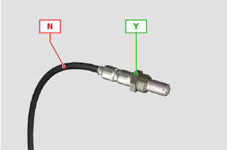  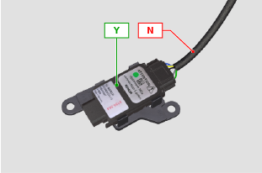  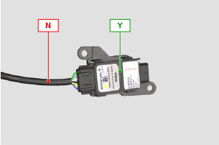  Fig 2.61a
2.17.6 SCR-T  - Only handle by means of the points marked by Y .  - It is forbidden to handle using the points marked by N . | 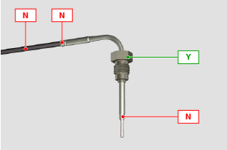  Fig 2.61b

Turbocharger

2.18.1 What to do and what not to do  What to do:  - Before assembling the turbocharger, make sure that the protection caps are fitted on all openings of the turbo.  - Ensure pre-lubrication of the turbocharger.  - Periodically check that the joints are sealed against oil and air.  - Use lubricating oil according to the specifications described in Par. 2.4 .  - Check the engine oil level.  - Before switching it off after it has been used, make the engine run idle, or without a load, for approximately 1 minute.  - Ensure that controls and maintenance intervals of the engine are observed as specified in Tab. 2.8 and 2.9 .  - Make sure that the engine and equipment are used correctly so as not to compromise the life of the turbocharger. | What not to do:  - Do not store turbocharges in damp, wet places if they are not in their original packaging.  - Do not expose the turbocharger to dust and dirt if it is not in its original packaging.  - Do not lift of hold the turbocharger from the actuator rod if it is not in its original packaging.  - Do not apply additives to the lubricating oil and fuel, unless instructed to do so by Kohler.  - Do not increase engine speed, or apply loads, immediately after start-up.  - Do not intervene on the actuator settings A (Fig. 2.61) .  - Do not let the vehicle / engine run at idle speed for more than 20-30 minutes at a time.
2.18.2 Practical operating rules  Users can help to maximise the duration of their turbocharger by following the rules described below.  - Start-up Start the engine at idle speed, or without a load, for approximately one minute. Oil operating pressure is reached within a few seconds and enables the moving parts to warm up and be lubricated.  Immediately increasing the engine speed upon start-up means making the turbocharger run at high speed with suboptimal lubrication, which may compromise the life of the turbocharger.  - After maintenance or a new installation  Proceed with pre-lubrication by filling new oil into the oil supply duct B until filling it completely. Start the engine at idle speed, or without a load, for a few minutes in order to ensure that the oil and bearings system operate satisfactorily.  - Low temperature air or engine inactivity  If the engine has been inactive for some time, or the air temperature is very low, start the engine at idle speed or without a load for a few minutes.  - Engine shutdown  Before switching the engine off after intense activity, one must allow the turbocharger to cool down. One must therefore let the engine run at idle speed or without a load for at least 2 minutes, thus allowing the turbocharger to cool.  - Engine at idle speed  Avoid using the engine at idle speed or without a load for long periods (more than 20-30 minutes). When operating at idle speed or without a load, the turbocharger is at low pressure in the exhaust chamber C and air supply D ; this may cause oil leaks from seals E  to the extremity of the shaft. Even if this does not cause damage, it can cause blue smoke from the exhaust when the engine speed and load are increased. | 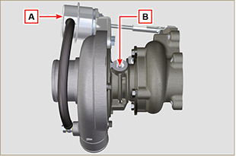  Fig 2.62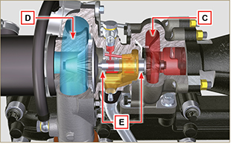  Fig 2.63
2.18.3 Before installing a new turbocharger  Important  - Do not lift the turbocharger with one hand from the box.  - Do not lift turbocharger from Comp hsg side.  - Lift the turbocharger with both hands from box.  - Make sure to use clean gloves.  - Handle the turbocharger as indicated in Par. 2.17.4. | 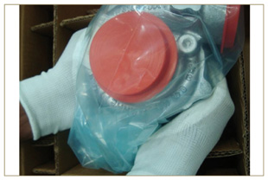  Fig 2.64
- Avoid lifting from the intake side G .  - Remove cap guard F and check that there is no excessive shaft axial and radial clearances. | 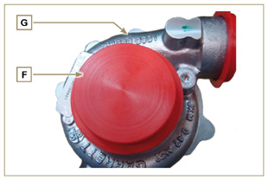  Fig 2.65
- Check for any signs of friction of the turbine on the turbocharger body.  - Check for any traces of oil leaks on the turbocharger body.  - After having check everything, reapply cap F on intake opening H of the turbocharger and do not remove it until assembly has been completed. | 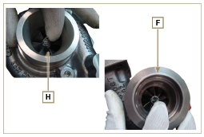  Fig 2.66
- Check the correct assembly of the capscrews and the presence of paint on them. | 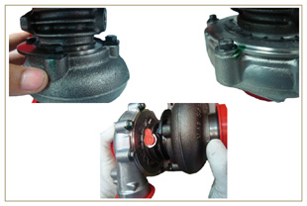  Fig 2.67
2.18.4 Installation instructions  - Remove the cap guards with care only when assembling.  Handle carefully avoiding erratic movements. | 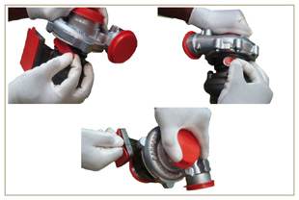  Fig 2.68
2.18.5 Replacement instructions

Always understand the cause of the breakage of the turbocharger before replacing it.

Correct the cause of the breakage before replacing it with a new turbocharger.

If in doubt, contact KOHLER service department.

Important

- Failure to comply with these instructions can cause damage to the turbocharger and void the warranty.
- Modifying the calibration of the turbocharger damages the turbocharger/engine.
- Always use the correct gaskets, and fit carefully to avoid blocking holes when mounting.
- Refer to the manual of the engine / vehicle, for: the correct type and quantity of oil, the correct tightening of components, instructions and installation.
- It is forbidden to use liquid gaskets or sealants, particularly for the oil inlet/outlet.
- Avoid dirt / debris while installing the turbocharger.
- Before mounting the turbocharger, check that the code of the component is correct for the type of engine, as mounting the wrong turbocharger can damage the turbo / engine and void the warranty.

DEF circuit (SCR versions only)
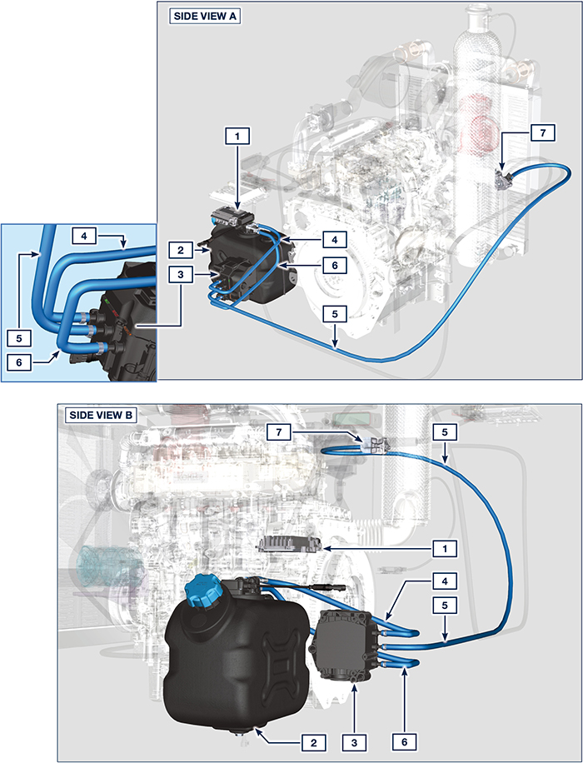

Certain components are for illustrative purposes only, can be subject to change and may not be supplied by KOHLER.
Tab 2.44
POS. | DESCRIPTION
1 | SCR system control unit
2 | DEF tank
3 | DEF pump
4 | DEF intake tube
5 | DEF delivery tube to DEF injector
6 | Return tube in DEF tank
7 | DEF injector

DEF (SCR versions only)
- Also known as "AUS 32" in Europe, "DEF" or "Urea Solution" in the USA, it is registered with the “AdBlue ® ” brand at the Verband der Automobilindustrie (VDA), and must comply with the following ISO standards:
- ISO 22241-1 Quality requirements
- ISO 22241-2 Test Methods
- ISO 22241-3 Handling, transportation and Storing
- ISO 22241-4 Refilling Interface
- The DEF tank must be filled by means of the specific automatic filling nozzle at the authorised distributors, refer to the car manual for refilling operations.
- Upon refilling, comply with the MAX level indicated on the tank.
- During the refilling operations prevent any impurity from entering the tank.
- At tank inlet there is a filter that must be periodically cleaned or replaced (see maintenance and replacement table - for tank supplied by Kohler only).
- DEF quality must comply with the specifications described in Table 2.45.
Warning
- Do not mix DEF with fuel or other liquids (including water) and do not fill the fuel tank with DEF.
- The presence of DEF inside the specific tank is required to start the engine.
- Purchase in containers: the container, even if opened, can be stocked with the same conditions of a sealed container.
- Do not stock the container with a temperature higher than 35°C as this could alter the DEF.
- In case of DEF freezing inside the container (< -11,5 °C | 11,3 °F), DEF can be used when it returns to its liquid state.
- Do not expose DEF to direct sunlight.
- In case of opening and closing of the original purchase container, DEF must be checked through a spectrometer to check its quality before use.
- Do not insert altered DEF in the tank as the engine could not respect the emission parameters, generate DCU errors and as a consequence turn off or fail to start the engine.
2.45
PARAMETERS | UNIT OF MEASUREMENT | VALUE
Title | Weight % | 31,8 ÷ 33,2
Density at 20°C | kg/m3 | 1.087 ÷ 1.093
Refraction index at 20°C | °C | 1,3814 ÷ 1,3843
Alkalinity like NH3 | Weight % | < 0,2
Biuret | Weight % | < 0,3
Aldehyde | mg/kg | < 5
Insoluble | mg/kg | < 20
Phosphates like PO4 | mg/kg | < 0,5
Calcium | mg/kg | < 0,5
Iron | mg/kg | < 0,5
Copper | mg/kg | < 0,2
Zinc | mg/kg | < 0,2
Chrome | mg/kg | < 0,2
Nickel | mg/kg | < 0,2
Aluminium | mg/kg | < 0,5
Magnesium | mg/kg | < 0,5
Sodium | mg/kg | < 0,5
Potassium | mg/kg | < 0,5
Freezing point | °C | -11

Balancer device (optional)
The balancer device is composed of a special crankshaft that activates 2 additional shafts (balancers).  Rotation of the balancers, which have counterweights that oppose the movement of alternating weights (crankshaft - connecting rods - pistons), reduces vibrations caused by them.  The device is developed under the crankshaft, fixed on the crankcase, closed by the oil sump.  Tab 2.43 | 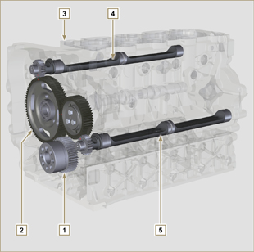  Fig 2.69
  POS. | DESCRIPTION
  1 | Crankshaft
  2 | Balancer shaft control gear
  3 | Balancer shaft support box
  4 | Conductor balance shaft
  5 | Conducted balance shaft



