General information
KDI-TCP 3404E5 Workshop Manual (Rev. 01.1)

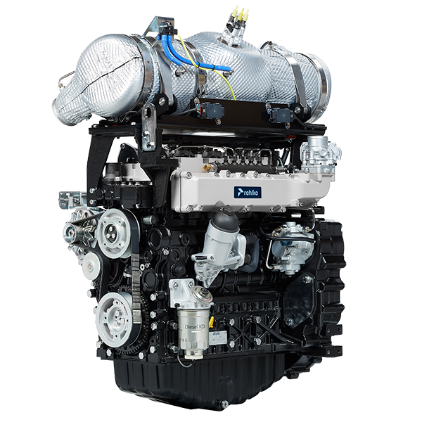

Registration of modifications to the document
Any modifications to this document must be registered by the drafting body, by completing the following table.

Released by | Code | Revision | Release Date | Revision date | Edited by | Endorsed
 | manoff

Translated from the original manual in Italian language
Data reported in this issue can be modified at any time by KOHLER.

Sommario
1. TITOLO 1 2
1.1. Asdfsdfsdf 2
1.2. Asdfsdfsdfggg 2

General information

Useful information
- This manual contains the instructions needed to carry out proper use and maintenance of the engine, therefore it must always be available, for future reference when required.
- Information, descriptions and pictures contained in this manual reflect the basic configuration of the engines ( Par. 1.4 and Par. 1.5 ).
- However, the development of engines is continuous. Therefore, the information in this manual is subject to change without notice.
- KOHLER reserves the right to make, at any time, changes on the engines for technical or commercial reasons.
- These changes do not require KOHLER to intervene on the production marketed up to that time and nor to consider this manual as inappropriate.
- The paragraphs, tables and figures are numbered by chapter and followed by the progressive paragraph, table and/or figure number.
Es: Par. 1.3 - chapter 1 paragraph 3 .
Tab. 2.4 - chapter 2 table 4 .
Fig. 4.5 - chapter 4 figure 5 .
NOTE: The paragraphs may contain sub-paragraphs.

- All technical terms, specific components and symbols ( Tab. 15.1 ) that are in the manual are listed and described inside the glossary, which can be consulted in ( Chap. 15 ).
- The references of the objects described in the text and in the figure are indicated by letters and numbers, which are always and only related to the paragraph you are reading unless there are specific references to other figures or paragraphs.
- Reference to values are indicated by letters or numbers.
- Other important references are highlighted in red.
- The mark ( ) after the title of a paragraph, indicates that the procedure is not required in order to disassemble the engine, however the procedures are featured in order to illustrate the disassembly of components.
- Any additional section that KOHLER will deem necessary to supply at a later stage must be kept with the manual and considered as an integral part of it.
- The information contained in this manual is the sole property of KOHLER , therefore no partial or total reproduction or replication is allowed without the express permission of KOHLER .

1.1.1 Useful Information - accident prevention - environmental impact

- Before proceeding repair - handling the motor , read the entire Chap. 3 , which contains important information about the procedures to be followed for safety and environment .

Manufacturer and engine identification
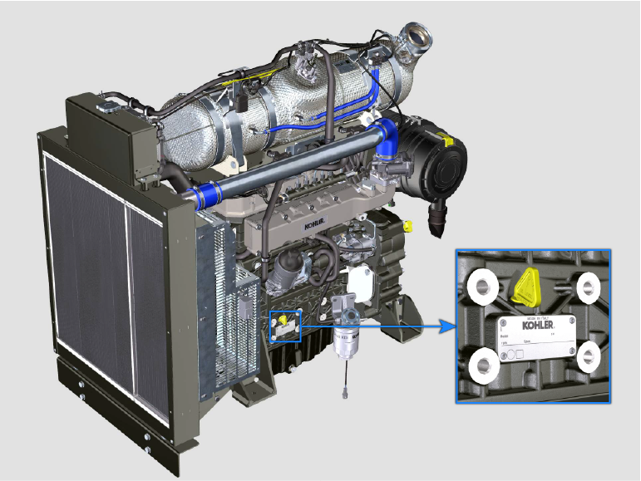
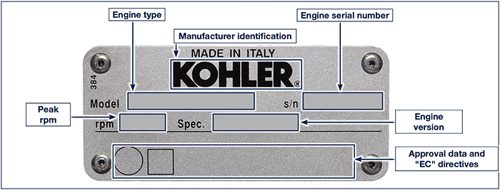
1.1

Homologation labels
1.3.1 Label for EPA rules (compilation example)

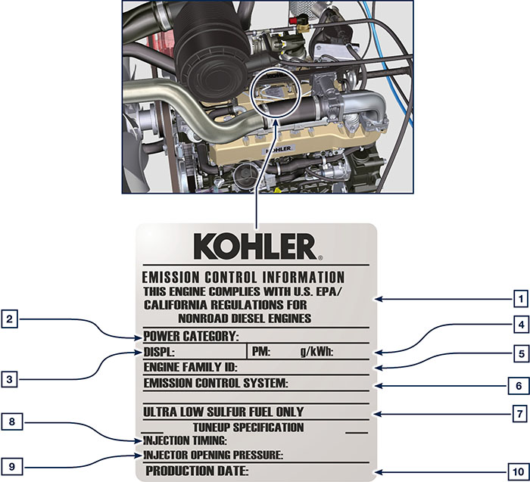

1.1
POS. | DESCRIPTION
1 | Model year in compliance with the rules
2 | Power category (kW)
3 | Engine displacement (L)
4 | Particulate emission limit (g/kWh)
5 | Engine family ID
6 | Emission Control System = ECS
7 | Fuel with low sulphur content
8 | Injection timing
9 | Electronic injector opening pressure (bar)
10 | Production date (example: 2013.JAN)

1.3.2 Label for China Standards (compilation example)

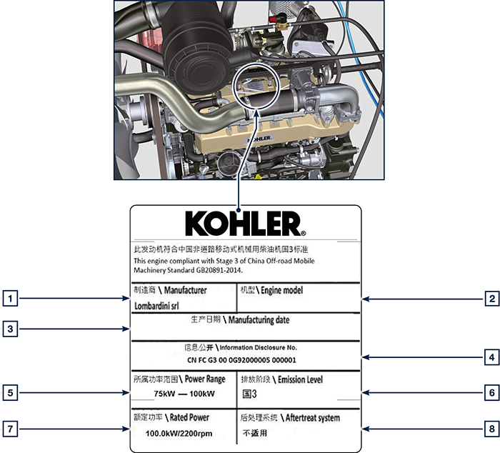

1.2
POS. | DESCRIPTION
1 | Manufacturer
2 | Engine model
3 | Manufactoring date
4 | Certificate N°
5 | Power range (kW)
6 | Emission level
7 | Rated power
8 | Aftertreat system

1.3.3 Label for Korea Standards (compilation example)

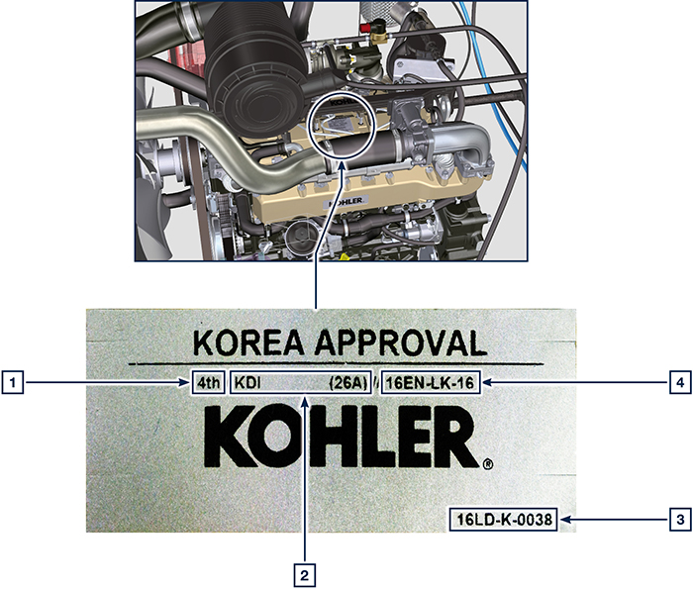

1.3
POS. | DESCRIPTION
1 | Tier 4 Final
2 | Engine model
3 | Manufactoring date and manufacturer code
4 | N° Korea emission certificate

Identification of the main internal components of the engine and operating reference (BASE CONFIGURATION)
WIEW OF EXHAUST SIDE
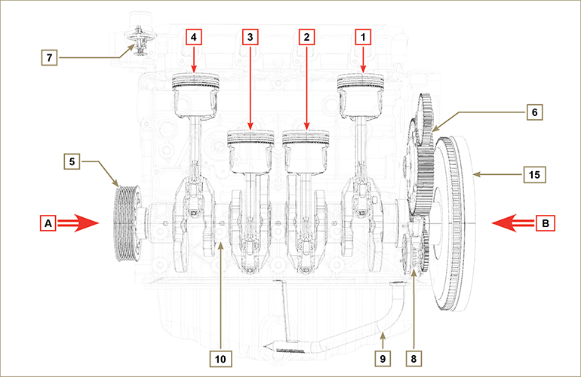
Fig 1.5

The following chapters contain operating references in order to clearly understand the engine. This paragraph illustrates these references that may be recognised by means of some main internal components.  Should you need to execute complex operations, always consult this paragraph.  NOTE: it is advisable to keepthis page visible during disassembly and assembly operations. | Tab 1.2
  REF. | DESCRIPTION
  A | View of timing system side (2 ^{nd} PTO)
  B | View of flywheel side (1 ^{nd} PTO)
  C | View of exhaust side
  D | View of intake side
  1 | Cylinder/Piston N. 1
  2 | Cylinder/Piston N. 2
  3 | Cylinder/Piston N. 3
  4 | Cylinder/Piston N. 4
  POS. | DESCRIPTION
  5 | Crankshaft pulley (2 ^{nd} PTO)
  6 | Gear timing system
  7 | Thermostatic valve
  8 | Oil pump
  9 | Oil suction hose
  10 | Crankshaft
  11 | Exhaust manifold
  12 | Intake manifold
  13 | Camshaft
  14 | Gears adaptor for 3 ^{th} /4 ^{th} PTO (optional)
  15 | Flywheel (1 ^{st} PTO)
  16 | Gears adaptor for 4th PTO (optional)
  17 | Balancer shafts
WIEW OF FLYWHEEL SIDE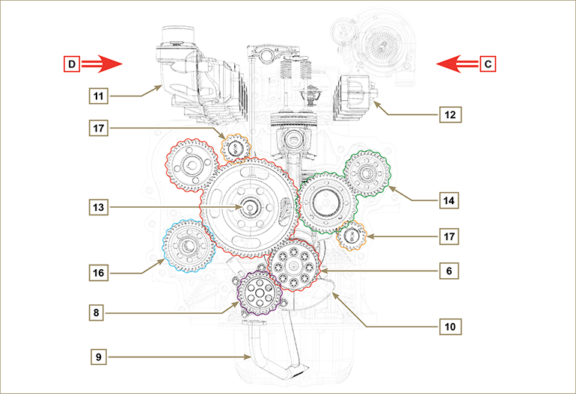
Fig 1.6

Engine component identification
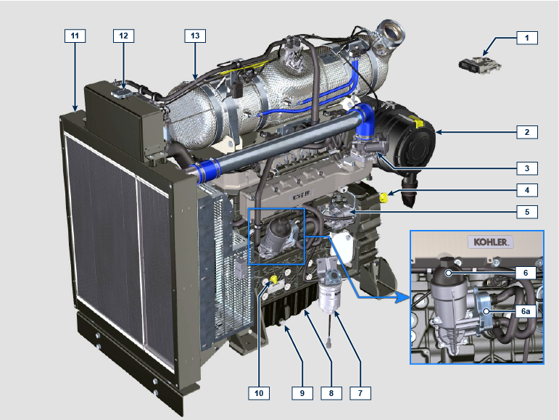

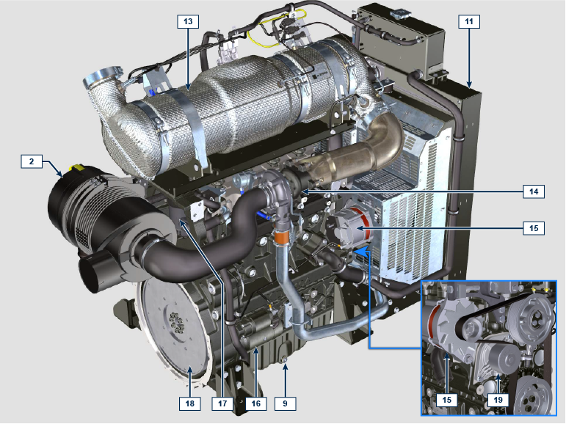

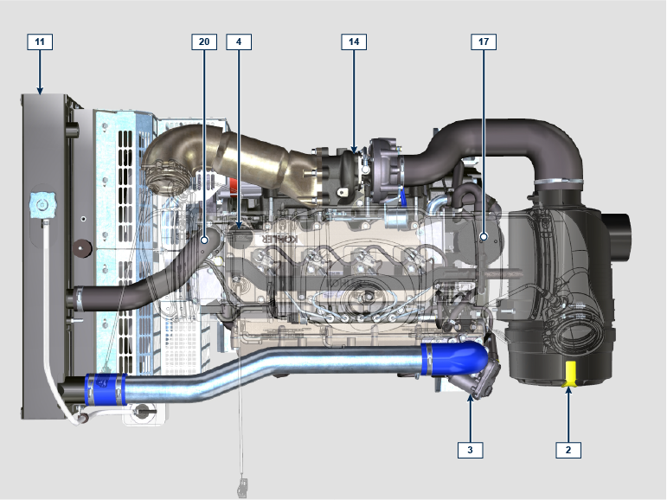

NOTE: Some components are for illustrative purposes only and may vary or they are not supplied by Kohler.
POS. | DESCRIPTION
1 | ECU
2 | Air filter
3 | Air inlet valve
4 | Oil filler cap
5 | High-pressure fuel injection pump
6 | Lub. oil filter
6a | Oil cooler
7 | Fuel filter
8 | Oil sump
9 | Oil drain plug
10 | Oil dipstick
11 | Radiator/Intercooler
12 | Coolant filler cap
13 | ATS
14 | Turbocharger
15 | Alternator
16 | Starter motor
17 | Oil steam separator
18 | Flywheel
19 | Coolant pump
20 | Thermostatic valve

Cooling circuit
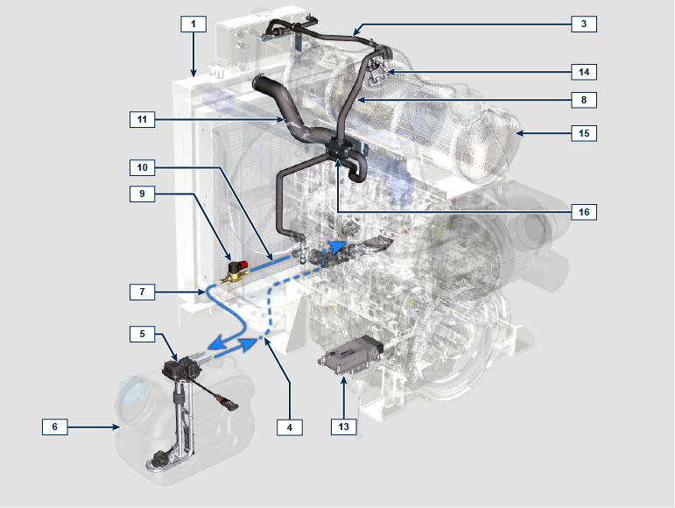
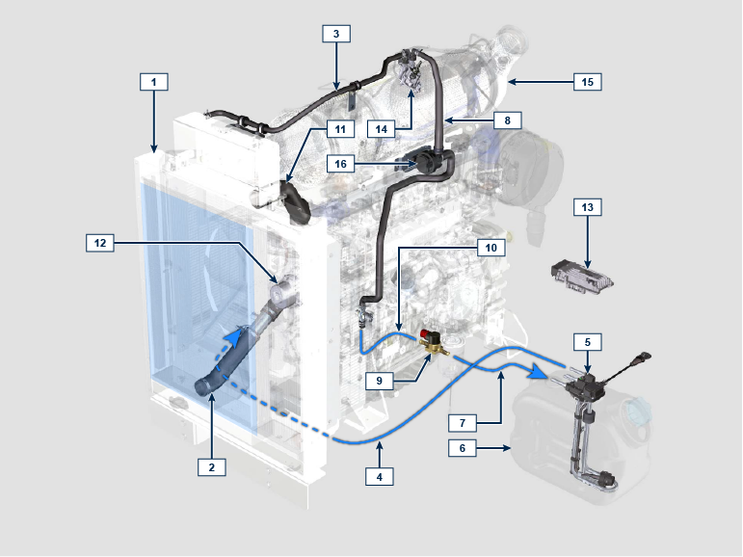

NOTE: Some components are for illustrative purposes only and may vary or they are not supplied by Kohler.
POS. | DESCRIPTION
1 | Radiator
2 | Intake sleeve
3 | Return tube to radiator
4 | Intake return tube
5 | Circuit for DEF heating
6 | DEF tank
7 | Coolant delivery tube in DEF tank
8 | Coolant delivery tube to DEF injector
9 | Electronic valve for coolant delivery to DEF tank
10 | Coolant delivery tube to SCR system
11 | Coolant to radiator return sleeve
12 | Coolant pump
13 | SCR system control unit
14 | DEF Injector
15 | ATS
16 | Coolant delivery pump to DEF injector (provided if needed)

DEF circuit
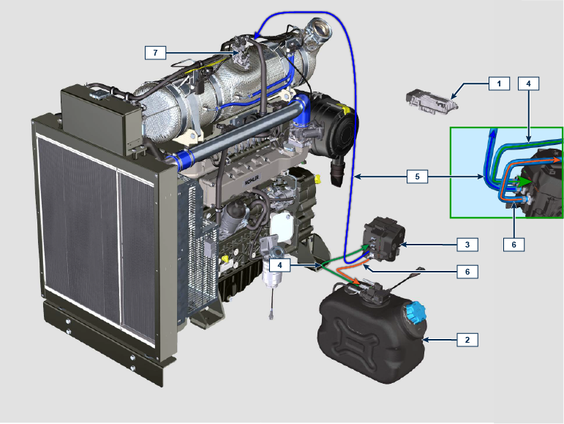

NOTE: Some components are for illustrative purposes only and may vary or they are not supplied by Kohler.
POS. | DESCRIPTION
1 | SCR system control unit
2 | DEF tank
3 | DEF pump
4 | DEF intake tube
5 | DEF delivery tube to injector
6 | Return tube in DEF tank
7 | DEF injector

Intake and exhaust circuit
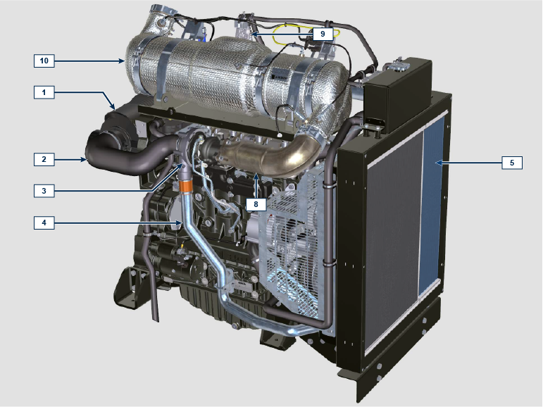

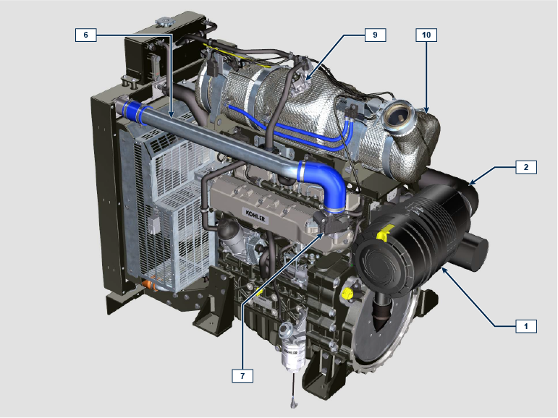

NOTE: Some components are for illustrative purposes only and may vary or they are not supplied by Kohler.
POS. | DESCRIPTION
1 | Air filter
2 | Air intake sleeve
3 | Turbocharger
4 | Air delivery tube to Intercooler
5 | Intercooler
6 | Air delivery tube to intake manifold
7 | Air inlet valve
8 | Exhaust gas delivery hose to SCR
9 | DEF injector
10 | ATS

ATS (After Treatment System)
ATS with DOC+DPF+SCR filter  NOTE: the ATS system with DPF filter is only present for versions compliant with "Stage V" emission regulations.  The ATS system can be installed in a different way than shown. | Tab 1.5
  POS. | DESCRIZIONE
  1 | Turbocharger
  2 | Turbine exhaust pipe
  3 | DOC
  4 | DPF
  5 | SCR
  6 | ETB
