Information about maintenance
KSD 1403 Owner Manual (Rev. 01)

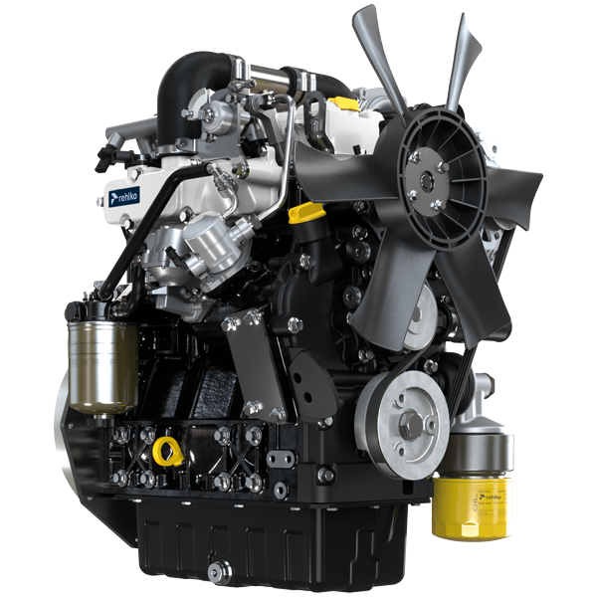

Registration of modifications to the document
Any modifications to this document must be registered by the drafting body, by completing the following table.

Released by | Code | Revision | Release Date | Revision date | Edited by | Endorsed
 | KSD1403

Translated from the original manual in Italian language
Data reported in this issue can be modified at any time by KOHLER.

Sommario
1. TITOLO 1 2
1.1. Asdfsdfsdf 2
1.2. Asdfsdfsdfggg 2

Information about maintenance

Pre-start check
- Read carefully the following pages and carry out the operations described below in accordance with the instructions specified.


Important

- Non compliance with the operations described in the following pages involves the risk of damages to the engine and vehicle on which it is installed as well as personal and/or property damage.
- Increase the frequency of maintenance operations in heavy working conditions (engine starts but stops, very dusty and hot environments, etc..).

First start procedure
Fuel system filling

Important

- Follow this instruction at the first start of the engine or in case the engine has stopped for empty fuel tank.
- Fill the fuel tank with approved fuel in Par. 2.5 .
For engine configuration with mechanical fuel feed pump  - Disconnect the connector A from injection pump B and put the connector A in a proper container.  - Push the lever C of the fuel feed pump D till the fuel spills from connector A .  - Connect the connector A on the injection pump B . | 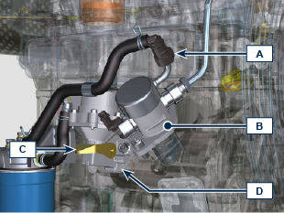
For engine configuration with electric fuel feed pump  - Disconnect the connector A from injection pump B and put the connector A in a proper container.  - Turn the control panel key to ON position till the fuel spills from connector A .  - Turn the control panel key to OFF position.  - Connect the connector A on the injection pump B . | 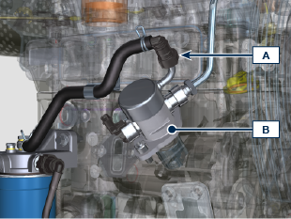

Starting and turning off
4.3.1 Starting

- Check the level of the engine oil, fuel and coolant and fill if necessary ( Par. 4.5 - 4.7 ).
- Put the ignition key in the ignition switch (if supplied).
- Tun the key to ON position.
- Turn the key beyond the ON position and release it when the engine starts (the key will return into ON position automatically).
Important

- At the first fuelling or if the tank was empty fill the fuel system ( Par. 4.2 ).
- Do not actuate the starter for more than 15 seconds at a time. If the engine does not start, wait for one minute before repeating attempt.
- If engine does not start after two attempts see Tab. 5.2 to found the cause.
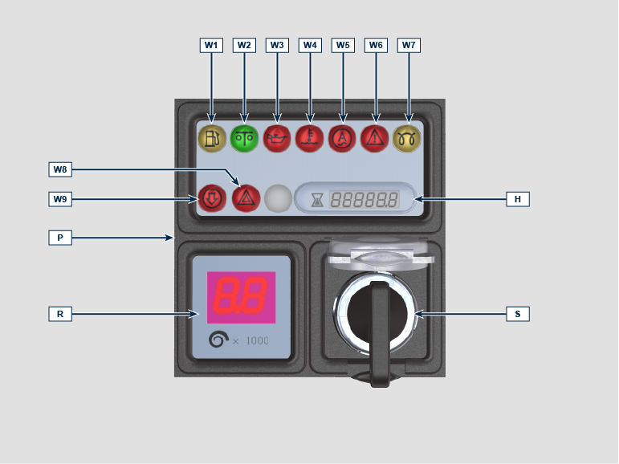
NOTE: the control panel image is for illustrative purposes only and may vary or it is not supplied by REHLKO .
Panel P can be assembled on the engine or machine. In Tab. 4.1 are described the main functions are illustrated.

Tab. 4.1
POS. | DESCRIPTION
H | Hour-meter indicator
R | Engine rpm indicator (RPM)
S | Control switch to start the engine
W1 | Warning Light - fuel below MIN level
W2 | No fault indicator
W3 | Warning Light - engine oil not pressurised
W4 | Warning Light - high coolant temperature
W5 | Warning Light - battery not charging
W6 | Warning Light - machine alarm indicator
W7 | Warning Light - glow plugs/heater ignition
W8 | Warning Light - alarm general indicator
W9 | Warning Light - air cleaner clogged

4.3.2 After starting

Warning

- Make sure that all the warning lights on the control panel are off when the engine is running.
- Run at minimum speed for a few minutes according to table (except constant speed engine).

Tab. 4.2
AMBIENT TEMPERATURE | TIME
≤-20°C | 2 minutes
from -20°C a -10°C | 1 minutes
from -10°C a -5°C | 30 seconds
from -5°C a 5°C | 20 seconds
≥ 5°C | 15 seconds

4.3.3 Turning off

- Do not turn off the engine when it is running at the maximum rotation speed (except constant speed engine).
- Before turning it off, keep it idle at minimum speed for about 1 minute.
- Turn the key to OFF position.

Periodic maintenance
- This chapter shows all operations described in the Tab. 4.3, 4.4, 4.5, 4.6 . if you have the skills appropriate may be directly carried out by the user.
- Periodic inspection and maintenance operations must be carried out as indicated in this manual and are the responsability of the user.
- Failure to comply with these service and maintenance intervals increases the risk of technical damage to the engine. Any non compliance makes the warranty become null and void.
- In order to prevent personal and property damage read carefully the instructions listed below before proceeding with any operation of the engine.

Warning

- Inspections must be made when the engine is off and cold.
- Place engine on level sur face to ensure accurate measurement of oil level.
- Before starting, to avoid spillages of oil make sure that: - the oil dipstick is inserted correctly;

- also check that:

oil drain plug and

oil filler cap are tightened firmly.

Important

- Before proceeding with operation, read Par. 3.2.2 .


Danger

- For safety precautions see Chap. 3 .

The intervals of preventive maintenance in Tab. 4.3, Tab. 4.4, Tab. 4.5 and Tab. 4.6 refer to the engine operating under normal operating conditions with fuel and oil meeting the approved specifications.
4.3
CLEANING AND CHECKING
OPERATION DESCRIPTION | PERIOD (HOURS)
OPERATION DESCRIPTION | 100 | 200 | 500
Engine oil level ⁽⁸⁾
Coolant level ⁽⁸⁾ ⁽⁹⁾
Water presence in fuel filter
Air filter cartridge ⁽²⁾
Radiator heat-exchange surface
Oil line hoses ⁽¹⁾ | TBD | TBD | TBD
Alternator belt ⁽⁸⁾
Rubber hoses (intake air / coolant) - Fuel hose ⁽³⁾
Starter Motor ⁽¹⁾
Alternator ⁽¹⁾
4.4
REPLACEMENT
OPERATION DESCRIPTION |  | PERIOD (HOURS)
 |  | 500 | 1000 | 2000 | 4000
Air filter Cartridge ⁽² ⁾
Oil line hoses ⁽⁵⁾ |  | TBD | TBD | TBD | TBD
Alternator belt ⁽ ³ ⁾
Rubber hoses (intake air / coolant) ⁽⁴ ⁾ ⁽⁶⁾ ⁽⁷⁾
Fuel line hose ⁽ ⁴ ⁾ ⁽⁶⁾ ⁽⁷⁾
Coolant | OAT ⁽ ⁴ ⁾ ⁽⁶⁾
Coolant | HOAT ⁽ ⁴ ⁾ ⁽⁶⁾ ⁽¹⁰⁾

4.5
ENGINE OIL AND OIL FILTER CARTRIDGE REPLACEMENT
ENGINE VERSION | PERIOD (HOURS)
ENGINE VERSION | 250 | 500 | 1000
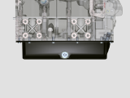 Small Sump ⁽¹⁾
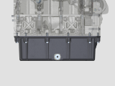 Compact Sump ⁽¹⁾
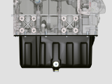 Deep Sump ⁽¹⁾

4.6
FUEL FILTER AND PREFILTER CARTRIDGE REPLACEMENT
ENGINE VERSION | PERIOD (HOURS)
ENGINE VERSION | 500 | 1000
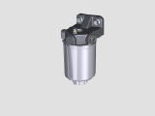 STD Filtration ⁽¹⁾
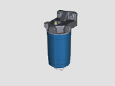 High Filtration ⁽¹⁾
(1) - In case of low use: 12 months. (2) - The period of time that must elapse before checking the filter element depends on the environment in which the engine operates. The air filter must be cleaned and replaced more frequently under very dusty conditions.

(3) - In case of low use: 36 months.
(4) - In case of low use: 5 years.
(5) - In case of low use: 24 months.
(6) - Contact authorized REHLKO workshops.
(7) - The replacement interval is only an indication, it strongly depends from environmental condition and hose status detected during regular visual inspection.
(8) - The first check must be done after 10 hours.
(9) - Test the coolant condition annually with coolant test strips.
(10) - It is recommended to have SCA (Supplemental Coolant Additives) added at the first maintenance interval.

Refuelling

Important

- Before proceeding with operation, read Par. 3.2.2 .

Danger

- Fill the engine off.
- The only approved fuels are those listed in Tab. 2.3 .
- In those countries where fuel has a high sulphur content, its is advisable to lubricate the engine with a high alkaline oil or alternatively to replace the lubricating oil approved by REHLKO more frequently.
- To avoid explosions or fire outbreaks, do not smoke or use open flames during the operations.
- Fuel vapours are highly toxic.Only carry out the operations outdoors or in a well ventilated place.
- Keep your face well away from the fuel fill to prevent harmful vapours from being inhaled.
- Dispose of fuel in the correct way and do not litter as it is highly polluting.
- When refuelling, it is advisable to use a funnel to prevent fuel from spilling out.The fuel should also be filtered to prevent dust or dirt from entering the tank.
Do not overfill the fuel tank. Leave room for the fuel to expand.

Engine oil and oil filter - Fill / Check / Replacement
Important

- For safety precautions see Par. 2.4 .
- Before proceeding with operation, read Par. 3.2.2 .
- Do not use the engine with the oil level below the MIN .
- Do not exceed the MAX level on the dipstick.
Filling  - Loosen the oil filler cap A or the oil filler cap C if the cap A is not accessible.  - Add the oil of type approved ( Tab. 2.2 ). | 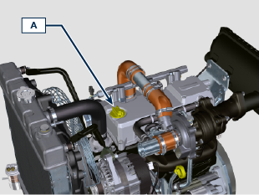  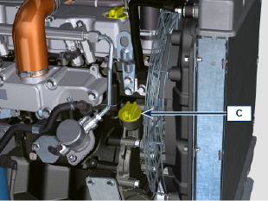  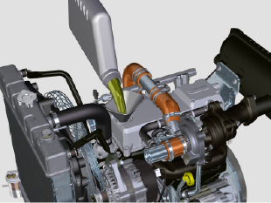
- Before checking oil engine needs to be level.  - Remove the oil dipstick B and check that the level is up to but does not exceed the MAX .  - If level is not at the MAX . level, add additional oil.  - Re-tighten the cap A, C . | 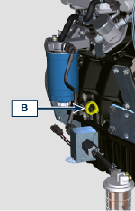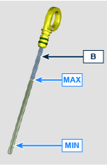
Oil level check

Perform the operations from point 3 to 6 .
Oil replacement

NOTE : Perform this operation with warm engine, to get a better fluidity of the oil and get a full discharge of oil and impurities contained in it.

- Loosen the oil filler cap A or the oil filler cap C if the cap A is not accessible.

- Unscrew the oil filter F with appropriate wrench.  - Before proceeding with operation, read Par. 3.2.2 . | 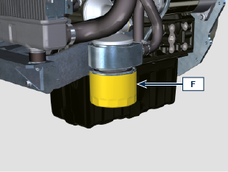  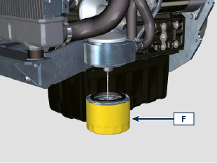
- Remove the oil dipstick B .  - Remove the oil drain plug D and the gasket E (the oil drain plug is on both sides of the oil sump).  - Drain oil in an appropriate container.  - Replace gasket E .  - Tighten the drain oil plug D (tightening torque at 35 Nm ). | 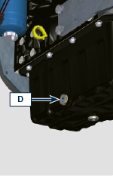  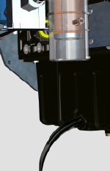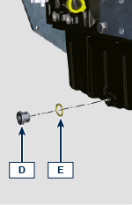
- Add the type of oil approved ( Tab. 2.2 ).
- Fit and remove the oil dipstick B to check the level.
Pour in fluid until reaching the MAX level mark.
- Upon completion, reinstall the oil dipstick B completely.
- Tighten the cap A, C .

Coolant - check/filling/replacement
Important

- Before proceeding with operation, read Par. 3.2.2 .
NOTE : Before proceeding with any operation on the engine, stop it and allow it to cool.

Warning

- Presence of steam pressurized coolant danger of burn.
- The freezing point of the refrigerant mixture depends on the amount concentration in water.
- As well as lowering the freezing point, the antifreeze also raises the boiling point.
- A 50% mixture is approved to ensure a general level at protection prevents the formation of rust, galvanic currents and calcium deposits.
NOTE : Component not necessarily supplied by REHLKO .
FILLING  - Loosen the cap A and fill the radiator with coolant composed of: 50% ANTIFREEZE and 50% decalcified water.  - Top liquid up until the pipes inside the radiator are covered by about 5 mm. Do not overfill the radiator, but leave room for the coolant to expand.  - For engines equipped with expansion tank, pour in fluid until reaching the max level mark.  - Re-tighten the cap A .  - Keep it running at idle speed until the cooling liquid level goes down and becomes steady (the waiting times varies according to the ambient temperature).  - Stop the engine and allow it to cool.  - If there is an expansion tank ( C ) top liquid up to the mark MAX .  - Without expansion tank top liquid up until the pipes inside the radiator are covered by 5 mm. Do not overfill the radiator, but leave room for the coolant to expand.  - Tighten the radiator cap A or the expansion tank ( C ) cap B .  Warning  - Before starting make sure that the radiator cap and expansion tank cap, if present, are installed correctly to avoid spillage of liquid or vapour at high temperatures.  - After a few hours of operation stop the engine and allow it to cool. Check and top up the coolant liquid.  CHECK  - Perform the operations from point 2 to 9. | 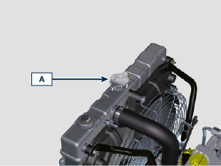  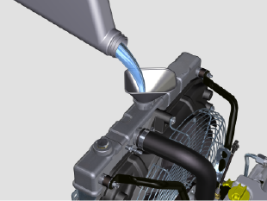  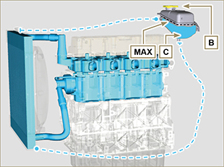
REPLACEMENT  - Undo the cap A carefully (circuit under pressure).  - Drain all the liquid inside the radiator via shut-off valve D into a suitable container.  - Loosen the screws E and remove the fuel filter bracket G .  - Unscrew cap F , remove gasket H to allow all the system fluid contained inside the pipes in the engine crankcase to drain.  - Tighten the drain oil plug F (tightening torque at 35 Nm ).  - Fasten the fuel filter bracket G with screws E (tightening torque 25 Nm ).  - Fill the radiator. | 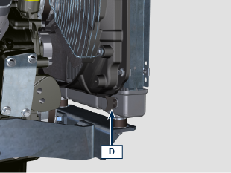  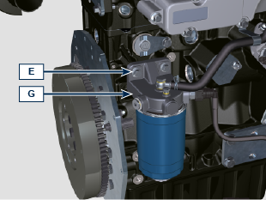  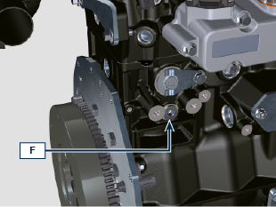  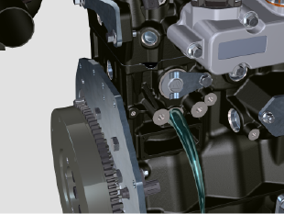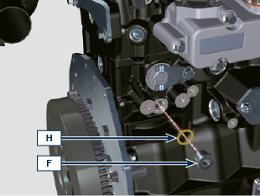  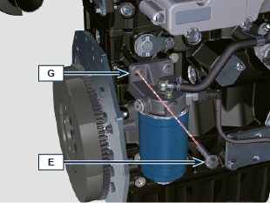

Air filter cartridge - Check/Replacement
Importante

- Before proceeding with operation, read Par. 3.2.2 .
NOTE : Components not necessarily supplied by REHLKO .

CHECKING / REPLACEMENT  - Release the two fastenings F of the cover A .  - Remove the cartridge B .  - Clean the inside components A and D with a damp cloth.  - Check the condition of cartridge B , replace it in case of suspecting of high level of clogging even if the hours of Tab. 4.4 are not reached.  - Reinstall:  - the cartridge B .  -the cover A checking the right tightness of fastenings F . | 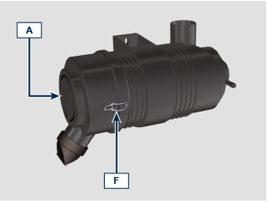  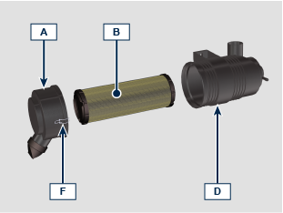

Fuel filter cartridge - Check/Replacement
Check  Important  - Before proceeding with operation, read Par. 3.2.2 .  Danger  - For safety precautions see Chap. 3.  - Gently loosen the water drain plug A without removing it.  - Spill out the water if present.  - Re-tighten the water drain plug A as soon as the fuel spills. | 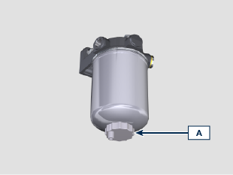
Replacement  Important  - Do not fill the new cartridge B with fuel.  - Procure a suitable container to collect the fuel.  - Loosen and remove cartridge B .  - Lubricate the gasket C .  - Tighten the new cartridge B onto support D (tighten manually). | 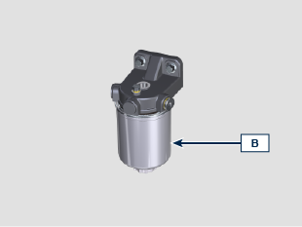  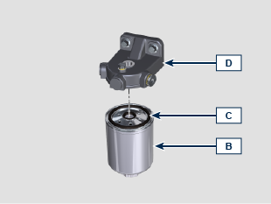
- Replace the prefilter H if present.  - Perform the operations described in Par. 4.2 . | 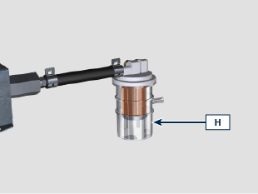

Check of the radiator heat - exchanger surface
Danger  - For safety precautions see Chap. 3 .  NOTE: Component not necessarily supplied by REHLKO .  Important  - Before proceeding with operation, read Par. 3.2.2 .  - Wear safety goggles when using compressed air.  - The radiator heat-exchange surface must be cleaned on both.  - Check the radiator heat-exchange surface A .  - Clean the surface with a brush soaked in special detergent if it is clogged. | 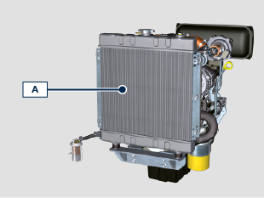

Rubber hoses check
  Danger  - For safety precautions see Cap. 3.  The check is carried out by exerting a slight deflection or bending along the pipe and near the hose clamps. Components must be replaced if they have clear signs of cracks, tears, cuts, leaks and do not retain a certain degree of elasticity.    Important  - Before proceeding with operation, read Par. 3.2.2 .  - If hoses are damaged contact an authorized REHLKO workshop.  - For other pipes not illustrated refer to the technical documentation of the vehicle. | 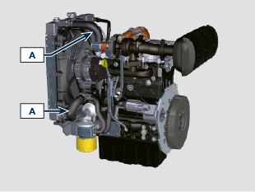
- Check the integrity of the pipes and hoses A . | 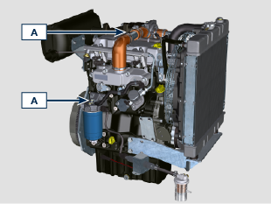

Alternator belt - check/replacement
Check  Important  - Before proceeding with operation, read Par. 3.2.2 .  Danger  - For safety precautions see Chap. 3 .  NOTE : The belt is not adjustable.  - Check the belt A condition, if worn out or deteriorated, replace it.  NOTE : Make sure that the ribs of the belt A are inserted correctly into the grooves of the pulleys B .  Replacement  - Remove the belt A using tool ST_57 .  - Install the new belt A using tool ST_57 . | 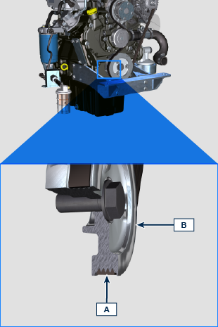
NOTE: ST_57 part number is ED0014604780-S.  Make sure that the ribs of the belt A are correctly placed into the grooves of the pulleys B . | 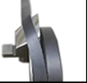  REMOVE | 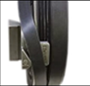  INTALL

Starter Motor
- Externally check the condition and clean motor A using compressed air. | 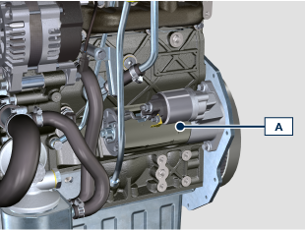

Alternator
- Externally check the condition and clean the alternator A using compressed air. | 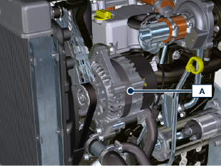

Product preservation
Important:
- If the engines are not to be used for 6 months, they must be protected by carrying out the operations described in Engine storage (up to 6 months) ( Par. 4.16 ).
- If the engine is still not in use after the first 6 months, it is necessary to carry out a further operation to extend the protection period (more than 6 months) ( Par. 4.17 ).
- If the engine is not to be used for an extended period, the protective treatment procedure must be repeated within 24 months of the previous one.

Engine storage (up to 6 months)
Before storing the engine check that:
- The environments are not humid or exposed to bad weather. Cover the engine with a proper protective sheet against dampness and atmospheric contaminants.
- The place is not near electric panel.
- Avoid storing the engine in direct contact with the ground.

Engine storage over 6 months
Follow the steps described in Par. 4.16 .
- Engine oil replacement ( Par. 4.6 ).
- Refuel with fuel additives for long storage.
- With expansion tank:
make sure that the coolant is up to the maximum level.
- Without expansion tank: Top liquid up until the pipes inside the radiator are covered by about 5 mm.

Do not overfill the radiator, but leave room for the fuel to expand.
- Start the engine and keep it idle at minimum speed for 2 minutes.
- Bring the engine to 3/4 of the maximum speed for 5÷10 minutes.
- Turn off the engine.
- Completely empty the fuel tank.
- Spray SAE 10W-40 on the exhaust and intake manifolds.
- Seal the exhaust and intake ducts to prevent foreign bodies from entering.
- When cleaning the engine, if using a pressure washer or steam cleaning device, avoid directing the nozzle on electrical components, cable connections and sealed rings (oil seals etc).
If cleaning engine with a pressure washer or steam cleaner, it is important to maintain a minimum distance of at least 200mm between the surface to be washed and the nozzle - avoiding absolutely electrical components such as alternators, starter motors and engine control units (ECU).
- Treat non-painted parts with protective products.

If the engine protection is performed according to the suggestions indicated no corrosion damage should occur.

Engine starting after storage
- Remove the protective sheet.
- Use a cloth soaked in degreasing product to remove the protective treatment from the external parts.
- Inject lubricating oil (no more than 2 cm ³ ) into the intake ducts.
- Refill the tank with fresh fuel.
- Make sure that the oil and the coolant are up to the MAX level.
- Start the engine and keep it idle at MIN speed for a two about minutes.
- Bring the engine to 75% of MAX rated speed for 5 to 10 minutes.
- Stop the engine while the oil is still hot, discharge the protective oil in a suitable container.

Warning

  - Over time, lubricants and filters lose their properties, so it is important consider whether they need replacing, also based on the criteria described in Par. 4.4 .

- Replace the filters (air, oil, fuel) with original spare parts.
- Pour new oil (Par. 4.6) up to the MAX level .
- Empty the cooling circuit completely and pour in the new coolant up to the MAX level ( Par. 4.7 ).

Unused machine
If the machine is not used for a certain amount of time, follow the operations below:

4.19.1 Operations for the engine
POINT | OPERATION
1 | Unused machine up to 2 months | - The place must be dry and fresh throughout the period in which the machine is not used.  - Consult the machine’s manual to disconnect the battery (before disconnecting the battery, wait for minimum 5 mins after turning off the engine).  - Make sure the engine is not exposed to direct sunlight.  - Make sure the engine is not near any heat sources.
1 | Starting | - Before starting the engine, check Par. 4.4 for maintenance operations.  - Consult the machine’s manual to connect the battery and start the engine.
2 | Unused machine from 2 to 9 months | - Perform the operations related to unused machine described in point 1.  - Perform the operations described in Par. 4.11.  - Start the engine at least every 4 months as per operations described in point 1:  - Avoid sudden accelerations for the first few minutes.  - Bring the engine to the working temperature by pressing the accelerator 3/4 from MAX.  - Leave the engine running at minimum speed for a few minutes and turning off the engine.
2 | - Starting | - Before starting the engine, check Par. 4.4 for maintenance operations.  - Consult the machine’s manual to connect the battery and start the engine.  - Avoid sudden accelerations for the first few minutes.
3 | Unused machine over 9 months | - Perform the operations related to unused machine described in point 1 and 2.
3 | Starting | - Before starting the engine, check Par. 4.4 for maintenance operations.  - Check the quality of coolant from the relative testing strips.  - Consult the machine’s manual to connect the battery and start the engine.  - Avoid sudden accelerations for the first few minutes.



