Information about use
KDI 2504TCR / KDI 2504TCRE5 Owner Manual (Rev_22)

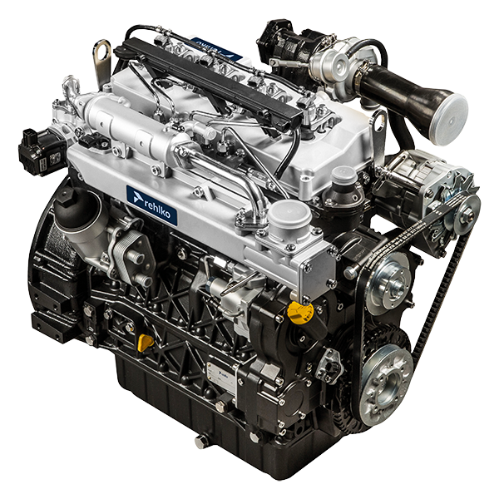

Registration of modifications to the document
Any modifications to this document must be registered by the drafting body, by completing the following table.

Released by | Code | Revision | Release Date | Revision date | Edited by | Endorsed
 | 2504tcr

Translated from the original manual in Italian language
Data reported in this issue can be modified at any time by KOHLER.

Sommario
1. TITOLO 1 2
1.1. Asdfsdfsdf 2
1.2. Asdfsdfsdfggg 2

Information about use

Pre-start check
- Read carefully the following pages and carry out the operations described below in accordance with the instructions specified.


Important

- Non compliance with the operations described in the following pages involves the risk of damages to the engine and vehicle on which it is installed as well as personal and/or property damage.
- Increase the frequency of maintenance operations in heavy working conditions (engine starts but stops, very dusty and hot environments, etc..).

Running-in period
NOTE: For the first 50 hours of engine operation, it is advisable not to exceed 75% of the maximum power supplied.

Starting and turning off
4.3.1 Starting
- Check the level of the engine oil, fuel and coolant and fill if necessary ( Par. 4.5 e Par. 4.6 ).
- Put the ignition key in the ignition switch (if supplied).
- Tun the key to ON position.
- Turn the key beyond the ON position and release it when the engine starts (the key will return into ON position automatically).

Important

- At the first fuelling or if the tank was empty filling the fuel system ( Par. 6.4 point 8 ).
- Do not actuate the starter for more than 15 seconds at a time. If the engine does not start, wait for one minute before repeating attempt.
- If engine does not start after two attempts see Tab. 7.1 and Tab. 7.2 to found the cause.
4.3.2 After starting

Warning

- Make sure that all the warning lights on the control panel are off when the engine is running.
- Run at minimum speed for a few minutes according to table (except constant speed engine).

NOTE: To avoid damaging the engine do not use it mostly at idle for a long time ( MAX 30min. ).

AMBIENT TEMPERATURE | TIME
≤ -20°C | 2 minutes
from -20°C a -10°C | 1 minutes
from -10°C a -5°C | 30 seconds
from -5°C a 5°C | 20 seconds
≥ 5°C | 15 seconds

4.3.3 Turning off
- Do not turn off the engine when it is running at the maximum rotation speed (except constant speed engine).
- Before turning it off, keep it idle at minimum speed for about 1 minute.
- Turn the key to OFF position.

Refuelling

Important

- Before proceeding with operation, read Par. 3.2.2 .


Danger

- Fill the engine off.
- The only approved fuels are those listed in Tab. 2.3 .
- In those countries where fuel has a high sulphur content, its is advisable to lubricate the engine with a high alkaline oil or alternatively to replace the lubricating oil recommended by REHLKO more frequently.
- To avoid explosions or fire outbreaks, do not smoke or use open flames during the operations.
- Fuel vapours are highly toxic. Only carry out the operations outdoors or in a well ventilated place.
- Keep your face well away from the fuel fill to prevent harmful vapours from being inhaled.
- Dispose of fuel in the correct way and do not litter as it is highly polluting.
- When refuelling, it is advisable to use a funnel to prevent fuel from spilling out.The fuel should also be filtered to prevent dust or dirt from entering the tank.
- Do not overfill the fuel tank. Leave room for the fuel to expand.
NOTE: At the first fuelling or if the tank was empty filling the fuel system ( Par. 6.4 point 8 ).

Oil filling
Important

- For safety precautions see Par. 2.4 .
- Before proceeding with operation, read Par. 3.2.2 .
- Do not use the engine with the oil level below the minimum.
- Loosen the oil filler cap A or the oil filler cap C if the cap A is not accessible.  - Add the oil of type recommended ( Tab. 2.1 and Tab. 2.2 ). | 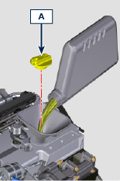 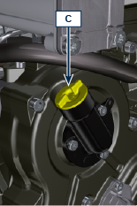  Fig 4.1
- Before checking oil engine needs to be level.  - Remove the oil dipstick B and check that the level is up to but does not exceed the MAX .  - If level is not at the MAX . level, add additional oil.  - Re-tighten the cap A or C . | 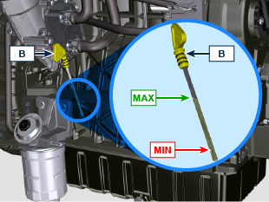  Fig 4.2

Coolant filling

Important

- Before proceeding with operation, read Par. 3.2.2 .

Warning

- An anti-freeze protection liquid (ANTIFREEZE) - mixed with decalcified water - must be used.
- The freezing point of the refrigerant mixture depends on the amount concentration in water.
- As well as lowering the freezing point, the antifreeze also raises the boiling point.
- A 50% mixture is recommended to ensure a general level at protection prevents the formation of rust, galvanic currents and calcium deposits.

NOTE: Before proceeding with any operation on the engine, stop it and allow it to cool.  Warning  Presence of steam pressurized coolant danger of burns.  - Loosen the cap A and fill the radiator with coolant composed of:  50% ANTIFREEZE and 50% decalcified water.  - Top liquid up until the pipes inside the radiator are covered by about 5 mm. Do not overfill the radiator, but leave room for the coolant to expand.  - For engines equipped with expansion tank, pour in fluid until reaching the max level mark.  - Loosen the screw C, release any air and tighten the screw C (Tightening torque of 8 Nm - Fig. 4.6 ).  - Re-tighten the cap A .  - After a few hours of operator, stop the engine and allow the liquid to cool returns to a ambient temperature and check the coolant level again. | 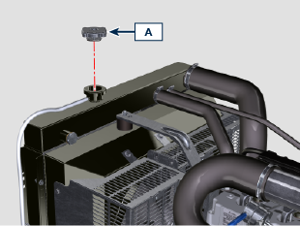  Fig. 4.3  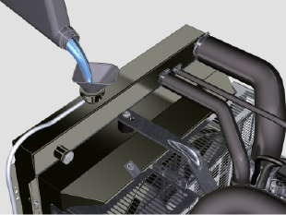  Fig. 4.4
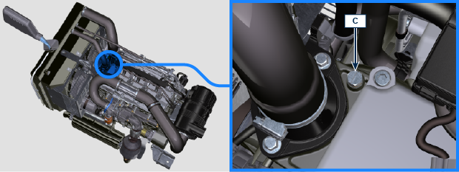
Fig. 4.5 - Fig. 4.6

ATS regeneration strategy (only for Stage V configurations)
Only for Stage V configurations (see Par. ATS)

You can intervene on the machine control panel for the DPF regeneration operations "only if requested by means of specific warning lights or messages on the control panel".
Tab. 4.11 describes the level of particulate accumulation, the relationship with the warning lights that will light up on the panel, the performance limitations of the engine and the operator’s options intervention.
Forced regeneration must be executed in accordance with the machine instructions.

4.11
SOOT LEVEL | WARNING LAMPS *1 | ENGINE DE-RATE | OPERATOR POSSIBLE ACTIONS | OPERATING CONDITIONS
Level 0 |  |  |  | - No condition
Level 1
Level 2
Level 3 |   Fixed |  | Forced Regeneration is Necessary. | - Coolant temperature at 60 °C  - Do not switch the engine off  - Stationary vehicle  - No load applied to the engine *2
Level 4 | Flashing | Engine de-rate. | Forced Regeneration is Necessary. | - Coolant temperature at 60 °C  - Do not switch the engine off  - Stationary vehicle  - No load applied to the engine *2
Level 5 |   Flashing | Strong Engine de-rate. | Contact an authorized REHLKO workshop.  Service Regeneration Required | REGENERATION via REHLKO software

*1: The warning lights be different – consult the machine manual.
*2: Unless stated otherwise in the machine manual.

Warning

- Forced regenerations must only be executed if required by the ECU when the "HIGH SOOT" warning light goes on (due to a Level 3 - 5 particulate accumulation).
- Do NOT execute the forced regenerations if not required by the ECU (due to a Level 0 - 2 particulate accumulation).
- The minimum engine speed increases during the forced regeneration phases.
- Repeated forced regenerations cause significant engine oil contamination by the fuel.
- The operations described in Par. 5.3 or 5.4 must be executed after every forced regeneration.
- If the regeneration inhibition function is misused, the particulate accumulation level will increase within a short time.
- The engine oil filter and oil must be changed after a Service Regeneration is completed via REHLKO software
- (Level 5 Particulate accumulation).
- Fuel contamination allowed in the engine oil is 3% MAX.
- Any engine load must be eliminated during forced regeneration so as to prevent damaging the ATS *2 system.
- Do not switch the engine off during level 3, 4 and 5 regeneration so as to prevent damaging the ATS system.



