Information for replacing the functional units
KDI 2504TCR / KDI 2504TCRE5 Workshop Manual (Rev. 17.8)

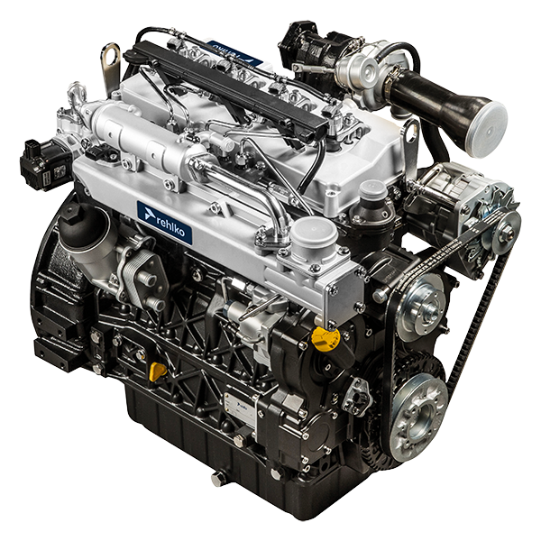

Registration of modifications to the document
Any modifications to this document must be registered by the drafting body, by completing the following table.

Released by | Code | Revision | Release Date | Revision date | Edited by | Endorsed
 | manoff

Translated from the original manual in Italian language
Data reported in this issue can be modified at any time by KOHLER.

Sommario
1. TITOLO 1 2
1.1. Asdfsdfsdf 2
1.2. Asdfsdfsdfggg 2

Information for replacing the functional units

Electronic injector replacement
  Important  - Before proceeding with operation, read Par. 3.3.2 .  - In the event of the electronic injectors being disassembled (not necessarily replaced) their position with respect to individual cylinders must not be changed when re-assembled. Refer to the reference between each injector and respective cylinder number.  - Seal all injection component unions as illustrated in Par. 2.9.8 during disassembly.  - Handle the components as described in Par. 2.17 .  - Replace all seal gaskets after each assembly for all components on which they are provided.  - The high pressure pipes must be replaced every time they are disassembled.  - Before disassembling the electronic injectors, make sure the new high pressure pipes are available.  - If a new (or different) electronic injector is fitted on the engine, the new calibration data must be entered in the ECU through a specific instrument ( ST_01 ) .  - Electronic injectors are not repairable.  - This procedure may be performed on one or more electronic injectors.  NOTE: In the event of a leak upon replacement (oil - coolant - fuel - air), do not intervene with the engine running, but stop it and wait for 5/10 minutes before checking and solving the problem. | 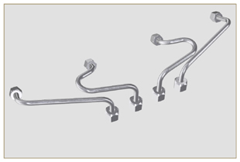  Fig 6.1
6.1.1 Fuel return pipes disassembly (Common Rail/electronic injectors)  - Disconnect the connector C . | 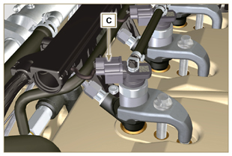  Fig 6.2
- Remove clips E from the electronic injector F .  - Disconnect the junction G from the electronic injector F .    Warning  - After removing the fittings, the clips E must automatically return to their initial position; otherwise they must be replaced.  - Seal all injection component unions as illustrated in Par. 2.9.8 . | 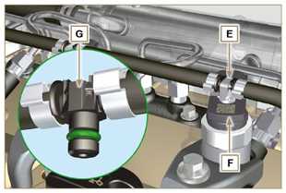  Fig 6.3
6.1.2 High pressure fuel pipes disassembly (Common Rail/electronic injectors)    Danger  - The fuel injection circuit is under high pressure, use safety protections as described in Par 3.4.3 .  - Ensure that the Common Rail is not under pressure by slowly and carefully unscrewing one of the nuts H .  - Undo the nut H on the Common Rail L and then the nut M on the electronic injector F and remove the pipe N .  Important  - In the event that the electronic injectors are disassembled (not necessarily replaced), mark them with the relevant cylinder number from which they originate so as not to confuse them during re-assembly.  - Seal all injection component unions as illustrated in Par. 2.9.8 . | 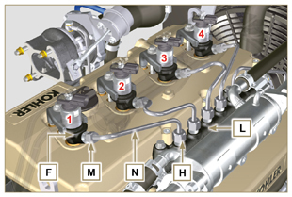  Fig 6.4
6.1.3 Electronic injectors disassembly  - Undo and remove the screw P with the washer R e and then the bracket Q .  Important  - Be careful not to damage the gaskets X .  - Replace rings X , if damaged.  2. Pull out the electronic injector F .  NOTE: Should you be unable to remove the electronic injector (acting only on point BC ), use an open-ended spanner (Ø 34 mm), by applying small rotations to unblock the component.  3. Seal all injection component unions as illustrated in Par. 2.9.8 .  4. Ensure that gasket S has remained in the correct position (Fig. 6.6) . Otherwise, recover the gasket from inside the electronic injector T manifold. | 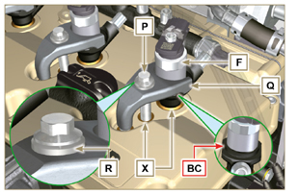  Fig 6.5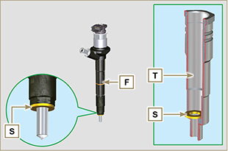  Fig 6.6
NOTE: Click by side to play the procedure. | https://www.youtube.com/embed/QQZtx2i75AY?rel=0
6.1.4 Electronic injector assembly  Important  - Always replace and lubricate the gaskets AA and S of the electronic injectors F with fuel, every time they are replaced.  - Reposition the electronic injectors (not replaced) by following the references made for disassembly, as indicated in Par. 6.1.2.  - If the engine is painted or protected with clear paint, clean the paint off the diesel injector F near to the part in contact with the gasket AB .  - Insert the gasket S on the electronic injectors F (Fig. 6.7) .  - Insert electronic injector F into manifold T , being extra careful not to damage gasket AB and direct it as indicated in Fig. 6.7 . | 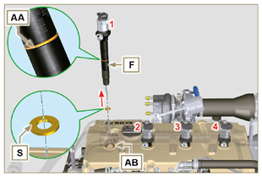  Fig 6.7
6.1.5 High pressure fuel pipes assembly  Important  - Always replace the pipes N after each assembly.  - If the engine is painted or protected with clear paint, replace the fastening screws P to ensure the gaskets are sealed properly.  - Position tube N in the Common Rail seat of the electronic injector; correct the position of the electronic injector by means of the entrance of the electronic injector unions F and Common Rail L .  - Apply the nuts H and M by hand without tightening them.  - Position the fastening brace of electronic injectors Q on capscrew surface AD , insert capscrews P in brace Q inserting washer R . | 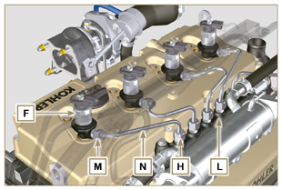  Fig 6.8
Important  - Ensure that brace S is perfectly positioned onto the electronic injector.  4. Tighten the fixing screws P of the electronic injector bracket (tightening torque at 20 Nm ).  5. Tighten the nut M (tightening torque at 25 Nm ).  6. Tighten the nut H (tightening torque at 30 Nm ). | 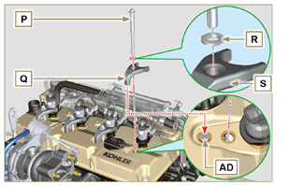  Fig 6.9
6.1.6 Fuel return pipes assembly  - Check the condition of the gaskets AE . | 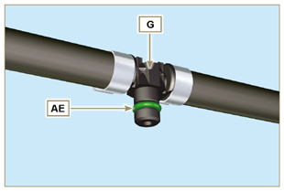  Fig 6.10
- Insert unions AF onto electronic injectors F and block them with clips E .  - Mount the connectors C on the electronic injectors F .  Warning  - Slightly move the wiring support to check that the electrical wire of connector C is not strained in correspondence with the outlet hole AF . | 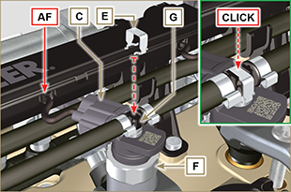  Fig 6.11
NOTE: Click by side to play the procedure. | https://www.youtube.com/embed/ArOgFV739EU?rel=0

High-pressure fuel injection pump replacement
Danger  - The fuel injection circuit undergoes high pressure, use safety protections as described in Par 3.4.3 .  - Ensure that the Common Rail is not under pressure by slowly and carefully unscrewing nut A .  Important  - Before proceeding with operation, read Par. 3.3.2 .  - Always replace the high pressure pipes after each disassembly.  - Before disassembling the injection pump, make sure the new high-pressure pipe is available.  - The injection pump is not repairable.  - Should the fuel feeding pump need to be replaced, after assembly, it is necessary to perform the Pump Learning procedure by means of instrument ST_01 .  - Seal all injection component unions as illustrated in Par. 2.9.8.  - To handling components refer to Par. 2.17.  - Always replace the gaskets (where are provided) after each disassembly. | 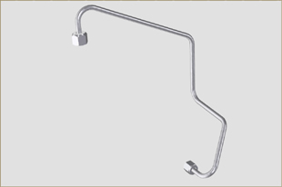  Fig 6.12
6.2.1 High-pressure fuel line disassembly (from the injection pump to the Common Rail).  - Undo the nut A . | 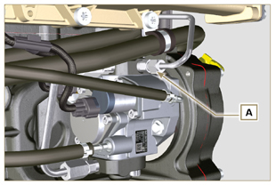  Fig 6.13
- Undo nut D from Common Rail E . | 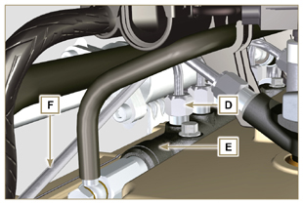  Fig 6.14
- Undo the nut B on the intake manifold C and remove the pipe F . | 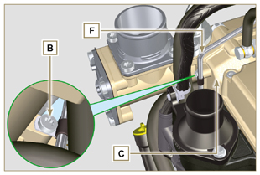  Fig 6.15
6.2.2 Timing system carter oil filling flange disassembly  - Remove starter motor ( Par. 7.3.2 ) and assemble special tool ST_34 ( Par. 7.7 point 2 ) .  - Undo the screws G ( ST_06 ) ,remove the clamp E and the flange H . | 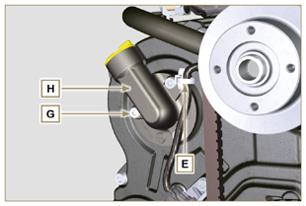  Fig 6.16
6.2.3 High-pressure fuel injection pump disassembly  - Undo and remove nut L fixing the fuel feeding pump control  gear M .  Important  - Be careful that the nut L does not fall into the timing cover.  - Tighten tool ST_04 on the gear M . | 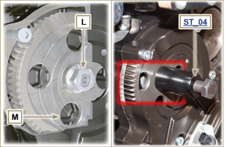  Fig 6.17
Important  - Do NOT use the cylinder connection pipe W as a handle, to prevent damage or fuel leaks.  - Before disassembling, carefully read Par. 2.17 .  - Seal all injection component unions as illustrated in Par. 2.9.8.  - Release the clamps N on the return pipe P and on the fuel inlet pipe Q .  - Disconnect tubes P and Q from fuel feeding pump R .  - Disconnect connectors S and T .  - Loosen the screws U .  - Redo the capscrew of tool ST_04 to disconnect injection  pump R from gear M .  - Undo capscrews U and extract injection pump R with the relevant gasket V .  - Undo and remove the tool ST_04 . | 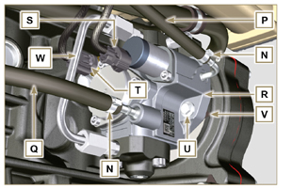  Fig 6.18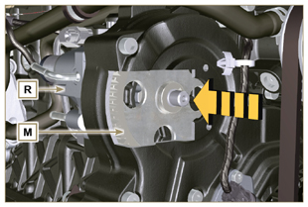  Fig 6.19
NOTE: Click by side to play the procedure. | https://www.youtube.com/embed/UaZgKyWrP48?rel=0
6.2.4 High-pressure fuel injection pump assembly  Important  - Before assembling, carefully read Par. 2.17  - Always replace the gasket V after each assembly. The gasket V can only be fitted in one direction.  - Remove the tool ST_04 from the pump control gear ( Ref. M of Par. 6.2.3 ) if applicable.  - Do NOT use the cylinder connection pipe W as a handle, to prevent damage or fuel leaks.  - Remove the protection caps only when reconnecting the hoses. | 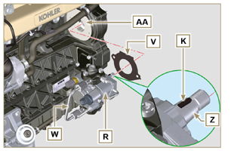  Fig 6.20
- Check that the contact surfaces AA are free from impurities.  - Insert the reference key K in the seat of the shaft Z .  - Assemble the new gasket V on injection pump R . Insert injection pump R in its housing on crankcase AA making key K coincide with key seat AH of gear M . | 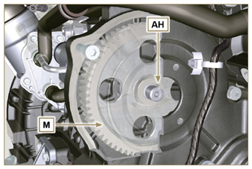  Fig 6.21
- Fully tighten the nut L on the shaft Z of the injection pump.  Important  - Apply nut L by hand, but do not tighten. | 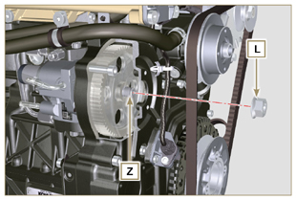  Fig 6.22
Important  - It is mandatory to replace the screws U or apply a few drops of Loctite 270 .  - Clamp the screws U on the crankcase AB (tightening torque at 25 Nm ).  - Clamp the nut L (Fig. 6.22) (tightening torque at 65 Nm ). | 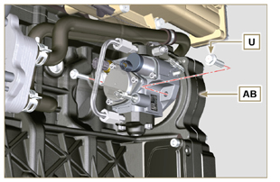  Fig 6.23
- Fit the connector T on the sensor J .  - Fit the connector S on the sensor Y .  - Remove the protection caps.  - Fit the pipe Q on the fitting AA .  - Fit the pipe P on the fitting AB .  - Hook the clamps N on the hoses Q and P . | 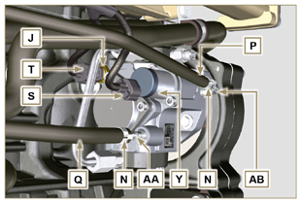  Fig 6.24
6.2.5 High-pressure line assembly (injection pump /  Common Rail)  - Remove the protection cap.  - Position the pipe F .  Important  - Manually tighten the nut A . | 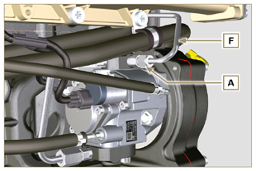  Fig 6.25
- Manually tighten the nut D .  - Fix clamp AC by means of capscrew B on intake manifold C (tightening torque 10 Nm - ST_06 ).  - Clamp nut D (tightening torque at 30 Nm ) and A (tightening  torque at 25 Nm ) in sequence. | 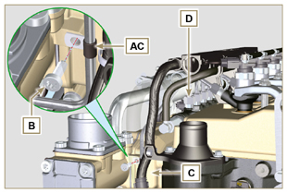  Fig 6.26
6.2.6 Timing system carter oil filling flange assembly  NOTE: Always replace the gasket AE after each assembly.  - Position the gasket AE in the set on the flange H .  - Fix the flange H on the crankcase AF with the screws AG (tightening torque at 10 Nm - ST_06 ).  - Fit the clamp E on the flange H .  - Disassemble the special tool ST_34 and assemble the starter motor (tightening torque 45 Nm ). | 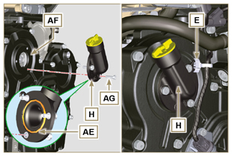  Fig 6.27
NOTE: Click by side to play the procedure. | https://www.youtube.com/embed/o3h6Say9sc4?rel=0

Unit EGR Cooler replacement
6.3.1 Disassembly  Important  - Before proceeding with operation, read Par. 3.3.2 .  - To handling components refer to Par. 2.17.  - Always replace the gaskets (where are provided) after each disassembly.  NOTE: Perform the operations described in Par. 5.1 .  - Undo the screws B of pipe C . | 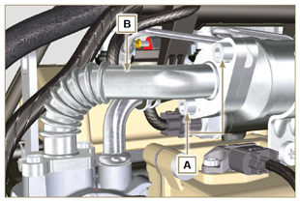  Fig 6.28
- Undo screws D and E .  - Remove pipe F and the relevant metal gaskets.  - Release the clamps G and remove the sleeve M . | 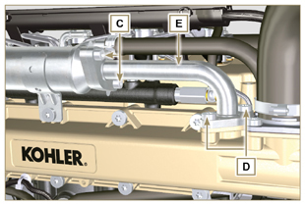  Fig 6.29
- Undo the screws H and remove the EGR Cooler L from the sleeve N ( ST_05 ).  - Should the passage ducts of the gas exhaust be clogged by soot or carbon, replace EGR Cooler L . | 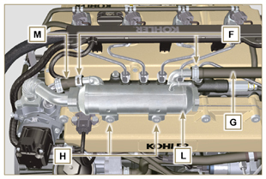  Fig 6.30
NOTE: Click by side to play the procedure. | https://www.youtube.com/embed/xGWUnc-V1YY?rel=0
6.3.2 Assembly  - Insert the fitting U in the manifold M of the EGR valve unit.  - Fit the EGR Cooler L with the screws H on the intake manifold S (tightening torque at 22 Nm - ST_05 )  - Insert the hose G on the fitting V .  - Secure the clamps F . | 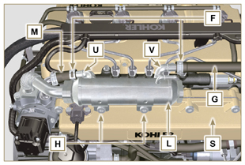  Fig 6.31
- Insert the gasket N between the hose B and the EGR Cooler L and fix the screws A (tightening torque at 25 Nm ) | 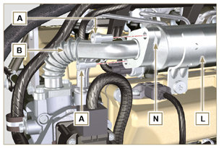  Fig 6.32
- Insert the hose E in its housing on the manifold S inserting the gasket R .  - Insert the gasket T between the hose E and the EGR Cooler L and fit the screws C (tightening torque at 25 Nm ).  - Fit the screws D (tightening torque at 22 Nm - ST_05 ).  NOTE: Perform the operations described in Par. 10.2 . | 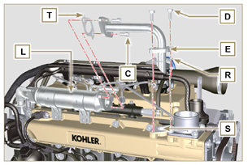  Fig 6.33
NOTE: Click by side to play the procedure. | https://www.youtube.com/embed/XSTfzyJa-9Q?rel=0

EGR valve replacement
6.4.1 Disassembly  Important  - Before proceeding with operation, read Par. 3.3.2 .  NOTE: Perform the operations described in Par. 5.1 .  - Disconnect the connector A from the valve C .  - Undo the screws B and remove the EGR valve C with the relevant gasket. | 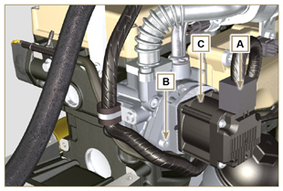  Fig 6.34
NOTE: Click by side to play the procedure. | https://www.youtube.com/embed/lZlk78GFzsg?rel=0
6.4.2 Assembly  Important  - Always replace gasket D after each assembly.  - The EGR valve is not a serviceable item, and if faulty / worn out, should be replaced with a new one.  - Movimentare i componenti come descritto nel Par. 2.17 .  - Mount the new gasket D on the valve C .  - Fit the valve C on the flange E with screws B (tightening torque at 10 Nm ). | 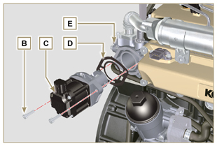  Fig 6.35
- Fit the connector A on the valve C .  NOTE: Perform the operations described in Par. 10.2 | 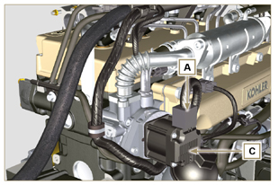  Fig 6.36
NOTE: Click by side to play the procedure. | https://www.youtube.com/embed/KGHm0dnsQdc?rel=0

Coolant pump replacement
6.5.1 Disassembly  NOTE: Perform the operations described in Par. 5.1 .  Important  - Before proceeding with operation, read Par. 3.3.2 .  - If the engine is fitted with the Poly-V belt, perform the operations described in Par. 11.3 .  - Loosen the screws A and B .  - Push the alternator C in the direction of the arrow D and remove the belt E .  - Release clamp F and disconnect tube G from the coolant pump N .  NOTE : If union R , is disassembled, replace it or alternatively apply Loctite 2701 on the thread when assembling on pump G (tightening torque of 20 Nm ). | 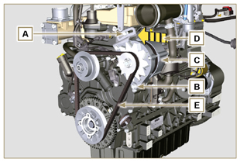  Fig 6.37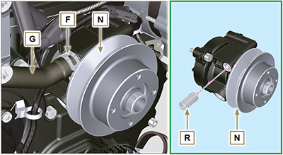  Fig 6.38
- Release the clamp M from the coolant pump N .  - Undo the screws H and remove the pump N with the relevant gasket L . | 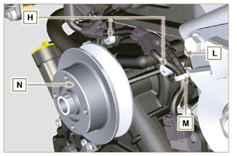  Fig 6.39
NOTE: Click by side to play the procedure. | https://www.youtube.com/embed/_QESHZf50PU?rel=0
6.5.2 Assembly  Important  - Always replace the gaskets L , after each disassembly.  - Always replace the belt E after each assembly.  - If the engine is fitted with the Poly-V belt, perform the operations described in Par. 11.3 .  - To handling components refer to Par. 2.17.  - Always replace the gaskets (where are provided) after each disassembly  - Fit the coolant pump N with the screws H interposing the new gasket L (tightening torque at 25 Nm ). | 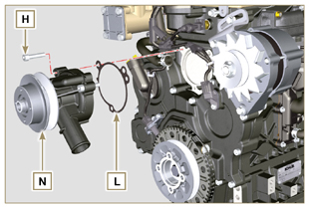  Fig 6.40
- Reinsert the pipe G and hook the clamp F ( Fig. 6.38 ).  - Rehook the clamp M on the pump N (Fig. 6.39) .  - Push the alternator C in the direction of the arrow D .  - Insert the belt E on the pulleys P . | 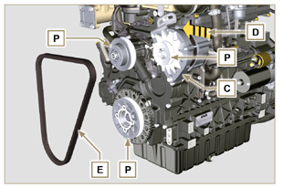  Fig 6.41
- Pull the alternator C in the direction of the arrow Q .  - While tensioning the alternator C , first clamp screw A (tightening torque at 25 Nm ) and then screw B (tightening torque at 69 Nm [thread M10] - 40 Nm [thread M8] ).  - Check the tension of the belt E with the instrument ( DENSO BTG-2 ), positioning it in point P (the tension must be between 350 and 450 Nm ).  - If the tension values do not correspond, tighten screws A and B , then repeat operations 6, 7 and 8 . | 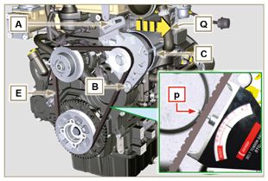  Fig 6.42
NOTE: Click by side to play the procedure. | https://www.youtube.com/embed/GbvNS15R9SQ?rel=0

Target wheel replacement
6.6.1 Disassembly  Important  - Before proceeding with operation, read Par. 3.3.2 .  - Position the crankshaft with the 1st cylinder in TDC, reference A upwards.  - Remove the alternator belt following steps 1 and 2 ( Par. 6.5.1 ) . | 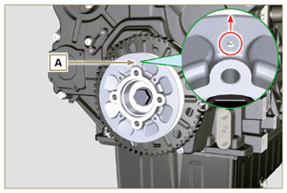  Fig 6.43
- Disassemble the starting motor.  - Mount the tool ST_34 in the seat of the starter motor C and fit it with the two starter motor fixing screws. | 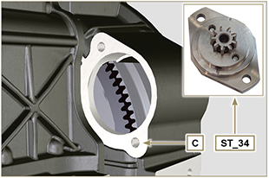  Fig 6.44
- Disconnect the connector L .  - Undo the screw M and remove the revolution sensor N and its respective spacer. | 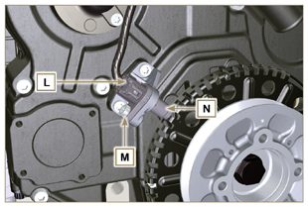  Fig 6.45
- Undo the screw P (clockwise) and remove the pulley/targetwheel unit Q . | 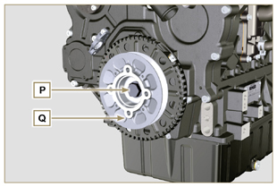  Fig 6.46
- Undo the screws R and remove the target wheel S with the relevant sound-absorption disk T . | 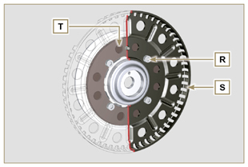  Fig 6.47
6.6.2 Assembly  - Check that the pin U is mounted properly on the pulley V .  - Insert the disk T on the pulley V respecting the reference of the pin U .  - Position the target wheel S on the pulley V respecting the reference of the pin U .  - Fit the target wheel S with the screws W (tightening torque 10 Nm ).  - Perform the operations described in Par. 6.7.7 and then the operations between point 2 and 9 of Par. 6.5.2 . | 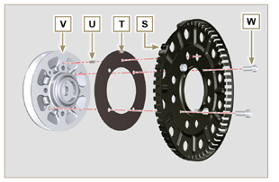  Fig 6.48

Oil pump replacement

Important

- Before proceeding with operations, read Par. 3.3.2 .
- The oil pump is not repairable.

6.7.1 Refrigerant pump disassembly  - Perform the operations described in Par 6.5.1 .  6.7.2 Crankshaft and target wheel pulley disassembly  - Perform the operations described in Par 6.6.1 .  - Disconnect the connector AE from the sensor S . | 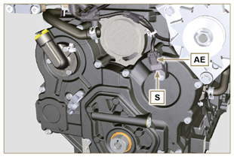  Fig 6.49
6.7.3 Timing system crankcase disassembly  Important  - Perform the operations described in Par. 5.2 .  - Make sure that the reference pin A is facing upwards.  - Undo the screw H ( ST_06 ) and remove the sensor S .  - Undo the screws B and remove the timing system crankcase C . | 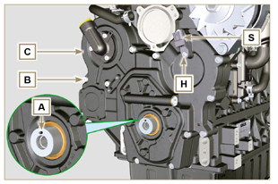  Fig 6.50
6.7.4 Oil pump disassembly  - Undo the screws D ( ST_06 ) and remove the group pump E from the timing system crankcase C .  - Remove the rotors F and G from the oil pump crankcase E . | 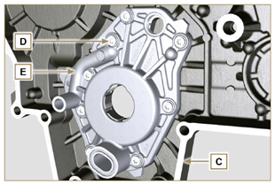  Fig 6.51  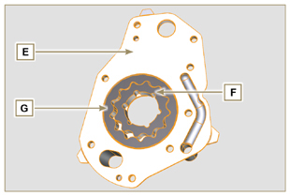  Fig 6.52
6.7.5 Oil pump assembly  NOTE: Carry out the checks described in Par. 8.7 prior to assembly.  - Check that all surfaces in contact between F, G, H, E and C are free from impurities - scratches - dents.  - When assembling, do not use any type of gasket between E and C .  - Thoroughly lubricate the seat of the rotors H on the oil pump crankcase E and the two rotors F and G .  - Within housing H insert the 2 rotors (in sequence) G and F , observing the references BP as described in figure (or refer to Par. 2.10.2 ).  - Check that the 2 pins L are inserted properly in the timing system crankcase C .  - Position the oil pump carter E using the reference pins L .  - Clamp the oil pump carter E with the screws D (tightening torque 10 Nm - ( ST_06 ) ). | 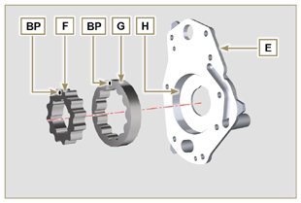  Fig 6.53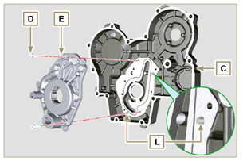  Fig 6.54
6.7.6 Timing system crankcase assembly  Important  - Always replace the oil seal J after each assembly.  - Always replace the gasket P after each assembly.  - To prepare the surface of the K plane for the new application of the sealant, it must be cleaned through the use of:  - initially Loctite SF 7200  - subsequently Loctite SF 7063  Avoid any contact with the K plane and be careful not to compromise the cleaning performed.  - Lubricate the lip of the oil seal J .  - Apply a coating of Loctite 5188 around 1mm thick on the surfaces K of the crankcase C .  - Make sure that the key M (Fig. 6.56) is inserted properly on the crankshaft and that it is facing upwards.  - Check that the 2 pins N are inserted properly in the timing system crankcase C . | 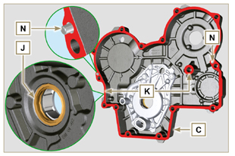  Fig 6.55
- Lubricate and insert the gasket P in the seat of the oil pump Q .  - Tighten the tool ST_10 on the crankshaft.  - Position the crankcase C on the base, using the reference pins N , inserting the oil pump Q on the crankshaft. | 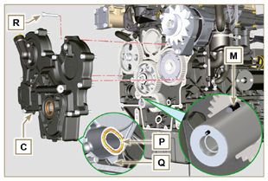  Fig 6.56
- Fit the timing system crankcase C with the screws R observing the indicated clamping sequence (tightening torque at 25 Nm ). | 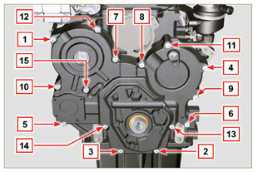  Fig 6.57
- Assemble sensor S by means of capscrew T on carter C inserting gasket U (tightening torque at 10 Nm ST_06 ). | 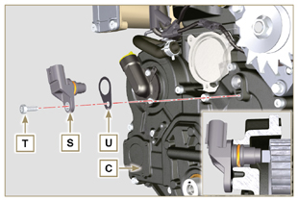  Fig 6.58
6.7.7 Crankshaft and target wheel pulley assembly  - Leave the tool ST_34 mounted ( Fig. 6.44 ) .  - Check that the pin A is mounted properly on the crankshaft Z .  - Position the pulley unit W on the crankshaft Z respecting the reference with the pin A .  - Apply Molyslip grease on the screw thread Y .  - Clamp the pulley unit W with the screw Y (tightening torque at 360 Nm ).  - Remove the special tool ST_34 ( Fig. 6.44 ) . | 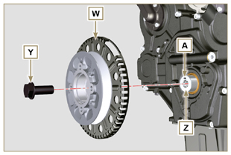  Fig 6.59
- Mount the bracket Z with the screws AA (tightening torque at 10 Nm ).  - Perform the operations described in Par. 9.12 .  - Insert the shim AB on the sensor AC .  - Clamp the sensor AC on the bracket Z with the screw AD (tightening torque at 10 Nm ).  6.7.8 Coolant pump assembly  - Perform the operations described in Par 6.5.2 . | 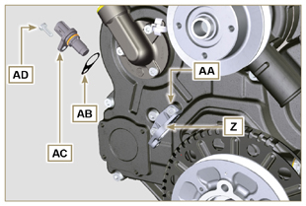  Fig 6.60

Oil pressure valve replacement
6.8.1 Disassembly  Important  - Before proceeding with operation, read Par. 3.3.2 .  - Undo cap A .  - Remove spring B , check its condition and replace it if broken.  - Remove the valve piston C using a magnet. | 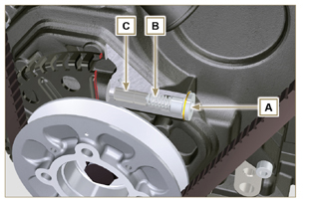  Fig 6.61
6.8.2 Assembly  - Lubricate the piston C and fully insert it in the seat E .  - Insert the spring B in the piston.  NOTE: Always replace the gasket F after each assembly.  - Mount the gasket F on cap A .  - Clamp the cap A on the crankcase D (tightening torque at 50 Nm ). | 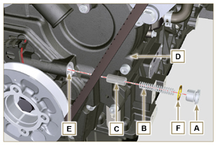  Fig 6.62

Oil vapour separator replacement
6.9.1 Disassembly  Important  - Before proceeding with operation, read Par. 3.3.2 .  - Release the clamp AA and remove the pipe D .  - Release the clamps F .  - Remove the clamp P cutting it in the point indicated and remove the separator body C removing it from the hose AG and G . | 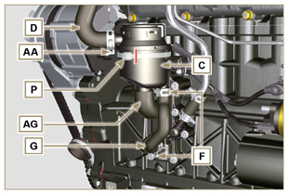  Fig 6.63
- Release the clamp F .  - Remove the pipes G and AG .  - Remove the clamp J .  - Undo the screws B .  - Release the clamp S from the sleeve K .  - Pull the flange H out of the manifold K and remove the relevant gasket, being careful not to bend the pipe E . | 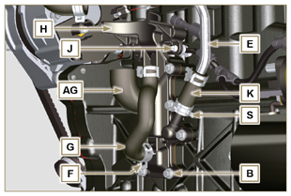  Fig 6.64
6.9.2 Assembly  Warning  - Always carefully inspect the condition of the tubes, and replace them if there is any doubt regarding their integrity.  - Always replace the gasket M after each assembly.  - Check that the contact surface L is free from impurities.  - Position flange H inserting hose K onto the flange union H , being careful not to bend tube E .  - Insert the gasket M between the flange H and the crankcase N .  - Secure the flange H using the screws B on the crankcase N (tightening torque at 10 Nm ).  - Secure the clamp S on the manifold K .  - Fit the pipes G and AG on the flange H .  - Fit the breather body C on the pipes G and D and fit the pipe G with the clamps F and the pipe D with the clamp AA .  - Fit the breather body C on the support flange H with the new clamp P . | 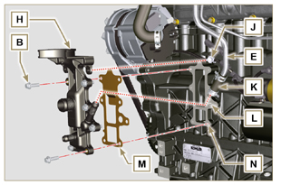  Fig 6.65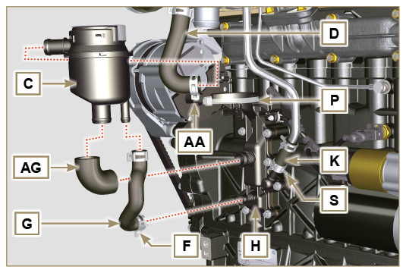  Fig 6.66

Oil cooler unit and oil filter replacement
6.10.1 Oil Cooler unit disassembly  Important  - Before proceeding with operation, read Par. 3.3.2 .  - Perform the operations described in Par 5.1 and Par 5.2 .  - Oil Cooler unit E is not repairable.  - Release the clamps A .  - Remove the pipes B out of the Oil Cooler unit E . | 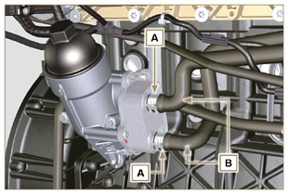  Fig 6.67
Warning  - Electric/pneumatic screwdrivers are forbidden.  - Use a suitable container to recover any residue oil.  - Unscrew cartridge holder cover H by performing three complete turns and wait 1 minute.  NOTE : this operation allows to oil contained in the support E to flow into the oil sump in the correct way.  - Unscrew cartridge holder cover H and check that the oil in the lub. oil filter support E has flowed towards the oil sump.  - Undo the screws C and D and remove the Oil Cooler unit E . | 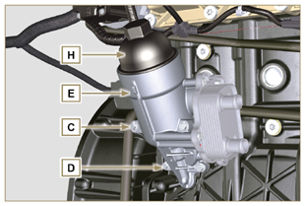  Fig 6.68
- Remove the gaskets F and G from the Oil Cooler unit E . | 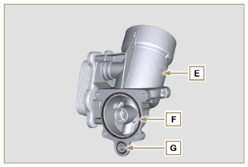  Fig 6.69
6.10.2 Oil filter cartridge replacement  - Remove gaskets L, M and N from element holder cover H .  - Remove cartridge P from element holder cover H . | 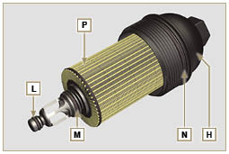  Fig 6.70
- Lubricate and insert gaskets L, M and N in the L1, M1 and N1 seats of element holder cover H .  - Insert element P into element holder cover H . | 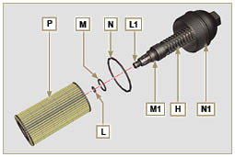  Fig 6.71
6.10.3 Oil Cooler unit assembly  Important  - In the event of assembly of union U on crankcase S , manual tightening torque with Loctite 2701 on the thread).  - Check that the surface Q on the support E and on the crankcase S are free from impurities.  - Lubricate and insert the gasket T on the fitting U .  - Lubricate and insert the gaskets on the support E :  F in seat F1 ;  G in seat G1 .  - Fit the support R with the screws C and D (tightening torque at 10 Nm ).  - Insert and tighten the cartridge support H on the filter support E (tightening torque at 25 Nm ).  - Fit the pipes B on the support E and secure the pipes B with the clamps A . | 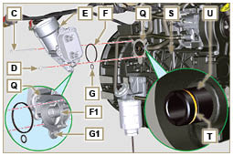  Fig 6.72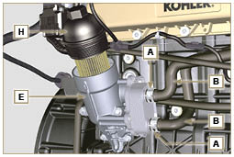  Fig 6.73

Fuel filter replacement
6.11.1 Disassembly  Important  - Before proceeding with operation, read Par. 3.3.2 .  Warning  - The fuel filter is not always mounted in the engine.  - When disassembling the sensor E , use a suitable container to recover the fuel contained in the cartridge F .  - Release the clamps A and pull the pipes B out of the support H .  - Unscrew the sensor E from the cartridge F .  - Unscrew the cartridge F from the support H .  - Undo the screws C and remove the support H . | 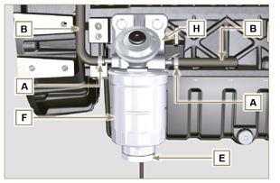  Fig 6.74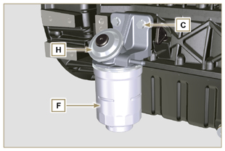  Fig 6.75
Warning  - Check that the fuel supply pump filter is present, and replace if necessary.  - Release the clamp D .  - Demount the hose E .  - Unscrew the filter G from the pump Q . | 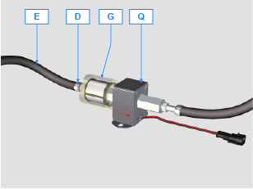
- Screw the new filter G onto the pump Q (tightening torque 20 Nm ).  - Connect the hose E to the filter G and fasten with the clamp D . | 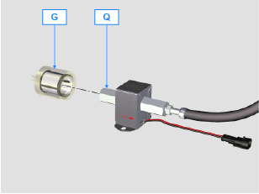
6.11.2 Assembly  - Clamp the fuel filter support H with the screws C on the crankcase M (tightening torque at 25 Nm ).  - Fit the pipes B on the support H .  - Secure the pipes B with the clamps A . | 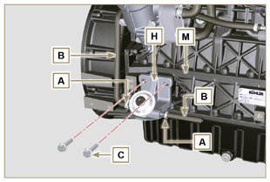  Fig 6.76
- Lubricate the gasket N with fuel.  - Tighten the cartridge F on the support H (tightening torque at 17 Nm ).  - Assemble gasket J onto sensor E and lubricate with fuel.  - Tighten the sensor E on the cartridge F (tightening torque at 5 Nm ). | 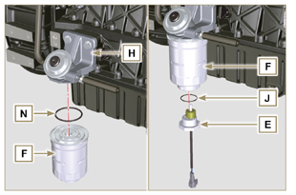  Fig 6.77

Replacement of SCV valve
Important  - Before starting any replacement operations, make sure the work area is free from dust (part X of valve B is extremely sensitive to micro-dust).  - Pay the utmost attention to cleaning in order to prevent any type of contamination during replacement operations  - - Before proceeding with the replacement, clean the outer part of pump A thoroughly - Avoid any type of contact with part X of the valve during replacement.  - Lubricate part X of valve B with oil spray.  - Before starting any replacement operations, make sure that the key on the vehicle’s panel is OFF .  - Assemble the new valve in the same position as the previous one. | 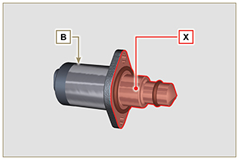  Fig. 6.78
6.12.1 Disassembly  1 - Disconnect connector C from valve B .  2 - Loosen screws D .  3 - Remove valve B from pump A . | 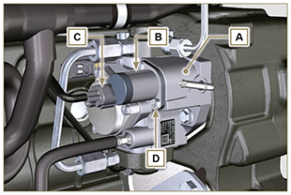  Fig. 6.79
6.12.2 Assembly  1 - Insert studs E supplied with valve B in the fastening holes of pump A and insert gasket F in the seat of pump A .  2 - Assemble valve B on pump A using studs E as positioning guides.  3 - Remove studs E and secure valve B with screws D (tightening torque of 6 Nm).  4 - Fasten valve B by means of screws D (tightening torque of 10 Nm). | 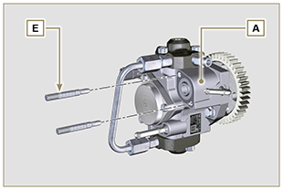  Fig. 6.80
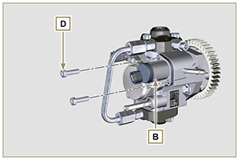  Fig. 6.81 | 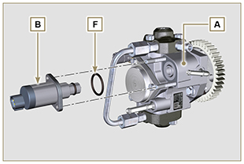  Fig. 6.82



