Assembly information
KDI 1903 M-MP Workshop manual (Rev.02.2)

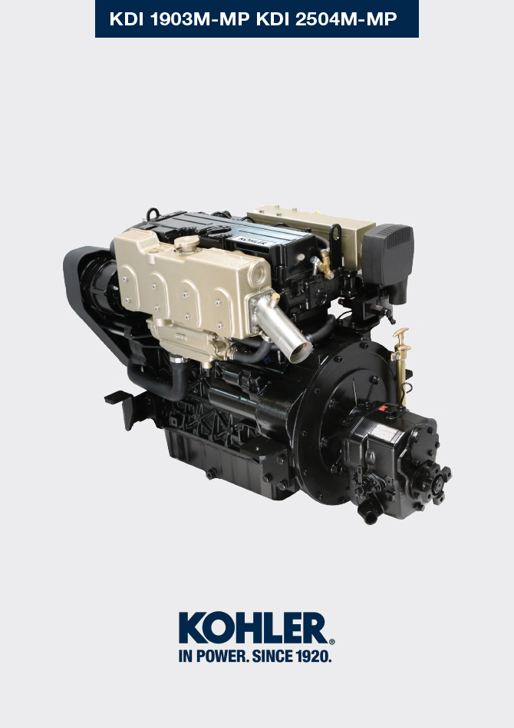
Sommario
1. TITOLO 1 2
1.1. Asdfsdfsdf 2
1.2. Asdfsdfsdfggg 2

Assembly information

Assembly recommendations
- The information is laid out in sequence, the intervention methods have been selected, tested and approved by the manufacturer's technicians.
- This chapter describes the installation procedures for the assemblies and/ or individual components which have already been checked, overhauled or possibly replaced with original spare parts.
- Where necessary, reference to special tools during assembly operations is indicated and identified in Cap.12 , hereinafter in Tab. 9.1 an example of a special tool ( ST_05 ).

Tab. 9.1
SPECIAL TOOLS
"ST" Code | Picture /draw | DESCRIPTION | PART NUMBER
ST_05 | 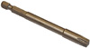 | Six nicks Key SN 8 | ED0014603650-S

Important

- Before proceeding with operations, read Cap. 3 .
- To easily locate specific topics, the reader should refer to the analytical index or chapter index .
- The operator must check that:
  - the components, the assemblies, the coupling surfaces of the parts are washed, clean and thoroughly dried;
  - the coupling surfaces are undamaged;
  - the equipment and tools are ready so that all work can be carried out correctly and safely;
  - ensure that the working environment is safe.
- The operator must:
  - carry out the procedures smoothly and safely. It is thus recommended to install the engine on a special rotating stand used when servicing engines to ensure the safety of the operator and the other individuals involved;
  - tighten the assemblies and / or components in a criss-cross or alternating pattern, initially with a value lower than that preset, and then subsequently, with the tightening torque specified in the procedure;
  - replace all seal gaskets after each assembly for all components on which they are provided.

Engine block assembly
9.2.1 Crankshaft bushings  Important  - Execute the procedure in Par. 8.2.1 and 8.2.2 , before proceeding with assembly..  - The crankshaft half-bearings are made of special material. Therefore, they must be replaced every time they are assembled to prevent seizures.  - Fit the new half-bearings B onto the crankcase upper half E adhering to the reference notches C .  Important  - After the half-bearings are fitted, check that the lubrication holes D correspond with the crankcase grooves E .  - The lower and upper half bearings CANNOT be singularly replaced, and both halves must be replaced together.  - Fit the new half-bearings A onto the lower crankcase F using the reference notches G .  - Lubricate the half-bearings A and B with oil. | 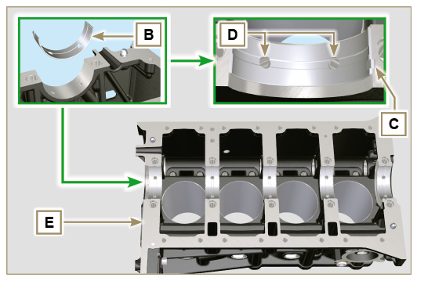  Fig 9.1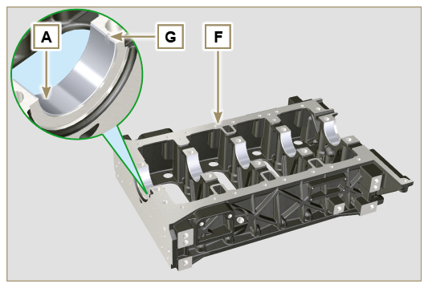  Fig 9.2
9.2.2 Tappets  - Lubricate the tappets G with oil.  - Insert the tappets G into the housings H of the upper crankcase. | 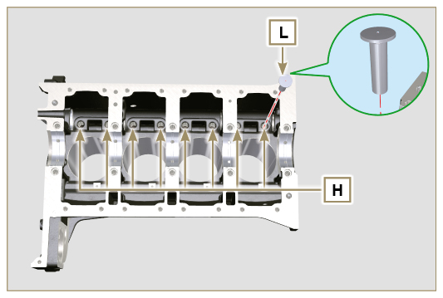  Fig 9.3
9.2.3 Camshaft  - Check that the bushing Q is correctly fitted.  - Lubricate the pins L , the cams M of the camshaft N , all the housing P ( Par. 8.2.4 or 8.2.6 )and the bushing Q with oil.  - Insert the camshaft N all the way into its housing P .  - Fit the lock ring R on to the crankcase E to hold the position of the camshaft N .  - Manually rotate the camshaft N ensuring that it is free. | 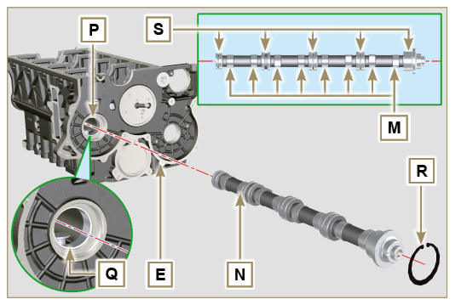  Fig 9.4
9.2.4 Vent compartment closure lid  - With the screws CF tighten the cover CG and the gasket CH (tightening torque to 10 Nm ). | 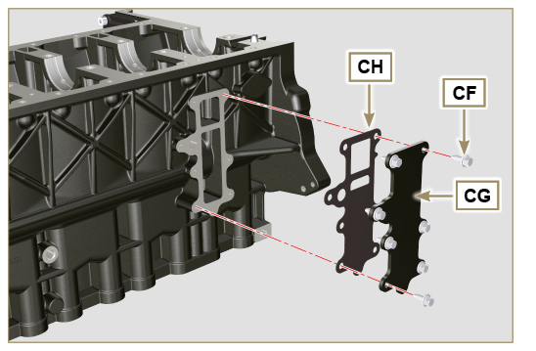  Fig 9.5
9.2.5 Crankshaft  Important  - Carry out the checks described in Par. 8.4.1 and Par. 8.4.2 .  - Check that the crankshaft half-bearings are mounted correctly on the upper crankcase E .  - Lubricate the main journal and crankpin J , with oil.  - Insert the crankshaft W into its seat on the upper crankcase E .  - Insert the 2 shoulder half-rings K , between the crankshaft W and the upper crankcase E ( AB detail). | 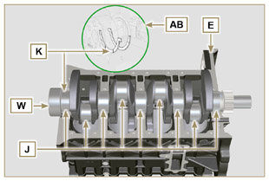  Fig 9.6
9.2.6 Lower crankcase  - Check that the crankshaft half-bearings are mounted correctly on the lower crankcase F ( AC detail).  - Assemble the 2 shoulder half-rings AD onto the lower crankcase F applying two drops of oil to keep them in their seat.  - Check that the coupling surfaces AE are free from dirt and grit. | 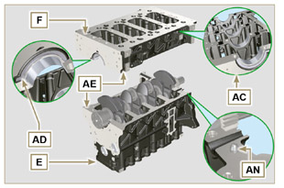  Fig 9.7
- Spread a bead of Loctite 5660 (rif. AL) of approx 1 mm thickness on the surface AM of the upper crankshaft half C being careful not to block the oil feed grooves AG and the return oil sump AH .  - Join the two crankshaft halves E and F observing the guide pins AN . | 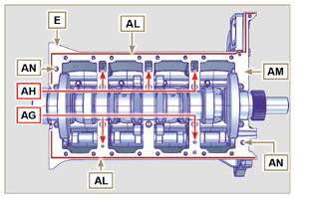  Fig 9.8
Important  - Failure to follow the bolting procedures compromises the functionality of the engine and can cause damage to people and property.  - Tighten the fastening screws strictly following the sequence and the tightening torque indicated.  Tightening sequence for 3 cylinders  Tightening Screws Torx M12x1,25 (from the n° 1 to the n° 8 ):  CYCLE 1 - with a torque of 40 Nm ;  CYCLE 2 - with a torque of 70 Nm ;  CYCLE 3 - with a torque of 120 Nm .  Tightening Screws Torx M8 (from the n° 9 to the n° 21 ):  CYCLE 4 - with a torque of 20Nm ;  CYCLE 5 - with a torque of 35 Nm ;  - Perform the operations described in Par. 8.4.2 .  - Check that crankshaft W rotates smoothly.  NOTE: In the next illustrations of Par. 9.3 the coupled crankcase half will be indicated with the letter E . | 3 Cylinders  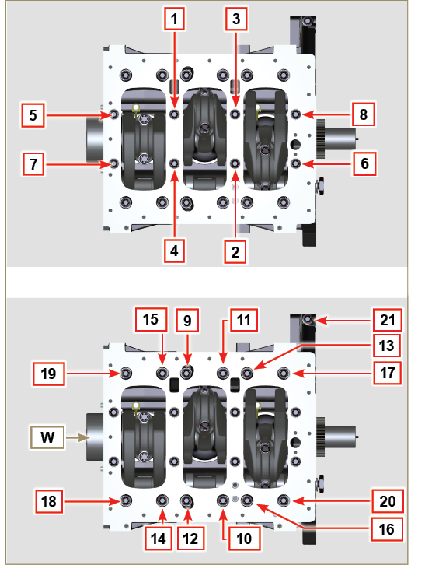  Fig 9.9
- Tightening sequence for 3 cylinders  Tightening Screws Torx M12x1,25 (from the n° 1 to the n° 10 ):  CYCLE 1 - with a torque of 40 Nm ;  CYCLE 2 - with a torque of 70 Nm ;  CYCLE 3 - with a torque of 120 Nm .  Tightening Screws Torx M8 (from the n° 11 to the n° 27 ):  CYCLE 4 - with a torque of 20Nm ;  CYCLE 5 - with a torque of 35 Nm ;  - Perform the operations described in Par. 8.4.2 .  - Check that crankshaft W rotates smoothly. | 4 Cylinders  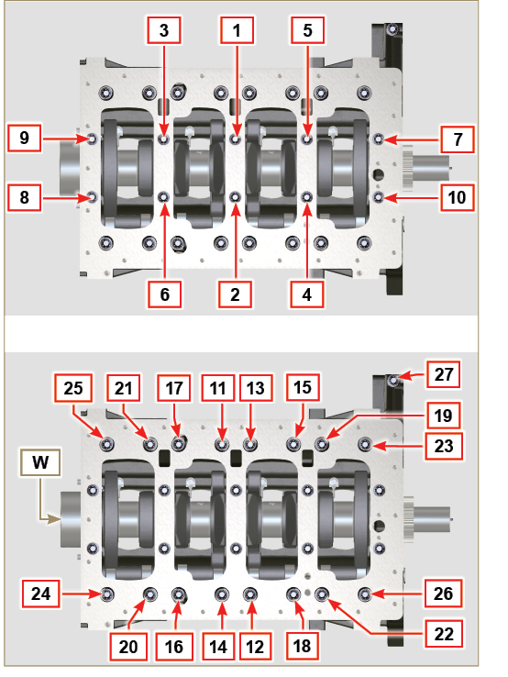  Fig 9.10
9.2.7 Piston rings  - Perform the operations described in Par. 8.5.3 .  - Put the scraper ring AP onto the piston AQ .  - Put the 2° seal ring AR on the piston AQ .  - Put the 1° seal ring AS onto the piston AQ . | 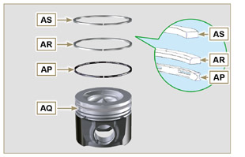  Fig 9.11
- Perform the operations described in Par. 8.5.4 .  - Position the segment openings with a 120° angle between them ( Y ).  NOTE: do not use the segment opening with the pin hole ( N )  - Lubricate the piston skirt and piston rings with oil. | 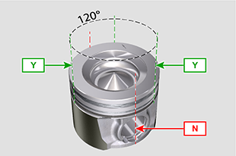  Fig 9.12
9.2.8 Piston and connecting rod  Important  - Before proceeding to the assembly of the piston and connecting rod, carry out the checks described in Par. 8.5.1 .  - Always replace the bearings CE after each assembly.  - Loosen the screws AU and remove the connecting rod cap AV .  - Fit the new bearings CE .  - Insert the connecting rod AZ into the piston AQ and align the seats BA .  - Insert the gudgeon pin BB into the seat BA for the assembly of the connecting rod and piston unit.  - Insert the lock rings BD inside the seat BE of the piston AQ to lock the gudgeon pin BB . | 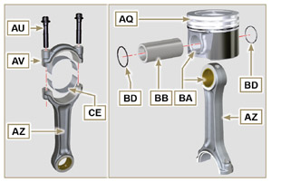  Fig 9.13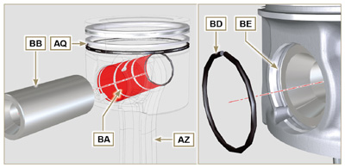  Fig 9.14

9.2.9 Piston and connecting rod assembly  Important  - Before assembling the piston and connecting rod assemblies, execute the controls described in Par. 8.5  - Rotate the crankshaft W by moving the crankpin BG to a TDC position of the affected cylinder.  - Push the piston AQ downwards by centering the crankpin BG with the connecting rod AZ .  - Turn the crankshaft on support to assemble the con rod capp on cylinder 1 and 4. | 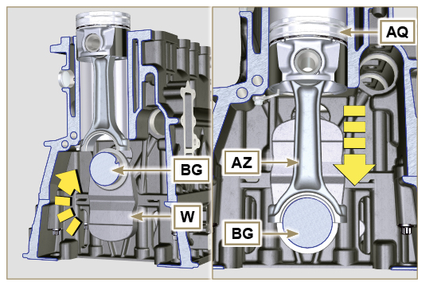  Fig 9.15
- Check that the half-bearing AS is mounted correctly on the connecting rod cap AV .  Important  - As the rods are divided by breaking pay particular attention to the coupling of the cap on the connecting rod.  - Check before you screw and tighten the bolts that the breaking surfaces are perfectly flush.  - Couple the connecting rod cap AV to the connecting rod AZ using the marks made at disassembly ( Par. 7.13.2 )  - Screw in the screws AU .  - Repeat the operations from 1 to 6 for the cylinders 2 and 3. | 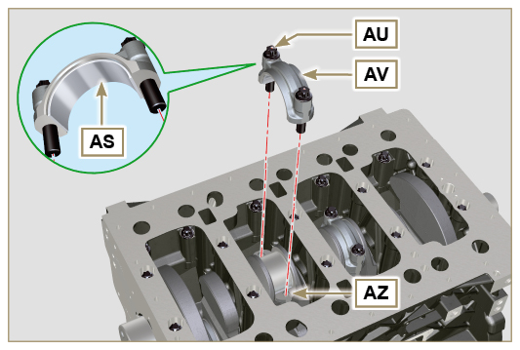  Fig 9.16
Important  - Failure to follow the assembly procedures compromises the functionality of the engine and can cause damage to people and property.  - Tighten the screws AU , alternately, strictly following the tightening torques indicated.  Tightening sequence of screws Torx M10x1:  1° PHASE - with a torque of 40 Nm ;  2° PHASE - with a torque of 85 Nm ;  - Check that the connecting rods have axial play and the crankshaft W rotates smoothly.  NOTE : After the check carried out at point 8, position the shaft W with the first cylinder to TDC. | 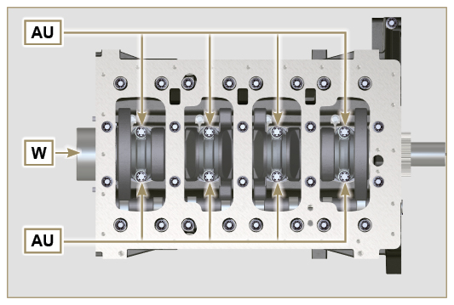  Fig 9.17

9.2.10 Crankshaft gasket flange  Important  - Check that the contact surface between the flange and the crankcase is free of grit and dirt.  - Always replace the gasket BS after each assembly.  - Check that there are bushings BT on the crankcase E .  - Lubricate the oil seal lip BU .  - Position the gasket BS and flange BV on the crankcase E in correspondence with the bushings BT .  - Put Loctite 243 on the 2 screws BW matching the bushings BT .  - Screw the fastening screws all the way in BW without tightening them.  - Tighten all the screws BW strictly following the tightening sequence indicated (tightening torque to 10 Nm ). | 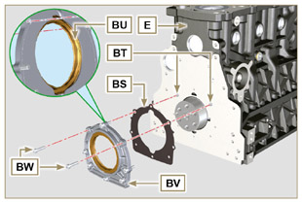  Fig 9.18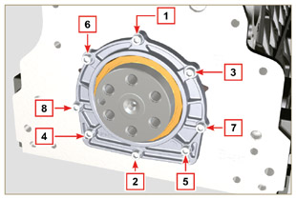  Fig 9.19
9.2.11 Flange 3 ^{rd} PTO  Important  - Replace capscrews CA with each assembly or alternatively apply Loctite 2701 on the thread.  - Secure the cover CB with the screws CA and CC inserting the gasket CD (tightening torque 25 Nm ). | 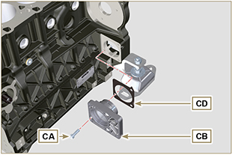  Fig 9.20

Oil sump unit assembly
9.3.1 Oil fume pipes  - Apply Loctite 648 on the pipe threads A .  - Screw and tighten the pipes A (tightening torque of 15 Nm ). | 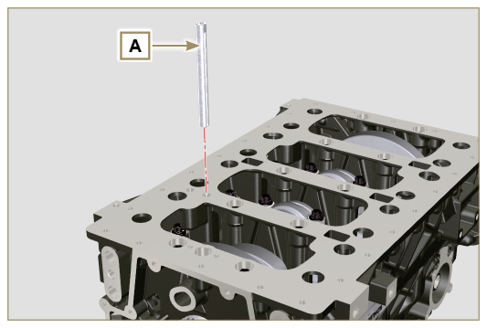  Fig 9.21
9.3.2 Oil suction pipe  Important  - It is mandatory to replace the gasket B after each assembly.  - Always replace capscrews D with new ones or alternatively apply Loctite 2701 .  - Insert the new gasket B in the seat of the oil suction hose flange D .  - Secure the hose C on the crankcase E with the screws D (tightening torque 10 Nm ). | 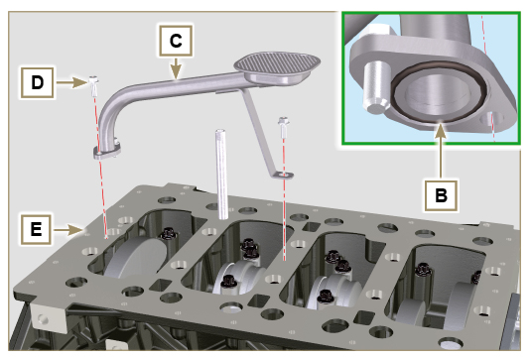  Fig 9.22
9.3.3 Oil Sump  - Ensure that the contact surfaces F of the oil sump G and the crankcase E are completely clean.  - Apply a bead of approx. 2.5 mm of sealant (Loctite 5660) on the surface F of the oil sump G .  - Note : alternatively apply Loctite 5699 . | 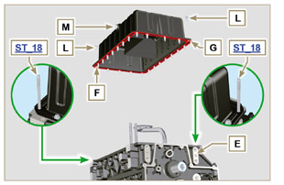  Fig 9.23
Important  - Tighten the screws L , strictly following the sequence and tightening torque indicated.  - Tighten the screws L following the sequence indicated (tightening torque 25 Nm ).  - Remove the two studs ST_18 with the appropriate screws (tightening torque 25 Nm)  - After tightening all of the screws, loosen screw n°1 and retighten it to the torque value specified in step 4 .  - Check that the oil drain plugs M are tight (tightening torque 35 Nm ). | 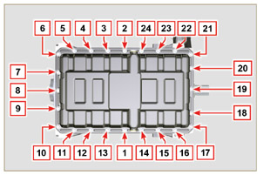  Fig 9.24

Cylinder head unit assembly
9.4.1 Valve stem gasket  Important  - Carry out the checks described in Par. 8.6.4 before proceeding with the following operations.  - Always replace gasket A with every assembly  - Lubricate the gaskets A on the inside.  - Fit the oil seals A on the valve guides B using the tool ST_08 . | 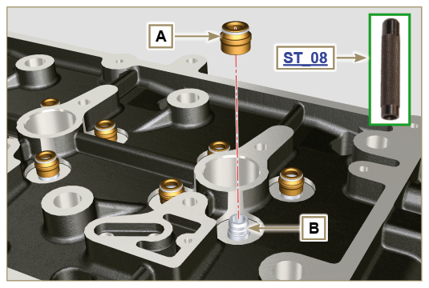  Fig 9.25
9.4.2 Injector sleeves ( )  - Insert the seals C in the seats of the sleeve D .  - Insert the seal E with the convex side facing upward at the base of the sleeve D .  - Lubricate the gaskets C .  - Insert and carefully screw the sleeve D into the seat of the head F .  NOTE: The sleeve D must not protrude above the surface of the head BF .  - Clamp the sleeve D (tightening torque at 30 Nm ). | 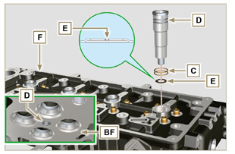  Fig 9.26
9.4.3 Injectors projection  - Insert the injector G inside the sleeve H .  - Mount the injector fixing bracket M and secure it with the screw N , without performing the calibration.  - Check protrusion of injectors by means of the tool ST_03 (Fig. 9.28) , check the projection of the injector, which must range between 1.68 ÷ 2.42 mm.  NOTE : if the value detected does not correspond, replace gasket Q with a different thickness. | 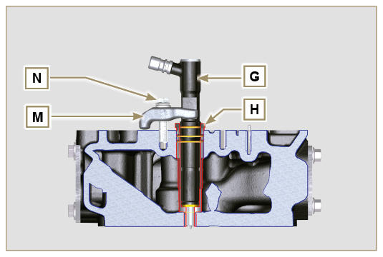  Fig 9.27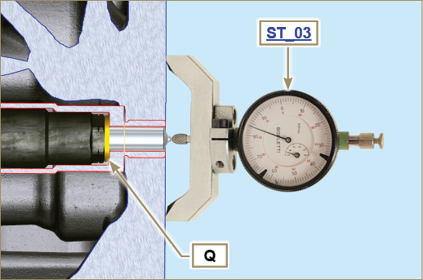  Fig 9.28
9.4.4 Valves  - Pre-lubricate and insert the valves X into the head F taking care to fit them in the original positions as per the reference marks made in Par. 7.13.4.1 .  - Position the spring Y on the seat of the head F .  - Position the disk S on the spring Y centering the valve X .  - Mount the tool ST_07 on the head F fixing it on one of the holes for securing the rocker arm cover.  NOTE: Change the fixing hole according to the position of the valves to be fitted.  - Position the tool ST_07 on the valve as shown in the figure.  - Push the lever of the tool ST_07 downwards, in order to lower the valve disks S in the direction of the arrow AK , and insert the valve cotters AJ inside the disk S .  - Check that the valve cotters AJ are properly mounted on the valve seats X and release the tool ST_07 .  NOTE: repeat all the steps for the relevant valves and remove the tool ST_07 . | 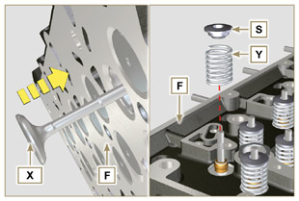  Fig 9.29
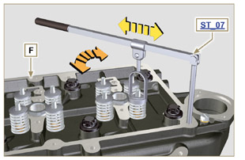
Fig 9.30
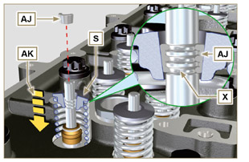
Fig 9.31
9.4.5 Cylinder head  - Fix the eyebolts AW with the screws AX onto the head F (tightening torque of 25 Nm ).  - Position the piston P at the TDC.  - Position the tool ST_03 on the crankcase surface of the head and measure the piston protrusion P from head level K in 4 diametrically opposed points R. Repeat the operation for all pistons P and take note of the highest average value, determining valu e S (Tab. 9.2) .  Tab. 9.2  S (mm) Hole number  0.030 - 0.126 1  0.127 - 0.250 2  0.251 - 0.375 3  - Based on the value detected at point 3 , select the relevant gasket T as shown in the Tab. 9.2 (Fig. 9.34 detail U ).  - Check that the crankcase surface K and the gasket T are completely free of dirt and grit.  Important  - The head gasket must be replaced for each assembly.  - Position the gasket T on the surface K with reference to the centering bushings J . | 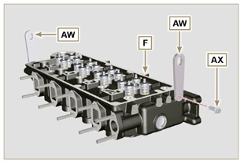  Fig 9.32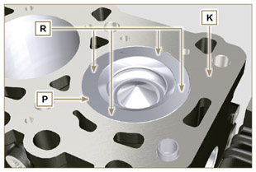  Fig 9.33  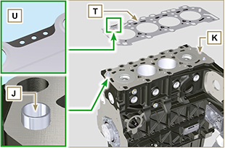  Fig 9.34
- Check that the surface head W is free from impurities.  - Position the head F on the crankcase Z with reference to the centering bushings J .  Important  - The fastening bolts V must be replaced every time they are assembled.  - Secure the head F by tightening the screws V strictly following the sequence indicated in the Fig. 9.36 or Fig. 9.37 and the tightening torque indicated in the Tab. 9.3 . | 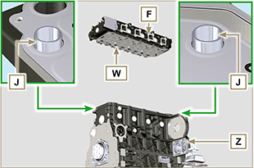  Fig 9.35
Important  - Failure to adhere to the bolt fixing procedures may compromise the functionality of the engine, and also may cause damage to persons and property.  - Tighten capscrews V observing the cycles, tightening, and subsequent rotation as indicated in Tab. 9.3 .  - For engine KDI 1903 M : 8 screws Torx M12x1,25 (Fig. 9.36) .  - For engine KDI 2504 M : 10 screws Torx M12x1,25 (Fig. 9.37) . | 3 CYLINDERS  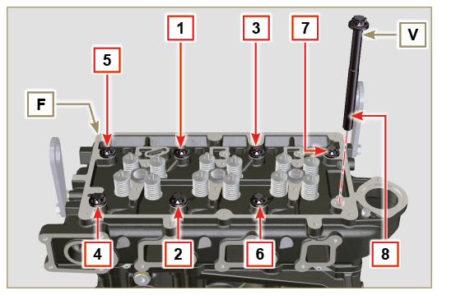  Fig 9.36
Tab. 9.3  CYCLE TORQUE  1 40 Nm  2 70 Nm  3 100 Nm  4 90°  5 90°  6 90° | 4 CYLINDERS  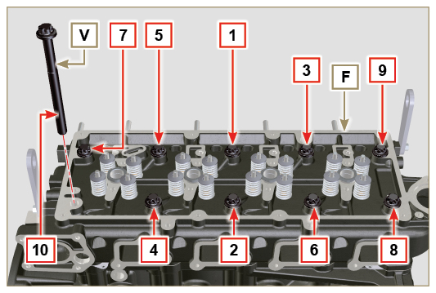  Fig 9.37
9.4.6 Rods and valve bridges  - Insert the rocker control rods AA into the niches of the head F .  Important  - Properly centre the rods AA into the spherical housing of the camshaft tappets AB .  - Mount the valve bridge AC on to the pairs of discharge and suction valves. | 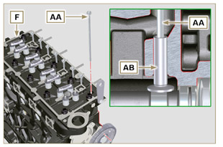  Fig 9.38
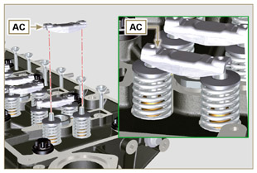
Fig 9.39
9.4.7 Rocker arms  Important  - To correctly position the rocker arms, turn the rocker arm pin AH with the lower height AL towards the timing system side as in Fig. 9.40 .  - The discharge rocker arm AT is shorter than the suction arm AR .  - Fit the lock ring AM into the seat AN of the rocker arm pin AH .  - Position the pin AH with the screw support surface AP facing upwards and insert the 2 shoulder rings AQ .  - Insert in sequence the suction rocker arm AR , the holder AS and the discharge rocker arm AT in the pin AH .  - Insert the spring AU in the pin AH .  - Repeat points 3, 4 for all the rocker arms.  NOTE: The holder AV must be fitted with the last pair of rocker arms towards the flywheel.  - Insert 2 shoulder rings AQ and the lock ring AN to lock all the components inserted in the pin AH .  NOTE : The spring AU ensures that the supports AS and AV are kept in place. | 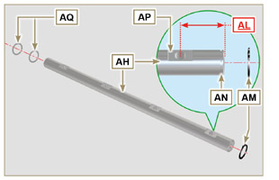  Fig 9.40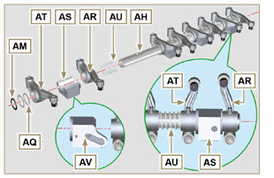  Fig 9.41
9.4.8 Rocker arm pin assembly  Important  - Position the rocker arm pin assembly BB on a level to align all the support surfaces.  - Check that the pistons are positioned half way between the TDC and BDC. Rotate the crankshaft 90° counterclockwise with regard to the 1st cylinder TDC, positioning the crankshaft pin BP as shown in Fig 9.44 . If the crankshaft pulley and the timing gear cover have not been removed, rotate the  crankshaft positioning the reference BQ located on the target wheel in correspondence of the speed sensor, as shown in Fig. 9.45 .  - Position the rocker arm pin assembly BB on the head F , respecting the plug BC on the head using the holder indicated AV .  - Check the correct positioning of all the rocker arms and the u-bolt control valves (detail BD ). House the tappet in the seat of the rocker arms control rod.  - Secure the rocker arm pin BB tightening the screws BE (tightening torque to 25 Nm ). Adhere to the screw tightening sequence BE as shown in Fig. 9.43 . | 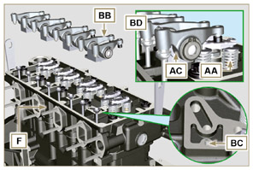  Fig 9.42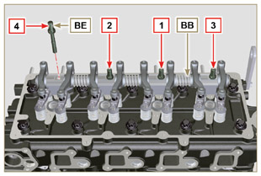  Fig 9.43
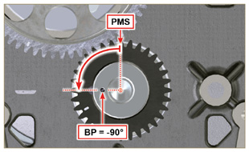  Fig 9.44 | 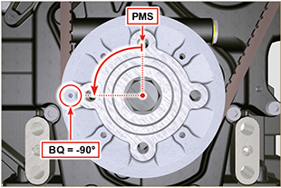  Fig 9.45

Flange unit assembly
9.5.1 Bell housing  Danger  - Bell A is very heavy; pay special attention during assembly operations to avoid dropping and causing serious risks to the operator.  - Install the bell housing A in accordance with the reference pins B on the base C . | 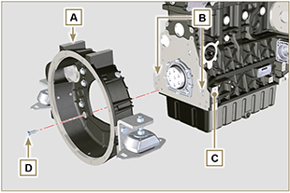  Fig 9.46
Important  - Failure to adhere to the assembly procedures may compromise the functionality of the engine, and also cause damage to persons and property.  - Tighten the fastening screws D strictly following the tightening sequence indicated (tightening torque 50 Nm ). | 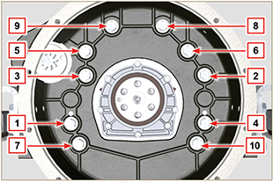  Fig 9.47
9.5.2 Flywheel  Danger  - Flywheel F is very heavy; pay special attention during assembly operations to avoid dropping and causing serious risks to the operator.  - Screw the special tool ST_09 on the crankshaft E instead of the screws G positioned higherup ( Fig. 9.33 ).  - Insert the flywheel F on the crankshaft E using the tool as a guide ST_09 and manually tighten all the screws G (the last screw is fitted in the place of the tool ST_09 ).  - Mount the tool ST_34 in the seat of the starter motor H and fit it with the two starter motor fixing screws.  - Tighten the screws G (tightening torque at 140 Nm ). | 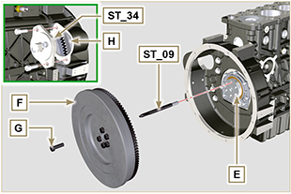  Fig 9.48

Assembling the flexible coupling
Important  - Leave the special flywheel locking tool ST_34 assembled .  - Fasten coupling A onto flywheel B by means of capscrews C and washers D ( Loctite 243 on the thread - tightening torque 25 Nm ). | 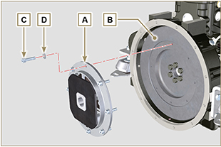  Fig. 9.49

Assembling the reversing gear
- Insert shaft A into the seat on coupling B .  - Place reversing gear C onto bell D .  - Fasten reversing gear C by means of capscrews E and E1 and washers F onto bell D (tightening torque of 50 Nm ). | 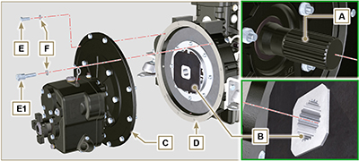  Fig. 9.50

Timing system gear assembly and injection pump
9.8.1 Timing system gear assembly  - Check that the key A is correctly fitted on the camshaft B .  - Position the gear C on the camshaft B adhering to the key reference A .  - Screw capscrew D until the end.  - Tighten the middle gear pin H , in the housing J of the crankcase, with the screws K (tightening torque 25 Nm ). | 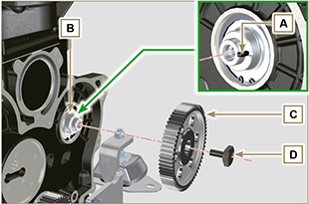  Fig 9.51
Important  - The fitting of the middle gear pin H has only one position, the 4 screw holes K are asymmetric.  - Always replace the gasket L at each assembly.  - Insert the shoulder ring M .  - Check the integrity of the bushing N into the middle gear P , and ensure that it is free from impurities.  - Thoroughly lubricate the pin H and the bushing N .  - Position the gear P on the pin H observing all the marks W of the gears C and S (Fig. 9.54) . | 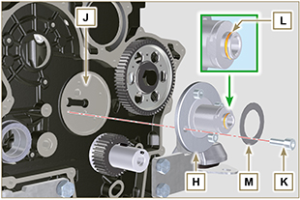  Fig 9.52
Important  - Failure to comply with the marks W on the gears C, P and S , causes engine malfunction and serious damage.  - Insert the shoulder ring Q and the lock ring R.  - Tighten the screw D ( Fig. 9.51 - tightening torque at 100 Nm ). | 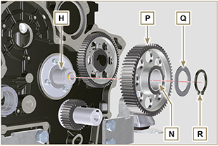  Fig 9.53 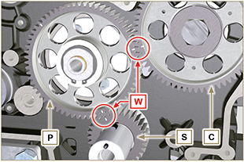  Fig 9.54
Important  - Always replace the gaskets at each assembly.  - Check that the perforated screw AF is free of impurities inside.  - Lubricate the thread and under the head of the AF screw with Molyslip .  - Position the gear unit AH on the bushing AM to centre.  - Secure the gear AH using the screw AF inserting the gasket AG (tightening torque at 40 Nm ). | 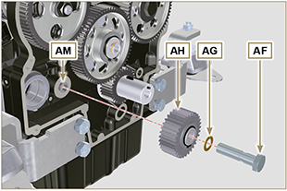  Fig. 9.55
- Loosen and tighten the screw AF again (tightening torque at 20 Nm + 20° ).  - Insert the gear AN in the flange AP .  - Insert the shoulder ring AQ on the flange AP and clamp the gear AN using the retainer ring AR . | 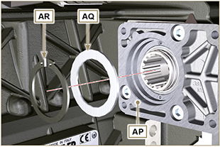  Fig. 9.56  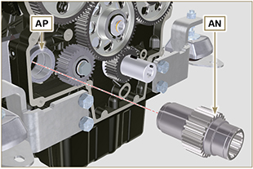  Fig. 9.57
- Insert the centring ring AS in the flange AP .  - Secure the plate AT using the screws AV on the flange AP (tightening torque at 20 Nm ) | 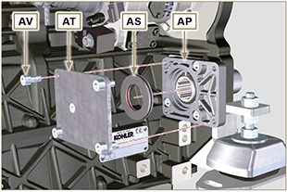  Fig. 9.58
9.8.2 Injection pump  Important  - Always change screws T with new ones or alternatively apply Loctite 270 (Fig. 9.59) to the threads.  - Perform the operations described in the warning in Par. 6.1.5 .  - Place a dial gauge to detect the TDC on piston N° 1 , then bring the indicator of the dial gauge to 0 .  NOTE : During the detection phase of the TDC, check that cylinder N° 1 is in compression phase (align the notches W as in Fig. 9.33 ). | 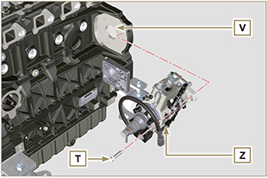  Fig 9.59
- By means of the identified pump code, refer to Tab. 6.1 to know the advance degrees and the corresponding value to lower the piston.  - Mount tool ST_34 in the seat of starter motor H (Fig. 9.61) and fix it with two motor fixing screws.  - Having identified the value to lower the piston, rotate the crankshaft anti-clockwise by going beyond the value described in Tab. 6.1 , once again, rotate the crankshaft clockwise stopping at the correct advance value by using tool ST_03 - ST_34 .  - Lock the ST_34 , ensure that the crankshaft does not rotate, which would alter the correct advance value.  If this happens, repeat the instructions described in points 4, 5 and 6. | 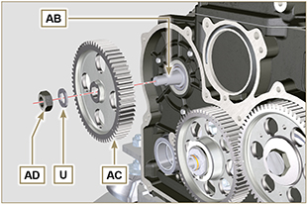  Fig 9.60
- Fix pump Z into housing V by means of screws T ( Fig. 9.59 - tightening torque at 25 Nm ).  - Position the gear AC onto shaft AB of the pump.  NOTE: You are not required to respect the reference Q gear AE ( Fig. 9.61 ).  - Insert washer U and tighten nut AD (tightening torque at 70 Nm ). | 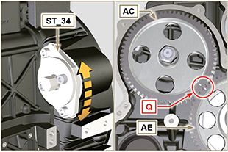  Fig 9.61

Fuel system assembly
Important  - Replace the high pressure pipes after two disassemblies.  - When repaired, RSN-A injectors must be certified by a Stanadyne centre to check their correct operation - check the type of engine mounted injectors on the spare parts list ( RSN-A is specified in the description).  - Remove the protective caps from all the components of the fuel circuit just before assembly (Par. 2.9.7) . | 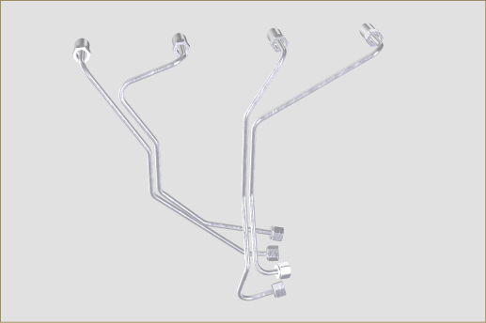  Fig 9.62
9.9.1 Injectors

- Perform the operations described in Par 6.1.7 .
9 .9.2 Fuel injector ricicle pipe

- Perform the operations described in Par 6.1.8 .
9.9.3 Rocker arm cover

- Perform the operations described in Par 6.1.9 .
9.9.4 Installation of the fuel injector pipes (injection pump/injectors)

- Perform the operations described in Par 6.1.10 .
9.9.5 Fuel filter  - Fasten fuel filter C with capscrews A and washers B onto bell D (tightening torque of 27 Nm ). | 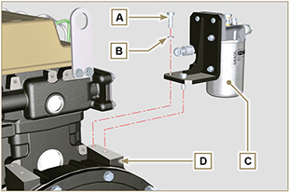  Fig 9.63
9.9.6 Fuel pipes

- Fasten union E by means of capscrews L1 with the relative gasket N1 (tightening torque of 15 Nm ).
- Fasten tubes G and H by means of capscrews L2 and L3 with the relative copper gaskets N2 and N3 (tightening torque of 25 Nm ).

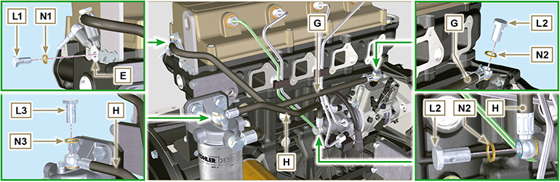
Fig 9.64

Lubrication circuit assembly
9. 10 .1 Oil filter

- Perform the operations described in Par 6.10.2 .
9. 10 .2 Oil pump

- Perform the operations described in Par 6.8.5 .
9. 10 .3 Timing system crankcase

- Perform the operations described in Par 6.8.6 .

9. 10 .4 Crankcase oil filler flange Timing System  Important  - Always replace the gasket A after each assembly.  - Position the gasket A in the seat on the flange B .  - Clamp the flange B on the crankcase C with the screws D (tightening torque of 10 Nm - ST_06 ). | 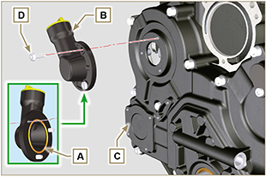  Fig 9.65
9. 10 .5 Oil pressure relief valve

- Perform the operations described in Par 6.9.2.

9.10.6 Oil extraction pump  - Fasten pump E on the fastening hollow stud of flange F by means of capscrew P (tightening torque of 25 Nm ).  - Fasten union G onto oil sump H , inserting gasket N1 ( Loctite 277 + tightening torque of 25 Nm ).  - Fasten tube L by means of capscrew M with gaskets N2 (tightening torque of 25 Nm ). | 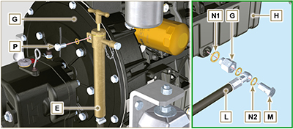  Fig. 9.66

Crankshaft pulley assembly
- Perform the operations described in Par 6.7.2 .

Coolant circuit assembly
9.12.1 Thermostatic valve  Important  - Always replace the gasket A after each assembly.  - Check the condition of the seal gasket A and fit it on the thermostatic valve B .  - Position the thermostatic valve B in the seat on the head C (detail D ).  - Secure the cover E with the screws F on the head C (tightening torque of 10 Nm ). | 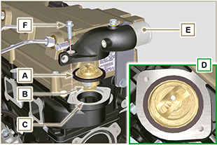  Fig 9.67
9.12.2 Coolant pump

- Perform the operations described in Par 6.6.2 .
9.12.3 External water pump  - Position capscrews N onto pump L and place gasket V .  - Insert hub G of pump L inside gear H .  - Fasten pump L onto timing system carter M by mean of capscrews N (tightening torque of 10 Nm ).  - Fasten clamp J onto crankcase K by means of capscrew P (tightening torque of 25 Nm ).  - Fasten clamp Q onto bell R by means of capscrew S with washer T (tightening torque of 25 Nm ). | 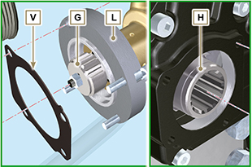  Fig. 9.68  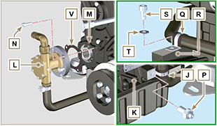  Fig. 9.69

Electric component assembly
9.13.1 Sensors and switches
9.13.1.1 Coolant temperature sensor  - Secure the sensor D onto the head E (tightening torque of 20 Nm ). | 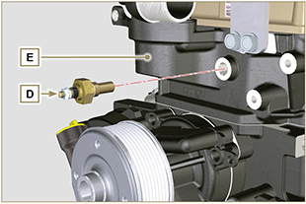 Fig 9.70
9.13.1.2 Oil pressure switch and sensor  - Fasten union E onto crankcase F by means of capscrew G with gaskets H (tightening torque of 25 Nm ). | 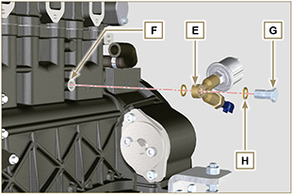 Fig 9.71
9.13.1.3 Coolant temperature switch  - Tighten switch J onto cylinder head K , inserting gasket J1 ( Loctite 511 - tightening torque of 10 Nm ). | 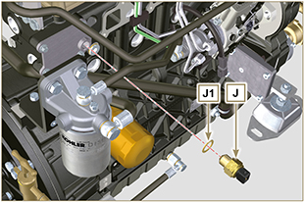  Fig 9.72

9.13.2 Belts and alternator  Important  - The belts must always be replaced every time it is disassembled, even if they have not reached the scheduled hours for replacement.  - Tighten hollow stud L onto crankcase M ( Loctite 243 - (tightening torque of 40 Nm ).  - Assemble alternator N onto hollow stud L by means of capscrew P with washer Q .  NOTE : Do not tighten capscrew P .  - Fasten support R onto cylinder head S by means of capscrews T with washers U , inserting spacers V between R and S ( Loctite 243 - tightening torque of 25 Nm ).  - Loosen hollow stud W .  - Perform the operations described in Par. 6.5.2 - 6.4.2. | 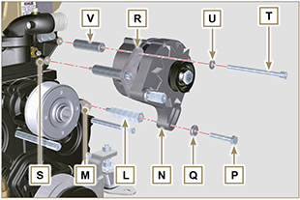  Fig 9.73
9.13.3 Electric fuel pump  - Fasten pump B onto support A by means of nuts X and washers Y (tightening torque of 10 Nm ).  - Fasten tube F1 onto Pump B by means of capscrew G1 with gaskets H1 (tightening torque of 25 Nm ). | 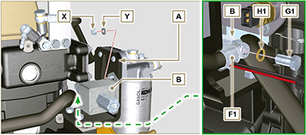  Fig. 9.74
9.13.4 Starter Motor  Important  - Remove the tool if still there ST_34 .  - Fit the starter E1 with the screws C on to the flange bell D1 (tightening torque of 45 Nm ). | 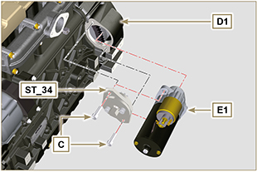  Fig 9.75
9.13.5 Electric wiring

- Connect the engine’s wiring.

NOTE: refer to Par. 2.13.1.3 to connect all connectors.

Assemble the intake line
- Insert tool ST_18 into the holes, as shown in the figure.  - Place gasket A and manifold B onto cylinder head C .  - Fasten manifold A by means of capscrews D (tightening torque of 25 Nm ).  - Insert tube E into rocker arm cover union F and fasten it with clamp G .  - Fasten oil dipstick tube M with hollow stud H1 onto manifold B , tighten hollow stud H2 with the washer  L on manifold B (tightening torque of 10 Nm ).  - Fasten plate P onto hollow studs H1 and H2 using capscrews Q with washers R (tightening torque of 10 Nm ). | 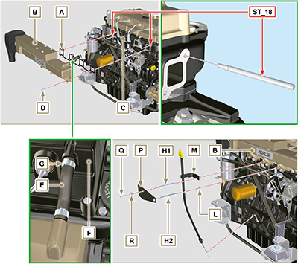  Fig 9.76 - Fig. 9.77

Assembly of the discharge line
- Insert tool ST_18 into the holes of cylinder head D .  - Place manifold A onto cylinder head D , inserting gaskets C .  - Fasten manifold A onto cylinder head D by means of capscrews B (tightening torque of 30 Nm ). | 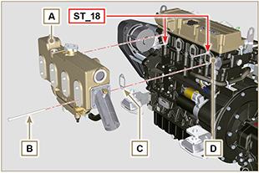  Fig 9.78

Tightening torques and the use of sealants
Tab. 9.4 - * Alternatively to the capscrew replacements, with "Dri-loc"
BASE CONFIGURATION
SHORT BLOCK
Component | Thread (mm) | Torque (Nm) | Sealer
Breather room closing cover fastening capscrew (EXHAUST SIDE) | M6x1 | 10
Lower crankcase fastening capscrew | M12x1.25 | 3 Torque cycles
1st Cycle |  | 40
2nd Cycle |  | 70
3rd Cycle |  | 120
Lower crankcase fastening capscrew | M8x1.25 | 2 Torque cycles
1st Cycle |  | 20
2nd Cycle |  | 35
Connecting rod screw | M8x1 | 2 Torque cycles
1st Cycle |  | 40
2nd Cycle |  | 85
Crankshaft gasket flange fastening capscrew | M6x1 | 10
Flange fastening capscrew 3 ^{rd} PTO | M8x1.25 | 25 | Loctite 2701*
Coolant drain hole closing cap | M16x1.5 | 50
OIL SUMP ASSEMBLY
Component | Thread (mm) | Torque (Nm) | Sealer
Oil fumes tube | M12x1,5 | 15 | Loctite 648
Oil suction hose fastening capscrew | M6x1 | 10 | Loctite 2701*
Oil sump fastening capscrew | M8x1.25 | 25
Oil drain cap | M18x1.5 | 35
Oil extraction pump tube reduction union | M18x1.5 | 25 | Loctite 2701
Oil extraction pump tube fastening screw | M14x1.5 | 25
Oil extraction pump fastening screw | M8x1.5 | 25
FLANGE ASSEMBLY AND REVERSING GEAR(1st PTO)
Component | Thread (mm) | Torque (Nm) | Sealer
Flange bell fastening capscrew | M10x1,5 | 50
Flywheel fastening capscrew | M12x1,25 | 140
Flexible coupling fastening screw | 5/16"-18UNC | 25 | Loctite 243
Reversing gear stud | M8x1.25 | 25 | Loctite 2701
Reversing gear flange fastening screw | M8x1.25 | 30 | Loctite 243
Reversing gear flange nut | M8x1.25 | 30 | Loctite 243
Reversing gear flange on bell flange fastening screw | M10x1.25 | 50
Bell flange fastening screw for reversing gear | 3/8" 16UNC | 50
GEAR DISTRIBUTION
Component | Thread (mm) | Torque (Nm) | Sealer
Intermediate gear gudgeon fastening screw | M8x1.25 | 25
Camshaft gear control fastening capscrew | M10x1 | 100
Fastening nut on fuel injection pump gear | M14x1.5 | 65
Idler gear fastening screw | M14x1.5 | 2 Torque cycles
1st Cycle |  | See Par. 9.8.1
2nd Cycle
ENGINE CYLINDER HEAD ASSEMBLY
Component | Thread (mm) | Torque (Nm) | Sealer
Air bleeding cap | M6x1 | 8
Lifting brace fastening capscrew | M8x1.25 | 25
Injector manifold | M12x1 | 30
Cylinder head fastening capscrew | M12x1.25 | 6 Torque cycles
1st Cycle |  | 40
2nd Cycle |  | 70
3rd Cycle |  | 100
4th Cycle |  | 90°
5th Cycle |  | 90°
6th Cycle |  | 90°
Rocker arm gudgeon fastening capscrew | M8x1,25 | 25
Rocker arm cover fastening capscrew | M6x1 | 10
INJECTION SYSTEM
Component | Thread (mm) | Torque (Nm) | Sealer
Injector brace fastening capscrew | M8x1.25 | 20
Waste line fastening drilled capscrew/nipple on Cyl. head | M8x1 | 15
Waste line fastening drilled capscrew on injectors | M6x1 | 14
Injector side injection tube nuts | M12x1.5 | 25
Injection pump side injection tubes nuts | M12x1.5 | 25
Injection pump fastening capscrew | M8x1.25 | 25 | Loctite 2701*
Fuel injection pump locking screw | ...
Fuel delivery fastening drilled capscrew (on injection pump) | M12x1.5 | 25
Waste line fastening drilled capscrew (on injection pump) | M12x1.5 | 25
Bleeding screw injection pump (on waste line fastening drilled capscrew) | M10x1.5 | 50
Fuel filter fastening capscrew | 1/8" | 25
Drilled capscrew on fuel feed (electric pump) | M14x1.5 | 25
Drilled capscrew on fuel filter | M8x1.25 | 27
Fuel filter bracket fastening screw | M12x1.5 | 25
Drilled capscrew on fuel return tube | M12x1.5 | 25
INTAKE MANIFOLD
Component | Thread (mm) | Torque (Nm) | Sealer
Fastening screw intake manifold | M8x1.25 | 25
Intake manifold line fastening screw | M8x1.25 | 25
EXHAUST MANIFOLD
Component | Thread (mm) | Torque (Nm) | Sealer
Cooled exhaust manifold fastening screw | M8x1.25 | 30
Exhaust gas outlet closing cover fastening screw (on cooled exhaust manifold) | M8x1.25 | 30
Raiser fastening screw | M8x1.25 | 27
LUBRICATION CIRCUIT
Component | Thread (mm) | Torque (Nm) | Sealer
Oil filter fastening union | M20x1.5 | 15 | Loctite 2701*
Oil filter | M20x1.5 | 15
Oil pump carter fastening capscrew | TG6 | 10
Carter distribution fastening capscrew | M8x1.25 | 25
Hollow stud timing system carter fastening | M8x1.25 | 25
Fastening capscrew for plug on timing system cover | TG6 | 10
Side oil load flange fastening capscrew (onto carter distribution) | TG6 | 10
Pressure relief valve cap | M16x1.5 | 50
Breather system cover fastening capscrew (on rocker arms cover) | M6x1 | 10
Hollow stud oil dipstick fastening | M6x1 | 10
CRANKSHAFT PULLEY
Component | Thread (mm) | Torque (Nm) | Sealer
Crankshaft pulley fastening screw | M16x1.5 | 360 | Molyslip
Spacer capscrew | M10x5 | 40 | Loctite 2701
Alternator drive pulley fastening screw | M8x1.25 | 25 | Loctite 243
COOLANT CIRCUIT

Component | Thread (mm) | Torque (Nm) | Sealer
Thermostatic valve cover fastening capscrew | M6x1 | 10
Coolant pump fastening capscrew | M8x1.25 | 25
External water pump support fastening screw | M6x1 | 10
External water pump fastening screw | M8x1.25 | 25
Water delivery clamp fastening screw (on crankcase) | M12x1.75 | 50
Water delivery clamp fastening screw (on bell) | M8x1.25 | 25
3rd PTO flange closing cover fastening screw | M8x1.25 | 25
External water feed cap capscrew on cooled exhaust manifold | M6x1 | MIN 5 - MAX 7.5
Zinc anode capscrew on external water feed cap | M18x1.5 | 30
ELECTRICAL COMPONENTS
Component | Thread (mm) | Torque (Nm) | Sealer
Coolant temperature sensor | M12x1.5 | 10 | Loctite 511
Oil pressure switch | M12x1.5 | 10 | Loctite 511
Oil pressure sensor | M14x1.5 | 10 | Loctite 511
Coolant temperature sensor/switch | M16x1.5 | 10 | Loctite 511
Electric fuel pump fastening screw/nut | M6x1 | 10
Alternator bracket fastening capscrew | M8x1.25 | 25 | Loctite 243
Alternator bracket hollow stud (on crankcase) | M10x1.5 | 40 | Loctite 243
Alternator bracket hollow stud | M10x1.5 | 40
Alternator fastening capscrew | M10x1.5 | 40
Alternator protection fastening screw | M6x1 | 10
Starter motor fastening capscrew | M10x1.5 | 45
Supply cable fastening nut (starter motor) | M8x1.25 | 10
CONTROLS
Component | Thread (mm) | Torque (Nm) | Sealer
Accelerator bracket fastening capscrew | M6x1 | 10
* Alternatively to the capscrew replacements, with "Dri-loc"

ENGINE SUPPORT
Component | Thread (mm) | Torque (Nm) | Sealer
Rear engine support fastening screw | M12x1.75 | 60
Front engine support fastening screw | M16x2 | 160
Vibration damping fastening nut | M12x1.75 | ...

