Information on adjustments
KDI-TCP 3404E5 Workshop Manual (Rev. 01.1)

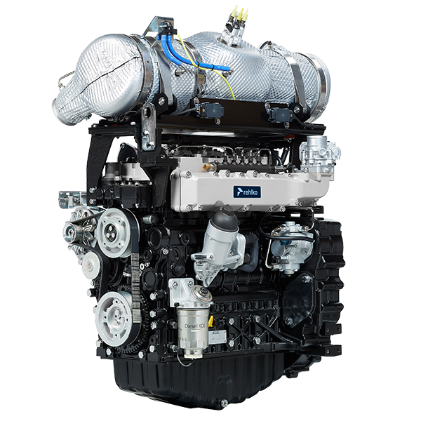

Registration of modifications to the document
Any modifications to this document must be registered by the drafting body, by completing the following table.

Released by | Code | Revision | Release Date | Revision date | Edited by | Endorsed
 | manoff

Translated from the original manual in Italian language
Data reported in this issue can be modified at any time by KOHLER.

Sommario
1. TITOLO 1 2
1.1. Asdfsdfsdf 2
1.2. Asdfsdfsdfggg 2

Information on adjustments

'Waste Gate' opening valve regulation


Important

- Before proceeding with operation, read Par. 3.3.2 .
- See service letter 710022 .
- Regulation must not be carried out with the engine running.
- During the procedure in point 5 , pay special attention not to bend rod H .

- Disconnect the hose A from the turbocharger.
- Connect a pressure reducer C to the network of compressed air.
- Position dial gauge D in such a way that feeler F rests onthe Waste Gate rod control valve extremity H (point E ).
- By using gradually the reduction gear C send the air to the Waste Gate actuator control L in order to move rod H forward by 1 mm (value M to check on dial gauge D). Pressure read on gauge B must be: 2500 mbar.
- If pressure is less or more than the indicated value, proceed as follows:
- Remove the retainer cotter pin (point E ) and disconnect rod H from the Waste Gate control lever.
- Tighten (to increase) / or loosen (to decrease) pressure of the ring nut of rod H until reaching the corrected calibration.
- Redo lock nut G .
- Reconnect rod H and assemble the cotter pin point E .

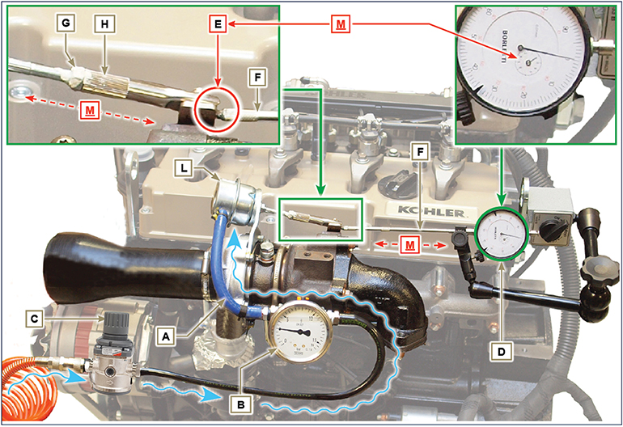
Fig 12.1

Air filter check
Important

- Before proceeding with operation, read Par. 3.3.2 .
- When the cartridge G is dirty, do not clean it but replace cartridges B and G .

- All manifolds connected to the turbo must be fully clean and not damaged.  - Clean the inside components A and D with a damp cloth.  - Do not use compressed air , tap the cartridge B lightly and repeatedly on a flat surface.. | 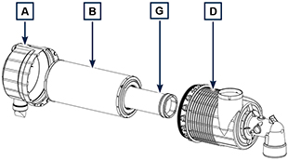  Fig 12.2

Oil steam separator check
Important

- Before proceeding with operation, read Par. 3.3.2 .
- Loosen clamp B and remove hose C .  - Remove rapid fitting D from separator A .  - Start the engine at idle speed or without a load and check if air comes out from unions A1 and A2 .  NOTE: If what is described in Point 3 does not occur, proceed with cleaning or replacing oil separator A and accurately clean all connecting  hoses, and repeat the operation from Point 3. | 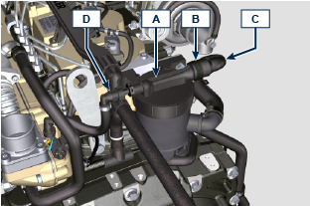  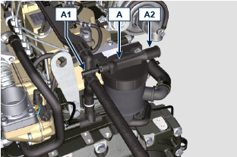

Rubber hoses and manifolds check
Important

- Before proceeding with operation, read Par. 3.3.2 .
The check is carried out by applying slight deflection or bending along the tube/hose and next to the hose clamps.  Components must be replaced if they have clear signs of cracks, tears, cuts, leaks, or do not retain a certain degree of elasticity.  - Check the condition of all hoses and rubber tubes highlighted in red.  - Check whether there are any leakages of air, refrigerant, oil or fuel next to their connections.  NOTE : Refer to the technical documentation of the machine for components that are not shown in the figure. | 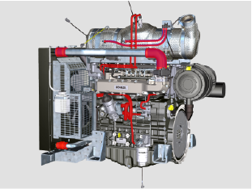  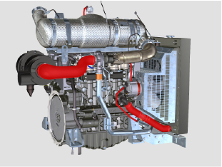  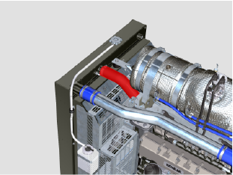  Fig 12.4

Oil leak check
Important

- Before proceeding with operation, read Par. 3.3.2 .
Check that there are no leakages next to area A .  - Start the engine at idle speed or without a load and check whether there are any leakages next to area A.  - It is anyhow necessary to also check the seals of all main components and their surface contact, such as:  - crankcase and gasket (side 1 ª PTO) - oil sump and exhaust caps  - cylinder head and its assembled components  - rocker arm cover  - Timing system carter and gasket (side 2 ª PTO) - oil dipstick housing or rod support tube.  NOTE: Perform the checks described in Points 1 and 2 periodically and during maintenance procedures.  It is also necessary to check for leakages on the components that are not listed.  If necessary, disassemble the components that have a leakage and investigate the possible cause.  The components must be replaced otherwise they do notguarantee their sealing. | 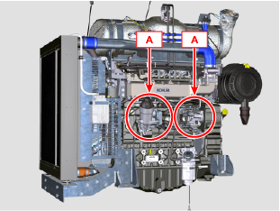  Fig 12.7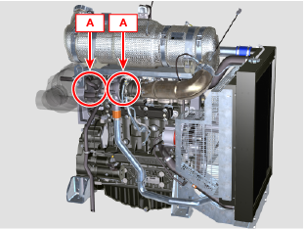  Fig 12.8

Oil pressure check
Important

- Before proceeding with operation, read Par. 3.3.2 .
- Replace the oil dipstick A with a thermocouple B (Fig. 12.6).  - Unscrew and remove the oil pressure switch C and screw on a 10 bar pressure gauge in its seat (Fig. 12.8) .  - Start the engine at idle speed and without a load, check the oil pressure value according to the oil temperature (Fig. 12.7 ).  NOTE : The graph in Fig. 12.7 illustrates the pressure line with speed of 1000 Rpm.  - If the pressure values are below the values indicated in Fig. 12.7 , check to identify the cause of the problem.  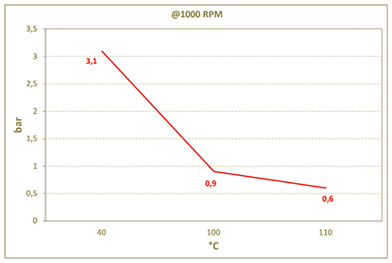  Fig. 12.7 | 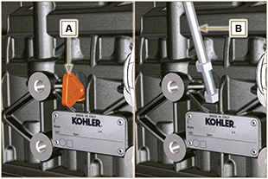  Fig. 12.6  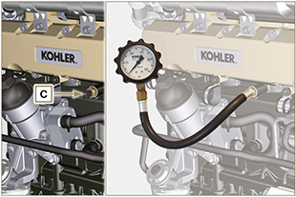  Fig. 12.8

DEF Check
1 - The inspection is carried out with refractometer A . Follow the instructions on the device; the correct value must comply with the values of 1% ± 32.5%.  Warning  Use of the engine with DEF that does not comply with the quality specifications described in point 1 will trigger an error code and result in an inducement strategy (Para. 2.12.3). | 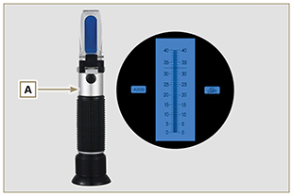  Fig 12.4

DEF tank filter check and cleaning
Warning
- Do not use pressurised air or water.
- Only use hot water for cleaning and lubrication of the gaskets - replace gasket D if damaged.
- The tank and its components cannot be repaired - do not damage the components during cleaning operations.
1 - Turn head A anticlockwise to release tank B.  2 - Remove head A from tank B. | 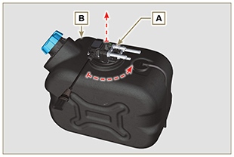  Fig. 12.5
3 - Visually check filter B and proceed to point 4 if there are traces of crystallisation or impurities.  4 - Wash filter C in a basin with hot water .  NOTE: the hot water will dissolve the crystal residues caused by the DEF liquid. It is permitted to use a brush to remove any impurities completely .  5 - Assemble head A by following the instructions in reverse in point 2 and 1.  NOTE: only use water to lubricate gasket D. | 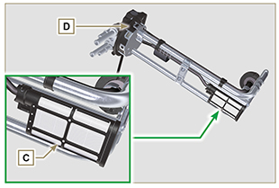  Fig. 12.6



