Safety information
KSD 1403 Owner Manual (Rev. 01)

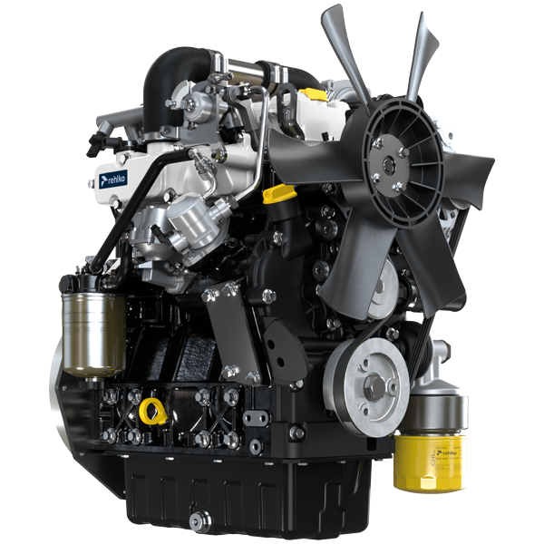

Registration of modifications to the document
Any modifications to this document must be registered by the drafting body, by completing the following table.

Released by | Code | Revision | Release Date | Revision date | Edited by | Endorsed
 | KSD1403

Translated from the original manual in Italian language
Data reported in this issue can be modified at any time by KOHLER.

Sommario
1. TITOLO 1 2
1.1. Asdfsdfsdf 2
1.2. Asdfsdfsdfggg 2

Safety information

Safety information
- The intended use of the engine is in conformity with the machine on which it is mounted.
- Any use of the machine other than that described cannot be considered as complying with its intended purpose as specified by REHLKO .
- REHLKO declines all responsibility for any change to the engine not described in this manual made by unauthorized REHLKO personnel.
- A proper use of the engine, a strict observance of the rules listed below and the rigorous application of all these precautions will avoid the risk of accidents or injuries.
- Those who carry out the use and maintenance on the engine must wear the safety equipment and the accident-prevention guards.
- REHLKO declines all direct and indirect liability for failure to comply with the standards of conduct contained in this manual.
- REHLKO is not responsible for any unreasonable use or neglect that may cause a potential danger.

General remarks
3.2.1 Note for OEM
- When installing the KSD engines, always bear in mind that any variation to the functional systems may result in serious failures to the engine.
- Any improvement must be verified at REHLKO testing laboratories before application of the engine.
- In case the approval to a modification is not granted, REHLKO shall not be deemed responsible for any consequential failures or damages to the engine.
- Those who carry out the use and maintenance on the engine must wear the safety equipment and the accident-prevention guards.
- REHLKO declines all direct and indirect liability for failure to comply with the standards of conduct contained in this manual.
- REHLKO cannot consider every reasonably unforeseeable misuse that may cause a potential danger.
3.2.2 Note for end user
- The following indications are dedicated to the user of the machine in order to reduce or eliminate risks concerning engine operation and the relative routine maintenance work.
- The user must read these instructions carefully. Failure to do this could lead to serious danger for his personal safety and health and that of any persons who may be in the vicinity of the machine.
- On starting, make sure that the engine is as horizontal as possible, unless the machine specifications differ.
- Make sure that the machine is stable to prevent the risk of overturning.
- The engine must not operate in places containing inflammable materials, in explosive atmospheres, where there is dust that can easily catch fire unless specific, adequate and clearly indicated precautions have been taken and have been certified for the machine.
- To prevent fire hazards, always keep the machine at least one meter from buildings or from other machinery.
- Children and animals must be kept at a due distance from operating machines in order to prevent hazards deriving from their operation.
- Thoroughly wash and clean all the external parts of the engine before performing any operation, in order to avoid the accidental introduction of impurities/foreign bodies. Use only water and/or appropriate products to clean the engine. If cleaning engine with a pressure washer or steam cleaner, it is important to maintain a minimum distance of at least 200mm between the surface to be washed and the nozzle. Avoid directing the nozzle on electrical components, cable connections and sealed rings (oil seals etc). Thoroughly wash and clean the area surrounding the engine following the instructions provided by machine manufacturer.
- Fuel and oil are inflammable. The tank must only be filled when the engine is off. Before starting, dry any spilt fuel.
- Make sure that no soundproofing panels and the ground or floor on which the machine is standing have not soaked up any fuel.
- Fuel vapour is highly toxic. Only refuel outdoors or in a well ventilated place
- Do not smoke or use open flames when refuelling.
- During operation, the surface of the engine can become dangerously hot. Avoid touching the exhaust system in particular.
- Before proceeding with any operation on the engine, stop it and allow it to cool.
- Always open the radiator plug or expansion chamber with the utmost caution, wearing protective garments and goggles.
- The coolant fluid is under pressure. Never carry out any inspections until the engine has cooled.
- If there is an electric fan, do not approach the engine when it is still hot as the fan could also start operating when the engine is at a standstill.
- The oil must be drained whilst the engine is hot. Particular care is required to prevent burns. Do not allow oil to come into contact with the skin because of the health hazards involved. It is recommended to use an oil intake pump.
- During operations that involve access to moving parts of the engine and/or removal of rotating guards, disconnect and insulate the negative wire (-) of the battery to prevent accidental short-circuits and to stop the starter motor from being energized.
- Check belt tension only when the engine is off.
- Fully tighten the tank cap each time after refuelling. Do not fill the tank right to the top but leave an adequate space for the fuel to expand.
- To start the engine follow the specific instructions provided in the engine and/or machine operating manual. Do not use auxiliary starting devices not originally installed on the machine (e.g. Startpilot).
- Before starting, remove any tools that were used to service the engine and/or machine. Make sure that all guards have been refitted.
- Do not mix fuel with elements such as oil or kerosene. Failure to comply with this prohibition will cause the non-operation of the catalyst and non-observance of the emissions declared by REHLKO .
- Pay attention to the temperature of the oil filter when the filter itself is replaced.
- Only check, top up and change the coolant fluid when the engine is off and reached the ambient temperature. Coolant fluid is polluting, it must therefore be disposed of in the correct way.
- Do not use air and water jets at high pressures on cables, connectors and injectors.


Important

- Only use the eyebolts A installed by REHLKO to move the engine (Fig. 3.1) .
- The angle between each lifting chain and the eyebolts shall not exceed 15° inwards.
- The correct tightening of the lifting screws is 25Nm.
- Do not interpose spacers or washers between the eyebolts and engine head.
- Engines equipped with an ATS device require regeneration to be inhibited if the engine is used in environments at risk of fire (e.g. forest areas, areas with flammable materials, areas with flammable gases or liquids and any type of combustible material - if the function is available).
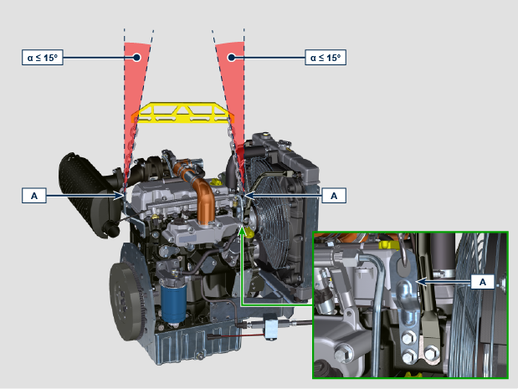
Fig 3.1

Safety signal description
- To ensure safe operation please read the following statements and understand their meaning.
- Also refer to your equipment manufacturer's manual for other important safety information.
- This manual contains safety precautions which are explained below.
- Please read them carefully.

Adhesive safety plates
The following is a list of the adhesive safety plates that may be found on the engine, which indicate potential points of danger to the operator.

NOTE: These stickers are applied on components engine by the machine manufacturer and some of them may be made of metal to resist at high temperatures.
 | Read the Operation and Maintenance handbook before performing any operation on the engine.
 | Hot Parts.  Danger of burns.
 | Presence of rotating parts.  Danger of jamming or cutting.
 | Presence of explosive fuel.  Danger of fire or explosion.
 | Presence of steam and pressurized coolant.  Danger of burns.
Warnings
Hereunder is a list of safety warnings that may be found in the manual, which advise you to pay attention when carrying out particular procedures that may be potentially dangerous to the operator or things.
 | Danger  This indicates situations of grave danger which, if ignored, may seriously threaten the health and safety of individuals.
 | Important  This indicates particularly important technical information that should not be ignored.
 | Warning  This indicates that failure to comply with it can cause minor damage or injury.
Safety guards Hereunder is a list of safety guards that must be worn prior to carrying out any type of operation and to avoid potential
harm to the operator.
 | Use suitable protective gloves before carrying out any type of operation.
 | Use protective goggles before carrying out any type of operation.
 | Use earmuffs before carrying out any type of operation.

Information and safety signals

  
  ACCIDENTAL START
   | Accidental Starts can cause severe injury or death.
  Before working on the engine or equipment, disconnect the battery negative (-) wire.
  HOT PARTS
   | Hot Parts can cause severe burns.
  Engine components can get extremely hot from operation. Do not touch engine while operating or just after stopping.
  Never operate the engine with heat shields or guards removed.
  ROTATING PARTS
   | Rotating Parts can cause severe injury.
  Stay away while engine is in operation. Keep hands, feet, hair, and clothing away from all moving parts to prevent injury.
  Never operate the engine with covers, shrouds, or guards removed.
  LETHAL EXHAUST GASES
   | Carbon Monoxide can cause severe nausea, fainting or death.
  Avoid inhaling exhaust fumes and never run the engine in a closed building or confined area.
  Carbon monoxide is toxic, odorless, colorless, and can cause death if inhaled.
  ELECTRICAL SHOCK
   | Electrical Shock can cause injury.
  Do not touch wires while engine is running.
  HIGH PRESSURE FLUID RISK OF PUNCTURE
   | High Pressure Fluids can puncture skin and cause severe injury or death.
  Do not work on fuel system without proper training or safety equipment. Fluid puncture injuries are highly toxic and hazardous.
  If an injury occurs, seek immediate medical attention.
  EXPLOSIVE FUEL
   | Explosive fuel can cause fires and severe burns.
  Fuel is flammable and its vapours can ignite. Store fuel only in approved containers, in well ventilated, unoccupied buildings. Do not fill the fuel tank while the engine is hot or running, since spilled fuel could ignite if it comes in contact with hot parts or sparks from ignition.
  Do not start the engine near spilled fuel.
  Never use fuel as a cleaning agent.
  EXPLOSIVE GAS
  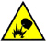 | Explosive Gas can cause fires and severe acid burns.
  Charge battery only in a well ventilated area. Keep sparks, open flames, and other sources of ignition away from the battery at all times. Batteries produce explosive hydrogen gas while being charged.
  Keep batteries out of the reach of children.
  Remove all jewelry when servicing batteries. Before disconnecting the negative (-) ground cable, make sure all switches are OFF.
  If ON, a spark will occur at the ground cable terminal which could cause an explosion.
  CALIFORNIA WARNING - DECLARATION 65
  Engine exhaust from this product contains chemicals known to the State of California to cause cancer, birth defects, or other reproductive harm.

Safety and environmental impact
Every organisation has a duty to implement procedures to identify, assess and monitor the influence of its own activities (products, services, etc.) on the environment. Procedures for identifying the extent of the impact on the environment must consider the following factors:

- Liquid waste.

- Waste management.

- Soil contamination.

- Atmospheric emission.

- Use of raw materials and natural resources.

- Regulations and directives regarding environmental impact.

In order to minimise the impact on the environment, REHLKO now provides a number of indications to be followed by all persons handling the engine, for any reason, during its expected lifetime. - All components and fluids must be disposed of in accordance with the laws of the country in which disposal is taking place.

- Keep the fuel and engine control systems and the exhaust pipes in efficient working order to limit environmental and noise pollution.

- When discontinuing use of the engine, select all components according to their chemical characteristics and dispose of them separately.



