Technical information
KDI 2504 TM Workshop manual (Rev. 07.6)

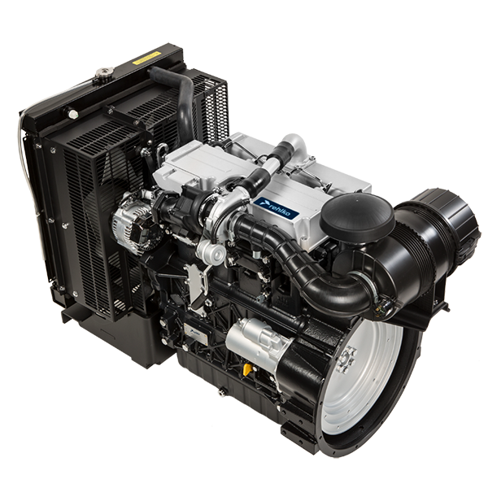

Registration of modifications to the document
Any modifications to this document must be registered by the drafting body, by completing the following table.

Released by | Code | Revision | Release Date | Revision date | Edited by | Endorsed
null | manoff

Translated from the original manual in Italian language
Data reported in this issue can be modified at any time by KOHLER.

Sommario
1. TITOLO 1 2
1.1. Asdfsdfsdf 2
1.2. Asdfsdfsdfggg 2

Technical information

Engine specifications
MANUFACTURER SPECIFICATIONS AND OPERATION
GENERAL INFORMATION | UNIT OF MEASURE | KDI 2504 TM
Operating cycle |  | diesel - 4 stroke
Cylinders | N° | 4
Bore x stroke | mm | 88x102
Displacement | cm ³ | 2482
Compression ratio |  | 17.4:1
Intake |  | Supercharged with Turbocharger
Cooling |  | Liquid
Crankshaft rotation (view from flywheel side) |  | Counterclockwise
Combustion sequence |  | 1-3-4-2
Timing System
Valves per cylinder | N° | 4
Timing System |  | Rods and rocker arms - Camshaft in the crankcase
Tappets |  | Hydraulic
Injection |  | Direct
Engine dry weight | Kg | 244
MAX inclination 30' continuous operation | (min./a) | 25°
MAX inclination 1' continuous operation | (min./a) | 35°
Volume of aspirated air (2600 rpm) | Kg/h | 2.9
POWER AND TORQUE
GENERAL INFORMATION | UNIT OF MEASURE | KDI 2504 T M
MAX operating speed | Rpm | 2600
MAX operating power (ISO TR 14396 - SAE J1995 - CE 97/68) | kW | 41
Maximum torque (at 1500 rpm) | Nm | 170
Admissible axial load on crankshaft | Kg | 300
CONSUMPTIONS
GENERAL INFORMATION | UNIT OF MEASURE | KDI 2504 T M
Specific fuel consumption (best point) | g/kWh | 210
Oil consumption | %Fuel | < 0.05
FUEL SUPPLY SYSTEM
GENERAL INFORMATION | UNIT OF MEASURE | KDI 2504 T M
Type of fuel |  | Diesel UNI-EN590 - ASTM D975
High-pressure fuel injection pump |  | STANADYNE - DB
Fuel supply |  | Low pressure electric pump
Fuel filter
Filtering surface | cm ² | 2300
Degree of filtration | µm | 5
Maximum pressure at injection pump inlet | bar | < 0.5
LUBRICATION CIRCUIT
GENERAL INFORMATION | UNIT OF MEASURE | KDI 2504 T M
Fuel

Lubrication |  | See Par. 2.4
Circuit forced |  | Lobe pump
Oil sump capacity ( MAX ) | Lt. | 11,5
Oil pressure switch
Intervention pressure ( MIN ) | bar | 0.8±0.1
Oil filter

Maximum operating pressure | bar | 7.0
Degree of filtration | µm | 17±2
Filtering surface | cm ² | 1744
COOLING CIRCUIT
GENERAL INFORMATION | UNIT OF MEASURE | KDI 2504 T M
Coolant | % | See Par. 2.6
Water pump | Lt./min | 75
Thermostatic valve
Opening temperature | °C | +79
Stroke at 91°C | mm | 7.50
Liquid recirculation | Lt./h | 9
ELECTRICAL SYSTEM - ELECTRIC FAN
GENERAL INFORMATION | UNIT OF MEASURE | KDI 2504 T M
Circuit rated voltage | V | 12
External alternator (rated current) | A | 80
Starter motor power | kW | 2
System electrical consumption, excluding:  heater, electric pump, electric fan, starter motor | W | 24
Coolant temperature indicator light
Indicator light operating temperature | °C | +100/+110

Engine dimensions (mm)
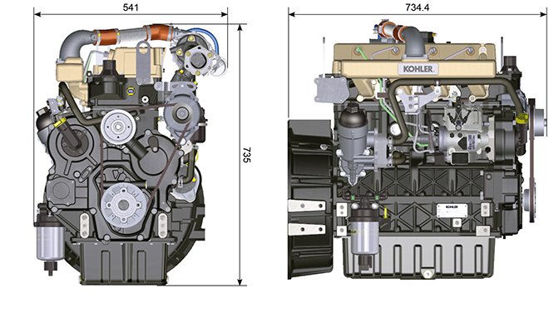

Performance
50 Hz @ 1500 rpm
 |  | KDI 2504 TM-30 | KDI 2504 TM-40 EU | KDI 2504 TM-40
 |  | POWER
Stand-by power (kW/HP) |  | 31,0 / 41,5 | 36,4 / 48,8 | 41,0 / 54,9
Prime power (kW/HP) |  | 28,2 / 37,8 | 33,1 / 44,3 | 37,3 / 49,9
 |  | FUEL CONSUMPTION (g/kWh)
Fuel consumption 100% load |  | 226,8 | 228,7 | 225,0
Fuel consumption 75% load |  | 238,0 | 235,7 | 228,0
Fuel consumption 50% load |  | 252,9 | 252,2 | 235,0
Fuel consumption 25% load |  | 280,6 | 278,4 | 265,0
Fuel consumption 10% load |  | 420,9 | 398,4 | 376,0

60 Hz @ 1800 rpm
 |  | KDI 2504 TM
 |  | POWER
Stand-by power (kW/HP) |  | 36,4 / 48,8
Prime power (kW/HP) |  | 33,1 / 44,3
 |  | FUEL CONSUMPTION (g/kWh)
Fuel consumption 100% load |  | 226,6
Fuel consumption 75% load |  | 236,5
Fuel consumption 50% load |  | 256,8
Fuel consumption 25% load |  | 299,8
Fuel consumption 10% load |  | 470,7

Oil


Important

- The engine may be damaged if operated with improper oil level.
- Do not exceed the MAX level because a sudden increase in engine rpm could be caused by its combustion.
- Use only the recommended oil to ensure adequate protection, efficiency and service life of the engine.
- The use of lubricants other than recommended may shorten the engine life.
- Viscosity must be appropriate to the ambient temperature to which the engine is to be exposed.


Danger

- Prolonged skin contact with the exhausted engine oil can cause cancer of the skin.
- If contact with oil cannot be avoided, thoroughly wash your hands with soap and water as soon as possible.
- For the exhausted oil disposal, refer to the Par. DISPOSAL and SCRAPPING .
2.4.1 SAE oil classification
- In the SAE classification, oils are identified according to viscosity without considering any other qualitative characteristic.
- The code is composed of two numbers, which indicate, and must correspond to, the ambient temperature in which the engine operates, the first number refers to the viscosity when cold, for use during winter (" W "), while the second number is for viscosity at high temperatures.

Use oil viscosity based on the experienced air temperature range during the period between oil changes as indicated
in the table below.
Kohler / Rehlko X-treme 10W-40 formula pro; X-treme 10W-40; X-treme 5W-40 oil are preferred:

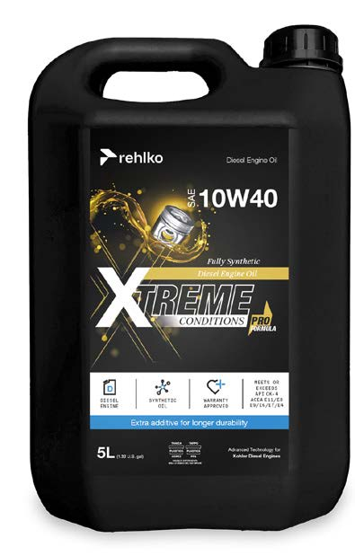 | 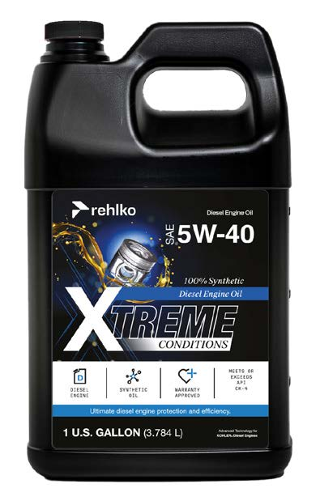 | 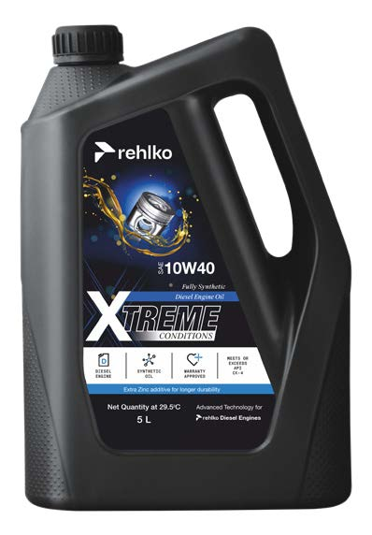

Oils meeting the following specifications are also recommended.

2.2
RECCOMENDED OIL
VISCOSITY | SAE | 10w-30 (-25°C ÷ +40°C) 10w-40 (-25°C ÷ +50°C)  5w-30 (-30°C ÷ +40°C)  0w-40 (-40°C ÷ +50°C)
WITH SPECIFICATIONS | API | CI-4 Plus CI-4  CH-4
WITH SPECIFICATIONS | ACEA | E7  E5

- Low S.A.P.S. oils, sulfate ashes <1% may not be used with fuels with a sulfur content >50ppm.
- Filtration of oils is critical to proper operation and lubrication; always change filters regularly as specified in this manual.

Fuel
  Important  - Use of other types of fuel could damage the engine. Do not use dirty diesel fuel or mixtures of diesel fuel and water since this will cause serious engine faults. |   Warning  - Clean fuel prevents the fuel injectors from clogging. Immediately clean up any spillage during refuelling.  - Never store diesel fuel in galvanized containers (i.e. coated with zinc). Diesel fuel and the galvanized coating react chemically to each other, producing flaking that quickly clogs filters or causes fuel pump and/or injector failure.  - Any failure resulting from the use of fuel other than Tab. 2.3, 2.4 will not be covered by warranty.
Cetane number of 40 minimum. Cetane number greater than 47 is preferred, especially for temperatures below –20 °C (–4 °F) or elevations above 1675 m (5500 ft.).

Highly Regulated Engines (EU, USA, CANADA, JAPAN, CHINA, INDIA)
- EU EN 590
- North America ASTM D975 No. 2-D S15; No. 1-D S15
- Japan JIS K 2204 No. 1; No. 2
- India BS-V ULSD; BS-VI ULSD
- China GB 19147-2016 ULSD; GB 17691—2018 ULSD
- HVO EN 15940 or ASTM D975
- Military NATO fuel F-54 S < 10ppm

Less or Not Regulated Engines (Rest of the World and Military applications)
- Equivalent to all above specification
- Equivalent to all above specification but with Suplhur < 500ppm
- Equivalent to all above specification but with Suplhur < 2000ppm
- F-34/F-35 (kerosene NATO designation) (1)
- F-44 (kerosene, NATO designation) (1)
- F-63 (kerosene, NATO designation, equivalent to F-34/F-35 with additives (1)
- JP-8 (kerosene, US military designation) (1)
- JP-5 (kerosene, US military designation) (1)
- Jet A / A1 (kerosene for civil aviation) (1)

(1) - Operations with Jet Fuels: The jet fuels can be used but only adopting an additional fuel filter with lubricity doser. Because of lower density and greater leak fuel volume due to lower viscosity, depending on the engine speed and torque, a power loss up to 10% is possible. There are some problematical fuel proprieties amongst the listed jet fuels (viscosity, lubricating capacities and low boiling point). A slight increase in wear in the injection system is to be expected which can lead to a statistically shorter life of these components. Sulphur content must be below 2000ppm.

2.5.1 Fuel Additives
To aid in maintaining performance of the engines injection system, Rehlko has developed a family of fuel additives product for North America market.

The Extra Performance Fuel Additive Arctic Formula a fuel conditioner in winter, the Extra Performance Fuel Additive a fuel injector deposit removal and prevention. See your local Rehlko dealer for availability.

2.3
Rehlko Extra Performance Fuel Additive  (North America only) | 
Use Rehlko Injector Cleaner Diesel Fuel Additive before filling the tank once a year or every 500hrs with summer or winter grade fuel. Formulated to clean deposits from injectors and provide lubrication to high pressure pump and injectors to reduce wear, increasing fuel quality. Compatible with all exhaust emission system, including diesel particulate filters (DPFs). Follow all recommended instruction on product label.
Rehlko Extra Performance Fuel Additive Arctic Formula  (North America only) | 
Use Rehlko Extra Performance Fuel Additive Arctic Formula, which contains anti-gel chemistry to treat non-winter grad fuel (No. 2-D in North America) during the cold-weather season. This extends the operability to about 10°C (18°F) below the could point. For operability at even lower temperatures, use winter grade fuel. Treat the fuel when the outside temperature drops below 0°C (32°F). For best results, use untreated fuel and follow all recommended instruction on product label.
Cloud point is the temperature at which wax begins to from in the fuel causing filters to plug.
Fuel additives with biocide/algaecide functions are allowed in case of storage of fuel in the tank for long periods (one year or more). | For suggested brands and types contact Rehlko staff
NOTE: These additives must be diluted in the fuel following the product prescribed percentages when filling the tank. | For suggested brands and types contact Rehlko staff

Coolant recommendation
Rehlko XtendedTM prediluted coolant 50% ethylene glycol OAT is preferred.

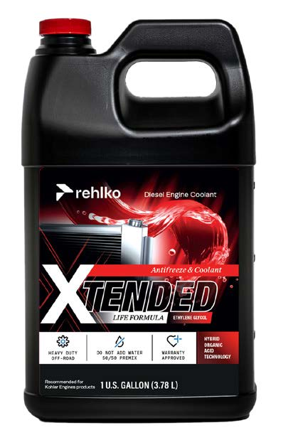

Coolant meeting the following specifications are also recommended.

A mixture of 50% demineralized water and 50% low silicate ethylene glycol based coolant liquid must be used. Use a Long Life or Extended Life Heavy Duty OAT coolant free of: silicates, phosphates, borates, nitrites and amines.

The following ethylene-glycol based engine coolant for all models within KSD engine family may be used:

- OAT (Organic Acid Technology) Low Silicate: ASTM D-3306 D-6210
- HOAT (Hybrid Organic Acid Technology) Low Silicate: ASTM D-3306 D-6210

The above coolants in concentrated formulation must be mixed with distilled, deionized, or demineralized water. A pre-mixed formulation (40-60% or 50-50%) can be used directly when available.

Important
- Do not mix ethylene glycol and propylene glycol based coolants. Do not mix OAT and HOAT based coolant. OAT performance life can be drastically reduced if contaminated with nitrite-containing coolants.
- Never use automotive-type coolants. These coolants do not contain the correct additives to protect heavy – duty diesel engines.

OAT coolants are maintenance free up to 5 years or 4000hrs of operation , provided that the cooling system is topped up using the same type of coolant. Do not mix different coolant types. Test the coolant condition annually with coolant test strips.
HOAT are not all maintenance free and it is recommended to have SCA (Supplemental Coolant Additives) added at the first maintenance interval.

Battery recommendation
Battery not supplied by Kohler

Tab. 2.7
RECOMMENDED BATTERIES
AMBIENT TEMPERATURE | BATTERY TYPE
> - 15°C | 12V 100 Ah - 800 CCA/SAE
-15°C ÷ -25°C | 12V 110 Ah - 950 CCA/SAE
< - 25°C | 12V 120 Ah - 1000 CCA/SAE

Periodic maintenance
The intervals of preventive maintenance in Tab. 2.8, Tab. 2.9, Tab. 2.10 and Tab. 2.11 refer to the engine operating under normal operating conditions with fuel and oil meeting the recommended specifications.
2.8
CLEANING AND CHECKING
OPERATION DESCRIPTION | PERIOD (HOURS)
OPERATION DESCRIPTION | 100 | 250 | 500 | 5000
Engine oil level ⁽⁸⁾
Coolant level ⁽⁸⁾ ⁽⁹⁾
Water presence in fuel filter
Cartridge dry-type air filter ⁽²⁾
Radiator heat-exchange surface and Intercooler ⁽²⁾ ⁽⁸⁾
Standard alternator belt ⁽⁸⁾
Poly-V alternator belt ⁽⁸⁾
Rubber hose (intake air / coolant)
Fuel hose
Starter Motor
Alternator
2.9
REPLACEMENT
OPERATION DESCRIPTION |  | PERIOD (HOURS)
 |  | 500 | 2000 | 5000
Cartridge dry-type air filter ⁽²⁾
Intake manifold hose (air filter - intake manifold) ⁽⁷⁾
Coolant hoses ⁽⁷⁾
Fuel line hose ⁽⁷⁾
Alternator belt | Standard alternator belt (trapezoidal) ⁽³⁾
Alternator belt | Poly-V belt heavy environmental condition
Alternator belt | Poly-V belt standard condition
Coolant | OAT
Coolant | HOAT ⁽¹⁰⁾

2.10
ENGINE OIL AND OIL FILTER CARTRIDGE REPLACEMENT
ENGINE VERSION | PERIOD (HOURS)
ENGINE VERSION | 250 | 500
KDI Mechanical Injection Tier 3 – Stage IIIA ⁽¹⁾
KDI Mechanical Injection Uncertified Engines ⁽¹⁾ ⁽¹¹⁾

2.11
FUEL FILTER AND PREFILTER CARTRIDGE REPLACEMENT
ENGINE VERSION | PERIOD (HOURS)
ENGINE VERSION | 250 | 500
KDI Mechanical Injection Tier 3 – Stage IIIA ⁽¹⁾
KDI Mechanical Injection Uncertified Engines ⁽¹⁾
(1) - In case of low use: 12 months.

(2) - The period of time that must elapse before checking the filter element depends on the environment in which the engine operates. The air filter must be cleaned and replaced more frequently under very dusty conditions.

(3) - In case of low use: 36 months.
(7) - The replacement interval is only an indication, it strongly depends from environmental condition and hose status detected during regular visual inspection.
(8) - The first check must be done after 10 hours.
(9) - Test the coolant condition annually with coolant test strips.
(10) - It is recommended to have SCA (Supplemental Coolant Additives) added at the first maintenance interval.
(11) - Read Cap. 2.5, "KDI Mechanical Injection Uncertified Engines (no EGR Engines)"

Fuel system
2.9.1 Supply system

Important

- The high pressure supply injection system is highly susceptible to damage if the fuel is contaminated.
- It is crucial that all components of the injection circuit are thoroughly cleaned before the components are removed.
- Thoroughly wash and clean the engine before maintenance.
- Contamination in the fuel supply injection system may cause a reduction in effectiveness / operation of engine fault indication.
- If the engine is cleaned with high pressure washer, then the nozzle must be kept at a minimum distance of 200mm from the surface, and not directed at electrical components and connectors.

The fuel supply system is under low pressure from the tank 1 to the high-pressure fuel injection pump 5 .  NOTE : The representation of fuel tank is purely indicative. Component not necessarily supplied by KOHLER .  Tab 2.12 | 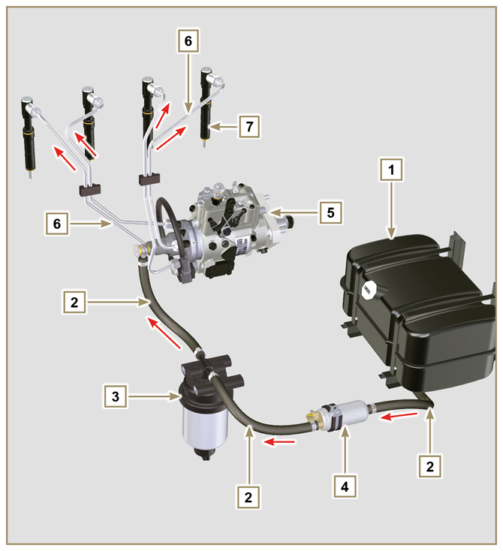  Fig 2.4
  POS. | DESCRIPTION
  1 | Fuel tank
  2 | Fuel supply hose from the tank to the injection pump
  3 | Fuel filter
  4 | Electrical fuel feed pump
  5 | Injection pump
  6 | Injector high-pressure hose from the injection pump to the injectors
  7 | Injectors
2.9.2 Fuel return circuit  The fuel return circuit is under low pressure.  NOTE : The representation of fuel tank is purely indicative. Component not necessarily supplied by KOHLER .  Tab 2.13 | 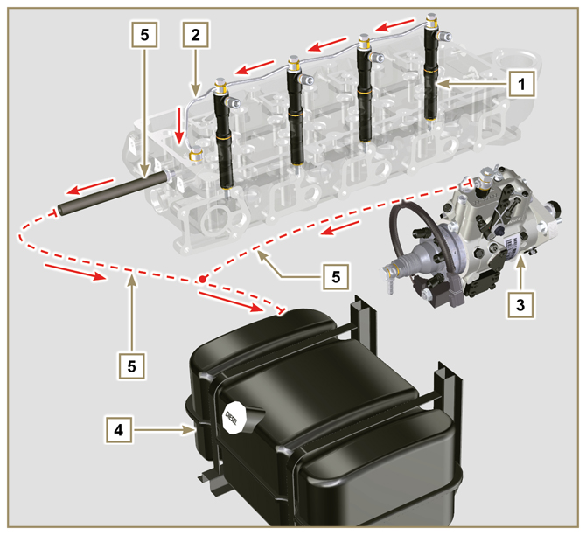  Fig 2.5
  POS. | DESCRIPTION
  1 | Injectors
  2 | Injectors fuel return pipe
  3 | Injection pump
  4 | Fuel tank
  5 | Fuel return pipe to the tank

2.9.3 Injection pump  Pressure into the injection pump must be positive in all operating conditions.  The injection pump is operated by means of the pump control gear and sends high-pressure fuel to the injectors.  NOTE: In the event of leakage from the high pressure circuit do not intervene with the engine running, but turn it off and wait 5 - 10 minutes before checking the leak.  Tab 2.14 | 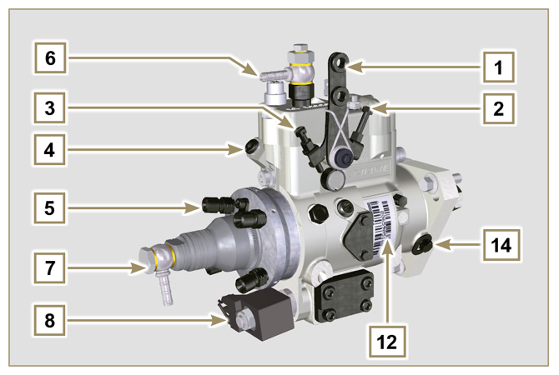  Fig 2.6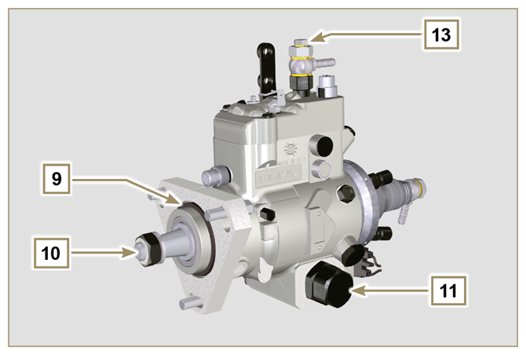  Fig 2.7
  POS. | COMPONENTS DESCRIPTION
  1 | Accelerator lever
  2 | Min Adjustment
  3 | Max Adjustment
  4 | Torque adjustment
  5 | High pressure delivery to injectors
  6 | Return to fuel tank
  7 | Inlet suction fuel
  8 | Cold starting device
  9 | Gasket
  10 | Shaft
  11 | Advance settings (locked)
  12 | Pump identification label
  13 | Air bleeding screw
  14 | Pump control shaft blocking device.

2.9.4 Injector  It is a device used to introduce fuel, in the form of one or more jets that are adequately pulverised and suitably oriented directly into the combustion chamber. They consist of a metallic body that internally provides a mobile element that acts on the needle: this, rising against the action of a calibrated spring,  allows the release of fuel under high pressure.  Opening pressure: 260-268 bar (3770-3886 PSI)  Important  - The injectors are calibrated individually.  - Fuel contamination causes serious damage to the injection system.  Tab 2.15 | 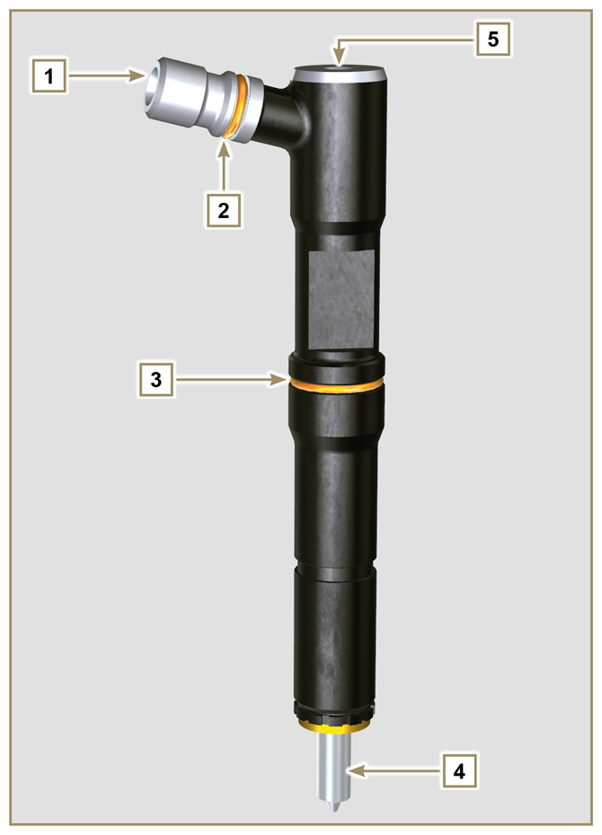  Fig 2.8
  POS. | COMPONENTS DESCRIPTION
  1 | Inlet fuel
  2 | Gasket
  3 | Gasket
  4 | Nozzle
  5 | Hole for fuel return to fuel tank

2.9.5 Fuel filter  The fuel filter is situated on the crankcase of the engine or it may be assembled on the frame of the vehicle.  Tab 2.16  Tab 2.17 Cartridge characteristics | 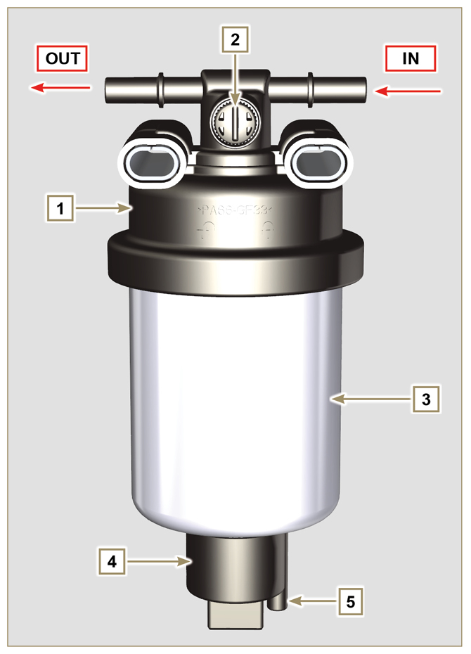  Fig 2.9
  POS. | COMPONENTS DESCRIPTION
  1 | Fuel filter support cartridge
  2 | Air bleeding screw
  3 | Cartridge
  4 | Water in fuel sensor
  5 | Hole water drainage
  DESCRIPTION | VALUE
  Filtering surface | 2.300 cm ²
  Degree of filtration | 5 µm
  Max operating pressure | 2.0 Bar

2.9.6 Electric fuel pump (optional)  When the electric fuel pump is installed in a diesel engine, one must:  - Remove any filters installed on the inlet of the electric fuel pump;  - Insert a pre-filter between the tank and the electric pump;  - The electric pump must be installed on the application at a height from the minimum tank level such as to generate a MAX . pressure drop equal to a column of 500 mm of fuel;  - Insert a shut-off valve to prevent dry operation due to the emptying of the intake manifold;  - The electric pump must guarantee a supply pressure at the inlet positive in all conditions.  Tab 2.18 | 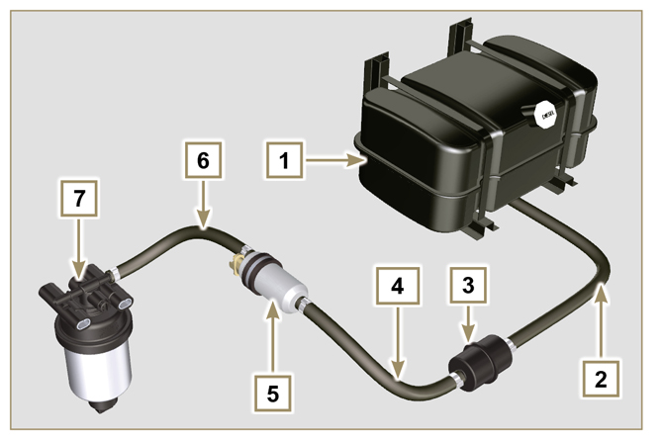  Fig 2.10
  POS. | DESCRIPTION
  1 | Fuel tank
  2 | Arrival pipe from the tank
  3 | Prefilter
  4 | Flow pipe from pre-filter to electric pump
  5 | Electric pump
  6 | Flow pipe to the fuel filter
  7 | Fuel filter
2.9.7 Guards for fuel injection circuit components  High-pressure injection circuit components are particularly sensitive to impurities.  To prevent impurities, even microscopic ones, from accessing the fuel input or output unions, you are required to close these accesses by means of specific caps as soon as the various tubes are disassembled and disconnected.  Disassembly of any component of the injection circuit must not occur in dusty environments.  Cap guards must remain closed in their housing (ST_40) until the moment they are to be used.  Pay special attention when using the caps and avoid any contamination of dust or dirt of any kind.  Even after using the caps illustrated in this paragraph, all components of the injection circuit must be placed with care in environments that are free of any type of impurity.  Fig. 2.11 and 2.12 illustrate the caps that must be used on components of the injection circuit.  Cap guards must be accurately washed after use and placed back in their housing (ST_40).  Important  - It is highly recommended to have this page visible during disassembly operations of the components of the fuel injection circuit. | 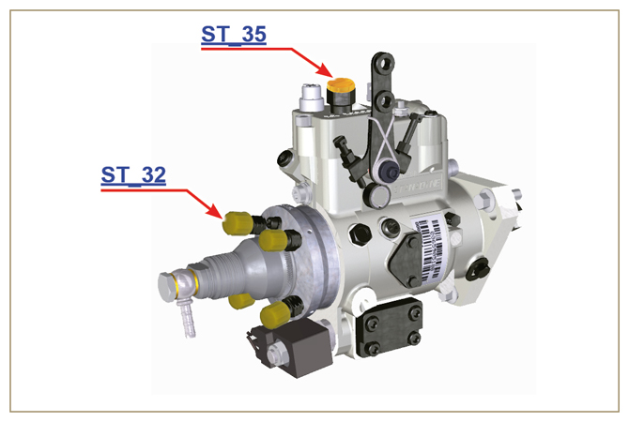  Fig 2.11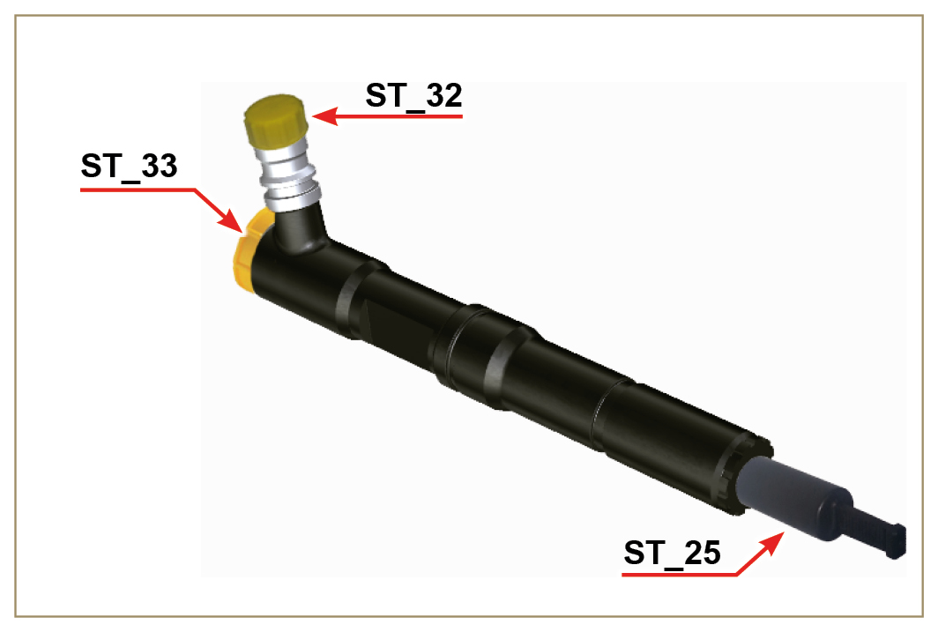  Fig 2.12

Lubrication circuit
2.10.1 Lubrication circuit diagram  The oil pump is driven by the crankshaft on the timing system side.  On the parts of the systems shown in green on In the parts in green, the oil is in intake, in the parts in red, the oil is under pressure and  in those in yellow the oil is returning towards the oil sump 2 (not under pressure).  Tab 2.19  Tab 2.20 | 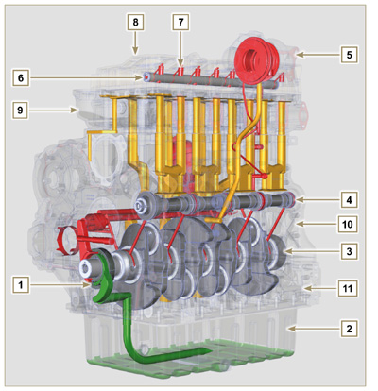  Fig 2.13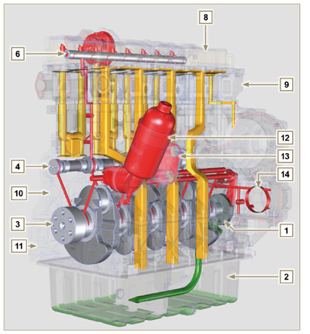  Fig 2.14
  COLOUR | DESCRIPTION
   | Oil in intake
   | Oil under pressure
   | Oil returning to the oil sump
  POS. | DESCRIPTION
  1 | Oil pump rotors
  2 | Oil sump
  3 | Crankshaft
  4 | Camshaft
  5 | Turbocharger
  6 | Rocker arm pin
  7 | Hydraulic tappets
  8 | Rocker arm cover
  9 | Cylinder head
  10 | Upper crankcase
  11 | Lower crankcase
  12 | Oil filter
  13 | Oil Cooler
  14 | Housing
NOTE : Click by side to play the procedure. | https://www.youtube.com/embed/Ig3XosQ8h0s?rel=0
2.10.2 Oil pump The oil pump rotors are trochoidal (with lobes) and are activated from the crankshaft by means of the key.  The pump body is situated inside the distribution guard.  It is imperative to assemble the rotors with reference A visible by the operator.  Tab 2.21 | 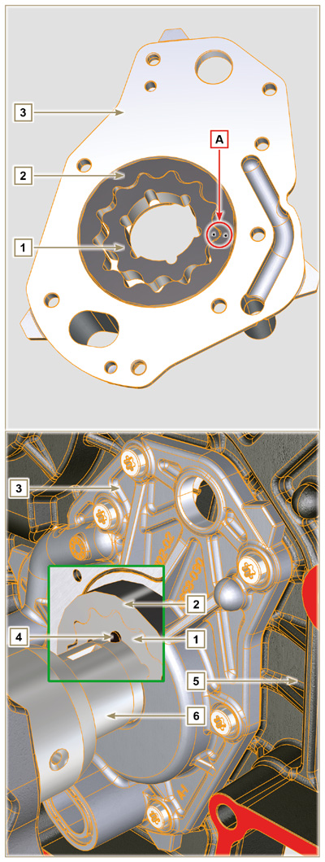  Fig 2.15
  POS. | DESCRIPTION
  1 | Internal rotor
  2 | External rotor
  3 | Oil pump crankcase
  4 | Pump control key
  5 | Timing system crankcase
  6 | Crankshaft

2.10.3 Oil filter and Oil Cooler

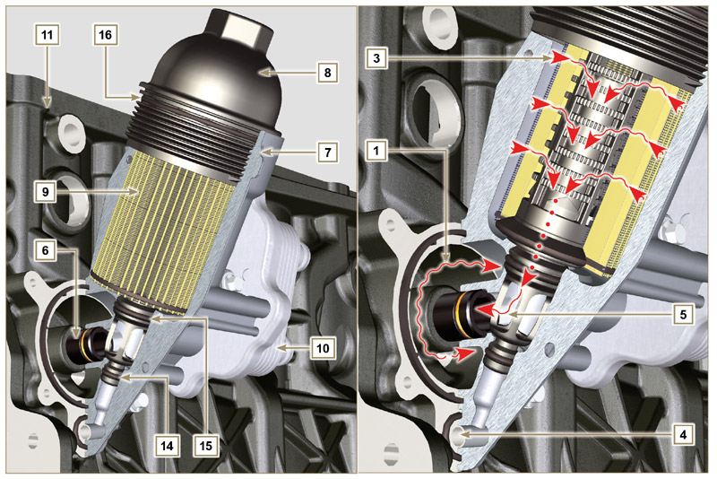
Fig 2.1 6

NOTE : unscrewing the cartridge holder cover makes the oil in support 7 flow towards the oil sump by means of the drain duct 4.
Tab 2.22  Tab 2.23 Cartridge characteristics. | 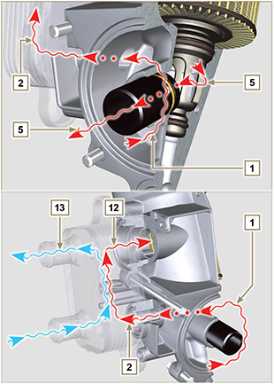  Fig 2.17
  POS. | DESCRIPTION
  1 | Oil arriving from the pump
  2 | Oil cooling
  3 | Oil filtering
  4 | Oil drain duct (oil sump return)
  5 | Oil returning into the circuit
  6 | Outgoing fitting from filter
  7 | Oil filter support
  8 | Cartridge holder cover
  9 | Oil filter cartridge
  10 | Oil Cooler
  11 | Crankcase
  12 | Oil directly from the cartridge
  13 | Coolant
  14 | Oil drain duct closure gasket
  15 | Oil filtering chamber closure gasket
  16 | Cartridge holder cover gasket
  DESCRIPTION | VALORE
  Filtering surface | 2.300 cm ²
  Degree of filtration | 2 µm
  Max operating pressure | 4.0 Bar
  Max flow rate | 190 litres/hour

Coolant circuit
2.11.1 Coolant circuit diagram
Tab 2.24 | 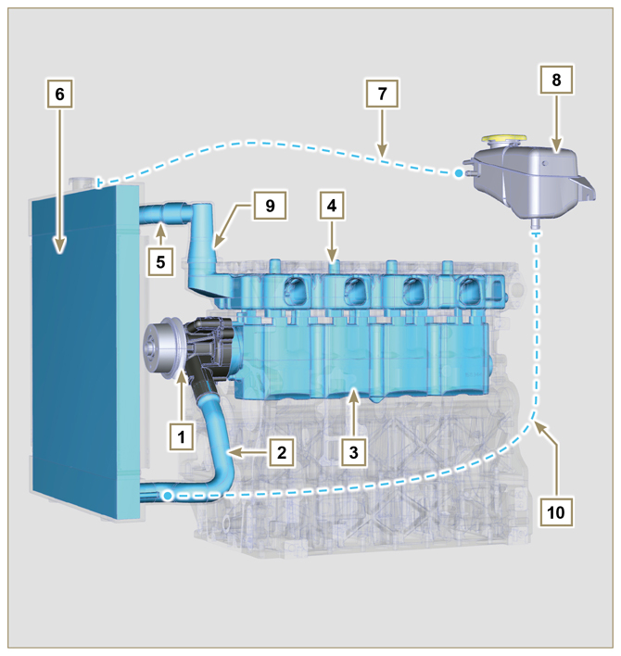  Fig 2.18
  POS. | DESCRIPTION
  1 | Coolant pump
  2 | Coolant intake
  3 | Coolant, cylinder
  4 | Coolant, cylinder head
  5 | Coolant to radiator
  6 | Coolant into radiator
  7 | Vent line from radiator (to 8)
  8 | Compensation tank
  9 | Thermostatic valve
  10 | Return from compensation tank
2.11.2 Coolant pump  Tab 2.25 | 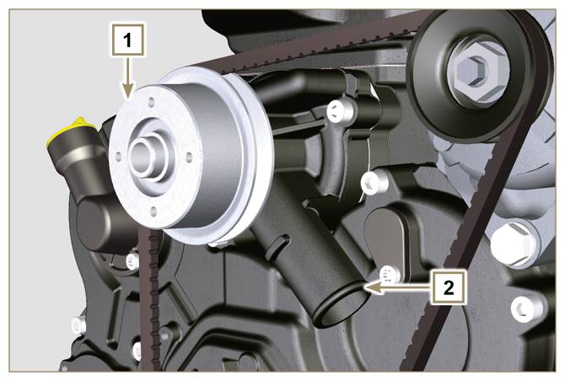  Fig 2.19
  POS. | DESCRIPTION
  1 | Coolant pump control pulley
  2 | Coolant intake fitting
2.11.3 Thermostatic valve  Tab 2.26  Opening temperature +79° ± 2°C. | 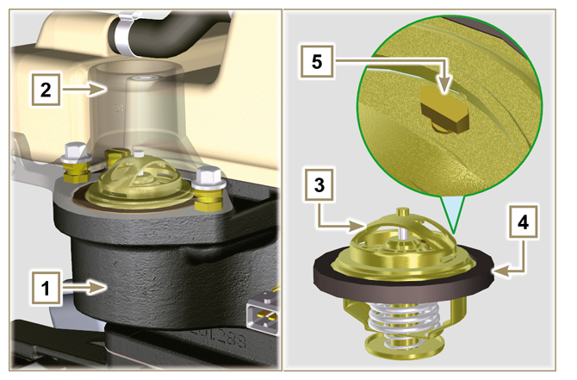  Fig 2.20
  POS. | DESCRIPTION
  1 | Cylinder head
  2 | Coolant outlet cover
  3 | Thermostatic valve
  4 | Gaskets
  5 | Air bleeding hole
2.11.4 Radiator (optional)  NOTE: Component not necessarily supplied by Kohler.  Tab 2.27 | 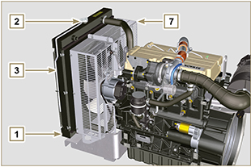  Fig 2.21  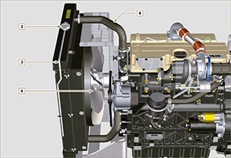  Fig 2.22
  POS. | DESCRIPTION
  1 | Radiator group
  2 | Coolant refill cap
  3 | Vent tube or excess coolant return
  4 | Coolant flow manifold
  5 | Coolant intake manifold
  6 | Fan
  7 | Protective grid

Intake and exhaust circuit
 | Air in intake |  | Gas in exhaust

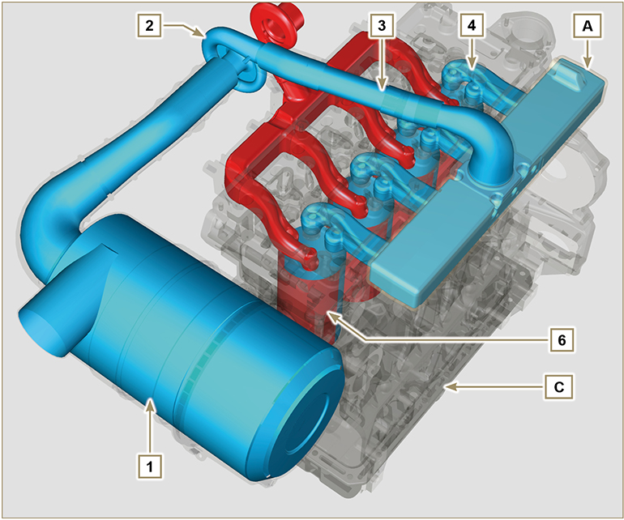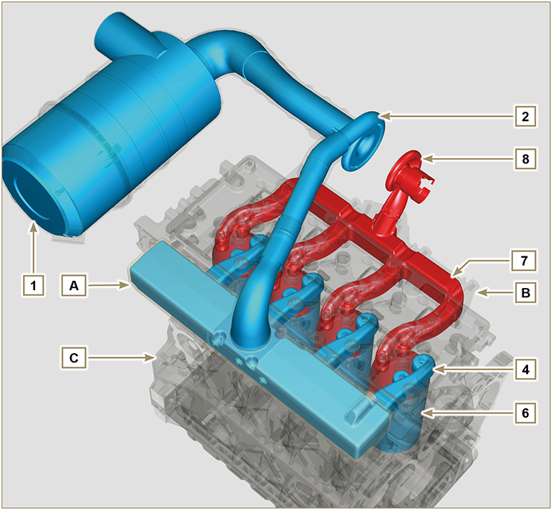
Fig 2.23

Important  - The air temperature inside the intake manifold must never exceed that of the environment by 10°C.  Clean air is sucked by the turbocharger, which compresses it in the intake manifold and via ducts in the cylinder head, enters the cylinders. Compressed air inside the cylinders and mixed with the fuel transforms into Gas after combustion. The gas is expelled from the cylinders and sent to the exhaust manifold. The exhaust manifold sends the gases to the turbocharger's body (the expelled gases activate the turbine), the gases then proceed towards the exhaust line to be definitely expelled. | Tab 2.28
  POS. | DESCRIPTION
  1 | Air in air filter
  2 | Air in compression in the turbocharger
  3 | Air in head intake
  4 | Air in cylinder intake
  5 | Gas in cylinder outlet
  6 | Gas in head outlet
  7 | Outlet gas to muffler
  8 | Exhaust gas from the turbocharger
  A | Inlet manifold
  B | Exhaust manifold
  C | Crankcase
  D | Exhaust muffler (optional)
2.12.1 Air filter (optional)  NOTE: Component not necessarily supplied by KOHLER.  Important  - The air filter is a dry-type one, with a replaceable paper filter cartridge  - The filter intake must be positioned in a cool area.  - The temperature of the aspirated air must never exceed ambient temperature by more than 10°C (if you are using a pipe, its length must not exceed 400 mm and it must be as straight as possible).  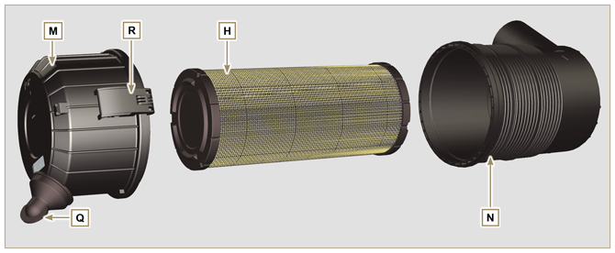 | Tab 2.29
  POS. | DESCRIPTION
  H | Air filter cartridge
  M | Filter cover
  N | Filter support
  Q | Dust exhaust valve
  R | Dust exhaust valve
2.12.2 Turbocharger  The turbocharger is controlled by means of exhaust gas that activates the turbine.  Important  - See Par 2.18 .  Tab. 2.29b | 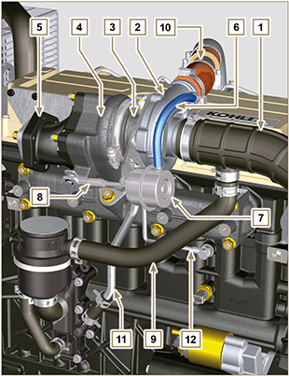  Fig 2.24
  POS. | DESCRIPTION
  1 | Air intake hose
  2 | Air compression volute
  3 | Turbo charger central body
  4 | Turbine housing with Waste Gate valve
  5 | Gas exhaust flange
  6 | Waste Gate control valve hose
  7 | Waste Gate valve control actuator
  8 | Waste Gate control valve linkage
  9 | Engine crankcase breather
  10 | Compressed air delivery hose to the intake manifold
  11 | Oil drain pipe
  12 | Turbo charger lubrication pipe

Electric system

2.13.1 Engine electrical wiring (opzional)  NOTE : Component not necessarily supplied by KOHLER .  Electrical wiring is supplied upon request, it interfaces with the panel by means of 19-way Deutsch connectors (female on engine panel - male on accessories panel).  The connectors are described in Tab. 2.30.  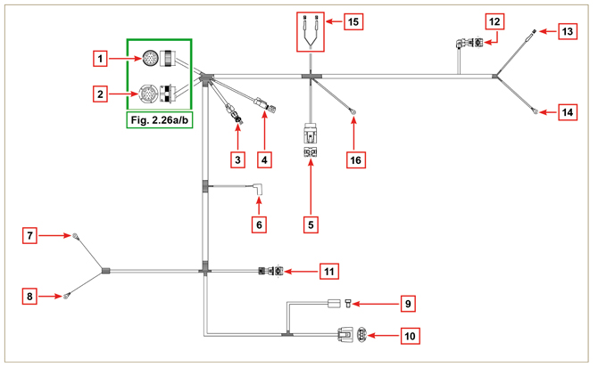  Fig 2.25 | Tab 2.30
  REF. | DESCRIPTION
  1 | Engine panel connector interface (Fig. 2.26a)
  2 | Accessories panel connector interface (Fig. 2.26b)
  3 | Electrical fuel pump connector
  4 | Cold Start Advance connector (on injection pump - Fig. 2.39 )
  5 | Fuse connector
  6 | Electro-Stop connector (on injection pump)
  7 | "L" alternator connector (Iskra)
  8 | "W" alternator connectors (Iskra)
  9 | Alternator connector without "W" (Chengdu)
  10 | Alternator connector with "W" (Chengdu)
  11 | Coolant temperature sensor connector
  12 | Coolant temperature sensor connector
  13 | Starter motor connector "+ 50"
  14 | Starter motor connector "+ 30"
  15 | Air cleaner clogging sensor connector
  16 | Earth connector

2.13.1.1 Connector panel on the engine/machine  The connector is a female 19-way Deutsch type. There is a list of all PIN connections in Tab. 2.31.  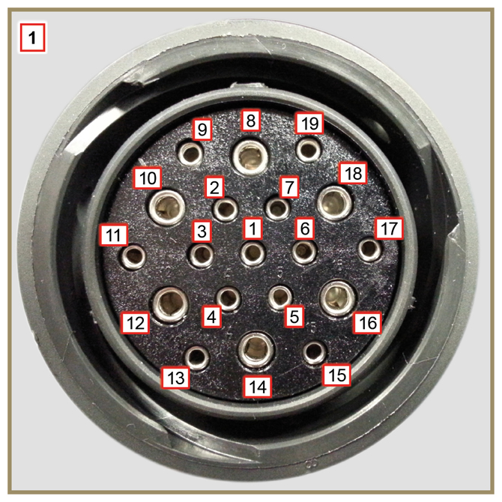  Fig 2.26a | Tab. 2.31
  PIN. | INLET SIGNALS TO THE PANEL
  1 | Oil pressure switch
  2 | Alternator indicator light
  3 | Coolant temperature warning light
  4 | Air cleaner clogging warning light
  7 | Air cleaner clogging warning light
  9 | Electro-Stop
  13 | Alternator (W)
  14 | Starter motor (+ 30)
  15 | Inlet indicator general alarm
  PIN. | OUTLET SIGNALS FROM THE PANEL
  5 | Earth
  6 | IG excitation alternator (+15 wrench)
  8 | Starter motor (+ 50)
  10 | Grid heater (Relay)
  11 | Electric pump
  18 | Injection pump (Cold Start Advance - Fig. 2.39 )

2.13.1.2 Accessories panel connector  The connector is a male 19-way Deutsch type. There is a list of all PIN connections in Tab. 2.32.  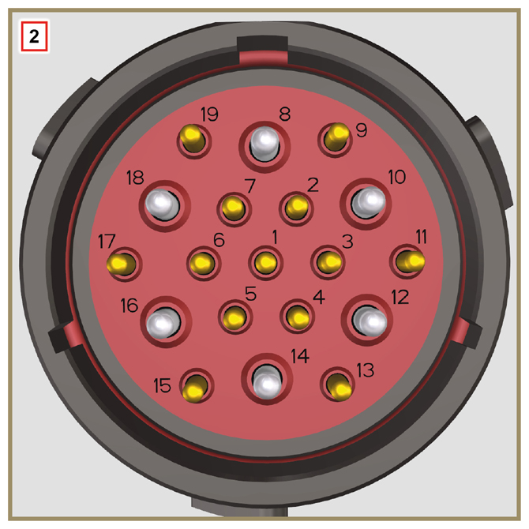  Fig 2.26b | Tab. 2.32
  PIN. | INLET SIGNALS TO THE PANEL
  2 | Fuel filter (water detection sensor)
  4 | Radiator (coolant level sensor)
  7 | Outlet indicator general alarm
  9 | External Stop
  15 | Inlet indicator general alarm
  1 | Fuel tank (fuel level sensor)
  PIN. | OUTLET SIGNALS FROM THE PANEL
  5 | Earth
  6 | Relay with 5A fuse (+ 15 wrench)
  10 | Grid heater (Relay)
  13 | Alternator (W)
  17 | Coolant temperature warning light

2.13.3.1 Wiring disconnection  Some sensor connectors and electronic control devices are sealed.  This tipe of connectors must be disconnected by means of pressure on tabs A or unblock the retainers B , as illustrated from Fig. 2.26c to Fig. 2.26g. | 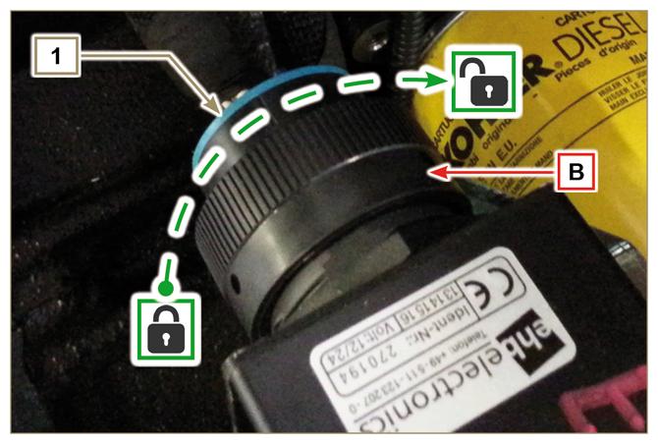  Fig 2.26c
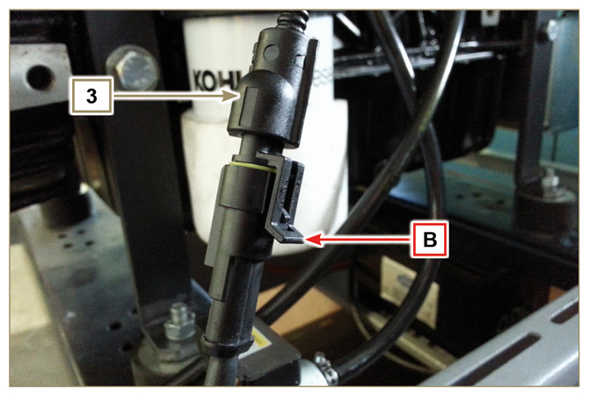  Fig 2.26d | 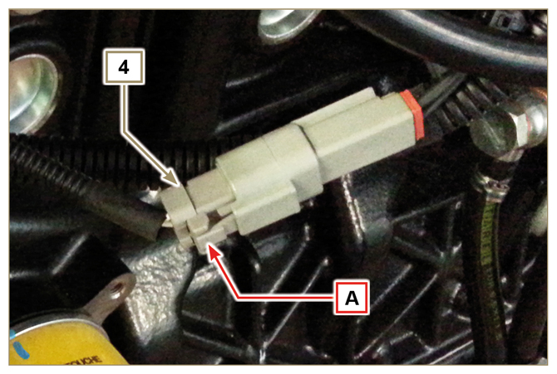  Fig 2.26e
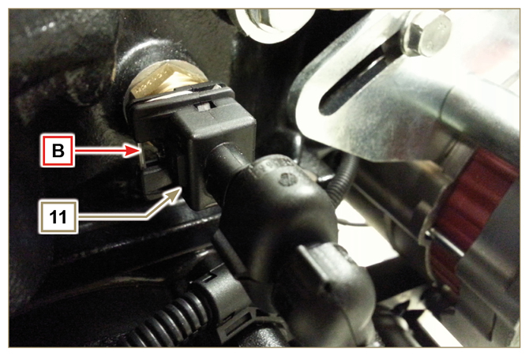  Fig 2.26f | 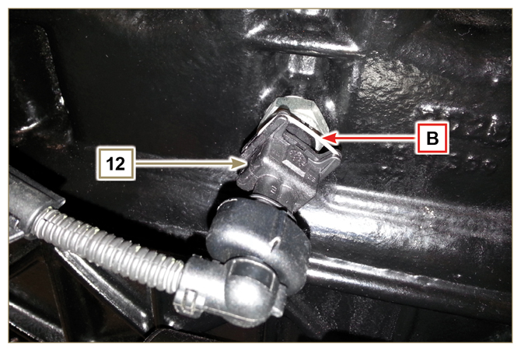  Fig 2.26g

Sensors and switches
2.14.1 Fuel filter water detection sensor (optional)  The water presence sensor in the fuel filter serves to indicate the presence of water in the fuel.  The sensor closes the electrical circuit and the warnin lamp in the panel board switches on the dashboard of the car on which the motor is mounted.  Water, if present in the fuel, because of its greater specific weight separates and settles in the lower part of the filter  where there is a drain plug.  Gently loosen the water drain plug without removing it and spill out the water if present. Re-tighten the water drain plug H as soon as the fuel spills. | 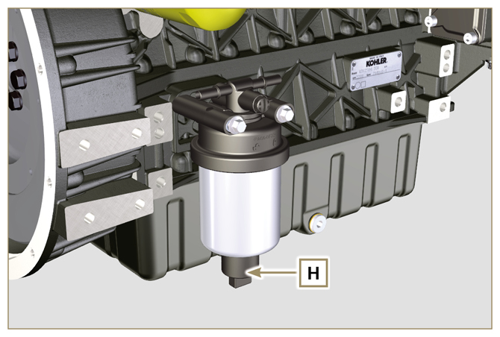  Fig 2.27
2.14.2 Oil pressure switch  Oil pressure switch N is assembled on the crankcase.  It is a N/C sensor, calibrated at 0.6 bar ± 0.1 bar.  With oil low pressure the sensor closes the electrical circuit and the warning lamp in the panel board switches on. | 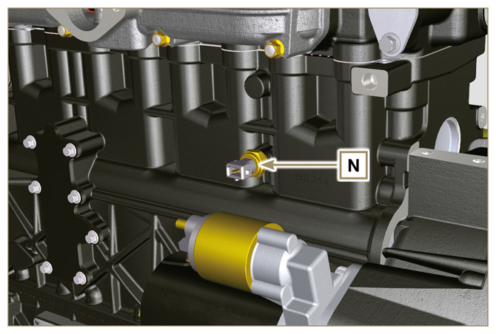  Fig 2.28

2.14.3 Coolant temperature sensor connector  The sensor has the dual function of a thermometer and thermal contact.  The coolant/thermal contact P temperature probe is applied to the cylinder head on the side of the thermostatic valve.  Sensor P1 or P2 (Fig. 2.29) can be assembled on the engine:  P1 Characteristics indicated in Tab. 2.33A (blue connector).  Thermal contact N/O with closing temperature at +110 °C ±3°C, re-opening +88 °C / +100 °C.  P2 Characteristics indicated in Tab. 2.33B (white connector).  Thermal contact N/O with closing temperature at +110 °C ±3°C, re-opening +88 °C / +100 °C.  NOTE : R indicates the pin where it is possible to measure electrical resistance.  Tab 2.33A  Tab 2.33B | 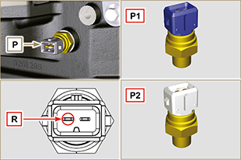  Fig 2.29
  SENSOR P1 CHARACTERISTICS
  Temperatura °C | R min Ω | R max Ω
  -35 | 53.983 | 73.806
  -30 | 39.229 | 52.941
  -15 | 18.006 | 20.825
  0 | 7.095 | 8.929
  30 | 1.717 | 2.039
  60 | 0.520 | 0.589
  90 | 0.188 | 0.204
  120 | 0.076 | 0.084
  SENSOR P2 CHARACTERISTICS
  Temperatura °C | R min Ω | R max Ω
  -36 | 11.835 | 15.724
  -30 | 8.258 | 10.834
  -16 | 3.721 | 4.753
  0 | 1.611 | 2.003
  30 | 414,1 | 493
  60 | 132 | 151,7
  90 | 50,27 | 56,11
  120 | 21,6 | 24,29
2.14.4 Air cleaner clogging switch  NOTE: Component not necessarily supplied by KOHLER .  The switch is assembled on the air cleaner. When the filter is clogged, it sends a signal to the panel.  Features:  - Operating temperature: -30 °C / +100°C  - Contact usually open.  - Contact closed by vacuum: -50 mbar. | 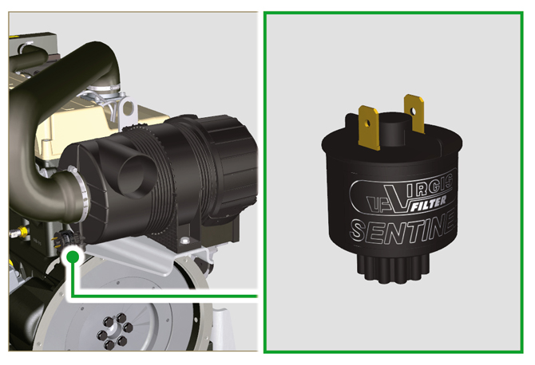  Fig 2.30

Electrical components
2.15.1 Alternator (A)  Externally controlled by the crankshaft by means of a belt.  Features:  - Ampere 55A (80 A optional)  (100A with Poly-V belt optional).  - Volt 12V | 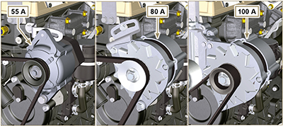  Fig 2.31

2.15.2 Starter Motor (C)  - Type Bosch 12 V  - Potenza 2 kW  - Anticlockwise rotation (seen from timing system side) | 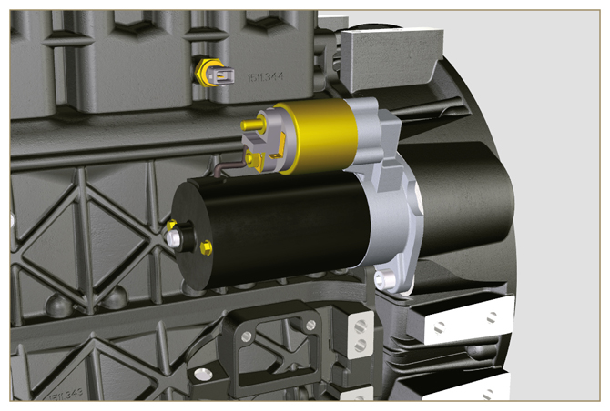  Fig 2.32
2.15.3 Cold starting device (Heater)  The cold starting device consists of a resistance, managed by the ECU, which is activated when the ambient temperature is ≤ -20° C.  The intake air is heated through the resistor and facilitates starting the engine.  Characteristics:  - Type Hidria AET 12 V  - Power 550 W  Characteristics pre-heater timer:  - Tipo Hidria GH + CSA 12 V | 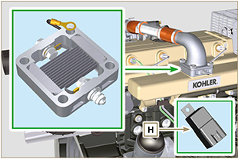  Fig 2.33
2.15.4 Electric pump (optional)  NOTE: Component not necessarily supplied by KOHLER.  The electric pump is located before the fuel filter. One of the following pumps can be assembled A1 - A2 - A3 - A4.  Tab. 2.34 a-b-c-d indicates the pumps' features.  Tab 2.34  Tab 2.34 a  Tab 2.34 b  Tab 2.34 c  Tab 2.34 d | 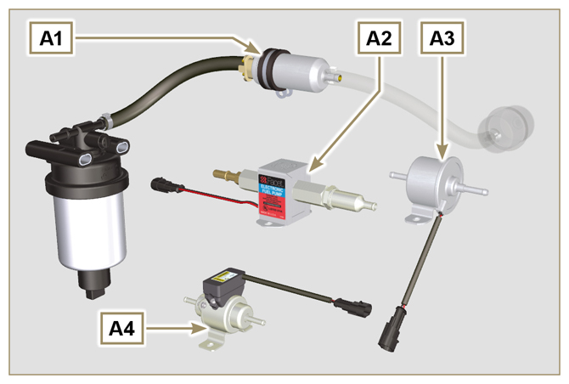  Fig 2.34  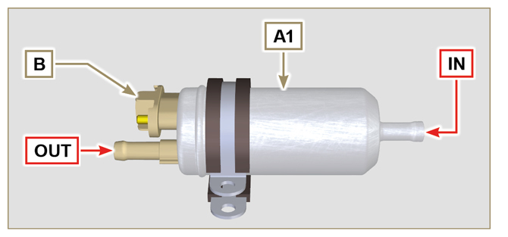  Fig 2.35  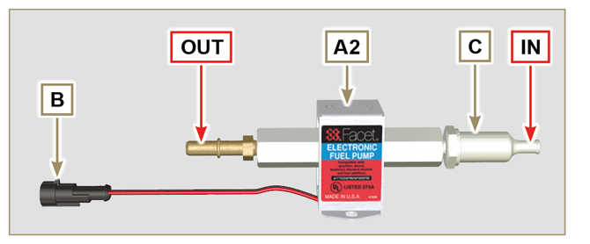  Fig 2.36  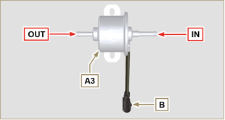  Fig 2.37  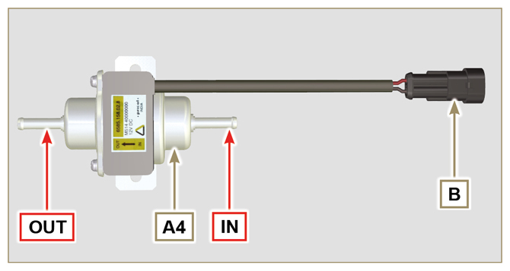  Fig 2.38
  POS. | DESCRIPTION
  1 | Electrical connection
  2 | Prefilter pump
  IN | Ingoing fitting ( IN ) from tank
  OUT | Outgoing fitting ( OUT ) to fuel filter
  A1 | VALUE
  Voltage | 12 - 24 V
  Delivery | 100 L/h @ 0.44 - 0.56 bar
  A2 | VALUE
  Voltage | 12 V
  Delivery | 60.56 L/h @ 0.41 bar
  A3 | VALUE
  Voltage | 12 V
  Delivery | 24 L/h @ 0.1 bar
  A4 | VALUE
  Voltage | 12 V
  Delivery | 30 L/h @ 0.4 bar
2.15.5 Cold start advance  The Cold Start Advance E device is part of injection pump D ; it provides for advance injection modification to enable advance of the engine at low temperatures.  The device is controlled by the ECU H . | 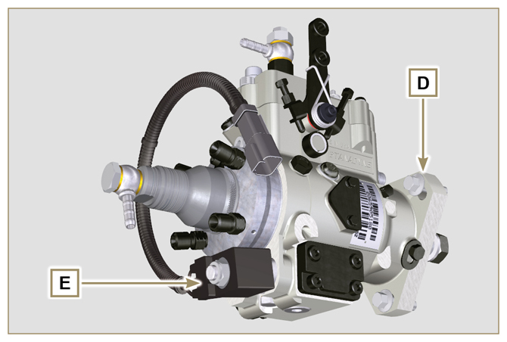  Fig 2.39a
2.15.6 Electro-Stop  The electro-stop F device is part of injection pump D ; it turns off the engine by blocking the flow of fuel into pump D . | 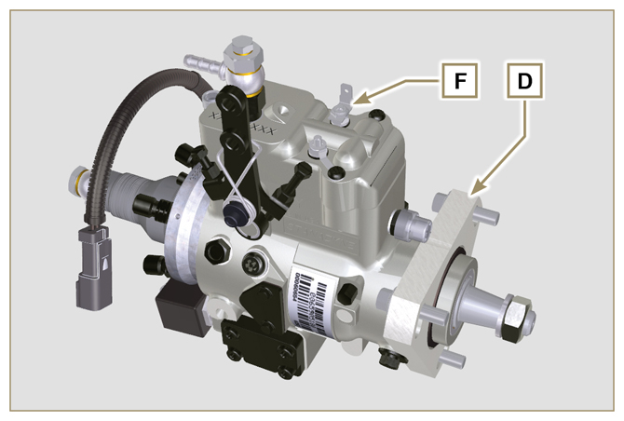  Fig 2.39b
2.15.7 ECU starting  The H device assists cold engine ignition controlling the "cold starting device" ( Heater ) and the "Cold Start Advance" ( CSA ). Tab. 2.35a indicates the activation times based on the ambient temperatur.  Tab. 2.35a  Tab. 2.35b | 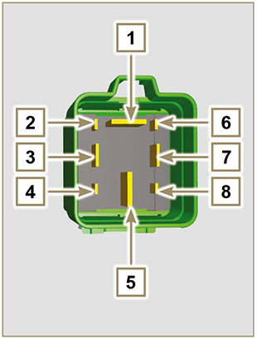  Fig 2.40
  °C | HEATER | CSA
  ≤ 20 ÷ -15 | 0'' | 120''
  - 16 | 16'' | 120''
  - 21 | 21'' | 120''
  -26 | 26'' | 120''
  ≤ -32 | 32'' | 120''
  POS. | DESCRIPTION
  1 | Heater
  2 | 50 - ignition
  3 | 15 - ignition
  4 | CSA
  5 | 30 - battery
  6 | ...
  7 | Earth
  8 | Control panel indicator
2.15.8 Fuse  Device G is assembled on cylinder head P (flywheel side); it protects the electrical circuit in the event of an overload or short circuit.  NOTE: Component not necessarily supplied by KOHLER. | 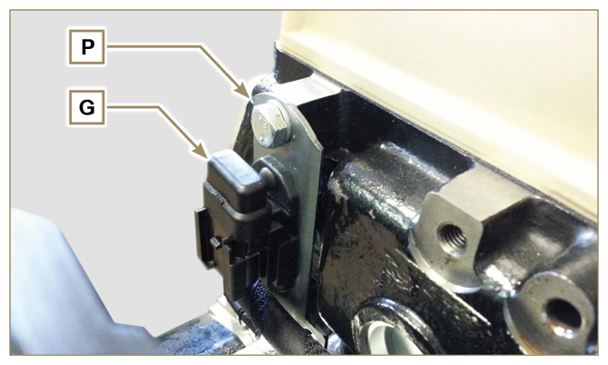  Fig 2.41
2.15.9 Control panel (optional)  Panel L can be assembled on the engine or machine.  The connectors are described in Tab. 2.36 , the main functions are illustrated.  NOTE: Component not necessarily supplied by KOHLER.  Tab 2.36 | 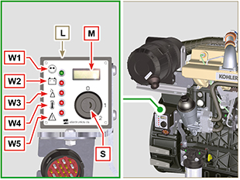  Fig 2.42
  POS. | DESCRIPTION
  M | Hour-meter indicator
  S | Control switch to start the engine
  W1 | Panel ignition indicator
  W2 | Warning Light - battery not charging
  W3 | Warning Light - engine oil not pressurised
  W4 | Warning Light - high coolant temperature
  W5 | Warning Light - alarm general indicator

Timing system and tappets

The timing system is equipped with hydraulic tappets that automatically recover the operation of the rocker rods assembly.
No registration is therefore required.

2.16.1 Components identification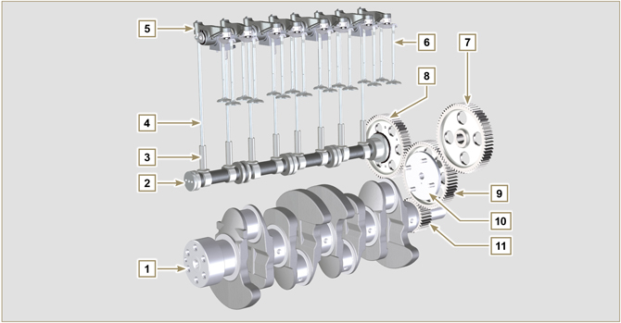
Fig 2.43
Tab 2.37 | 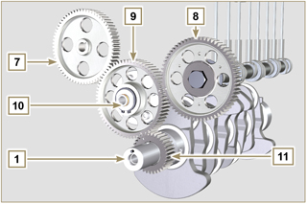  Fig 2.44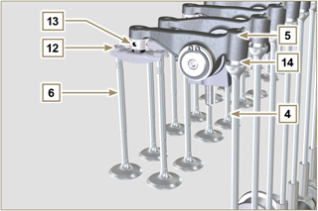  Fig 2.45
  POS. | DESCRIPTION
  1 | Crankshaft
  2 | Camshaft
  3 | Camshaft tappets
  4 | Rocker arm control rod
  5 | Rocker arms
  6 | Valves
  7 | Injection pump control gear
  8 | Camshaft control gear
  9 | Intermediate gear
  10 | Intermediate gear pin
  11 | Crankshaft gear
  12 | Valve control bridge
  13 | Articulation control valves
  14 | Hydraulic tappets
2.16.2 Rocker arm pin  Tab 2.39 | 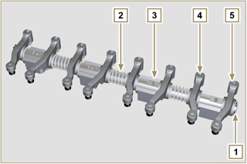  Fig 2.47
  POS. | DESCRIPTION
  1 | Rocker arm pin
  2 | Rocker arm distancing spring
  3 | Rocker arm pin support
  4 | Exhaust rocker arm
  5 | Intake rocker arm
2.16.3 Rocker arms  Tab 2.40 | 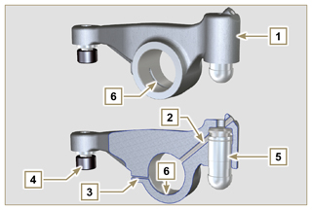  Fig 2.48
  POS. | DESCRIPTION
  1 | Rocker arm body
  2 | Hydraulic tappet oil refill line
  3 | Valve tappet lubrication line
  4 | Valve tappet
  5 | Hydraulic tappet
  6 | Oil flow line
2.16.4 Hydraulic tappets  Tab 2.41  2.16.4.1 Hydraulic tappet operation  The operating principle of the hydraulic tappet is based on the incompressibility of the liquids and on controlled leakage.  The oil under pressure enters the tappet chamber A , providing a constant supply of oil in the low-pressure chamber.  Through the non-return valve, 4 the oil can only access the high-pressure chamber B and exit via the clearance between the piston 3 and the tappet body 5 (controlled leakage).  The chamber B is filled when the rocker arm is on the base radius of the cam and the spring 6 keeps the piston 3 against the valve stem, thus eliminating any system play. Thanks to the spring extension, the tappet "extends", creating a small depression in the chamber B , making the non-return  valve 4 open, and allowing the oil in the chamber A to pass to chamber B , restoring the proper amount of oil required to eliminate any play in the valves. | 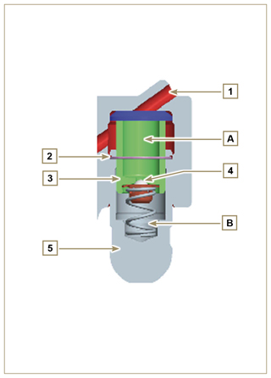  Fig 2.49
  POS. | DESCRIPTION
  A | Hydraulic tappets
  B | Hight pressure chamber
  1 | Hydraulic tappets oil refill pipe
  2 | Retaining ring
  3 | Piston
  4 | Unidirectional valve
  5 | Tappet body
  6 | Spring

2.16.4.2 Difficult operating conditions
For proper operation on the hydraulic tappets it is essentia that the low pressure chamber of the piston 3 is always full of oil.

In some conditions this may not occur (due to the fact that the oil leaks away when the engine is switched off, which can also partially drain the tappets). This situation will be the cause of clearances that will result in a characteristic noise similar toa ticking sound.
- When the engine is cold, the tappet filling time could be very long if the oil used is not suitable for the specific environmental conditions ( Tab. 2.2 )
- If the engine is very hot: at idle speed, oil pressure may be low, and small air bubbles could form in the circuit. Because of this, this compressing the tappet slightly and producing valve play which is responsible for the ticking sound. On account of this, the tappet compresses slightly giving rise to a valve clearance, thus generating a slight ticking sound, which however disappears rapidly ( MAX 10 seconds) once normal operating conditions have been restored.
Anyway the duration of ticking Anyway the duration of ticking sound must be MAX 30 seconds. If not, the problem is surely due to the poor quality of the oil, wear or impurities that, transported by the oil, can infiltrate between the ball valve and its seat inside the piston, compromising the operation of the tappet itself; In these cases, the only solution is to replace the oil or hydraulic tappets.

The prolonged persistence of the ticking sound or abnormal noise must be investigating in order to prevent any malfunctions; if necessary, replace the hydraulic tappets and engine oil.

Components handling
2.17.1 Injection pump  - Only handle by means of the points marked by Y .  - It is forbidden to handle using the points marked by N . | 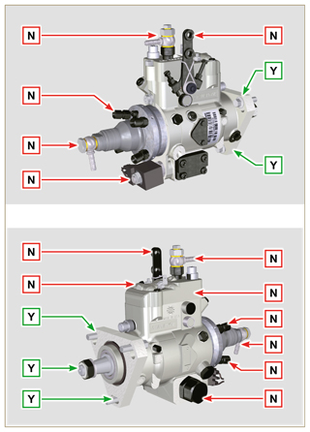  Fig 2.56
2.17.2 Injector  - Only handle by means of the points marked by Y .  - It is forbidden to handle using the points marked by N . | 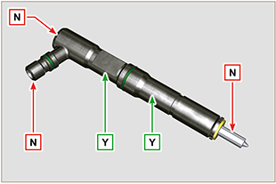  Fig 2.57
2.17.2 Turbochargerector  - Only handle by means of the points marked by Y .  - It is forbidden to handle using the points marked by N . | 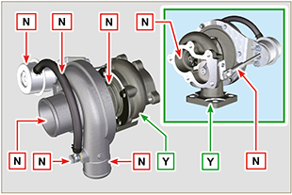  Fig 2.58

Turbocharger

2.18.1 What to do and what not to do  What to do:  - Before assembling the turbocharger, make sure that the protection caps are fitted on all openings of the turbo.  - Ensure pre-lubrication of the turbocharger.  - Periodically check that the joints are sealed against oil and air.  - Use lubricating oil according to the specifications described in Par. 2.4 .  - Check the engine oil level.  - Before switching it off after it has been used, make the engine run idle, or without a load, for approximately 1 minute.  - Ensure that controls and maintenance intervals of the engine are observed as specified in Tab. 2.8 and 2.9 .  - Make sure that the engine and equipment are used correctly so as not to compromise the life of the turbocharger. | What not to do:  - Do not store turbocharges in damp, wet places if they are not in their original packaging.  - Do not expose the turbocharger to dust and dirt if it is not in its original packaging.  - Do not lift of hold the turbocharger from the actuator rod if it is not in its original packaging.  - Do not apply additives to the lubricating oil and fuel, unless instructed to do so by Kohler.  - Do not increase engine speed, or apply loads, immediately after start-up.  - Do not intervene on the actuator settings A (Fig. 2.52) .  - Do not let the vehicle / engine run at idle speed for more than 20-30 minutes at a time.
2.18.2 Practical operating rules  Users can help to maximise the duration of their turbocharger by following the rules described below.  - Start-up Start the engine at idle speed, or without a load, for approximately one minute. Oil operating pressure is reached within a few seconds and enables the moving parts to warm up and be lubricated.  Immediately increasing the engine speed upon start-up means making the turbocharger run at high speed with suboptimal lubrication, which may compromise the life of the turbocharger.  - After maintenance or a new installation  Proceed with pre-lubrication by filling new oil into the oil supply duct B until filling it completely. Start the engine at idle speed, or without a load, for a few minutes in order to ensure that the oil and bearings system operate satisfactorily.  - Low temperature air or engine inactivity  If the engine has been inactive for some time, or the air temperature is very low, start the engine at idle speed or without a load for a few minutes.  - Engine shutdown  Before switching the engine off after intense activity, one must allow the turbocharger to cool down. One must therefore let the engine run at idle speed or without a load for at least 2 minutes, thus allowing the turbocharger to cool.  - Engine at idle speed  Avoid using the engine at idle speed or without a load for long periods (more than 20-30 minutes). When operating at idle speed or without a load, the turbocharger is at low pressure in the exhaust chamber C and air supply D ; this may cause oil leaks from seals E  to the extremity of the shaft. Even if this does not cause damage, it can cause blue smoke from the exhaust when the engine speed and load are increased. | 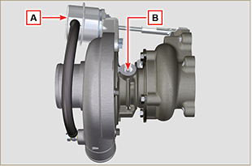  Fig 2.52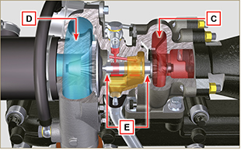  Fig 2.53
2.18.3 Before installing a new turbocharger  Important  - Do not lift the turbocharger with one hand from the box.  - Do not lift turbocharger from Comp hsg side.  - Lift the turbocharger with both hands from box.  - Make sure to use clean gloves. | 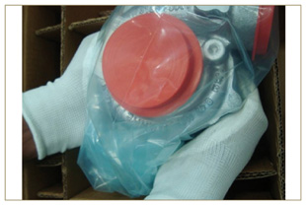  Fig 2.54
- Avoid lifting from the intake side G .  - Remove cap guard F and check that there is no excessive shaft axial and radial clearances. | 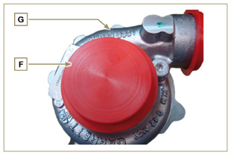  Fig 2.55
- Check for any signs of friction of the turbine on the turbocharger body.  - Check for any traces of oil leaks on the turbocharger body.  - After having check everything, reapply cap F on intake opening H of the turbocharger and do not remove it until assembly has been completed. | 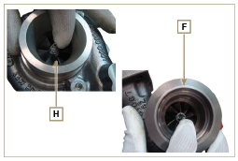  Fig 2.56
- Check the correct assembly of the capscrews and the presence of paint on them. | 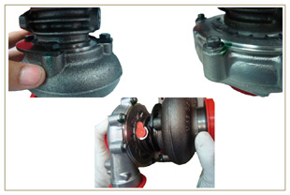  Fig 2.57
2.18.4 Installation instructions  - Remove the cap guards with care only when assembling.  Handle carefully avoiding erratic movements. | 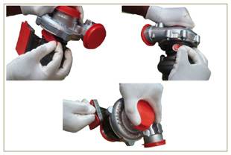  Fig 2.58
2.18.5 Replacement instructions

Always understand the cause of the breakage of the turbocharger before replacing it.

Correct the cause of the breakage before replacing it with a new turbocharger.

If in doubt, contact KOHLER service department.

Important

- Failure to comply with these instructions can cause damage to the turbocharger and void the warranty.
- Modifying the calibration of the turbocharger damages the turbocharger/engine.
- Always use the correct gaskets, and fit carefully to avoid blocking holes when mounting.
- Refer to the manual of the engine / vehicle, for: the correct type and quantity of oil, the correct tightening of components, instructions and installation.
- It is forbidden to use liquid gaskets or sealants, particularly for the oil inlet/outlet.
- Avoid dirt / debris while installing the turbocharger.
- Before mounting the turbocharger, check that the code of the component is correct for the type of engine, as mounting the wrong turbocharger can damage the turbo / engine and void the warranty.

Balancer device (optional)
The balancer device is composed of a special crankshaft that activates 2 additional shafts (balancers).  Rotation of the balancers, which have counterweights that oppose the movement of alternating weights (crankshaft - connecting rods - pistons), reduces vibrations caused by them.  The device is developed under the crankshaft, fixed on the crankcase, closed by the oil sump.  Tab 2.42 | 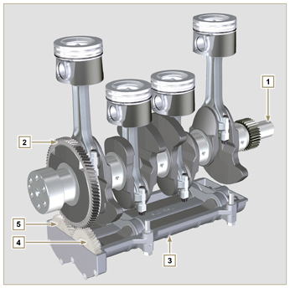  Fig 2.59
  POS. | DESCRIPTION
  1 | Crankshaft
  2 | Balancer shaft control gear
  3 | Balancer shaft support box
  4 | Conductor balance shaft
  5 | Conducted balance shaft



