Glossary
KDI 2504 M-MP Owner Manual (Rev.01)

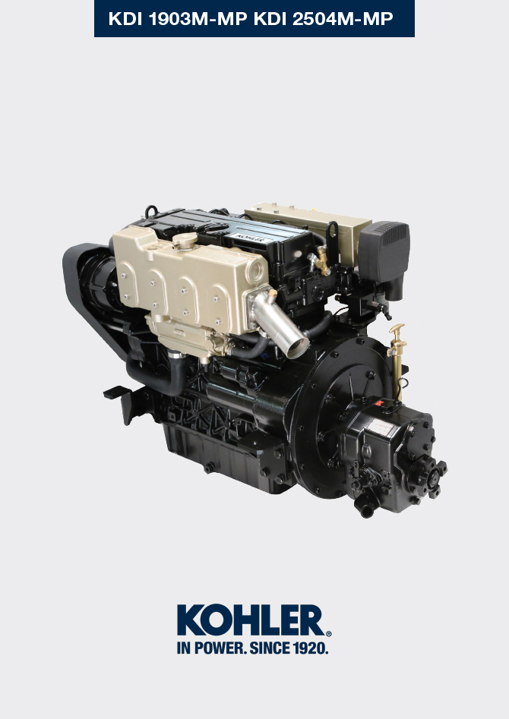

Registration of modifications to the document
Any modifications to this document must be registered by the drafting body, by completing the following table.

Released by | Code | Revision | Release Date | Revision date | Edited by | Endorsed
Technical Documentation | ED0053030860 | 05.1 | 02/2016 | 04/2023 | M. SILVESTRONE | C. TAGLIAVINI

Translated from the original manual in Italian language
Data reported in this issue can be modified at any time by KOHLER.

Sommario
1. TITOLO 1 2
1.1. Asdfsdfsdf 2
1.2. Asdfsdfsdfggg 2

Glossary

Glossary and Definitions
A

Authorised workshop | Kohler authorised service centre.

B

Bore | Internal diameter of the cylinder in combustion engines.

C

Catalyst | A device in charge of filtering exhausted gas.
Combustion | Chemical reaction of a mixture composed of fuel and fuel (air) inside a combustion chamber.

E

EC | "European Community".

F

Fig. | Figure.

G

Galvanised | Material that has undergone surface protection treatment.

H

Heavy conditions | Type of extreme condition referred to the work environment in which the engine is used (very dusty - dirty area, or in a contaminated environment due to various types of gas).

K

KDI | Kohler Direct Injection

M

Maintenance - periodic | A group of maintenance actions that have the sole objective to control and replace elements on their expiry, without modifying or improving the functions carried out by the system, neither increasing the value nor improving performance.
Max | Maximum.
Methyl ester | It is a mixture of products by means of a chemical conversion of oils and animal and/or vegetable fat, which is used to produce Biofuel.
Min. | Minutes.
MIN | Minimum.
Model | Model, engine identification plate, which indicates the engine's model.

P

Par. | Paragraph.
Paraffin | Fatty and solid substance that may form inside the diesel.

R

Raiser | Mixing device that reduces the temperature of the exhaust gases by mixing them with the water from the coolant cooling process. The water and gas mixture is then eliminated through the exhaust pipe.
Ref. | Reference.

S

s/n | Serial number (engine identification name plate) indicating the engine identification series/chassis number.
Sec. | Seconds.
Spec. | Specification, (engine identification name plate) indicating the engine version.

T

Tab. | Table.
Tightening torque | A term indicated for installation of threaded components and which is determined by means of a unit of measurement Nm.

U

Used oil | Oil altered by operation or time, which is no longer compliant for correct lubrication of the components.

Z

Zinc anode | Element whose purpose is to prevent the corrosion of components due to the water flow from the water pump.

SYMBOLS AND UNITS OF MEASUREMENT
SYMBOL | UNIT OF MEASUREMENT | DESCRIPTION | EXAMPLE
α | degree | Rotation/inclination angle | 1°
cm ² | square centimetre | Area | 1 cm ²
Ø | millimetre | Circumference | Ø 1 mm
Nm | newton-metre | Torque | 1 Nm
mm | millimetre | Length | 1 mm
µm | 1/1000 of a millimetre (micron) | Length | 1 µm
H | hour | Time | 1 h
g/kW | grammes per kilowatt per hour | Specific consumption | 1 g/kWh
kg/h | kilogramme per hour | Max. flow rate | 1 kg/h
Lt./min. | litres per minute | Flow rate | 1 Lt./min.
Lt./h | litres per hour | Flow rate | 1 Lt./h
ppm | parts per million | Percentage | 1 ppm
N | newton | Force | 1 N
A | Ampere | Intensity of electrical current | 1 A
gr. | gramme | Weight | 1 gr.
kg | kilogramme | Weight | 1 kg
W | Watt | Power | 1 W.
kW | kiloWatt | Power | 1 kW
pa | pascal | Pressure | 1 pa
KPa | Kilopascal | Pressure | 1 KPa
bar | barometric pressure | Pressure | 1 bar
mbar (1/1000 bar) | barometric pressure | Pressure | 1 mbar
R | Resistance | Resistance to electrical current (referred to a component) | 1 Ω
Ω | ohm | Resistance of electrical current | 1 Ω
Rpm | revs per minute | Rotation of an axis | 1 Rpm
Ra | average roughness expressed in microns | Roughness | 1 Ra
°C | degree centigrade | Temperature | 1°C
V | Volt | Electrical voltage | 1 V
 | millimetre | Hex-head capscrew | 1 mm
cm ³ | cubic centimetre | Volume | 1 cm ³
Lt. | litre | Volume | 1 Lt.



