KDI 3404TCR / KDI 3404 TCR HT
KDI 3404 TCR / KDI 3404 TCR HT Owner Manual (Rev. 13)



Registration of modifications to the document
Any modifications to this document must be registered by the drafting body, by completing the following table.

Released by | Code | Revision | Release Date | Revision date | Edited by | Endorsed
 | 3404tcr

Translated from the original manual in Italian language
Data reported in this issue can be modified at any time by KOHLER.

Sommario
1. TITOLO 1 2
1.1. Asdfsdfsdf 2
1.2. Asdfsdfsdfggg 2

General Information

Manual's Purpose
- This manual contains the instructions needed to carry out proper use and maintenance of the engine, therefore it must always be available, for future reference when required.
- This manual is an integral part of the engine, in the event of transfer or sale, it must be attached to it.
- Safety pictograms can be found on the engine and it is the operator's responsibility to keep them in a perfectly visible place and replace them when they are no longer legible.
- Information, description and pictures in this manual reflect the state of the art at the time of the marketing of engine.
- However, development on the engines is continuous. Therefore, the information within this manual is subject to change without notice and without obligation.
- REHLKO reserves the right to make, at any time, changes in the engines for technical or commercial reasons.
- These changes do not require REHLKO to intervene on the marketed production up to that time and not to consider this manual as inappropriate.
- Any additional section that REHLKO will deem necessary to supply some time after the main text shall be kept together with the manual and considered as an integral part of it.
- The information contained within this manual is the sole property of REHLKO . As such, no reproduction or replication in whole or part is allowed without the express written permission of REHLKO .

Glossary and Definitions
The paragraphs, tables and figure are divided into chapter with their progressive numbers.
Es: Par. 2.3 - chapter 2 paragraph 3.
Tab. 3.4 - chapter 3 table 4.

The references of the objects described in the text and in figure and number are indicated by letters, which are always and only related to the paragraph you are reading unless there are specific references to other figures or paragraphs.
NOTE: All data, measurements and relevant symbols are shown in the glossary section.

Emission-Related Installation Instructions
Failing to follow the instructions in the applications guidebook when installing a certified engine in a piece of nonroad equipment violates federal law (40 CFR 1068.105(b)), subject to fines or other penalties as described in the Clean Air Act. OEM must apply a separate label with the following statement: “ULTRA LOW SULFUR FUEL ONLY” near the fuel inlet.

Ensure you are installing an engine appropriately certified for your application. Constant speed engines may only be installed on constant speed equipment for constant speed operation.

If you install the engine in a way that makes the engine's emission control information label hard to read during normal engine maintenance, you must place a duplicate label on the equipment, as described in 40 CFR 1068.105.

Service request
- The complete and updated list of authorized Rehlko service centers can be found on websites:
https://www.engines.rehlko.com/ & https://www.engines.rehlko.com/dealers .
- If you have any questions regarding your warranty rights and responsibilities or the location of the nearest Rehlko authorized service location, you should contact Rehlko at 1-800-544-2444 or access our website at https://www.engines.rehlko.com/ (USA and North American).

Engine component identification
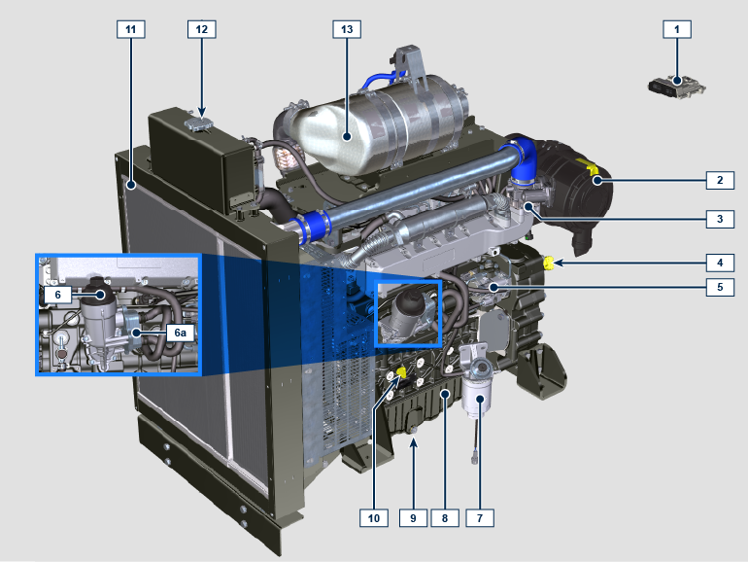
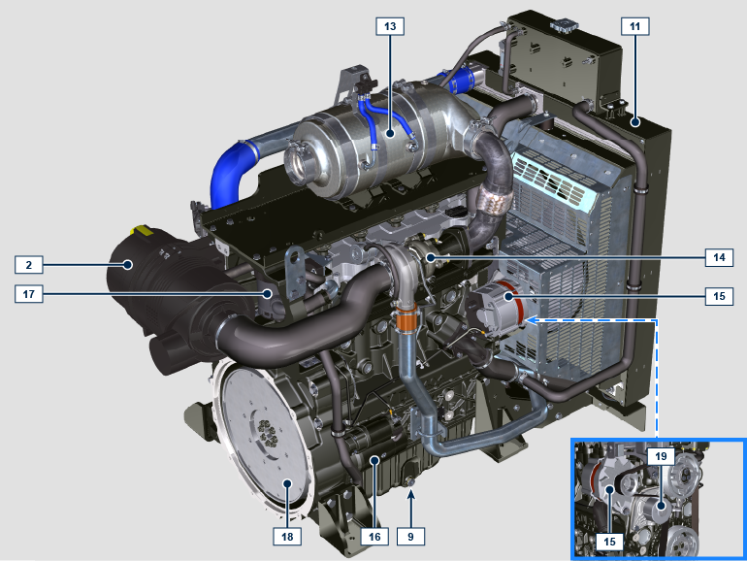
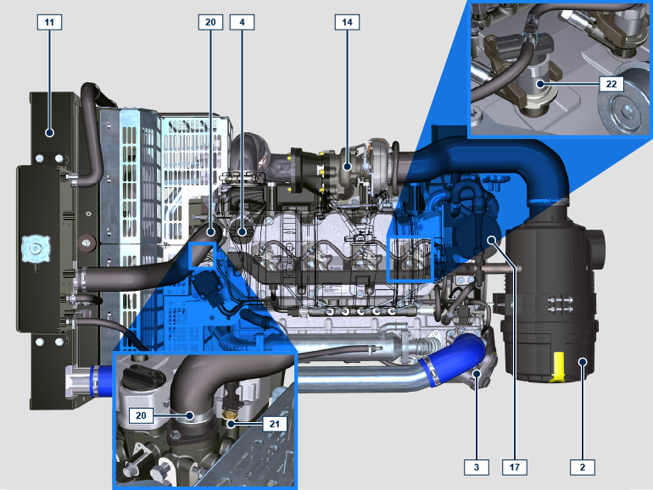

NOTE: Some components are for illustrative purposes only and may vary or they are not supplied by REHLKO.
POS. | DESCRIPTION
1 | ECU
2 | Air filter
3 | ETB
4 | Oil filler cap
5 | High-pressure fuel injection pump
6 | Lub. oil filter
6a | Oil cooler
7 | Fuel filter
8 | Oil sump
9 | Oil drain plug
10 | Oil dipstick
11 | Radiator/Intercooler
12 | Coolant filler cap
13 | ATS
14 | Turbocharger
15 | Alternator
16 | Starter motor
17 | Oil steam separator
18 | Flywheel
19 | Coolant pump
20 | Thermostatic valve
21 | Coolant temperature sensor
22 | Electronic injector

ATS (After Treatment System)
ATS with DOC+DPF+SCR filter  NOTE: the ATS system with DPF filter is only present for versions compliant with "Stage V" emission regulations.  The ATS system can be installed in a different way than shown. | Tab 1.5
  POS. | DESCRIZIONE
  1 | Turbocharger
  2 | Turbine exhaust pipe
  3 | DOC
  4 | DPF
  6 | ETB
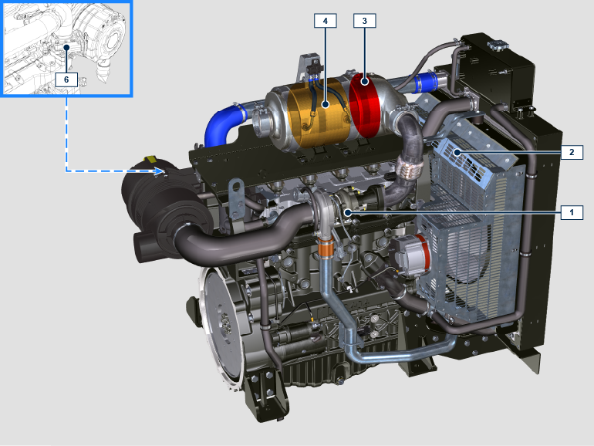

Manufacturer and engine identification
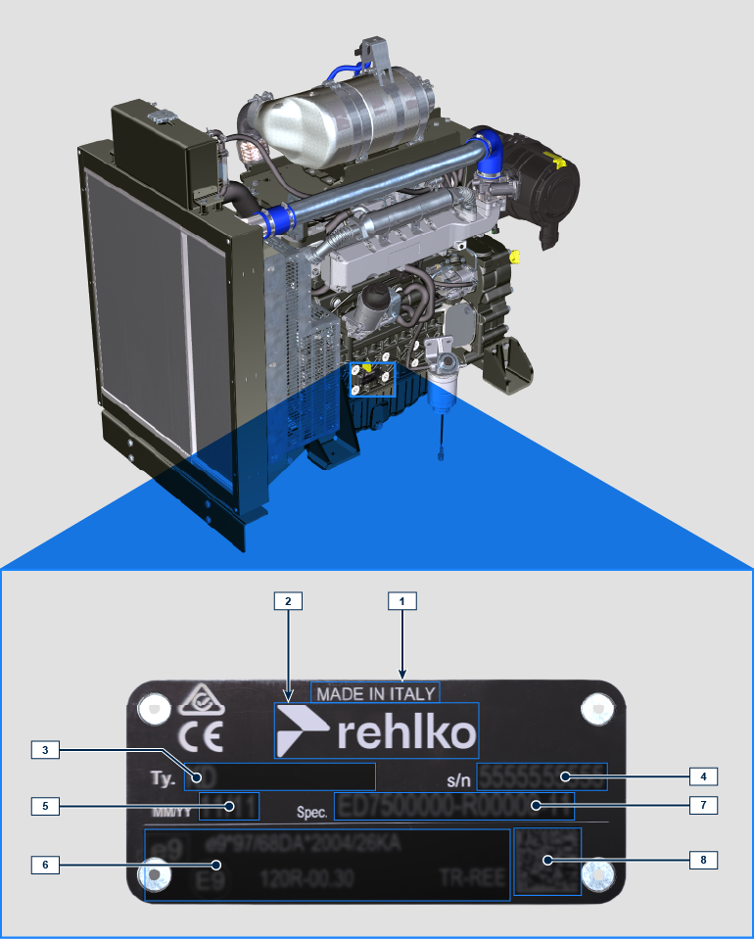
1.1
Pos. | Description
1 | Production place
2 | Manufacturer identification
3 | Engine model
4 | Engine serial number
5 | Month and year of production
6 | Approval data
7 | Engine version
8 | Data matrix

Homologation labels
1.10.1 Label for EPA rules (compilation example)

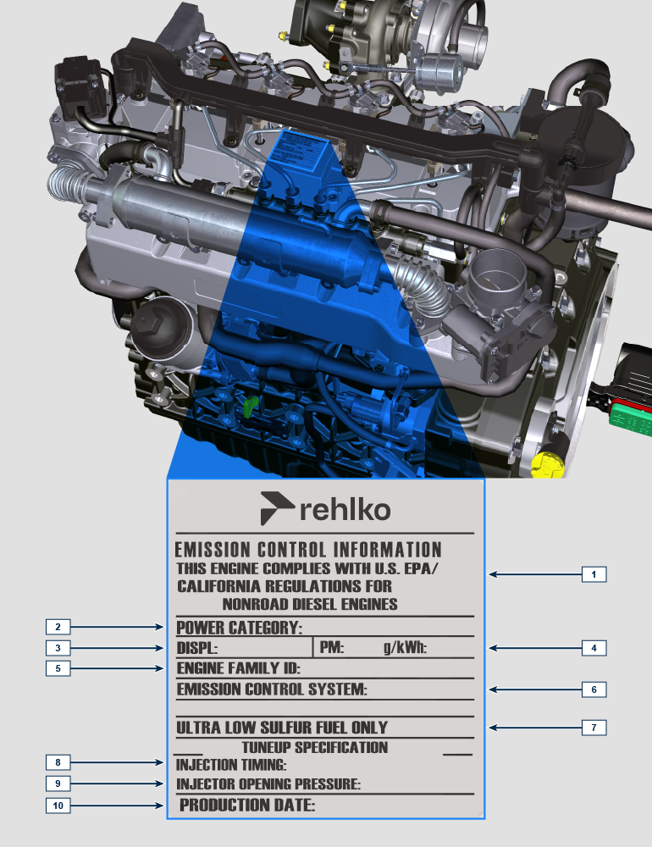
POS. | DESCRIPTION
1 | Model year in compliance with the rules
2 | Power category (kW)
3 | Engine displacement (L)
4 | Particulate emission limit (g/kWh)
5 | Engine family ID
6 | Emission Control System = ECS
7 | Fuel with low sulphur content
8 | Injection timing
9 | Electronic injector opening pressure (bar)
10 | Production date (example: 2013.JAN)

1.10.2 Label for China Standards (compilation example)


POS. | DESCRIPTION
1 | Manufacturer
2 | Engine model
3 | Manufactoring date
4 | Certificate N°
5 | Power range (kW)
6 | Emission level
7 | Rated power
8 | Aftertreat system

1.10.3 Label for Korea Standards (compilation example)


POS. | DESCRIPTION
1 | Tier 4 Final
2 | Engine model
3 | Manufactoring date and manufacturer code
4 | N° Korea emission certificate

Technical information

General description of the engine
- 4-stroke, in-line cylinders Diesel engine; - Liquid-cooling system;

- 4 valves per cylinder with hydraulic tappets;

- Turbocharger with Waste-gate valve;

- Common rail - Direct injection.

Engine specifications
Tab. 2.1
TECHNICAL DATA |  | UNIT OF MEASURE | 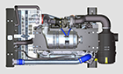
Engine type |  |  | KDI 3404 TCR
Cylinders |  | n. | 4
Bore |  | mm | 96
Stroke |  | mm | 116
Displacement |  | cm ³ | 3359
MAX INCLINATION DURING OPERATION (even in combined) |  | α | 40° max 30 min.
 |  | α | 45° max 1 min.
OIL CAPACITY (MAX level.) including oil filter | standard version | lt. | 15.6
DRY WEIGHT |  | Kg. | 394

Engine dimensions (mm)
NOTE : Dimensions vary according to engine configuration.

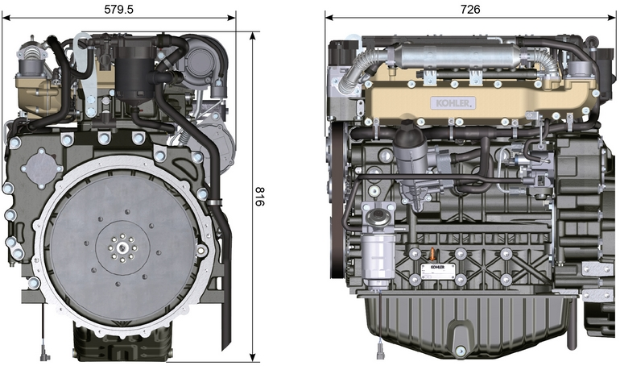
Fig. 2.1 - Fig. 2.2

Oil


Important

- The engine may be damaged if operated with improper oil level.
- Do not exceed the MAX level because a sudden increase in engine rpm could be caused by its combustion.
- Use only the recommended oil to ensure adequate protection, efficiency and service life of the engine.
- The use of lubricants other than recommended may shorten the engine life.
- Viscosity must be appropriate to the ambient temperature to which the engine is to be exposed.


Danger

- Prolonged skin contact with the exhausted engine oil can cause cancer of the skin.
- If contact with oil cannot be avoided, thoroughly wash your hands with soap and water as soon as possible.
- For the exhausted oil disposal, refer to the Par. DISPOSAL and SCRAPPING .
2.4.1 SAE oil classification
- In the SAE classification, oils are identified according to viscosity without considering any other qualitative characteristic.
- The code is composed of two numbers, which indicate, and must correspond to, the ambient temperature in which the engine operates, the first number refers to the viscosity when cold, for use during winter (" W "), while the second number is for viscosity at high temperatures.

Use oil viscosity based on the experienced air temperature range during the period between oil changes as indicated
in the table below.
Rehlko X-treme 10W-40 formula pro; X-treme 10W-40; X-treme 5W-40 oil are preferred:

 |  | 

Oils meeting the following specifications are also recommended.

2.2
RECCOMENDED OIL
 |  | TCR STAGE-V (*1) (*2) | TCR TIER IV FINAL (*1) | TCR/D TIER III o NON CERTIFICATO (*3)
WITH SPECIFICATIONS | API | CJ-4 Low S.A.P.S  CK-4 Low S.A.P.S | CJ-4 Low S.A.P.S  CK-4 Low S.A.P.S | CI-4 Plus  CI-4  CH-4
WITH SPECIFICATIONS | ACEA | E6 Low S.A.P.S. | E6 Low S.A.P.S. | E7  E4
VISCOSITY | SAE | 0w-40 (-40°C ÷ +50°C)  5w-40 (-30°C ÷ +50°C)  10w-40 (-25°C ÷ +50°C) | 0w-40 (-40°C ÷ +50°C)  5w-40 (-30°C ÷ +50°C)  10w-40 (-25°C ÷ +50°C) | 0w-40 (-40°C ÷ +50°C)  5w-40 (-30°C ÷ +50°C)  10w-40 (-25°C ÷ +50°C)

- Low S.A.P.S. technology (oil with low Sulfated Ash, Phosphorus, Sulfur content) keeps catalyst in good working conditions. The presence of sulfated ash, phosphorus and sulfur causes with time the catalyst clogging and its consequent inefficiency.
- For Mid S.A.P.S oil sequence the sulfated ash level is the same as API CJ-4 ≤ 1.0% but as per ACEA standardization those oils are referenced as mid SAPS.
- Filtration of oils is critical to proper operation and lubrication; always change filters regularly as specified in this manual.

(*1) NOTE : Do NOT use fuel with sulphur content above 15ppm.

(*2) - On all engines compliant with Stage-V emission regulation (engines with DPF device), the oil to use must comply with the specification API CJ-4 Low S.A.P.S or ACEA E6 Low S.A.P.S.

(*3) - NOTE : Do NOT use fuel with sulphur content above 500ppm.

(*3) - NOTE : Low S.A.P.S. oils, sulfate ashes <1% may not be used with fuels with a sulfur content >50ppm.

Fuel
  Important  - Use of other types of fuel could damage the engine. Do not use dirty diesel fuel or mixtures of diesel fuel and water since this will cause serious engine faults. |   Warning  - Clean fuel prevents the fuel injectors from clogging. Immediately clean up any spillage during refuelling.  - Never store diesel fuel in galvanized containers (i.e. coated with zinc). Diesel fuel and the galvanized coating react chemically to each other, producing flaking that quickly clogs filters or causes fuel pump and/or injector failure.  - Any failure resulting from the use of fuel other than Tab. 2.3 will not be covered by warranty.
Cetane number of 40 minimum. Cetane number greater than 47 is preferred, especially for temperatures below –20 °C (–4 °F) or elevations above 1675 m (5500 ft.).

Highly Regulated Engines (EU, USA, CANADA, JAPAN, CHINA, INDIA)
- EU EN 590
- North America ASTM D975 No. 2-D S15; No. 1-D S15
- Japan JIS K 2204 No. 1; No. 2
- India BS-V ULSD; BS-VI ULSD
- China GB 19147-2016 ULSD; GB 17691—2018 ULSD
- HVO EN 15940 or ASTM D975
- Military NATO fuel F-54 S < 10ppm

Less or Not Regulated Engines (Rest of the World and Military applications)
- Equivalent to all above specification
- Equivalent to all above specification but with Suplhur < 500ppm
- Equivalent to all above specification but with Suplhur < 2000ppm
- F-34/F-35 (kerosene NATO designation) (1)
- F-44 (kerosene, NATO designation) (1)
- F-63 (kerosene, NATO designation, equivalent to F-34/F-35 with additives (1)
- JP-8 (kerosene, US military designation) (1)
- JP-5 (kerosene, US military designation) (1)
- Jet A / A1 (kerosene for civil aviation) (1)

(1) - Operations with Jet Fuels: The jet fuels can be used but only adopting an additional fuel filter with lubricity doser. Because of lower density and greater leak fuel volume due to lower viscosity, depending on the engine speed and torque, a power loss up to 10% is possible. There are some problematical fuel proprieties amongst the listed jet fuels (viscosity, lubricating capacities and low boiling point). A slight increase in wear in the injection system is to be expected which can lead to a statistically shorter life of these components. Sulphur content must be below 2000ppm.

2.5.1 Fuel Additives
To aid in maintaining performance of the engines injection system, Rehlko has developed a family of fuel additives product for North America market.

The Extra Performance Fuel Additive Arctic Formula a fuel conditioner in winter, the Extra Performance Fuel Additive a fuel injector deposit removal and prevention. See your local Rehlko dealer for availability.

2.3
Rehlko Extra Performance Fuel Additive  (North America only) | 
Use Rehlko Injector Cleaner Diesel Fuel Additive before filling the tank once a year or every 500hrs with summer or winter grade fuel. Formulated to clean deposits from injectors and provide lubrication to high pressure pump and injectors to reduce wear, increasing fuel quality. Compatible with all exhaust emission system, including diesel particulate filters (DPFs). Follow all recommended instruction on product label.
Rehlko Extra Performance Fuel Additive Arctic Formula  (North America only) | 
Use Rehlko Extra Performance Fuel Additive Arctic Formula, which contains anti-gel chemistry to treat non-winter grad fuel (No. 2-D in North America) during the cold-weather season. This extends the operability to about 10°C (18°F) below the could point. For operability at even lower temperatures, use winter grade fuel. Treat the fuel when the outside temperature drops below 0°C (32°F). For best results, use untreated fuel and follow all recommended instruction on product label.
Cloud point is the temperature at which wax begins to from in the fuel causing filters to plug.
Fuel additives with biocide/algaecide functions are allowed in case of storage of fuel in the tank for long periods (one year or more). | For suggested brands and types contact Rehlko staff
NOTE: These additives must be diluted in the fuel following the product prescribed percentages when filling the tank. | For suggested brands and types contact Rehlko staff

Coolant recommendation
Rehlko XtendedTM prediluted coolant 50% ethylene glycol OAT is preferred.



Coolant meeting the following specifications are also recommended.

A mixture of 50% demineralized water and 50% low silicate ethylene glycol based coolant liquid must be used. Use a Long Life or Extended Life Heavy Duty OAT coolant free of: silicates, phosphates, borates, nitrites and amines.

The following ethylene-glycol based engine coolant for all models may be used:

- OAT (Organic Acid Technology) Low Silicate: ASTM D-3306 D-6210
- HOAT (Hybrid Organic Acid Technology) Low Silicate: ASTM D-3306 D-6210

The above coolants in concentrated formulation must be mixed with distilled, deionized, or demineralized water. A pre-mixed formulation (40-60% or 50-50%) can be used directly when available.

Important
- Do not mix ethylene glycol and propylene glycol based coolants. Do not mix OAT and HOAT based coolant. OAT performance life can be drastically reduced if contaminated with nitrite-containing coolants.
- Never use automotive-type coolants. These coolants do not contain the correct additives to protect heavy – duty diesel engines.

OAT coolants are maintenance free up to 5 years or 4000hrs of operation , provided that the cooling system is topped up using the same type of coolant. Do not mix different coolant types. Test the coolant condition annually with coolant test strips.
HOAT are not all maintenance free and it is recommended to have SCA (Supplemental Coolant Additives) added at the first maintenance interval.

Battery recommendation
Battery not supplied by REHLKO

Tab. 2.6
RECOMMENDED BATTERIES
AMBIENT TEMPERATURE | BATTERY TYPE
≥ - 15°C | 120 Ah/20 h - 1000 CCA/SAE
< -15°C | 130 Ah/20 h - 1100 CCA/SAE

Control panel
Tab. 2.8 shows the control panel components.  Tab 2.8 | 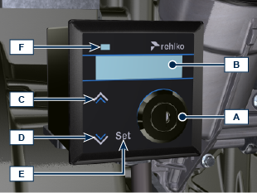
  POS. | DESCRIPTION
  A | Switch key to start the panel and motor
  B | Engine data or errors display
  C | Top navigation menu arrow push button
  D | Bottom navigation menu arrow push button
  E | Data selection or entry push button
  F | Engine operating status (green = no problem detected)
NOTE : if LED F is red, contact authorised REHLKO workshops to know what type of problem it is. Certain problems automatically switch off the engine.

Tab. 2.9 shows data that can be consulted on display B by pressing push buttons C or D .

NOTE : data described in Tab. 2.9 can differ, therefore, consult the machine's manual.
Tab 2.9
DESCRIPTION
Operating hours
Hours left for maintenance
Engine rpm
Engine oil pressure
Coolant temperature
Torque used @ rpm (% used)

Safety information

Safety information
- The intended use of the engine is in conformity with the machine on which it is mounted.
- Any use of the machine other than that described cannot be considered as complying with its intended purpose as specified by REHLKO .
- REHLKO declines all responsibility for any change to the engine not described in this manual made by unauthorized REHLKO personnel.
- A proper use of the engine, a strict observance of the rules listed below and the rigorous application of all these precautions will avoid the risk of accidents or injuries.
- Those who carry out the use and maintenance on the engine must wear the safety equipment and the accident-prevention guards.
- REHLKO declines all direct and indirect liability for failure to comply with the standards of conduct contained in this manual.
- REHLKO is not responsible for any unreasonable use or neglect that may cause a potential danger.

General remarks
3.2.1 Note for OEM
- When installing the KDI engines, always bear in mind that any variation to the functional systems may result in serious failures to the engine.
- Any improvement must be verified at REHLKO testing laboratories before application of the engine.
- In case the approval to a modification is not granted, REHLKO shall not be deemed responsible for any consequential failures or damages to the engine.
- Those who carry out the use and maintenance on the engine must wear the safety equipment and the accident-prevention guards.
- REHLKO declines all direct and indirect liability for failure to comply with the standards of conduct contained in this manual.
- REHLKO cannot consider every reasonably unforeseeable misuse that may cause a potential danger.
3.2.2 Note for end user
- The following indications are dedicated to the user of the machine in order to reduce or eliminate risks concerning engine operation and the relative routine maintenance work.
- The user must read these instructions carefully. Failure to do this could lead to serious danger for his personal safety and health and that of any persons who may be in the vicinity of the machine.
- On starting, make sure that the engine is as horizontal as possible, unless the machine specifications differ.
- Make sure that the machine is stable to prevent the risk of overturning.
- The engine must not operate in places containing inflammable materials, in explosive atmospheres, where there is dust that can easily catch fire unless specific, adequate and clearly indicated precautions have been taken and have been certified for the machine.
- To prevent fire hazards, always keep the machine at least one meter from buildings or from other machinery.
- Children and animals must be kept at a due distance from operating machines in order to prevent hazards deriving from their operation.
- Thoroughly wash and clean all the external parts of the engine before performing any operation, in order to avoid the accidental introduction of impurities/foreign bodies. Use only water and/or appropriate products to clean the engine. If cleaning engine with a pressure washer or steam cleaner, it is important to maintain a minimum distance of at least 200mm between the surface to be washed and the nozzle. Avoid directing the nozzle on electrical components, cable connections and sealed rings (oil seals etc). Thoroughly wash and clean the area surrounding the engine following the instructions provided by machine manufacturer.
- Fuel and oil are inflammable. The tank must only be filled when the engine is off. Before starting, dry any spilt fuel.
- Make sure that no soundproofing panels and the ground or floor on which the machine is standing have not soaked up any fuel.
- Fuel vapour is highly toxic. Only refuel outdoors or in a well ventilated place
- Do not smoke or use open flames when refuelling.
- During operation, the surface of the engine can become dangerously hot. Avoid touching the exhaust system in particular.
- Before proceeding with any operation on the engine, stop it and allow it to cool.
- Always open the radiator plug or expansion chamber with the utmost caution, wearing protective garments and goggles.
- The coolant fluid is under pressure. Never carry out any inspections until the engine has cooled.
- If there is an electric fan, do not approach the engine when it is still hot as the fan could also start operating when the engine is at a standstill.

Important
- The oil must be drained whilst the engine is hot. Particular care is required to prevent burns. Do not allow oil to come into contact with the skin because of the health hazards involved. It is recommended to use an oil intake pump.
- During operations that involve access to moving parts of the engine and/or removal of rotating guards, disconnect and insulate the negative wire (-) of the battery to prevent accidental short-circuits and to stop the starter motor from being energized.
- Check belt tension only when the engine is off.
- Fully tighten the tank cap each time after refuelling. Do not fill the tank right to the top but leave an adequate space for the fuel to expand.
- To start the engine follow the specific instructions provided in the engine and/or machine operating manual. Do not use auxiliary starting devices not originally installed on the machine (e.g. Startpilot).
- Before starting, remove any tools that were used to service the engine and/or machine. Make sure that all guards have been refitted.
- Do not mix fuel with elements such as oil or kerosene. Failure to comply with this prohibition will cause the non-operation of the catalyst and non-observance of the emissions declared by REHLKO .
- Pay attention to the temperature of the oil filter when the filter itself is replaced.
- Only check, top up and change the coolant fluid when the engine is off and reached the ambient temperature. Coolant fluid is polluting, it must therefore be disposed of in the correct way.
- Do not use air and water jets at high pressures on cables, connectors and injectors.
Important
- Only use the eyebolts A installed by REHLKO to move the engine.
- The angle between each lifting chain and the eyebolts shall not exceed 15° inwards for the base version and 0° for ATS mounted version.
- The correct tightening of the lifting screws is 80 Nm .
- Do not interpose spacers or washers between the eyebolts and engine head.
- Provided that the above requirements are met, if the lifting eyebolts are subject to permanent deformation (inwards), all subsequent lifting operations must be performed in order to prevent them from bending in the opposite direction.

BASE VERSION:
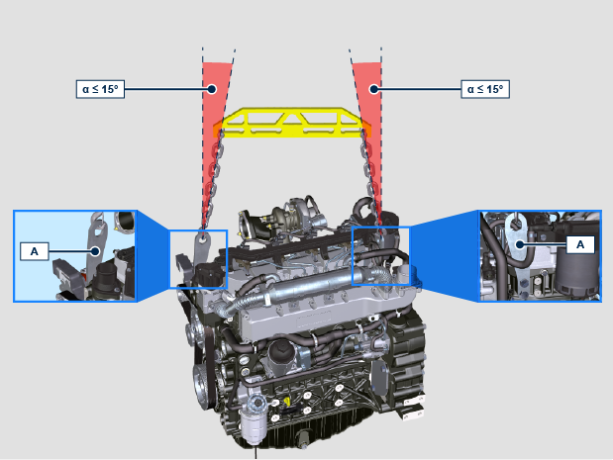

ATS MOUNTED:
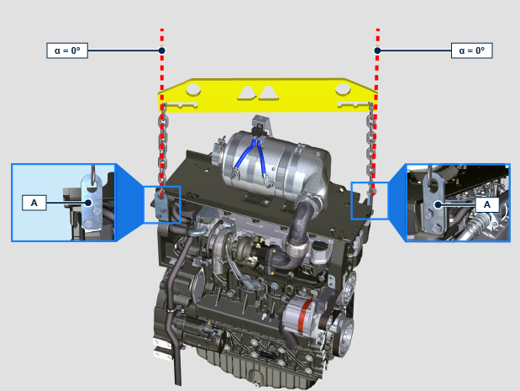

Safety signal description
- To ensure safe operation please read the following statements and understand their meaning.
- Also refer to your equipment manufacturer's manual for other important safety information.
- This manual contains safety precautions which are explained below.
- Please read them carefully.

Adhesive safety plates
The following is a list of the adhesive safety plates that may be found on the engine, which indicate potential points of danger to the operator.

NOTE: These stickers are applied on components engine by the machine manufacturer and some of them may be made of metal to resist at high temperatures.
 | Read the Operation and Maintenance handbook before performing any operation on the engine.
 | Hot Parts.  Danger of burns.
 | Presence of rotating parts.  Danger of jamming or cutting.
 | Presence of explosive fuel.  Danger of fire or explosion.
 | Presence of steam and pressurized coolant.  Danger of burns.
Warnings
Hereunder is a list of safety warnings that may be found in the manual, which advise you to pay attention when carrying out particular procedures that may be potentially dangerous to the operator or things.
 | Danger  This indicates situations of grave danger which, if ignored, may seriously threaten the health and safety of individuals.
Important
This indicates particularly important technical information that should not be ignored.
Warning
This indicates that failure to comply with it can cause minor damage or injury.
Safety guards Hereunder is a list of safety guards that must be worn prior to carrying out any type of operation and to avoid potential
harm to the operator.
 | Use suitable protective gloves before carrying out any type of operation.
 | Use protective goggles before carrying out any type of operation.
 | Use earmuffs before carrying out any type of operation.

Information and safety signals

  ACCIDENTAL START
   | Accidental Starts can cause severe injury or death.
  Before working on the engine or equipment, disconnect the battery negative (-) wire.
  HOT PARTS
   | Hot Parts can cause severe burns.
  Engine components can get extremely hot from operation. Do not touch engine while operating or just after stopping.
  Never operate the engine with heat shields or guards removed.
  ROTATING PARTS
   | Rotating Parts can cause severe injury.
  Stay away while engine is in operation. Keep hands, feet, hair, and clothing away from all moving parts to prevent injury.
  Never operate the engine with covers, shrouds, or guards removed.
  LETHAL EXHAUST GASES
   | Carbon Monoxide can cause severe nausea, fainting or death.
  Avoid inhaling exhaust fumes and never run the engine in a closed building or confined area.
  Carbon monoxide is toxic, odorless, colorless, and can cause death if inhaled.
  ELECTRICAL SHOCK
   | Electrical Shock can cause injury.
  Do not touch wires while engine is running.
  HIGH PRESSURE FLUID RISK OF PUNCTURE
   | High Pressure Fluids can puncture skin and cause severe injury or death.
  Do not work on fuel system without proper training or safety equipment. Fluid puncture injuries are highly toxic and hazardous.
  If an injury occurs, seek immediate medical attention.
  EXPLOSIVE FUEL
   | Explosive fuel can cause fires and severe burns.
  Fuel is flammable and its vapours can ignite. Store fuel only in approved containers, in well ventilated, unoccupied buildings. Do not fill the fuel tank while the engine is hot or running, since spilled fuel could ignite if it comes in contact with hot parts or sparks from ignition.
  Do not start the engine near spilled fuel.
  Never use fuel as a cleaning agent.
  EXPLOSIVE GAS
   | Explosive Gas can cause fires and severe acid burns.
  Charge battery only in a well ventilated area. Keep sparks, open flames, and other sources of ignition away from the battery at all times. Batteries produce explosive hydrogen gas while being charged.
  Keep batteries out of the reach of children.
  Remove all jewelry when servicing batteries. Before disconnecting the negative (-) ground cable, make sure all switches are OFF.
  If ON, a spark will occur at the ground cable terminal which could cause an explosion.
  CALIFORNIA WARNING - DECLARATION 65
  Engine exhaust from this product contains chemicals known to the State of California to cause cancer, birth defects, or other reproductive harm.

Safety and environmental impact
Every organisation has a duty to implement procedures to identify, assess and monitor the influence of its own activities (products, services, etc.) on the environment. Procedures for identifying the extent of the impact on the environment must consider the following factors:

- Liquid waste.

- Waste management.

- Soil contamination.

- Atmospheric emission.

- Use of raw materials and natural resources.

- Regulations and directives regarding environmental impact.

In order to minimise the impact on the environment, REHLKO now provides a number of indications to be followed by all persons handling the engine, for any reason, during its expected lifetime. - All components and fluids must be disposed of in accordance with the laws of the country in which disposal is taking place.

- Keep the fuel and engine control systems and the exhaust pipes in efficient working order to limit environmental and noise pollution.

- When discontinuing use of the engine, select all components according to their chemical characteristics and dispose of them separately.

Information about use

Pre-start check
- Read carefully the following pages and carry out the operations described below in accordance with the instructions specified.

Important

- Non compliance with the operations described in the following pages involves the risk of damages to the engine and vehicle on which it is installed as well as personal and/or property damage.
- Increase the frequency of maintenance operations in heavy working conditions (engine starts but stops, very dusty and hot environments, etc..).

Running-in period
NOTE: For the first 50 hours of engine operation, it is advisable not to exceed 75% of the maximum power supplied.

Starting and turning off
4.3.1 Starting
- Check the level of the engine oil, fuel and coolant and fill if necessary ( Par. 4.5 e Par. 4.6 ).
- Put the ignition key in the ignition switch (if supplied).
- Tun the key to ON position.
- Turn the key beyond the ON position and release it when the engine starts (the key will return into ON position automatically).

Important

- Do not actuate the starter for more than 15 seconds at a time. If the engine does not start, wait for one minute before repeating attempt.
- If engine does not start after two attempts see Tab. 7.1 and Tab. 7.2 to found the cause.
4.3.2 After starting

Warning

- Make sure that all the warning lights on the control panel are off when the engine is running.
- Run at minimum speed for a few minutes according to table (except constant speed engine).

NOTE: To avoid damaging the engine do not use it mostly at idle for a long time ( MAX 30min. ).

AMBIENT TEMPERATURE | TIME
≤ -20°C | 2 minutes
from -20°C a -10°C | 1 minutes
from -10°C a -5°C | 30 seconds
from -5°C a 5°C | 20 seconds
≥ 5°C | 15 seconds

4.3.3 Turning off
- Do not turn off the engine when it is running at the maximum rotation speed (except constant speed engine).
- Before turning it off, keep it idle at minimum speed for about 1 minute.
- Turn the key to OFF position.

Refuelling

Important

- Before proceeding with operation, read Par. 3.2.2 .

Danger

- Fill the engine off.
- The only approved fuels are those listed in Tab. 2.3 .
- In those countries where fuel has a high sulphur content, its is advisable to lubricate the engine with a high alkaline oil or alternatively to replace the lubricating oil recommended by REHLKO more frequently.
- To avoid explosions or fire outbreaks, do not smoke or use open flames during the operations.
- Fuel vapours are highly toxic.Only carry out the operations outdoors or in a well ventilated place.
- Keep your face well away from the fuel fill to prevent harmful vapours from being inhaled.
- Dispose of fuel in the correct way and do not litter as it is highly polluting.
- When refuelling, it is advisable to use a funnel to prevent fuel from spilling out.The fuel should also be filtered to prevent dust or dirt from entering the tank.
Do not overfill the fuel tank. Leave room for the fuel to expand.
NOTE: At the first fuelling or if the tank was empty filling the fuel system (Par. 6.3 point 8).

Oil filling
Important
- For safety precautions see Par. 2.4 .
- Before proceeding with operation, read Par. 3.2.2 .

- Loosen the oil filler cap A or the oil filler cap C if the cap A is not accessible.  - Add the type oil recommended ( Tab. 2.2 ). | 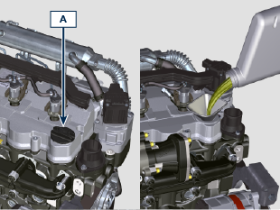  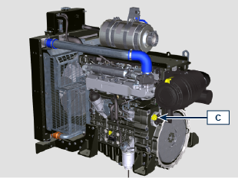
- Before checking oil engine needs to be level.  - Remove the oil dipstick B and check that the level is up to but does not exceed the MAX .  - If level is not at the MAX . level, add additional oil.  - Re-tighten the cap A .  Important  - Do not use the engine with the oil level below the minimum.  - Oil dipsticks may vary depending on engine configuration. | 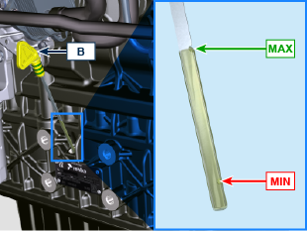

Coolant filling

Important

- Before proceeding with operation, read Par. 3.2.2 .

Warning

- An anti-freeze protection liquid (ANTIFREEZE) - mixed with decalcified water - must be used.
- The freezing point of the refrigerant mixture depends on the amount concentration in water.
- As well as lowering the freezing point, the antifreeze also raises the boiling point.
- A 50% mixture is recommended to ensure a general level at protection prevents the formation of rust, galvanic currents and calcium deposits.

NOTE: Before proceeding with any operation on the engine, stop it and allow it to cool.  Warning  Presence of steam pressurized coolant danger of burns.  - Loosen the cap A and fill the radiator with coolant composed of:  50% ANTIFREEZE and 50% decalcified water.  - Top liquid up until the pipes inside the radiator are covered by about 5 mm. Do not overfill the radiator, but leave room for the coolant to expand.  - For engines equipped with expansion tank, pour in fluid until reaching the max level mark B .  - Re-tighten the cap A .  - After a few hours of operator, stop the engine and allow the liquid to cool returns to a ambient temperature and check the coolant level again. | 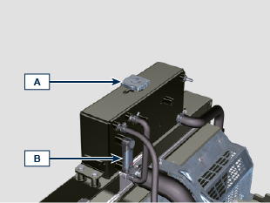  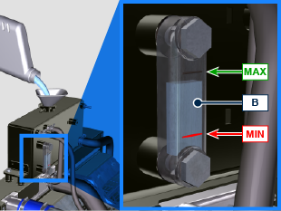

ATS regeneration strategy
Only for Stage V configurations (see Chap. 1 Par. ATS)

You can intervene on the machine control panel for the DPF regeneration operations "only if requested by means of specific warning lights or messages on the control panel".
Tab. 4.11 describes the level of particulate accumulation, the relationship with the warning lights that will light up on the panel, the performance limitations of the engine and the operator’s options intervention.
Forced regeneration must be executed in accordance with the machine instructions.

4.11
SOOT LEVEL | WARNING LAMPS *1 | ENGINE DE-RATE | OPERATOR POSSIBLE ACTIONS | OPERATING CONDITIONS
Level 0 |  |  |  | - No condition
Level 1
Level 2
Level 3 |   Fixed |  | Forced Regeneration is Necessary. | - Coolant temperature at 60 °C  - Do not switch the engine off  - Stationary vehicle  - No load applied to the engine *2
Level 4 | Flashing | Engine de-rate. | Forced Regeneration is Necessary. | - Coolant temperature at 60 °C  - Do not switch the engine off  - Stationary vehicle  - No load applied to the engine *2
Level 5 |   Flashing | Strong Engine de-rate. | Contact an authorized REHLKO workshop.  Service Regeneration Required | REGENERATION via REHLKO software

*1: The warning lights be different – consult the machine manual.
*2: Unless stated otherwise in the machine manual.

Warning

- Forced regenerations must only be executed if required by the ECU when the "HIGH SOOT" warning light goes on (due to a Level 3 - 5 particulate accumulation).
- Do NOT execute the forced regenerations if not required by the ECU (due to a Level 0 - 2 particulate accumulation).
- The minimum engine speed increases during the forced regeneration phases.
- Repeated forced regenerations cause significant engine oil contamination by the fuel.
- The operations described in Par. 5.3 or 5.4 must be executed after every forced regeneration.
- If the regeneration inhibition function is misused, the particulate accumulation level will increase within a short time.
- The engine oil filter and oil must be changed after a Service Regeneration is completed via REHLKO software
- (Level 5 Particulate accumulation).
- Fuel contamination allowed in the engine oil is 3% MAX.
- Any engine load must be eliminated during forced regeneration so as to prevent damaging the ATS *2 system.
- Do not switch the engine off during level 3, 4 and 5 regeneration so as to prevent damaging the ATS system.

Information about maintenance

Useful information about maintenance
- This chapter shows all operations described in the Tab. 5.1 and Tab. 5.2 . if you have the skills appropriate may be directly carried out by the user.
- Periodic inspection and maintenance operations must be carried out as indicated in this manual and are the responsability of the user.
- Failure to comply with these service and maintenance intervals increases the risk of technical damage to the engine. Any non compliance makes the warranty become null and void.
- In order to prevent personal and property damage read carefully the instructions listed below before proceeding with any operation of the engine.

Warning

- Inspections must be made when the engine is off and cold.
- Place engine on level sur face to ensure accurate measurement of oil level.
- Before starting, to avoid spillages of oil make sure that: - the oil dipstick is inserted correctly;

- also check that:

oil drain plug and

oil filler cap are tightened firmly.

Important

- Before proceeding with operation, read Par. 3.2.2 .

Danger

- For safety precautions see Chap. 3 .

Periodic maintenance
The intervals of preventive maintenance in Tab. 5.1, Tab. 5.2, Tab. 5.3 and Tab. 5.4 refer to the engine operating under normal operating conditions with fuel and oil meeting the recommended specifications.

5.1
CLEANING AND CHECKING
OPERATION DESCRIPTION | PERIOD (HOURS)
OPERATION DESCRIPTION | 100 | 250 | 500 | 5000
Engine oil level ⁽⁴⁾ ⁽⁸⁾
Coolant level ⁽⁸⁾⁽⁹⁾ | Components not supplied by REHLKO .  Refer to the technical documentation of the vehicle
Cartridge dry-type air filter ⁽²⁾
Radiator heat-exchange surface and Intercooler ⁽²⁾
Alternator belt ⁽⁸⁾
Rubber components
Starter Motor ⁽⁶⁾
Alternator ⁽⁶⁾
5.2
REPLACEMENT
OPERATION DESCRIPTION |  | PERIOD (HOURS)
 |  | 2000 | 5000
Intake manifold hose (air filter - intake manifold) ⁽⁶⁾ ⁽⁷⁾
Coolant hoses ⁽⁶⁾ ⁽⁷⁾
Fuel line hose ⁽⁶⁾ ⁽⁷⁾
Delta-P > DPF pipes ⁽⁶⁾
Alternator belt | Poly-V belt heavy environmental condition ⁽⁶⁾
Alternator belt | Poly-V belt standard condition ⁽⁶⁾
Coolant | OAT ⁽⁶⁾
Coolant | HOAT ⁽⁶⁾⁽¹⁰⁾
Cartridge dry-type air filter ⁽²⁾ |  | Components not supplied by REHLKO .  Refer to the technical documentation of the vehicle
ATS ⁽⁶⁾ |  | ECU request (message or warning light activation) refer to the machine documentation

5.3
ENGINE OIL AND OIL FILTER CARTRIDGE REPLACEMENT
ENGINE VERSION | PERIOD (HOURS)
ENGINE VERSION | 250 | 500
KDI TCR Tier 4 final – Stage IIIB – Stage IV- Stage V ⁽¹⁾
KDI TCR/D Tier 3 – Stage IIIA ⁽¹⁾

5.4
FUEL FILTER AND PREFILTER CARTRIDGE REPLACEMENT
ENGINE VERSION | PERIOD (HOURS)
ENGINE VERSION | 250 | 500
KDI TCR Tier 4 final – Stage IIIB – Stage IV- Stage V ⁽¹⁾
KDI TCR/D Tier 3 – Stage IIIA ⁽¹⁾
(1) - In case of low use: 12 months.

(2) - The period of time that must elapse before checking the filter element depends on the environment in which the engine operates. The air filter must be cleaned and replaced more frequently under very dusty conditions.

(3) - In case of low use: 36 months.
(4) - The inspection must be carried out every 50 hours or every week in engines with an ATS system ( see Par. 1.6 ).
(6) - Contact authorized REHLKO workshops.
(7) - The replacement interval is only an indication, it strongly depends from environmental condition and hose status detected during regular visual inspection.
(8) - The first check must be done after 10 hours.
(9) - Test the coolant condition annually with coolant test strips.
(10) - It is recommended to have SCA (Supplemental Coolant Additives) added at the first maintenance interval.

Oil level check
- Loosen the oil filler cap A or the oil filler cap C if the cap A is not accessible.
- Remove the oil dipstick B and check that the level is up to MAX .
- Pour in recommended oil until reaching the MAX level mark.
- Reinstall the oil dipstick B completely.
- Re-tighten the cap A or C .

Important
- Do not use the engine with the oil level below the MIN .

Air filter check
Important  - Before proceeding with operation, read Par. 3.2.2 .  - When the cartridge G is dirty, do not clean it but replace cartridges B and G.  NOTE: Components not necessarily supplied by REHLKO .  - Release the two clasps F of the cover A .  - Remove the cartridges B and G .  - Clean the inside components A and D with a damp cloth.  - Check the condition of cartridge B , replace it in case of suspecting of high level of clogging even if the hours of Tab. 5.2 are not reached.  - Reinstall:  - cartridges G and B.  - the cover A checking the right tightness of clasps F . | 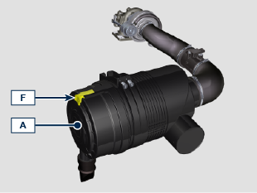  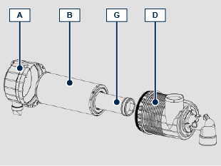

Check of the radiator heat - exchanger surface
Danger  - For safety precautions see Chap. 3 .  NOTE: Component not necessarily supplied by REHLKO .  Important  - Before proceeding with operation, read Par. 3.2.2 .  - Wear safety goggles when using compressed air.  - The radiator heat-exchange surface must be cleaned on both.  - Check the radiator heat-exchange surface D .  - Clean the surface with a brush soaked in special detergent if it is clogged. | 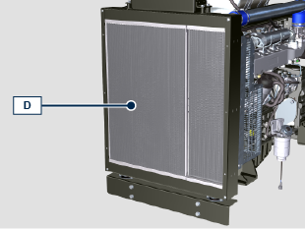

Rubber hoses check
Danger
- For safety precautions see Cap. 3.

The check is carried out by exerting a slight deflection or bending along the pipe and near the hose clamps. Components must be replaced if they have clear signs of cracks, tears, cuts, leaks and do not retain a certain degree of elasticity.

Important
- Before proceeding with operation, read Par. 3.2.2 .
- If hoses are damaged contact an authorized REHLKO workshop.
- For other pipes not illustrated refer to the technical documentation of the vehicle.
- Check that the:
- Fuel system pipes.
- Cooling circuit hoses.
- Oil circuit pipes
- Air system hoses.

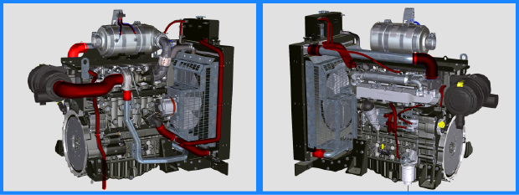

Check coolant level
Important  - Before proceeding with operation, read Par. 3.2.2 .  Danger  - For safety precautions see Chap. 3 .  NOTE : Before proceeding with any operation on the engine, stop it and allow it to cool.  Warning  - Presence of steam pressurized coolant danger of burn.  NOTE : Component not necessarily supplied by REHLKO .  - Start the engine without the radiator cap A .  - Top liquid up until the pipes inside the radiator are covered by about 5 mm.  - Top up if necessary.  - Do not overfill the radiator, but leave room for the coolant to expand.  - Reinstall radiator cap A  - For engines equipped with expansion tank, check that the fluid is until reaching the max level mark B .  NOTE : For coolant filling see Par. 4.6 .  Warning  - Before starting make sure that the radiator cap and cap, if present, are installed correctly to avoid spillage of liquid or vapour at high temperatures. | 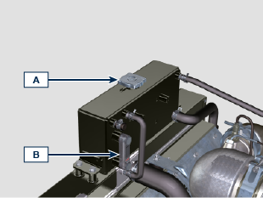  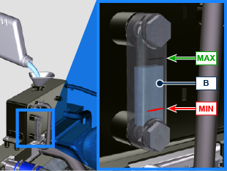

Check Poly-V alternator belt
Important  - Before proceeding with operation, read Par. 3.2.2 .  Warning  - For safety precautions see Cap. 3 .  NOTE: The poly-v belt is not adjustable .  Check the belt A condition, if worn out or deteriorated, replace it.  NOTE: Make sure that the ribs of the belt A are properly installed into the grooves of the pulleys B.  Start the engine and run it for some minutes, then turn off it, and let it cool down at ambient temperature. Check by the appropriate tool that at point P the tension value is between 135 and 178 Hz .  NOTE: If the poly-v belt tension results out of the above mentioned values contact REHLKO authorised workshops for replacement. | 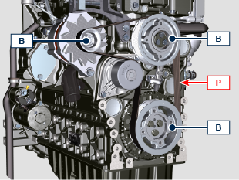  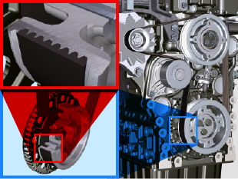

Filter cartridge and fuel pre-filter check
Important  - Before proceeding with operation, read Par. 3.2.2 .  Warning  - For safety precautions see Cap. 3 .  When turn on lights on control water filter cartridge fuel:  - Gently loosen the wing screw A without removing it.  - Drain the water if present.  - Re-tighten the wing screw A as soon as the fuel begins to flow. | 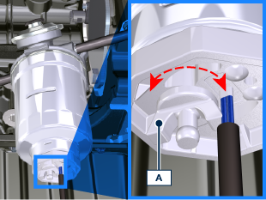

Product preservation

Important

- If the engines are not to be used for 6 months, they must be protected by carrying out the operations described in Engine storage (up to 6 months) ( Par. 5.11 ) .
- If the engine is still not in use after the first 6 months, it is necessary to carry out a further operation to extend the protection period (more than 6 months) ( Par. 5.12 ) .
- If the engine is not to be used for an extended period, the protective treatment procedure must be repeated within 24 months of the previous one.

Engine storage up to 6 months
Before storing the engine check that:
- The environments are not humid or exposed to bad weather. Cover the engine with a proper protective sheet against dampness and atmospheric contaminants.
- The place is not near electric panel.
- Avoid storing the engine in direct contact with the ground.

Engine storage over 6 months
Follow the steps described in Par. 5.11 .
- Engine oil replacement ( Par. 6.1 ) .
- Refuel with fuel additives for long storage.
- With expansion tank:
make sure that the coolant is up to the maximum level.
- Without expansion tank: Top liquid up until the pipes inside the radiator are covered by about 5 mm.

Do not overfill the radiator, but leave room for the fuel to expand.
- Start the engine and keep it idle at minimum speed for 2 minutes.
- Bring the engine to 3/4 of the maximum speed for 5÷10 minutes.
- Turn off the engine.
- Completely empty the fuel tank.
- Spray SAE 10W-40 on the exhaust and intake manifolds.
- Seal the exhaust and intake ducts to prevent foreign bodies from entering.
- When cleaning the engine, if using a pressure washer or steam cleaning device, avoid directing the nozzle on electrical components, cable connections and sealed rings (oil seals etc).
If cleaning engine with a pressure washer or steam cleaner, it is important to maintain a minimum distance of at least 200mm between the surface to be washed and the nozzle - avoiding absolutely electrical components such as alternators, starter motors and engine control units (ECU).
- Treat non-painted parts with protective products.

If the engine protection is performed according to the suggestions indicated no corrosion damage should occur.

Engine starting after storage
- Remove the protective sheet.
- Use a cloth soaked in degreasing product to remove the protective treatment from the external parts.
- Inject lubricating oil (no more than 2 cm ³ ) into the intake ducts.
- Refill the tank with fresh fuel.
- Make sure that the oil and the coolant are up to the maximum level.
- Start the engine and keep it idle at minimum speed for a two about minutes.
- Bring the engine to 75% of maximum rated speed for 5 to 10 minutes.
- Stop the engine while the oil is still hot ( Par. 6.1 ) , discharge the protective oil in a suitable container.

Warning

  - Over time, lubricants and filters lose their properties, so it is important consider whether they need replacing, also based on the criteria described in Tab. 5.2 .

- Replace the filters (air, oil, fuel) with original spare parts.
- Pour new oil ( Par. 4.5 ) up to the maximum level .
- Empty the cooling circuit completely and pour in the new coolant up to the maximum level ( Par. 4.6 ) .

Unused machine
If the machine is not used for a certain amount of time, follow the operations below:

POINT | OPERATION
1 | Unused machine up to 2 months | - The place must be dry and fresh throughout the period in which the machine is not used.  - Consult the machine’s manual to disconnect the battery (before disconnecting the battery, wait for minimum 5 mins after turning off the engine).  - Make sure the engine is not exposed to direct sunlight.  - Make sure the engine is not near any heat sources.
1 | Starting | - Before starting the engine, check Par. 5.2 for maintenance operations.  - Consult the machine’s manual to connect the battery and start the engine.
2 | Unused machine from 2 to 9 months | - Perform the operations related to unused machine described in point 1.  - Perform the operations described in Par. 5.6.  - Start the engine at least every 4 months as per operations described in point 1: Avoid sudden accelerations for the first few minutes.  Bring the engine to the working temperature by pressing the accelerator 3/4 from MAX.  Leave the engine running at minimum speed for a few minutes and turning off the engine.
2 | Starting | - Before starting the engine, check Par. 5.2 for maintenance operations.  - Consult the machine’s manual to connect the battery and start the engine.  - Avoid sudden accelerations for the first few minutes.
3 | Unused machine over 9 months | - Perform the operations related to unused machine described in point 1 and 2.
3 | Starting | - Before starting the engine, check Par. 5.2 for maintenance operations.  - Check the quality of coolant from the relative testing strips.  - Consult the machine’s manual to connect the battery and start the engine.  - Avoid sudden accelerations for the first few minutes.

Information about replacements

Engine oil replacement
Danger:
- Disconnect the negative wire (-) from the battery to avoid accidental engine starting.

Important:
- Before proceeding with operation, read Cap. 3 .

Important :  - Place engine on level surface to ensure accurate measurement of oil level.  Before proceeding, perform the operation described in Par. 6.2 - Point 1.  NOTE: Perform this operation with warm engine, to get a better fluidity of the oil and get a full discharge of oil and impurities contained in it.  - Loosen the oil filler cap A or the oil filler cap C if the cap A is not accessible.  - Remove the oil dipstick B . | 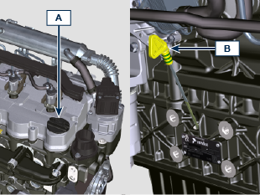
- Remove the oil drain plug D and the gasket E (the oil drain plug is on both sides of the oil sump).  - Drain oil in an appropriate container (For the exhausted oil disposal, refer to ( Par. 6.6 DISPOSAL and SCRAPPING ).  - Replace gasket E .  - Tighten the drain oil plug D (tightening torque at 35 Nm ).  - Perform the operation described in Par. 6.2 - point 2 to 5. | 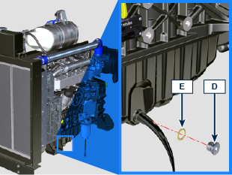
- Add the type oil recommended ( Tab. 2.1 and Tab. 2.2 ).  Important :  - Do not exceed the MAX level on the dipstick.  - Do not use the engine with the oil level below the MIN .  - Fit and remove the oil dipstick B to check the level. Pour in fluid until reaching the MAX level mark.  - Upon completion, reinstall the oil dipstick B completely.  - Tighten the cap A or C . | 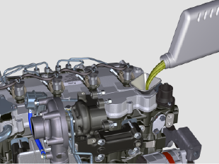

Oil filter cartridge replacement
Important

- Before proceeding with operation, read Par. 3.2.2

Warning:
- Oil filter cartridge replacement (Par. 6.2) and fuel filter replacement ( Par. 6.3 ).
- In case of low use replace it 12 months.
- For disposal of oil filter cartridge and fuel filter refer to Par. 6.6 DISPOSAL and SCRAPPING .
Important:  - Electric/pneumatic screwdrivers are forbidden  - Unscrew cartridge holder cover A by performing three complete turns and wait 1 minute.  NOTE: This operation allows to oil contained in the support F to flow into the oil sump in the correct way.  - Unscrew cartridge holder cover A and check that the oil in the lub. oil filter support F has flowed towards the oil sump.  - Remove the cap A as well as the oil cartridge B from the oil filter support.  - Remove and replace the oil cartridge B with a new one. Remove and replace the gaskets C , D and E with new ones.  - Fit and tighten the cover A on the oil filter support F (tightening torque of 25 Nm ). | 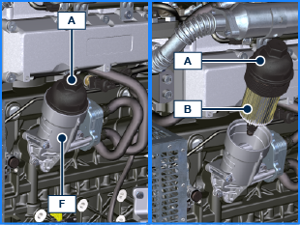  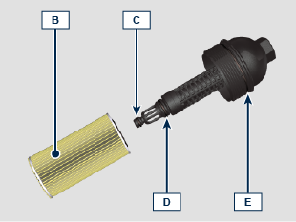

Filter cartridge and fuel pre-filter replacement
NOTE: The fuel filter is situated on the crankcase of the engine or it may be assembled on the frame of the vehicle.  Important  - Before proceeding with operation, read Par. 3.2.2  Warning  - In case of low use replace il 12 months.  - For disposal of oil filter cartridge and fuel filter refer to Par. 6.5 DISPOSAL and SCRAPPING  - Disconnect the cable A of the water presence sensor C.  - Remove the water presence sensor C from its cartridge B.  - Loosen the cartridge B using the appropriate wrench.  - Lubricate the gasket D of the new cartridge B.  Important:  - Do not fill the new cartridge B with fuel.  - Tighten the new empty cartridge B on the diesel fuel filter support E using the special wrench (tightening torque of 17 Nm).  - Tighten the water presence sensor C on the new cartridge B (tightening torque of 5 Nm).  - Reconnect the cable A of the water presence sensor C.  NOTE: Bleeding.  - Push repeatedly the button G in order to fill the circuit. | 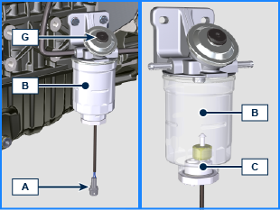  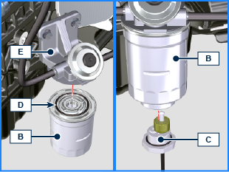

Air filter cartridge replacement
Important
- Before proceeding with operation, read Par. 3.2.2

NOTE: Component not necessarily supplied by REHLKO .
- Pull insert F to unlock cover A .
- Rotate counter clockwise and remove cover A .
- Remove the cartridges B and G .
- Fit cartridges G and B .
- Fit cover A by performing the operations indicated in points 2 and 1 in the reverse order.

DPF filter replacement
NOTE : Component to be replaced in the REHLKO authorised workshops.

- A warning light will be activated to indicate that the DPF filter must be replaced.

NOTE : Refer to the machine manual.

- New or regenerated DPF KITS are available
- The regenerated KITS are certified and covered by a specific REHLKO warranty.
- Cleaning processes that are not certified by REHLKO could cause irreversible damage to the DPF filter or the ATS system.

Disposal and scrapping
- In case of scrapping, the engine shall be disposed of in appropriate locations, in conformity with the law in force.
- Before scrapping, it is necessary to separate the rubber or plastic parts from the rest of the components.
- The parts only composed of plastic material, aluminium and steel can be recycled if collected by the appropriate centers.
- Waste oil must properly be recycled and disposed of in the correct way to safeguard the environment. According to the laws in force, it is classified as hazardous waste, therefore it must be collected by the appropriate centers.

Information about failures

Useful information about failures
- This chapter contains information about the problems that may appear during engine operation with its causes and trouble shooting Tab. 7.2 .
- In some cases, you shall turn off the engine immediately to avoid further damage Tab. 7.1 .
Tab 7.1
THE ENGINE MUST BE IMMEDIATELY TURNED OFF WHEN
1 | Warning RED light turn on
2 | The oil pressure indicator light turns on while running
3 | The engine rpms suddenly increase and decrease
4 | A sudden and/or unusual noise is heard
5 | Colour the exhaust fumes suddenly darkens

Tab 7.2
TROUBLES | POSSIBLE CAUSE | SOLUTION
Warning YELLOW light turn on | Engine ECU has detect a malfunctions | Contact REHLKO authorised workshops
The engine does not start | Sulphated battery terminals corroded | Clean the battery terminals
The engine does not start | Battery voltage too low | Recharge the battery or replace it
The engine does not start | Low fuel level | Refuel
The engine does not start | Frozen fuel | Contact REHLKO authorised workshops
The engine does not start | Clogged fuel filter | Replace with a new filter
The engine does not start | Air suction in fuel system | Contact REHLKO authorised workshops
The engine does not start | Clogged air filter | Replace with a new filter
The engine does not start | Clogged pipes | Contact REHLKO authorised workshops
The engine does not start | Intake or exhaust system clogged | Replace with a new fuse; if the problem persists,  Contact REHLKO authorised workshops
The engine does not start | Intake or exhaust system clogged | Contact REHLKO authorised workshops
Engine starts but stops | Inefficient electrical connections | Clean the electrical contacts; if the problem persists,  Contact REHLKO authorised workshops
Engine starts but stops | Sulphated battery terminals | Clean the battery terminals
Engine starts but stops | Clogged fuel filter | Replace with a new filter and clean the tank
Engine starts but stops | Clogged fuel pipes | Contact REHLKO authorised workshops
RPM instability at idle speed | Clogged fuel pipes | Contact REHLKO authorised workshops
Numero dei giri al minimo basso | Clogged fuel pipes | Contact REHLKO authorised workshops
Numero dei giri al minimo basso | Poor quality fuel | Clean the tank and refuel with quality fuel
Blue smoke | High oil sump level | Replace the engine oil; if the problem persists,  Contact REHLKO authorised workshops
Blue smoke | Clogged air filter | Replace with a new filter
Excessive fuel consumption | Clogged air filter | Replace with a new filter
Excessive fuel consumption | High oil sump level | Replace the engine oil; if the problem persists,  Contact REHLKO authorised workshops
Engine lost its initial performance | Clogged air filter | Replace with a new filter
Engine lost its initial performance | Clogged fuel pipes | Contact REHLKO authorised workshops
Engine lost its initial performance | Cheap fuel | Clean the tank and refuel with quality fuel
Engine lost its initial performance | High oil sump level | Replace the engine oil; if the problem persists,  Contact REHLKO authorised workshops
Slow acceleration | Clogged fuel filter | Replace the fuel filter
Engine jerking | Clogged fuel pipes | Contact REHLKO authorised workshops
Engine overheats | Insufficient coolant level | Fill up to the level
Engine overheats | High oil sump level | Replace the engine oil; if the problem persists,  Contact REHLKO authorised workshops
Engine overheats | Clogged radiator | Clean the radiator; if the problem persists, contact REHLKO authorised workshops
In the event that the solutions proposed in Tab. 7.2 do not eliminate the trouble, contact a REHLKO authorized workshop

Information about warranty

Warranty terms
REHLKO DIESEL ENGINES GLOBAL WARRANTY TERMS

Consult the web page https://www.engines.rehlko.com/warranty and select Diesel Engines

Glossary

Glossary
A
Alternator | A component that transforms mechanical energy into AC electrical energy.
Authorised workshop | REHLKO authorised service centre.
ATS | After Treatment System - Post-treatment system, referred to the exhaust gases produced by the engine.

B
Bore | Internal diameter of the cylinder in combustion engines.

C
Catalyst | A device in charge of filtering exhausted gas.
Combustion | Chemical reaction of a mixture composed of fuel and fuel (air) inside a combustion chamber.
Common Rail | A high-pressure "Common Duct" that produces a constant supply of fuel directly to the injectors.

D
DOC | Diesel Oxidation Catalyst - Catalyst for diesel engines that reduces harmful exhaust gas emissions produced by the engine.
DPF | Diesel Particulate Filter - A filter that captures particles of carbonaceous origin emitted by diesel engines.

E
EC | "European Community".
ECS | "Emission Control System"
ECU | "Electronic Control Unit"; an electronic device in charge of electronically detecting and controlling other electronic control devices.
EGR | Exhaust Gas Recirculation, in internal combustion engines; a system that enables recirculation of combusted gas by means of taking it in once again, which enables it to break down a part of the pollutants present in the exhaust gas.
EGR Cooler | Recirculated exhaust gas cooling; a system that is able to cool recirculated gas (EGR) from the exhaust. This enables the temperature to remain constant inside the intake manifold, thus improving combustion inside the cylinders and breaking down pollutants further.
Electronic injector | An electronically activated component able to inject jets of atomised fuel inside the cylinders.
EPA | "Environmental Protection Agency - The United States' authority that safeguards the environment" ; its duty is to govern and control polluting emissions.
ETB | Electronic Throttle Body - This is controlled by the ECU upon request of the accelerator pedal, and its function is crucial for the correct regeneration of the ATS system.

G
Galvanised | Material that has undergone surface protection treatment.

H
Heavy conditions | Type of extreme condition referred to the work environment in which the engine is used (very dusty - dirty area, or in a contaminated environment due to various types of gas).

I
Intercooler | Air-cooling element under pressure from the turbo situated between the turbine and intake manifold.

M
Maintenance - periodic | A group of maintenance actions that have the sole objective to control and replace elements on their expiry, without modifying or improving the functions carried out by the system, neither increasing the value nor improving performance.
Max. | "Maximum".
Methyl ester | It is a mixture of products by means of a chemical conversion of oils and animal and/or vegetable fat, which is used to produce Biofuel.
Min | "Minutes".
Min. | "Minimum".
Model | "Model", engine identification plate, which indicates the engine's model.

O
Oil Cooler | Small radiator used to cool the oil.

P
Par. | Paragraph.
Paraffin | Fatty and solid substance that may form inside the diesel.
Poly-V | "Poly-V", the name associated with a service belt, which derives from the profile of its section that is constructed with joined Vs.

R
Ref. | Reference.

S
s/n | "Serial number" (engine identification name plate) indicating the engine identification series/chassis number.
Spec. | "Specification", (engine identification name plate) indicating the engine version.

T
Tab. | Table.
T-MAP | "T-MAP" (sensor), measures the temperature and absolute pressure inside the intake collector.
TCR | "Turbo Common Rail"
Tightening torque | A term indicated for installation of threaded components and which is determined by means of a unit of measurement Nm.
Turbocharger | Device that compresses air intake by sending it to the intake manifold by means of a turbine.

U
Used oil | Oil altered by operation or time, which is no longer compliant for correct lubrication of the components.

W
Waste-Gate valve | A device, which is directly or automatically controlled, used to limit the pressure of exhaust gas inside the turbine.

SYMBOLS AND UNITS OF MEASUREMENT
SYMBOL | UNIT OF MEASUREMENT | DESCRIPTION | EXAMPLE
α | degree | Rotation/inclination angle | 1°
cm ² | square centimetre | Area | 1 cm ²
Ø | millimetre | Circumference | Ø 1 mm
Nm | newton-metre | Torque | 1 Nm
mm | millimetre | Length | 1 mm
µm | 1/1000 of a millimetre (micron) | Length | 1 µm
H | hour | Time | 1 h
g/kW | grammes per kilowatt per hour | Specific consumption | 1 g/kWh
kg/h | kilogramme per hour | Max. flow rate | 1 kg/h
Lt./min. | litres per minute | Flow rate | 1 Lt./min.
Lt./h | litres per hour | Flow rate | 1 Lt./h
ppm | parts per million | Percentage | 1 ppm
N | newton | Force | 1 N
A | Ampere | Intensity of electrical current | 1 A
gr. | gramme | Weight | 1 gr.
kg | kilogramme | Weight | 1 kg
W | Watt | Power | 1 W.
kW | kiloWatt | Power | 1 kW
pa | pascal | Pressure | 1 pa
KPa | Kilopascal | Pressure | 1 KPa
bar | barometric pressure | Pressure | 1 bar
mbar (1/1000 bar) | barometric pressure | Pressure | 1 mbar
R | Resistance | Resistance to electrical current (referred to a component) | 1 Ω
Ω | ohm | Resistance of electrical current | 1 Ω
Rpm | revs per minute | Rotation of an axis | 1 Rpm
Ra | average roughness expressed in microns | Roughness | 1 Ra
°C | degree centigrade | Temperature | 1°C
V | Volt | Electrical voltage | 1 V
 | millimetre | Hex-head capscrew | 1 mm
cm ³ | cubic centimetre | Volume | 1 cm ³
Lt. | litre | Volume | 1 Lt.



