Fluids filling information
KDI 1903 M Workshop manual (Rev. 09.6)

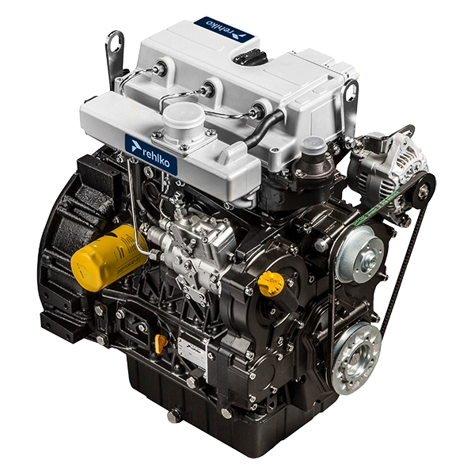

Registration of modifications to the document
Any modifications to this document must be registered by the drafting body, by completing the following table.

Released by | Code | Revision | Release Date | Revision date | Edited by | Endorsed
Technical Documentation | ED005302-960 | 9.6 | 04/2013 | 03/2023 | M. SILVESTRONE | V. MANINI

Translated from the original manual in Italian language
Data reported in this issue can be modified at any time by KOHLER.

Sommario
1. TITOLO 1 2
1.1. Asdfsdfsdf 2
1.2. Asdfsdfsdfggg 2

Fluids filling information

Engine oil

Important

- Before proceeding with operation, read Par. 3.3.2 .
- Do not use the engine with the oil level below the minimum.
- Loosen the oil filler cap A or the oil filler cap C if the cap A is not accessible.  - Add the type and amount of oil recommended ( Tab. 2.2 ). | 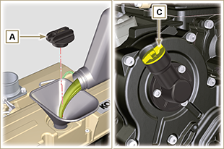  Fig 10.1
- Remove the oil dipstick B and check that the level is up to but does not exceed the MAX .  - If the oil level is not at MAX , insert more oil until the MAX level is reached as indicated on the dipstick.  - Re-tighten the cap A or C .  NOTE: See the Par. 11.1 for the various configurations of the oil dipstick. | 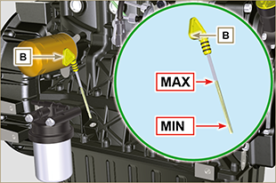  Fig 10.2

Coolant
Important

- Before proceeding with operation, read Par. 3.3.2 .
- Screw the cap. G , replacing the copper gasket (Tightening torque of 50 Nm ). | 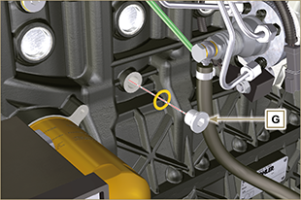  Fig 10.3
- Tighten the cap E , replacing the copper gasket D . | 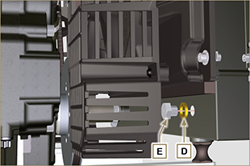  Fig 10.4
- Refill the radiator with coolant (refer to Par. 2.6 for the liquid specifications).  - Top liquid up until the pipes inside the radiator are covered by about 5 mm.  - For engines equipped with separate expansion tank, pour in fluid until reaching the max level mark.  - Loosen the screw F on the head H , release any air and tighten the screw F (Tightening torque of 8 Nm - Fig. 10.7 ).  - Start the engine without the radiator cap A or the expansion tank ( C ) cap B . | 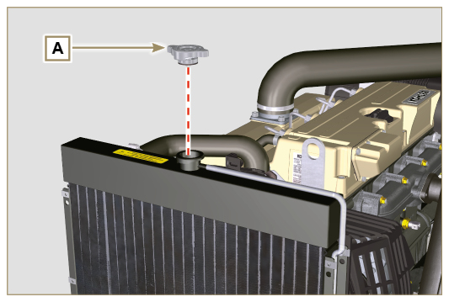  Fig 10.5
- Keep it running at idle speed until the cooling liquid level goes down and becomes steady (the waiting times varies according to the ambient temperature).  - Stop the engine and allow it to cool.  - If there is an expansion tank ( C ) top liquid up to the mark MAX .  - Without expansion tank top liquid up until the pipes inside the radiator are covered by 5 mm. Do not overfill the radiator, but leave room for the coolant to expand.  - Tighten the radiator cap A or the expansion tank ( C ) cap B .    Warning  - Before starting make sure that the radiator cap and expansion tank cap, if present, are installed correctly to avoid spillage of liquid or vapour at high temperatures.  - After a few hours of operation stop the engine and allow it to cool.  Check and top up the coolant liquid. | 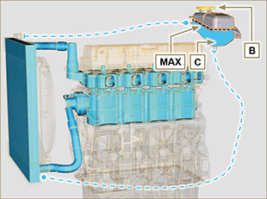  Fig 10.6
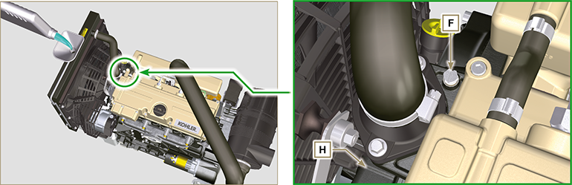
Fig 10.7



