DIAGBOX
Diagnostic tool manual

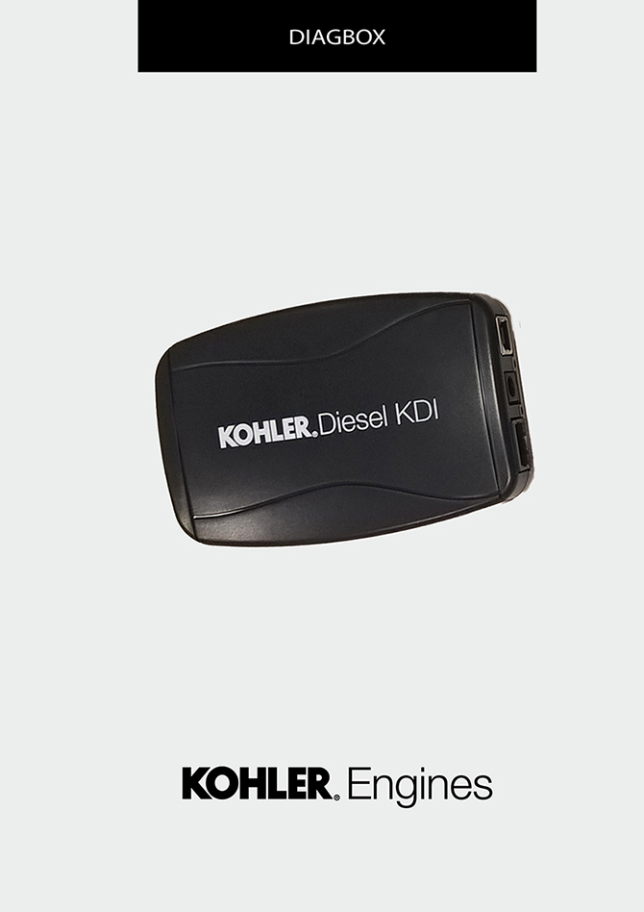
Sommario
1. TITOLO 1 2
1.1. Asdfsdfsdf 2
1.2. Asdfsdfsdfggg 2

DIAGBOX

DIAGBOX Diagnostic tool
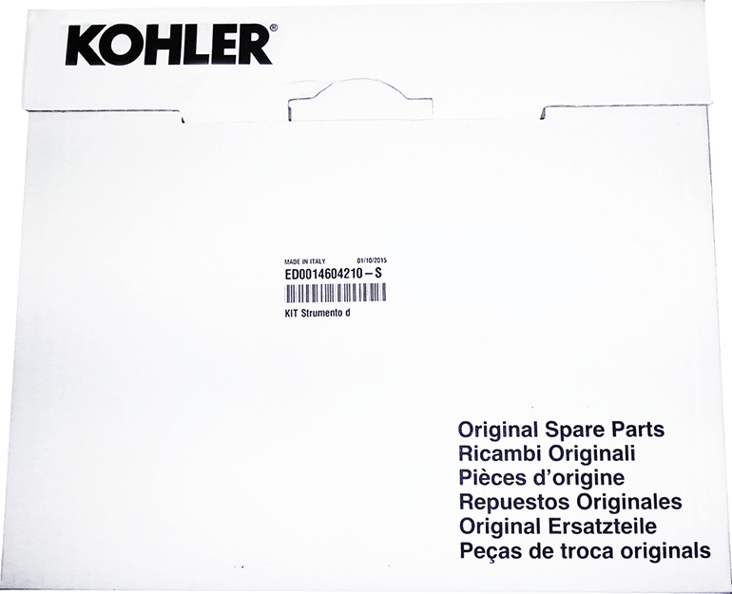

Cod. ED0014604210-S - * Pn to the complete kit tool

Contents of suitcase
