Assembly information
KDI 3404 TCR-SCR Workshop Manual (Rev. 10.3)

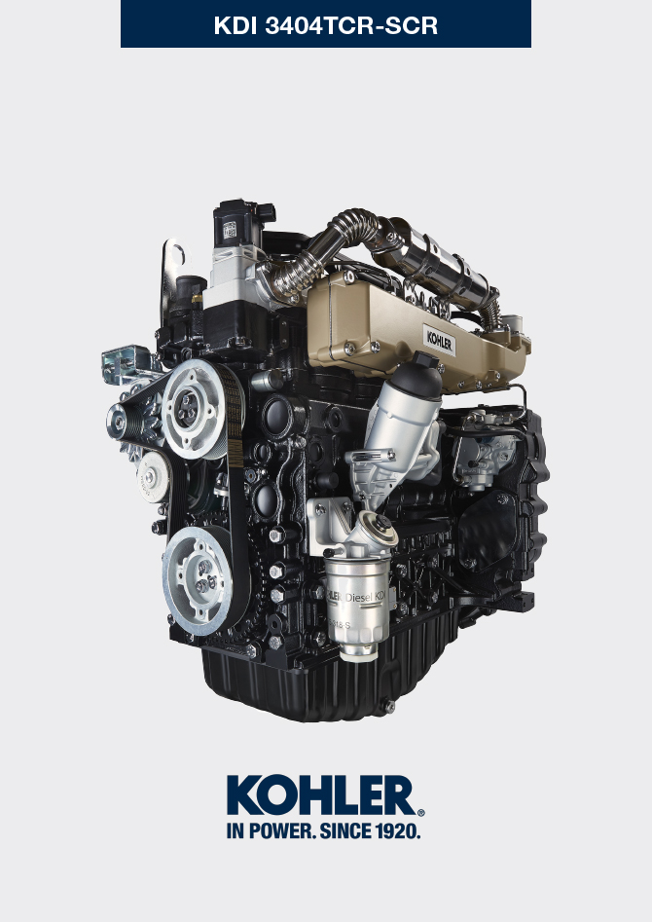
Sommario
1. TITOLO 1 2
1.1. Asdfsdfsdf 2
1.2. Asdfsdfsdfggg 2

Assembly information

Information on engine configuration
- In this chapter, the engine is represented as "BASE CONFIGURATION" (refer to Par. 1.4 - 1.5 ).
- For the assembly of components not described in this chapter refer to Chap. 11 .
- The following are the components described in Chap. 11 .

11.1 Heater (reaplacement)
11.2 Idler gear (for III/IV PTO)
11.3 III PTO (replacement)
11.4 IV PTO (replacement)
11.5 Balancer shafts (replacement)
11. 6 ETB (replacement)

Assembly recommendations
- The information is laid out in sequence, the intervention methods have been selected, tested and approved by the manufacturer's technicians.
- This chapter describes the installation procedures for the assemblies and/ or individual components which have already been checked, overhauled or possibly replaced with original spare parts.
- Where necessary, reference to special tools during assembly operations is indicated and identified in Tab 13.1 , hereinafter in Tab. 9.1 an example of a special tool ( ST_05 ).

Tab. 9.1
SPECIAL TOOLS
"ST" Code | Picture /draw | DESCRIPTION | PART NUMBER
ST_05 | 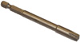 | Six nicks Key SN 8 | ED0014603650-S

Important

- Before proceeding with operations, read Par. 3.3.2 .
- To easily locate specific topics, the reader should refer to the analytical index or chapter index .
- The operator must check that:
  - the components, the assemblies, the coupling surfaces of the parts are washed, clean and thoroughly dried;
  - the coupling surfaces are undamaged;
  - the equipment and tools are ready so that all work can be carried out correctly and safely;
  - ensure that the working environment is safe.
- The operator must:
  - carry out the procedures smoothly and safely. It is thus recommended to install the engine on a special rotating stand used when servicing engines to ensure the safety of the operator and the other individuals involved;
  - tighten the assemblies and / or components in a criss-cross or alternating pattern, initially with a value lower than that preset, and then subsequently, with the tightening torque specified in the procedure;
  - replace all seal gaskets after each assembly for all components on which they are provided.

Engine block assembly
9.3.1 Crankshaft bushings  Important  - Execute the procedure in Par. 8.2.1 and 8.2.2 , before proceeding with assembly.  - The crankshaft half-bearings are made of special material. Therefore, they must be replaced every time they are assembled to prevent seizures.  - Fit the new half-bearings A1 onto the crankcase upper half B1 adhering to the reference notches C .  Importante  - After the half-bearings are fitted, check that the lubrication holes D correspond with the crankcase grooves B1 .  - The lower and upper half bearings CANNOT be singularly replaced, and both halves must be replaced together.  - Fit the new half-bearings A2 onto the lower crankcase B2 using the reference notches C .  - Lubricate the half-bearings A1 and A2 with oil. | 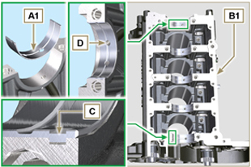  Fig 9.1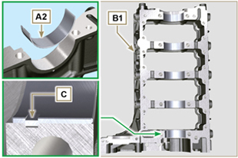  Fig 9.2
9.3.2 Tappets  - Lubricate the tappets E with oil.  - Insert the tappets E into the housings F of the upper crankcase B1 . | 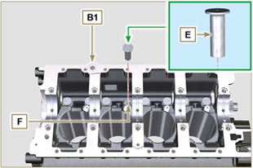  Fig 9.3
9.3.3 Oil spray nozzles  - Insert the sprayers G onto the upper crankcase B1 manually screwing the screw fittings H .  - Ensure that the spray nozzles G are inserted correctly in their seat, as shown in detail L and tighten the capscrews of union H (tightening torque of 10 Nm ). | 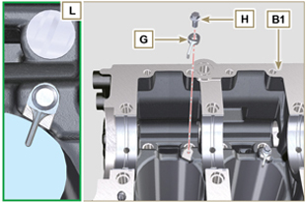  Fig 9.4
9.3.4 Crankshaft  Important  - Carry out the checks described in Par. 8.4.1 and Par. 8.4.2 .  - Check that the crankshaft half-bearings A1 are mounted correctly on the upper crankcase B1 .  - Lubricate the main journal and crankpin J , with oil.  - Insert the crankshaft M into its seat on the upper crankcase B1 .  - Insert the 2 shoulder half-rings N1 , between the crankshaft M and the upper crankcase B1 ( Q detail). | 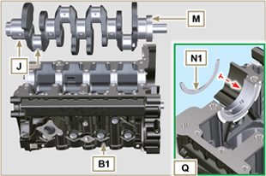  Fig 9.5
9.3.5 Lower semi-crankcase  - Check that the coupling surfaces P are free from dirt and grit.  - Spread a bead of Loctite 5660 of approx 1,5 mm thickness on the surface P of the upper crankshaft half B1 being careful not to block the oil feed grooves X and the return oil sump Y .  - Insert gasket S into the seat of crankcase B1 .  Note :alternatively apply Loctite 5699 . | 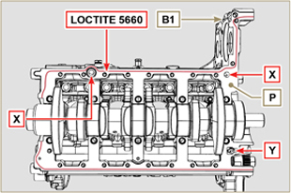  Fig 9.6

- Check that the crankshaft half-bearings A2 are mounted correctly on the lower crankcase B2 .
- Assemble the 2 shoulder half-rings N2 onto the lower crankcase B2 applying two drops of grease to keep them in their seat.
- Join the two crankshaft halves B1 and B2 observing the guide pins T .
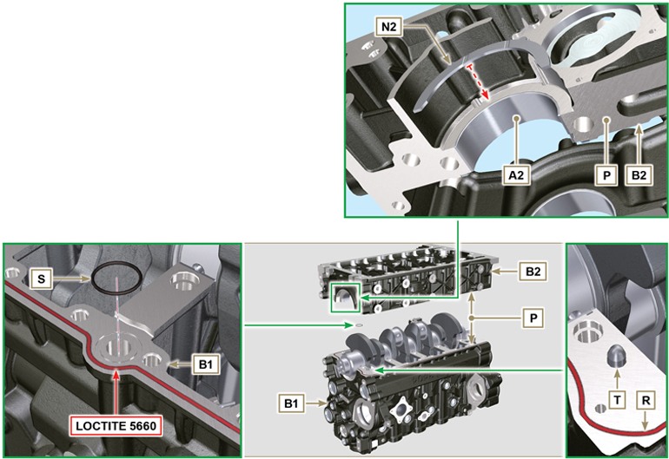
Fig 9.7 - F ig 9.8

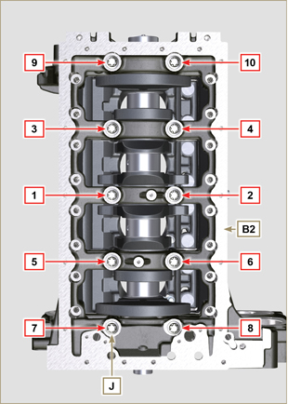  Fig 9.9 | 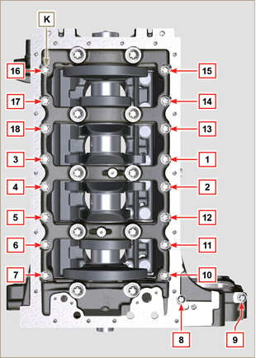  Fig 9.10
Tab 9.2  CYCLE SCREWS TORQUE  1 J - Torx M14x1,5 60 Nm  2 K - Torx M10x1.25 30 Nm  3 J - Torx M14x1,5 45°  4 J - Torx M14x1,5 45°  Important  - The fastening bolts J , K must be replaced every time they are assembled.  - Failure to adhere to the bolt fixing procedures may compromise the functionality of the engine, and also may cause damage to persons and property.  - Tighten capscrews J , K observing the cycles, tightening, and subsequent rotation as indicated in Tab. 9.2 .  - Apply " Molyslip AS COMPOUND 40 " on the threads and under the head of capscrews J and K and manually tighten them until their stop.  - Tightening the screws J , K strictly following the sequence indicated in the Fig. 9.9 or Fig. 9.10 and the tightening torque indicated in the Tab. 9.2 .  - Check that crankshaft M rotates smoothly.  - Insert gasket W into the seat of crankcase B ( ST_47 ) . | 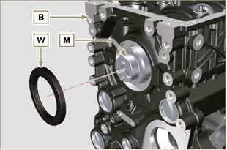  Fig 9.11
9.3.6 Camshaft  - Check that the pin P1 is correctly fitted on the crankshaft M .  - Position the gear M1 on the crankshaft M respecting the reference with pin P1 .  - Fully tighten the screw N1 .  - Lubricate the pins S2 , the cams S3 of the camshaft S1 , all the housing Q1 with oil.  - Insert the camshaft S1 all the way into its housing Q1 .  - Position the gear R1 observing all the marks T1 of the gears M1 .  Important  - Failure to comply with the marks T1 on the gears M1 and R1 causes engine malfunction and serious damage.  7. Check that crankshaft M rotates smoothly. | 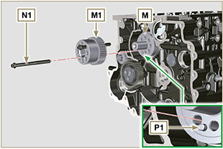  Fig 9.12  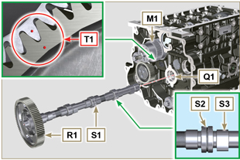  Fig 9.13
9.3.7 Piston rings  - Perform the operations described in Par. 8.5.3 .  - Put the scraper ring Z3 onto the piston Z .  - Put the 2° seal ring Z2 on the piston Z .  - Put the 1° seal ring Z1 onto the piston Z .  - Perform the operations described in Par. 8.5.4 .  - Position the segment openings with a 120° angle between them ( Y ).  NOTE: do not use the segment opening with the pin hole ( N )  - Lubricate the piston skirt and piston rings with oil. | 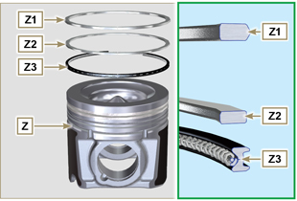  Fig 9.14  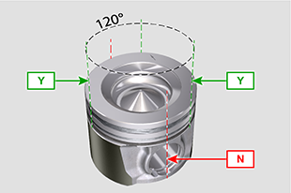  Fig 9.15
9.3.8 Piston  Importante  - The fastening bolts E1 must be replaced every time they are assembled.  - Before proceeding to the assembly of the piston and connecting rod, carry out the checks described in Par. 8.5.1 .  - Always replace the bearings D1 after each assembly.  - Mate components respecting references at Par. 7.15.5 .  - Loosen the screws E1 and remove the connecting rod cap F1 .  - Insert the connecting rod F2 into the piston Z and align the seats G1 .  - Insert the gudgeon pin H1 into the seat G1 for the assembly of the connecting rod and piston unit.  - Insert the lock rings L1 inside the seat G2 of the piston Z to lock the gudgeon pin H1 . | 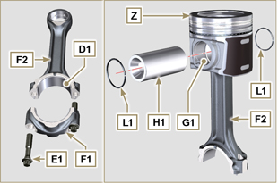  Fig 9.16  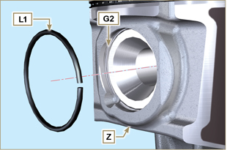  Fig 9.17

9.3.9 Piston and connecting rod assembly  Important  - Before assembling the piston and connecting rod assemblies, execute the controls described in Par. 8.5.5 .  - Rotate the crankshaft M by moving the crankpin J1 to a TDC position of the affected cylinder. | 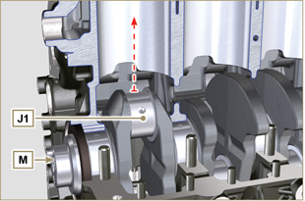  Fig 9.18
- Lubricate the piston skirt and rings Z .  - Check that the half-bearing U1 is mounted correctly and lubricate it thoroughly.  - Using the piston ring compression pliers, insert the piston inside the cylinder W1 by around 10mm (height T2 ).  Important  - Make sure you are at the stage described in Point 1 .  - Piston Z must be assembled with notch K1 on the side of the skirt facing oil spray nozzles G .  - Rotate the piston Z by 10° counter-clockwise with respect to its correct assembly position (Fig. 9.20 - height T3 ).  NOTE: Doing this prevents the impact between the connecting rod F2 and the sprayer G . | 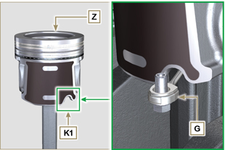  Fig 9.19  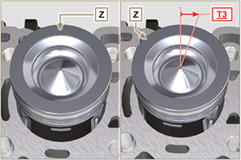  Fig 9.20  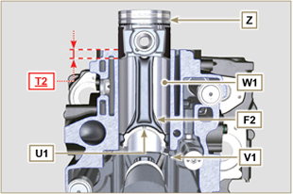  Fig 9.21  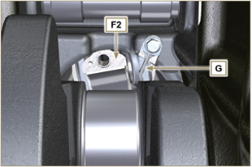  Fig 9.22
Important  - Leave the ring compressor assembled on the piston.  - Push piston Z downwards without introducing the segments in the cylinder, rotate piston Z by 10° in a clockwise direction (value T3 – correct assembly position). | 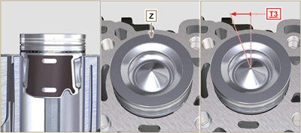  Fig 9.23

- Push the piston Z downwards by centering the crankpin J1 with the connecting rod F2 .  - Rotate the crankshaft M by moving the crankpin J1 to a BDC position of the affected cylinder.  - Push the piston Z downwards by centering the crankpin J1 with the connecting rod F2 .  - Turn the crankcase on support to assemble the con rod capp F1 .  - Check that the half-bearing U1 is mounted correctly on the connecting rod cap F1 .  Important  - Check that the break levels of connecting rod cap F1 coincide perfectly onto connecting rod F2 before screwing on and tightening capscrews E1 .  - Couple the connecting rod cap F1 to the connecting rod F2 using the marks made at disassembly ( Par. 7.15.2 and 7.15.5 ).  - Apply "Molyslip AS COMPOUND 40" on the threads and under the head of capscrew E1 and manually tighten them until their stop.  Important  - Failure to adhere to the assembly procedures may compromise the functionality of the engine, and also cause damage to persons and property.  - Tighten the screws E1 , alternately, strictly following the tightening torques indicated ( Tab. 9.3 ).  - Repeat the operations from 1 to 14 for each cylinder.  - Check that the connecting rods have axial play and the crankshaft M rotates smoothly.  NOTE: After the check carried out at point 16, position the shaft M with the first cylinder to TDC. | 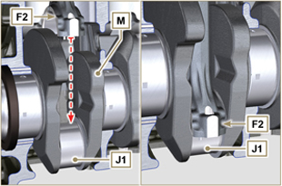  Fig 9.24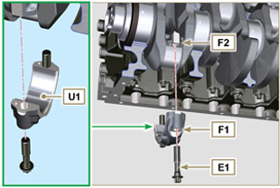  Fig 9.25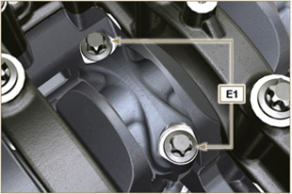  Fig 9.26
Tab 9.3
CYCLE | SCREWS | TORQUE
1 | E1 | 28 Nm
2 | E1 | 30°
3 | E1 | 30°

NOTE : Click by side to play the procedure. | https://www.youtube.com/embed/V4aXYc_0x8U?showinfo=0&rel=0

Oil sump unit assembly
9.4.1 Oil drain pipe  Important  - It is mandatory to replace the gasket D after each assembly.  - Always replace capscrews B with new ones or alternatively apply Loctite 2701 .  - Secure the hose A on the crankcase C with the screws B inserting the gasket D (tightening torque 10 Nm ). | 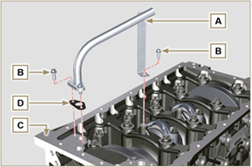  Fig 9.27
9.4.2 Oil suction pipe  Important  - It is mandatory to replace the gasket F after each assembly.  - Always replace capscrews B with new ones or alternatively apply Loctite 2701 .  - Secure the hose E on the crankcase C with the screws B (tightening torque 10 Nm ) fitting the gasket F . | 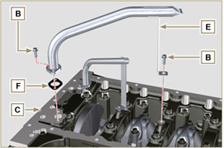  Fig 9.28
9.4.3 Oil Sump  - Ensure that the contact surfaces G of the oil sump H and the crankcase C are completely clean.  - Apply a bead of approx. 2.5 mm of sealant ( Loctite 5660 ) on the surface G of the crankcase C .  Note : alternatively apply Loctite 5699 . | 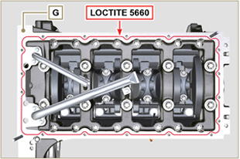  Fig 9.29
- Position the oil sump H on the crankcase C in line with the fastening holes (use the aid of tool ST_18 ). | 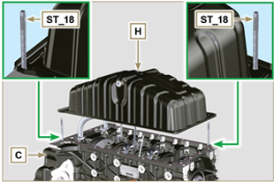  Fig 9.30
Important  - Tighten the screws L , strictly following the sequence and tightening torque indicated.  - Secure oil sump H by means of capscrews L .  - After tightening of the screw n° 10 , loosen screw n°1 and re-tighten it to the torque value specified in step 4 . | 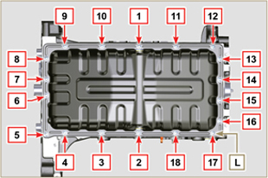  Fig 9.31

Cylinder head unit assembly
9.5.1 Valve stem gasket  Important  - Carry out the checks described in Par. 8.6.4 before proceeding with the following operations.  - Always replace gasket A with every assembly.  - Lubricate the oil seals A on the inside.  - Fit the oil seals A on the valve guides B using the tool ST_08 . | 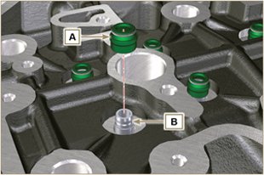  Fig 9.32
9.5.2 Electronic injector sleeves ( )  - Insert the seals C in the seats of the sleeve D .  - Insert the seal E with the convex side facing upward at the base of the sleeve D .  - Lubricate the gaskets C .  - Insert and carefully screw the sleeve D into the seat of the head F .  NOTE: The sleeve D must not protrude above the surface of the head G .  - Clamp the sleeve D (tightening torque at 30 Nm ). | 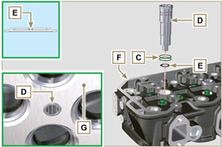  Fig 9.33
9.5.3 Electronic injectors projection  - Perform the operations of point 1 and 2 Par. 6.1.4.  - Perform the operations of point 3 and 4 Par. 6.1.5.  - Check using ST_03 tool (Fig. 9.35) , the projection of the injector, which must range between 1.68 ÷ 2.42 mm.  NOTE : if the value detected does not correspond, replace gasket Q with a different thickness. | 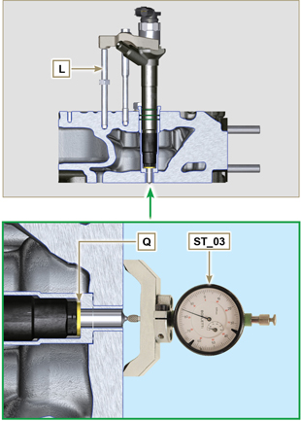  Fig 9.34 - Fig. 9.35
9.5.4 Valves  - Pre-lubricate and insert the valves X into the head F taking care to fit them in the original positions as per the reference marks made in Par. 7.12.4.1 .  - Position the spring Y on the seat of the head F .  - Position the disk S on the spring Y centering the valve X .  - Mount the tool ST_07 on the head F fixing it on one of the holes for securing the rocker arm cover.  NOTE: Change the fixing hole according to the position of the valves to be fitted.  - Position the tool ST_07 on the valve as shown in the Fig. 9.37 .  - Push the lever of the tool ST_07 downwards, in order to lower the valve disks S in the direction of the arrow AK , and insert the valve cotters AJ inside the disk S .  - Check that the valve cotters AJ are properly mounted on the valve seats X and release the tool ST_07 .  NOTE: repeat all the steps for the relevant valves and remove the tool ST_07 . | 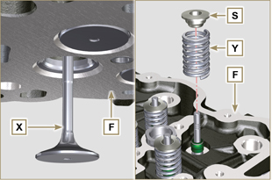  Fig 9.36
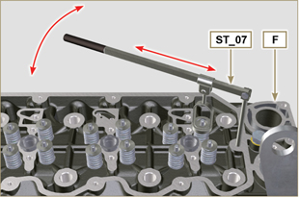
Fig 9.37
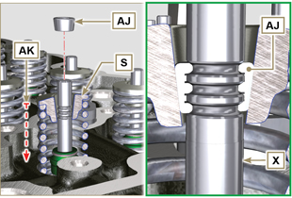
Fig 9.38
9.5.5 Cylinder head  - Fix the eyebolts AW with the screws AX onto the head F (tightening torque of 80 Nm ).  - Position the piston P at the TDC.  - Position the tool ST_03 on the crankcase surface of the head and measure the piston protrusion P from head level K in 4 diametrically opposed points R. Repeat the operation for all pistons P and take note of the highest average value, determining valu e S (Tab. 9.4) .  Tab. 9.42  S (mm) Hole number  0.030 - 0.126 1  0.127 - 0.250 2  0.251 - 0.375 3  - Based on the value detected at point 3 , select the relevant gasket T as shown in the Tab. 9.4 (Fig. 9.41 detail U ).  - Check that the crankcase surface K and the gasket T are completely free of dirt and grit.  Important  - The head gasket must be replaced for each assembly.  - Position the gasket T on the surface K with reference to the centering bushings J . | 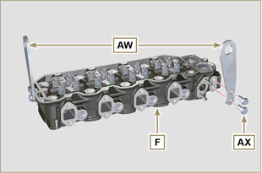  Fig 9.39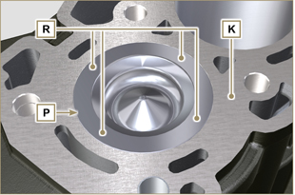  Fig 9.40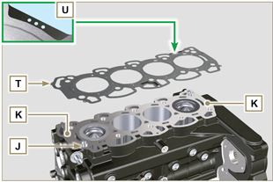  Fig 9.41
- Check that the surface head W is free from impurities.  - Position the head F on the crankcase Z with reference to the centering bushings J .  Important  - The fastening bolts V must be replaced every time they are assembled.  Modified component, see service letter 710009.  - Failure to adhere to the bolt fixing procedures may compromise the functionality of the engine, and also may cause damage to persons and property.  - Tighten capscrews V observing the cycles, tightening, and subsequent rotation as indicated in Tab. 9.5 .  - Secure the head F by tightening the screws V strictly following the sequence indicated in the Fig. 9.43 and the tightening torque and pauses between cycles indicated in the Tab. 9.5 . | 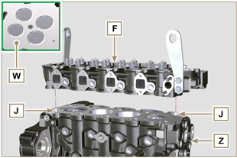  Fig 9.42
Tab. 9.5  CYCLE TORQUE PAUSE  1 75 Nm 3min  2 90° 3min  3 90° 3min  4 90° --- | 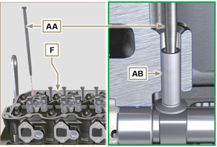  Fig 9.44
9.5.6 Rods and valve bridges  - Insert the rocker control rods AA into the niches of the head F .  Important  - Properly centre the rods AA into the spherical housing of the camshaft tappets AB .  - Mount the valve bridge AC on to the pairs of discharge and suction valves. | 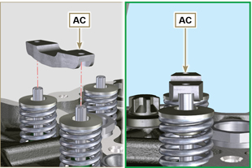  Fig 9.45
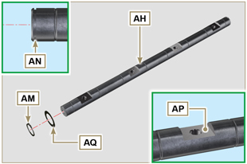
Fig 9.46
9.5.7 Rocker arms  Important  - The discharge rocker arm AT is shorter than the suction arm AR .  - Fit the lock ring AM into the seat AN of the rocker arm pin AH .  - Position the pin AH with the screw support surface AP facing upwards and insert the 2 shoulder rings AQ .  - Insert in sequence the suction rocker arm AR , the holder AS and the discharge rocker arm AT in the pin AH .  - Insert the spring AU in the pin AH .  - Repeat points 3, 4 for all the rocker arms.  NOTE: Support AV , which contains taper pin BV , must be assembled in correspondence with cylinder n° 3 .  - Insert 2 shoulder rings AQ and the lock ring AN to lock all the components inserted in the pin AH .  NOTE : The spring AU ensures that the supports AS and AV are kept in place. | 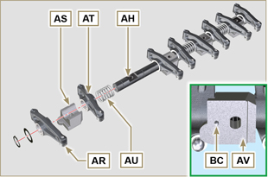  Fig 9.47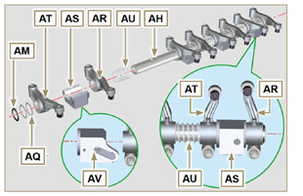  Fig 9.58
9.5.8 Rocker arm pin assembly  Important  - Position the rocker arm pin assembly BB on a level to align all the support surfaces.  - Check that the pistons are positioned half way between the TDC and BDC. As seen from A ⇒ ( Par. 1.4 ) turn the crankshaft anticlockwise by 90°, complying with TDC of the 1st cylinder , positioning taper pin BP of the crankshaft as shown in Fig. 9.48 .  - If the engine is painted or protected with clear paint, replace the fastening screws BE .  - Position rocker arm shaft unit BB on cylinder head F , complying with the taper pin BC reference with hole BF of cylinder head F .  - Check the correct positioning of all the rocker arms and the u-bolt control valves (detail BD ).  House the tappet in the seat of the rocker arms control rod.  - Secure the rocker arm pin BB tightening the screws BE (tightening torque to 40 Nm ). Adhere to the screw tightening sequence BE as shown in Fig. 9.50 . | 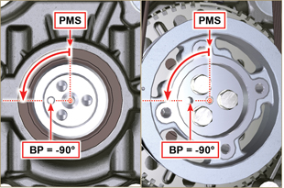  Fig 9.48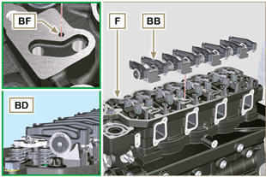  Fig 9.49
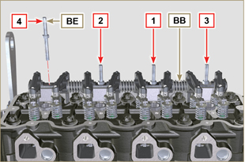
Fig 9.50
9.5.9 Assembly Rocker arm cover  Important  - Replace gasket BF, BL and BM with each assembly ( ST_11 - ST_12 apply Loctite 480 to the seats of cap BN before assembling the gaskets).  - Observe the order of tightening illustrated in Fig. 9.52 .  - Position tool ST_17 onto the head in correspondence with the two fastening holes 9 and 10 .  - With vaseline lubricate the gaskets BL in the upper part, and the gaskets BM in the lower part.  - Position gasket BF and the rocker arm cover BN on cylinder head F using tool ST_17 as a guide.  - Attach the rocker arm cover BN on the head F with the screw BG (tightening torque to 10 Nm ). | 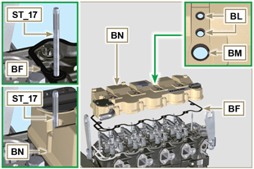  Fig 9.51
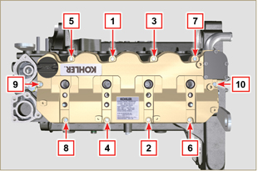
Fig 9.52

Intake manifold assembly
9.6.1 Internal half-manifold  Important  - Check that the contact surfaces between the semi-collector C and the head D are free from impurities.  - Insert the special tool ST_18 into indicated point.  - Position gasket B and manifold C on cylinder head D .  - Secure the semi-collector C with the screws A on the head D (tightening torque of 25 Nm ). | 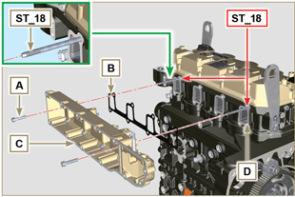  Fig 9.53
9.6.2 External half-manifold  Important  - Check that the contact surfaces between the two semi collectors C and D are free from impurities.  - Insert the special tool ST_18 into indicated point.  - Position gasket N , panel P and semi-manifold M onto semi-manifold C .  - Fit the semi-collector M on the semi-collector C with the screws L (tightening torque of 22 Nm - ST_05 ). | 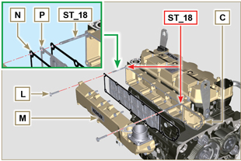  Fig 9.54

Fuel system assembly
Important

- Do NOT mount new or different injectors without the required tool ( Chap. 13 ).
- Remove the protective caps from all the components of the fuel circuit just before assembly just before assembly ( Par. 2.9.8 ).
9.7.1 High-pressure injection pump  - Check that the surface A is free from impurities ( Fig. 9.56 ).  Important  - Always replace gasket B with every assembly.  - The seal gasket B can only be fitted in one direction ( Fig. 9.55 ).  - Always replace capscrews C with new ones or alternatively apply Loctite 2701 ( Fig. 9.55 ).  - Fit the new gasket B on the injection pump D ( Fig. 9.56 ).  - Fix the pump D into the housing A1 together with the gasket B by the screws C ( Fig. 9. 56 - tightening torque at 25 Nm ).  - Check the correct fitting of the key E on the shaft F of the injection pump D ( Fig. 9.57 ).  - Place the gear G on the shaft F of the pump D respecting the reference to the key E and the reference H of the gear L ( Fig. 9.57 ).  - Tighten the nut M (tightening torque at 140 Nm ). | 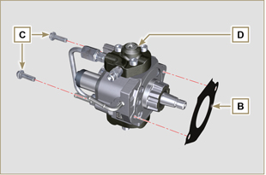  Fig 9.55
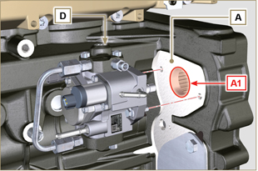
Fig 9.56
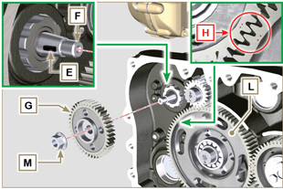
Fig 9.57
9.7.2 Fuel filter  - Secure the fuel filter holder N with the screws P on the crankcase Q (tightening torque of 25 Nm ).  NOTE : For the assembly of the fuel cartridge, refer to operations 4 and 5 of Par. 6.9.2 . | 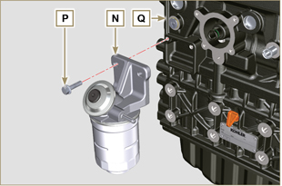  Fig 9.58
9.7.3 Electronic injectors  Importante  - Always replace and lubricate the gaskets R of the electronic injectors S with fuel, every time they are assembled.  - Pay attention when repositioning the electronic injectors, using the marks as described in Par. 7.10.5 .  - If a new (or different) electronic injector is fitted on the engine, you are required to prepare tool ST_01 .  - If the engine is painted or protected with clear paint, clean the paint off the diesel injector S near to the part in contact with the gasket AB .  - Assemble gasket T onto electronic injector S .  - Insert the electronic injectors S inside the rocker arm cover U being extra careful not to damage gasket AB and direct it as indicated in Fig. 9.59. | 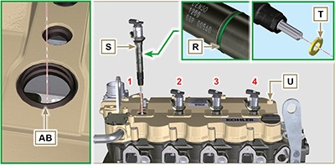  Fig 9.59
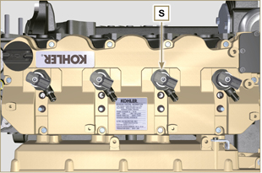
Fig 9.60
9.7.4 Common Rail  - Secure the rail W on the intake manifold X with the screws V (tightening torque at 25 Nm ). | 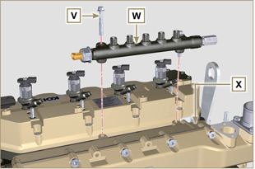  Fig 9.61
9.7.5 High pressure fuel pipes  Important  - Always replace the pipes Y and tube Z after each assembly.  - Position the pipes Y on the Common Rail W and on the electronic injectors S , adjust the position of electronic injectors S via the fitting inlets with the pipes Y .  Important  - Tighten the nuts J and K manually, without clamping them.  - If the engine is painted or protected with clear paint, replace the fastening screws B1 .  - Position the injector fastening brackets A1 and the screws B1 , inserting the washer C1 .  Important  - Replace the pipes Y ( Fig. 9.62 ) if the screws B1 do not rotate freely.  - Tighten all the nuts K (tightening torque at 30 Nm ).  - Tighten the nuts J (tightening torque at 25 Nm ).  - Make sure that the mounting brackets A1 are positioned correctly on electroinjectors S and on fixing screws of the rocker arm assembly D1 .  - Tighten the fixing screws B1 of the injector mounting bracket (tightening torque of 20 Nm ).  - Position the pipe Z screwing the nuts J and K .  Important  - Screw the nuts J and K manually without tightening them.  - Tighten the nut K (tightening torque of 30 Nm ).  - Tighten the nut J (tightening torque of 25 Nm ).  - Fasten the clamp E1 with the screw F1 (tightening torque of 10 Nm ). | 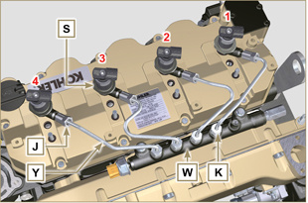  Fig 9.62
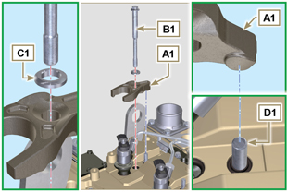
Fig 9.63
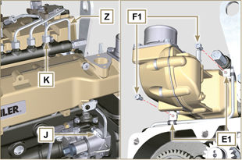
Fig 9.64
9.7.6 Fuel flow pipes  - Insert the pipes G1 on the fitting coming out of the filter holder N and on the fuel inlet fitting of the injection pump D . | 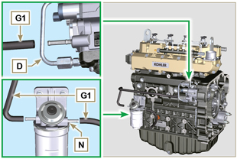  Fig 9.65
9.7.7 Fuel return pipes  - Check the gaskets H1 on the fittings J1 .  NOTE : Do not disconnect the pipes from the distributor K1 .  - Position the return pipes and fitting the distributor K1 with the screw L1 on the intake manifold X ( Fig. 9.67 - tightening torque of 10 Nm ).  - Mount the fittings J1 ( Fig. 9.67 ) on the injectors S and lock them with the clips M1 .  - Insert the pipe N1 on the fitting P1 .  - Fit the gaskets Q1 and the fitting R1 on the screw S1 .  - Tighten capscrews S1 on Common Rail W (tightening torque 15 Nm ) with the opening of union R1 facing upwards. | 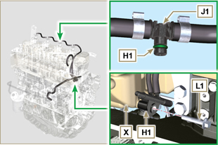  Fig 9.66
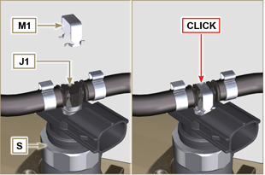
Fig 9.67
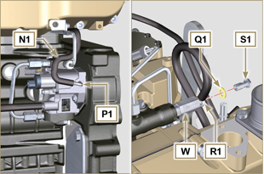
Fig 9.68

Assembly lubrication circuit
9.8.1 Assembly oil mist separator unit  Important  - Always carefully inspect the condition of the pipes, and replace them if there is any doubt regarding the integrity of their seal.  - Secure the plate A using the screws B (tightening torque of 10 Nm - ST_05 ).  - Assemble clamps C onto tube D .  - Secure tube D by means of fastening clamp C with capscrews E , inserting clamp F.  - Fit hose G onto union H .  - Secure tube J by means of capscrew K , inserting gasket L .  - Secure the clamp M .  - Perform the operations of Par. 6.7.2 . | 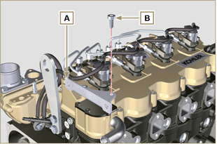  Fig 9.69
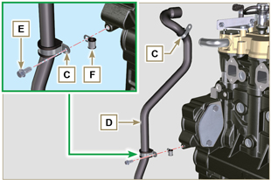
Fig 9.70
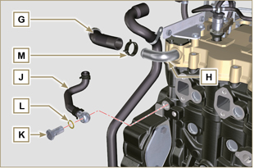
Fig 9.71
9. 8 .2 Oil Cooler and oil filter Unit Assembly

- Perform the operations of Par. 6.8.3 .

NOTE :To replace the oil cartridge, refer to operations of Par. 6.8.2 .

9. 8 .3 Oil pressure relief valve  - Lubricate the piston N and fully insert it in the seat P .  - Insert the spring Q in the piston N .  - Insert disk R onto spring Q .  - Insert cotter pin S in the provided seat of oil pump T to lock components N, Q and R . | 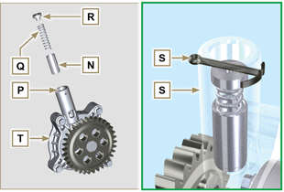  Fig 9.72
9. 8 .4 Oil pump  NOTE: Carry out the checks described in Par. 8.7 before proceeding with the following operations.  - Check that all contact surfaces between T, V are free of impurities – scratches - dents.  - When assembling, do not use any type of gasket between T and V .  - Thoroughly lubricate the seat of the rotors on oil pump T .  - Make sure the external rotor is assembled correctly with Ref. U visible, as shown in the picture (or refer to Par. 2.10.2 ).  - Fasten the oil pump cover T on the crankcase V with the screws X (tightening torque 10 Nm ). | 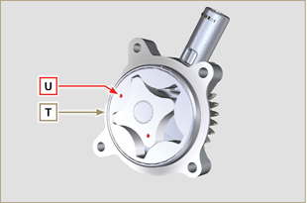  Fig 9.73
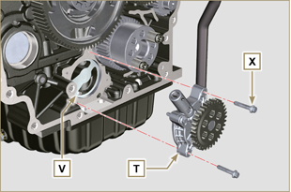
Fig 9.74

Flange unit assembly
9.9.1 Bell housing  Danger  - Bell A is very heavy; pay special attention during assembly operations to avoid dropping and causing serious risks to the operator.  Important  - Failure to adhere to the assembly procedures may compromise the functionality of the engine, and also cause damage to persons and property.  - Always replace and lubricate gasket C with oil with each assembly (gasket C is to be mounted after the operation in point 5 ( ST_47 ) ).  - To assemble components P, Q, R, S , and T , proceed with the operations described in Par. 11.2.2 - 11.3.2 - 11.4.2 - 11.5.2 .  - Apply a bead of approx. 2.5 mm of sealant ( Loctite 5188 ) on the surface B of the bell A .  - Ensure that bearing J is correctly assembled on camshaft K .  - Assemble bell A onto crankcase D , complying with reference taper pins E ( ST_45 ) .  - Apply the screws F by hand without tightening them.  - Tighten the screws F following the tightening sequence indicated (tightening torque 75 Nm ). | 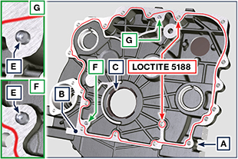  Fig 9.75  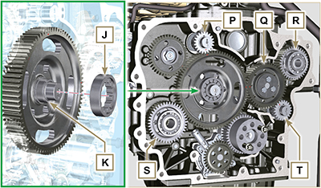  Fig 9.76A  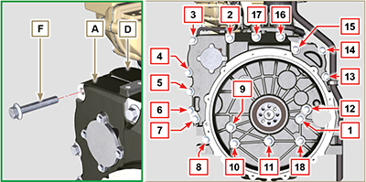  Fig 9.76B

9.9.2 Flywheel  Danger  - Flywheel F is very heavy; pay special attention during assembly operations to avoid dropping and causing serious risks to the operator.  - Loosen capscrews G and remove tool ST_41 .  - Position flywheel H onto crankshaft L by means of tool ST_43 - ST_46 .  - Apply " Molyslip AS COMPOUND 40 " on the threads and under the head of capscrews G and manually tighten them until their stop.  - Secure flywheel H with capscrews G (tightening torque 60 Nm ).  - Once again, tighten capscrews G (2 cycles with tightening torque 130 Nm ). | 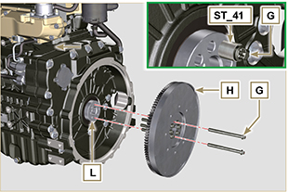  Fig 9.77

Exhaust manifold assembly
Important  - Replace the metal gaskets A, B every time they are assembled.  - In the event of mounting the studs C , fix ( 25 Nm tightening torque) with Loctite 2701 on the thread.  - Gasket B must be assembled with the wording " TOP " visible and facing upwards.  - Check that the contact surfaces D are free from impurities.  - Insert the gasket B on the studs C .  - Position manifold E onto cylinder head G by manually tightening capscrews F , inserting:  - gaskets A between cylinder head G and manifold E ;  - spacers H between capscrews F and manifold E .  - Secure manifold E onto cylinder head G by means of capscrews F (tightening torque 25 Nm ).  - Clamp the nuts L ( 25 Nm tightening torque). | 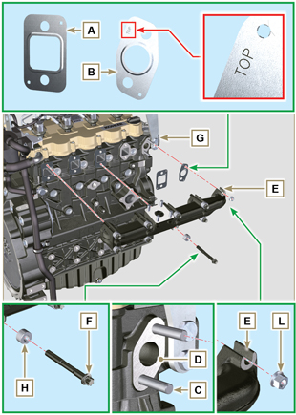  Fig 9.78

Crankshaft pulley assembly
- Perform the operations from point 1 to 7 of Par. 6.6.2 .

Turbocharger Assembly
Importante  - Before proceeding, perform the operation described in Par. 2.18 .  - Ensure that tube C is not clogged.  - Always replace the gaskets A, B, Q at each assembly.  - Remove the plastic or foam caps from the turbo compressor before assembling.  - Check that the contact surfaces D are free from impurities deformations or cracks, otherwise replace the damaged component.  - Position the turbo-compressor E on the bolts F on the manifold G .  - Fasten the turbo-compressor E with the nuts H (tightening torque of 25 Nm ).  - Fasten the pipe L with the screws M to the turbo-compressor E .  - Fasten the pipe G with the screws N on the crankcase P .  Importante  - Always replace the gasket Q after each assembly.  - Before assembly of the tube R , perform the operation described in Par. 2.18.2 - Point 2 .  - Ensure that tube R is not clogged.  - Fasten the pipe R with the fittings S on the turbo-compressor E and on the crankcase P (tightening torque of 15 Nm ).  Insert the gaskets Q between:  - S and R; - E and R;  - P and R. | 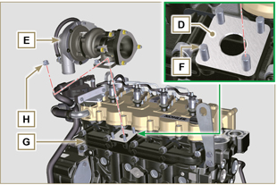  Fig 9.79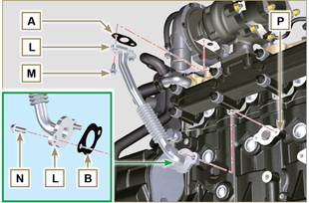  Fig 9.80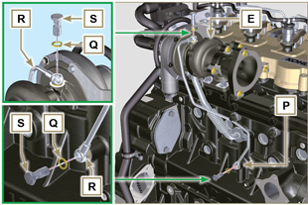  Fig 9.81

Electric component assembly
9.13.1 Sensors and switches

9.13.1.1 T-MAP Sensor  - Fasten the sensor A with the screws B on the manifold C (tightening torque of 10 Nm - ST_06 ). | 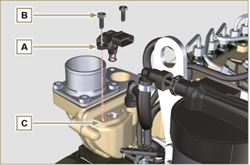  Fig 9.82
9.13.1.2 Coolant temperature sensor  - Secure the sensor D onto the head E (tightening torque of 20 Nm ). | 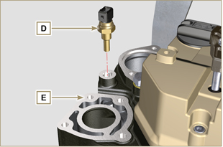  Fig 9.83
9.13.1.3 Oil Pressure Switch  - Clamp the oil pressure switch F on the crankcase G (tightening torque at 35 Nm ). | 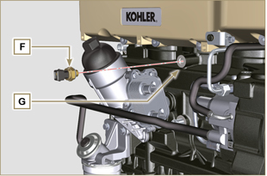  Fig 9.84
9.13.1.4 Camshaft phase sensor disassembly  - Measure the distance between the coupling surface P1 to gear teeth G1 (X1).  - Measure the distance between the coupling surface P1 and the sensor surface S7 (Y1).  - The difference between the 2 measurements determines the air gap value (Z1). The value (Z1) permitted must be a MIN of 0.2 mm and a MAX of 1.2 mm. Insert one spacers K2 based on the value (Z1) detected.  NOTE : The calibrated spacers K1 have a thickness of 0.2mm.  - Insert the shim K1 on the sensor S10.  - Secure phase sensor S10 onto crankcase L using capscrew R2 (tightening torque 10 Nm). | 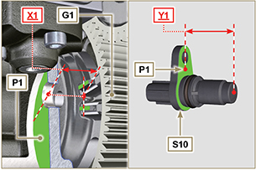  Fig 9.85
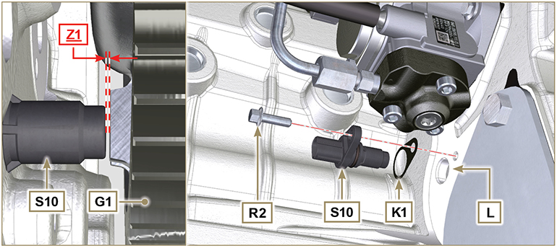
Fig 9.85A
9.13.1.5 Speed sensor  - Measure the distance from the coupling surface J to the external diameter of the phonic wheel ( X2 ).  - Measure the distance between the coupling surface J and the sensor surface H ( Y2 ).  - The difference between the 2 measurements determines the air gap value ( Z2 ).  The value ( Z2 ) permitted must be a MIN of 0.2 mm and a MAX of 1.2 mm .  Insert one or two spacers K based on the value ( Z2 ) detected.  NOTE : The calibrated spacers K have a thickness of 0.2mm.  - Secure the bracket M with the screws N inserting the washer S (tightening torque at 10 Nm ).  - Insert the shim K on the sensor H .  - Clamp the sensor H on the bracket M with the screw R (tightening torque at 10 Nm - ST_06 ). | 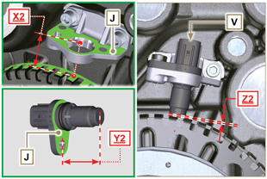  Fig 9.86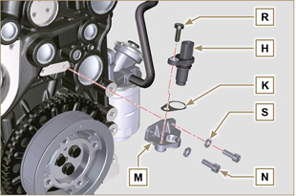  Fig 9.87
9.13.1.6 Fuel filter water detection sensor  - Lubricate and insert the gasket V on the fitting W .  - Tighten the sensor W onto the cartridge Z (tightening torque of 5 Nm ). | 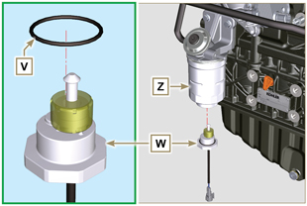  Fig 9.88
9.13.2 EGR valve  Important  - Check that the contact surfaces between flange B and the head D are free from impurities.  - Always replace the gasket A after each assembly.  - Position gasket A onto cylinder head D .  - Secure the flange B with the screws C on the head D (tightening torque of 10 Nm ).  - Perform the operations of Par. 6.4.2 . | 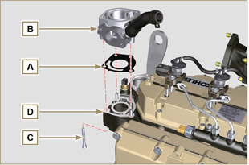  Fig 9.89
9.13.3 Alternator  - Insert the washer E onto the screw F .  - Insert the screw F onto the alternator G .  - Secure the bracket H and the alternator G using the screws L1, F onto the crankcase L .  9.13.4 Starter Motor  - Perform the operations to point 10 of Par. 6.6.2 . | 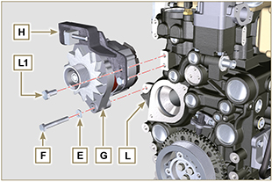  Fig 9.90
9.13.5 Electric cabling  - Position the cable holder N together with the cabling P on the rocker cap Q .  - Screw the wiring holder N on the rocker cap Q with the screws R (tightening torque of 10 Nm - ST_06 ).  - Mount the connectors C1 on the electronic injectors S1 .  Warning  - Slightly move wiring support N to check that there is no voltage in the electrical wire of connector C1 in correspondence with the outlet hole N1 . | 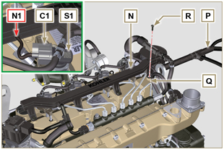  Fig 9.91
- Fit the connector C2 on the sensor S2 . | 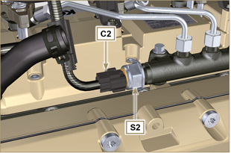  Fig 9.92
- Fit the connector C3 on the sensor S3 . | 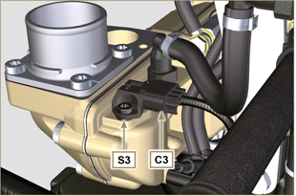  Fig 9.93
- Insert the connector C4 on the fuel intake valve S4 .  - Insert the connector C5 on fuel temperature sensor S5 . | 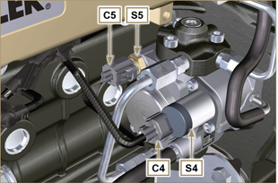  Fig 9.94
- Fit the connector C6 on the sensor S6 . | 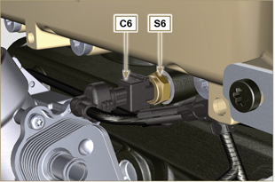  Fig 9.95
- Fit the connector C7 on the sensor S7 .  - Insert the clamp P1 onto the crankcase M .  - Fasten the clamp P2 with the screw T onto the crankcase M (tightening torque of 10 Nm ). | 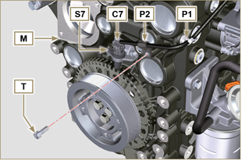  Fig 9.96
- Fit the connector C8 on the valve S8 .  - Fit the connector C9 on the sensor S9 . | 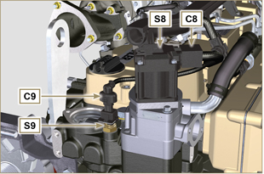  Fig 9.97
- Secure cable X on motor V by means of nut J .  - Secure cable Y on alternator W by means of nut K . | 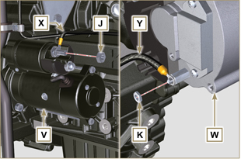  Fig 9.98

Coolant circuit assembly
9.14.1 Thermostatic valve  Important  - Always replace the gasket A after each assembly.  - Check the condition of the seal gasket A and fit it on the thermostatic valve B .  - Position the thermostatic valve B in the seat on the head C (detail D ).  - Secure the cover E with the screws F on the head C (tightening torque of 10 Nm ). | 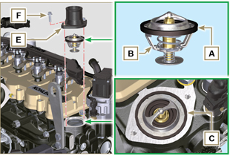  Fig 9.99
9.14.2 Coolant pump  Important  - Always replace the gasket L every time it is assembled.  - Secure the flange G with the screws H interposing the gasket L onto the crankcase M (tightening torque of 25 Nm ).  - Perform the operations of Par. 6.5.2 . | 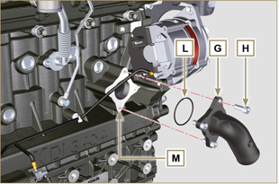  Fig 9.100
9.14.3 Oil Cooler hoses  - Secure hose N on Oil Cooler P and on crankcase M by means of clamps Q .  - Position and secure hose R by means of clamp S on Oil Cooler P and on crankcase M .  - Secure clamps T on manifold U by means of capscrews V in points X (tightening torque 10 Nm - ST_06 ). | 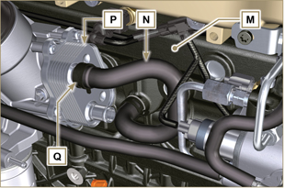  Fig 9.101
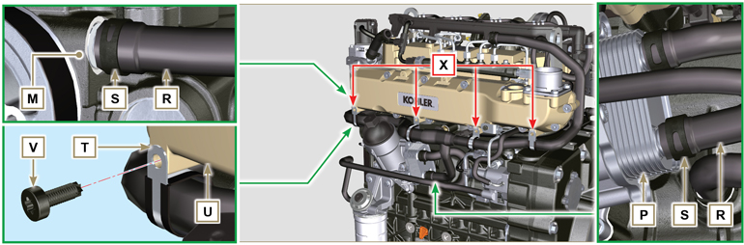
Fig 9.102

EGR Circuit Assembly
9.15.1 EGR Cooler  - Insert the fitting A1 of EGR Cooler B in the sleeve C of the EGR valve unit.  - Position EGR Cooler B on the intake manifold D with the screws E ( ST_05 ).  - Secure the fitting A1 with the clamp F1 to the sleeve C .  - Secure hose G onto union A2 of EGR Cooler B by means of clamp F2 . | 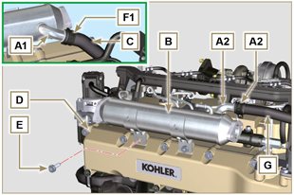  Fig 9.103
- Fasten the pipe H with the screws L on the EGR valve unit M inserting the gasket N (tightening torque of 22 Nm - ST_05 ).  - Fasten the pipe H with the screws P on EGR Cooler B inserting the gasket Q (tightening torque of 25 Nm ). | 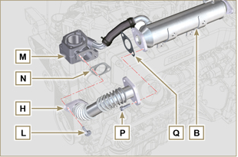  Fig 9.104
- Fasten the pipe J on the intake manifold D with the screws R (tightening torque of 22 Nm - ST_05 ) inserting the gasket S .  - Fasten the pipe J on the EGR Cooler B with the screws T (tightening torque of 25 Nm ) inserting the gasket U .  - Fit the EGR Cooler B on the intake manifold D with the screws E (tightening torque of 22 Nm - ST_05 - Fig. 9.103 ). | 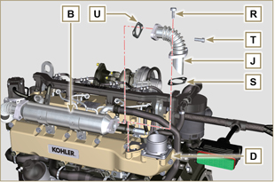  Fig 9.105

Tightening torques and the use of sealants
Tab. 9.4 - *Alternatively to the capscrew replacements, with "Dri-loc"
BASE CONFIGURATION

SHORT BLOCK
Component | Thread (mm) | Torque (Nm) | Sealer
Oil sprays fastening capscrew | M6x1 | 10
Lower crankcase fastening capscrew | M14x1.25 | 3 Torque cycles
1st Cycle |  | 60
2nd Cycle |  | +45°
3rd Cycle |  | +45°
Lower crankcase fastening capscrew | M10x1.25 | 30
Connecting rod screw | M11x1 | 3 Torque cycles
1st Cycle |  | 28
2nd Cycle |  | +30°
3rd Cycle |  | +30°
Coolant drain hole closing cap | M16x1.5 | 50
Main oil delivery line closing plate | M6x1 | 15
Intermediate idle gear cap fastening screw | M8x1 | 25
OIL SUMP ASSEMBLY
Component | Thread (mm) | Torque (Nm) | Sealer
Oil suction hose fastening capscrew | M6x1 | 10 | Loctite 2701*
Oil return pipe fastening screw | M6x1 | 10 | Loctite 2701*
Oil sump fastening capscrew | M8x1 | 25
Oil drain cap | M18x1.5 | 30
FLANGE ASSEMBLY (1st PTO)
Component | Thread (mm) | Torque (Nm) | Sealer
Flange bell fastening capscrew | M12x1,75 | 75
Flywheel fastening capscrew | M12x1,25 | 3 Torque cycles
1st Cycle |  | 60
2nd Cycle |  | 130
3rd Cycle |  | 130
ENGINE CYLINDER HEAD ASSEMBLY
Component | Thread (mm) | Torque (Nm) | Sealer
Air bleeding cap (Rev. 00) | M6x1 | 6
Air bleeding cap (Rev. 01) | M14x1,5 | 50
Lifting brace fastening capscrew | M8x1.25 | 80
Injector manifold | M12x1 | 30
Cylinder head fastening capscrew | M12x1.25 | 4 Torque cycles
1 ^{st} Cycle |  | 75
2 ^{nd} Cycle |  | +90°
3 ^{rd} Cycle |  | +90°
4 ^{th} Cycle |  | +90°
Rocker arm gudgeon fastening capscrew | M8x1,25 | 40
Rocker arm cover fastening capscrew | M6x1 | 10
INJECTION SYSTEM
Component | Thread (mm) | Torque (Nm) | Sealer
Fuel filter fastening capscrew | M8x1.25 | 25
Fuel cartridge fastening | ... | 17
Common rail fastening capscrew | M8x1.25 | 25
Electronic injector brace fastening capscrew | M8x1.25 | 20
Distributor fastening capscrew | M8x1.25 | 25
Waste line fastening drilled capscrew on common rail | M10x1 | 30
Injector side injection tube nuts | M12x1.5 | 25
Injection pump side injection tubes nuts | M12x1.5 | 25
Common Rail side injection tubes nuts | M14x1.5 | 30
Injection pump fastening capscrew | M8x1.25 | 25 | Loctite 2701*
Gear fastening nut on high-pressure fuel injection pump | M14X1.5 | 140
Screw for cover over injection pump shaft nut (on bell housing) | M6x1 | 10
INTAKE MANIFOLD
Component | Thread (mm) | Torque (Nm) | Sealer
Internal semi-manifold fastening capscrew (on cylinder head) | M8x1.25 | 25
External semi-manifold fastening capscrew | TG8 | 22
Intake flange fastening capscrew | TG8 | 22
EXHAUST MANIFOLD
Component | Thread (mm) | Torque (Nm) | Sealer
Exhaust manifold fastening screw | M10x1.5 | 50
Exhaust manifold fastening nut | M10x1.5 | 50
Exhaust manifold fastening stud | M10x1.5 | 2 Torque Cycles
1 ^{st} Cycle |  | 40
2 ^{nd} Cycle |  | 80
LUBRICATION CIRCUIT
Component | Thread (mm) | Torque (Nm) | Sealer
Oil vapour separator support plate fastening capscrew | TG8 | 22
Oil vapour separator support fastening capscrew (on crankcase) | M6x1 | 12
Oil steam separator return tube drilled fastening screw (on cranckase) | M16x1.5
Oil filter fastening union | M20x1.5 | 15 | Loctite 2701*
Oil cooler fastening capscrew | M6x1 | 10
Cartridge-holder cover | ... | 25
Oil pump fastening screw | M6x1 | 10
CRANKSHAFT AND TARGET WHEEL PULLEY ASSEMBLY (2nd PTO)
Component | Thread (mm) | Torque (Nm) | Sealer
Phonic wheel fastening capscrew (on crankshaft pulley) | M6x1 | 10
Crankshaft pulley fastening capscrew | M12x1.75 | 100 | Molyslip
COOLANT CIRCUIT

Component | Thread (mm) | Torque (Nm) | Sealer
Coolant tube clamp fastening capscrew (Oil Cooler return) | TG8 | 22
Thermostatic valve cover fastening capscrew | M6x1 | 10
Coolant pump fastening capscrew | M8x1.25 | 25
Blower fastening capscrew | M8x1.25 | 25
TURBOCHARGER
Component | Thread (mm) | Torque (Nm) | Sealer
Oil return tube fastening capscrew | M6x1 | 10
Oil supply tube fastening capscrew | M10x1 | 15
Turbine fastening stud (on manifold) | M10x1.5 | 25
Exhaust flange fastening stud (on turbine) | M8x1.25 | 25
Turbine fastening stud | M10x1.5 | 30
Exhaust flange fastening nut (on turbine) | M8x1.25 | 25
ELECTRICAL COMPONENTS
Component | Thread (mm) | Torque (Nm) | Sealer
MAP sensor fastening capscrew | M6x1 | 10
Coolant temperature sensor | M12x1.5 | 20 max.
Oil pressure switch | M12x1.5 | 35
Phase sensor fastening capscrew | M6x1 | 10
Speed sensor fastening capscrew | M6x1 | 10
Sensor for water presence in fuel |  | 5
Alternator fastening capscrew | M10x1.5 | 45
Alternator fastening capscrew | M8x1.25 | 25
Alternator brace fastening capscrew | M12x1.75 | 75
Starter motor fastening capscrew | M10x1.5 | 45
Supply cable fastening nut (starter motor) | M10x1.5 | 15
EGR CIRCUIT
Component | Thread (mm) | Torque (Nm) | Sealer
Flange EGR valve fastening capscrew | M8x1.25 | 25
EGR valve fastening capscrew | M6x1 | 10
EGR Cooler tube fastening capscrew (on flange EGR valve) | TG8 | 22
EGR Cooler fastening capscrew | TG8 | 22
Tube fastening capscrew on EGR Cooler | M8x1.25 | 25
Tube fastening capscrew on intake manifold | TG8 | 22
SCR CIRCUIT
Component | Thread (mm) | Torque (Nm) | Sealer
DCU fastening screw | M6 | 8
ETB fastening screw | M6 | 10
DEF heating valve fastening screw | M6 | 10
DEF injector fastening screw | M6 | 8
DEF pump fastening screw | M8 | 19
Ambient temperature sensor | M12x1.5 | 20
SCR temperature sensor | M14x1.5 | 45
DEF draining screw (tank supplied by KOHLER) | .... | 20
NOx Sensor | M20x1.5 | 60 | Castrol Optimol Paste MF  o  Bostik Never-Seez Grade
NOx control unit | ... | 3
clamp fastening capscrew SCR | ... | 12
* Alternatively to the capscrew replacements, with "Dri-loc"

OPTIONAL COMPONENTS (Chap. 11)
HEATER
Component | Thread (mm) | Torque (Nm) | Sealer
Flange intake with heater fastening capscrew | M8x1.25 | 25
IDLE GEAR (FOR 3 ^{rd} )
Component | Thread (mm) | Torque (Nm) | Sealer
Gear fastening capscrew | M8x1 | 25
* Alternatively to the capscrew replacements, with "Dri-loc"

