|  |
| --- |
| **Connections** |
| **Diagnostic tool manual** |

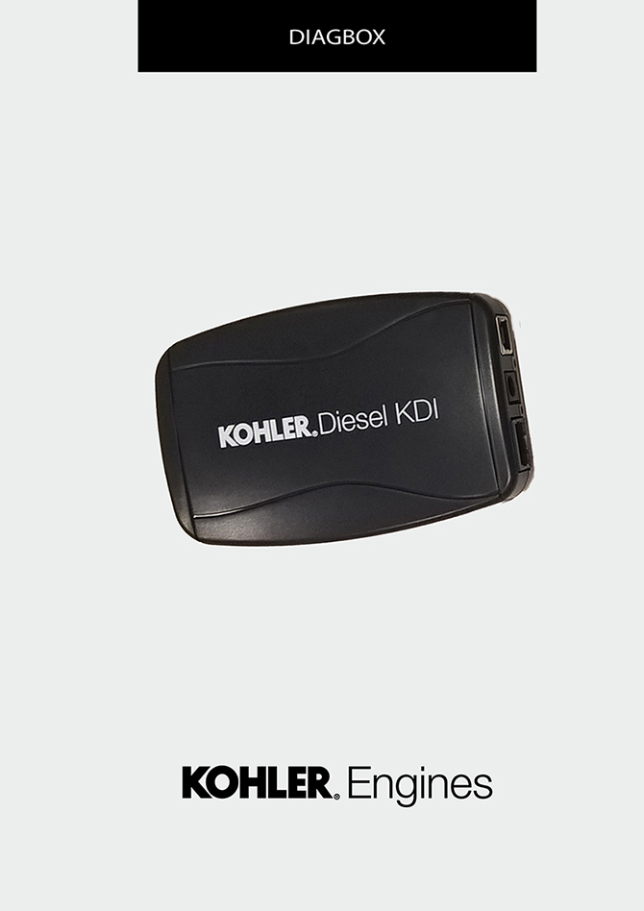

Sommario

[1. TITOLO 1 2](#_Toc495648770)

[1.1. Asdfsdfsdf 2](#_Toc495648771)

[1.2. Asdfsdfsdfggg 2](#_Toc495648772)

# Connections

## Connection with OBD II connector

|  |
| --- |
| DIAGBOX_2.1_EN.jpg |

## Connection with DEUTSCH connector

|  |
| --- |
| DIAGBOX_2.2_EN.jpg |

## USB connection

|  |
| --- |
| DIAGBOX_2.3.jpg |

## Complete connection with DEUTSCH

|  |
| --- |
| DIAGBOX_2.4.jpg |

## Complete connection with OBD II

|  |
| --- |
| DIAGBOX_2.5.jpg |

