Fluids filling information
KDI 1903TCR / KDI 1903TCRE5 Workshop manual (Rev. 17.7)


Sommario
1. TITOLO 1 2
1.1. Asdfsdfsdf 2
1.2. Asdfsdfsdfggg 2

Fluids filling information

Engine oil
Important

- Before proceeding with operation, read Par. 3.3.2 .
- Loosen the oil filler cap A or the oil filler cap C if the cap A is not accessible.  - Add the type and amount of oil recommended ( Tab. 2.2 ). | 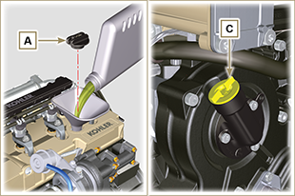  Fig 10.1
- Remove the oil dipstick B and check that the level is up to but does not exceed the MAX .  - If the oil level is not at MAX , insert more oil until the MAX level is reached as indicated on the dipstick.  - Re-tighten the cap A or C .  NOTE: See the Par. 11.1 for the various configurations of the oil dipstick. | 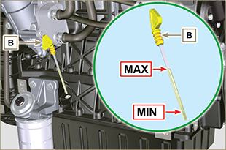  Fig 10.2
NOTE : Click by side to play the procedure. | https://www.youtube.com/embed/cVpoy_m253A?showinfo=0&rel=0

Coolant
Important

- Before proceeding with operation, read Par. 3.3.2 .
- Tighten the cap G , replacing the copper gasket (Tightening torque of 50 Nm ). | 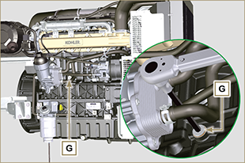  Fig 10.3
NOTE: A sealing plug or connecting pipe to the expansion tank may be present on the junction B , both should be secured with a strap.  - Reinsert on the junction B the sealing plug or a connecting pipe to the expansion tank. | 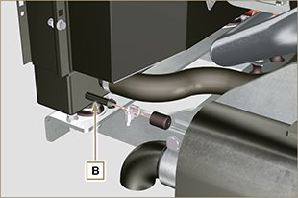  Fig 10.4
Warning  - Presence of steam pressurized coolant danger of burns.  - Refill the radiator with coolant (refer to Par. 2.6 for the liquid specifications).  - Top liquid up until the pipes inside the radiator are covered by about 5 mm.  - For engines equipped with separate expansion tank, pour in fluid until reaching the max level mark.  - Loosen the screw F on the head H , release any air and tighten the screw F (Tightening torque of 8 Nm - Fig. 10.7 ).  - Start the engine without the radiator cap A or the expansion tank (C) cap B.  - Keep the engine at idle speed or without a load until the coolant level goes down and becomes steady (the waiting times varies according to the ambient temperature).  - Turn off the engine and allow it to cool.  - If there is an expansion tank (C) top liquid up to the mark MAX .  - Without expansion tank top liquid up until the pipes inside the radiator are covered by 5 mm. Do not overfill the radiator, but leave room for the coolant to expand.  - Tighten the radiator cap A or the expansion tank (C) cap B.  Warning  - Before starting make sure that the radiator cap and expansion tank cap, if present, are installed correctly to avoid loss of liquid or vapour at high temperatures.  - After a few hours of operation stop the engine and allow it to cool.  Check and top up the coolant. | 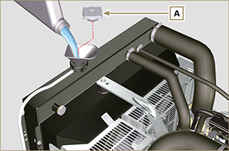  Fig 10.5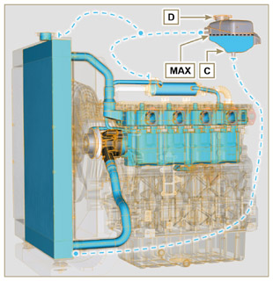  Fig 10.6
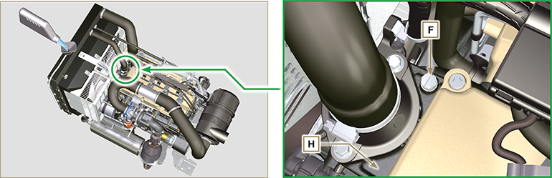
Fig. 10.7

NOTE : Click by side to play the procedure. | https://www.youtube.com/embed/S79xPhTZMps?showinfo=0&rel=0

