Information for disassembly
KDI 3404 TM Workshop Manual (Rev. 08.3)

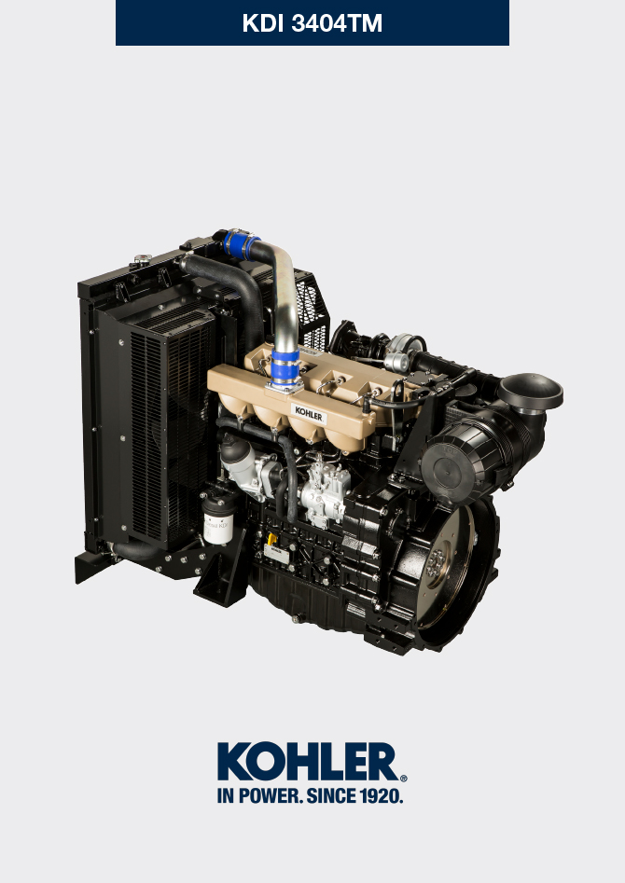
Sommario
1. TITOLO 1 2
1.1. Asdfsdfsdf 2
1.2. Asdfsdfsdfggg 2

Information for disassembly

Recommendations for disassembly

Important

- The mark ( ) after the title of a paragraph, indicates that the procedure is not required in order to disassemble the engine, however the procedures are featured in order to illustrate the disassembly of components.
- The operator should prepare all equipment and tools in order to enable him to carry out the operations correctly and safely.
- Before disassembly, perform the operation described in Chap. 5 .
- Before proceeding with operation, carefully read Chap. 3 .
- In order to operate safely and easily, we recommend positioning the engine on a rotating stand for engine overhauling.
- Seal all injection component unions as illustrated in Par. 2.9.8 during assembly.
- Protect all disassembled components and coupling surfaces subject to oxidation with lubricant.
- Where necessary, reference to special tools to use during disassembly operations is indicated (es. ST_05 ), identified in Tab. 13.1 - 13.2 - 13.3 .

Turbocharger disassembly
- Unscrew the fittings A and remove the pipe B with the relative gaskets C . | 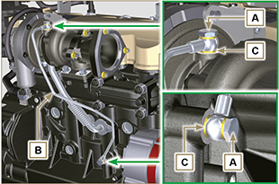  Fig 7.1
- Undo the screws D and remove pipe E and the relevant gaskets. | 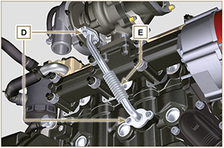  Fig 7.2
- Undo the nuts F and remove the turbocharger G . | 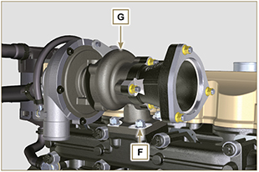  Fig 7.3

Coolant recirculation components disassembly
7.3.1 Oil Cooler manifold  - Release the clamps A .  - Undo the screw B and remove hoses C . | 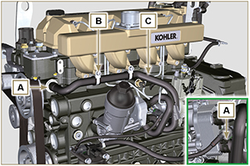  Fig 7.4
- Release the clamp D and remove hoses E . | 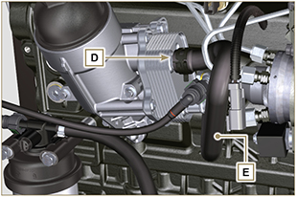  Fig 7.5
7.3.2 Coolant pump  Important  - The pump B is not repairable.  - Perform the operations described in Par. 6.2.1 .  - Undo capscrews F and remove flange G with the relative gasket. | 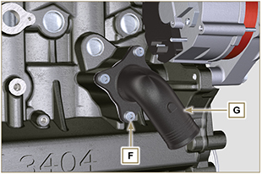  Fig 7.6
7.3.3 Thermostatic valve  - Undo the screws A and remove the thermostatic valve cover B .  - Remove the thermostatic valve C and its gasket.  Important  - Always replace the gasket D every time it is disassembled.  - Check that the air bleeding hole is not clogged or blocked ( Par. 2.11.3 ). | 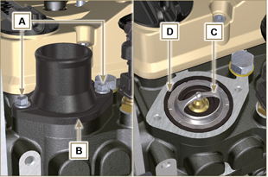  Fig 7.7

Electric components disassembly
7.4.1 Starter motor  Important  - The motor is not repairable.  - Perform the operations from point 2 to 3 of Par. 6.1.5 .  7.4.2 Alternator  - Undo the screws A1 and B1 and remove the alternator C1 . | 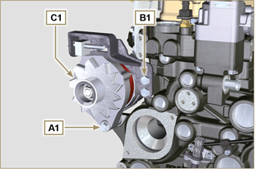  Fig 7.8
7.4.2 Sensors and switches  Important  - After disassembly, protect the sensors suitably against knocks, dampness and any high temperature sources.  - The sensors and switches cannot be repaired, therefore they must be replaced in the event of anomalies.  7.4.2.1 Oil pressure switch ( )  - Unscrew and remove the oil pressure switch AD . | 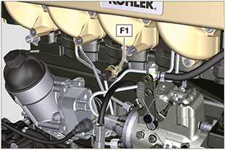  Fig 7.9
7.4.2.2 Coolant temperature sensor ( )  - Unscrew and remove the coolant temperature sensor AE . | 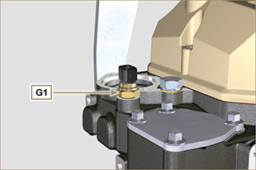  Fig 7.10

Exhaust manifold disassembly
- Remove nuts A , capscrews B and spacers C , manifold D and gaskets E .  - Close the openings and manifolds to prevent foreign bodies from entering. | 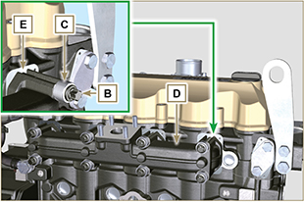  Fig 7.11

Fuel system disassembly
Important

- Seal all injection component unions as illustrated in Par. 2.9.8 during disassembly.

7.6.1 Injection fuel pipes

- Perform the operations of Par. 6.1.1 .
7.6.2 Rocker arms cover

- Perform the operations of Par. 6.1.1 .
7.6.3 Fuel return pipes  - Perform the operations of Par. 6.1.3 .  - Perform the operations of point 18 of Par. 6.1.5 .  - Loosen union A from cylinder head B and remove return line C . | 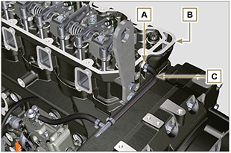  Fig. 7.12
7.6.4 Injectors

- Perform the operations of Par. 6.1.4 .

7.6.5 Injection pump

- Perform the operations of Par. 6.1.5 .
7.6.6 Fuel filter

- Perform the operations of Par. 6.5.1 .

Crankshaft pulley disassembly
- Undo the screws A and remove the pulley B . | 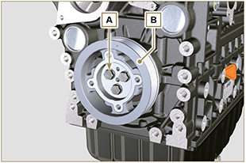  Fig 7.13

Flange unit disassembly
7.8.1 Flywheel  Danger  - The flywheel A is very heavy. Pay the utmost attention while removing it in order to prevent it dropping or falling, as this may have serious consequences for the operative.  - Undo the screws B and remove the flywheel A by means of tool ST_43 .  - Secure tool ST_41 onto gear C by means of capscrews B . | 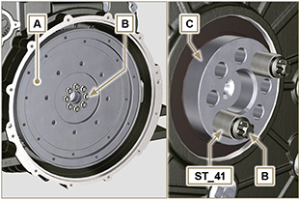  Fig 7.14
7.8.2 Flange housing  Danger  - The flange housing D is very heavy. Pay the utmost attention while removing it in order to prevent it dropping or falling, as this may have serious consequences for the operative  - Undo capscrews E by following the order indicated in the figure.  - Remove the engine housing D by means of tool ST_44 . | 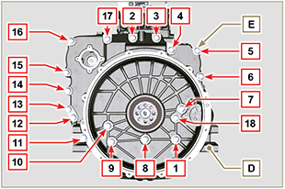  Fig 7.15

Lubrication circuit disassembly
7.9.1 Oil pump  Important  - The oil pump is not repairable.  - Undo the screws A and remove the pump unit B . | 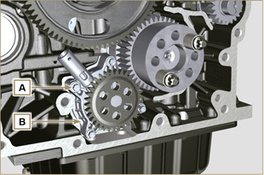  Fig 7.16
7.9.2 Oil pressure valve ( )  - Remove cotter pin C .  - Remove disk D , spring E , piston valve F using a magnet. | 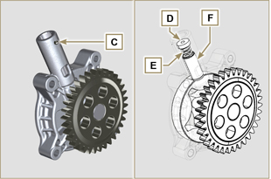  Fig 7.17

Cylinder head unit disassembly
7.10.1 Rocker arm pin  - Undo the screws D .  - Remove the rocker arm pin unit E . | 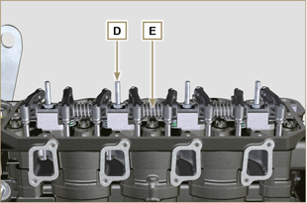  Fig 7.18
7.10.1.1 Rocker arm ( )  - Remove the retainer ring F .  - Remove the shoulder rings G .  - Remove the rocker arms H . | 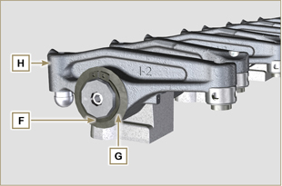  Fig 7.19
7.10.3 Valve rods and bridges  - Remove the valve control U-bolts M .  - Remove the rocker arm control rods N . | 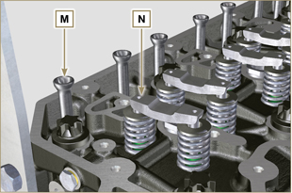  Fig 7.20
7.10.4 Cylinder head  Important  - The capscrews P must be replaced every time they are disassembled.  - Do NOT remove the capscrews completely, first loosen them by turning them a whole cycle following the order shown in the figure.  - Loosen fastening screws P , turning them by one turn following the order shown in the figure.  - Undo capscrews P by following the order indicated in the figure.  Important  - To lift cylinder head Q , only use both eyebolts AE provided by KOHLER (refer to Fig. 7.28 ).  - When removing the cylinder head Q and subsequent disassembly, control, and assembly operations, it is necessary to protect the contact surface W of cylinder head Q and crankcase J against impacts.  - Remove the cylinder head Q .  - Remove the head gasket R . | 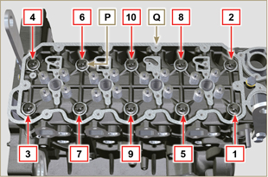  Fig 7.21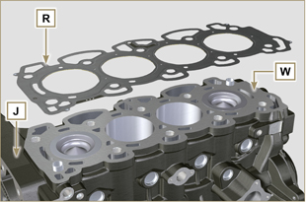  Fig 7.22
7.10.4.1 Valves ( )  - Mount the tool ST_07 on the head Q fixing it on one of the holes for fixing the rocker arm cover.  NOTE: Change the fixing hole according to the position of the valves to be removed.  - Position the tool ST_07 on the valve as shown in the figure. | 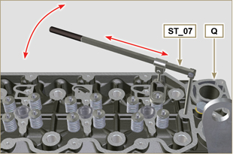  Fig 7.23
- Push the lever of the tool ST_07 downwards, in order to lower the valve plates S in the direction of the arrow T , remove cotters U using a magnet.  NOTE: Repeat all the operations for all the valves concerned. | 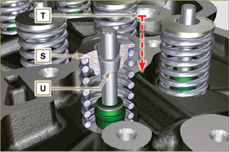  Fig 7.24
Important  - Before removing the valves, make some marks to record their original position, in order to avoid confusing them when reassembling (if they are not replaced).  - Remove the valves V . | 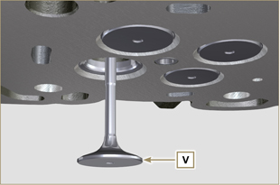  Fig 7.25
7.10.4.2 injector sleeves ( )  - Unscrew and remove the sleeves Z from the head Q .  - Remove the gaskets J, K . | 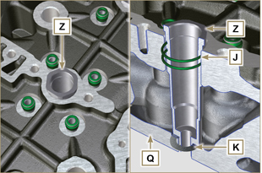  Fig 7.26
7.10.4.3 Valve stem gasket ( )  - Remove the gaskets W . | 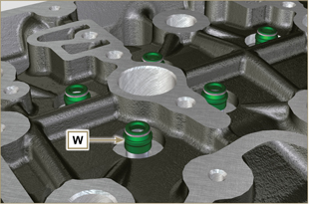  Fig 7.27
7.10.4.4 Lifting eyebolts ( )  - Undo the screws X and remove the eyebolts Y .  - Thoroughly wash the cylinder head Q . | 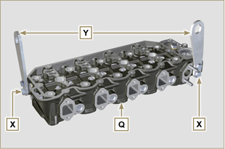  Fig 7.28

Oil sump unit disassembly
7.11.1 Oil sump  - Undo the screws A .  - Remove the oil sump B by inserting a plate between surface C of crankcase D and oil sump B .  - Remove the oil dipstick E . | 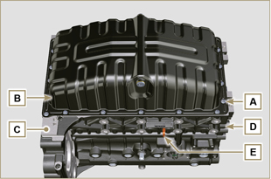  Fig 7.29
7.11.2 Oil suction pipe  - Undo the screws F and remove the oil pipe G . | 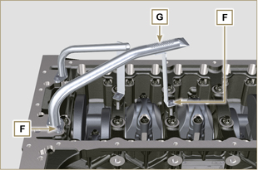  Fig 7.30
7.11.3 Oil drain pipe ( )  - Undo the screws H and remove the pipe L . | 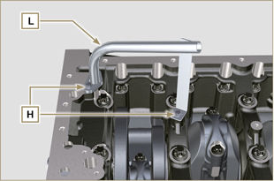  Fig 7.31

Engine block disassembly
7.12.1 Piston unit/connecting rod  Important  - Mark some numerical references (cylinder n°) on the connecting rods, connecting rod caps N , pistons and gudgeon pins to prevent unintentionally confusing the components not replaced during assembly. Failure to do this may result in engine malfunctions.  - References on connecting rod M and cap N must only be carried out on a side in correspondence with K1 and K2 , as illustrated in Fig. 7.35 .  - Screw the bolt M temporarily. | 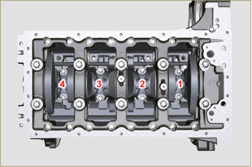  Fig 7.32
NOTE : coupling cap N on the connecting rod can be carried out with centring taper pins (Fig. 7.33) or broken ( Fig. 7.34 - without centring taper pins).  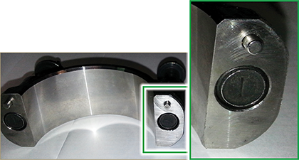  Fig. 7.33  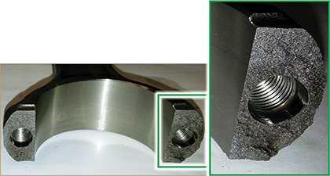  Fig. 7.34 | 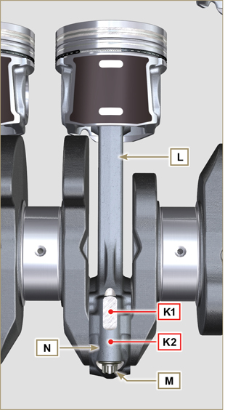  Fig 7.35
- Pull out the connecting rod - piston assembly from position 2 and 3 by manually applying pressure on the connecting rod big end M in the direction of arrow AK .  - Couple the connecting rod big end caps L with the relevant piston and connecting rod unit M .  - Rotate the crankshaft by 180°.  - Repeat points 2 to 5 to disassemble the connecting rod-piston assembly to position 1 and 4 . | 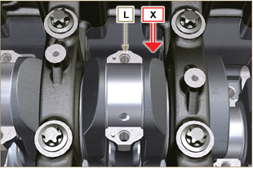  Fig 7.36
Warning  - The connecting rod half-bearings Z are made of special material. Therefore, they must be replaced every time they are removed to prevent seizures. | 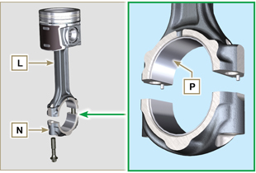  Fig 7.37
7.12.2 Timing system gear disassembly  - Unscrew screws A and remove the gear B .  - Remove the gear C .  - Unscrew screws D and remove the gear E . | 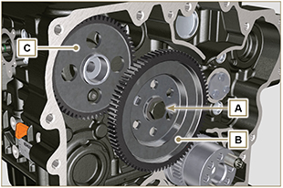  Fig 7.38  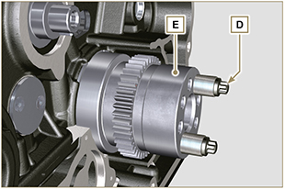  Fig 7.39
7.12.3 Lower semi-crankcase  Important  - The capscrews Q must be replaced every time they are disassembled.  - Do NOT remove the capscrews completely, first loosen them by turning them a whole cycle following the order shown in the figure.  - Loosen fastening screws Q , turning them by one turn following the order shown in the figure.  - Undo capscrews Q by following the order indicated in the figure. | 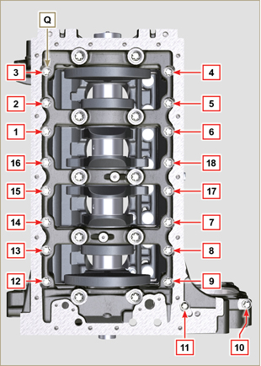  Fig 7.40
Important  - The capscrews R must be replaced every time they are disassembled.  - Do NOT remove the capscrews completely, first loosen them by turning them a whole cycle following the order shown in the figure.  - Loosen fastening screws R , turning them by one turn following the order shown in the figure.  - Undo capscrews R by following the order indicated in the figure.  - Remove the lower semi-crankcase D1 and store it in a suitable container for washing. | 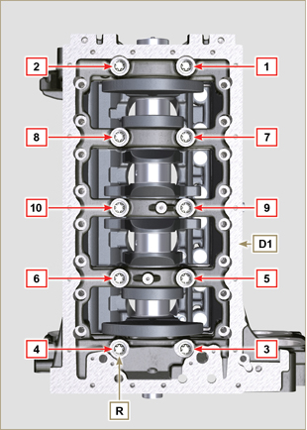  Fig 7.41
7.12.4 Crankshaft  Remove:  - Crankshaft S .  - The shoulder semi-rings T .  - gasket U from crankshaft S . | 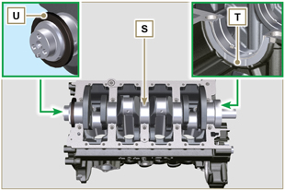  Fig 7.42
7.12.5 Piston ( )  - Remove the retainer ring V .  - Remove the pin Z to separate the piston J from the connecting rod L .  Important  - If they are not replaced, keep the components together (connecting rod - piston - gudgeon pin) by using references in order to prevent them from getting mixed up during assembly. | 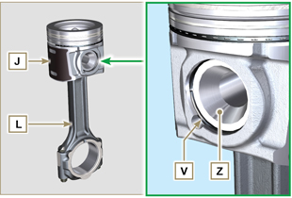  Fig 7.43
7.12.5.1 Rings ( )  - Remove the rings K . | 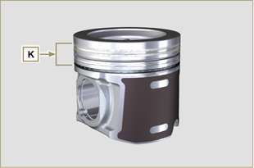  Fig 7.44
7.12.6 Oil spray nozzles ( )  - Undo the screws W and remove the spray nozzles X from the upper semi-crankcase D2 . | 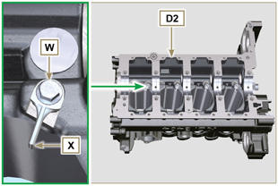  Fig 7.45
7.12.7 Camshaft  - Remove the lock ring C .  - Extract the camshaft F from the upper semi-crankcase D2 . | 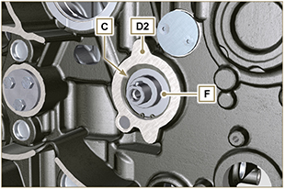  Fig 7.46
7.12.8 Camshaft tappets  - With a magnet, remove the tappets Y from the upper semi-crankcase D2 . | 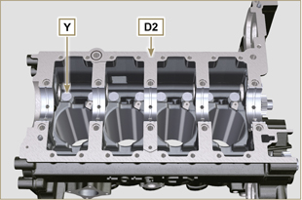  Fig 7.72
7.12.9 Crankshaft bushings  - Remove the crankshaft bushings A1 from the upper crankcase D2 .  Important  - The crankshaft half-bearings A1, B1 are made of special material. Therefore, they must be replaced every time they are removed to prevent seizures. | 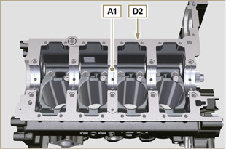  Fig 7.73
- Remove the crankshaft bushings B1 from the lower semicrankcase D2 . | 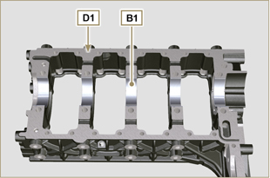  Fig 7.74

