Information for replacing the functional units
KDI 3404 TCR Workshop Manual (Rev. 10.3)

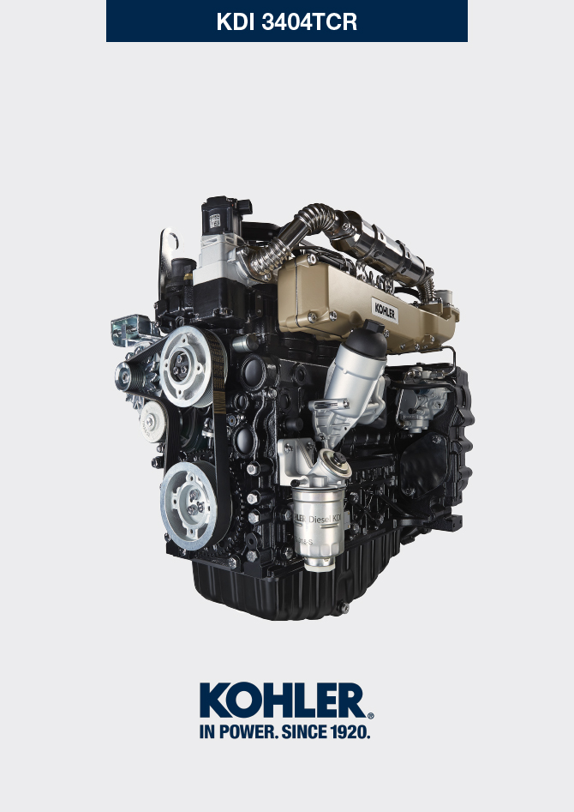
Sommario
1. TITOLO 1 2
1.1. Asdfsdfsdf 2
1.2. Asdfsdfsdfggg 2

Information for replacing the functional units

Electronic injector replacement
Important  - Before proceeding with operation, read Par. 3.3.2 .  - In the event of the electronic injectors being disassembled (not necessarily replaced) their position with respect to individual cylinders must not be changed when re-assembled. Refer to the reference between each injector and respective cylinder number.  - Seal all injection component unions as illustrated in Par. 2.9.8 during disassembly.  - Handle the components as described in Par. 2.17 .  - Replace all seal gaskets after each assembly for all components on which they are provided.  - The high pressure pipes must be replaced every time they are disassembled.  - Before disassembling the electronic injectors, make sure the new high pressure pipes are available.  - If a new (or different) electronic injector is fitted on the engine, the new calibration data must be entered in the ECU through a specific instrument ( ST_01 ) .  - Electronic injectors are not repairable.  - This procedure may be performed on one or more electronic injectors.  NOTE: In the event of a leak upon replacement (oil - coolant - fuel - air), do not intervene with the engine running, but stop it and wait for 5/10 minutes before checking and solving the problem. | 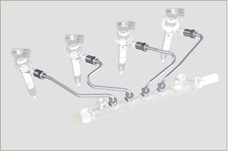  Fig 6.1
6.1.1 Fuel return pipes disassembly (Common Rail/electronic injectors)  - Disconnect the connector C . | 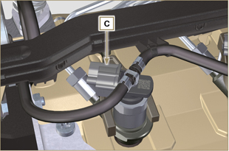  Fig 6.2
- Remove clips E from the electronic injector F .  - Disconnect the junction G from the electronic injector F .  Warning  - After removing the fittings, the clips E must automatically return to their initial position; otherwise they must be replaced.  - Seal all injection component unions as illustrated in Par. 2.9.8 . | 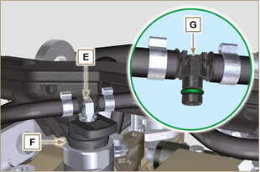  Fig 6.3
6.1.2 High pressure fuel pipes disassembly (Common Rail/electronic injectors)  Danger  - The fuel injection circuit is under high pressure, use safety protections as described in Par 3.4.3 .  - Ensure that the Common Rail is not under pressure by slowly and carefully unscrewing one of the nuts H .  - Undo the nut H on the Common Rail L and then the nut M on the electronic injector F and remove the pipe N .  Important  - In the event that the electronic injectors are disassembled (not necessarily replaced), mark them with the relevant cylinder number from which they originate so as not to confuse them during re-assembly.  - Seal all injection component unions as illustrated in Par. 2.9.8 . | 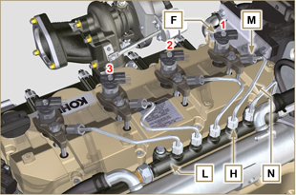  Fig 6.4
6.1.3 Electronic injectors disassembly  - Undo and remove the screw P with the washer R e and then the bracket Q .  Important  - Be careful not to damage the gaskets X .  - Replace rings X , if damaged.  2. Pull out the electronic injector F .  NOTE: Should you be unable to remove the electronic injector (acting only on point BC ), use an open-ended spanner (Ø 34 mm), by applying small rotations to unblock the component.  3. Seal all injection component unions as illustrated in Par. 2.9.8 .  4. Ensure that gasket S has remained in the correct position (Fig. 6.6) . Otherwise, recover the gasket from inside the electronic injector T manifold. | 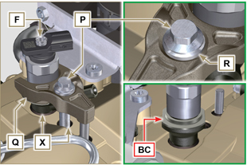  Fig 6.5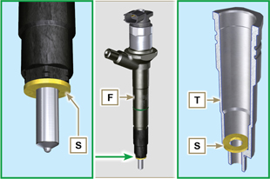  Fig 6.6
NOTE: Click by side to play the procedure. | https://www.youtube.com/embed/slELtJW2bFE?showinfo=0&rel=0
6.1.4 Electronic injector assembly  Important  - Always replace and lubricate the gaskets AA and S of the electronic injectors F with fuel, every time they are replaced.  - Reposition the electronic injectors (not replaced) by following the references made for disassembly, as indicated in Par. 6.1.2.  - If the engine is painted or protected with clear paint, clean the paint off the diesel injector F near to the part in contact with the gasket AB .  - Insert the gasket S on the electronic injectors F (Fig. 6.7) .  - Insert electronic injector F into manifold T , being extra careful not to damage gasket AB and direct it as indicated in Fig. 6.7 .  NOTE : to replace gaskets AB , follow the operations in Para. 7.12.1 and 9.5.9 . | 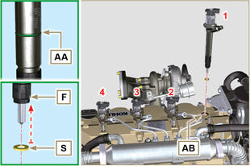  Fig 6.7
6.1.5 High pressure fuel pipes assembly  Important  - Always replace the pipes N after each assembly.  - If the engine is painted or protected with clear paint, replace the fastening screws P to ensure the gaskets are sealed properly.  - Position tube N in the Common Rail seat of the electronic injector; correct the position of the electronic injector by means of the entrance of the electronic injector unions F and Common Rail L .  - Apply the nuts H and M by hand without tightening them.  - Position the fastening brace of electronic injectors Q on capscrew surface AD , insert capscrews P in brace Q inserting washer R . | 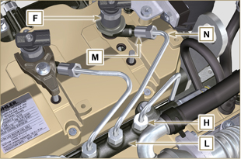  Fig 6.8
Important  - Ensure that brace S is perfectly positioned onto the electronic injector.  4. Tighten the fixing screws P of the electronic injector bracket (tightening torque at 20 Nm ).  5. Tighten the nut M (tightening torque at 25 Nm ).  6. Tighten the nut H (tightening torque at 30 Nm ).  Important  - Replace the pipes N (Fig. 6.8) if the screws P are stiff when tightened. | 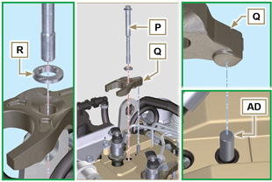  Fig 6.9
6.1.6 Fuel return pipes assembly  - Check the condition of the gaskets AE . | 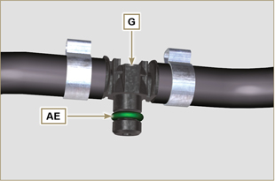  Fig 6.10

- Insert unions G onto electronic injectors F and block them with clips E .  - Mount the connectors C on the electronic injectors F .  Warning  - Slightly move the wiring support to check that there is no voltage in the electrical wire of connector C in correspondence with the outlet hole AF . | 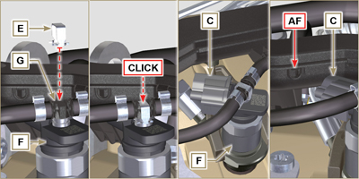  Fig 6.11
NOTE: Click by side to play the procedure. | https://www.youtube.com/embed/IVoumDwS7oY?showinfo=0&rel=0

High-pressure fuel injection pump replacement
Danger  - The fuel injection circuit undergoes high pressure, use safety protections as described in Par 3.4.3 .  - Ensure that the Common Rail is not under pressure by slowly and carefully unscrewing nut A .  Important  - Before proceeding with operation, read Par. 3.3.2 .  - Always replace the high pressure pipes after each disassembly.  - Before disassembling the injection pump, make sure the new high-pressure pipe is available.  - The injection pump is not repairable.  - Should the fuel feeding pump need to be replaced, after assembly, it is necessary to perform the Pump Learning procedure by means of instrument ST_01 . .  - Seal all injection component unions as illustrated in Par. 2.9.8  - To handling components refer to Par. 2.17  - Always replace the gaskets (where are provided) after each disassembly. | 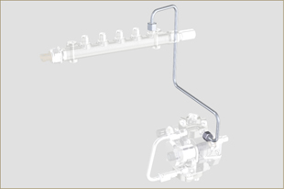  Fig 6.12
6.2.1 High-pressure fuel line disassembly (from the injection pump to the Common Rail).  - Undo the nut A . | 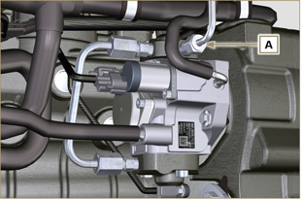  Fig 6.13
- Undo nut D from Common Rail E . | 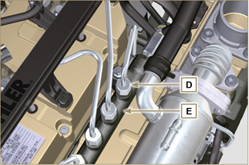  Fig 6.14
- Undo the nut B1 on the intake manifold C.  - Undo the nut B2 on the intake manifold C and remove the pipe F (Fig. 6.16) . | 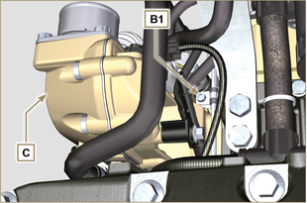  Fig 6.15
6.2.2 Timing system carter oil filling flange disassembly  - Remove starter motor ( Par. 6.6.1 point 2 ) and assemble special tool ST_34 ( Par. 6.6.1 point 3 ) .  - Undo the screws G ,remove the plate H . | 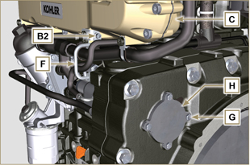  Fig 6.16
- Undo and remove nut L fixing the fuel feeding pump control gear M .  Important  - Be careful that the nut L does not fall into the timing cover.  - Tighten tool ST_13 on the gear M . | 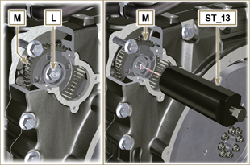  Fig 6.17
Important  - Do NOT use the cylinder connection pipe W as a handle, to prevent damage or fuel leaks.  - Before disassembling, care read Par. 2.17 .  - Seal all injection component unions as illustrated in Par. 2.9.8  - Disconnect tubes P and Q from fuel feeding pump R .  - Disconnect connectors S and T .  - Loosen and distance capscrews U .  - Redo the capscrew of tool ST_13 to disconnect injection  pump R from gear M .  - Undo capscrews U and extract injection pump R with the relevant gasket V .  Important  - Do NOT remove tool ST_13 in order to prevent gear M inside the distribution carter from falling. | 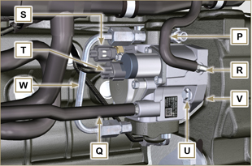  Fig 6.18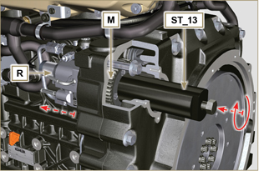  Fig 6.19
NOTE: Click by side to play the procedure. | https://www.youtube.com/embed/jPnRSYu0sKM?showinfo=0&rel=0
6.2.3 High-pressure fuel injection pump assembly  Important  - Before assembling, carefully read Par. 2.17  - Always replace the gasket V after each assembly. The gasket V can only be fitted in one direction.  - Do NOT use the cylinder connection pipe W as a handle, to prevent damage or fuel leaks.  - Remove the protection caps only when reconnecting the hoses. | 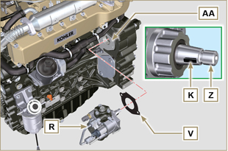  Fig 6.20
- Check that the contact surfaces AA are free from impurities.  - Make sure reference key K is properly inserted into the Z shaft seat.  - Assemble the new gasket V on injection pump R . Insert injection pump R in its housing on crankcase AA making key K coincide with key seat AH of gear M . | 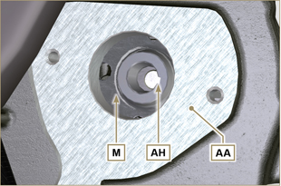  Fig 6.21
- Remove the tool ST_13 from the pump control gear ( Ref. M of Par. 6.2.3 ) if applicable.  Important  - Pay the utmost attention when executing the operation in point 5 so as to prevent nut L from falling inside the distribution carter.  - Fully tighten the nut L on the shaft Z of the injection pump.  Important  - Apply nut L by hand, but do not tighten.  - It is mandatory to replace the screws U or apply a few drops of Loctite 2701 . | 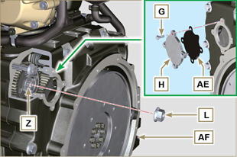  Fig 6.22
- Clamp the screws U on the crankcase AB (tightening torque at 25 Nm ).  - Clamp the nut L (Fig. 6.22) (tightening torque at 70 Nm ).  - Disassemble the special tool ST_34 and assemble the starter motor (tightening torque 45 Nm ).  NOTE: Always replace the gasket AE after each assembly.  - Position the gasket AE in the set on the plate H .  - Fix the plate H on the crankcase AF with the screws G (tightening torque at 10 Nm ). | 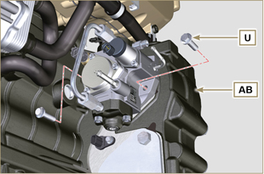  Fig 6.23
- Fit the connector T on the sensor J .  - Fit the connector S on the sensor Y .  - Remove the protection caps.  - Fit the pipe Q on the fitting AA .  - Fit the pipe P on the fitting AB . | 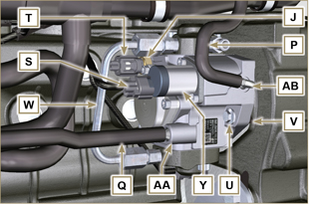  Fig 6.24
6.2.4 High-pressure line assembly (injection pump / Common Rail)  - Remove the protection cap.  - Position the pipe F .  - Manually tighten the nut A . | 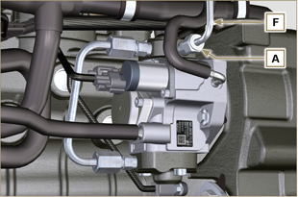  Fig 6.25
- Manually tighten the nut D . | 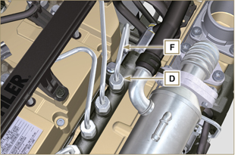  Fig 6.26
- Secure clamps F1 and F2 by means of capscrews B1 and B2 onto intake manifold C (tightening torque 10 Nm ).  - In order, tighten nut D (tightening torque 30 Nm ) and A (tightening torque 25 Nm ). | 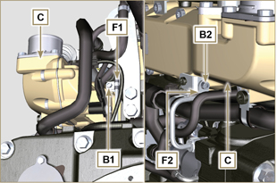  Fig 6.27
NOTE: Click by side to play the procedure. | https://www.youtube.com/embed/3ULD_PiHEaw?showinfo=0&rel=0

Unit EGR Cooler replacement
6.3.1 Disassembly  Important  - Before proceeding with operation, read Par. 3.3.2 .  - To handling components refer to Par. 2.17  - Always replace the gaskets (where are provided) after each disassembly.  NOTE: Perform the operations described in Par. 5.1 .  - Undo the screws B of pipe C .  - Release the clamps F and remove the hose M . | 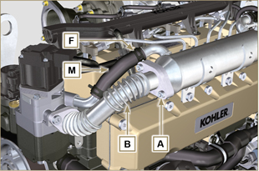  Fig 6.28
- Undo the screws C of pipe E .  - Release the clamp F and remove the hose G. | 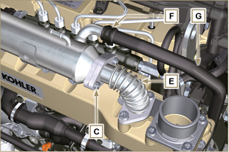  Fig 6.29
- Undo the screws H and remove the EGR Cooler L and the relevant metal gaskets ( ST_05 ).  - Should the passage ducts of the gas exhaust be clogged by soot or carbon, replace EGR Cooler L . | 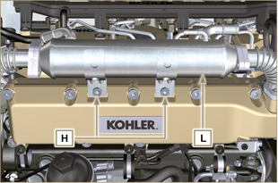  Fig 6.30
NOTE: Click by side to play the procedure. | https://www.youtube.com/embed/A8fU76g4nUQ?showinfo=0&rel=0
6.3.2 Assembly  - Fit the EGR Cooler L with the screws H on the intake manifold S (tightening torque at 22 Nm - ST_05 ). | 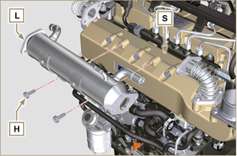  Fig 6.31
- Insert the gasket N between the hoses B-E and the EGR Cooler L . | 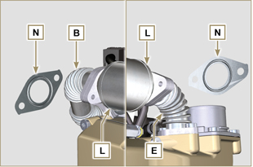  Fig 6.32
- Fit the screws A and C (tightening torque at 25 Nm ).  - Insert the hose M on the fitting V1 and G on V2 .  - Secure the clamps F .  NOTE: Perform the operations described in Par. 10.2 . | 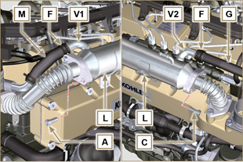  Fig 6.33
NOTE: Click by side to play the procedure. | https://www.youtube.com/embed/vTWVObqWIGE?showinfo=0&rel=0

EGR valve replacement
6.4.1 Disassembly  Important  - Before proceeding with operation, read Par. 3.3.2 .  NOTE: Perform the operations described in Par. 5.1 .  - Disconnect the connector A from the valve C .  - Undo the screws B and remove the EGR valve C with the relevant gasket. | 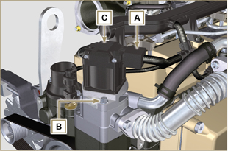  Fig 6.34
NOTE: Click by side to play the procedure. | https://www.youtube.com/embed/JZWXxa3UssY?showinfo=0&rel=0
6.4.2 Assembly  Important  - Always replace gasket D after each assembly.  - The EGR valve is not a serviceable item, and if faulty / worn out, should be replaced with a new one.  - Handle the components as described in Par. 2.17 .  - Mount the new gasket D on the valve C .  - Fit the valve C on the flange E with screws B (tightening torque at 10 Nm ). | 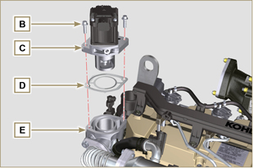  Fig 6.35
- Fit the connector A on the valve C .  NOTE: Perform the operations described in Par. 10.2 . | 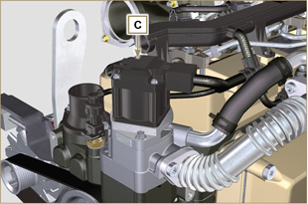  Fig 6.36
NOTE: Click by side to play the procedure. | https://www.youtube.com/embed/JZWXxa3UssY?showinfo=0&rel=0

Coolant pump and Poly-V belt replacement
6.5.1 Disassembly  NOTE: Perform the operations described in Par. 5.1 .  Important  - Before proceeding with operation, read Par. 3.3.2 .  - Loosen the screws A and B .  - Loosen capscrew C and disconnect voltage from belt D and remove belt D .  - Undo the screws E and remove the pulley F . | 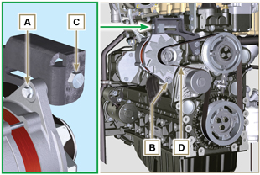  Fig 6.37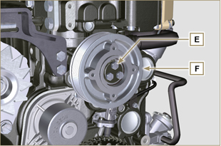  Fig 6.38
- Undo the screws G and remove the pump H with the relevant gasket. | 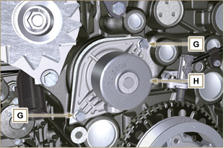  Fig 6.39
NOTE: Click by side to play the procedure. | https://www.youtube.com/embed/tgDL1w2AUd0?showinfo=0&rel=0
6.5.2 Assembly  Important  - Always replace the gaskets J , after each disassembly.  - Always replace the belt D after each assembly.  - To handling components refer to Par. 2.17  - Always replace the gaskets (where are provided) after each disassembly  - Fit the coolant pump G with the screws H interposing the new gasket J (tightening torque at 25 Nm ). | 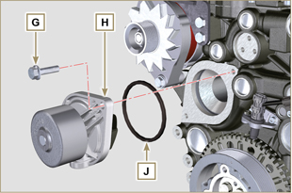  Fig 6.40
- By means of capscrews E , secure pulley F to crankcase K . | 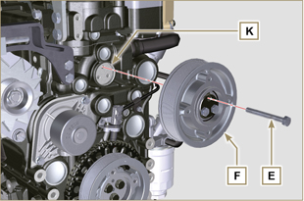  Fig 6.41
- Insert the belt D on the pulleys M .  - Tighten screw C and bring block L at 10 mm from bracket N (value C1 ).  - Fit the screw A (tightening torque at 25 Nm ).  - Fit the screw B (Fig. 6.37 - tightening torque at see service letter 710007 ).  - Start the engine and run it for some minutes, then turn off it, and let it cool down at ambient temperature. Check by the appropriate tool that at point p the tension value is between 135 and 178 Hz.  NOTE: If the poly-v belt tension results out of the above mentioned values, proceed with the replacement. | 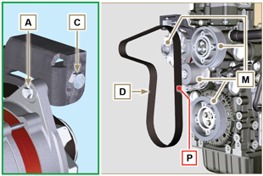  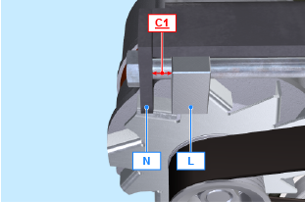  Fig 6.42
NOTE: Click by side to play the procedure. | https://www.youtube.com/embed/Zrhc5qTwPRM?showinfo=0&rel=0

Target wheel replacement
6.6.1 Disassembly  Important  - Before proceeding with operation, read Par. 3.3.2 .  - Remove the alternator belt following steps 1 and 2 ( Par. 6.5.1 ) .  - Undo the screws N and Remove starter motor A .  - Mount the tool ST_34 in the seat of the starter motor B and fit it with the two starter motor fixing screws. | 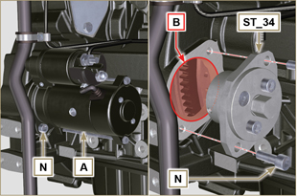  Fig 6.43
Important  - Pay the utmost attention when executing the operation in point 4 so as to prevent knocking speed sensor E .  - Undo the screws C and remove the pulley D . | 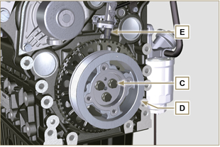  Fig 6.44
- Undo the screws F and remove the target wheel G . | 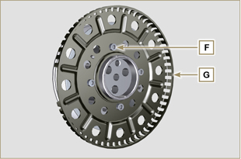  Fig 6.45
6.6.2 Assembly  - Check that the pin H is mounted properly on the pulley D .  - Position the phonic wheel G on the pulley D respecting the reference of the pin H .  - Fit the phonic wheel G with the screws F (tightening torque 10 Nm ). | 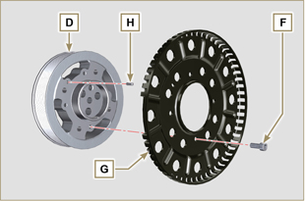  Fig 6.46
- Check that the pin L is mounted properly on the crankshaft M .  Important  - Pay the utmost attention when executing the operation in point 4 so as to prevent knocking speed sensor E .  - Position the pulley unit D on the crankshaft M respecting the reference with the pin L .  - Apply Molyslip grease onto the thread and under the head of capscrew C .  - Clamp the pulley unit D with the screw C (tightening torque at 100 Nm ).  - Perform the operations from point 3 to 7 of Par. 6.5.2. | 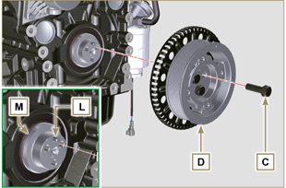  Fig 6.47
- Undo the screws N and remove special tool ST_34 .  - Secure motor A by means of capscrews N (tightening torque at 45 Nm ). | 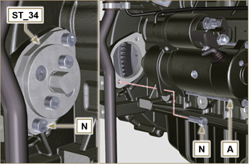  Fig 6.48

Oil vapour separator replacement
6.7.1 Disassembly  Important  - Before proceeding with operation, read Par. 3.3.2 .  - Remove quick fitting A .  - Release the clamps B and C .  - Remove hose D from breather body E . | 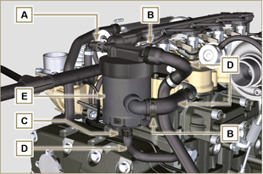  Fig 6.49
- Remove capscrews F and remove breather body E . | 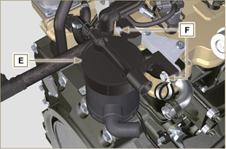  Fig 6.50
6.7.2 Assembly  Warning  - Always carefully inspect the condition of the tubes, and replace them if there is any doubt regarding their integrity.  - Always replace the gasket M after each assembly.  - Secure breather body E by means of capscrews F .  NOTE : Insert clamp G between capscrew F and breather body E .  - Fit hose D onto breather body E (Fig. 6.49) .  - Secure the clamps B and C (Fig. 6.49). | 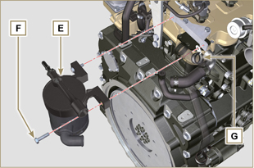  Fig 6.51

Oil cooler unit and oil filter replacement
6.8.1 Oil Cooler unit disassembly  Important  - Before proceeding with operation, read Par. 3.3.2 .  - Perform the operations described in Par 5.1 and Par 5.2 .  - Oil Cooler unit E is not repairable.  - Release the clamps A .  - Remove the manifolds B out of the Oil Cooler unit E . | 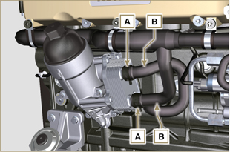  Fig 6.52
Warning  - Electric/pneumatic screwdrivers are forbidden.  - Use a suitable container to recover any residue oil.  - Unscrew cartridge holder cover H by performing three complete turns and wait 1 minute.  NOTE : this operation allows to oil contained in the support E to flow into the oil sump in the correct way.  - Unscrew cartridge holder cover H and check that the oil in the lub. oil filter support E has flowed towards the oil sump.  - Undo the screws C and D and remove the Oil Cooler unit E . | 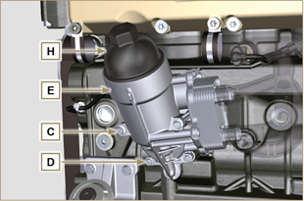  Fig 6.53
- Remove the gaskets F and G from the Oil Cooler unit E . | 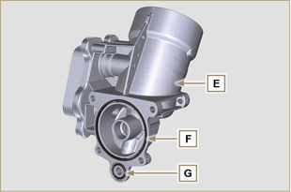  Fig 6.54
6.8.2 Oil filter cartridge replacement  - Remove gaskets L, M and N from element holder cover H .  - Remove cartridge P from element holder cover H . | 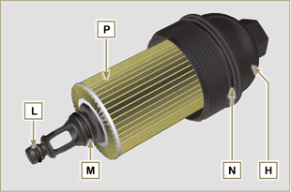  Fig 6.55
- Lubricate and insert gaskets L, M and N in the L1, M1 and N1 seats of element holder cover H .  - Insert element P into element holder cover H . | 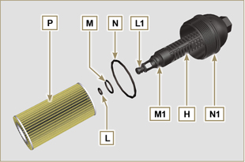  Fig 6.56
6.8.3 Oil Cooler unit assembly  Important  - In the event of assembly of union U on crankcase S , manual tightening torque with Loctite 2701 on the thread).  - Check that the surface Q on the support E and on the crankcase S are free from impurities.  - Lubricate and insert the gasket T on the fitting U .  - Lubricate and insert the gaskets on the support E :  F in seat F1 ;  G in seat G1 .  - Fit the support R with the screws C and D (tightening torque at 10 Nm ).  - Insert and tighten the cartridge support H on the filter support E (tightening torque at 25 Nm ).  - Fit the hoses B on the support E and secure the hoses B with the clamps A . | 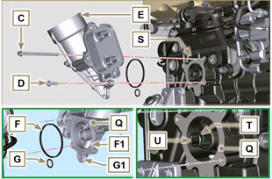  Fig 6.57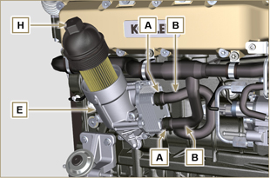  Fig 6.58

Fuel filter replacement
6.9.1 Disassembly  Important  - Before proceeding with operation, read Par. 3.3.2 .  Warning  - The fuel filter is not always mounted in the engine.  - When disassembling the sensor E , use a suitable container to recover the fuel contained in the cartridge F .  - Release the clamps A and pull the pipes B out of the support H .  - Unscrew the sensor E from the cartridge F .  - Unscrew the cartridge F from the support H .  - Undo the screws C and remove the support H . | 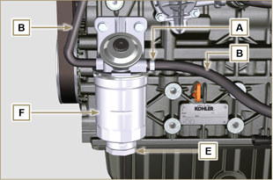  Fig 6.59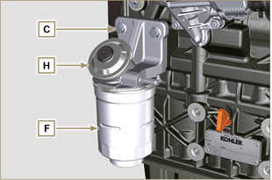  Fig 6.60
Warning  - Check that the fuel supply pump filter is present, and replace if necessary.  - Release the clamp D .  - Demount the hose E .  - Unscrew the filter G from the pump Q . | 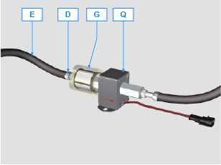
- Screw the new filter G onto the pump Q (tightening torque 20 Nm ).  - Connect the hose E to the filter G and fasten with the clamp D . | 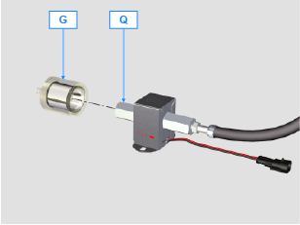
6.9.2 Assembly  - Secure the fuel filter support H with the screws C on the crankcase M (tightening torque at 25 Nm ).  - Fit the pipes B on the support H .  - Secure the pipes B with the clamps A . | 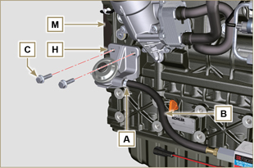  Fig 6.61
- Lubricate the gasket N with fuel.  - Tighten the cartridge F on the support H (tightening torque at 17 Nm ).  - Assemble gasket J onto sensor E and lubricate with fuel.  - Tighten the sensor E on the cartridge F (tightening torque at 5 Nm ). | 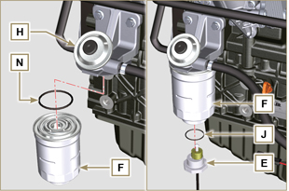  Fig 6.62

Replacement of SCV valve
Warning  - Before starting any replacement operations, make sure the work area is free from dust (part X of valve B is extremely sensitive to micro-dust).  - Pay the utmost attention to cleaning in order to prevent any type of contamination during replacement operations  - - Before proceeding with the replacement, clean the outer part of pump A thoroughly - Avoid any type of contact with part X of the valve during replacement.  - Lubricate part X of valve B with oil spray.  - Before starting any replacement operations, make sure that the key on the vehicle’s panel is OFF .  - Assemble the new valve in the same position as the previous one. | 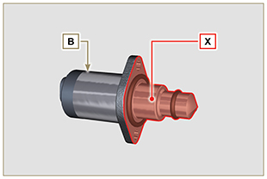  Fig. 6.60
6. 10 .1 Disassembly  1 - Disconnect connector C from valve B .  2 - Loosen screws D .  3 - Remove valve B from pump A . | 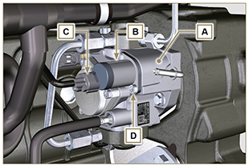  Fig. 6.61
6. 10 .2 Assembly  1 - Insert studs E supplied with valve B in the fastening holes of pump A and insert gasket F in the seat of pump A .  2 - Assemble valve B on pump A using studs E as positioning guides.  3 - Remove studs E and secure valve B with screws D (tightening torque of 6 Nm).  4 - Fasten valve B by means of screws D (tightening torque of 10 Nm). | 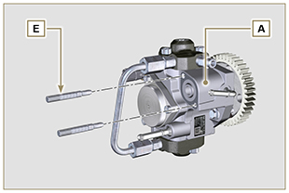  Fig. 6.62
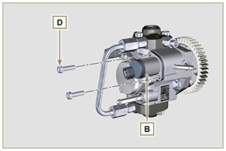  Fig. 6.63 | 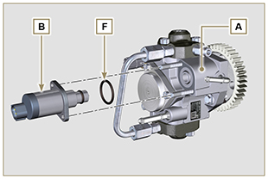  Fig. 6.64

