Fluids filling information
KDI 3404 TM Workshop Manual (Rev. 08.4)

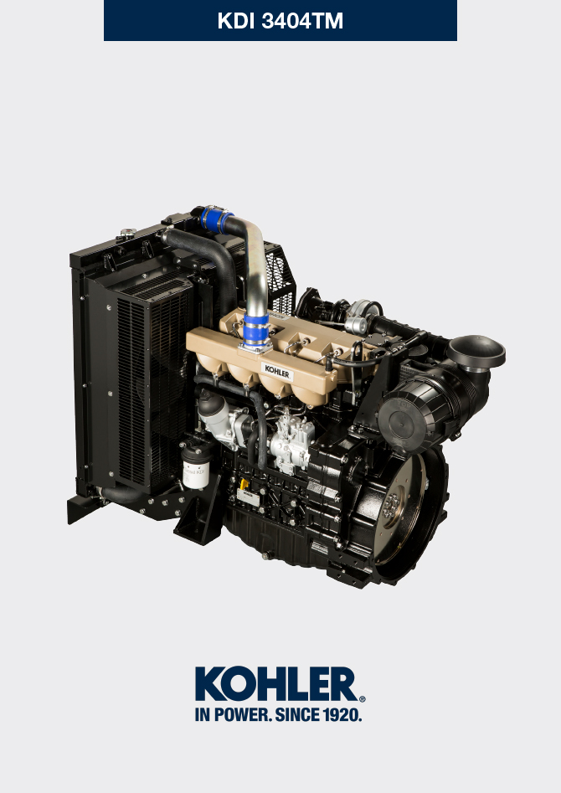
Sommario
1. TITOLO 1 2
1.1. Asdfsdfsdf 2
1.2. Asdfsdfsdfggg 2

Fluids filling information

Engine oil
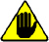
Warning

- Before proceeding with operation, carefully read Par. 3.3.2 .

- Loosen the oil filler cap A .  - Add the type and amount of oil recommended ( Tab. 2.2 ).  - Remove the oil dipstick B and check that the level is up to but does not exceed the MAX .  Important  - Do not use the engine with the level of oil below MIN or above MAX  - If the oil level is not at MAX , insert more oil until the MAX level is reached as indicated on the dipstick.  - Re-tighten the cap A . | 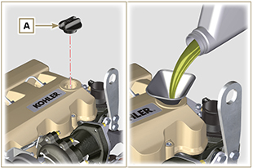  Fig 10.1
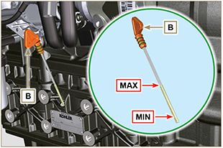
Fig 10.2
NOTE : Click by side to play the procedure. | https://www.youtube.com/embed/AKB8FW8k5rY?rel=0

Coolant
Important

- Before proceeding with operation, read Par. 3.3.2 .
- Fit tube A onto radiator B and secure it with clamp C . | 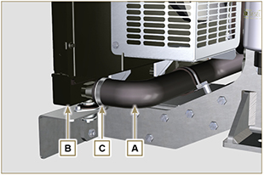  Fig 10.3
- Refill the radiator with coolant (refer to Par. 2.6 for the liquid specifications).  - Top liquid up until the pipes inside the radiator are covered by about 5 mm.  - For engines equipped with separate expansion tank, pour in fluid until reaching the max level mark.  - Loosen the screw F on the head H , release any air and tighten the screw F (Tightening torque of: 8 Nm for screw M6 (Rev. 00); 30 Nm for screw M12 (Rev. 01) ).  - Start the engine without the radiator cap D or the expansion tank cap. | 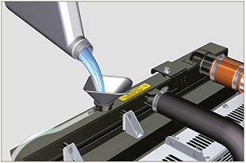  Fig 10.4
- Keep it running at idle speed until the cooling liquid level goes down and becomes steady (the waiting times varies according to the ambient temperature).  - Stop the engine and allow it to cool.  - If there is an expansion tank ( C ) top liquid up to the mark MAX .  - Without expansion tank top liquid up until the pipes inside the radiator are covered by 5 mm. Do not overfill the radiator, but leave room for the coolant to expand.  - Tighten the radiator cap D or the expansion tank cap.  Warning  - Before starting make sure that the radiator cap and expansion tank cap, if present, are installed correctly to avoid spillage of liquid or vapour at high temperatures.  - After a few hours of operation stop the engine and allow it to cool.  Check and top up the coolant liquid. | 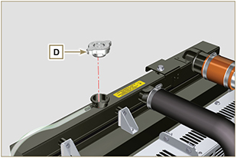  Fig 10.5  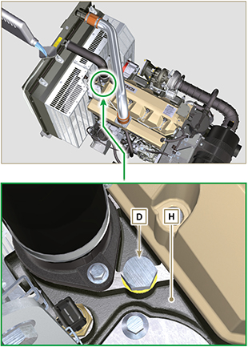  Fig 10.6
NOTE: Click on the right to play the procedure. | https://www.youtube.com/embed/AHBKX3Q90p4?rel=0

