Information about maintenance
KDI 3404 TCR-SCR Owner Manual (REV. 03.5)

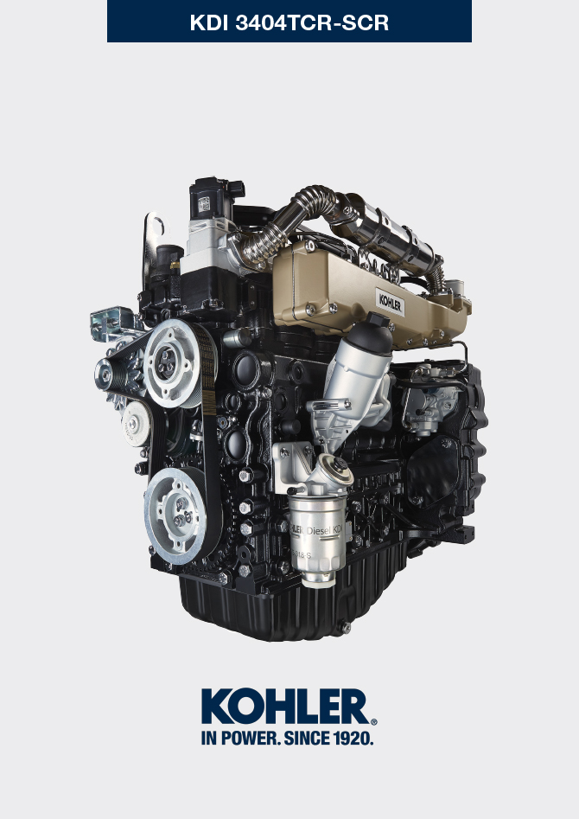
Sommario
1. TITOLO 1 2
1.1. Asdfsdfsdf 2
1.2. Asdfsdfsdfggg 2

Information about maintenance

Useful information about maintenance
- This chapter shows all operations described in the Tab. 5.1 and Tab. 5.2 if you have the skills appropriate may be directly carried out by the user.  - Periodic inspection and maintenance operations must be carried out as indicated in this manual and are the responsability of the user.  - Failure to comply with these service and maintenance intervals increases the risk of technical damage to the engine. Any non compliance makes the warranty become null and void.  - In order to prevent personal and property damage read carefully the instructions listed below before proceeding with any operation of the engine. | Important  - Before proceeding with operation, read Par. 3.2.2 .  Warning  - Inspections must be made when the engine is off and cold.  - Place engine on level surface to ensure accurate measurement of oil level.  - Before starting, to avoid spillages of oil make sure that: - the oil dipstick is inserted correctly;  - also check that:  - oil drain plug and;  - oil filler cap are tightened firmly.

Periodic maintenance
The intervals of preventive maintenance in Tab. 5.1 and Tab. 5.2 refer to the engine operating under normal operating conditions with fuel and oil meeting the recommended specifications.
5.1
CLEANING AND CHECKING
OPERATION DESCRIPTION | PERIOD (HOURS)
 | 100 | 250 | 500
Engine oil level ⁽⁸⁾
Coolant level ⁽⁸⁾⁽⁹⁾
Cartridge dry-type air filter ⁽²⁾
Radiator heat-exchange surface and Intercooler ⁽² ⁾ ⁽⁸⁾
Rubber hose (intake air / coolant)
Fuel hose

5.2
REPLACEMENT
OPERATION DESCRIPTION |  | PERIOD (HOURS)
 |  | 500 | 2000 | 5000
Engine oil ⁽¹⁾
Oil filter cartridge ⁽¹⁾
Fuel filter and pre-filter cartridge ⁽¹⁾
Cartridge dry-type air filter ⁽²⁾
AdBlue®/DEF filter cartridge ⁽¹⁾ ⁽⁶⁾ ⁽¹¹⁾

Coolant hoses ⁽⁶⁾ ⁽⁷⁾
Fuel line hose ⁽⁶⁾ ⁽⁷⁾
Intake manifold hose (air filter - intake manifold) ⁽⁶⁾ ⁽⁷⁾
Poly-V belt ⁽⁶⁾
Coolant | OAT ⁽⁶⁾
 | HOAT ⁽⁶⁾ ⁽¹⁰⁾

1 - In case of low use: 12 months. 2 - The period of time that must elapse before checking the filter element depends on the environment in which the engine operates. The air filter must be cleaned and replaced more frequently under very dusty conditions.

6 - Contact authorized KOHLER workshops.

7 - The replacement interval is only an indication, it strongly depends from environmental condition and hose status detected during regular visual inspection.

8 - The first check must be done after 10 hours.

9 - Test the coolant condition annually with coolant test strips.

10 - It is recommended to have SCA (Supplemental Coolant Additives) added at the first maintenance interval.
11 - If the AdBlue tank is not equipped with filtering system, it must be replaced at 500h.

Oil level check
- Loosen the oil filler cap A. Remove the oil dipstick B and check that the level is up to MAX.  - Pour in recommended oil until reaching the MAX level mark.  - Reinstall the oil dipstick B completely.  - Re-tighten the cap A (Fig. 5.2).  Important  - Do not use the engine with the oil level below the minimum. | 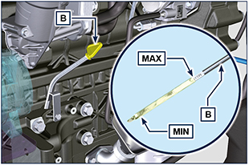  5.1
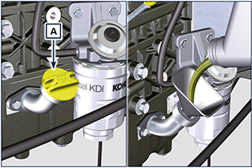
5.2

Air filter check
NOTA: Components not necessarily supplied by KOHLER.  - Pull insert F to unlock cover A.  - Rotate counter clockwise and remove cover A.  - clean the inside components A and D with a damp cloth.  - Do not use compressed air, repeatedly tap the front side E on a flat surface. | 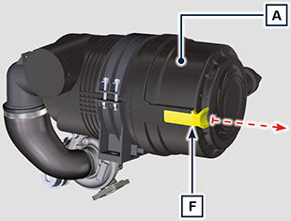  5.3
Important  - When the cartridge G is dirty, do not clean it but replace cartridges B and G.  - Fit cartridges G and B.  - Fit cover A by performing the operations indicated in points 2 and 1 in the reverse order. | 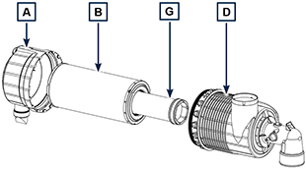  5.4  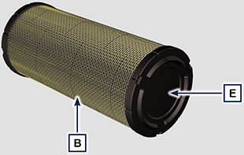  5.5

Check of the radiator heat - exchanger surface
NOTE : Components not supplied by KOHLER .
Refer to the technical documentation of the vehicle..

Rubber hoses check
Danger  - For safety precautions see Cap. 3.  The check is carried out by exerting a slight deflection or bending along the pipe and near the hose clamps. Components must be replaced if they have clear signs of cracks, tears, cuts, leaks and do not retain a certain degree of elasticity.  Important  - Before proceeding with operation, read Par. 3.2.2 .  - If hoses are damaged contact an authorized KOHLER workshop.  - For other pipes not illustrated refer to the technical documentation of the vehicle. | 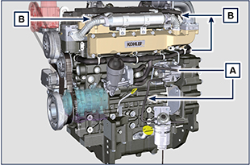  5.3
- Check that the:  - Fuel system hoses A are intact.  - Cooling circuit hoses B.  - Vent system pipes C. | 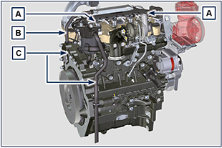  5.4

Check coolant level
Important  - Before proceeding with operation, read Par. 3.2.2 .  Danger  - For safety precautions see Chap. 3 .  NOTE : Before proceeding with any operation on the engine, stop it and allow it to cool.  Warning  - Presence of steam pressurized coolant danger of burn.  NOTE : Component not necessarily supplied by KOHLER .  - Start the engine without the radiator cap A .  - Top liquid up until the pipes inside the radiator are covered by about 5 mm.  - Top up if necessary.  - Do not overfill the radiator, but leave room for the coolant to expand.  - Reinstall radiator cap A  - For engines equipped with expansion tank, check that the fluid is until reaching the max level mark B .  NOTE : For coolant filling see Par. 4.6 .  Warning  - Before starting make sure that the radiator cap and cap, if present, are installed correctly to avoid spillage of liquid or vapour at high temperatures. | 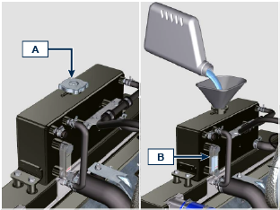  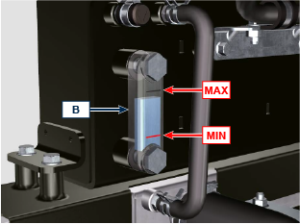  Fig 5.7

Check Poly-V alternator belt
Important  - Before proceeding with operation, read Par. 3.2.2 .  Warning  - For safety precautions see Cap. 3 .  NOTE: The poly-v belt is not adjustable.  Check the belt A condition, if worn out or deteriorated, replace it.  NOTE: Make sure that the ribs of the belt A are inserted correctly into the grooves of the pulleys B (as shown in D1 and D2).  Start the engine and run it for some minutes, then turn off it, and let it cool down at ambient temperature. Check by the appropriate tool that at point p the tension value is between 135 and 178 Hz.  NOTE: If the poly-v belt tension results out of the above mentioned values contact KOHLER authorised workshops for replacement.  NOTE: Belts A2, A3 are not supplied by KOHLER. Refer to the technical documentation of the vehicle.. | 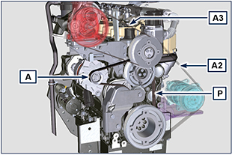  5.5
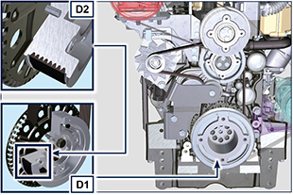
5.6

Filter cartridge and fuel pre-filter check
Important  - Before proceeding with operation, read Par. 3.2.2 .  Warning  - For safety precautions see Cap. 3 .  When turn on lights on control water filter cartridge fuel:  - Gently loosen the wing screw A without removing it.  - Drain the water if present.  - Re-tighten the wing screw A as soon as the fuel begins to flow. | 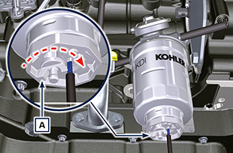  5.7

Product preservation
Important:
- If the engines are not to be used for 6 months, they must be protected by carrying out the operations described in Engine storage (up to 6 months) ( Par. 5.11 ).
- If the engine is still not in use after the first 6 months, it is necessary to carry out a further operation to extend the protection period (more than 6 months) ( Par. 5.12 ).
- If the engine is not to be used for an extended period, the protective treatment procedure must be repeated within 24 months of the previous one.

Engine storage up to 6 months
Before storing the engine check that:
- The environments are not humid or exposed to bad weather. Cover the engine with a proper protective sheet against dampness and atmospheric contaminants.
- The place is not near electric panel.
- Avoid storing the engine in direct contact with the ground.

Engine storage over 6 months
Follow the steps described in Par. 5.11 .

- Engine oil replacement ( Par. 6.1 ).
- Refuel with fuel additives for long storage. The following additives are recommended:

DEFA Fluid Plus (Pakelo Lubricants),

Diesel Treatment (Green Star),

Top Diesel (Bardhal),

STP® Diesel Fuel Injector Treatment.
- With expansion tank: make sure that the coolant is up to the MAX level.
- Without expansion tank: Top liquid up until the pipes inside the radiator are covered by about 5 mm. Do not overfill the radiator, but leave room for the fuel to expand.
- Start the engine and keep it idle at minimum speed for 2 minutes.
- Bring the engine to 3/4 of the MAX speed for 5÷10 minutes.
- Turn off the engine.
- Completely empty the fuel tank.
- Spray SAE 10W-40 on the exhaust and intake manifolds.
- Seal the exhaust and intake ducts to prevent foreign bodies from entering.
- When cleaning the engine, if using a pressure washer or steam cleaning device, avoid directing the nozzle on electrical components, cable connections and sealed rings (oil seals etc). If cleaning engine with a pressure washer or steam cleaner, it is important to maintain a minimum distance of at least 200mm between the surface to be washed and the nozzle - avoiding absolutely electrical components such as alternators, starter motors and engine control units (ECU).
- Treat non-painted parts with protective products.
- Fill the AdBlue®/DEF tank to the MAX level allowed.
If the engine protection is performed according to the suggestions indicated no corrosion damage should occur.

Engine starting after storage
- Remove the protective sheet.
- Use a cloth soaked in degreasing product to remove the protective treatment from the external parts.
- Inject lubricating oil (no more than 2 cm3) into the intake ducts.
- Refill the tank with fresh fuel.
- Make sure that the oil and the coolant are up to the MAX level.
- Proceed with the disposal of the AdBlue®/DEF contained in the tank; replace the AdBlue®/DEF pump filter and wash the AdBlue®/DEF tank/circuit with hot distilled water.
- Check the AdBlue®/DEF injector at an authorized Kohler workshop.
- Start the engine and keep it idle at minimum speed for a two about minutes.
- Bring the engine to 75% of MAX rated speed for 5 to 10 minute.
- Stop the engine while the oil is still hot ( Par. 6.1 ), discharge the protective oil in a suitable container.

Warning:
- Over time, lubricants and filters lose their properties, so it is important consider whether they need replacing, also based on the criteria described in Tab. 5.2 .

- Replace the filters (air, oil, fuel) with original spare parts.
- Pour new oil ( Par. 4.5 ) up to the MAX level.
- Empty the cooling circuit completely and pour in the new coolant up to the MAX level ( Par. 4.6 ).

Unused machine
If the machine is not used for a certain amount of time, follow the operations below:
Operations for the engine

5.3
POINT | PERIOD | OPERATION
1 | up to 2 months | - The place must be dry and fresh throughout the period in which the machine is not used.  - Consult the machine’s manual to disconnect the battery (before disconnecting the battery, wait for minimum 5 mins after turning off the engine).  - Make sure the engine is not exposed to direct sunlight.  - Make sure the engine is not near any heat sources.
1a | Start-up after 2 months | - Before starting the engine, check Para. 5.2 for maintenance operations.  - Consult the machine’s manual to connect the battery and start the engine.
2 | up to 9 months | - Perform the operations described in point 1.  - Perform the operations described in Para. 5.6.  - Start the engine at least every 4 months as per operations described in point 1a:  - Avoid sudden accelerations for the first few minutes.  - Bring the engine to the working temperature by pressing the accelerator 3/4 from MAX.  - Leave the engine running at minimum speed for a few minutes and turning off the engine.
2a | Start-up after 9 months | - Before starting the engine, check Para. 5.2 for maintenance operations.  - Consult the machine’s manual to connect the battery and start the engine.  - Avoid sudden accelerations for the first few minutes.
3 | over 9 months | - Perform the operations described in point 1 and 2.
3a | Start-up after 9+ months | - Before starting the engine, check Para. 5.2 for maintenance operations.  - Check the quality of coolant from the relative testing strips.  - Consult the machine’s manual to connect the battery and start the engine.  - Avoid sudden accelerations for the first few minutes.

Operations for the SCR system

5.4
POINT | PERIOD | OPERATION
1 | up to 2 months | - Perform the operations described in point 1 of Tab. 5.3  - Fill the AdBlue®/DEF tank with AdBlue®/DEF to the MAX level  - The ambient temperature must be kept between -40 and 40 °C  - Do not disconnect any electrical or hydraulic connections
1a | Start-up after 2 months | - Before starting the engine, check Para. 5.2 for maintenance operations.  - Consult the machine’s manual to connect the battery and start the engine.
2 | up to 9 months | - Perform the operations described in point 2 in Tab. 5.3  - Fill the AdBlue®/DEF tank with AdBlue®/DEF to the MAX level  - The ambient temperature must be kept between -40 and 25 °C  - Do not disconnect any electrical or hydraulic connections
2a | Start-up after 9 months | - Before starting the engine, check Para. 5.2 for maintenance operations.  - Consult the machine’s manual to connect the battery and start the engine.
3 | over 9 months | - Perform the operations described in point 3 of Tab. 5.3  - Fill the AdBlue®/DEF tank with AdBlue®/DEF to the MAX level  - The ambient temperature must be kept between -40 and 25 °C  - Do not disconnect any electrical or hydraulic connections
3a | Start-up after 9+ months | - Before starting the vehicle, proceed as follows:  - Replace the AdBlue®/DEF in the tank (consult the machine’s manual)  - Replace the AdBlue®/DEF filter (Par. 6.5)  - Check Par. 5.2 for maintenance frequency.  - Consult the machine’s manual to connect the battery.  - Start the engine. If faults are detected when starting the engine or during operation, turn off the engine and wait 5 mins before starting the engine.  - If the fault persists, contact KOHLER authorised workshops.

