Information for replacing the functional units
KDI 3404 TM Workshop Manual (Rev. 08.4)

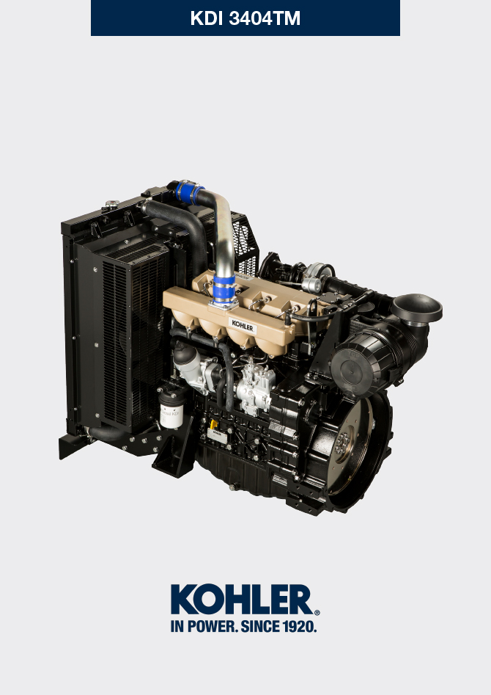
Sommario
1. TITOLO 1 2
1.1. Asdfsdfsdf 2
1.2. Asdfsdfsdfggg 2

Information for replacing the functional units

Injector and injection pump replacement
Important  - Before proceeding with operation, carefully read Par. 3.3.2 .  - Replace the high pressure pipes after two disassemblies.  - Seal all injection component unions as illustrated in Par. 2.9.7 during disassembly.  - Always replace the gaskets after each disassembly.  - Handle the components as described in Par. 2.18 .  - Refer to Par. 1.3 for operating references when assembling and disassembling.  - When repaired, RSN-A injectors must be certified by a Stanadyne centre to check their correct operation - check the type of engine mounted injectors on the spare parts list ( RSN-A is specified in the description). | 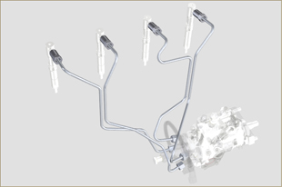  Fig 6.1
6.1.1 Injection fuel pipes disassembly (injection pump/injectors)  - Undo the screw s A .  - Undo the screws B .  - Remove quick fitting C .  - Undo the screws D and remove the manifold E . | 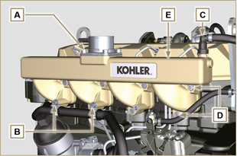  Fig 6.2
- Undo the screw H1 and remove the clamp H2 and remove rubber.  - Undo the nuts F .  - Undo the nuts G .  - Remove the tube H . | 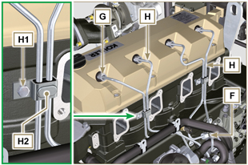  Fig 6.3
6.1.2 Rocker arms cover disassembly  - Undo the screw L .  - Undo the screw M.  - Undo the screws N and remove the rocker arm cap P . | 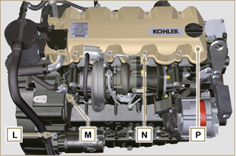  Fig 6.4
6.1.3 Fuel return pipes disassembly  - Undo the screws Q and remove hose R . | 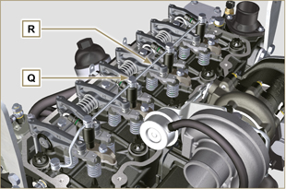  Fig 6.5
6.1.4 Injectors disassembly  - Undo the screw J and remove washer K and then bracket X .  - Remove the injector Z .  NOTE: Should you be unable to remove the electronic injector (acting only on point BC), use an open-ended spanner (Ø 11 mm), by applying small rotations to unblock the component.  - Seal all injection component unions as illustrated in Par. 2.9.7 .  - Ensure that gasket S has remained in the correct position ( Fig. 6.7 ). Otherwise, recover the gasket from inside the electronic injector V manifold. | 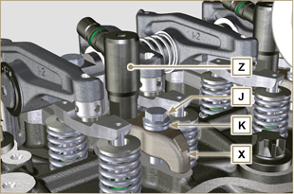  Fig 6.6  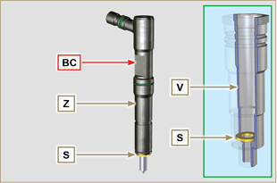  Fig 6.7
NOTE: Click on the right to play the procedure. | https://www.youtube.com/embed/mt-Dsw4A81A?rel=0
6.1.5 Injection pump disassembly  Importante  - Before proceeding with the disassembly, identify the pump code from its identifying name plate ( Pos. 12 - Tab. 2.12 ) and remove the cylinder injector 1 ( Par. 1.4 - 6.1.1 - 6.1.2 - 6.1.3 - 6.1.4 ).  - Alternatively, you can identify the pump from the online spare parts catalogue ( https://partners.lombardini.it/App/SparepartCatalogue/Default/Catalogue.aspx )  - Insert the tool ST_30 into the injector N°1 and fix it with the fixing brace X , capscrew J and washer K .  NOTE : Do not tighten the capscrew J . | 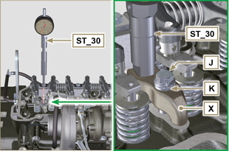  Fig 6.8
- Disassemble the starter motor.  - Mount the tool ST_34 in the seat of the starter motor Y and fit it with the two starter motor fixing screws.  - Rotate the crankshaft clockwise (Rif. A Par. 1.4 ) through the ST_34 tool bringing reference X upwards.  NOTE : When positioning reference X , make sure cylinder N° 1 is in compression phase (the valves on piston N° 1 must all be closed). | 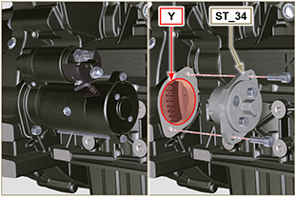  Fig 6.9

- With reference X pointed upwards, find the TDC through tool ST_30 , then bring the dial gauge indicator to 0. | 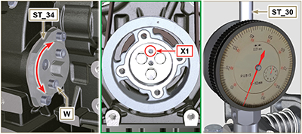  Fig 6.10
- By means of the identified pump code, refer to Tab. 6. 1 to know the advance degrees and the corresponding value to lower the piston.  - Having identified the value to lower the piston, rotate the crankshaft anti-clockwise by going beyond the value described in Tab. 6.1 , once again, rotate the crankshaft clockwise, stopping at the correct advance value by using tool ST_30 ( Rif. A Par. 1.4 ).  NOTE: The value indicated in Tab. 6.1 must be reached by rotating the shaft with the piston in compression phase. Use the ST_34 tool to totate the crankshaft. | Pump code Piston lowering (mm) Advance  ED0065905290-S 0,733 (0.562 - 0.927) 8° (± 1°)  ED0065905430-S 0,562 (0.413 - 0.733) 7° (± 1°)  ED0065905440-S 1,033 (0.828 - 1.261) 9,5° (± 1°)  ED0065905690-S 0,645 (0.485 - 0.828) 7.5° (± 1°)  Tab. 6.1
- Lock the ST_34 tool through J screws and ensure that the crankshaft does not rotate, which would alter the correct advance value. If this happens, repeat the instructions described in points 4 , 5 , 6 , 7 and 8 .  - Undo the screws A1 , remove the plate B1 . | 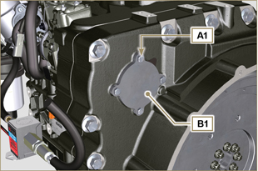  Fig 6.11
- Undo and remove the nut C1 fixing the injection pump control gear D1 .  Important  - After removing the nut C1 , ensure that the correct advance value has remained unchanged on ST_30 .  - Be careful that the nut C1 does not fall into the timing cover. | 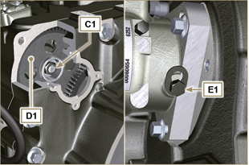  Fig 6.12
- Undo the capscrew E1 and shift the slotted plate F1 in the direction of arrow G1 .  - Tighten screw E1 to block the pump (tightening torque to 12 Nm ).  - Screw the tool ST_13 on the gear D1 . | 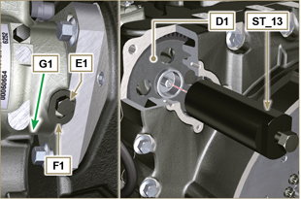  Fig 6.13
- Perform the operations of point 1 of Par. 5.2 .  - Remove quick fitting N1 .  - Undo the screws K1 and K2 and remove the Oil Cooler group L1 from the crankcase M1 .  - Loosen the screws J2 . | 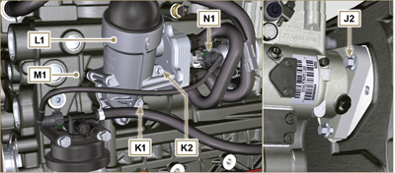  Fig 6.14
- Undo the screw P1 .  - Tighten the screw of tool ST_13 to disconnect the injection pump J1 from the high pressure pump control gear D1 .  - Svitare le viti J2 ed estrarre la pompa iniezione J1 .  - DO NOT remove the tool ST_13 . | 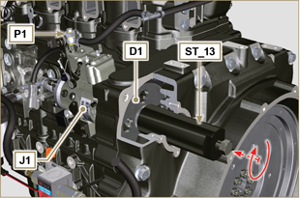  Fig 6.15
NOTE: Click on the right to play the procedure. | https://www.youtube.com/embed/lll9hIO0pXM?rel=0
6.1.6 Injection pump assembly  Important  - Before assembling the new pump J1 , make sure that plate F1 can move freely and that fastening capscrews E1 are not loose (the pump sold as a spare part is, upplied with the cylinder injection timing blocked N° 1 ).  - Ensure that the coupling surfaces on shaft Q1 and gear D1 are free from impurities and lubrication residues.  - Remove the guard cap only when the pipes are reconnected.  - Do not remove the tool ST_30 .  - Mount the injection pump J1 , inserting the shaft Q1 in the gear D1 .  Important  - Always change screws J2 with new ones or apply Loctite 2701 to the threads.  - Clamp the screws J2 on the crankcase M1 (tightening torque at 25 Nm ).  - Remove the tool ST_13 .  - Ensure that the correct advance value has remained unchanged, tighten nut C1 on shaft Q1 (as shown in Fig. 6.17, you are allowed to use a screwdriver to guide nut C1 onto shaft Q1 in order to prevent it from accidentally falling inside carter S1 - tightening torque at see service letter 710018 ). | 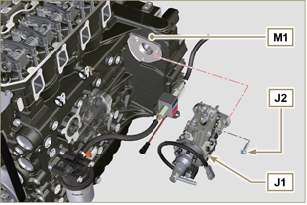  Fig 6.16  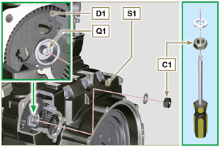  Fig 6.17
- Undo the capscrew E1 and shift the slotted plate F1 in the direction of arrow G2 .  - Tighten screw E1 (tightening torque to 5.5 Nm ). The injection pump is unlocked.  - Remove the tool ST_30 and ST_34 . | 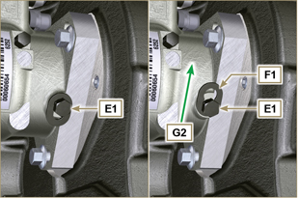  Fig 6.18
- Assemble Oil Cooler L1 onto crankcase M1 by means of capscrews K1 and K2 .  NOTE: Always replace the gasket R1 , R2 at each assembly. | 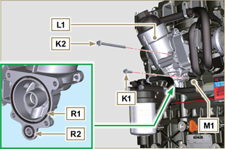  Fig 6.19
- Secure tube U1 by means of capscrew P1 , inserting gasket T1 .  - Fit quick coupling N1 onto pump J1 . | 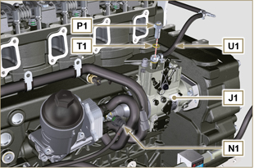  Fig 6.20
- Secure plate B1 by means of capscrews A1 , inserting gasket V1 onto carter S1 (tightening torque at 10 Nm ). | 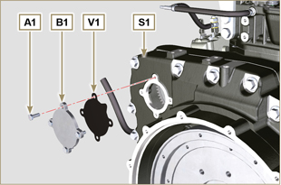  Fig 6.21
NOTE: Click on the right to play the procedure. | https://www.youtube.com/embed/xAUa9IQBmpU?rel=0
6.1.7 Injector assembly  Important  - To prevent damaging the injection system, the protection caps ( Par. 2.9.7 ) must be removed during assembly.  - Lubricate the gaskets U, T, S , and fit them on the injector Z . | 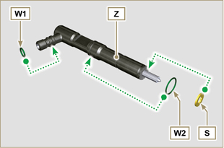  Fig 6.22
- Fit the injector Z in the sleeve V . | 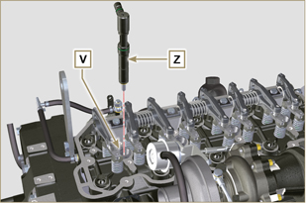  Fig 6.23
- Assemble the parts P, Q, R . and fit the parts so assembled on the injector Z . | 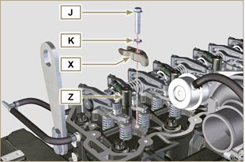  Fig 6.24
- Insert tool ST_52 on the injectors junctions Z (detail X2 ).  - Tighten the screw J (tightening torque to 20 Nm - Fig. 6.24 ). | 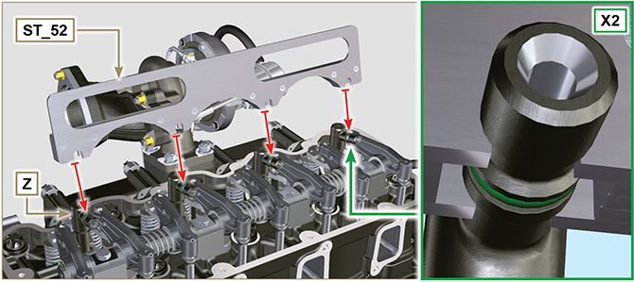  Fig 6.25
6.1.8 Assembly of the injector return pipes  - Position the tube N on the injectors Z and tighten screws M (tightening torque to 14 Nm ). | 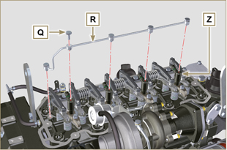  Fig 6.26
6.1.9 Assembly Rocker arm cover  Important  - The gasket Z1 between the rocker arm cover and the cylinder head must always be replaced every time it is disassembled.  - Position tool ST_17 onto the head in correspondence with the two fastening holes 9 and 10 .  - Position gasket Z1 and cap P on cylinder head A2 matching the holes of fastening capscrews N with the aid of the gudgeon guides ST_17 .  - Attach the rocker arm cover P on the head A2 with the screw N adhering to the tightening sequence shown in Fig. 6.28 (tightening torque to 10 Nm ).  - Secure the hose M2 with the screw L (tightening torque to 10 Nm ).  - Clamp the fitting M3 with the screw M (tightening torque to 25 Nm ) inserting the gasket B2 . | 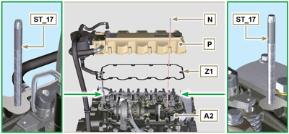  Fig 6.27  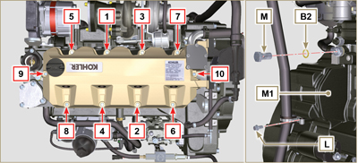  Fig 6.28
6.1.10 Installation of the fuel injector pipes (pump injector/injectors)  - Position pipes D on the injectors and on the injector pump.  Important  - Tighten the nuts F and G manually, without clamping them.  - Tighten the nuts F and G (tightening torque at 25 Nm ).  - Secure tubes H by means of clamps H2 , assembling:  - H3 rubber element;  - clamp H2 on element H3 ;  - secure clamp H2 by means of capscrew H4 and nut H5 (tightening torque at 10 Nm ).  - Secure manifold E onto cylinder head A2 by means of capscrews D , inserting gasket C2 .  - Secure suction line E2 onto manifold E by means of capscrews A , inserting gasket D2 .  - Fit quick coupling C onto manifold E .  - Fasten the pipe H6 on the manifold E with the screws B. | 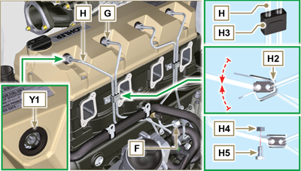  Fig 6.29
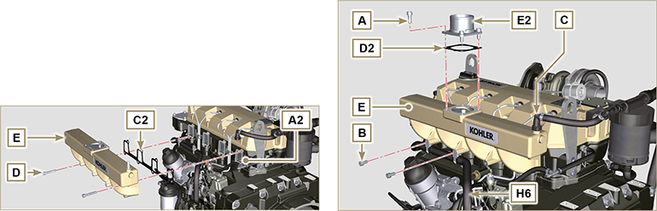
Fig. 6.30/6.31

Coolant pump replacement
6.2.1 Disassembly  NOTE: Perform the operations described in Par. 5.1 .  Important  - Before proceeding with operation, read Par. 3.3.2 .  - The coolant pump is not repairable.  - Loosen the screws A and B .  - Loosen capscrew C and disconnect voltage from belt D and remove belt D .  - Undo the screws E and remove the pulley F . | 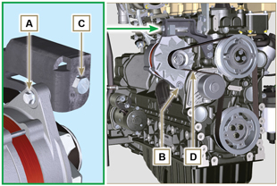  Fig 6.32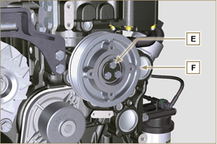  Fig 6.33
- Undo the screws G and remove the pump H with the relevant gasket. | 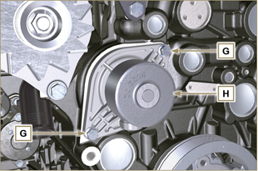  Fig 6.34
NOTE: Click by side to play the procedure. | https://www.youtube.com/embed/FdI56hBo_R0?rel=0
6.2.2 Assembly  Important  - Always replace the gaskets J , after each disassembly.  - Always replace the belt D after each assembly.  - To handling components refer to Par. 2.17  - Always replace the gaskets (where are provided) after each disassembly  - Fit the coolant pump G with the screws H interposing the new gasket J (tightening torque at 25 Nm ). | 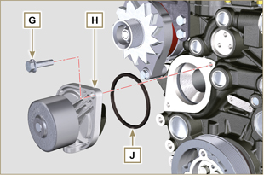  Fig 6.35
- By means of capscrews E , secure pulley F to crankcase K ( tightening torque at 25 Nm). | 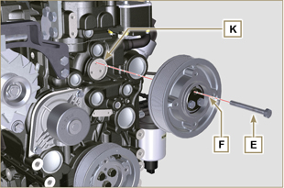  Fig 6.36
- Insert the belt D on the pulleys M .  - Tighten screw C and bring block L at 10 mm from bracket N (value C1 ).  - Fit the screw A (tightening torque at 25 Nm ).  - Fit the screw B (Fig. 6.32 - tightening torque at see service letter 710007 ).  - Start the engine and run it for some minutes, then turn off it, and let it cool down at ambient temperature. Check by the appropriate tool that at point P the tension value is between 135 and 178 Hz.  NOTE: If the poly-v belt tension results out of the above mentioned values, proceed with the replacement. | 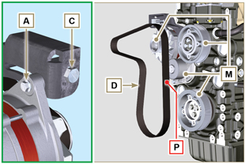  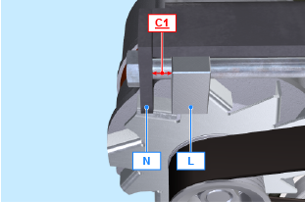  Fig 6.37
NOTE: Click by side to play the procedure. | https://www.youtube.com/embed/edCJrMN0G5M?rel=0

Oil vapour separator replacement
6.7.1 Disassembly  Important  - Before proceeding with operation, read Par. 3.3.2 .  - Remove quick fitting A .  - Release the clamps B and C .  - Remove hose D from breather body E . | 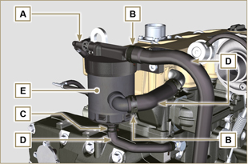  Fig 6.38
- Remove capscrews F and remove breather body E . | 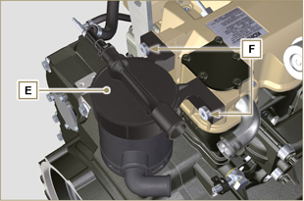  Fig 6.39
6.7.2 Assembly  - Secure breather body E by means of capscrews F (tightening torque at 22 Nm ).  - Fit hose D onto breather body E (Fig. 6.38) .  - Secure the clamps B and C (Fig. 6.38). | 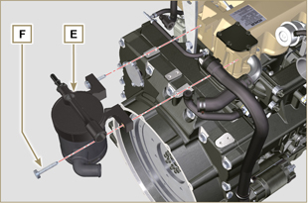  Fig 6.40

Oil cooler unit and oil filter replacement
6.4.1 Oil Cooler unit disassembly  Important  - Before proceeding with operation, read Par. 3.3.2 .  - Perform the operations described in Par 5.1 and Par 5.2 .  - Oil Cooler unit E is not repairable.  - Release the clamps A .  - Remove the manifolds B out of the Oil Cooler unit E . | 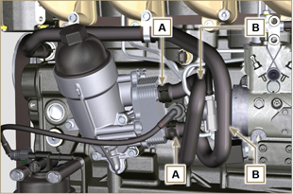  Fig 6.41
Warning  - Electric/pneumatic screwdrivers are forbidden.  - Use a suitable container to recover any residue oil.  - Unscrew cartridge holder cover H by performing three complete turns and wait 1 minute.  NOTE : this operation allows to oil contained in the support E to flow into the oil sump in the correct way.  - Unscrew cartridge holder cover H and check that the oil in the lub. oil filter support E has flowed towards the oil sump.  - Remove quick fitting N1 . | 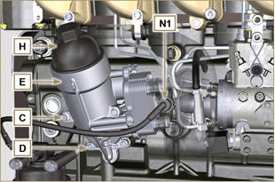  Fig 6.42
- Undo the screws C and D and remove the Oil Cooler unit E .  - Remove the gaskets F and G from the Oil Cooler unit E . | 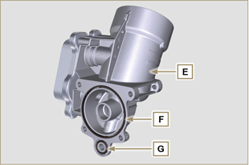  Fig 6.43
6.4.2 Oil filter cartridge replacement  - Remove gaskets L, M and N from element holder cover H .  - Remove cartridge P from element holder cover H . | 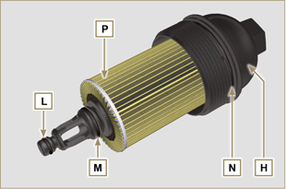  Fig 6.44
- Lubricate and insert gaskets L, M and N in the L1, M1 and N1 seats of element holder cover H .  - Insert element P into element holder cover H . | 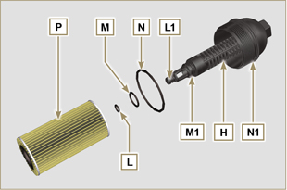  Fig 6.45
6.4.3 Oil Cooler unit assembly  Important  - In the event of assembly of union U on crankcase S , manual tightening torque with Loctite 2701 on the thread).  - Check that the surface Q on the support E and on the crankcase S are free from impurities.  - Lubricate and insert the gasket T on the fitting U .  - Lubricate and insert the gaskets on the support E :  F in seat F1 ;  G in seat G1 .  - Fit the support R with the screws C and D (tightening torque at 10 Nm ).  - Insert and tighten the cartridge support H on the filter support E (tightening torque at 25 Nm ).  - Fit the hoses B on the support E and secure the hoses B with the clamps A .  - Fit quick coupling N1 onto pump J1 . | 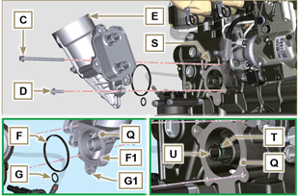  Fig 6.46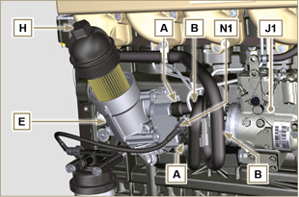  Fig 6.47

Fuel filter replacement
6.5.1 Disassembly  Important  - Before proceeding with operation, read Par. 3.3.2 .  Warning  - The fuel filter is not always mounted in the engine.  - When disassembling, use a suitable container to recover the fuel contained in the cartridge F .  - Remove quick fitting N1 .  - Release the clamps A and pull the pipes B out of the support H .  - Unscrew the cartridge F from the support H .  - Undo the screws C and remove the support H . | 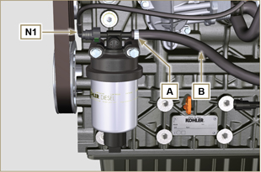  Fig 6.48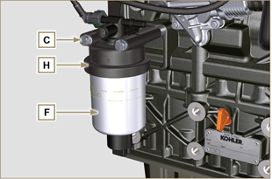  Fig 6.49
Warning  - Check that the fuel supply pump filter is present, and replace if necessary.  - Release the clamp D .  - Demount the hose E .  - Unscrew the filter G from the pump Q . | 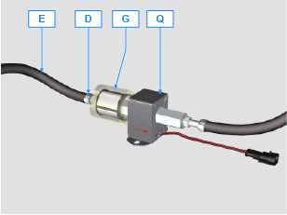
- Screw the new filter G onto the pump Q (tightening torque 20 Nm ).  - Connect the hose E to the filter G and fasten with the clamp D . | 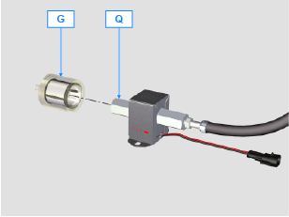
6.5.2 Assembly  - Secure fuel filter bracket H with capscrews C onto crankcase M , inserting spacer L between M and H and washer P between H and C (tightening torque at 25 Nm ).  - Fit the pipes B on the support H .  - Secure the pipes B with the clamps A . | 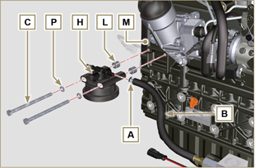  Fig 6.50
- Lubricate the gasket N with fuel.  - Tighten the cartridge F on the support H (tightening torque at 17 Nm ).  - Fit quick coupling N1 onto support H . | 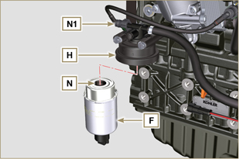  Fig 6.51

