Information on resources used in graphics software
Diagnostic tool manual

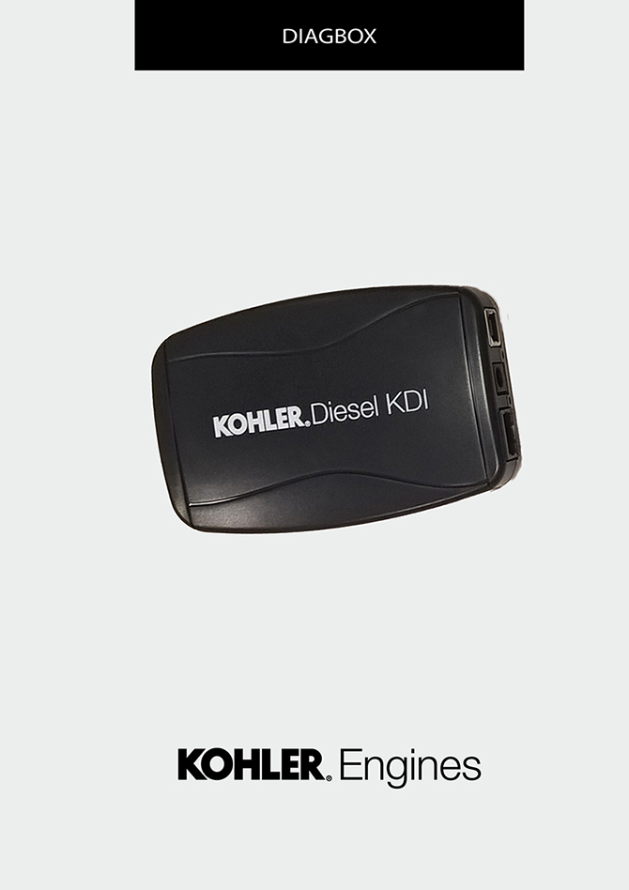
Sommario
1. TITOLO 1 2
1.1. Asdfsdfsdf 2
1.2. Asdfsdfsdfggg 2

Information on resources used in graphics software

Home Screen
The purpose of this document is to provide a reference for the images that characterise the graphical user interface of software.

Warning
The screens are for information purposes.

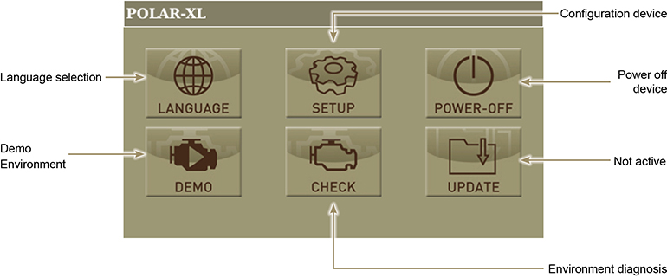

Language selection
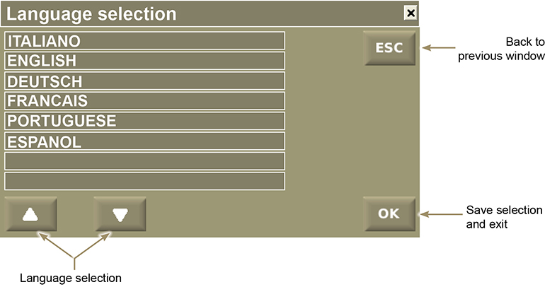

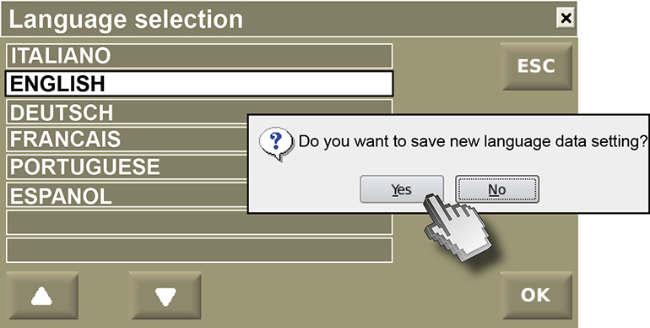

Diagnosis selection
Press the "Check" push button to access the "Diagnosis" display screen.

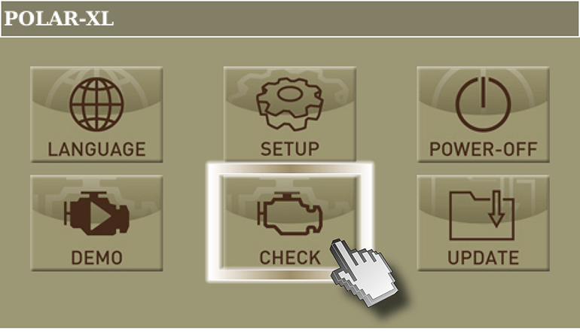

Press on "I agree"

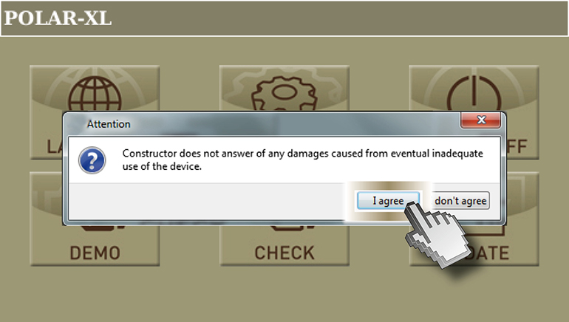

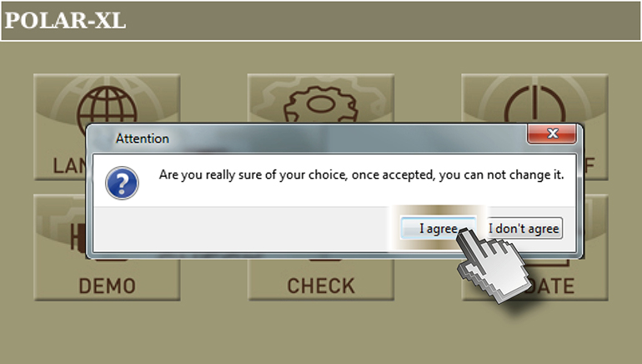

Press the "KDI" push button to access the "KDI engine series diagnosis"

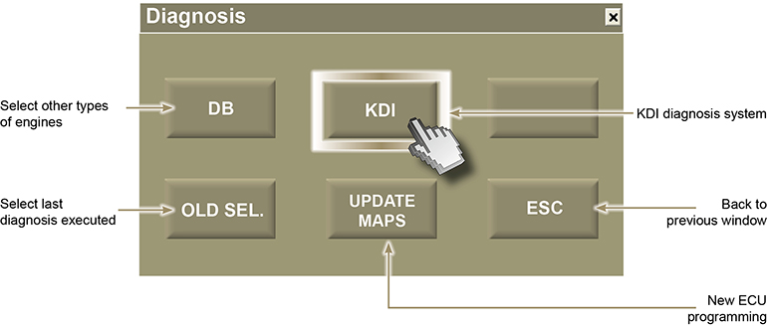

Press "OK" to enter the "Engine parameters" menu.

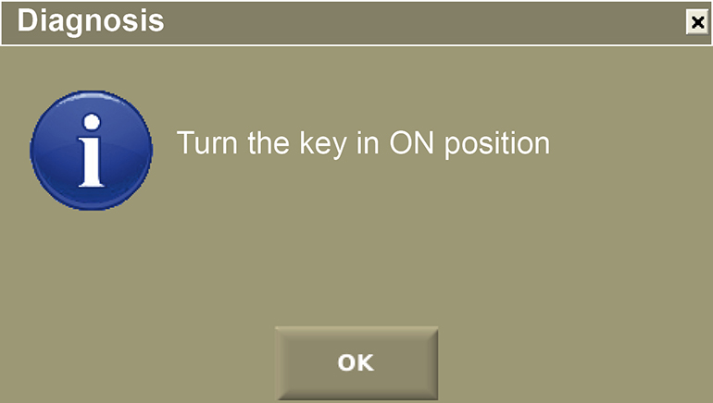

Diagnosis menu
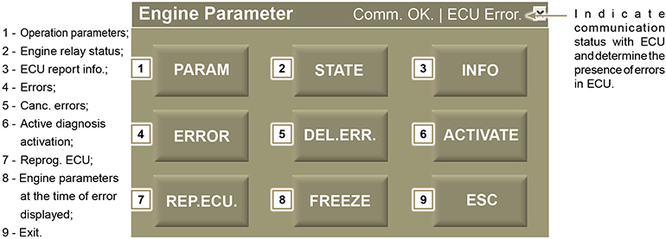

Parameters menu
Press the ''Param.'' push button to access the ''Parameter'' display screen.

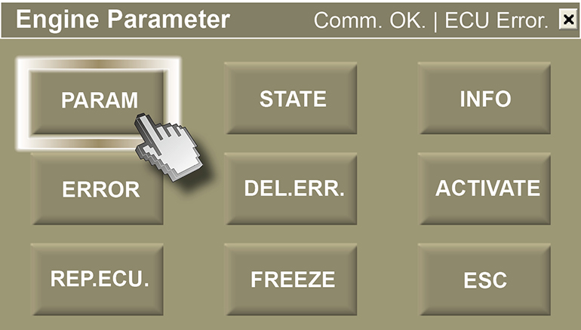

Parameters

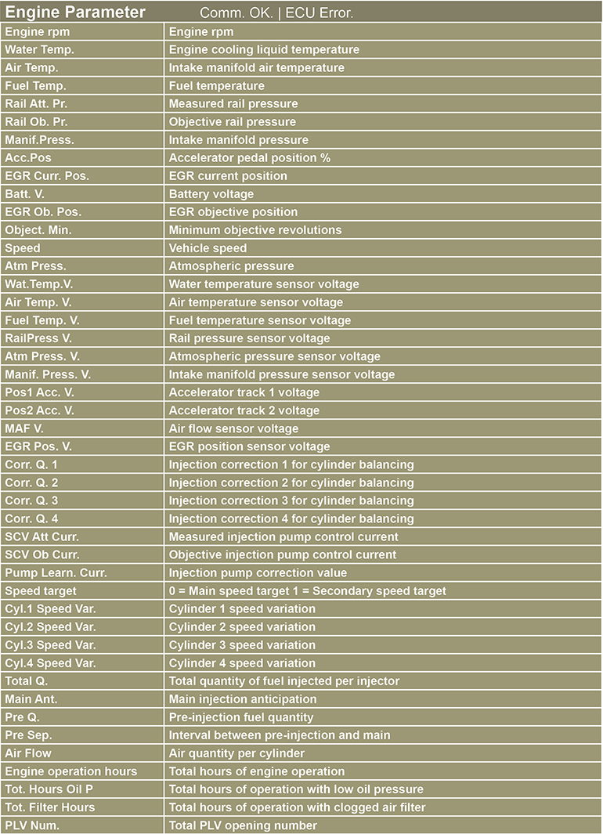

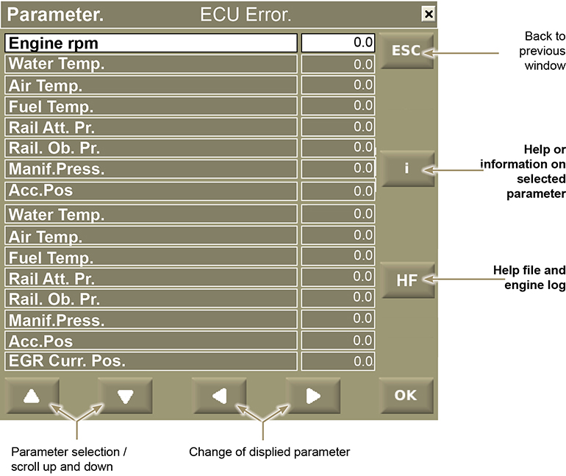

Press the ''i'' push button to access the ''Help'' display screen.

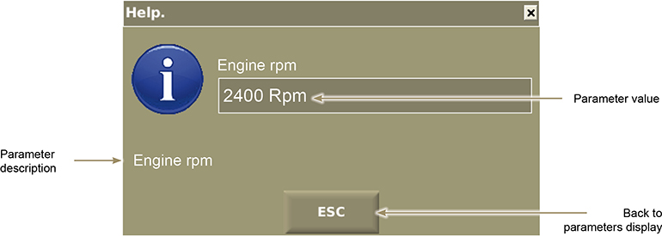

Engine log

Press "HF" to start engine parameters log. "Attention" box is displayed when log starts.
Click “OK” to stop the log..

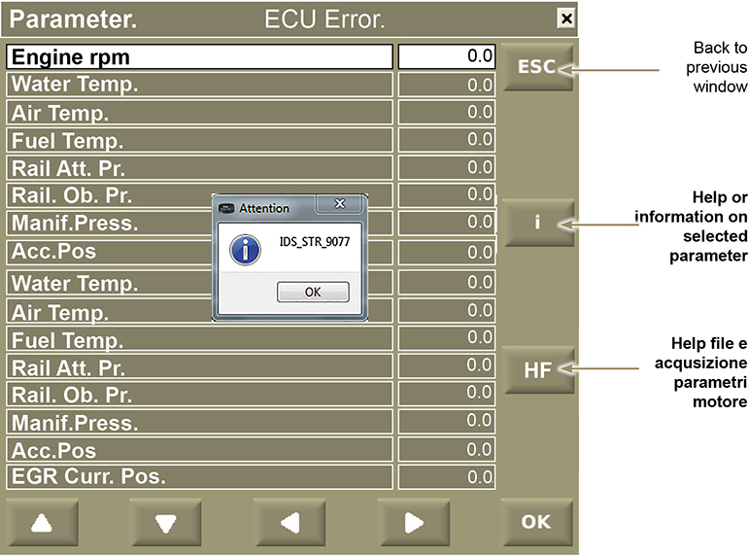

Warning
Log can record a maximum of 40 minutes

Once engine parameters are logged, the relevant file will be saved to "Documents > Lombardini Kohler > Road tests" which was automatically created upon software installation.

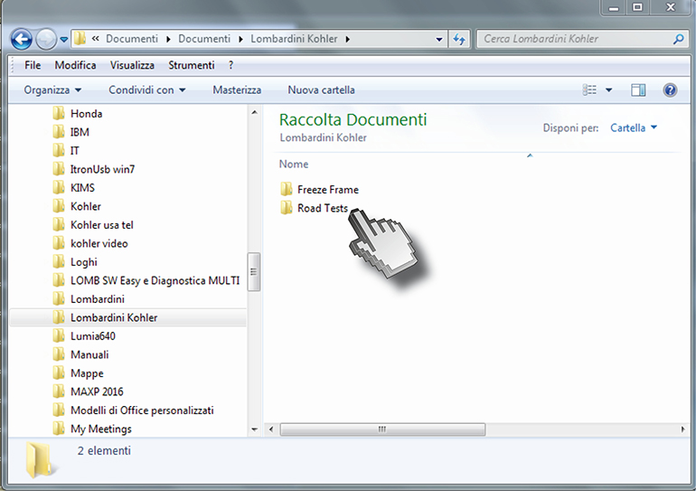

Click "ROAD TESTS" and then .csv excel file to view engine parameters.

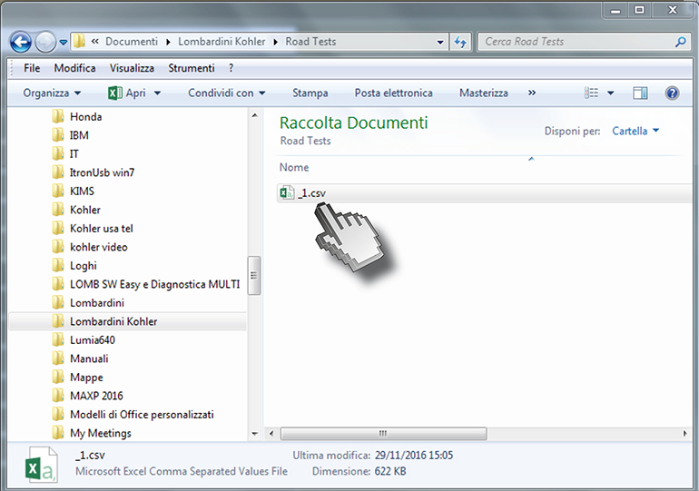

Warning
When several log files are recorded, it is recommended to move any previous log file to another folder and rename it, or it will be overwritten

Relay status menu and ECU sensors
Press the ''Status'' push button to access the ''Status'' display screen.

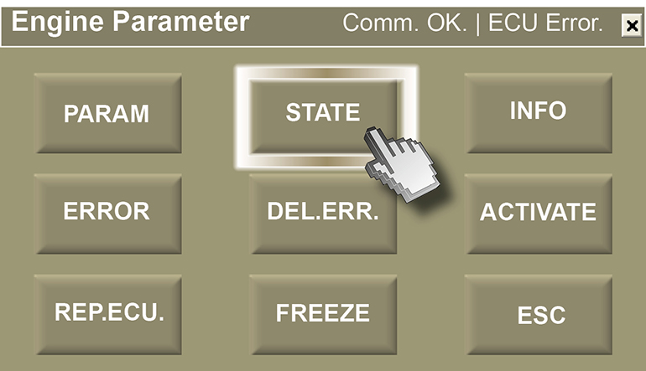

List of existing engine statuses displayed

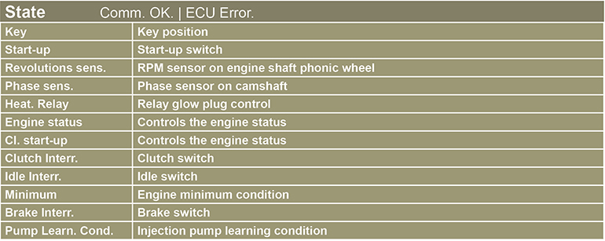

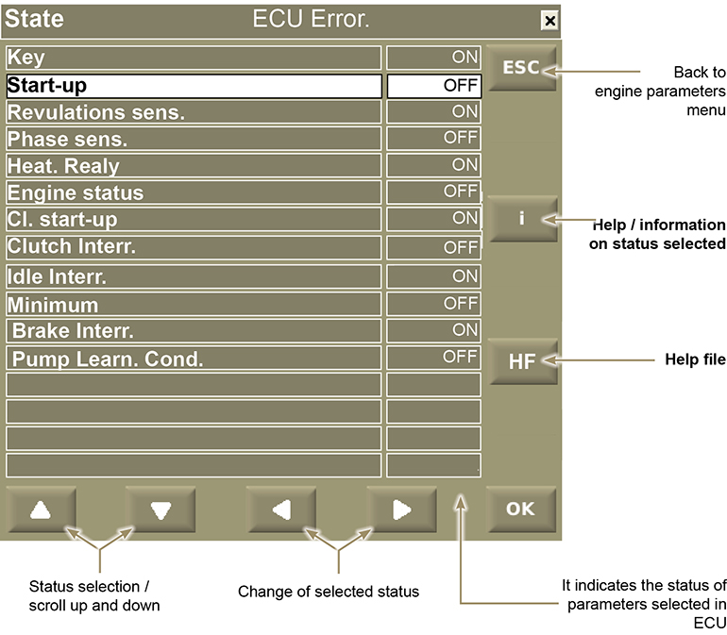

Press the ''i'' push button to access the ''Help'' display screen.

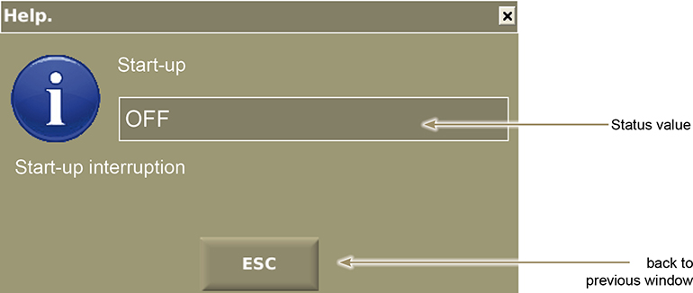

Menu information reported in ECU
Press the ''Info'' push button to access the ''Information'' display screen.

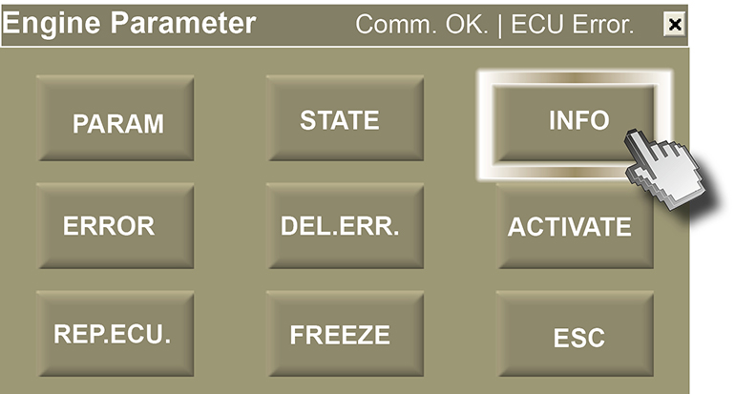

List of information engine statuses displayed

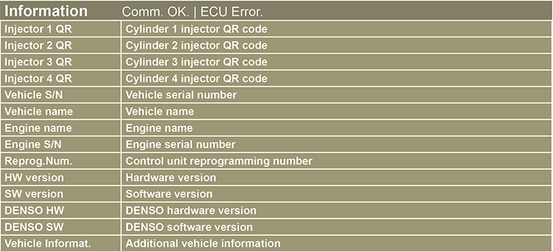

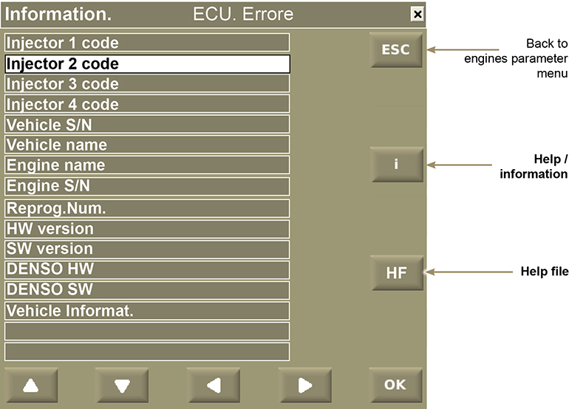

Press the ''i'' push button to access the ''Information'' display screen.

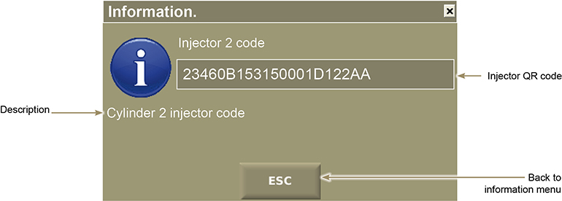

Activation menu for active diagnosis
Press the ''Activate'' push button to access the ''Activation'' display screen.

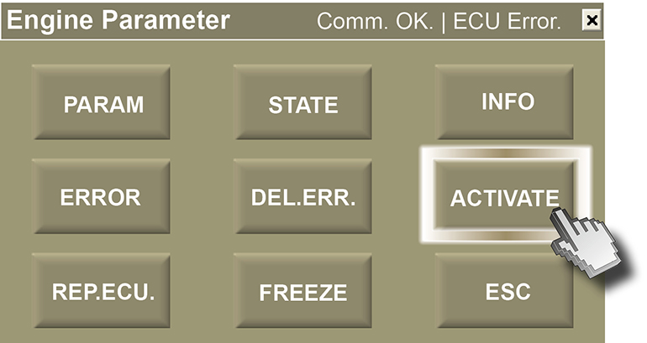

List of activation engine statuses displayed

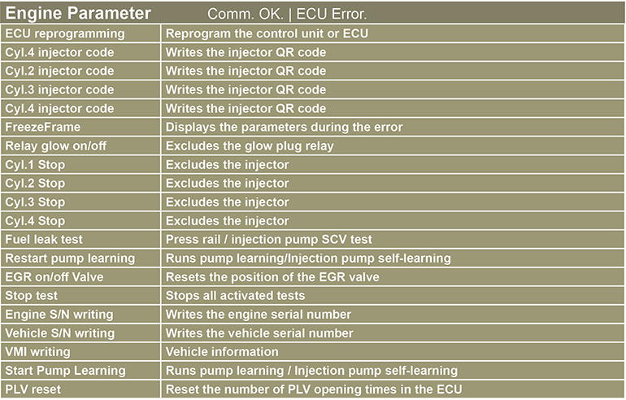

Reset PLV opening times
To open the "Reset no.PLV" menu, use arrow button to select "Select other detail from list" and then "Replace selected activation with activation not displayed".
Once you open the "Reset no.PLV" menu, press "ACT" to reset the number of PLV opening times.

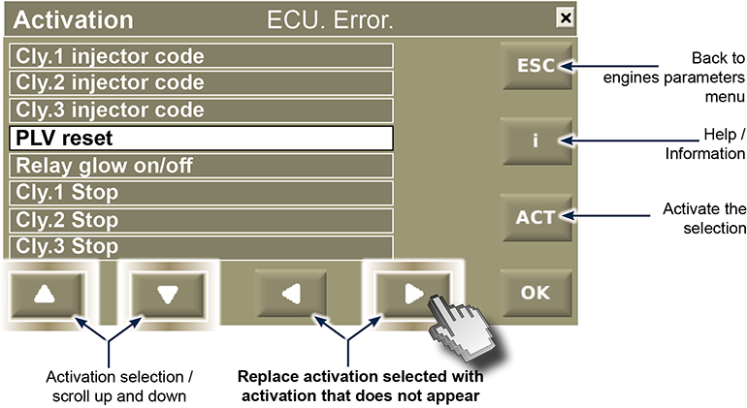

QR injectors entry code

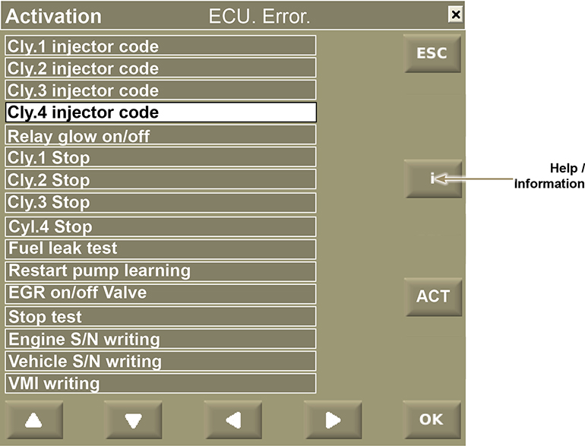

Press the ''i'' push button to access the ''Activation" (information)' display screen.

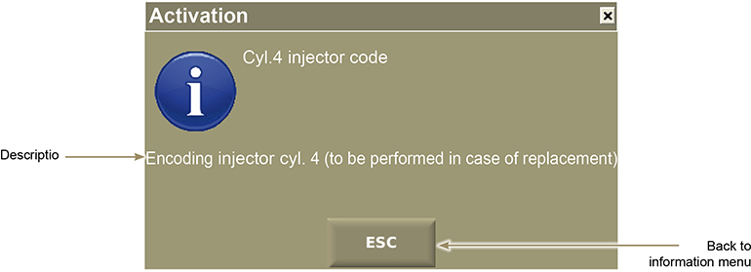

Push the button "ACT" to activate the QR code writing procedure.

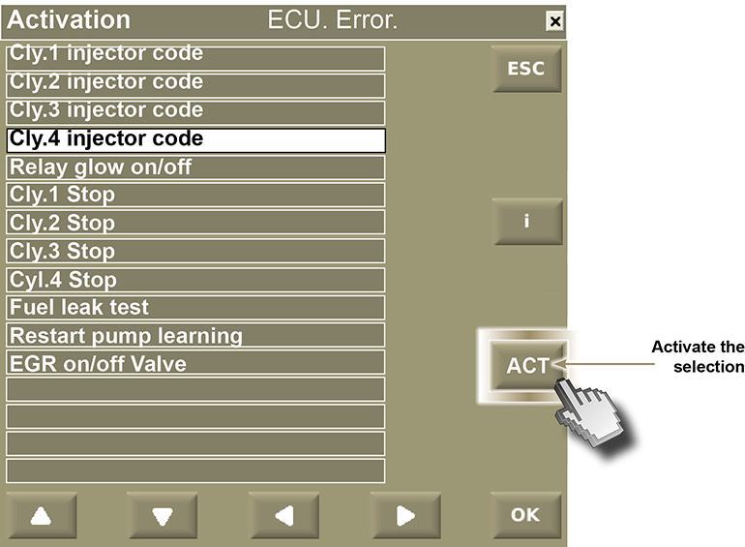

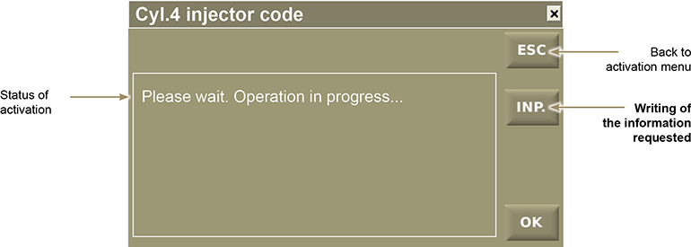

The injector code is composed of 30 characters to insert at two different times.
Insert the first 15 characters of the code and press "OK"

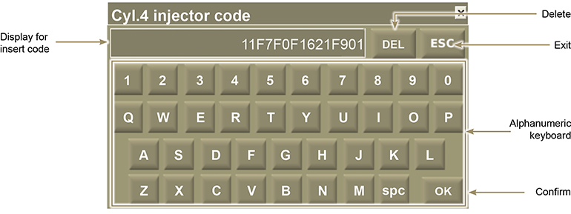

Wait for confirmation to insert the second 15 characters of the injector code

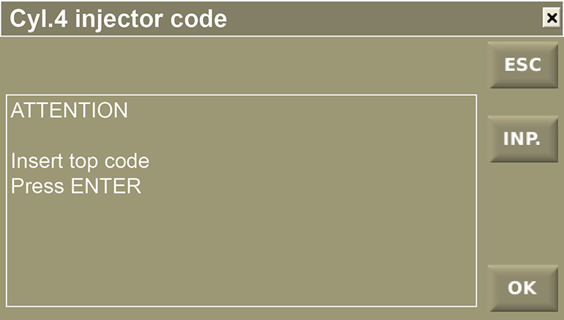

Insert the second 15 characters of the code and press "OK"

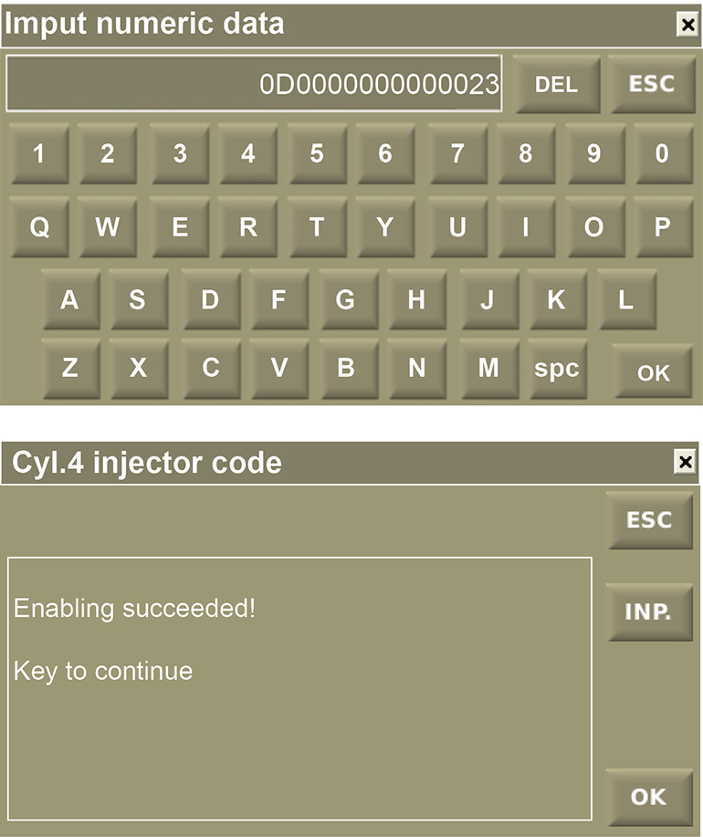

"Activate" diagnosis example .

If you wish to verify the operation of the EGR valve, follow this procedure:

To access the "EGR valve on/off" display screen, press the right push button "Activation selection / scroll up and down".

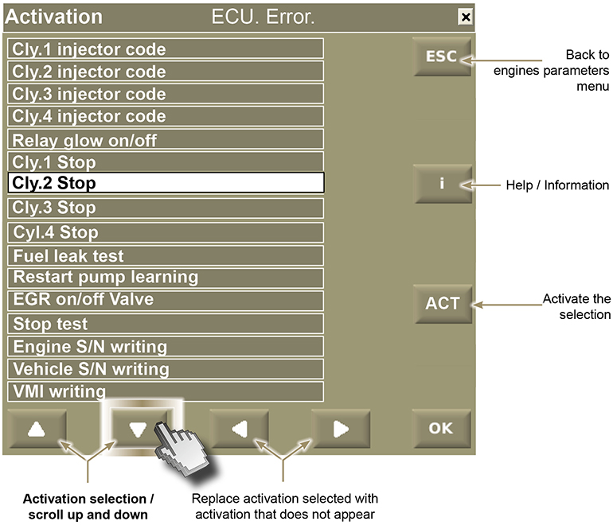

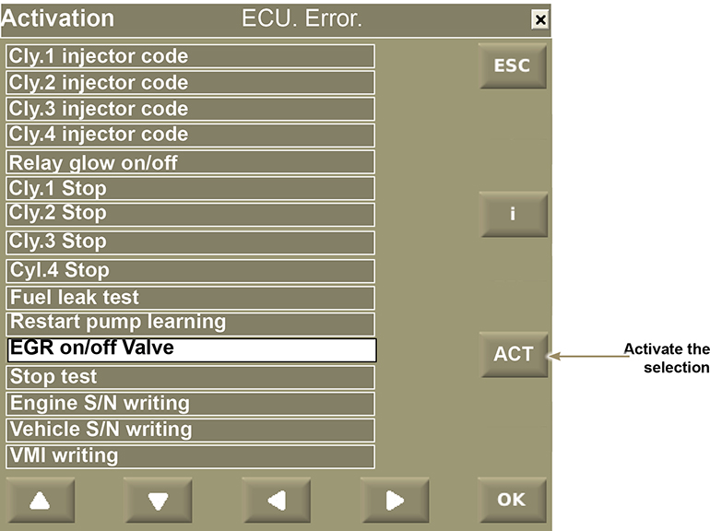

By pressing the "ACT" push button, it activates the "EGR" test.

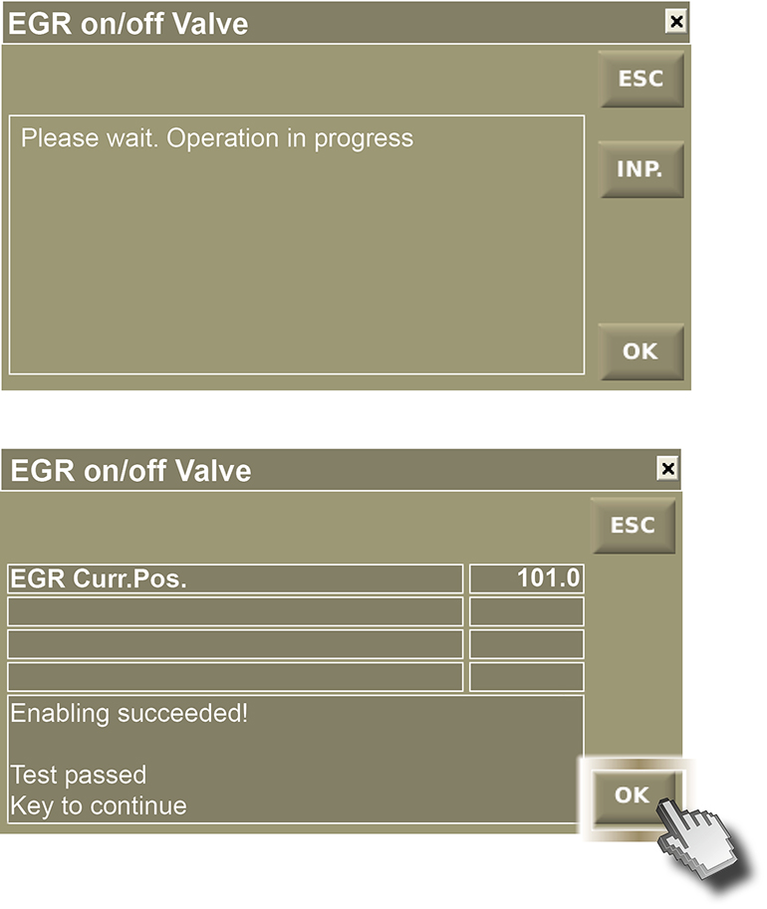

Press "OK"

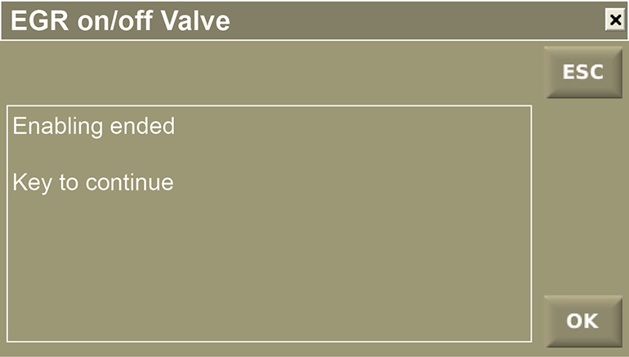

NOTE : For another active diagnosis, select the desired activations by following the previous example

Error menu
Press the ''Error'' push button to access the ''Error'' display screen.

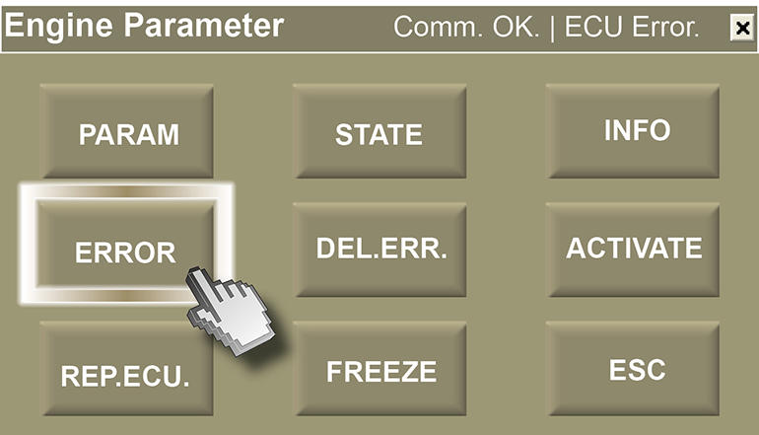

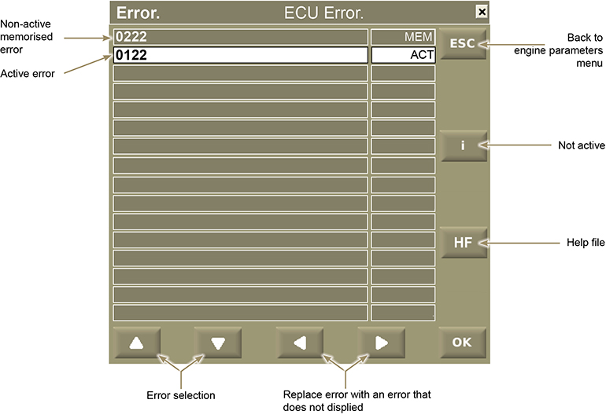

Press the "HF" push button to access the "Active error image information" video display

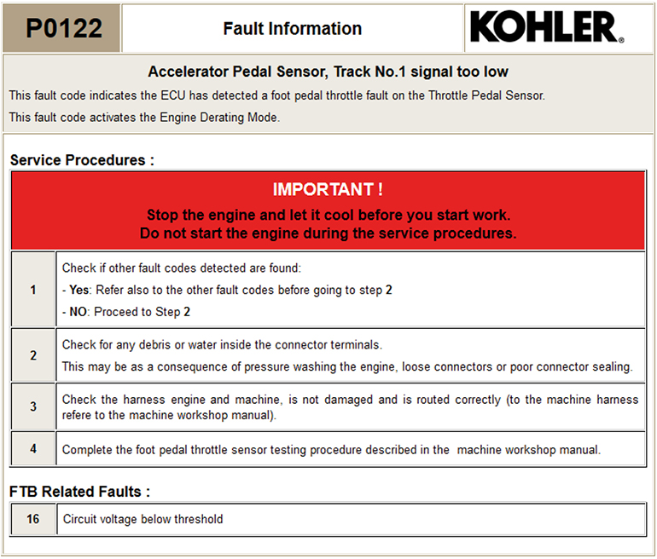

Freeze frame menu
Displays engine parameters that are memorised at the time of the error.

Press the ''Freeze'' push button to access the ''Freeze Frame'' display screen"

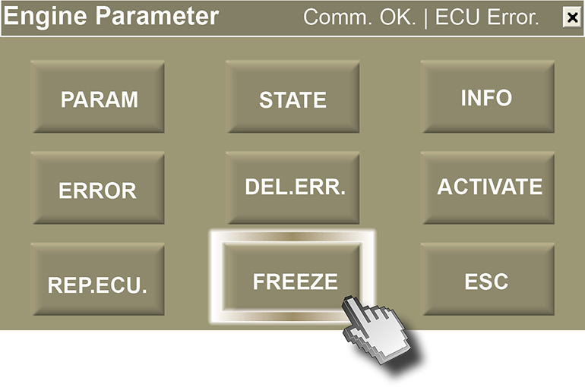
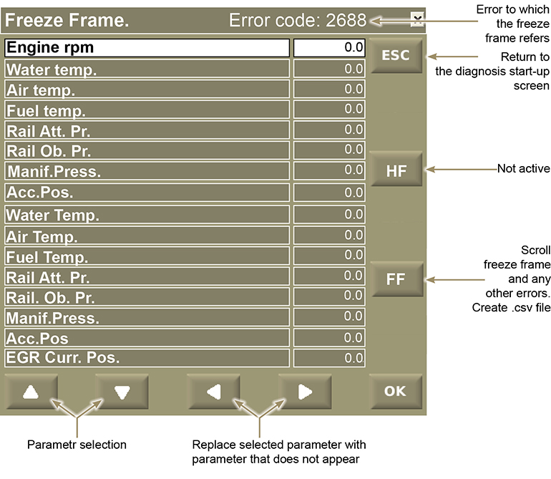

Press "FF" to scroll the "Freeze Frame" referred to any errors.
Every error will create a .csv file and data will be saved to "Documents > Lombardini Kohler > Freeze Frame".
At the end of the list, the following page will be displayed.

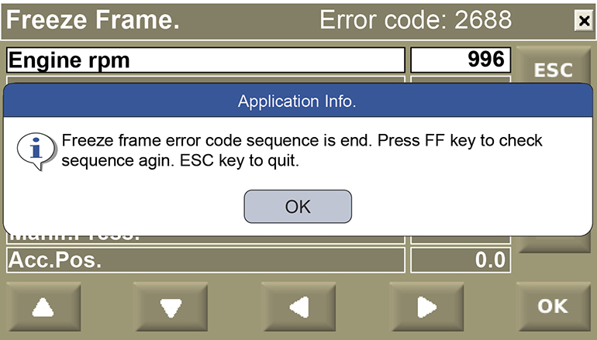

Page "Documents > Lombardini Kohler > Freeze Frame".

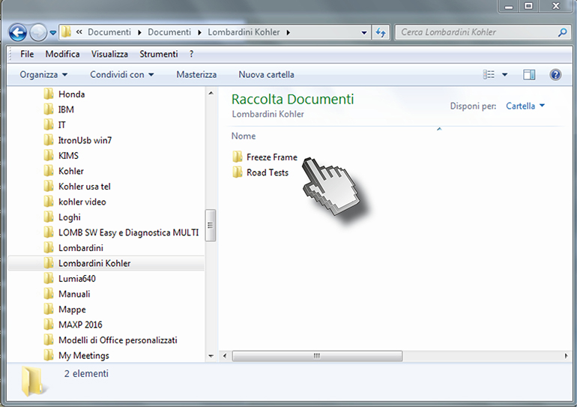

Click "FREEZE FRAME" and then file .csv.

