Tools information
KDI 1903TCR / KDI 1903TCRE5 Workshop manual (Rev. 17.8)


Sommario
1. TITOLO 1 2
1.1. Asdfsdfsdf 2
1.2. Asdfsdfsdfggg 2

Tools information

Information regarding specific tools

In Tab 13.1 - 13.2 - 13.3 there is a list of all the specific tools that are required and approved to carry out operations of disassembly - assembly - regulations - settings - repairs on engine series KDI

, correctly and safely.
Warning

- KOHLER declines all responsibility for any damage to the engine, persons, or things caused by the use of different types of tools to those indicated in Tab 13.1 - 13.2 - 13.3 , where referred to them in the manual.

Tab. 13.1
SPECIAL TOOLS FOR DISASSEMBLY AND ASSEMBLY
"ST" | Picture/Draw | DESCRIPTION | PART NUMBER
ST_03 | 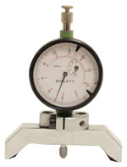 | Piston protrusion - electronic injectors cylinder head surface control tool | ED0014602980-S
ST_04 | 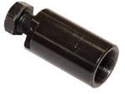 | High-pressure fuel injection pump puller gear | ED0014603680-S
ST_05 | 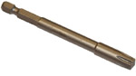 | Spanner for capscrews Six nicks SN 8 | ED0014603650-S
ST_06 | 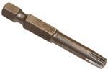 | Spanner for capscrews Six nicks SN 5 | ED0014603640-S
ST_07 | 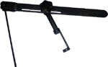 | Tool for disassembling / reassembling valves | ED0014603720-S
ST_08 | 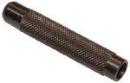 | Tool for gasket valve stem | ED0014603660-S
ST_09 | 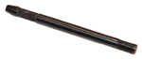 | Tool for flywheel assembling / disassembling | ED0014603610-S
ST_10 | 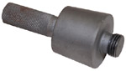 | Crankshaft gasket assembling tool | ED0014603670-S
ST_11 | 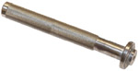 | Rocker arm cover gasket assembling tool (electronic injector seat) | ED0014603620-S
ST_12 | 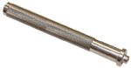 | Rocker arm cover gasket assembling tool (rocker arm capscrew gudgeon seat - electronic injector fastening capscrew brace seat) | ED0014603630-S
ST_14 | 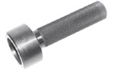 | Buffer insertion of a crankshaft gasket onto a timing system carter | ED0014603750-S
ST_15 | 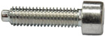 | Locking screw balance shafts | ED0097301980-S
ST_17 | 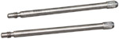 | Rocker arm cover mounting studs | ED0014603730-S
ST_18 | 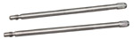 | Intake and oil sump manifold mounting studs | ED0014603740-S
ST_34 | 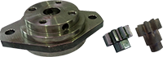 | Crankshaft blocking tool | ED0014604270-S
Tab. 13.2
SPECIFIC EQUIPMENT TO PROTECT COMPONENTS OF THE INJECTION CIRCUIT

ST_40 | 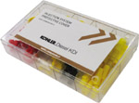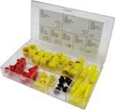 | Complete box with caps to close holes and unions for high-pressure injection circuit components. | ED0082051380-S
Tab. 13.3
SPECIAL TOOLS TO TEST THE ENGINE ON THE TEST BENCH - DIAGNOSTIC PROCEDURE
ST_01 | 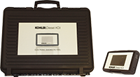 | Complete instrument Kit for diagnostics  "POLAR XL" | ED0014603690-S
ST_49 | 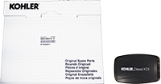 | Complete instrument Kit for diagnostics  "DIAGBOX" | ED0014604210-S
ST_50 | 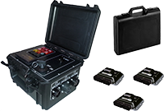 | Complete instrument Kit for engines bench test | ED0014604110-S

