Information for disassembly
KDI 1903TCR / KDI 1903TCRE5 Workshop manual (Rev. 17.8)


Sommario
1. TITOLO 1 2
1.1. Asdfsdfsdf 2
1.2. Asdfsdfsdfggg 2

Information for disassembly

Recommendations for disassembly

Important

- The mark ( ) after the title of a paragraph, indicates that the procedure is not required in order to disassemble the engine, however the procedures are featured in order to illustrate the disassembly of components.
- The operator should prepare all equipment and tools in order to enable him to carry out the operations correctly and safely.
- Before disassembly, perform the operation described in Chap. 5 .
- Before proceeding with operation, carefully read Chap. 3 .
- In order to operate safely and easily, we recommend positioning the engine on a rotating stand for engine overhauling.
- Seal all injection component unions as illustrated in Par. 2.9.8 during assembly.
- Protect all disassembled components and coupling surfaces subject to oxidation with lubricant.
- Where necessary, reference to special tools to use during disassembly operations is indicated (es. ST_05 ), identified in Tab. 13.1 - 13.2 - 13.3 .

EGR circuit disassembly
7.2.1 EGR cooler unit  - Undo the screws A ( ST_06 ) and B and remove the pipe C with the relative gaskets. | 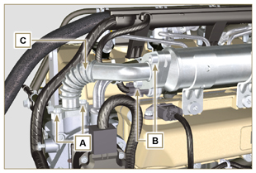  Fig 7.1
- Undo the screws D, E ( ST_06 ) and remove pipe F and the relevant gaskets. | 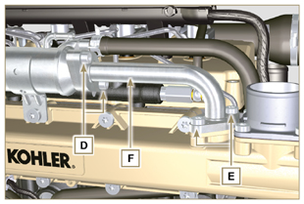  Fig 7.2
- Release the clamp M and remove pipe N .  - Release the clamp L .  - Undo capscrews G and remove EGR Cooler H from hose X ( ST_05 ) . | 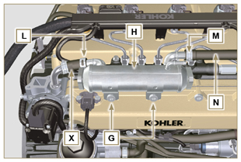  Fig 7.3
7.2.2 EGR Valve  - Disconnect the connector P .  - Undo the screws Q and remove the EGR valve R with the relevant gasket.  NOTE: The EGR valve is not a serviceable item, and if damaged/worn, it should be replaced with a new one. | 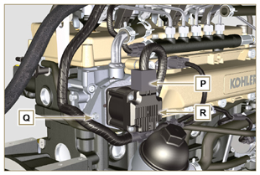  Fig 7.4
- Undo capscrews S and remove flange T with the relative gasket. | 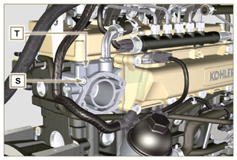  Fig 7.5

Electric components disassembly
7.3.1 Electric wiring  Important  - Refer to Par. 2.13 prior to proceeding with disassembly.  - Disconnect the connectors A, B and C .  - Release the clamp D . | 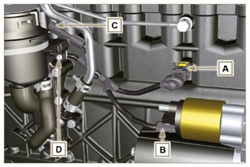  Fig 7.6
- Disconnect the connectors E, F and G .  - Release the clamps J and H . | 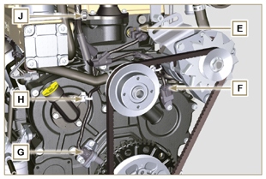  Fig 7.7
- Disconnect the connectors K and L . | 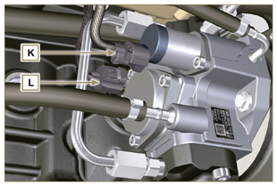  Fig 7.8
- Disconnect the connectors M and P .  - Release the clamp Q . | 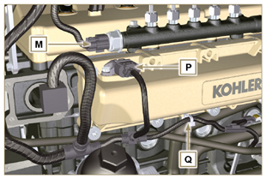  Fig 7.9
- Disconnect the connectors R .  - Undo the screws S and remove the wiring support T ( ST_06 ) . | 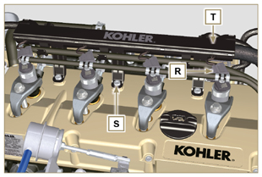  Fig 7.10
7.3.2 Starter motor  Important  - The motor is not repairable.  - Undo the screws U and remove the starter motor V . | 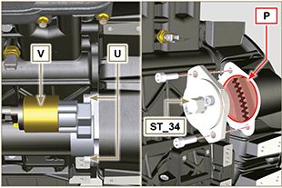  Fig 7.11
7.3.3 Belt and alternator  - Loosen the screws Z and W .  - Push the alternator AA in the direction of the arrow AB .  - Remove the belt AC from the pulleys AR .  - Undo the screws Z and W and remove the alternator AA .  Important  - The belt must always be replaced every time it is disassembled, even if it has not reached the scheduled hours for replacement. | 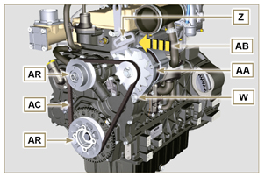  Fig 7.12
7.3.4 Sensors and switches  Important  - After disassembly, protect the sensors suitably against knocks, dampness and any high temperature sources.  - The sensors and switches cannot be repaired, therefore they must be replaced in the event of anomalies.  7.3.4.1 Oil pressure switch ( )  - Unscrew and remove the oil pressure switch AD . | 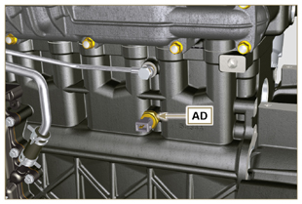  Fig 7.13
7.3.4.2 Coolant temperature sensor ( )  - Unscrew and remove the coolant temperature sensor AE . | 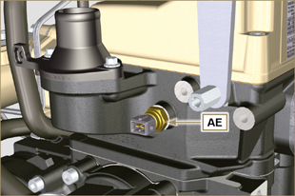  Fig 7.14
7.3.4.3 Speed sensor ( )  - Undo the screw AF and remove the sensor AG with the relative spacer ( ST_06 ) .  - Undo the screws AH and remove the sensor ( ST_06 ) . | 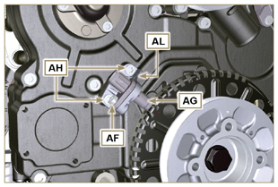  Fig 7.15
7.3.4.4 Camshaft phase sensor  - Undo the screw AM and remove the sensor AN with the relative spacer ( ST_06 ). | 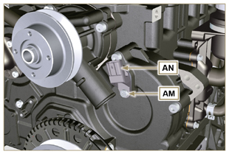  Fig 7.16
7.3.4.5 T-MAP Sensor ( )  - Undo the screw AP and remove the sensor AQ ( ST_06 ). | 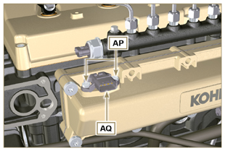  Fig 7.17
7.3.4.6 Fuel filter water detection sensor ( )  Warning  - The fuel filter is not always mounted on the engine.  - When disassembling the sensor A , use a suitable container to recover the fuel contained in the cartridge B .  - Unscrew the sensor A from the cartridge B . | 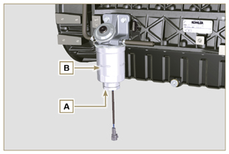  Fig 7.18

Turbocharger disassembly
- Release the clamps A and B and remove the manifold C . | 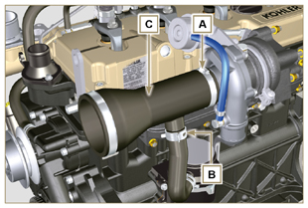  Fig 7.19
- Unscrew the fittings D and remove the pipe E with the relative gaskets G .  - Undo the screws F .  - Release clamp M . | 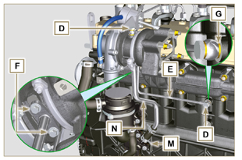  Fig 7.20
- Undo the nuts L .  - Remove tube N . | 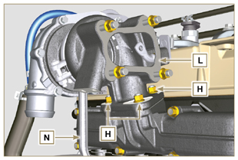  Fig 7.21

Exhaust manifold disassembly
- Undo the nuts A and remove the manifold B and the gaskets C .  - Close the openings and manifolds to prevent foreign bodies from entering. | 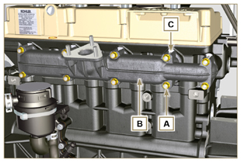  Fig 7.22

Coolant recirculation components disassembly
7.6.1 Oil Cooler manifold  - Release the clamps Z .  - Undo the screw W and remove hoses J ( ST_05 ) . | 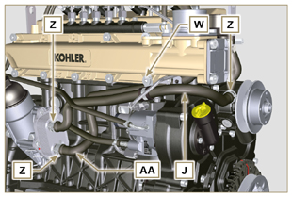  Fig 7.23
- Release the clamp K and remove hoses AA . | 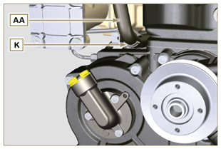  Fig 7.24
7.6.2 Coolant pump  Important  - The pump B is not repairable.  - Undo the screws A and remove the water pump unit B with its gasket C . | 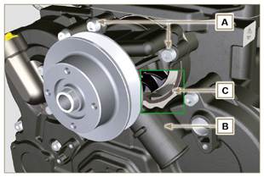  Fig 7.25
7.6.3 Thermostatic valve  - Undo the screws A and remove the thermostatic valve cover B .  - Remove the thermostatic valve C and its gasket.  Important  - Always replace the gasket D every time it is disassembled.  - Check that the air bleeding hole is not clogged or blocked ( Par. 2.11.4 ). | 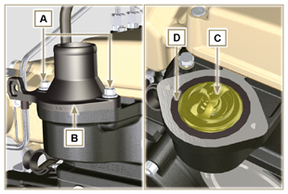  Fig 7.26

Crankshaft and target wheel pulley disassembly
- Position the crankshaft with the 1st cylinder at TDC,reference H .  - Undo the screw C clockwise.  - Remove the drive pulley unit and the target wheel D . | 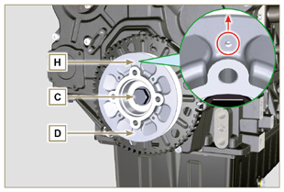  Fig 7.27

Lubrication circuit disassembly
7.8.1 Oil pressure valve( )  - Undo the cap A .  - Remove the spring B , check its condition and replace it if broken.  - Remove the valve piston C using a magnet. | 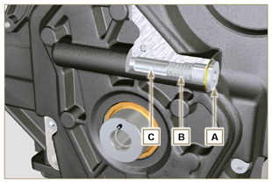  Fig 7.28
7.8.2 Timing system carter oil filling flange ( )  - Undo the screws D and remove the oil filling flange E ( ST_06 ) .  - Remove the gasket F . | 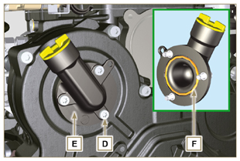  Fig 7.29
7.8.3 Timing system carter  - Ensure that the crankshaft with the 1st cylinder is at the TDC (taper pin W must be facing upwards).  - Undo the screws G .  - Remove the timing system semi-crankcase H . | 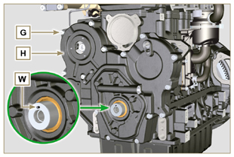  Fig 7.30
7.8.4 Oil pump  Important  - The oil pump is not repairable.  - Undo the screws L and remove the pump unit M from the timing system carter H ( ST_06 ) . | 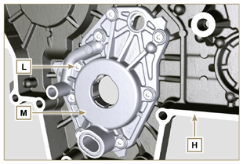  Fig 7.31
- Remove the rotors N and P from oil pump carter M . | 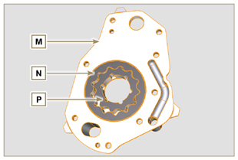  Fig 7.32
7.8.5 Oil Cooler unit and lub. oil filter  - Screw the lid cartridge holder V .  - Undo the screws Q, R and remove Oil Cooler group S .  Warning  - Use a suitable container to recover any residue oil.  - Oil Cooler unit S is not repairable. | 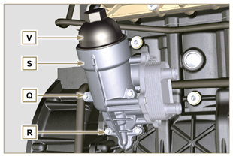  Fig 7.33
- Remove the gaskets T and U .  NOTE: To replace the oil cartridge, refer to Par. 6.10.2 . | 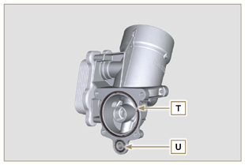  Fig 7.34
7.8.6 Oil vapour separator unit  - Release the clamps AA .  - Remove the manifolds AB, AC and AD .  - Remove the clamp AE by carefully cutting it at the point indicated and remove the oil separator AF . | 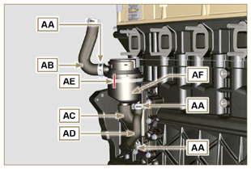  Fig 7.35
- Undo the screws AG .  - Remove la flangia di supportoRemove flange support AH and the gasket seal AL . | 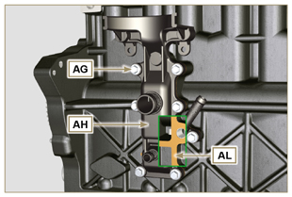  Fig 7.36

Intake manifold disassembly
- Undo the screws A and remove the semi-manifold B ( ST_05 ) .  - Remove the separation plate C and the gaskets H . | 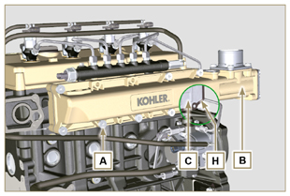  Fig 7.37
- Undo the screws D ( ST_06 ) and E .  - Remove the semi-manifold F and the gasket G . | 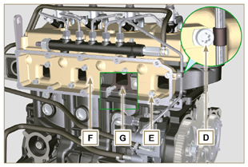  Fig 7.38

Fuel system disassembly
7.10.1 Fuel return pipes  - Release the clip A .  Warning  - After removing the union, the clip A must automatically return to its initial position; otherwise it must be replaced.  - Undo the B distributor return fixing capscrew.  - Release the clamp D .  - Disconnect the pipe E from the fuel return fitting.  - Undo and remove the screw G with the relative gaskets and put the cap on the Common Rail pressure relief valve AA .  - Disconnect unions M from electronic injectors N .  - Remove the fuel return pipes. | 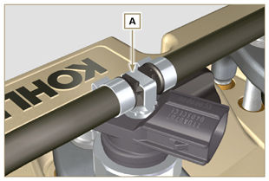  Fig 7.39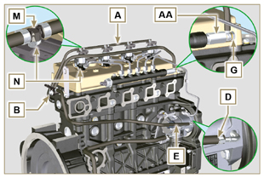  Fig 7.40
7.10.2 Fuel flow pipes  Important  - Seal all openings of the inlet and return unions on the injection pump D with the relevant caps, in order to prevent impurities from entering.  - Loosen the clamps P .  - Remove the pipes Q and R . | 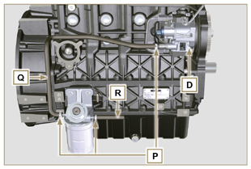  Fig 7.41
7.10.3 High pressure fuel pipes  Danger  - The fuel injection circuit undergoes high pressure, use safety protections as described in Par 3.4.3 .  - Ensure that the Common Rail is not under pressure by slowly and carefully unscrewing one of the nuts S .  - Loosen the nuts S and T in sequence.  - Fully undo the nuts S and T in sequence, and remove the high pressure pipes U and V . | 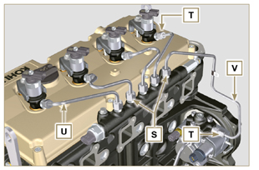  Fig 7.42
7.10.4 Common Rail  - Undo the screws AB and remove the Common Rail AC .  NOTE: Take care to protect te sensor AD from knocks, moisture and any high temperature source. The internal parts of the rail cannot be repaired.  Important  - Seal all injection component unions as illustrated in Par. 2.9.8 .  - Common rail cannot be repaired. | 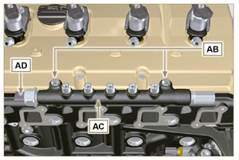  Fig 7.43
7.10.5 Electronic injectors  Important  - In the event that the electronic injectors are disassembled (not necessarily replaced), mark them with the relevant cylinder number from which they originate so as not to confuse them during re-assembly (Fig. 7.45) .  - The electronic injectors cannot be repaired.  - If one or more electronic injectors are to be replaced, the new calibration data must be inserted in the ECU via a specific instrument ( ST_01 ).  - Be careful not to damage the gaskets X .  - Undo capscrews AE and remove them together with the relative washers AF and then brace AG .  - Pull out the electronic injector AH .  NOTE: Should you be unable to remove the electronic injector (acting only on point BC ), use an open-ended spanner (Ø 34 mm), by applying small rotations to unblock the component.  - Seal all injection component unions as illustrated in Par. 2.9.8 .  - Ensure that gasket AL has remained in the correct position (Fig. 7.46) .  Otherwise, recover the gasket from inside the electronic injector AM . | 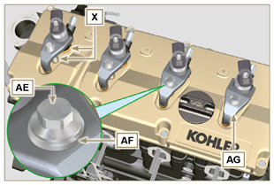  Fig 7.44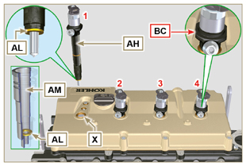  Fig 7.45
7.10.6 Fuel filter ( )  - Undo the fuel cartridge AW from support AP .  - Undo the screws AN and remove the filter support AP . | 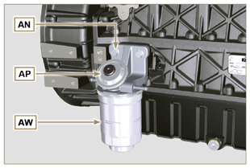  Fig 7.46
7.10.7 High-pressure fuel injection pump  Important  - Before disassembling, carefully read Par. 2.17 .  - The injection pump is not repairable  - Should the fuel feeding pump need to be replaced, after assembly, it is necessary to perform the Pump Learning procedure by means of instrument ST_01 .  - Undo the nut AQ .  - Loosen the screws AR of the injection pump.  - Screw the tool ST_04 on the thread of the gear AS .  - Tighten the screw AT on the puller to disconnect the gear AS from the injection pump and remove the injection pump control gear AS .  - Undo the screws AR .  - Remove injection pump AU and the relative gasket AV .  - Seal all injection component unions as illustrated in Par. 2.9.8 . | 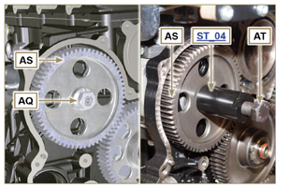  Fig 7.47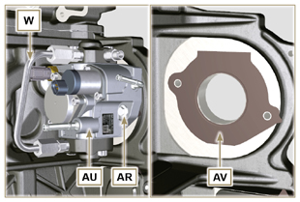  Fig 7.48

Timing system gear disassembly
- Unscrew screws H and remove target wheel G .  - Unscrew screws D and remove camshaft gear E .  - Remove retainer ring A and the shoulder ring B .  - Remove the intermediate gear C . | 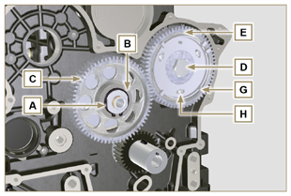  Fig 7.49
- Remove the shoulder ring F .  - Unscrew the screws L and remove the intermediate gear support M . | 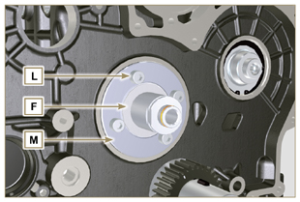  Fig 7.50

Flange unit disassembly
7.12.1 Flywheel  Important  - Leave the special tool ST_34 for blocking the flywheel ( Par. 7.7 ) .  - Only undo the screw C located uppermost.  - Insert the tool ST_09 in the seat of the screw C tightening it all the way.  - Undo the remaining screws D .  Danger  - The flywheel E is very heavy. Pay the utmost attention while removing it in order to prevent it dropping or falling, as this may have serious consequences for the operative.  - Remove the flywheel E .  - Remove the tool ST_09 .  - Remove the tool ST_34 shown in Fig. 7.11 . | 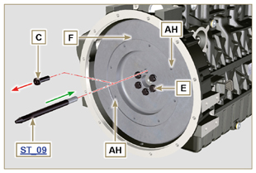  Fig 7.51
7.12.2 Flange housing  - Undo the screws A and remove the engine housing B .  Danger  - The flange housing is very heavy. Pay the utmost attention while removing it in order to prevent it dropping or falling, as this may have serious consequences for the operative. | 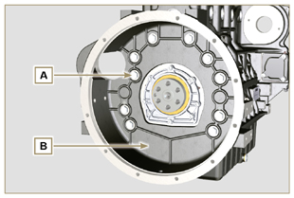  Fig 7.52

Cylinder head unit disassembly
7.13.1 Rocker arms cover  - Undo the screws A .  - Remove the rocker arms cover B .  - Remove the gasket C . | 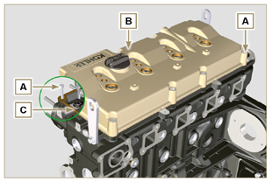  Fig 7.53
7.13.2 Rocker arm pin  - Undo the screws D .  - Remove the rocker arm pin unit E . | 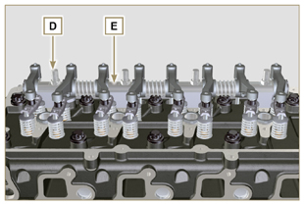  Fig 7.54
7.13.2.1 Rocker arm ( )  - Remove the retainer ring F .  - Remove the shoulder rings G .  - Remove the rocker arms H . | 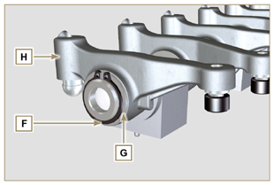  Fig 7.55
7.13.3 Valve rods and bridges  - Remove the valve control U-bolts M .  - Remove the rocker arm control rods N . | 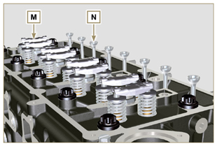  Fig 7.57
7.13.4 Cylinder head  Important  - The cylinder head fastening bolts P must be replaced every time they are disassembled.  - Undo the bolts P .  Important  - To lift cylinder head Q , only use both eyebolts AE provided by KOHLER (refer to Fig. 7.66 ).  - When removing the cylinder head Q and subsequent disassembly, control, and assembly operations, it is necessary to protect the contact surface W of cylinder head Q and crankcase J against impacts.  - Remove the cylinder head Q .  - Remove the head gasket R . | 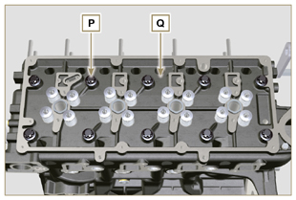  Fig 7.58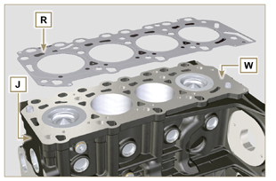  Fig 7.59
7.13.4.1 Valves ( )  - Mount the tool ST_07 on the head AF fixing it on one of the holes for fixing the rocker arm cover.  NOTE: Change the fixing hole according to the position of the valves to be removed.  - Position the tool ST_07 on the valve as shown in the figure. | 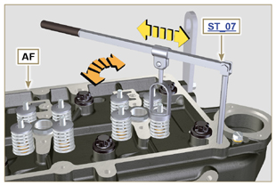  Fig 7.60
- Push the lever of the tool ST_07 downwards, in order to lower the valve plates S in the direction of the arrow T , remove cotters U using a magnet.  NOTE: Repeat all the operations for all the valves concerned. | 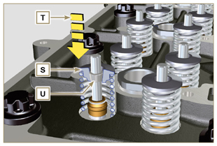  Fig 7.61
Important  - Before removing the valves, make some marks to record their original position, in order to avoid confusing them when reassembling (if they are not replaced).  - Remove the valves V . | 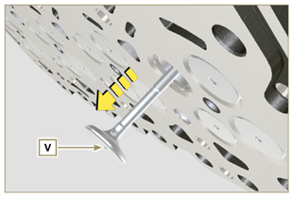  Fig 7.62
7.13.4.2 Electronic injector sleeves ( )  - Unscrew and remove the sleeves Z from the head Q .  - Remove the gaskets AA and AB . | 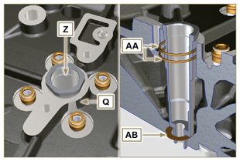  Fig 7.63
7.13.4.3 Valve stem gasket ( )  - Remove the gaskets AC . | 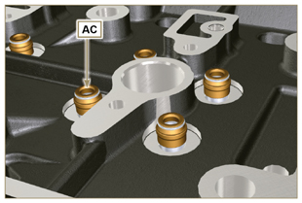  Fig 7.64
7.13.4.4 Lifting eyebolts ( )  - Undo the screws AD and remove the eyebolts AE .  - Thoroughly wash the cylinder head Q . | 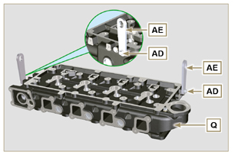  Fig 7.65

Oil sump unit disassembly
7.14.1 Oil sump  - Undo the screws A .  - Remove the oil sump B by inserting a plate in the areas indicated by the arrow AA . | 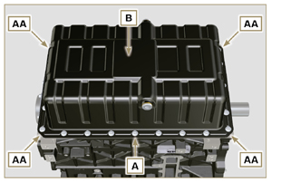  Fig 7.66
7.14.2 Oil suction pipe  - Undo the screws C and remove the oil pipe D . | 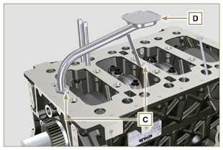  Fig 7.67
7.14.3 Oil vapour pipes ( )  - Unscrew and remove the pipes E . | 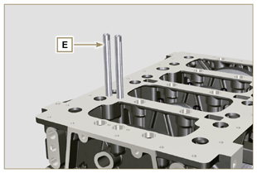  Fig 7.68

Engine block disassembly
7.15.1 Crankshaft gasket flange  - Undo the screws A .  - Remove the flange B and the gasket C . | 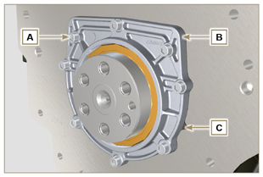  Fig 7.69
7.15.2 Piston unit/connecting rod  Important  - Mark some numerical references (cylinder n°) on the connecting rods, connecting rod caps F1 , pistons and gudgeon pins to prevent unintentionally confusing the components not replaced during assembly. Failure to do this may result in engine malfunctions.  - References on connecting rod M and cap F1 must only be carried out on a side in correspondence with K1 and K2 , as illustrated in Fig. 7.70a .  - Screw the bolt AM temporarily.  - Unsrew bolts E1 and remove the connecting rod caps F1 . | 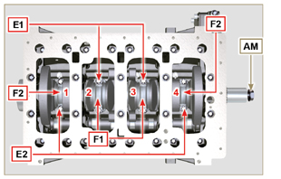  Fig 7.70
NOTE : coupling cap F1 on the connecting rod can be carried out with centring taper pins (Fig. 7.70b) or broken ( Fig. 7.70c - without centring taper pins).  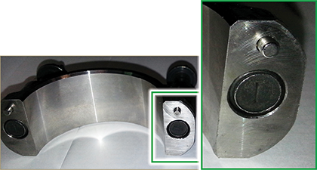  Fig. 7.70b  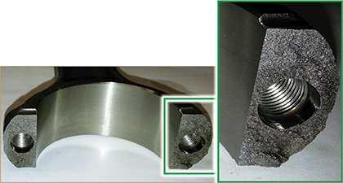  Fig. 7.70c | 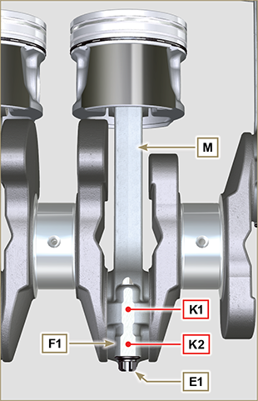  Fig 7.70a
- Pull out the connecting rod - piston assembly from position 2 and 3 by manually applying pressure on the connecting rod big end L in the direction of arrow AK .  - Couple the connecting rod big end caps L with the relevant piston and connecting rod unit M .  - Turn capscrew AM and rotate the crankshaft by 180°.  - Repeat points 2 to 5 to disassemble the connecting rod-piston assembly to position 1 and 4 . | 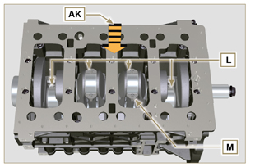  Fig 7.71
Warning  - The connecting rod half-bearings Z are made of special material. Therefore, they must be replaced every time they are removed to prevent seizures. | 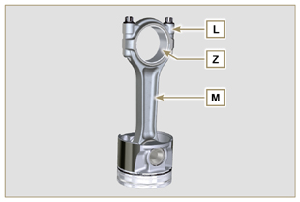  Fig 7.72
7.15.3 Lower semi-crankcase  3 CYLINDERS  - Undo capscrews E and F by following the order indicated in the figure.  - Remove the lower semi-crankcase D and store it in a suitable container for washing. | 3 Cylinders  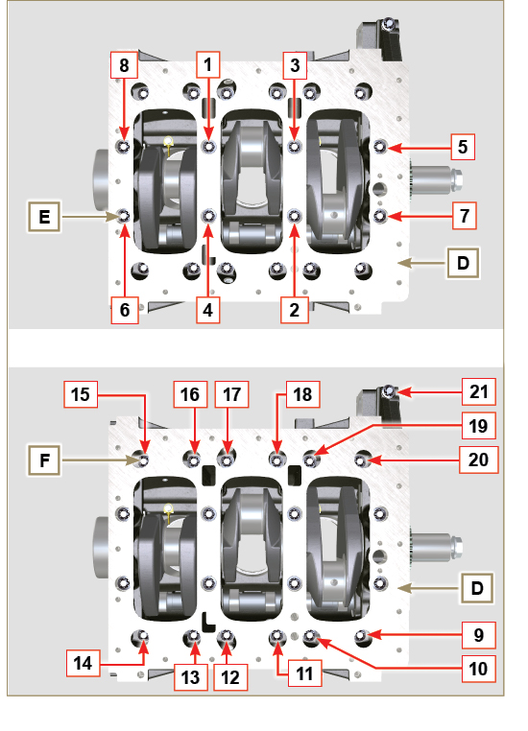  Fig 7.73
4 CYLINDERS  - Undo capscrews E and F by following the order indicated in the figure.  - Remove the lower semi-crankcase D and store it in a suitable container for washing. | 4 Cylinders  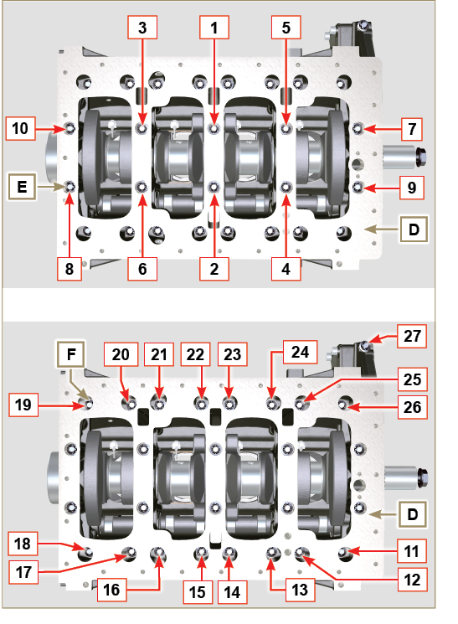  Fig 7.74
7.15.4 Crankshaft  Remove:  - Crankshaft G .  - The shoulder semi-rings H . | 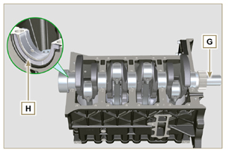  Fig 7.75
7.15.5 7.15.5 Piston ( )  - Remove the retainer ring N .  - Remove the pin P to separate the piston Q from the connecting rod R .  Important  - If they are not replaced, keep the components together (connecting rod - piston - gudgeon pin) by using references in order to prevent them from getting mixed up during assembly. | 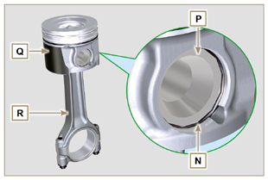  Fig 7.76
7.15.5.1 Rings ( )  - Remove the rings S . | 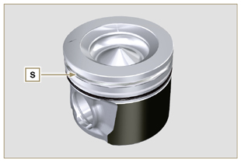  Fig 7.77
7.15.6 Oil spray nozzles ( )  - Undo the screws T and remove the spray nozzles U from the upper semi-crankcase AB . | 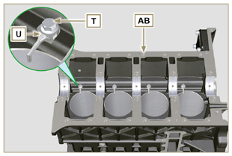  Fig 7.78
7.15.7 Camshaft  - Remove the lock ring V .  - Extract the camshaft W from the upper semi-crankcase AB . | 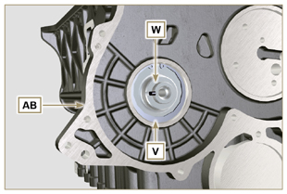  Fig 7.79
7.15.8 Camshaft tappets  - With a magnet, remove the tappets AA from the upper semi-crankcase AB . | 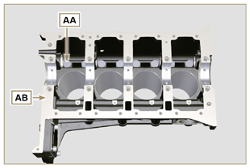  Fig 7.80
7.15.9 Crankshaft bushings  - Remove the crankshaft bushings AC from the upper crankcase AB .  Important  - The crankshaft half-bearings AC are made of special material. Therefore, they must be replaced every time they are removed to prevent seizures. | 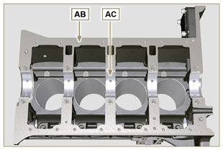  Fig 7.81
- Remove the crankshaft bushings AF from the lower semicrankcase AE . | 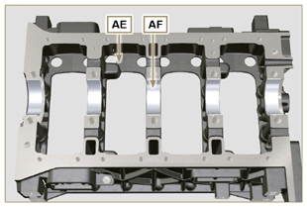  Fig 7.82
7.15.10 Cover 3 ^{th} PTO ( )  - Undo the screws AG .  - Remove the cover AH and the gasket AL from the semicrankcase top. | 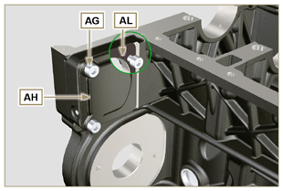  Fig 7.83

