Technical information
KSD 1403 Owner Manual

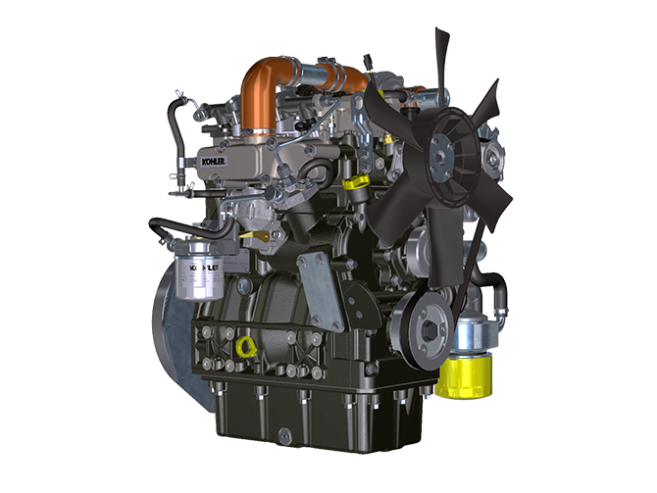
Sommario
1. TITOLO 1 2
1.1. Asdfsdfsdf 2
1.2. Asdfsdfsdfggg 2

Technical information

General description of the engine
- 4-stroke, in-line cylinders Diesel engine; - Liquid-cooling system;

- 2 valves per cylinder;

- Indirect injection.

Engine specifications
2.1
TECHNICAL DATA |  | UNIT OF MEASURE
Engine type |  |  | KSD 1403 NA | KSD 1403 TC
Cylinders |  | n. | 3
Bore |  | mm | 81
Stroke |  | mm | 90
Displacement |  | cm ³ | 1391
MAX INCLINATION DURING OPERATION (even in combined) |  | α | 40° max 30 min.
 |  | α | 45° max 1 min.
OIL CAPACITY (MAX level.) including oil filter | Compact Sump | lt. | 3.72
 | Deep Sump |  | 5.44
DRY WEIGHT |  |  | 121 | 126

Engine dimensions (mm)

KSD 1403 NA | KSD 1403 TC

NOTE : Dimensions vary according to engine configuration.

Oil

Important

- The engine may be damaged if operated with improper oil level.
- Do not exceed the MAX level because a sudden increase in engine rpm could be caused by its combustion.
- Use only the recommended oil to ensure adequate protection, efficiency and service life of the engine.
- The use of lubricants other than recommended may shorten the engine life.
- Viscosity must be appropriate to the ambient temperature to which the engine is to be exposed.

Danger

- Prolonged skin contact with the exhausted engine oil can cause cancer of the skin.
- If contact with oil cannot be avoided, thoroughly wash your hands with soap and water as soon as possible.
- For the exhausted oil disposal, refer to the Par. DISPOSAL and SCRAPPING .
2.4.1 SAE oil classification
- In the SAE classification, oils are identified according to viscosity without considering any other qualitative characteristic.
- The code is composed of two numbers, which indicate, and must correspond to, the ambient temperature in which the engine operates, the first number refers to the viscosity when cold, for use during winter (" W "), while the second number is for viscosity at high temperatures.

2.2
RECCOMENDED OIL
 |  | TCR STAGE-V (*1) (*2) | TCR TIER IV FINAL (*1) | TCR/D TIER III o NON CERTIFICATO (*3)
WITH SPECIFICATIONS | API | CJ-4 Low S.A.P.S  CK-4 Low S.A.P.S | CJ-4 Low S.A.P.S  CK-4 Low S.A.P.S | CI-4 Plus  CI-4  CH-4
 | ACEA | E6 Low S.A.P.S. | E6 Low S.A.P.S. | E7  E4
VISCOSITY | SAE | 0w-40 (-40°C ÷ +50°C)  5w-40 (-30°C ÷ +50°C)  10w-40 (-25°C ÷ +50°C) | 0w-40 (-40°C ÷ +50°C)  5w-40 (-30°C ÷ +50°C)  10w-40 (-25°C ÷ +50°C) | 0w-40 (-40°C ÷ +50°C)  5w-40 (-30°C ÷ +50°C)  10w-40 (-25°C ÷ +50°C)
- Low S.A.P.S. technology (oil with low Sulfated Ash, Phosphorus, Sulfur content) keeps catalyst in good working conditions. The presence of sulfated ash, phosphorus and sulfur causes with time the catalyst clogging and its consequent inefficiency.
- For Mid S.A.P.S oil sequence the sulfated ash level is the same as API CJ-4 ≤ 1.0% but as per ACEA standardization those oils are referenced as mid SAPS.
- Filtration of oils is critical to proper operation and lubrication; always change filters regularly as specified in this manual.

(*1) NOTA : Do NOT use fuel with sulphur content above 15ppm.

(*2) - On all engines compliant with Stage-V emission regulation (engines with DPF device), the oil to use must comply with the specification API CJ-4 Low S.A.P.S or ACEA E6 Low S.A.P.S.

(*3) - NOTE : Do NOT use fuel with sulphur content above 500ppm.

(*3) - NOTE : Low S.A.P.S. oils, sulfate ashes <1% may not be used with fuels with a sulfur content >50ppm.

Fuel
Important
- Use of other types of fuel could damage the engine. Do not use dirty diesel fuel or mixtures of diesel fuel and water since this will cause serious engine faults.
- Any failures resulting from the use of fuels other than recommended will not be warranted.
Warning
- Clean fuel prevents the fuel injectors from clogging. Immediately clean up any spillage during refuelling.
- Never store diesel fuel in galvanized containers (i.e. coated with zinc). Diesel fuel and the galvanized coating react chemically to each other, producing flaking that quickly clogs filters or causes fuel pump and/or injector failure.

NOTE: In a warranty case the customer must prove by a certificate from the fuel supplier that an allowed fuel was used.

2.3

Country | EU |  | USA (ASTM D 975) | other countries
Fuel type | (EN 590) | (EN 15940) | Grade 1-D S15  Grade 2-D S15 | NATO F-54 (equivalent to diesel fuel in accordance with EN 590)  EN 590 or ASTM D 975 Grade 1, 2 -D S15 Arctic Diesel  JIS K 2204 N. 1, N. 2

Coolant recommendation
A mixture of 50% demineralized water and 50% low silicate ethylene glycol based coolant liquid must be used. Use a Long Life or Extended Life Heavy Duty OAT coolant free of: silicates, phosphates, borates, nitrites and amines.

The following ethylene-glycol based engine coolant for all models within KDI engine family may be used:

- OAT (Organic Acid Technology) Low Silicate: ASTM D-3306 D-6210
- HOAT (Hybrid Organic Acid Technology) Low Silicate: ASTM D-3306 D-6210

The above coolants in concentrated formulation must be mixed with distilled, deionized, or demineralized water. A pre-mixed formulation (40-60% or 50-50%) can be used directly when available.

Important
- Do not mix ethylene glycol and propylene glycol based coolants. Do not mix OAT and HOAT based coolant. OAT performance life can be drastically reduced if contaminated with nitrite-containing coolants.
- Never use automotive-type coolants. These coolants do not contain the correct additives to protect heavy – duty diesel engines.

OAT coolants are maintenance free up to 6 years or 6000hrs of operation , provided that the cooling system is topped up using the same type of coolant. Do not mix different coolant types. Test the coolant condition annually with coolant test strips.
HOAT are not all maintenance free and it is recommended to have SCA (Supplemental Coolant Additives) added at the first maintenance interval.

Battery recommendation
Battery not supplied by Kohler

Tab. 2.7
RECOMMENDED BATTERIES
AMBIENT TEMPERATURE | BATTERY TYPE
> - 15°C | 12V 100 Ah - 800 CCA/SAE
-15°C ÷ -25°C | 12V 110 Ah - 950 CCA/SAE
< - 25°C | 12V 120 Ah - 1000 CCA/SAE

